MIDTERM #1 Notes

Chapter 2 The Economic Problem
Chapter 3 Demand & Supply
Chapter 4 Elasticity
Chapter 5.2-5.3 Efficiency & Equity
Chapter 6 Government Actions in Markets

CHAPTER 2: The Economic Problem

  - Production Possibilities & Opportunity Cost
- Production Possibilities Frontier (PPF ): boundary between combinations of goods and services that can be produced and those that cannot, when all available resources are used to their limit. It’s the curve connecting points on a graph of productions of 2 goods vs. each other; points on or inside it are attainable but outside are not.
- Production efficiency: if we produce goods and services at the lowest possible cost. This outcome occurs at all the points on the PPF, but inside curve is inefficient b/c unused & misallocated resources.
- At any given point in time, we have a fixed amount of the 4 factors of production (labor, land, capital, and entrepreneurship). So tradeoffs occur b/c of opportunity cost (highest-valued alternative forgone) always being involved.

2.2 Using Resources Efficiently
- Allocative efficiency: When goods and services are produced at the lowest possible cost and in quantities that provide the greatest possible benefit point on PPF most preferred. Occurs when marginal benefit = marginal cost.
- Marginal cost: opportunity cost of producing one more unit of it of a good; calculated from slope of PPF. Value changes along PPF curve.
- Marginal benefit from a good/service is the benefit received from consuming one more unit of it, but benefit is subjective & depends on preferences/willingness to pay for it. So we use marginal benefit curve, which is a curve that shows marginal benefit vs. quantity consumed of good unrelated to PPF.
- Principle of decreasing marginal benefit: more we have of any good or service, the smaller is its marginal benefit (the less we are willing to pay for an additional unit/less we’re willing to give up for it).

2.3 Economic Growth: expansion of production possibilities increases our standard of living, but doesn’t overcome scarcity or avoid opportunity cost. It comes from technological change and capital accumulation.
- Opportunity cost of economic growth is forgone current consumption.
- The benefit of economic growth is increased future consumption.

2.4 Gains from Trade
- A person has a comparative advantage in an activity if they can perform it at a lower opportunity cost than anyone else.
- A person who is more productive (produces more per hour) than others has an absolute advantage.
- We can benefit and move to a point outside PPF by specializing (producing only one good or few goods in which you have comparative advantage) and trading.

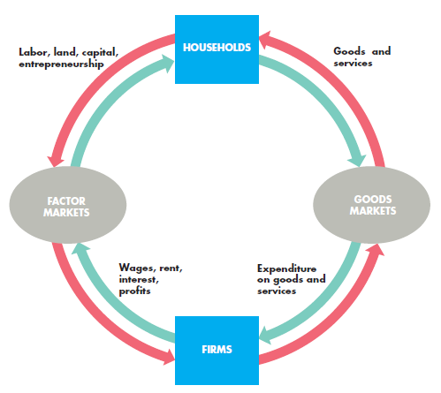
2.5 Economic Coordination
2 competing economic coordination systems have been used: central economic planning (government planning like Cuba & North Korea) and decentralized markets (works well but needs 4 complementary social institutions: firm (economic unit that hires factors of production and organizes those factors to produce and sell goods and services like Walmart); market (any arrangement that enables buyers and sellers to get information and to do business with each other like world oil market); .property rights (social arrangements that govern the ownership, use, and disposal of anything that people value); & money (any commodity or token that is generally acceptable as a means of payment)

Circular flow through markets: The outer red flows are real flow (flow of factors of production from households firms and flow of goods and services from firms households). The inner green flows are the payments for the red flows (flow of incomes from firms households and the flow of expenditure on goods and services from households firms).

CHAPTER 3: Demand & Supply

3.1 Markets & Prices
- Competitive market: one that has so many buyers and sellers that no single buyer or seller can influence the price.
- Opportunity cost is a relative price (ratio of 1 price to another – can be price of an item divided by average price of other goods & service); demand and supply determine relative prices.

3.2 Demand: relationship between the quantity demanded (amount per unit time) of a good and its price when all influences on buying plans other than price remain the same. If you demand something, you can afford it and are planning to buy it.
- Demand curve shows this relationship (price vs quantity demanded); graphed version of demand schedule. Marginal benefit curve
- Law of demand: higher the price of a good, the smaller the quantity demanded because of substitution effect (people wanna buy something else instead) and income effect (people can’t afford it anymore). INVERSELY proportional
- Demand depends on 6 things: the prices of related goods (substitutes—like energy bar to drink and complements—like ketchup to hot dogs), expected future prices, income (as income increases, demand for normal goods like air travel increases & inferior goods like bus trip decreases), expected future income and credit, the population, and preferences. A change in any of these shifts demand curve. * Note: if just moving along curve, it’s a change in quantity demanded, but if shifting curve, it’s a change in demand.

3.3 Supply: relationship between quantity supplied of a good and its price when all other influences on selling plans remain the same. If you supply something, you have the resources to produce it and can make profit off it.
- Supply curve shows the lowest price at which someone is willing to sell (marginal cost).
- Law of supply: higher the price of a good, greater the quantity supplied because marginal cost increases. PROPORTIONAL
- Supply depends on 6 things: the prices of factors of production used to produce a good, the prices of related goods produced, expected future prices, the number of suppliers, technology, and the state of nature (all the natural forces that influence production like environment).

3.4 Market Equilibrium
- At the equilibrium price, quantity demanded = quantity supplied.
- At any price above the equilibrium price, there is a surplus and price falls.
- At any price below the equilibrium price, there is a shortage and the price rises.

3.5 Predicting Changes in Price & Quantity
- Increasing demand increases price & quantity of good, while decreasing it decreases them (demand is proportional to price & quantity)
- Increasing supply decreases price & increases quantity (supply is inverse to price & proportional to quantity).
- An increase in both increases quantity but brings uncertain price change.
- An increase in demand and a decrease in supply bring a higher price but an uncertain change in quantity.

CHAPTER 4: Elasticity

4.1 Price Elasticity of Demand
- Elasticity: measure of the responsiveness of the quantity demanded of a good to a change in its price (other things remaining the same).
- Price elasticity of demand equals the % change in the quantity demanded divided by % change in the price. The larger the magnitude of the price elasticity of demand, the greater is the responsiveness of the quantity demanded to a given price change. Always positive (take absolute value).
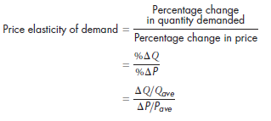
- Perfectly inelastic demand: If the quantity demanded remains constant when the price changes, so price elasticity of demand = 0 (e.g. insulin)
- Unit elastic demand: If the percentage change in the quantity demanded equals the percentage change in the price, then the price elasticity = 1
- Perfectly elastic demand: If quantity demanded changes by an infinitely large percentage in response to a tiny price change, so price elasticity of demand is infinity (e.g. any good that has perfect substitute)
Generally:
- Inelastic demand: %change in quantity demanded < %change in the price so the price elasticity of demand is between zero and 1 (e.g. food & shelter)
- Elastic demand: %change in quantity demanded > %change in the price so elasticity > 1 (e.g. automobiles & furniture)
On a linear demand curve, demand is unit elastic at midpoint (elasticity is 1), elastic before midpoint, and inelastic after midpoint.
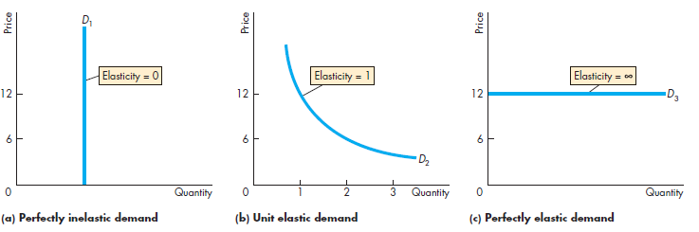
- If demand is elastic, a cut in price leads to an increase in total revenue. If demand is unit elastic, a cut in price leaves total revenue unchanged. And if demand is inelastic, a cut in price leads to a decrease in total revenue. (Just analyze formula/their meaning)
- Price elasticity of demand depends on 3 things: closeness of subtitutes (how easily one good serves as a substitute for another—closer = more elastic), the proportion of income spent on the good (higher portion = more elastic demand for it b/c effects more), and the length of time elapsed since the price change (longer = more elastic).

4.2 More Elasticities of Demand
- Cross elasticity of demand: unitless measurement of responsiveness of the demand for one good to a change in the price of a substitute or a complement (other things remaining the same). Calculated same way. The cross elasticity of demand with respect to the increasing price of a substitute is positive & for complement is negative.
- Income elasticity of demand: measures responsiveness of demand to a change in income, other things remaining the same. For a normal good, the income elasticity of demand is positive. For an inferior good, the income elasticity of demand is negative.
- When the income elasticity of demand > 1 (income elastic/normal good), the percentage of income spent on the good increases as income increases (proportional)
- When the income elasticity of demand < 1 (income inelastic and inferior good), the percentage of income spent on the good decreases as income increases (inverse).

4.3 Elasticity of Supply: measures the responsiveness of the quantity supplied of a good to a change in its price (other things remaining the same). Usually positive and ranges between zero (vertical supply curve) and infinity (horizontal supply curve).
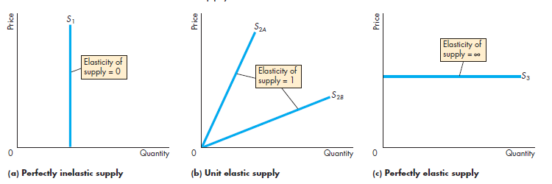

- Elasticity of supply depends on 2 factors: Resource substitution possibilities & Time frame for the supply decision supply decisions have 3 time frames:
- Momentary supply refers to the response of the quantity supplied to a price change at the instant that the price changes.
- Short-run supply refers to the response of the quantity supplied to a price change after some of the technologically feasible adjustments in production have been made.
- Long-run supply refers to the response of the quantity supplied to a price change when all the technologically feasible adjustments in production have been made (usually elastic while momentary & short-run are typically inelastic)

CHAPTER 5: Efficiency & Equity

5.2 Benefit, Cost, & Surplus
Demand curve is also called marginal benefit curve b/c it shows maximum price willingly paid.
- Market demand curve: horizontal sum of the individual demand curves and is the marginal social benefit curve. (DESCENDING… cause demand curve)
- Value: what people are willing to pay; price is what people must pay.
- Consumer surplus: excess of the benefit received from a good/service over the amount paid for it. Calculated by finding area under curve (triangle) upto the market price.

Supply curve is also called marginal cost curve b/c shows minimum supply-price.
- Market supply curve: horizontal sum of the individual supply curves and is the marginal social cost curve. (ASCENDING… cause supply curve)
- Cost: what producers pay; price is what producers receive.
- Producer surplus: excess of the amount received from the sale of a good or service over the cost of producing it. Calculated by finding area above curve upto market/equilibrium price.
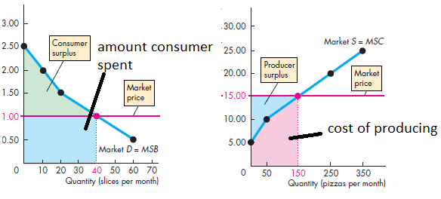

5.3 Is the Competitive Market Efficient?
- In a competitive equilibrium, marginal social benefit = marginal social cost and resource allocation is efficient. Total surplus (consumer surplus + producer surplus) is maximized.
- Buyers and sellers acting in their self-interest end up promoting the social interest.
- Producing less than or more than the efficient quantity creates deadweight loss (decrease in total surplus that results from an inefficient level of production).
- 6 things can lead to market failure (underproduction & overproduction): Price and quantity regulations; taxes and subsidies (taxes increase price buyers have to pay & lowers what sellers receive so underproduction while subsidies do exact opposite b/c it’s what government pays producers); externalities (cost or a benefit that affects someone other than the seller or the buyer); public goods and common resources (good or service that is consumed simultaneously by everyone even if they don’t pay for it); monopoly (firm that is the sole provider of a good or service.); and high transactions costs (costs of the services that enable a market to bring buyers and sellers together).
*NOTE: All lead to underproduction except for subsidies, which lead to overproduction.
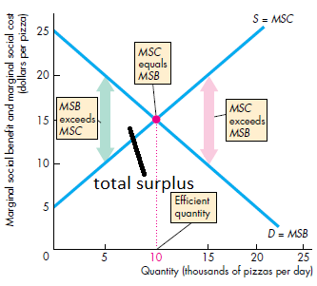

CHAPTER 6: Government Actions in Markets

  - A Housing Market with a Rent Ceiling
Price ceiling or cap: government regulation that makes it illegal to charge a price higher than a specified level.
- A rent ceiling that is set above the equilibrium rent has no effect.
- A rent ceiling that is set below the equilibrium rent creates 3 things: housing shortage (quantity demanded > quantity supplied), increased search activity (time spent looking for someone with whom to do business), and a black market (illegal market in which equilibrium price exceeds the price ceiling) is inefficient and unfair.
- Only fair way to allocate scarce housing is benefitting the poor, so lottery, first-come first-served & discrimination are not fair, so rent ceiling is only fair way.

6.2 A Labour Market with a Minimum Wage
Price floor: government imposed regulation that makes it illegal to charge a price lower than a specified level.
- A minimum wage set below the equilibrium wage rate has no effect.
- A minimum wage set above the equilibrium wage rate creates unemployment and increases the amount of time people spend searching for a job is inefficient (marginal benefit exceeds marginal cost), unfair, and hits low-skilled young people hardest blocks voluntary exchange.

6.3 Taxes: raises the price paid by buyers, but usually by less than the tax.
- Tax incidence: division of the burden of a tax between buyers and sellers. Determined by elasticity of demand and supply. So:
- If demand is perfectly elastic or supply is perfectly inelastic, sellers pay the entire tax. And if demand is perfectly inelastic or supply is perfectly elastic, buyers pay entire tax.
Basically, the less elastic the demand or the more elastic the supply, the larger is the share of the tax paid by buyers.
- Only situation where taxes don’t create deadweight loss: if supply & demand are both perfectly inelastic (rare).
- Fairness of taxes 2 conflicting principles: benefits principle (people should pay taxes equal to the benefits they receive from the services provided by government) & ability-to-pay principle (people should pay taxes according to how easily they can bear the burden of the tax).

6.4 Production Quotas & Subsidies
- Production quota (upper limit to the quantity of a good that may be produced in a specified period) leads to inefficient underproduction b/c marginal cost decreased to below market price, which raises the price if quota is below equilibrium quantity.
- Subsidy (payment made by the government to a producer) is like a negative tax. It lowers the price, increases the cost of production, and leads to inefficient overproduction b/c marginal cost increased to more than market price. Opposite of production quota effects.

6.5 Markets for Illegal Goods
- Penalties on sellers increase the cost of selling the good & decrease supply of the good.
- Penalties on buyers decrease their willingness to pay & decrease demand for the good.
- Penalties on buyers and sellers decrease the quantity of the good, raise the price buyers pay, and lower the price sellers receive.
Legalizing and taxing can achieve the same outcome as penalties on buyers and sellers

