Topic 1 – Business & IT
- Three ways to compete:
- Cost – By being a low cost producer of a service or good.
- Differentiation – Offering products or services customers prefer due to quality, customer service, brand image…
- Focus – Competing on cost or differentiation within a specific market niche
- Internet – eg. Travel companies (Thomas Cook).

- New ways to work:
- Telecommuters – Individuals who use mobile technology and/or network connections to work remotely from the office
Pros | Cons
- Flexibility | - Isolation
- Work-life Balance | - Fewer opportunities

- Free Agents – Individuals who chose to contract out their services and are not tied to an organization.
Pros | Cons
Fast, convenient communication | Lack of benefits
No long-term contract required from organization | Unpredictability in scheduling and work
Lots of ‘free’ materials on the internet

- IT and Business Decision-making
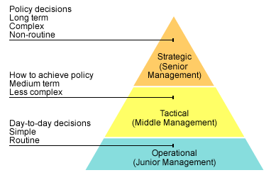
- Types of Businesses

Sole Trader  Business owned and operated by one person  Adv  - Easy to start as little capital needed  - Owner makes all decisions  - All profits go to owner  Dis  - Unlimited liability (liable for all his debts, money and assets)  - All losses go to owner  - Difficult to raise capital to start  - If owner dies, business ends | Partnership  Business owned by 2 or more people.  Adv  - Easy to start business  - Easy to raise capital  - More skills available  - Shared decision-making  Dis  - Each partner is liable for debts  - Conflicts arise btwn partners  Limited partnership = limited liability (debts limited to amount they invested)
Corporation  Business owned by number of people and operated under written permission  Adv  - Unlimited numbers of shareholders  - Easy to raise capital  - Limited liability  - Risks shared  Dis  - Difficult to start  - Profits are shared  - Owners have less control over decision making | Public Limited Company  A business owned by shareholders that can sell shares to the public  Adv  - Limited liability  - Continuity  - Potential to raise large capital  Dis  - Many legal formalities  - Selling shares is expensive  - Difficult to control since it’s too large
Private Limited Company – A business owned by shareholders that cannot sell shares to the public

Adv
- Limited Liability
- Sell of shares makes it easy to raise finance
Dis
- Too many legal formalities
- Cannot sell shares to the public

Topic 2 -Project Management
- Project Management - Discipline of planning, organizing, securing, and managing resources to achieve specific goals. Helps you organize and prioritize.

- Why projects fail?
- Unrealistic project aim
- Poorly defined system requirements
- Little understanding of current project status
- Lack of understanding of risks
- Poor communication between stakeholders
- Poor planning

- Project Management Phases
---------------------PLANNING------------------ ---------------------------IMPLEMENTATION----------------------------

Topic 3 – Cloud Computing

- Cloud Computing - cloud computing means storing and accessing data and programs over the Internet instead of your computer's hard drive.
Pros | Cons
Lower cost computing (pay as you go) | Security of data
Better computer performance | Internet access dependent
Unlimited storage | Qos (Quality of service) – provider servers may encounter errors/crashes

- 3 ways to cloud compute:
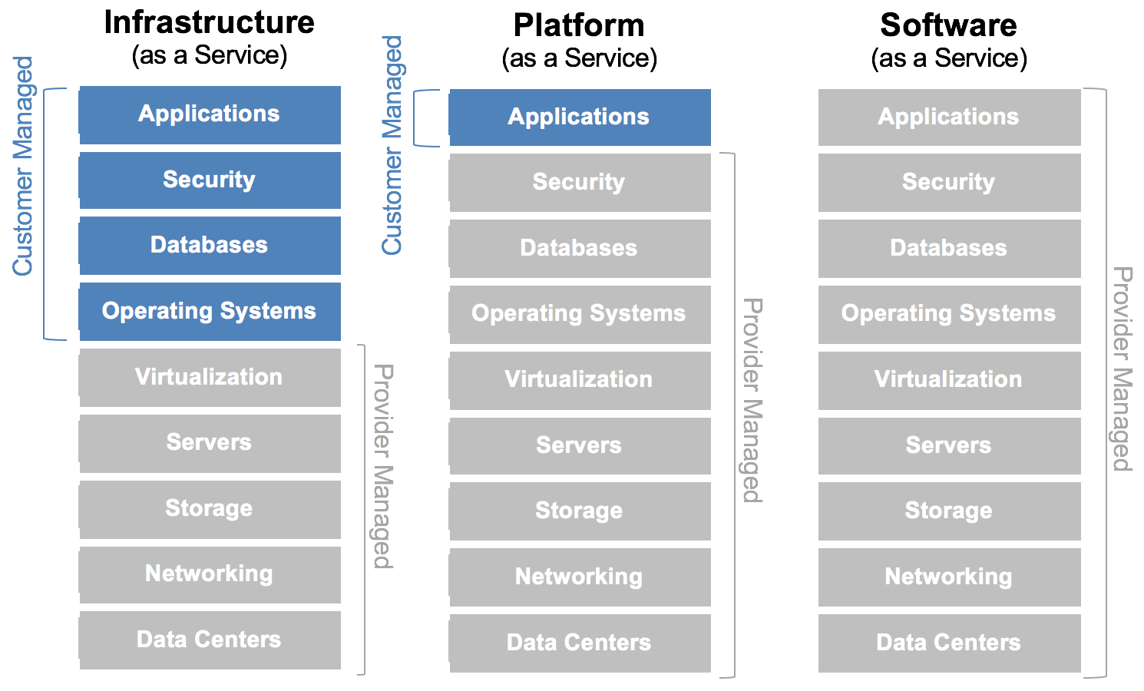
- IAAS – Allows user to run any application they please on suppliers’ cloud hardware. Virtualization.
Pros | Cons
Reduced cost (less hardware, power usage) | Maintenance could be costly
Full control over server

- PAAS – Allows users to create their own cloud applications using tools and environment provided by the provider
Pros | Cons
Rapid development at low cost | Limits developers to languages and tools provided by the provider
Private or public deployment (could be made private for a company only) | Applications built on one providers platform might not be movable to another’s.

- SAAS – Allows user to run existing online applications
Pros | Cons
Free or paid via subscription | Might not be suitable for business use
Accessible form any computer

- Cloud Deployment Model

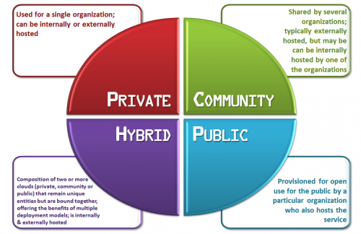

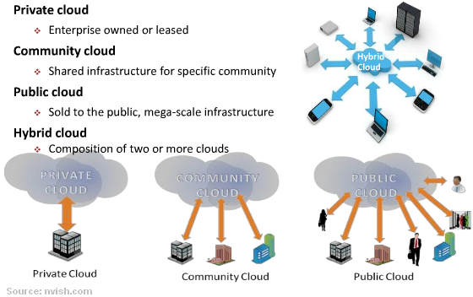
Topic 4 – Open Source Software

- Open Source - denoting software for which the original source code is made freely available and may be redistributed and modified.

Advantages
- Access to the source of the product
- Liberty to remix and redistribute the product
- Change the code – tailor it to your needs
- Change vendor without significant costs

- Open Source Licenses
- GPL – Freedom to use, modify and distribute the source code, but has to be linked to source codes that are GPL.
- LGPL - Freedom to use, modify and distribute the source code, can be linked by commercial software with license restriction
- Mozilla - Freedom to use, modify and distribute the source code, allowed to use code in commercial projects as long as Mozilla code is kept separate.
- Apache - Freedom to use, modify and distribute the source code and can be combined in a closed-source software but not allowed to use the trademark of the original licensor in modifications
- MIT - Freedom to use, modify and distribute the source code and can be combined in a closed-source software, but copy of copy of license and copyright notice should be included with the code.

- Is open source profitable? Yes.
- Dual Licenses (Upgrades)
- IT Services (Manage servers/applications, customer support)
- Professional Training (courses)

Topic 5 - Software Development Methodologies File
- An approach to managing the project life cycle from the beginning to the end of the project.
Why?
- Better control, execution and reduction in overall development
- Promotes communication
- Reduce rework
- Reduce risk

- Methodology Types:
- Waterfall – Create software which develops systematically from one phase to the other.
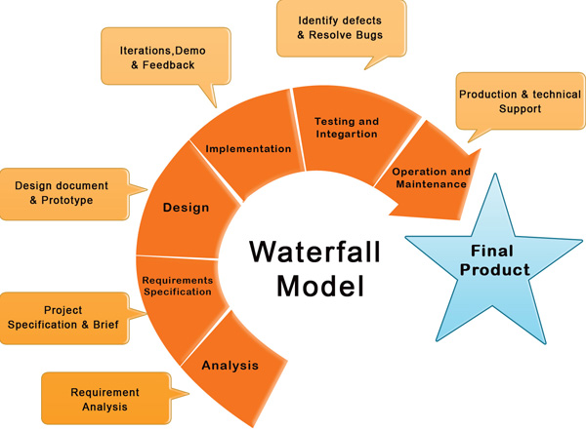

Adv | Dis
Easy to understand | Requirements must be known form start
Sequential approach adds discipline | Slow to embrace changes
Each stage must be completed before the next | Holdup delays

- Waterfall with iteration – Same as waterfall but provides possibility to go back to certain phase to make changes. Iterates until criteria satisfied.
…
Design
Analysis
Implementation

Software prototyping – Mock-up of features of a system.
Adv | Dis
Quick and cost effective | Not great for testing rich interactions
Improved understanding btwn client/developer | If user not satisfied, new prototype is developed until user’s satisfied. Thus, time-consuming

- Agile – Tries to minimize risks by developing project iterative model. Each task is split into smaller blocks which include its own development process (requirement, analysis, design, implementation, testing and documentation).

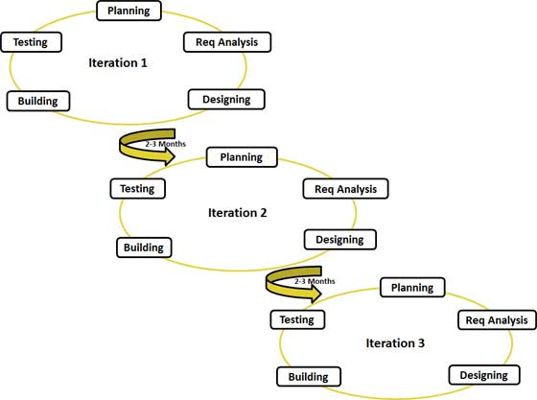

Adv | Dis
Flexibility to make changes and requirements | Requires high commitment time from developers
Testing is done from start to finish | Projects can run longer than estimated
Less defects in final product

TYPES OF AGILE METHODOLOGIES

TYPES OF AGILE METHODOLOGIES

- DSDM (Dynamic System Development Method) - created to meet the changing requirements of software development in industry.
  - 9 Principles:
- Active user involvement
- Empowering the development teams
- Focusing on frequent delivery of products
- Business driven development
- Iterative and incremental development
- All changes are reversible
- Initial requirements are high level
- Integrated testing
- Collaborative and cooperative working

  - Requirements are prioritized using MoSCoW rules:
Must have - fundamental to the projects success
O
Should have - important but the projects success does not rely on these
Could have – can easily be left out without impacting on the project
O
Won’t have – this time round, can be left out and done at a later date.

Topic 6 – Off the Shelf
Application Software | System Software
Used to control and manage computer device and operations. Also enables the computer to start (BIOS). | Used to help a user perform a task and solve a problem. (ms word, chrome)

Off-the-Shelf  Can be purchased, installed and used immediately (readily available) | Custom Made (Tailor-made/bespoke)  Designed and specifically written for a company
Adv  - Less expensive (more sold = lower price)  - Can be bought straight away  - Less bugs as its tried and tested  - Updates provided with no extra cost  - Supports wide range of hardware  Dis  - Subscriptions and upgrades may be expensive  - May have too many additional features  - Larger memory required than custom | Adv  - Meets purpose exactly  - Can be integrated with existing software  - Source code available for future developments  - Less memory required than off the shelf  Dis  - Expensive (design, development, testing)  - Not immediately available  - Less guide materials available

Topic 8 – Usability and HCI
- Usability – “Usability is the effectiveness, efficiency and satisfaction with which specific users can achieve specific tasks in a particular environment”.
Basic def: “Able or fit to use”.
Why HCI and Usability?
- Can increase; Effectiveness, Efficiency, Satisfaction and Learnability.
- Bad design: Makes users not want to use the program = costly; bad-reputation…

- 10 Usability Heuristics:
- Visibility of system status – The system should always keep users informed about what is going on, through appropriate feedback within reasonable time.
Example: If it takes a long time to load a screen, display a progress bar and/or an estimate of the time it may take to load, so users know what to expect.

- Match between system and the real world – Use common words/phrases,
system-oriented terms.
Example: When designing a website for children, use terms with which they are familiar and display information in formats they are used to seeing.

- User control and freedom – Provide undo, redo and exit points to help users leave an unwanted state caused by mistake.

- Consistency and standards – Users should not have to wonder whether different words, situations, or actions mean the same thing.
Example: Use icons with which people are familiar, rather than creating new designs that mean the same thing.

- Error prevention – Even better than good error messages is a careful design which prevents a problem from occurring in the first place.
Example: Auto-correct to prevent users from making errors, or date calendar instead of input field to prevent errors.

- Recognition rather than recall – Reduce the memory load of users by presenting familiar icons, actions, and options whenever possible. Do not require the user to recall information from one screen to another. Use mouse-over tooltips to describe the functionality of icons which may be unfamiliar.
Example: On a web form, allow easy access to previously entered information, such as serial numbers, so the user does not need to recall the information or write it down.

- Flexibility and efficiency of use – Make the system efficient for different experience levels through shortcuts, advanced tools and frequent actions.

- Aesthetic and minimalist design – Don’t show irrelevant or rarely needed information since extra elements diminishes others.
Example: Background graphics can make viewing text difficult or irrelevant text could compete with relevant/important texts.
- Help users recognize, diagnose, and recover from errors – Error messages should be expressed in plain language (no codes), indicate the problem, and suggest a solution.
Example: If users enter invalid email, don’t show “Incorrect email”, rather show “Please enter an email address in this format: email@address.com.”

- Help and documentation – Even though it is better if the system can be used without documentation, provide a short, concrete, searchable and focused documentation.

- HCI (Human-Computer Interactions) – “a discipline concerned with the design, evaluation and implementation of interactive computing systems for human use”
Basic def: HCI is the study of how people interact with technology interfaces.

- 8 Rules of HCI design
- Strive for Consistency – menus, prompts and commands should be consistent throughout the application.

- Enable frequent users to use shortcuts – as the user gets more comfortable with the software they would like to reduce the number of interactions they perform. The user should be able to use shortcut keys to perform actions.

- Offer informative feedback – For every user action, the system should provide feedback.

- Design dialogs to yield closure – Action sequences should have a beginning, middle and end. Eg. Purchasing item online has step-by-step process.

- Offer simple error handling – Limit errors a user can make. In the case of an error the user should be given an option to resolve the error. Eg. Calendar box instead of manual user input

- Permit easy reversal of actions – As much as possible, actions should be reversible (undo). Eg. Trash can.

- Support internal locus of control – design the system to ensure users are the initiators of actions and not the responders. Users like to feel in control of the application.

- Reduce short-term memory load – Reducing the need for users to remember (autofill).

Topic 9 – Ethics
- Ethics – Belief of what is right and wrong.
  - Laws are regulations compulsory to follow, Ethics are morals of a culture.
- Social responsibilities – The way a business attempts to balance its commitments to relevant groups and individuals. Eg. Fairness in recruitment, salaries, safety, work/life balance.

- Ethical Principles:
- Golden Rule – Do unto others as you would have them do to you.
- Immanuel Kant’s Categorical Imperative – If an action is not right for everyone to take, it is not right for anyone.
- Descartes’ Rule of Change – If an action cannot be taken repeatedly, it is not right to take at all.
- Utilitarian Principle – Take an action that achieves the higher or greater value.
- Risk Aversion Principle – Take the action that produces least harm or potential cost.

Topic 10 – UML and Use Cases
- UML (Unified Modeling Language) – “A language for specifying, visualizing, constructing, and documenting the artefacts of software systems”
- Use Case – A task of a system that provides a measurable result of value for an actor
- Use Case Diagram – A visual representation of actors and use cases, and their relationships.

- Actor – someone or something outside the system that interacts with the system.
  - Provides input and receives information from the system
  - Is external to the system and had no control over the use cases

- USE CASE DIAGRAMS are helpful in 3 ways:
  - Determine requirements of the system
  - Communicating with clients
  - Generating test cases

- Use Case Notation
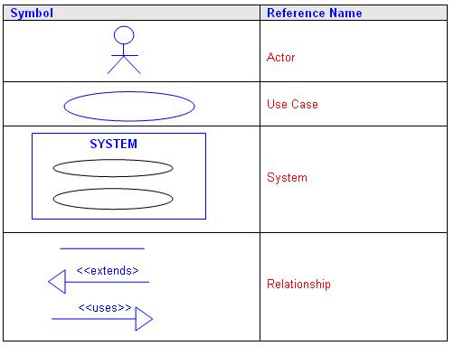

- Dependencies – A dependency relationship between two modelling elements is where a change to one will require a change to the other because the one is dependent in some way to the other

- Includes/uses – An include relationship allows one use case to use the functionality provided by another use case, one use case ALWAYS uses the functionality provided by another.
- Extends – An extends relationship allows one use case the OPTION to extends the functionality provided by another use case.
  - Example: I am going to the city.
includes -> drive the car (MUST)
extends -> fill the petrol (OPTIONAL)

- USE CASE DOCUMENTATION - A document that describes a use case. A use case document’s fundamental parts are the
  - Title – Name of the use case.
  - Brief Description – Summary outlining the purpose of the use case.
  - Actors – Which actor interacts with this use case.
  - Pre-Conditions – What is necessary for the use case to start.
  - Flow of events – Course of events.
  - Post-Conditions – State of the system after the use case ends.
  - Alternative Scenarios – Define exceptional situations.

  - Example:
Title | Order Computer
Brief Description | Allows customer to enter a purchase order
Actors | Customer
Pre-Conditions | - Customer has signed in  - Order entry page is displayed  - Order item has been selected  - Stock details are up to date
Flow of Events | - Customer select ‘Buy’ button  - System requests item quantity  - Customer enters item quantity  - System requests delivery details  - Customer enters deliver details  - System accepts details  - System requests payment details  - <<includes>> Verify payment details
Post-Conditions | - System generates order number
Alternative Scenarios | - Item not in stock  - Customer not signed in  - Payment not accepted

Topic 11 – Objects and Classes
- Class Diagram – A collection of objects with common structure, common behavior, common relationships and common semantics
  - Class Diagram provides an overview of the target system by describing the objects and classes inside the system and the relationships between them.

- Objects – An object is a ‘thing’ in the real world. It can be;
  - Physical things – customer, books.
  - Conceptual things – orders, loans, reservations.
  - Organizational things – companies, departments.

- Developing a class diagram;
  - Identify objects and derive objects from them.
  - Identify attributes of classes.
  - Identify operations of classes.
  - Identify relationships between classes, using associations.
  - Iterate and refine the model.

Toyota : Car
Fuel = 6.4 litres
Speed = 32mph
Temperature = cool
Brake()
Accelerate()
Reverse()
Toyota is an instance of the class car
Instance = single object

- A class is a template for creating objects, has structure – attributes and methods
- Notation:
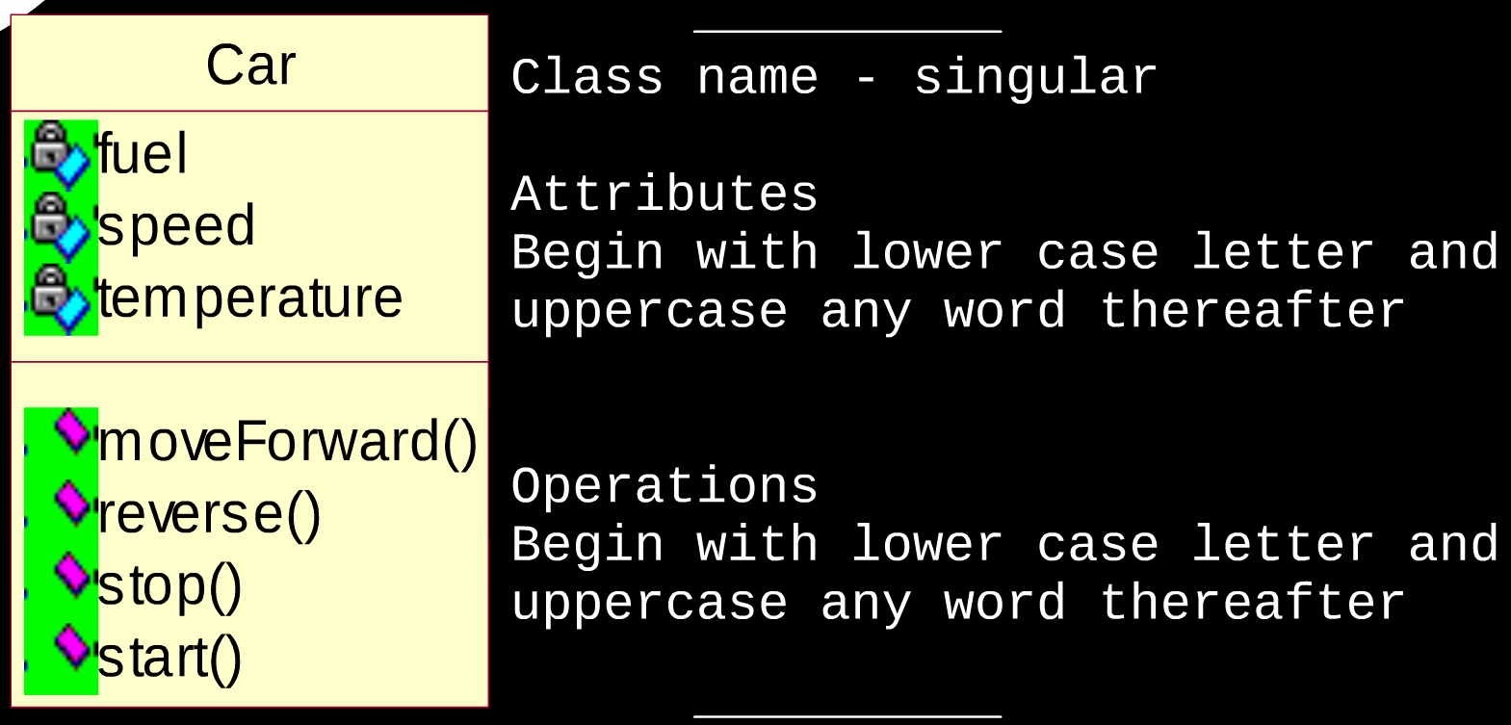
- CLASS RELATIONSHIPS
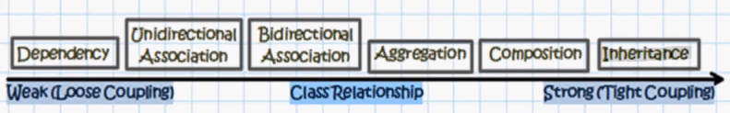
- Associations
  - Association - any logical connection or relationship between classes. (HAS A)
Passenger
Airplane

Aggregation (type of association) – Just like basic association but associated with a single arrow at the end of the association. (PART OF)
Student
Faculty

  - Multiplicites– Specifies how many instances of one class may be associated with a single instance of another.
*..1
Courses
Student

1
Student
Courses

  - Composition (types of aggregation) – When an object contains the other object, if the contained object cannot exist without the existence of container object. (OWNS A)
0.2
Hand
Person

  - Dependency - Change in structure or behavior of a class affects the other related class.
Supplier
Client

  - Generalization (Inheritance) – Connects a subclass to its superclass, the child class inherits all the functionalities of its parent class. (IS A)
Fixed Account
Bank Account

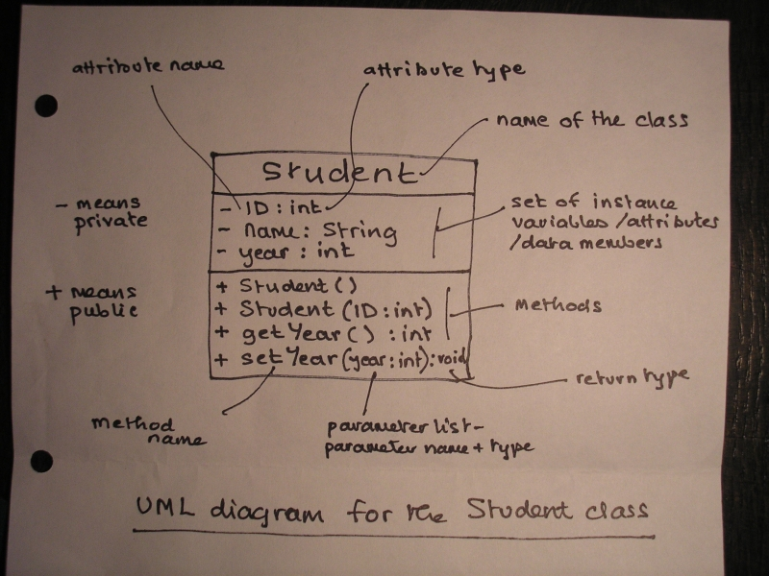
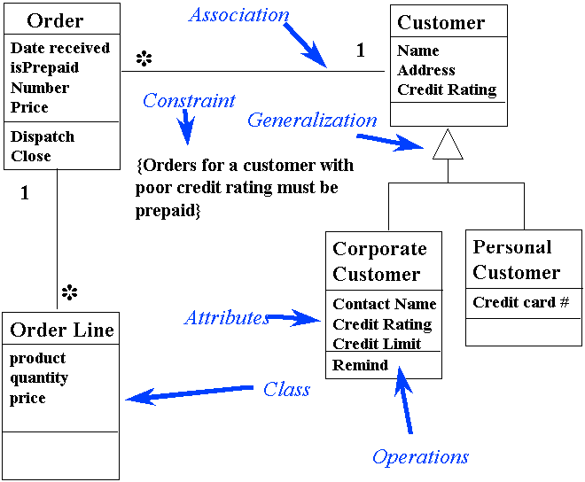

Topic 12 – Database Development
- Database - A searchable collection of related data
  - Record - individual data
  - Field/Attribute – The information contained

- What do databases contain?
  - Entity Set – Set of entities (table)
  - Entity - Information about something (column) eg. Employee
  - Attribute/field – Contained in an entity (cell) eg. Name

- Connect using AND, OR and NOT

- Features:
  - High availability
  - High reliability
  - Low response time
  - Long lifetime
  - Security

- ENTITY RELATIONSHIP MODELING
  - Constructs of;
    - Entities – A single person, place or thing about which data can be stored
    - Relationships – Relationship links between entities
    - Attribute – Property or characteristic of an entity or relationship type
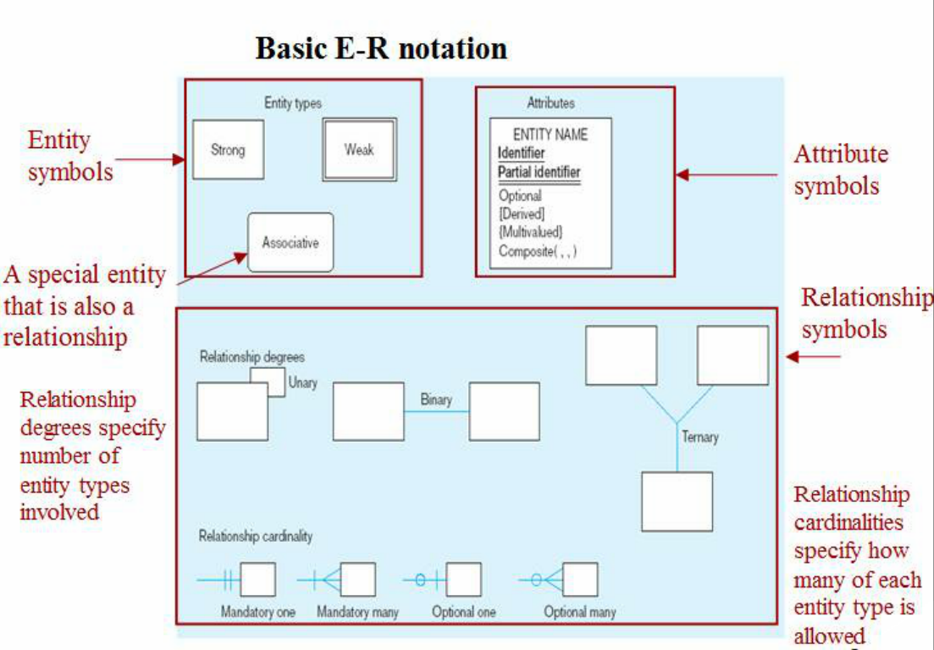
- KEYS – A key is a data item that allows us to uniquely identify an entity type.
  - Composite Key – Combines more than one field to make a unique value
  - Primary Key – A field in a table which is unique and enables you to identify records in a table (primary key attribute is underlined).
    - Keys will not change value
    - Keys cannot be null
    - No more than one primary key per table
- RELATIONSHIPS – A meaningful association between entity types.

- CARDINALITY - The count of instances that are necessary between entity relationships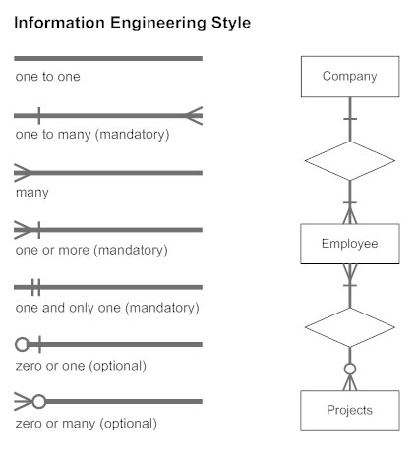
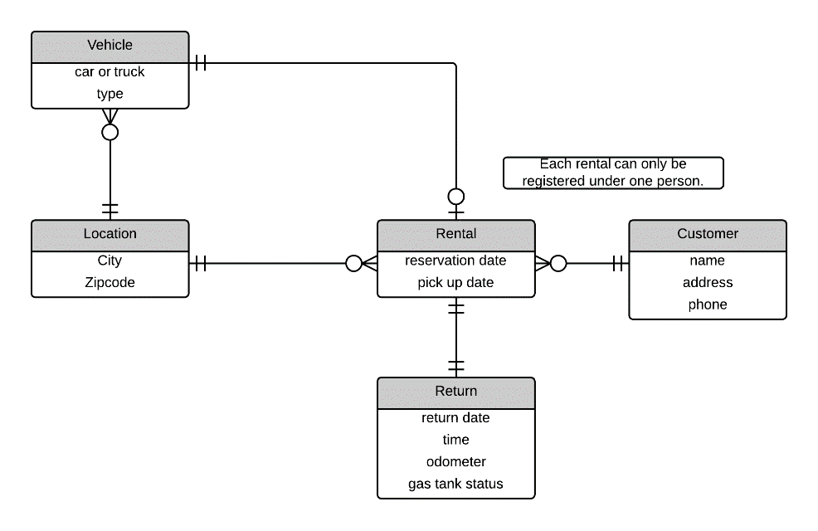
- Strong Entities – Exists independently, has its own unique key, underlined with a single line.

- Weak Entities – Dependent on a strong entity (cannot exist on its own), entity box has double-line, partial key underlined with double-line
- SQL – A special-purpose programming language used for managing data held in a database management system. Can create tables, insert data, update, query, delete and secure.
  - Data Definition Language – Creates the Database. (insert)
  - Data Manipulation Language – Working with it. (query)

- Rules:
  - Not case-sensitive, names must start with A-Z, a-z, 0-9, _, ($, #)
  - Keywords written in uppercase
  - Each statement is terminated with ‘;’

- Data Types:
  - String:
    - CHAR(n) < VARCHAR(n) < LONG n=characters long
    - DATE eg. (07-jan-16)
  - Numeric:
    - NUMBER(L,R) L=max significant digits, R=number of decimal digits
    - INT – integer

- CREATE TABLE
- CREATE TABLE Employees
- (
- Employee_id INT PRIMARY KEY,
- Employee_no INT NOT NULL,
- Department_Id INT,
- CONSTRAINT fk_deptid FOREIGN KEY (Department_Id)
- REFERENCES departments(Department_Id )
- )

- ALTER TABLE
- ALTER TABLE contacts
- ADD full_name varchar(40) NOT NULL;

- ALTER TABLE movies
- DROP COLUMN rating;

- ALTER TABLE
- ALTER TABLE contacts
- ADD full_name varchar(40) NOT NULL;

- ALTER TABLE movies
- DROP genre;
- CREATE TABLE  - CREATE TABLE Employees  - (  - Employee_id INT PRIMARY KEY,  - Employee_no INT NOT NULL,  - Department_Id INT,  - CONSTRAINT fk_deptid FOREIGN KEY (Department_Id)  - REFERENCES departments(Department_Id )  - ) | - ALTER TABLE  - ALTER TABLE contacts  - ADD full_name varchar(40) NOT NULL;  - ALTER TABLE movies  - DROP COLUMN rating;
- ALTER TABLE  - INSERT INTO employees VALUES (12345, "Salman", 9876)  - INSERT INTO employees(id, name) VALUES (12345, "Salman") | - DROP TABLE  - DROP TABLE employees;  - COMMIT (commit changes)  - COMMIT;

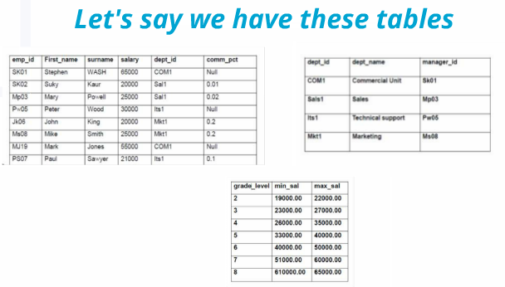
- SELECT * FROM employees;
- SELECT emp_id, first_name AS "First Name", surname FROM employees;
- SELECT * FROM orders WHERE order_date BETWEEN '14-sep-2015' AND '01-aug-2016'
- SELECT * FROM jobgrades WHERE min_sal > 20000 AND max_sale < 100000;
- SELECT * FROM employees ORDER BY surname ASC, salary DESC;

- UPDATE employees SET salary = 35000 WHERE surname = "King";

