Work Sheet – Experiment 1

Experiment Title: “DO I DARE DISTURB THE UNIVERSE?” (T. S. Eliot)
VERIFICATION OF GAS LAWS
Author(s) Name(s):

Submitting Author’s Partner:

TA (Demonstrator)’s Name:

Date Experiment Performed: Friday, September 13/2019
Date Experiment Submitted: Friday, September 20/2019

(The report for Experiment 1 does not require an Introduction)
Attach here (if required, indicate the appropriate document(s)):
Medical or other Acceptable Document: N/A
Change of Lab Day Form: N/A
Change of Lab Section Form: N/A
Late Pass: N/A

Procedure – Charles’ Law: (As outlined in the lab manual)
(“What in the World ISN’T Chemistry”, General Chemistry Laboratory Manual, Dr. Rashmi Venkateswaran, 2019)

Procedure – Boyle’s Law:
- Prepare the gas sample in a 20 mL syringe
- Turn the syringe 180 to lock it into the Gas Pressure Sensor
- Start at 2 mL (approx. at 101.62 kPa)
- Record your data as you increase the volume by 2 mL until the syringe reaches 20 mL
- Record data electronically on LabQuest
- Repeat Step 4 until all data is collected
Discussion:
Charles’ Law
Table 1.1: Data of Volume and Temperature Collected During Experiment
Volume (mL) | Temperature (K)
V1 = 156.0 mL | T1 = 373.15 K
Vcw = 8.100 mL | T2 = 275.15 K

The results from the experiment for Part A where the final volume (V2) is calculated (Refer to Appendix) to be 109.1 mL at a constant pressure using Charles’ law. Because temperature was not measured during the process of boiling the water and the procedure clearly states T1 to be 100°C, even though the temperature of the water exceeded much higher. Most errors occur during the experiment when the students do not pay attention or have not read the instructions properly or do not ask any questions when they are in need for help. These factors can make the data useless and time wasting. To verify Charles’ law indicating that volume and temperature are directly proportional to each other. At constant pressure of 101.62 kPa both temperature and volume increase when heated and decreased when cooled, portraying the increasing/decreasing linear motion. (Refer to Graph 1.1 for Charles’ Law in Appendix) Using V= m TK and inputting values found at the highest temperature (100°C) the slope of this linear function is 0.2923. This graph demonstrates that they are directly proportional to one another when increasing in temperature.
Boyle’s Law
Table 1.2: Data Collected of Two Trials Performed for Boyle’s Law
Trial 1 |  | Trial 2
Volume (mL) | Pressure (kPa) | Volume (mL) | Pressure (kPa)
2.80 | 101.62 | 2.80 | 101.62
4.80 | 61.15 | 4.80 | 58.33
6.80 | 42.61 | 6.80 | 42.33
8.80 | 34.34 | 8.80 | 33.34
10.80 | 28.94 | 10.80 | 28.53
12.80 | 25.53 | 12.80 | 25.77
14.80 | 22.94 | 14.80 | 21.71
16.80 | 21.09 | 16.80 | 19.71
18.80 | 19.17 | 18.80 | 18.06
20.80 | 17.96 | 20.80 | 16.81

These final results of two trials demonstrates pressure as the dependent variable on volume which is the independent variable. To determine which is dependent on the independent variable, consider that positive and negative pressure exists and only positive volume exists in the real world. Such as time is continuous, only increasing, volume would have to be the independent variable and pressure is the dependent variable. Because volume is best to be increasing, therefore pressure must be decreasing, they are inversely proportional, shown in Table 1.2. If volume were to be decreasing, the process will have to start at 20 mL, to show increasing pressure, but it is a possible option if there no other force exerting from the Gas Pressure Sensor. This is a human limitation, pulling the plunger is the best option for this experiment. A common human error is not tightly screwing in the syringe into the Gas Pressure Sensor, the results will show either a fluctuation or a constant pressure. Between these two trials the results are similar, because they are not exactly the same, this indicates another human error when pulling the plunger to increase the volume. The volume of the syringe is vague which can inaccurately change results of the data but will have a small distance to the previous result. For example, in the data at volume 8.80, the pressure for both trials were only 1.00 apart. To calculate a Boyle’s law constant which states pressure and volume equal a constant. (PV = constant) Using Trial 1 and two points to find an average (Refer to Sample Calculations for Boyle’s Law), this is known as a secant, the average rate of change between two points will give a constant for this graph. With an average rate of change of -4.648, which has a negative slope. The mathematical relationship illustrated in Boyle’s law where the volume of a given mass varies inversely with the pressure. Using this equation to formulate an equation for Boyle’s Law, P= k(1/V), k is the constant, P = -4.648(1/V).
Conclusion:
Therefore, in Charles’ Law, volume and pressure are proportional to each other stated by the equation V1T2=V2T1, and proven by solving for V2 to find a final volume and observing that at high temperatures increase the volume of the gas with a percent error of 5.15%.
Therefore, in Boyle’s Law, pressure and volume are inversely proportional to each other stated by the equation P1V1=P2V2, and proven by using the Gas Pressure Sensor also observing the two trials’ graphs show that when volume is increasing, pressure is decreasing.
Reference(s):
J. Chem. Educ.2007843465
Publication Date:March 1, 2007
https://doi.org/10.1021/ed084p465

Appendix:
Raw Data:
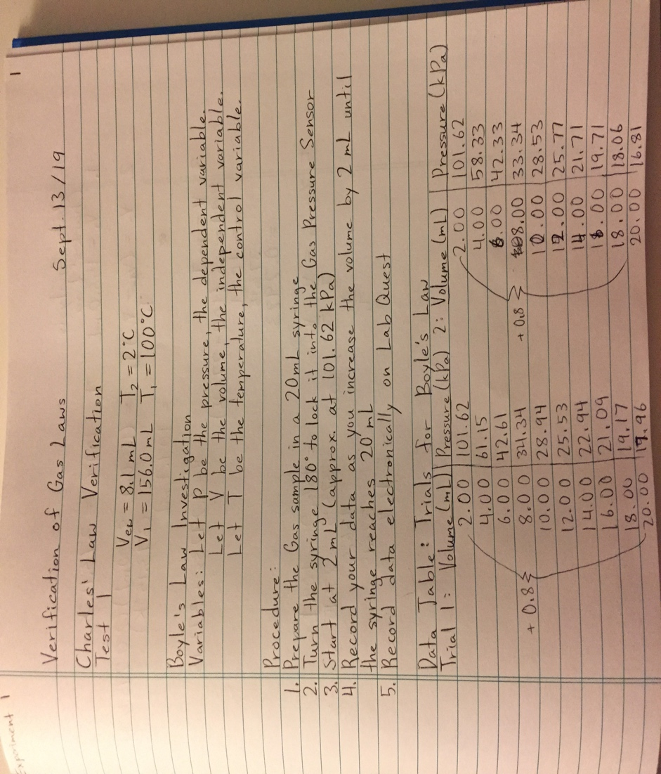
Additional Data, Charles’ Law

Additional Graphs, Charles’ Law
Graph 1.1
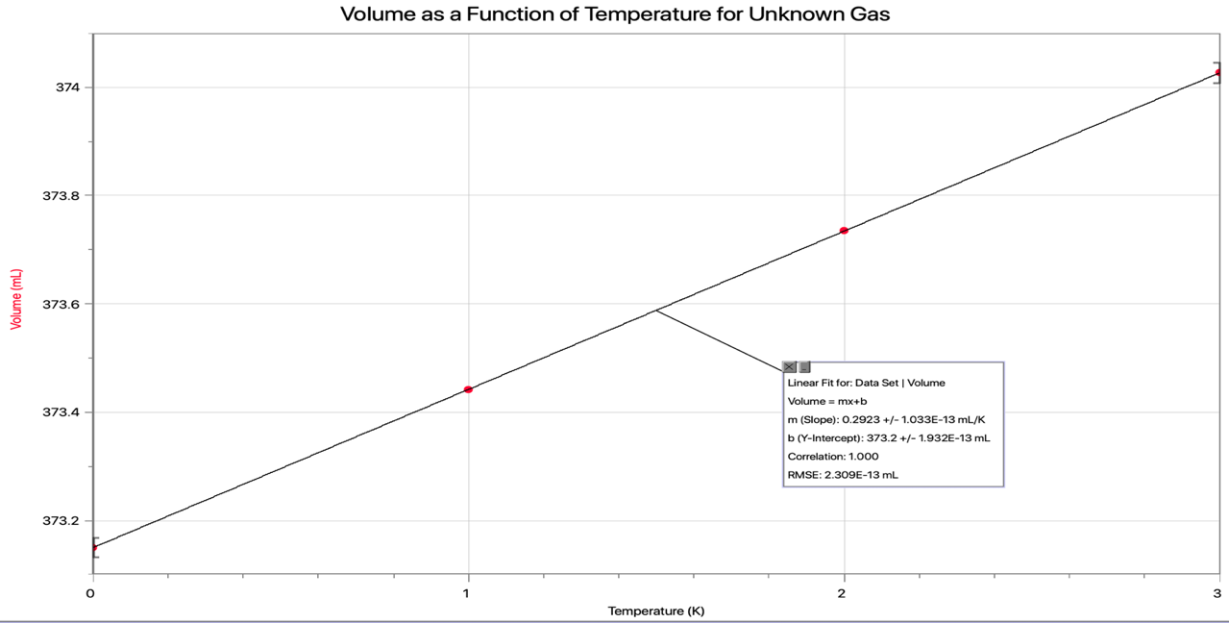
Sample Calculations, Charles’ Law
Calculating V2
V2 = (V1 – Vcw) T2 =(156.0 – 8.1)(275.15)
T1 373.15
=109.1 mL

Calculating Percent Error
% Error = V1/T1 – V2/T2 x 100%
V1/T1
= (156.0/373.15) – (109.1/275.15) x 100%
156.0/373.15
= 5.15 %
≈ 5.2 %
Additional Data, Boyle’s Law

Additional Graphs, Boyle’s Law
Graph 1.2
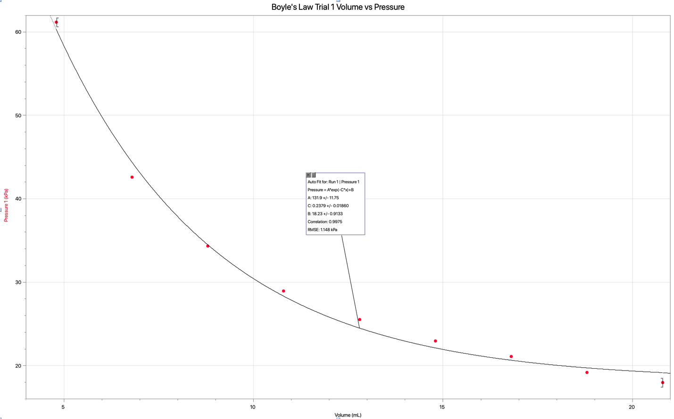
Graph 1.3
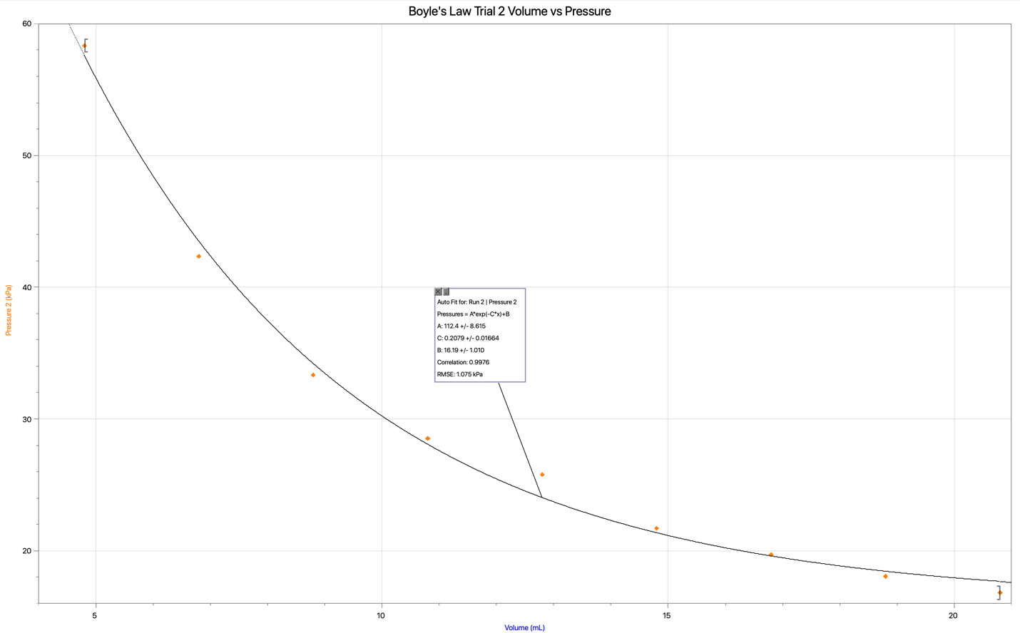
Sample Calculations, Boyle’s Law
Boyle’s Law Constant
Δx/Δy = (y2-y1)/(x2-x1)
= (17.96 – 101.62)/(20.80 – 2.80)
= -4.648
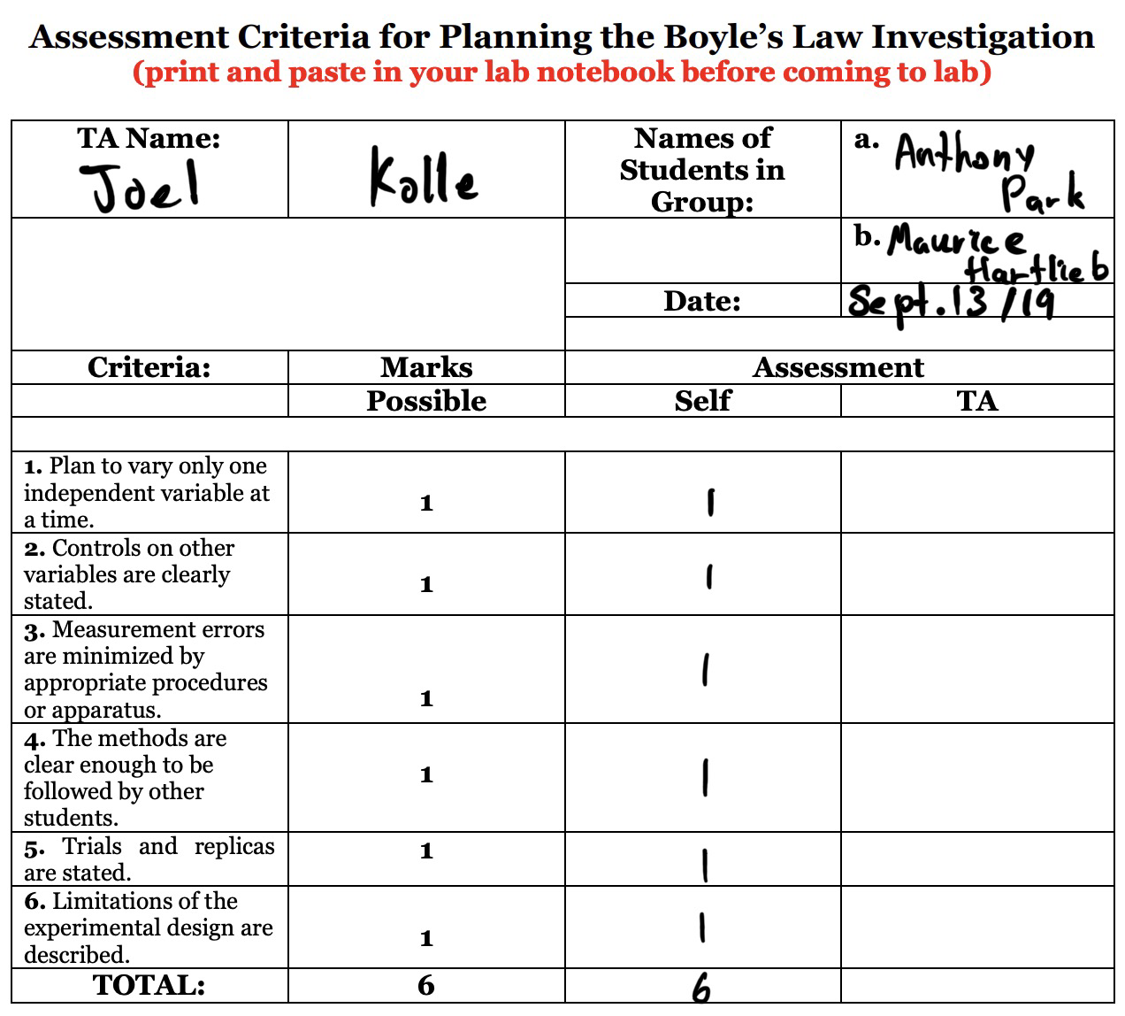
Assessment Criteria Sheet

