Fragile Systems: Learning Goals

- Explain what density is and how it relates to stratification.
- Density is mass per unit volume. How much mass fits into a space.
- Sometimes given the variable (p or d)
- Units = kg / m³
- E.g.:
  - Iron = 7870 kg/m³
  - Ocean water = 1025 kg/m³
  - Air = 1.2 kg/m³
- Less dense materials float on top of denser materials in the presence of gravity creates layers/stratification
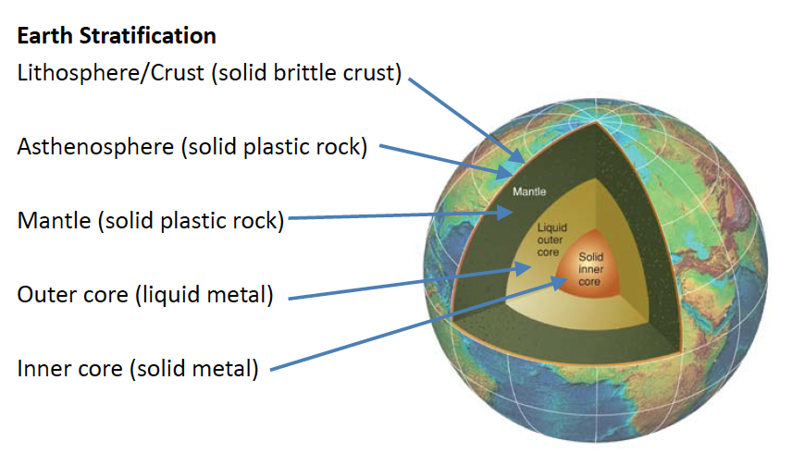

- Compare and contrast risk, perception of risk, hazard, and vulnerability
- Hazard: any event/situation that could cause human damage (death, injuries, economic harm property and prosperity)
- Risk: probability that an even might occur
- Humans do not deal well with probabilities and our perception of risk is flawed
  - E.g. lottery (bad with numbers), reckless driving
  - More people are afraid of dying in a plane than a car
  - Unrealistic since we get into cars everyday.
- Vulnerability – likelihood that suffering/damage will occur
- Hazard x Vulnerability = risk

- Recognizing how poor humans are at judging risk.
- Humans do not deal well with probabilities and our perception of risk is flawed
  - E.g. lottery (bad with numbers), reckless driving
  - More people are afraid of dying in a plane than a car
  - Unrealistic since we get into cars everyday, and planes like twice a year

- Recognize how your perceptions skew your ability to judge risk.
- More deaths in cars rather than motorcycles
- Poverty and highly populated areas increase vulnerability

- List the components of the atom
- Protons, neutrons, electrons, nucleus (center)

- List the 1st, 2nd, and 3rd most common elements in the earth, ocean and atmosphere.
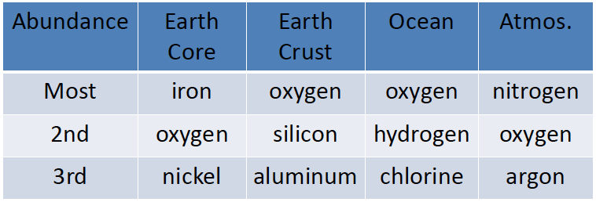

- Define fluid, viscosity, and compressibility and how they relate to the phases of matter.
- Fluids = liquids or gases, flow easily, change shape easily
- Viscosity = how thick a fluid is. Measure of resistance to flow and depends on temperature and chemical structure.
  - High viscosity = thick, slow flow
  - Low viscosity = runny, quick flow
- Compressibility = ability to be squeezed/expanded so that the mass fills less/more space.
  - Results in a chance in density (mass/volume) of the object because volume changes
- Phases of matter: solid, liquid, gas (vapor)
  - Solids – not very fluid, not very compressible
  - Liquids – very fluid, not very compressible
  - Gases – very fluid, very compressible

- Explain why disaster scales are based on the order of magnitude concept, and interpret graphs with logarithmic scales.
- Order of magnitude = powers of ten
- Logarithmic scale – steps by powers of 10
- Quantifies intensity using logarithmic scales: many disaster scales use a “power” surrogate to indicate intensity
- X axis usually steps by orders of magnitude (0-5…), Y axis is steps by the powers of 10 (bigger numbers)

- Relate natural disaster risk and intensity to frequency; return period, and consequences (cost).
- Intensity vs. frequency more intense disasters occur less frequently
- Return period = average number of years between disaster events of the same magnitude
- RP = time span of data / # of cases

- Explain how disasters are associated with concentration or dilution of energy.
- The bigger the disaster, the more spread out and diluted the concentration of energy is.
- Smaller disasters have a smaller concentration of energy

- List 5 types of energy, and describe what causes them to vary
- energy causes things to move/change and disasters release immense energy
- force – 1 (N) = 1(kg x m/s²)
- gravity = 9.8 (m/s²)
- 5 forms
  - work
    - force (F) that pushes an object times the distance (d) the object moves
    - W = F x d
    - SI Unit = Joule (j)
  - potential energy
    - work needed to raise an object of mass (m) a distance (d) against the pull of gravity
    - PE = g x m x d
  - kinetic energy
    - moving object posses kinetic energy
    - KE = 0.5 x m x V²
  - sensible heat
    - heat we can sense/feel/measure
    - e.g. measuring temperature = sensible heat
  - latent heat
    - “hidden” heat energy
    - sensible heat “stored” as latent heat during melting/boiling (or sublimating)
    - latent heat released as sensible heat when condensing or freezing
    - liquid gas = heat taken from surroundings
    - gas liquid = heat transferred/released to surroundings

- Explain how the force of gravity affects motion and energy
- Gravitational systems of earth, moon, and sun generates tidal energy

- Explain (with examples) how energy conservation applies to natural disasters
- Describe population growth and why it is important for natural disasters
- Doubling time = 70/ (% growth rate or year)
- People can be evacuated with warning of disaster, infrastructure destroyed by natural disaster
- Need to know how many supplies needed and building codes etc. for safety of the people during disaster

- Explain how Earth’s carrying capacity and overpopulation are related to the fate of he human race and anticipate your role in it.
- Carrying capacity = population that can be sustainably supported within a given domain
  - Depends on food, living space, natural resources (energy, water, clear air etc.,) sanitation, medical care…
- Growing population makes infrastructure more sensitive/important
- People less likely to be evacuated successfully
- Functionality of human society in jeopardy.

EARTH NOT A FRAGILE SYSTEM, HUMAN POPULATION IS.

Earthquakes:
- Use concepts of stress causing strain, and plastic versus brittle deformation to explain how energy is released causing earthquakes
- Ridge push – plate moves at ridges propelled by sliding along the elevated lithosphere-asthenosphere boundary
- Slab pull (convergent)– dense subducting lithosphere pulls plate along with it
- Stress = force (N) applied per unit area (aka pascals)
  - Compression, tension, shear
- Strain (deformation) = change in the shape or size of body because application of stress
  - Elastic = temporary change, recovers when stress removed
  - Plastic = permanent change, results in FOLDING of rocks
  - Brittle = loss of cohesion due to stress, material fractures, resulting in FAULTS
- Type/extent of strain consequence of type of stress, temperature, material properties.
- Faults:
  - Point of origin for most earthquakes
  - Fractures in the earth’s crust
- Recognize visual evidence of tectonic forces in rocks and landscapes (e.g. fault types, topography)
- Normal fault:
  - Caused by tension
  - Blocks move away
  - Hanging wall block moves down relative to footwall
- Reverse faults:
  - Caused by compression
  - Blocks move towards each other
  - Hanging wall moves upwards relative to footwall
- Strike-slip faults:
  - Caused by shear stress
  - Motion is lateral (like highway traffic)
  - Fault itself is vertical (no hanging wall or footwall blocks)

- Recognize an association between seismic/volcanic events and plate margins.
- events are concentrated where the plates are interacting
- intra-plate earthquakes earthquakes can occur within plates
  - less common , can be large and damaging
  - occur along ancient fault lines/plate boundaries

- Distinguish between oceanic crust, continental crust, lithosphere and plates
- oceanic crust = thick and dense
- continental crust – thick and relatively buoyant – not as dense at oceanic
- lithosphere = crust and upper mantle
- plates are blocks of lithosphere floating on asthenosphere.

- Explain the global distribution of earthquakes (rare, large and frequent small quakes) in terms of tectonic plate interactions and the forces that drive them.
- divergent boundaries
  - plates moving apart
  - rifting:
    - hot magma is coming up and forming itself on both sides, smaller earthquakes
  - small earthquakes
- convergent boundaries
  - plates moving towards each other
    - Causes mountains, volcanoes
  - denser chunk goes under =subduction
- subduction does not occur at continental – continental
  - ocean lithosphere = older and cooler
  - convergent margins stress of those 2 plates causes movements
  - small very large earthquakes
- transform boundaries
  - boundaries that move both ways
  - no melting here
  - moderate large earthquakes
- Explain the global distribution of earthquakes (rare, large, and frequent small quakes) in terms of tectonic plate interactions and the forces that drive them
-
- Describe how the Earth builds, stores, and releases energy in earthquakes
- elastic rebound theory – how earthquakes build and release energy
  - pre-existing fault held together by friction
  - elastic strain accumulates and deformation occurs (storing potential energy)
  - movement takes place – brittle deformation, stored energy is released (as seismic waves) and an earthquake occurs.
  - Two blocks have moved relative to each other (slip has occurred along the fault), and each block returns to its undeformed shape.
- Describe how earthquake moves though the Earth, comparing the different kinds of waves.
- energy moving through as waves through the earth = seismic waves
- surface waves – move at surface, slower than body waves, and cause more damage
  - Rayleigh
    - Largest waves
    - Cause the most damage
    - Felt like ocean by witnesses
  - Love
    - Side to side motion
- Body waves – move within earth, faster than surface waves, and generally not damaging to buildings
  - P waves
    - Fastest
    - Travel through solids or fluids
  - S waves
    - Travel through solids only
    - Secondary/ shear

- Describe how an earthquake is recorded and how to locate the epicenter
- recorded with seismograph
- p waves will always arrive first
- time between the p and s waves arrival = distance from focus (hypocenter)
- one station = how far away the quake is but not where/direction of waves
- two stations = two points
- three stations = triangulation

- Compare and contrast he meanings and uses of earthquake magnitude and intensity scales
- quantitative = richter and moment magnitude scale
  - richter scale measures amplitude (size of waves on seismograph)
  - moment magnitude scale
    - measures strain energy along rupture surface (energy released)
    - logarithmic
    - each # higher on scale is 32 times MORE ENERGY RELEASED and 10 times more shaking
- high magnitude = greater areas, shake longer, damage more buildings
- Qualitative = what we feel, modified mercali scale
  - ranges from 1(felt by very few or not at all) -12 (total destruction)
- distance from epicenter – further = less intense (seismic waves weaken as they travel)
- intensity = ground motion during earthquake
  - how we perceive it depends on several factors
- magnitude
  - lower magnitude = less intense, less energy – waves less powerful

- Given any structure, ground type, and earthquake location, predict the types and extent of damage likely to be caused by the different seismic waves.
- foundation
  - bedrock = less intense
  - well compacted sediment = less intense
  - water saturated sediment = very intense
- structural resistance
  - building reaction to ground motion
  - more resistant = less intense
  - brick and concrete = BAD
  - wood, steel, and reinforced concrete = good
- duration
  - short = less intense
  - long = more intense
- base isolators, cross bracing = dampens intensity

- Be aware of earthquake hazards and notice how they can be the cause of other natural disasters
- ground shaking (first thing we feel)/rupture
  - buildings may fall down responsible for most fatalities
  - buildings on bedrock/compacted sediments safer
  - wet, loose sediment and artificial fill have longer and harder shaking (shaking amplified by ground materials)
  - can sever transportation infrastructure
- liquefaction
  - causes unconsolidated soils to liquefy
  - ground looses cohesion and flowsssss
- fire
  - gas and electrical lines severed
  - water lines severed
  - buildings collapse and burn
  - can more urban areas inaccessible to fire figthters
  - fires after earthquakes are very dangerous
- tsunami
  - large waves generated by displacement of the ocean floor
  - land that is locked in fails, and seafloor moves displaces water, generating large waves.
- Ground failure/landslide
  - Earthquakes trigger landslides
  - Very important in BC
    - VERY mountainous terrain
    - Lots of loose sediments
- Problems in predicting earthquakes. Understand that earthquake prediction is difficult and why. Different between prediction and forecasting
- prediction = earthquake of a given magnitude will occur in a defined region within a specific period of time
- forecast = less specific than a prediction, probability statement
- possible pre-quake phenomena
  - deformation at surface (due to elastic strain, monitor deformation to predict earthquake), foreshock frequency and strength
- predicting earthquake:
  - use evidence of past quakes (lines along rocks to see fault movements, date materials in sediments by carbon dating)
  - land-level change (GPS)
  - seismic gaps
    - places where there has not been failure/rupture (strain has not been released)
  - physical and chemical phenomena (groundwater levels, temperature, chemistry
- specific predictions are generally not successful
- many large earthquakes don’t’ have foreshocks

- Local earthquakes and survival strategies
- Cascadia subduction zone:
  - Juan de fuca plate subducting under north American plate
  - Convergent margin
  - Contact builds up straing
  - Young oceanic plate (hot and buoyant)
  - Does not subduct smoothly (rocks and sediment)
  - Plates are locked, stress builds up
  - Causes strain as elastic deformation (storing energy)
    - 90% of earthquakes associated with plate boundaries
  - Stress in the continent causes brittle deformation
  - Smaller earthquakes occur
- Possible damage in BC
  - Liquefaction on unstable ground
  - Shaking concrete pillar construction
  - Shaking transportation corridors
  - Fire extensive natural gas network
  - Landslides
- Stay under strong tables, desks, stand under archways/inside corner of a room, avoid doorways
- Be prepared for 3 days without help/

