ANP1105B
Dr. J Carnegie
Mon. (4-5:20) + Wed. (2:30-3:50)
ANP1105 Lecture Notes
Sept. 4th, 2019
Topic 1: Structural Organization of the Human Body
1.1
Atom: smallest particle of an element with all of the properties of that element
Components of an atom:
- proton
- neutron
- electron
Molecule: smallest amount of a substance that can exist alone (a combination of atoms)
Organelle: molecules associate in specific ways to form organelles (basic components of living cells)
Examples:
- ribosomes
- Golgi body
- mitochondria
- endoplasmic reticulum
Cell: fundamental structural and functional unit of a living thing; cells vary widely in size and shape, reflecting unique functions in the body
Tissue: groups of similar cells that have a common function
4 types of tissues:
- epithelium (protection, absorption)
- muscle (movement)
- connective tissue (hold things together)
- nervous tissue (relays/communicates information)
Organ: structure composed of at least 2 (but usually 4) tissue types that performs a specific function for the body
Example: Stomach, Heart, etc. (identify tissues in the organs)
Organ systems: organs that work closely with one another to accomplish a common purpose (ie digestive, respiratory, circulatory/cardiovascular, lymphatic, nervous, etc.)

1.2
**jeopardy game will be on midterm (cell organelles)
Cell Organelles:
Endoplasmic reticulum: membranes of sacs and tunnels
Video Notes:
- rough ER extends from nucleus and is covered in ribosomes
- connects to nucleus and is important in transporting substances proteins
- storage area for newly synthesized molecules
- smooth ER serves as storage area for proteins that will be exported out of cell
- ribosomes are most numerous in cell
- ribosomes are composed of RNA and proteins
- ribosomes on rough ER synthesize proteins for plasma membrane
- ribosomes in cytoplasm synthesize proteins for interior of cell
- Golgi body sorts, processes, packages, and delivers proteins/lipids throughout cell for
- Lysosomes are membrane-bound vesicles containing digestive enzymes
- Lysosomes fuse w old organelles to destroy/recycle old structures in the cell
- Mitochondria generates energy (ATP), cells can have one large or many smaller mitochondria
- Liver and kidney cells have more mitochondria because they require more energy
- Mitochondria are double membranes (cristae folds and smooth outer membrane)
- Cristae provide surface area for chemical reactions
PowerPoint Continued
- Cells are the basic unit of life
- Come in many different shapes and sizes however each type of cell contains everything it needs to function as part of a living human being
- Know what each cell looks like (Fig 3.1)
Nucleus
- Control centre of the cell
- Contains genetic inheritance in the form of DNA for that cell in the form of instructions for all possible proteins the cell can make
- Every cell in the body will have the same DNA even though they carry out different functions associated within the DNA (activate different parts of the genetic info to carry out cell-specific functions)
- Stores genes on chromosomes
- Organizes genes into chromosomes to allow cell division
- Enclosed in a membrane, transports regulatory factors and gene products via pores
- Produces different types of RNA (mRNA, tRNA, rRNA) + know functions of RNA
- Produces ribosome
- Organizes the uncoiling of DNA to replicate and decode genes (highly regulated process)
- DNA repair

** each nucleus contains a complete set of genes but a given cell type used just a subset of that information, needs to be regulated
- DNA codes for polypeptides
- Types of protein a cell produces determines what kind of cell it is and what it is able to do
- DNA replication must be carried out very carefully so as to minimize the introduction of genetic errors
- Semi-conservative replication (one strand from original parent cell and one copied strand from DNA synthesis in each daughter cell during mitosis) in preparation for mitosis

- Cytoplasm fills the space between the nucleus and the plasma membrane
- Organelles are part of the cytoplasm; cytosol is the liquid inside the cell, suspends the organelles
- Cytosol consists of water as well as proteins, salts, sugars, other solutes
- Organelles are discrete, membrane-bound parts of the cell where cellular activities such as ATP production, protein synthesis, etc. occur
- Inclusions: dependent on cell type, may be storage forms of important molecules or have other functions within the cell; examples: glycogen, granules (liver/muscle cells)
Plasma Membrane
- encloses the cell, separating the intracellular fluid from the extracellular fluid (physical layer)
- semi-permeable: allows some substances to cross while restricting movement of others
- wrapped around entire outside of the cell
- composed of a phospholipid bilayer
- concentration of sodium and potassium is much higher outside cells than inside cells
HOMEWORK: Organelle function table
Organelle
Mitochondria
Ribosome
Rough ER
Smooth ER
Golgi Apparatus
Peroxisome
Lysosome

Cytoskeleton
- provides structural support, permits shape changes and allows movements
- microfilaments
- actin subunits
- involved in cell shape and changes in cell shape (ex: extending a pseudopod)
- intermediate filaments
- different components, common one is keratin
- structured like a rope, very strong provide strength and sturdiness
- line esophagus and GI tract
- microtubules
- tubulin subunits
- involved in movement
- mitosis, helps separate chromatids
- “highway” for inclusions, etc. to attach
- Involved in movement, usually of structures within the cell
Chromatin
- DNA + associated proteins (histones & nonhistone proteins)
- Proteins package the DNA into the nucleus in a way that specific genes can be found for DNA synthesis so DNA strands do not get tangled or break
Nucleus to Cytoplasm (One-way movement)
- Pores regulate what is able to enter and exit the nucleus
- Gated passageways that allow RNA to exit
- mRNA – bring instructions for protein synthesis out to ribosomes
- ribosomal subunits
- tRNA molecules
Cytoplasm to Nucleus
- proteins for construction of ribosomes
- ie histone that
- nuclear proteins
Nucleolus
- rich in DNA, newly-transcribed rRNA, ribosomal proteins
- site of ribosome production
Anucleate(?)
Chapter 4: Tissues
- nervous tissue: internal communication
- brain
- spinal cord
- nerves
- muscle tissue: contracts to cause movement
- muscles attached to bones (skeletal)
- muscles of heart (cardiac)
- muscles of walls of hollow organs (smooth muscle)

- epithelial tissue: forms boundaries between different environments, protects, secretes, absorbs, filters
- a sheet of cells that covers a body surface or lines a body cavity **creates a boundary
- covering and lining epithelium (lining oral cavity, bladder, esophagus, anything that is a hollow organ)
- glandular epithelium
Functions of Various Epithelia:
- protection (mechanical, chemical, infectious) - skin
- absorption – GI Tract specifically small intestine absorbing amino acids, glucose, etc. during digestion
- filtration - kidney
- excretion - kidney
- secretion – glands, stomach
- sensory reception – taste buds, olfactory membranes **only a small number of epithelial cells are sensory receptors, highly specialized
5 Special Epithelial Characteristics
- polarity: apical (up part) and basal surfaces; apical surface often specialized such as having cilia or microvilli
- specialized contacts: tight junctions (tightly attached to each other and connective tissue so they’re not ripped off as stuff is transported through the tissue) & desmosomes – import to prevent wear and tear
- supported by connective tissue: basement membrane is composed of a basal lamina (underlying supportive sheet of primarily glycoproteins) sitting on top of a reticular lamina (primarily collagen fibres)
- innervated but avascular: no blood vessels running through epithelial tissue layers (how are they nourished??)
**an important feature of cancerous epithelial cells is failure to respect the boundary imposed by the basement membrane allows them to metastasize
- regeneration: high regenerative capacity, easily replaceable due to constant damage
Identifying Epithelial Cells
- Dependent on shape and layers
- Shape
- Squamous (skin is stratified squamous)
- Cuboidal
- Columnar
- Layers
- Simple: single layered
**Simple squamous: thin and permeable – filtration, diffusion eg. Endothelium and in kidney, lungs
**Simple cuboidal: secretion and absorption eg. Kidney tubules, small glands
**Simple columnar: also digestion and secretion eg.. digestive tract
**Pseudostratified ciliated columnar epithelium: a single layer that looks like its more than one layer and columnar in shape. Eg. Respiratory tract where cilia and mucus secretion are local specialization, but has the appearance of a stratified epithelium
- Stratified: multi-layered
** protective role, basal cells cuboidal and undergo mitosis to keep regenerating the layer from bellow
** our skin is the most widespread example of stratified squamous epithelium
**avascular, lots of diffusion to distribute nutrients to half of layers other half (top layers) are dead, start off as living cells but as cells continue to undergo mitosis are pushed too far from nutrients (apical layers of cells die)
** Transitional epithelium (stratified epithelium that is a mix of columnar and squamous cells:
Lines the bladder, an organ that has to fill – the basal layers are cuboidal in shape and the apical layers become increasingly flattened and squamous-like as filling occurs. Multi-layered. Cells change in shape in response to filling and emptying
- connective tissue: supports, protects
Tissues
- individual specialized body cells, division of labour
- at organ level, cooperation for orfan to work as a whole
- groups of structurally similar cells that perform common/related function
4 primary tissue types:
- epithelial
- connective
- muscle
- nervous
Sept. 11th, 2019
Glandular Epithelia
- gland: 1 or more cells that make and secrete a particular product
Glands are:
- endocrine: tend to produce substances that travel through blood (often hormone-secreting)
- exocrine: if multicellular, release product into lumen which then travels via duct (ie salivary, sweat glands)
- unicellular or multicellular:
- multicellular epithelial glands form by inward growth of an epithelial sheet
- exocrine glands retain the connecting cells, which form a duct that transports secretions to the epithelial surface
- endocrine glands lose their ducts during development. They secrete hormones into the interstitial fluid. These hormones then enter the blood
- endocrine glands are ductless, products are called hormones
- exocrine glands: mucous, sweat , oil/salivary glands, liver (bile), pancreas (insulin and digestive enzymes), etc.
- unicellular exocrine glands:
- no ducts because only one cell, does not use blood to travel
- goblet cells produce mucous, interspersed through epithelial cells that line the respiratory and digestive tracts
- multicellular exocrine glands:
- epithelium-derived duct and secretory cells; surrounded by supportive CT (connective tissues) which brings blood vessels and nerves
iii) secretory method
- merocrine/eccrine: exocytosis, product is continuously being produced/released continuously most common type of excretory secretion (pancreas, salivary glands, most sweat glands)
- holocrine (whole cell is used up): cell rupture releases products in a burst, only sebaceous glands
- apocrine: cell apex pinches off with secretory product
- mammary gland apocrine or merocrine?
Review Questions
- lines stomach, most of intestines (simple columnar)
- lines the inside of the mouth (stratified squamous)
- lines much of the respiratory tract (pseudostratified ciliated columnar)
- endothelium (simple squamous)
- composes lung alveoli (simple squamous)
-gland type that secretes its product continuously by exocytosis is…merocrine
Connective Tissues
5 Major Types:
- mesenchyme
- connective tissue proper
- cartilage
- bone
- blood
Main Functions:
- binding or support (skeleton)
- protection (skeleton, adipose tissue)
- insulation (adipose tissue)
- transportation (blood)
Structural Elements:
- ground substance: interstitial fluid + cell adhesion proteins and proteoglycans; molecular sieve
- fibronectin, laminin – help cells attach to CT elements (cell adhesion)
- proteoglycans – (can hold water molecules and conver ground substance into more viscous jelly consistency)
- fibres
- collagen fibres: high tensile strength (thickest and strong, provide sturdiness)
- elastic fibres: elastin has coiled structure to allow stretch + recoil
- reticular fibres: thin collagen protein; fine network to support blood vessels
- cells
- immature (blast) forms vs mature (cyte) forms
- “blasts” are actively dividing/synthesizing cells during growth and repair
- “cytes” primarily provide a level of maintenance

- CT proper, fibroblast, fibrocyte
- Cartilage, chondroblast, chondrocyte
- Bone, osteoblast, osteocyte
- Blood, hemocytoblast, RBCs (erythrocyte) WBC (leukocyte) & platelets
Types of CT:
- Mesenchyme: first tissue formed from mesoderm germ layer – mesenchymal cells + fluid ground substances and fine fibrils -> source of al other CT’s
- CT proper: 2 subclasses
- Loose connective tissue (areolar, adipose, reticular)
- Dense connective tissue (dense regular, dense irregular, elastic)
Loose CT
- Areolar CT: gel-like matrix with all 3 fibre types; cells = fibroblasts, macrophages, mast cells, and WBC
Description: loose arrangement of fibres; reservoir of water and salts but is also a prime site of edema during inflammatory reaction
Location: widely distributed under epithelia of body
Function: cushioning of organs, immunity and inflammation; fluid reservoirs
- Adipose tissue: areolar CT modified to store nutrients; adipocytes
description fat-filled adipocytes with displaced nuclei, do not reproduce; scanty matrix
location: under skin, around kidneys and eyeballs, in bones and within abdomen, in breasts, 18% of average weight (15% male and 22% female)
function: fuel reservoir, insulation, supports and protects organs
- Reticular act: like areolar CT, but only reticular fibres
Location: lymphoid organs (lymph nodes, bone marrow, spleen)
Function: fibres form soft internal skeleton that supports free blood cells
Dense CT
- Dense regular CT: bundles of collagen fibres running parallel to direction of pull
Location: tendons, ligaments, also aponeuroses
Function: attachment with strength
- Dense irregular CT: same as regular, but collagen bundles thicker and arranged irregularly
Location: dermis, submucosa of digestive tract, fibres capsules of organs and joints
Function: withstand tension exerted in many directions; strength
- Elastic CT: like dense regular CT, but a very high content of elastic fibres (stretch + recoil); found in some very elastic ligaments
Location: spine, etc.
Cartilage
- Features between CT and bone (tough but flexible)
- Avascular, devoid of nerve fibres
- Ground substance contains lots of the GAGs (glycosaminoglycans) chondroitin sulfate and hyaluronic acid – also chondronectin, (adhesive protein)
- Collagen fibres (can have some elastic fibres)
- Up to 80% water
Bone
- Calcium salts give hardness and strengths for support/protection of softer tissues, cavities for fat storage and synthesis of blood cells
- Osteoblasts, immature
- Osteocytes, maintain bone
- Osteoclasts, chew up bone to replenish calcium if blood-calcium levels are low
- Bone is vascularized
Blood
- Classified as a connective tissue because it consists of cells (red and white) surrounded by nonliving fluid matrix, blood plasma
- “fiber” components are soluble protein molecules – only visible during clotting, called fibrin
Review Questions
- What gives a CT high tensile strength (collagen fibres)?
- Cells that form bone is osteoblast
- CT that acts as a sponge, soaking up fluid when an edema occurs (areolar CT)
Topic 2
Cellular Physiology of Nerve and Muscle
Membrane Transport
- Is a phospholipid bilayer (hydrophilic phosphate components on outside, hydrophobic 2 lipid hydrocarbon chains on inside)
- Hydrophilic and hydrophobic properties allow bilayer to form because phospholipids naturally orient themselves like this
- Also makes up nuclear membrane
- “fluid mosaic model” because it is a semi-fluid barrier between outside and inside of cell
Why is minor damage to plasma membrane usually not a problem?
- Can flow and seal up area of damage
- Integral membrane proteins – span plasma membrane (transmembrane)
- Integral membrane proteins go the whole way through the membrane (must have hydrophobic and hydrophilic areas)
- Hydrophilic and hydrophobic regions; channels, carriers

- Peripheral proteins: attached to integral proteins (often internal face of plasma membrane); can be enzymes, involved in attachment of functions, shape changes…
- Cytoskeleton: anchors to plasma membrane
- Glycocalyx: mix of carbs attached to lipids and proteins on outer face; “sugar coating on outside of plasma membrane” allows cells to recognize one another
-when cell becomes cancerous glycocalyx changes repeatedly making it hard for immune system to keep up
- Cholesterol: reduces general membrane fluidity and stabilizes its structure- apprx.. 20% of membrane lipid
- Too much cholesterol causes membranes to lose flexibility (wont be able to fix itself if to rigid)
Functions of PM Proteins
- Transport
- Enzymatic activity (that faces inside of cell)
- Receptors for signal transduction or neurotransmitter to stimulate cell to carry out certain response
- Intercellular joining
- Cell-cell recognition
- Attachment to ECM, cytoskeletal filaments
Types of Junctions Found Between Cells
- Tight junctions
- Prevent passage of molecules such as enzymes and bacteria
- Fusion of adjacent plasma membranes
- Importance in digestive tract
- Desmosomes
- Anchoring junctions: molecular linking of cells to resist mechanical stress
- Plaque
- Linker proteins (cadherins)
- Keratin filaments (extending into cytoskeleton of adjacent cells to really anchor)
- Desmosomes are found kin cells, lining GI tract,
- Gap junctions
- Molecular channels between cells to allow passage of cytoplasmic molecules
- Connexins, proteins that structurally make up these passageways
- Found in heart, Electrically-excitable tissues
4 functions of plasma membranes:
- Effective barrier between intracellular and extracellular fluids
- Selectively permeable (water soluble will need help to get through, lipid soluble will not I think cold be wrong)
- Allows cell tor respond to changes in extracellular fluid
- Site of cell-to-cell interaction and recognition
Sept. 16th, 2019

- selectively permeable (can control what goes in and out), hydrophobic (lipid-soluble not water-soluble) barrier between interstitial fluid and cytoplasm (so, how do water-soluble substances get across?) – (need a pathway through a channel, transport mechanisms, etc.)
- oily, lipid-rich membrane that separates inside of cell from outside of cell
- interstitial fluid: a filtrate of blood - contains salts, sugars, amino acids, vitamins, hormones, metabolites, gases such as O₂ and CO₂, etc.
- to stay healthy, cell must get nutrients out of interstitial fluid
- releases waste into interstitial fluid
- to maintain homeostasis and function normally, a cell must be extract needed items, keep valuable materials inside & discard wastes
- transport across plasma membrane can be active or passive
Passive Processes (Simple diffusion, facilitated diffusion, filtration, osmosis)
- diffusion: tendency of molecules or ions to scatter evenly throughout the environment
- molecules have kinetic energy (how does this facilitate diffusion)
- when molecules have energy they bump into each other which pushes them away in a way that they space themselves eat out evenly
- How is diffusion rate influenced by:
- 1. Concentration gradient slope?? (slope steep = rapid diffusion, shallow slope = slow)
- 2. Molecule size?? (larger will be slower, smaller will be faster)
- 3. Temperature?? (increasing temp. will provide more kinetic energy which will allow faster diffusion because molecules will bump into each faster and with more speed)
- PM is hydrophobic barrier: to traverse PM a molecule must be lipid-soluble or have access to channels or transporters
- Simple diffusion = even distribution
- Facilitated diffusion = used for water-soluble substances (channel for ions, carriers for amino acids, glucose, etc.)
- Filtration = water with dissolved substances
- Osmosis = movement of water from high concentration to low concentration via gradient
- Respiratory gases are lipid-soluble
Simple Diffusion
- No carries needed if lipid-soluble
- Nonpolar, lipid-soluble: ocygen, carbon dioxide, fats, urea, alchol
- Oxygen and carbon dioxide ollow gradients into and out of cells
- Molecule is moving DOWN concentration gradient (no ATP required)
Facilitated Diffusion
- Water soluble substances need help to transverse PM
- Specific
- No ATP needed (substance naturally moving from where there is more of it to where there is less of it via a provided pathway in the form of a channel or carrier)
- Limited by carrier or channel saturation
- Movement down concentration gradient
- Can be inhibited by certain substances
- Carrier-Mediated Facilitated Diffusion:
- Lipid-insoluble molecules too large to pass through membrane pores/channels
- Glucose is most common substance that is transported by carrier-mediated facilitated diffusion
- Channel-Mediated Facilitated Diffusion:
- Selective due to pore size and the charges of the amino acids that line the channels
- Some channels are always open (leakage channels, constant movement)
- Opening of others is regulated (gated channels), requires stimulus to open
- Movement is always down the concentration gradient
- Can be inhibited, can show saturation and are usually specific
- For ions
Filtration
- Water and solutes forced through membrane or capillary wall by fluid or hydrostatic pressure
- i.e. fluid out of capillaries to cell soft tissues to form urine in kidneys
- selective only by size: only RBC’s and large protein molecules don’t get through
- most plasma proteins, etc. can’t get through
- what kind of gradient? Pressure gradient (force pushes against walls of capillaries so fluid is pushed across and out of any opening)
- no ATP needed
Active Transport
- uses ATP because:
- substance is too large for pores and is lipid insoluble
- moving against concentration gradient
- requires a carrier: combines specifically and reversible with substance
- solute pumps move substances against concentration gradients
- many active transport systems are coupled systems:
- symport: eg Na ions, amino acids, or glucose, potassium ions, chlorine ions, coltransporter (all moving in the same directions) , secondary
- antiport: sodium ions/potassium ion, ATPase, moving molecules in opposite directions because one is brought in and other is taken out (primary)
Primary Active Transport: Sodium Potassium Pump
- concentration of potassium ions is 10-20 times higher inside the cell than out; concentration of Na ions is higher outside cell than inside
- maintenance of gradient is challenged by:
- slow leakage of potassium ions and sodium ions along their concentration gradients
- stimulation of muscle and nerve cells
- Na ions/Potassium ion ATPase functions continuously to maintain sodium and potassium gradients
- 2 sodium ions pumped out for every 2 potassium ions pumped in moving against their concentration gradients to maintain cell responsiveness
- Antiport
Secondary Active Transport
- Transport of a solute is NOT couple directly to energy-yielding reactions
- i.e. transport of an ion or amino acid as sodium ion leaks back into cell along its concentration gradient (gradient drives transport but gradient would not exist without Na/Ka ATPase)
- symport
Vesicular Transport/ Bulk Mechanisms
- ATP-requiring
- exocytosis (out) and endocytosis (in)
- Exocytosis:
- secretion of hormones, neurotransmitters, mucus, ejection of wastes
- substance is enclosed in a vesicle, vesicle moves to PM, fuses with PM, ruptures, releasing contents outside of cell
- Approached plasma membrane, then membrane of vesicle incorporates itself into PM, ruptures and releases its contents outside of the cell
- Vesicle docking:
- V-snare
- T-snare (corkscrew twist motion to fuse)
- Endocytosis:
- Means by which large particles can enter cell: ATP-requiring; energy for vesicle movement
- Vesicle encloses substance; pinches off and moves into cytoplasm where contents may be digested; may also traverse cell to exit at other side
- Special cases: receptor-mediated endocytosis allows hormones, enzymes, other important macromolecules to be concentrated within cell
- Diagram on slide is receptor-mediated
Osmosis
- Unassisted movement of water form area of more water to one of less water across a semipermeable membrane
- Type of facilitated diffusion
- No ATP
- Polar, but small enough for most pores
- Net movement due to water concentration gradient
- Special water channel protein called aquaporin
- If not through aquaporin then through lipid bilayer
- Plans vs animal cells if there is a lot of water entry? Cell walls in plants regulate water intake, humans don’t have cell walls so water will keep going in until the cell bursts (lyses/lyces)
- Water concentration decreases as you increase number of solute particles (osmolarity)
- Lower osmolarity to higher osmolarity, trying to equilibrate osmolarity
- Animal cells swell or shrink in response to water movement until equilibrium or rupture
- Osmolarity: total concentration of solute particles in a solution
- Ions dissociate so to calculate osmolarity must multiply or some shit idek she went so fast
- Tonicity: ability of solution to change the shape of a cell bathed by that solution – what are important are nonpenetrating solute particles
- Tonicity usually described in relative terms: hypertonic, hypotonic, isotonic
- Osmolarity an tonicity are not the same
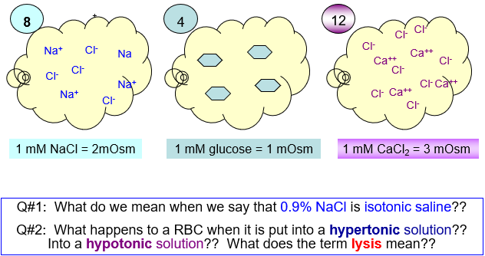
Question 2: swell, possible to point of rupture
Isotonic: causes no net change
Applications:
- Hypertonic solutions for edema: pull water out of swollen tissues
- Hypotonic solutions to carefully rehydrate dehydrated patients
Chapter 3: A&P Flix (Membrane Transport), in study area
Physiology of the Neuron (Chapter 11)
Readings: 394-396
400-409
409-412
412-420
- neurons are highly specialized cells
- structural units of NS: conduct electrical impulses from one body part to another
- Special features:
- Extreme longevity: adequately nourished ⇒ 100 yr+
- Amitotic: won’t replace themselves by mitosis due to complex learning pathways and high level of specialization, why? what does this mean if neurons are damaged?
- High metabolic rate: go through lot’s of ATP, and need constant supply of O₂/glucose
- large, complex cells: all have a cell body + one or more processes
- electrical cells, that if sufficiently stimulated will create action potential
3 functional regions:
- receptive region
- conducting region
- secretory region
- myelinated sheath
Neuron Cell Body
- large, spherical nucleus and granular cytoplasm (biosynthetic center)
- extensive Rough endoplasmic reticulum + ribosome clusters (Nissl bodies)
- elaborate Golgi body and lots of mitochondria because lots of biosynthesis receive info from many neurons and need to make neurotransmitters, make proteins, etc. need a lot of ATP to power metabolic and transmission activities
- extensive network of microtubules
- ganglion cell of neuro cell bodies not in CNS
- dendrite is receptive region of neuron
- axon sends electrical information down towards axon terminal
- cluster of cell bodies is a nucleus in central nervous system and peripheral nervous system (lots of synaptic communication)
- dendrites
- axons
- axonal terminals
- tract: bundle of nerve processes (axons) in CNS
- nerve: bundle of nerve processes (axons) in PNS, heading towards or coming from a particular part of the body
Axons
- arise from axon hillock
- variable in length (can be as long as 1 metre)
- rate of conduction increases with axon diameter
- Schwann cell (one inter-node), spaces in between Schwann cells are called Nodes of Ranvier
- Usually 1 axon or neuron; branches at end (apprx. 10000 terminal branches) which end in knob-like axonal terminals
Dendrites
- Short, tapering, branched extensions; usually for hundreds
- Enormous surface area for reception from other neurons
- Conduct impulses toward cell body
- Short distance, graded potentials that are headed towards axon hillock
- Graded potentials vary in intensity. Created once and fizzle out with intensity due to distance
- To generate depolarization at axon hillock to create action potential require many graded potentials (like a relay race)
Axons (2)
- Neurotransmitters convey information from one axon to the next
- Axon has same organelles as cell body, but no Nissl bodies; axons quickly degenerate if cut
- Elaborate cytoskeleton in axon to move material to and fro:
- Anterograde (mitochondria, cytoskeletal elements, neurotransmitters)
- Retrograde (primarily organelles to be degraded or recycled)
- Viruses such as polio, rabies, herpes simplex, and tetanus toxin reach cell body by retrograde transport
- Neurons don’t replace themselves by mitosis, if completely severed will degenerate, if slightly damaged may recover slowly
Creation of Resting Membrane Potential (RMP)
- Voltage: electrical potential energy due to separation (PM) of oppositely-charged particles (ions)
- -70mV for many neurons
- Resting membrane potential: all cells polarized, value of RMP is cell-type-dependent (negative)
- Current = flow of electrical charge
- Negative because of inside of cell negative compared to outside negativity only at level of membrane
- RMP due to differential permeability of membrane to sodium and potassium ions
- Negative inside cell, positive outside cell
- Primary ion inside cells: potassium
- Primary ion outside cells: sodium
- At rest: membrane is somewhat permeable to potassium but only very slightly permeable to sodium
- Sodium ion pump 3 sodium OUT for every 2 potassium IN(using ATP because against concentration gradient) works to maintain potassium inside and sodium outside
- Greater movement of potassium than sodium
- Lose positive charge faster than we’re gaining it (net negative charge on inside of plasma membrane)

Electrochemical Gradient
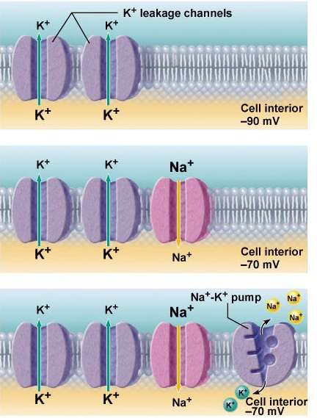

- Need sodium/potassium pump to maintain -70mV because without it voltage would eventually go down to zero as in middle picture
- Charge difference is measured as shown below (just inside and just outside of cell)
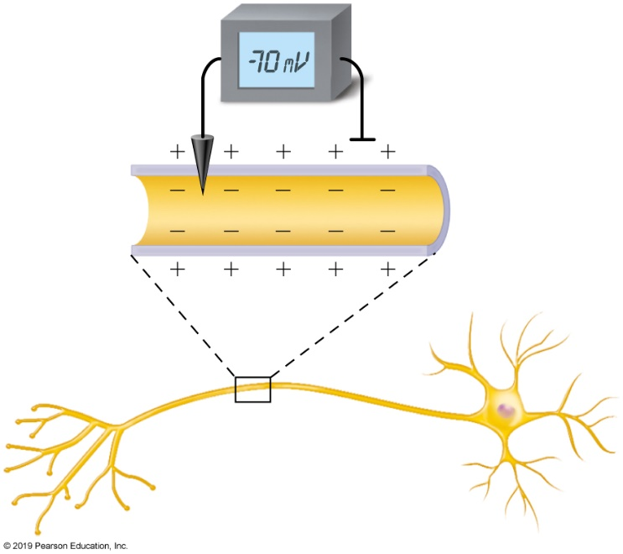

- More leaky potassium channels than sodium channels
Channels in Plasma Membranes
- Passive/leaky channels: always open
- Active/gated channels: signal required to open/close
- Chemically-gated (neurotransmitter/hormone), has receptor for neurotransmitter/hormone; neurotransmitter/hormone binds to receptor and channel opens allowing ions to move in and out
- Voltage-gated (change in membrane potential)
- Channels are ion-specific: channels open, ions move in response to electrochemical gradient
- Neurons and muscle cells communicate by changing membrane potentials
- 2 types of signals:
- Graded potential
- Action potential
- Depolarization increases the probability of producing nerve impulses (moving towards 0mV)
- Hyperpolarization decreases the probability of producing nerve impulses (moving towards -90mV)
Graded Potentials
- Short-lived depolarizations or hyperpolarization
- Current decreases with distance travelled
- Graded because magnitude determined by strength of stimulus
- Initial stimulus depolarizes or hyperpolarizes local area of membrane -> decremental movement of ions on either side of membrane propagates signal for short distances
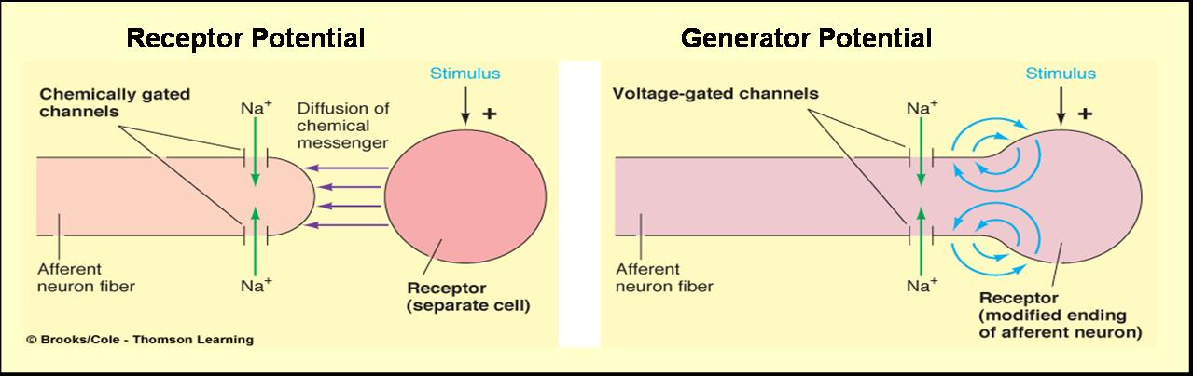
- General or receptor potential – triggered by an external stimulus

- Receptor potential (vision is an example)
- General and receptor potential are involved in starting point/development of action potential
- Postsynaptic potential – trigger is neurotransmitter released by neuron in pathway
- Can be excitatory or inhibitory
A Resting Neuron:
- Its inside is negative relative to its outside.
- The cytoplasm contains more K⁺ and less Na⁺ than does the ECF.
- A charge separation exists at the plasma membrane.
- The electrochemical gradient for the movement of Na⁺ across the membrane is greater than that for K⁺
- The membrane is more permeable (leaky) to K⁺ than to Na⁺
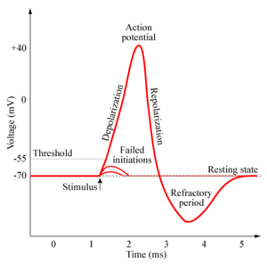
Action Potential
- a brief reversal of membrane potential; total amplitude = ~100 mV (from -70mV to +30 mV)
- cells with excitable membranes (neurons, muscle cells) can generate action potentials; in neurons, only axons can generate action potentials (go from axon hillock and then regenerate down length of axon)
- Action potentials do not decrease in amplitude with distance travelled!! (always same magnitude of apprx. 100mV)
- voltage-gated channels on axons open & close in response to local currents (graded potentials)
- threshold
- keep recreating action potential down axon using voltage-gated channels that open and close to allow ions to enter
Generation of an Action Potential
- transient increase in Na⁺ permeability
- restoration of Na⁺ impermeability
- transient increase in K⁺ permeability
- Depolarizing Phase:
- (i) Increase in Na⁺ permeability
- resting state: voltage-gated Na⁺ & K⁺ channels closed; normal leakage
- local depolarization: voltage-gated Na⁺ channels open (fast activation gates)
Questions
- threshold (-55 to -50mV) is the point when there’s enough voltage to allow sodium channels down the axon to open on their own (to allow charge difference to get to +30mV)
- both Na⁺ gates must be open for entry
- closure of either gate stops Na⁺ entry
Decrease in Na⁺ Permeability
- as membrane potential passes 0mV, inside positivity resists further Na ⁺ entry
- Na⁺ gates begin to close….
Increase in K⁺ Permeability
MISSED SLIDE
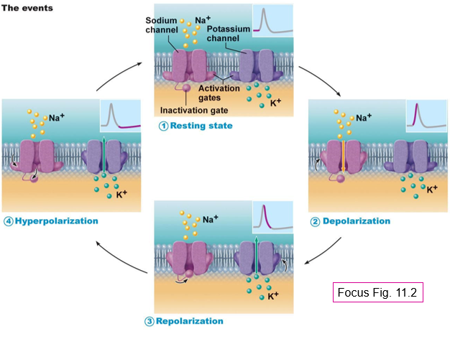

- Absolute refractory period
- Impossible to stimulate area of axon again because sodium channels are already open
- Can’t have second stimulus during this time
- Relative refractory period
- Possible to stimulate again
- Need a high stimulation at level of axon hillock to stimulate another action potential
- Touching very hard (ie pinch) does this
- Allows you to be aware in differences of stimulus
- Or differences in motor output (lifting something heavy vs light)
Action Potential Phases
- Depolarization (sodium channels open, +30mV)
- Repolarization (sodium channels close, potassium channels open)
- Hyperpolarization (potassium channels close, and ions move through leaky channels only, -90mV)
- Neuron is ready to fire again once membrane potential reaches -70mV)
Propagation of an Action Potential
- Action potential must transverse length of neuron to signal next neuron
- Propagation rather than conduction of action potential because conduction is spreading but propagating is recreating action potential with same characteristics
- Recreated with same magnitude, and characteristics down axon until it reaches end and signals transmission of neurotransmitters
- Unidirectional because area is refractory and is not welcoming to regeneration (sodium channels aren’t ready to be activated again)
- Myelin sheath allows jumping from node to node along pathway of axon
Threshold and All-Or-None Phenomenon
- At threshold, outward potassium ions current = inward sodium ions current (about 20mV of depolarization)
- All action potentials are all the same size; stimulus intensity is coded by action potential frequency
- Either reach threshold or don’t
- If threshold is reached, action potential happens and if not, action potential is not generated
- Absolute refractory period: sodium gates open and second depolarization is impossible
- Relative refractory period: sodium gates closed, but potassium gates open; can only be stimulated by a very strong stimulus (greater than threshold); a means of increasing frequency when incoming stimulus is strong
Myelin Sheath
- White, lipid-protein; insulates/protects peripheral nerves
- Increases (up to 150 times) rate of impulse propagation
- Schwann cells: membranes less than 25% protein (minimal channels because main function is to w
- Nodes of Ranvier (myelin sheath gap)
- Saltatory conduction: pattern AP follows as it jumps from node to node down length of axon
- Dendrites are not myelinated, only axons area
- Some neurons in CNS are also myelinated: oligodendrocytes; white vs grey matter
- White matter has axons with myelin sheaths given by oligodendrocytes
- Grey matter is cell bodies, dendritic regions, and shorter axons that don’t need a myelin sheath
Multiple Sclerosis
- Persistent inflammatory response in which myelin sheaths gradually destroyed
- Could be an autoimmune disease, could be a virus
- Cycles of relapse and remission: flare-ups and then some healing and myelin regeneration; axons develop more sodium channels in demyelinated areas
- Blindness (optic nerve), muscle weakness, clumsiness, urinary incontinence
- Ultimately, myelin destruction is permanent and axons “drop out” or degenerate (progressive disease)
- Therapy:
- Reduce inflammatory destruction
- Manage symptoms
- Promote repair of damaged myelin
The Synapse
- Junction between 2 neurons or neuron and an effector
- Presynaptic v postsynamptic neuron (most neurons areboth because they are part of a pathway)
- Voltage-gated calcium channels opened and neurotransmitters are released into synaptic gap
- Neurotransmitters bind to receptors which allow them to trigger a graded potential

Types of synapses:
- Electrical: not as common, like gap junctions (allow for direct flow of ions from cytoplasm of one cell to other)
- Direct current flow via gap junctions
- Neurons can be synchronized
- Rapid transmission (electrically-coupled)
- Primarily embryonic, also eye movement, in non-nervous tissue, found in cardiac and smooth muscle where can synchronize contractions
- Chemical: use neurotransmitters, chemical being released by presynaptic neuron which goes through synaptic cleft to postsynaptic neuron
- Release and binding of neurotransmitters
- Neurotransmitters function to open or close ion channels that influence membrane permeability and consequently, membrane potential
- 2 parts:
- Axonal terminal
- Receptor region (dendritic region of neuron number two or plasma membrane of target)
- What occurs in synaptic cleft (30-50 nm fluid-filled space)
- Why is synaptic transmission unidirectional? Because force
Mechanisms of Synaptic Communication
- Initiation:
- Calcium gates open in presynaptic terminal
- Neurotransmitter released
- Neurotransmitter binds to postsynaptic receptors
- Ion channels open in postsynaptic membranes
- Graded potential is created in postsynaptic neuron
- 300 vesicles emptied/impulse

- Termination:
- Degradation by enzymes of postsynaptic membrane (acetylcholine)
- Reuptake by presynaptic terminal (norepinephrine)
- Diffusion away from synaptic site (nitric oxide)
Synaptic Delay
- Synaptic communication is the slowest (rate-limiting) step of neurotransmission because it is very complex
- Time required for neurotransmitter release, diffusion and receptor binding
Postsynaptic Potentials
- Channels respond to chemicals rather than changes in membrane potentiall channels mediate….FINISH SLIDE
- Excitatory postsynaptic potentials
- NT binding, membrane depolarization, opens one channel for both sodim and potassium electrochemical gradient for sodium steeper than for potassium
- Local, graded depolarization generated
- Inhibitory postsynaptic potentials (stop movement, relax muscle, etc.)
- Neurotransmitter binding, membrane hyperpolarization by increasing permeability to potassium or chlorine
- Tries to stop generation of graded potential
- If hyperpolarization is stronger than depolarization action potential won’t be generated and vice versa

Summation by Postsynaptic Neuron
- Single ESPS cannot generate an AP
- Axon hillock is neural integrator, most effective synapses; closest to axon hillock (less energy required to make it where necessary)
- No summation: 2 stimuli separated in time cause EPSP
- Temporal summation
- Spatial summation: 2+ simultaneous stimuli at different locations but at same time that cause EPSPs that add together, bringing it to threshold and generating an action potential
- Spatial summation of EPSPs and IPSPs: changes in membrane potential can cancel each other (no action potential)
Topic 2.3: Physiology of Muscles
- Elongated cells = muscle fibers
- Terminology: “myo- “, “sarco- “
- Muscle contraction depends on actin and myosin myofilaments
Types of muscle:
- Skeletal muscle (attach to and cover bony skeleton, longest muscle fibers, striated, voluntary, can contract rapidly; tires easily and must rest, strong and adaptable)
- Cardiac muscle (only in heart, striated, involuntary, pacemaker sets rate of contraction; neural input can change rate)
- Smooth muscle (walls of hollow, visceral organs, nonstriated, involuntary, slow, sustained contractions)
Muscle Functions
- Generate movement: locomotion, manipulation, blood flow & pressure (cardiac muscle), respiration, propelling of food, urine, etc. (smooth muscles)
- Maintain posture: constantly working against gravity (skeletal muscle)
- Stabilize joints: ie shoulders, knees, when moving parts of skeleton
- Generate heat: maintenance of body temp (esp. skeletal muscle – at least 40% of body mass)
Functional Characteristics of Muscle:
- Excitability (responsiveness): can reeive and respond to stimulus (usually a chemical like neurotransmitter, or hormone, or change in pH)
- Response = action potential slong sarcolemma + muscle contraction
- Contractility: ability to short when stimulated
- Extensibility: ability to be stretched or extended
- Elasticity: ability to resume resting length after being stretched
Microscopic Anatomy of a Skeletal Muscle Fiber
- Long, cylindrical cells w many oval nuclei (sarcolemma?)
- Muscle cell is said to be a syncytium (single cell containing several nuclei due to cell not dividing but multiplying nucleus)
- Huge cells (diameters of 10-100um and lengths in cm)
- Sarcoplasm contains lots of glycogen (stored glucose so muscles can draw on it if needed) and myoglobin (oxygen-binding protein for intense activity), lots of myofibrils (actin and myosin), extensive sarcoplasmic reticulum (stored calcium), T-tubules
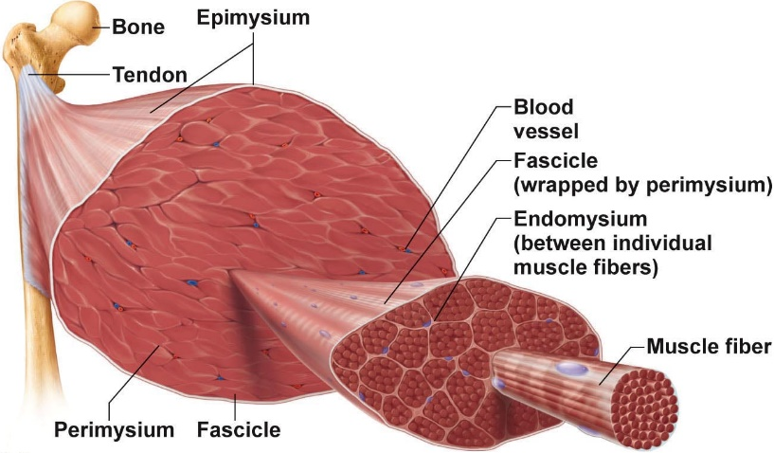
Myofibrils
- Muscle fiber = one muscle cell
- Each muscle fiber consists of parallel myofibrils (apprx. 80% of cell volume + 100s to 1000s per cell)
- Myofilaments arranged in a pattern, forming end-to-end sarcomeres
- Myofilament examples: actin, myosin, etc. that are bundled
- Striated muscle (sarcomere = basic unit)
Levels of Wrapping:
- Endomysium = connective tissue wrapping round single cell, need endomysium to protect from electrical impulse
- Perimysium =
- Epimysium = last wrapping that eventually gives way to tendon that attaches to bone
- Sarcomeres extend from one Z disc to the next Z; give this muscle type the name striated muscle
- Myofilaments:
- Actin = thin filaments – across 1 band and partly into A band (when muscle is relaxed no thin filaments will be seen)
- Myosin = thick filaments – entire width of A band
- Myosin and actin are contractile proteins (slide over one another to allow muscle to contract and do work)
Zones and Lines
- Z disc made of alpha-actinin and anchors thick filaments via titin (elastic)
- H zone is area with no thin filaments (relaxed muscle)
- M line is fine strands connecting adjacent thick filaments, connecting perpendicularly for added support
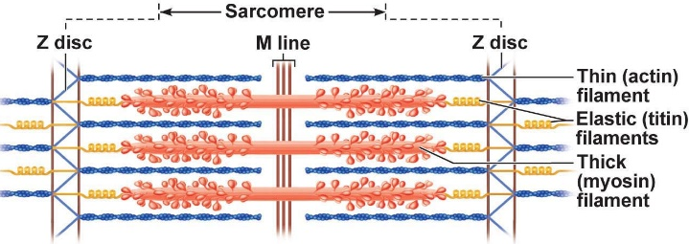
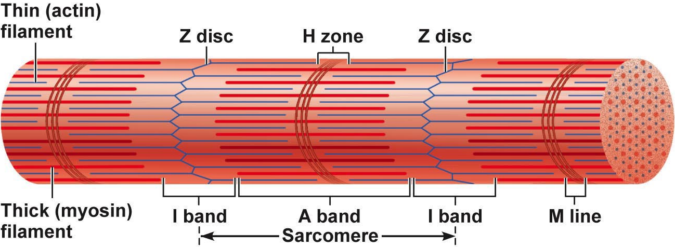
Ultrastructure + Molecular Composition of Myofilaments
- Thick myosin filaments
- Rod-like tail (2 heavy chains) + 2 globular heads (ens of heavy chains + 4 light chains = cross bridges)
- Cross bridges are business of thick filaments because they use ATP
- Each thick filament consists of apprx. 200 myosins; arrayed so central part smooth & each end studded with many myosin heads
- myosin heads contain ATPase
- Thin filaments
- Binding sites for myosin (crossbridges)
- Strands are F-actin; 2 strands wound as helix
- Tropomyosin = 2 strands that stiffen filament and blocks crossbridge binding
- Troponin = 3-polypeptide complex
- TnC = interacts with calcium
- TnT = interact with tropomyosin
- TnI = bound to actin
1. Connective tissue surrounding a fascicle. (perimysium)
2. Contractile unit of muscle. (sarcomere)
3. A muscle cell. (muscle fiber)
4. Thin connective tissue investing each muscle cell. (endomysium)
5. Plasma membrane of the muscle cell. (sarcolemma)
6. Cordlike extension of CT beyond muscle - attaches it to bone. (tendon)
7. A discrete bundle of muscle cells. (fascicle)
Clinical Note
- Dystrophin helps bind everything to outer extracellular matrix
- Link to muscular dystrophy
Sarcoplasmic Reticulum
- Elaborate web of ER around each myofibril inside plasma membrane
- Most sarcoplasmic reticulum tubules run longitudinally; pairs of terminal cisternae across A-I junctions
- Role is to regulate intracellular Calcium+, storage depot for calcium, releases it when muscle is stimulated to contract
T-Tubules
- At A-I junction sarcolemma penetrates cytoplasm to form hollow elongated tubules
- Triad: group of 3 structures, 2 terminal cisternae + 1 tubule (middle)
- Invaginations of plasma membrane, when AP spreading it goes down each t-tubule which brings depolarization to another level and allows muscle cells to be depolarized throughout all muscle cells deeper in not just those close to plasma membrane
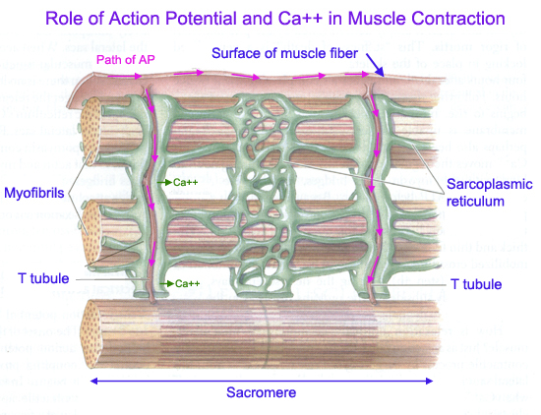
- muscle fiber shortens because sarcomeres shorten; individual filaments remain the same length
- Thin filaments slide over thick filaments
- Relaxed = slight overlap of thick and thin filaments
- Contracted = thin filaments penetrate more deeply into A band - Z discs pulled toward thick filaments
Overall:
- Distance between Z discs reduces
- I bands shorten
- H zones disappear
- A bands move closer together, but stay same length (don’t shorten)
- If crossbridge is covered up and ATP is unavailable muscle can’t contract
How Does Sliding Occur
- Stimulus to contract
- Myosin cross bridges attach to actin
- Detached and attaches numerous times to pull thin filaments toward centre of sarcomere
- Muscle shortens as this process occurs simultaneously in all sarcomeres
- Crossbridge attachment to actin requires calcium
- Nerve impulse increases concentration of calcium in muscle cells
- Details on the Mechanism
- intracellular [Ca⁺⁺] low: myosin binding sites on actin blocked by tropomyosin
- Ca⁺⁺ influx: binds to troponin >> shape change & brief detachment from actin >> moves tropomyosin away from myosin binding sites >> sites are exposed
- single power stroke of all cross bridges = 1% shortening;
- How much muscle shortening occurs on average??30%-35%
- Estimated that only ½ of myosin heads actively pulling at one time
- relaxation occurs as SR reclaims Ca⁺⁺

- motor neurons use acetylcholine to stimulate muscles

Regulation of Contraction
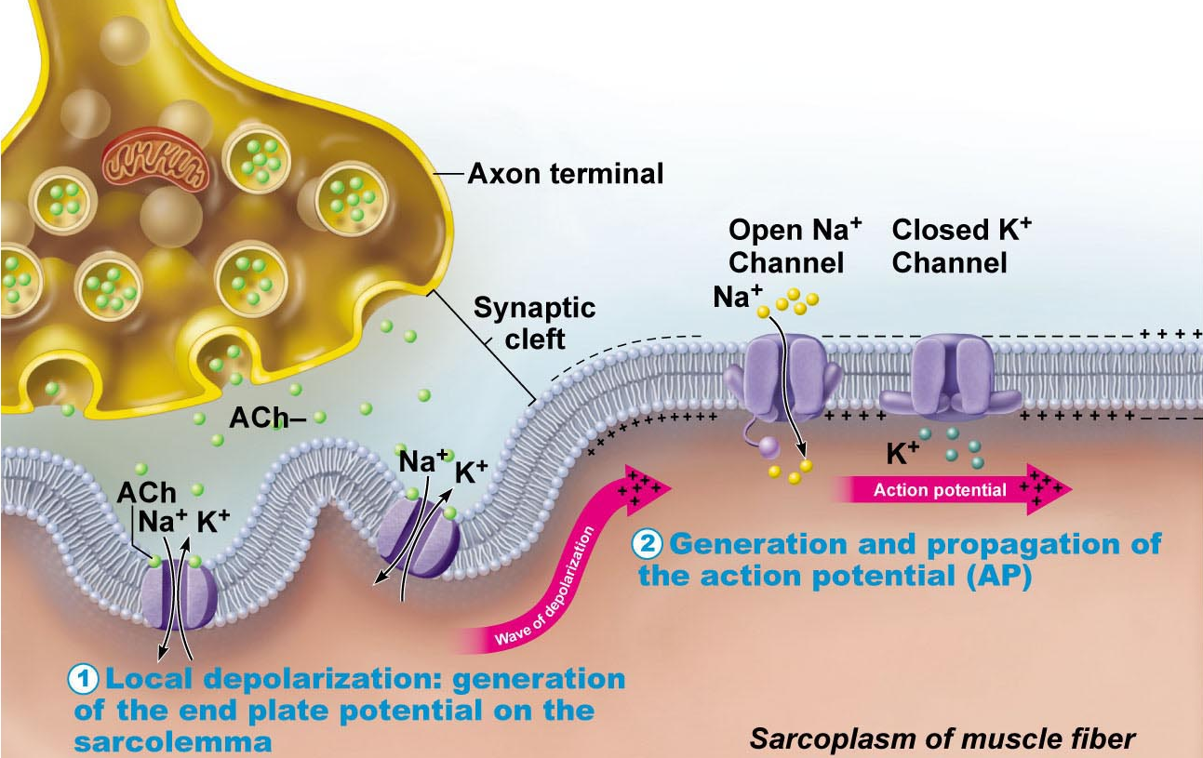
- diagram shows excitation-contraction coupling
- skeletal muscles are stimulated by motor neurons of the somatic nervous system
- 1 neuromuscular junction in middle of fiber – will have synaptic cleft; neurotransmitter is acetylcholine
- Motor end plate is specialized area of muscle sarcolemma that is able to communicate with neuron and is able to create graded potential
- Events at nerve-muscle synapse identical to those in nerve-nerve synapse
Generation of an AP Across Sarcolemma
- Invaginations to increase surface area
- Chemically-gated channels: local depolarization (AP in all directions)
- Depolarization followed by repolarization uses soidum and then potassium as for neuron action potentials
- Sodium-potassium pump to restore correct ion distributions
- Once initiated’ AP is unstoppable – all or none response of muscle cell AP is brief (1-2 msec); contraction can be 100 msec or more
- Ligand gated channel = ion gated channel

MISSED CLASS (slide 47)
Oct. 2nd, 2019
Smooth Muscle
- 2 layers (as in GI tract because trying to propel)
- Walls of all hollow organs except the heart
- Circular smooth muscle does what when it contracts
- Longitudinal smooth muscle shortens when it contracts
- Smaller than skeletal, don’t have sarcomeres
- Has cross bridges, sliding filament of
- Small, spindle-shaped cells (taper to narrowing at end and fatter in the middle), one centrally-located nucleus because small
- Skinnier and shorter than skeletal muscle
- Cells are separated by fine CT; sheets of closely opposed fibers; usually at least 2 with opposite orientations
- Alternating contractions of opposing layers provide mixing, peristalsis (directional movement, gradually propelling things from site of origin by contracting from behind and relaxing muscles ahead to create opening that pushes), expelling
- Varicosities instead of neuromuscular junctions; bulbous swellings of autonomic nervous system – release neurotransmitters into wide synaptic cleft near smooth muscle cells – diffuse junctions
- Sarc. Reticulum less developed than in skeletal muscle; no T tubules; but SR touches sarcolemma and smooth muscle cells have large surface area to volume ration
- No striations but do have interdigitating thick and thin filaments
- Ratio of thick to thin is 1:13 (smooth) vs 1:2 (skeletal); but smooth muscle myosin has actin-gripping heads along entire length >>> strength
- Lots of opportunities for crossbridges to interact with myosin (?)
- Tropomyosin but no troponin (calmodulin instead)
- No sarcomeres: thick and thin filaments spiral down smooth muscle cell
- Noncontractile intermediate filaments and dense bodies (attach to thin filaments)
- Linking for sliding so muscle will contract, pull inwards at level of smooth muscle
Contractions of Smooth Muscle
- Mechanism: electrical coupling via gap junctions (slow, synchronized contractions)
- Some smooth muscle cells are pacemaker cells (can depolarize spontaneously)
- Actin and myosin interact by sliding filament mechanism
- Final trigger is rise in intracellular calcium
- Sliding process is energized by ATP
- Contraction of smooth muscle is slow (30x), sustained, fatigue-resistant because @ intermediate level of activity (24 hour maintenance of tone of blood vessels, visceral organs)
- Few mitochondria because not usually carrying out max-intensity contractions; most ATP generated aerobically (works because not carrying out activity at maximum)
Special Features of Smooth Muscle Contraction
- Response to stretch
- More stretch (120% resting length), more vigorous contraction – stretching can induce brief contraction (gut) or can have stretch relaxation response (filling)
- Length and tension changes
- Stretches more than skeletal; can generate more tension than skeletal (contracts in a corkscrew-like manner) (150% vs 60%)
- Smooth muscle in stomach has to stretch when stomach is filled from eating
- Bladder smooth muscle contracts to empty
Types of Smooth Muscle
- Urinary smooth muscle
- Visceral muscle; more common
- Arranged in opposing (longitudinal and circular) sheets
- Innervated by autonomic nervous system varicosities and often exhibit rhythmic spontaneous Aps
- Electrically coupled by gap junctions; contract as a functional unit
- Can respond to various chemical stimuli
- Wall of bladder, stomach, tubular structure (vas deferens, etc.)
- Multiunit smooth muscle
- ie large airways to lungs, large arteries, arrector pili muscles of hair follicles in skin, internal eye muscles used for focus
- rarely have gap junctions or spontaneous synchronized contractions
- muscle fibers structurally independent of each (more nerve ending)
- richly supplied with nerve endings, each forms a motor unit with a number of muscle fibers
- responds to neural stimulation with graded contractions (still regulated…FINISH POINT)
UP TO MIDTERM #1 DONE
Midterm:
- 55 multiple choice
- + 6 marks of filling in the blanks/labelling
- 15 tissues + some cell biology
- 10 on transport mechanisms
- 15 on neurons
- 15 on muscle mechanisms
Homeostasis: Control Mechanisms
Walter Cannon: ability of the body “to maintain relatively stable internal conditions even though there is no continuous change in the outside world”
- not unchanging, dynamic state of equilibrium involving many systems
- adequate blood levels of vital nutrients
- heart activity/blood pressure monitored and adjusted as needed
- wastes must not accumulate
- core body temperature must remain within range
Essential Characteristics:
- receptor: senses change (stimulus) and sends info (afferent pathway)
- control centre: determines set point for variable maintenance, analyzes info and determines correct response
- effector: provides means for response (output along efferent pathways)
- feedback (negative/positive) allows for regulation within a range/enhanced response
Negative Feedback Mechanisms
- output reduces or shuts off stimulus in one of two ways:
- 1 hormone or neural pathway regulation a process: negative feedback decreases secretion
- Process regulated in opposite directions by 2 different hormones or neural pathways (ie blood glucose)
- Goal of negative feedback: prevent sudden, severe changes
- Body temperature regulation occurs through negative feedback
Positive Mechanism
- Response of mechanism enhances original stimulus (output is further stimulated)
- Change occurs in same direction as original response
- Goal to be attained
- i.e. blood clotting
Homeostatic Imbalance:
- most disease seen as a disturbance of homeostasis = a homeostatic imbalance
- aging is associated with progressive decrease in our ability to maintain homeostasis (greater risk for illness)
Autonomic Nervous System
- system of motor neurons to smooth and cardiac muscle and glands to allow responses usually without our awareness
- sensory afferent division and motor efferent division
- sympathetic = fight or flight
- parasympathetic = resting
- functions:
- shunt blood to more needy areas
- speeds/slow heart and respiratory rates
- adjust blood pressure, body temperature
- increase/decrease gastric secretions
Effectors
- somatic: skeletal muscle
- autonomic nervous system: smooth muscle, cardiac muscle and glands
- know neurotransmitter/neuropathways from diagram on slide (3.2.1.2)
Pathways and Ganglia
- somatic: thick, myelinated axon from spinal cord to skeletal muscle; rapid conduction of impulses (no ganglia)
- autonomic nervous system: two neuron chain; preganglionic neuron originates n brain OK rude I missed the rest of the slife
Parasympathetic Division
- active in non-stressful situations – resting and digesting system
- keeps body’s energy use low while regulating “housekeeping” activies (digestion, elimination of feces and urine)
- “D” system: digestion, defecation, diuresis
Sympathetic Division
- “fight or flight” system: also important during exercise: increased heart rate, deep breathing, cold sweaty (cold because sweating without a change in body temperature and redirected body flow more to heart and skeletal muscle because want to be ready to run so lose heat faster than you make it), dilated eye pupils
- “E” system: exercise, excitement, emergency, embarrassment
Sympathetic Nervous System and Vascular Tone: blood vessels kept in a state of partial vasoconstriction; blood shunting possible via variations in sympathetic output to specific vessles
Peripheral Nervous System and Tone: tonic slowing effect on heart, regulation of contractile activity of smooth muscle or GI and urinary tracts – can be overridden by sympathetic nervous system
Interactions of the Autonomic Divisions:
- Most visceral organs receive dual innervation
Antagonistic Interactions:
- i.e. MISSED SLIDE
Unique Roles of Sympathetic Nervous System
- SNS regulation only: adrenal medulla, sweat glands, arrector pili, muscles of skin, kidneys, most blood vessels, thermoregulatory responses to heat, renin releases from kidneys – result will be increased blood pressure
- Metabolic effects:
- Increases metabolic rate of body cells
- Raises blood glucose levels
- Stimulates mobilization of fats
- Increases mental alertness
- Increases speed/strength of muscle contraction
Oct. 21st, 2019
Topic 4.1 – Blood
Blood Components
- Only fluid tissue in body (formed elements suspended in plasm)
- Formed elements (not cells): erythrocytes (RBC), leucocytes (WBC), platelets
- Not cells because incomplete
Physical Characteristics
- Colour is scarlet (oxygen rich, systemic arterial) to dark red (oxygen poor, systemic veinous) – whether or not hemoglobin (a pigment) has oxygen attached at all binding sites or just some
- More dense, viscous than water
- Normal pH = 7.35-7.45
- 8% body weight (5-6L in males; 4-5L in females)
Functions
- Distribution
- Oxygen and nutrients
- Metabolic wastes
- Hormones
- Regulation
- Body temperature: distribution, conservation, dissipation – need to keep body temp within a specific range, temp managed by blood vessel dilation or constriction (vasoconstrict for conservation of heat, vasodilate for heat dissipation), blood + blood vessels are important for this
- pH in body tissues (plasma proteins, bicarbonate reserves), usually worried about moving in acidic direction, certain blood elements like plasma proteins soak up extra hydrogen ions to prevent acidosis (short-term), bicarbonate reserves also buffer acidosis by picking up hydrogen ions (also do something with carbon dioxide but I missed what she said exactly)
- adequate fluid volume (osmolarity), solute concentration and water content in blood help maintenance in body
- Protection
- Platelets, plasma proteins, blood clotting (preventing blood loss, promote formation of blood clot when there is damage to wall of blood vessel)
- Antibodies, complement system (helps prevent against invading bacteria), white blood cells
Blood Plasma
- Fluid you get when you centrifuge a sample of blood
- Straw coloured; 90% water + many solutes
- More dense stuff sinks to bottom (red blood cells, about 45%)
- White blood cells + platelets in middle
- Plasma at top
- Plasma proteins: produced in liver (except gamma globulins); functional proteins which remain in blood
- Albumin: (60% of all plasma proteins)
- Carrier of various molecules (hormones, etc.), important blood bluffer ( a lot of it so helps buffer when small changes to blood pH occur); major osmotic protein (major osmotic ion in blood is sodium ion)
- Blood constantly adjusted to keep its composition, pH within normal range
Formed Elements
- Erythrocytes, leukocytes, platelets
- Most formed elements are short-lived and disposable; replaced by bone marrow
- Red blood cells
- Biconcave discs, scrunched down because they don’t have a nucleus so basically bag of hemoglobin; other proteins maintain plasma membrane and regulate cell shape
- Spectrin = maintains red blood cell shape
- Transport oxygen from lungs to tissues; transport 20% of carbon dioxide back to lungs
Specialized characteristics that optimize functions:
- Small size and biconcave shape (large SA to volume ratio)
- 97% non-water composition is hemoglobin
- Do not carry out aerobic metabolism, generate ATP anaerobically, have no mitochondria
- Women have lower RBC count than men (hematocrit)
- Rate of blood flow inversely affected by RBC count (as hematocrit goes up blood becomes more viscous)
- Hemoglobin = protein globin bound to red heme pigment
- Globin = 4 polypeptide chains (2 alpha and 2 beta); 4 Fe-containing central heme groups
- Each Fe can reversibly bind one molecule of oxygen (4 per hemoglobin molecule; each RBC has 250 million hemoglobin molecules)
- Hemoglobin contained in erythrocytes which keeps it from fragmenting anf being lost, and keeps it from contributing directly to osmotic pressure and blood viscosity
- Oxyhemoglobin is a different shape and colour than deoxyhemoglobin
- Oxygen combines with heme group, but carbon dioxide combines with globin component (carbaminohemoglobin)
- Bind to different places on hemoglobin molecule, no competition between the two both can bind at once
- Hemocytoblast
- Proerythroblast
- Reticulocyte
- When does it move to circulatory system
- Erythropoiesis: production of red blood cells (about 15 days):
- Ribosome synthesis
- Hemoglobin accumulation
- Ejection of nucleus
- Red blood cells only last 120 days
- Reticulocyte vs RBC (reticulocyte still has ribosomes that finish up synthesizing hemoglobin, RBC has no ribosomes)
- Hematopoiesis = production of blood cells in bone marrow
- Immature red blood cells here, as they mature migrate through capillary walls to blood
- Hematopoietic stem cell (hemocytoblast): stem cell for all formed elements (cells become committed to a particular pathway)
- Reticulocyte count is usually 1-2%, if low they are iron deficient, if high lots of cells just died and are being replaces
Regulation of erythropoiesis:
- Balance between RBC production and destruction (need to be at same rate)
- Too few = anemia
- Too many = polycythemia
- Erythropoietin regulates blood oxygen levels by stimulation
- Production rate is 2 million per second if healthy (sufficient iron and B vitamins)
Homeostatic process
- Stimulus (hypoxia, inadequate oxygen delivery due to decreased RBC count, decreased amount of hemoglobin, or decreased availability of oxygen)
- Kidney and liver to a small extent, releases erythropoietin
- Erythropoietin stimulates red bone marrow
- Enhanced erythropoietin increases RBC count
- Oxygen-carrying ability of blood rises
Hormonal control:
- Erythropoietin: glycoprotein produced in kidney
- Always some EPO in blood; additional release by kidney of hypoxia due to hemorrhage or excess RBC destruction, high altitude, pneumonia, increased demand
- Level of oxygen delivery (especially going to kidneys) monitored, if too low kidneys release erythropoietin
- Erythropoietin enhances maturation rate of committed BC precursors (1-2 days to see results)
- Route of stimulation: hypoxia, kidneys, erythropoietin, activation of bone marrow, more mature RBCs
- Renal (kidney) failure patents have the additional problem of lacking EPO (RBC counts can be 50% of normal); helped by recombinant EPO
- Athletes and EPO abuse can cause abnormally high hematocrit and dehydration along with stroke, clotting, and heart failure due to increased blood viscosity
- Effect of testosterone on renal EPO production: stimulatory effect (why males have slightly higher hematocrit than males)
Dietary requirements (iron, B-vit)
- Absorption of dietary iron controlled by body’s storage levels
- Free iron is toxic
- 65% already in hemoglobin
- Rest is stored in liver, spleen, bone marrow (iron-binding proteins ferritin, hemosiderin)
- If transported in blood is loosely bound to protein transferrin
- Loss of iron through feces, urine, sweat (avg daily loss is 1.7mg in females, and 0.9 mg in males – higher in females due to menstruation)
- Vitamin B12 and folic acid are essential for DNA synthesis
- Need to intake some iron, not a lot but a little because we lose
Fate or Destruction of Erythrocytes:
- Mature erythrocytes become rigid (can’t squeeze through capillaries and gets stuck), fragile with time and hemoglobin begins to degenerate
- Lifespan is maximum 120 days
- A lot gets stuck in spleen so its called “RBC graveyard” (microphages recycle)
- Iron stored and reused; heme degraded to bilirubin – eventually becomes stercobilin (what makes feces brown) or urobilinogen
- Amino acids of globin part recycled
FIG 17.7: Life cycle of red blood cells
Anemia: tired, pale, short of breath, chilly
- Caused by not enough normal RBCs produced
- Significant blood loss
- RBCs too quickly destroyed (Sickle cell anemia) – one different amino acid in hemoglobin beta chain causes shape change so blood cells can’t pass through capillaries and get broken down
Polycythemia: too many red blood cells (blood can become too viscous which could cause stroke)
- Polycythemia vera
- True polycythemia
- Caused by cancerous condition in red bone marrow
- Secondary polycythemia
- Caused by something else that causes polycythemia
- Example: someone in high altitudes with less oxygen, kidneys release EPO more RBCs released, or someone with pneumonia
- Artificial polycythemia
- Blood doping
Platelets
Know platelet developmental pathway (diagram on slide)
- Cytoplasmic fragments of megakaryocytes
- Contain purple-staining granules that contain clotting factors and enzymes; anucleate; 10-day lifespan
- Platelet formation regulated by thrombopoietin (keeps platelet levels between 150,000 – 40000 platelets per microliter of blood)
Hemostasis: formation of blood clot
- 3 phases:
- Vascular spasms (attempt to slow down rate of blood flow to slow down rate of blood loss, makes ti easier for platelets to aggregate to form a clot)
- Vasoconstriction of vessel in response to damage
- Triggers:
- Platelet plug formation
- NO and PGl2 (prostacyclin) produced by endothelial cells; inhibit platelet aggregation so platelets do not stick to each other or to endothelial linings (important to keep blood clots from forming under normal conditions)
- Exposure of collagen (occurs when there is damage to blood vessel) stimulates platelets to swell, become spiky and sticky, adhere to exposed collagen (von Willebrand factor), degranulation
- ADP: enhances aggregation and degranulation
- Serotonin and thromboxane A2 – enhance vascular spasm and aggregation

