Laboratory 1. Hand Sectioning and Staining for Microscopic Observation of Plant Structures
The objective of this laboratory is to train you in some of the simple techniques we will be using throughout the term to prepare and analyse plant specimens under the microscope. This laboratory will also give you the opportunity to see some of the amazing anatomical features that plants have acquired during their evolution and which we will be covering in more detail during the term.
This laboratory was adapted from a document initially written by Edward Yeung from the University of Calgary and a publication by Lux et al. (2005).

During this laboratory, we will learn how to:

- Prepare thin sections from fresh plant specimens;
- Use specific stains to emphasize some specific features of the prepared thin sections;
- Use a light microscope to observe the prepared thin sections;
- Analyze microscope photos using a software to measure distance and surface area.

EXPECTED LEARNING OUTCOMES

Theory
- None; simply observe and appreciate some of the amazing features of plants.

Hands-on experience
- Perform hand sections of living plant specimens;
- Stain hand sections with dyes to reveal the internal organization of plant cells and tissues;
- Use a compound microscope to take pictures of hand sections;
- Calibrate your microscope to accurately measure distances and surface areas;
- Save and document your microscope photos.

PRE-LABORATORY ACTIVITIES

Pre-Laboratory Quiz

The pre-lab quiz 1 covers the following contents: (1) the Organizational Guidelines section, (2) the present document, (3) the document Research Project: Week 1, and (4) the video 1 illustrating and explaining the technique you will use to prepare fresh plant specimens. All documents are available on Brightspace.

This first lab may seem long to read, but both appendices go over information already covered in BIO1130 and BIO1140. The information provided is also intended to adequately explain some microscopy techniques that you will use this semester and for which you will be evaluated during the practical exam at the end of the semester.

ONE STEP AT A TIME

PART 1 - Use of Lumenera Analyze
Lumenera Analyze is a complete image capture and processing software package for advanced imaging. In this section we will explore how to calibrate Lumenera Analyze to accurately measure distances and areas on microscopy images. To accurately measure distances on microscope images one may use an ocular micrometer with graduated divisions, but the microscopes we have in the teaching laboratories are not equipped with an ocular micrometer (Figure 1). We will instead use the known width of the field of view as a reference for the calibration process.

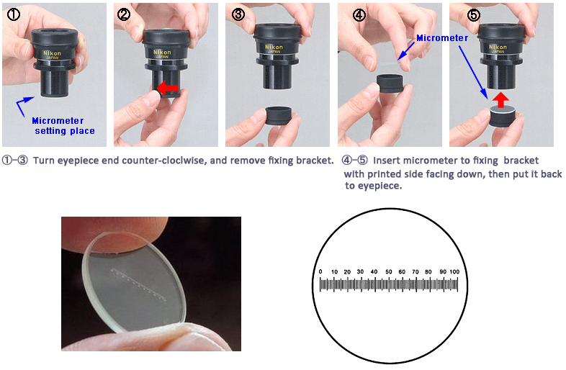
Figure 1 Overview of the process for installing an ocular micrometer. We would need to follow this process if ocular micrometers were available, but this is not the case. In this laboratory, we will use the full field of view as a reference to calibrate Lumenera Analyze and proceed with distance and area measurements. This figure was adapted from http://www.mecanusa.com/microscope/micrometer/Calibration.htm.

Calibration
- On the revolving nosepiece select the 4X lens for a total magnification of 40X (4X lens x 10X the ocular lens).
- Insert a clean microscope slide on the microscope stage and adjust the luminosity and the focus.
- Verify that the option Preview Captured image is selected in the Capture Options Panel.
- Capture the image.
- Select Calibrate from the Measure drop-down menu (Figure 2a) then left click once on a reference position at the far left of the camera field of view. Drag the cursor across the full field of view up to a reference position at the far right of the image then left click again to complete the operation. The Micrometer Calibration box should display automatically (Figure2b).
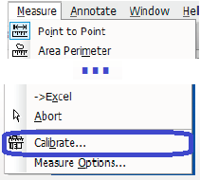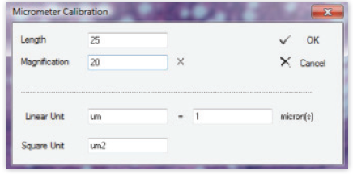
Figure 2. Screen capture from Lumenera Analyze. (a) Image of Measure drop-down menu. (b) Image of Micrometer Calibration dialog box.

- Input the length you just measured and the numerical value for the magnification. The size of the full field of view for the objective 4X (total magnification 40X) is 1 800 um (Laboratory 1 of BIO1140).
- Specify the desired laboratory abbreviation for both linear and square measurement units. For the purpose of BIO2137 it is recommended to use microns (1 um = 10⁻⁶ m).
- Enter the number of microns in one of your measurement units (i.e. if using microns then enter 1).
- Press OK to complete the calibration.
- Verify the accuracy of your calibration process by measuring the full width of your image, which should indicate a value close to 1 800 um as indicated in Figure 3.

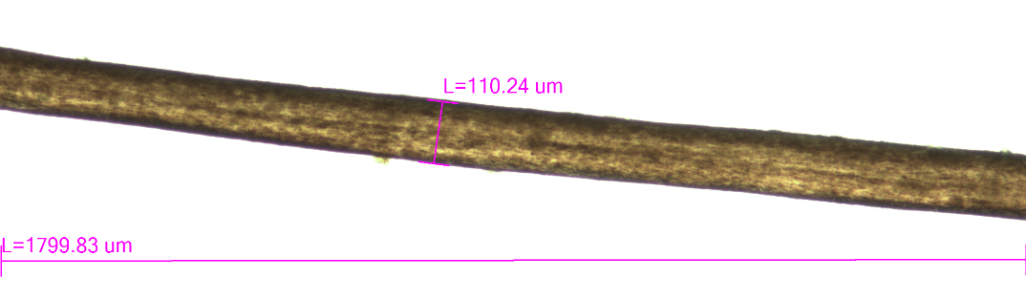
Figure 3. Miscroscope photo of a human hair at 40X. The indicated full width value, 1 799.83 um, is very close to the reference field of view (1 800 um) that had been used for the calibration of Lumenera Analyze. Microscope photo from G. Guillet.

The measure of the full width of a figure does not only corroborate that Lumenera Analyze had been calibrated with success, but it also suggests that the distance values indicated in a figure are accurate. The full width value of a figure can be seen as a scale bar useful to indicate the relative size of the displayed items. For all these reasons, you will be required to systematically insert the distance value of the full width of each of your microscope photos. Note that the field of view varies with magnification. For the compound microscopes available in the teaching labs, the field of views captures by the camera are 1 800 um at 40X, 720 um at 100X and 180 um at 400X.

Calibration adjustment
The calibration has been saved for the 4x lens, but it must be adjusted if you select another magnification lens. To adjust the magnification choose Magnification & Units from the Adjust menu and set the magnification to 100X or 400X if you use either the 10X or 40X lens. The new adjusted calibration will be used by default for all new images, but you should select the option ‘All open images’ to apply the new adjustment to an image that had been previously saved.

Measure a distance
Select Point-to-point from the Measure drop-down menu then successively click at the two ends of an item to visualize its distance in the selected units, which should be microns. You can change the text format of the annotations by selecting Select from the Annotate menu then double left click on a measure value to set the text font and size as needed. You can set the default text format of the measures and annotations by successively choosing the options Annotate, Properties and Measurement (Figure 4).

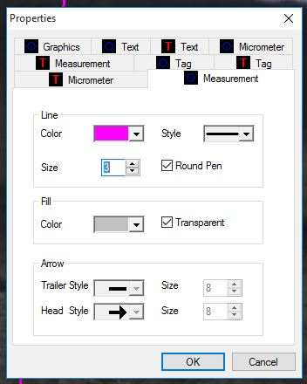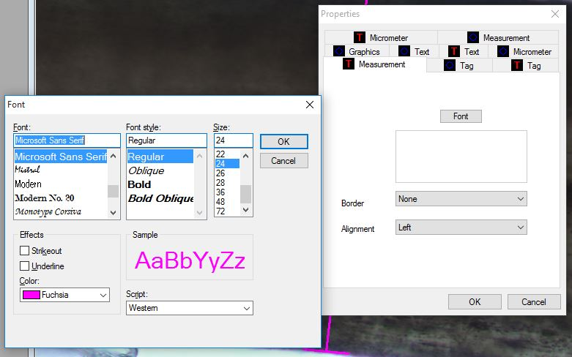
Figure 4. Measurement format options in Lumenera Analyze. There are two distinct parameters for the format of measurements. The first, which can be accessed by clicking on the option Measurement, is for the format of the lines. It is highly recommended to increase the line size to 3 to improve visibility of lines in your figures. The second parameter is the text size of the measurement values and it can be edited by clicking on the option T Measurement. The default text font is far too small and it is recommended to use a font size value of 24. Figure 3 was prepared using the suggested values for line size (3) and font size (24).

Measure a surface area
Select Polygon from the Measure drop-down menu then delineate the periphery of any item you wish to determine its surface area.

Export your data to an Excel file
Select the Excel option from the Measure menu.

Grab one of your hair and transfer it onto a slide then add some water and a cover slip. Capture and save one image with each of the objectives 4X, 10X and 40X. On each of your three images, use the option Measure and Annotate to display the measured thickness or width of your hair. Are the three values comparable? Adjust the format and size of your annotations to optimize their readability.

To save your photos, you can use the build-in saving options in Lumenera Analyze. If you prefer, you can use Snipping Tool accessible by clicking on the Windows 10 icon located at the left bottom of the computer screen. Snipping Tool is an intuitive application, but be aware that you will reduce the field of view if you select and save only a portion of the displayed image that is captured by the camera.

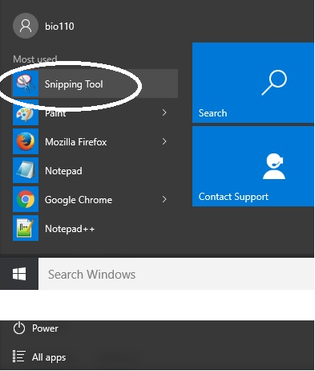

Combine your three images in one single composite figure (refer to Appendix 1) using letters (A, B and C) to identify each image. Use an editing application (Paint, Word build-in options, Photoshop…) to cut-out, crop and resize your images. As indicated above, the full width of each of your images is to be to be displayed at the bottom of each individual image. Your three images should be assembled side by side with a uniform height. Use one single figure caption specifying the nature (tissue or organ) of the observed sample and the total magnification (total magnification is the magnification power of the objective multiplied by the magnification of the eyepiece or ocular) for each individual image. Please follow these formatting guidelines (composite figures and removal of unwanted image areas) each time you are required to insert a microscopy image in a worksheet (even if they are not explicitly repeated).

PART 2 - Cross Sectioning of Plant Specimens
Most plant parts are too thick to be mounted intact and viewed with a microscope. In order to study the structural organization of the plant body, sections have to be made so that enough light can be transmitted through the specimen to resolve cell structures under the microscope. A hand section is the simplest method of preparing specimens for microscopic viewing. This method allows one to examine the specimen in a few minutes. It is also suitable for a variety of plant materials, such as soft herbaceous stems and small woody twigs. Patience, experience, and perhaps inherent skill are the chief requirements for this technique. Also keep in mind that thinner sections, which are more difficult to obtain, will allow more light to be transmitted with less diffraction and better resolution (see Figure 5)

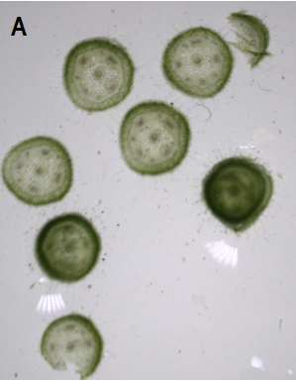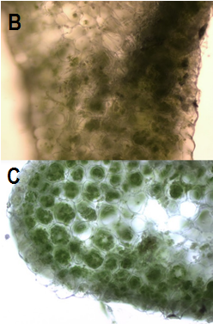
Figure 5 Different section thicknesses of a geranium stem (A). Thicker sections (B) do not allow you to see as much anatomical detail as thin sections (C). Individual chloroplasts can be seen in the thin section of a geranium leaf (C), but not in a thicker section (B). Photos by G. Guillet.

Sectioning of small samples directly on a microscope slide
- Obtain a single edge razor blade. To avoid injury, hold the blade from the handle side only.
- Soft samples (moss, thin leaf…) should be hydrated, although tough tissues (pine needle, stem…) can be directly cut. First practice your sectioning skills using pine needles as they are relatively easy to section.
- Use forceps to transfer a plant specimen onto a slide and add a drop or two of water. Put the slide under the dissecting microscope. Small specimens should be cut while looking through the oculars of the dissecting microscope.
- Position your left (or right) finger upright on top the specimen. Cut sections in a slight up and down motion that is perpendicular to the long axis of your specimen; do not saw.
- Cut at least a dozen sections and place them in a drop of water to keep them moist. Observe your sections under the dissecting microscope and save an image of all your prepared sections. If needed, gently spread your sections so you can see them all in your image.
- Add one drop of water and spread out your sections and discard the ones that are too thick as well as any unwanted debris. Transfer two of the thin sections onto a new microscope slide that will be needed for staining in Part 3 (add some water to your sections to keep them moist), then place a cover slide over the remaining sections and observe them under the compound microscope. Save two images showing two perspectives or distinct features of your plant sample. Choose the magnification that you consider as best suited to highlight what you wish to display.
- Repeat steps 3-6 with a stem or a leaf of the Spanish moss (Figure 6), an epiphytic flowering plant.
- Repeat steps 3-6 with a stem or a leaf of geranium.

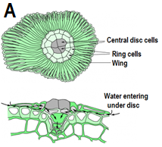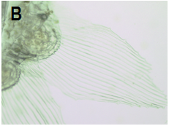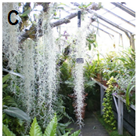
Figure 6 Spanish moss, a rootless so-called ‘air-plant’, has succulent leaves covered with specialised hairs called trichomes that are used to absorb water. Both characteristics are adaptations to the dry environments in which Spanish moss species (genus Tillandsia family Bromeliaceae) live. Diagram (A) was obtained from http://plantsinaction.science.uq.edu.au/edition1/?q=content/15-4-3-epiphytes and the other photos from G. Guillet.

Prepare a composite figure for each of your three plant specimens (pine needle, Spanish moss and geranium). Each composite figure should contain an image of all your prepared sections (step 5, image taken with the dissecting microscope) and two other images taken with the compound microscope (step 6). Three composite figures are therefore expected with a concise caption (organ, species, magnification) under each one.

Insert your three composite figures along with their individual caption.

PART 3 - Histological and Histochemical Staining Techniques
In general, most biological and plant tissues have very little contrast and cellular details are hard to discern with an ordinary light microscope. Stains can enhance and improve the visibility of cells and cell features. In addition, different stains have different affinities for various organelles and macromolecules. Therefore, the careful selection and utilization of stains can also suggest the chemical nature of the substances within the cell.
A general histological stain is the Toluidine Blue O stain.
The stain, toluidine blue O (TBO), is an excellent stain for hand sections. TBO has the advantage of being a polychromatic dye, which means that it produces a multi-coloured specimen because it does not react the same with all the different chemical components of a cell. The colours generated can thus provide information on the nature of the cell and its cell walls.
TBO is a cationic dye (cations are attracted toward a negatively charged cathode and are therefore positively charged) that binds to negatively charged groups. An aqueous solution of this dye is blue, but different colors are generated when the dye binds with different anionic groups in the cell (Table 1).
Table 1. The different colours generated in plant tissues when TBO binds to the anionic groups of certain macromolecules and their typical intracellular localization.
Substrate | Colors observed in presence of toluidine blue O | Intracellular localization
Carboxylated polysaccharides (pectic acids) | Pinking purple | Division line between cells (almost exclusively restricted to the cell wall
Phenolics (lignin, tannins) | Green, greenish blue, bright blue | Cell wall
Nucleic acids | Purplish or greenish blue | Nuclei

The TBO stain solution will be prepared for you by the laboratory technologists.
Dissolve 0.1 g of toluidine blue “O” in 100 ml of 0.1 M benzoate buffer, pH 4.4 (benzoic acid 0.25 g, sodium benzoate 0.29 g, water 200 ml). If benzoate buffer is not available, for general use, tap water can be used as the solvent for TBO.
- Retrieve the thin sections of a pine needle, Spanish moss (stem and/or leaf) and geranium (stem and/or leaf) that you prepared and put aside in step 6 of Part 2.
- Add one drop of an aqueous 0.1% TBO solution on each of your three microscope slides and wait for one minute.
- Gently remove excess stain with a Kimwipe and add one or two drops of water onto each microscope slide to wash the sections. Remove the excess water using the same Kimwipe and repeat for two more washes.
- Add a drop of clean water over the sections and apply a cover slip. Examine your sections using the compound microscope and save two images of each species showing the same aspects and at the same magnification as in step 6 of Part 2.

For each of the three investigated species, prepare a composite figure with the two unstained and the two TBO-stained images. Each of the three composite figures should therefore combine four microscope images. Insert a distinct caption for each of the three composite figures.

Briefly describe (maximum 5 lines) the color differences between the unstained and TBO-stained sections. What are the structures that are specifically stained by TBO? Are these structures the same for all three investigated specimens?

The Iodine-Potassium-Iodide test (IKI) for starch
The iodine-potassium iodide (IKI) stain is specific for starch. Apparently, the basis of the reaction is the accumulation of iodine in the center of the helical starch molecule. The length of the starch molecule determines the colour of the reaction - the shorter the molecule, the more red the colour; the longer the molecule, the more blue the colour.
The IKI stain solution will be prepared for you by the laboratory technologists as described below.
Stain Preparation: The IKI solution is prepared by first dissolving 2 g of KI in 100 ml of water, and adding 0.2 g of iodine into the KI solution. Prepare this solution ahead of time, as iodine takes some time to dissolve. Store the solution in a dark glass bottle and cap tightly. Exposure to light and air degrades the solution's usefulness. Iodine sublimates at room temperature. It is preferable to prepare the solution in a fume hood. The stain, once prepared, can be kept for several months or longer, as long as the bottle is tightly capped.
We will use a potato tuber to practice the technique of iodine staining (Figure 7).
- With a razor blade, cut a potato tuber to form a short and thin "fry" with a cross section of about 0.5 cm x 0.5 cm, then prepare thin sections on a microscope slide as described in Part 2. Only retain your thinnest tuber sections for staining with IKI since thicker sections will retain too much of the stain that they will appear as too dark to visualize the starch granules.
- Place a drop of the IKI solution directly onto your sections and apply a cover slip and examine the specimen under the compound microscope. Save an image at each of the total magnification 100X and 400X and, for each one use the Measure and Annotate options described in Part 1 to estimate the size of a small and large starch granules.

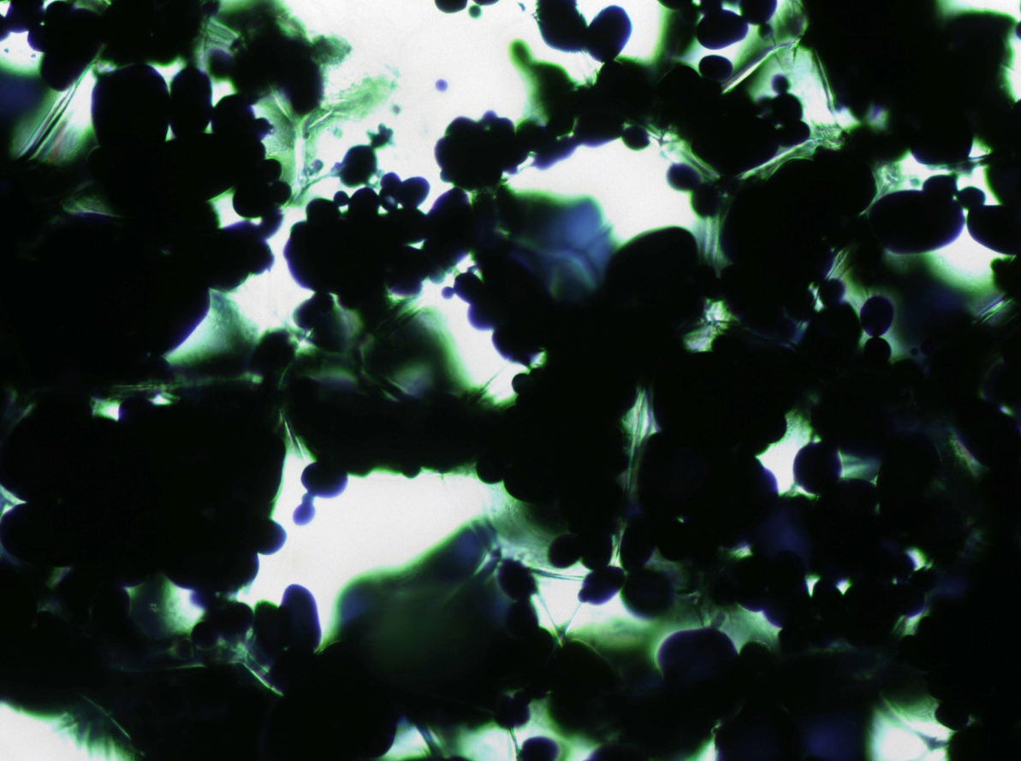
Figure 7. Cross-sections of a potato tuber stained with IKI solution as described in the protocol above (magnification 100X). Potato tubers have a high content in starch that is stored inside specific organelles called amyloplasts. Following staining with iodine, the starch-filled amyloplasts will appear as dark blue and possibly ‘black’ due to the dense packing of starch. Thicker sections with numerous cell layers will show up as completely black. Photo by C. Lesage-Pelletier.

Prepare and insert a composite figure displaying your two microscope images at 100X and 400X with the annotations for the size of a small and large starch granules. Insert a text caption.

Refer to your previous composite figure to estimate the cumulative volume of starch granules within a cell of a potato tuber. What is the percentage volume of a typical potato tuber cell that is occupied by the starch granules? Show your calculations and explain and justify your answer.

PART 4 Seed Sowing for the Research Project

The four groups sharing the same lab island must coordinate their effort to collectively prepare a series of four sowing pots labelled as indicated in Table 2. Each team of two is responsible to label and prepare one pot. Michelle, the chief supervisor of the research and teaching greenhouses, will take care of your plants and administer the proper light and fertilization regimes.

Table 1. Detail of our 2x2 factorial design to assess the impact of light and fertilization on Carthamus tinctorius seedlings. Seedlings will be maintained in the greenhouse for 6 weeks and specimens will be harvested and analyzed in lab 6.
 | Low fertilization (5% of recommended rate¹) | Optimal fertilization (full recommended rate¹)
Sun (greenhouse lighting regime²) | L+F-  (#_BSC3****)³ | L+F+  (#_BSC3****)
Shade (≈10% of greenhouse lighting regime) | L-F-  (#_BSC3****) | L-F+  (#_BSC3****)
¹Recommended fertilization rate is based on Plant-Prod recommendation for greenhouse crops, which is 110 ml/pot of a 20-20-20 fertilizer solution at 300mg/L (reference).
²The lighting system in the research greenhouse is the natural light supplemented with high pressure sodium lamps. These lamps have a spectrum rich in red wavelengths that provide an effect on daylength perception in plants, hence effectively promoting both growth and flowering. High pressure sodium lamps are the most efficient at converting electricity into light and for this reason they are the most economical for greenhouse supplemental lighting. The photoperiod is the greenhouse is set to 16 hours.
³Labeling template is the treatment code (L+F-, L+F+, L-F- or L-F+) followed by the lab section number (1 to 7) and the workstation number.

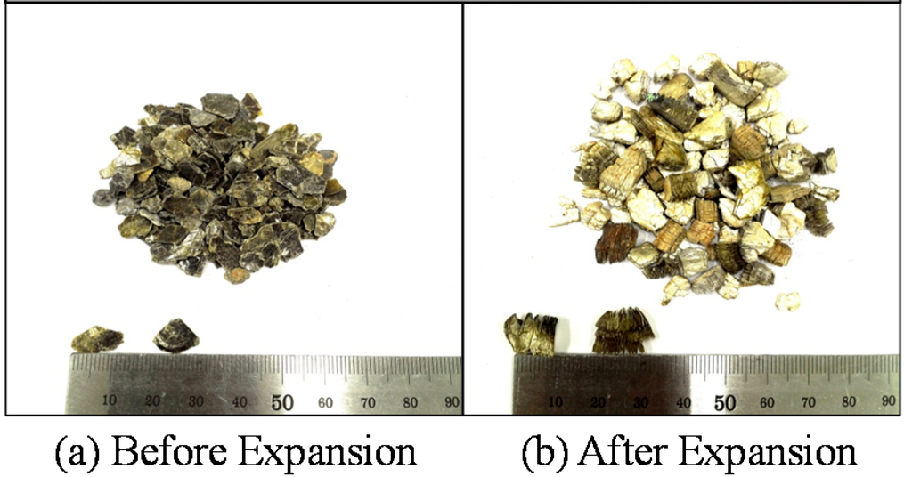
Figure 8. Vermiculite before (left) and after (right) heat-induced expansion. Reference

Safflower, Carthamus tinctorius, will be used as a study model as it is a small herbaceous with a relatively short life cycle.

Vermiculite is to be used as a growing substrate. The fluffy texture of vermiculite is due to its significant expansion when heated (Figure 8). Vermiculite is considered as a neutral substrate as it doesn’t supply any significant levels of nutrients; the supplied nutrients are the only ones that will be available to plants.

Sowing is to be restricted to the indicated area in the lab – there should be no vermiculite on your bench.

- First coordinate your work with the other three teams seating around your lab island so each team is assigned to one of the four treatments.
- Use some tape to label your pot as indicated in the table above.
- Fill your pot with vermiculite and firmly compress the surface to ensure a uniform bed. The surface after compaction should be 10-15 mm below the rim; add more vermiculite as needed.
- Select four large safflower seeds (carefully discard small or darker seeds) and dispose them evenly over the surface of each pot. Upon germination, the technical staff members will leave only two seedlings per pot to minimize competition.
- With your index press on each seed until it reaches a depth of 15-20 mm then fill the openings with extra vermiculite.
- Again coordinate your work with the other three teams sharing your lab island so all of your four pots are gathered and returned at once as indicated by your TA.

APPENDIX 1
Assembly of Composite Figures
A composite figure is the assembly of different items within one single panel or figure. The preparation of composite figures may be time consuming. For the purpose of this lab, you are not expected to provide professional composite figures, but you should effectively convey the requested information.

Consideration 1: Cropping of photos
Cropping a photo means the removal of redundant information to emphasize the aspect you wish to convey to your reader. Below is an example of microscope photo of a trichome observed in a maceration preparation of Coleus sp. before (A) and after (B) cropping.

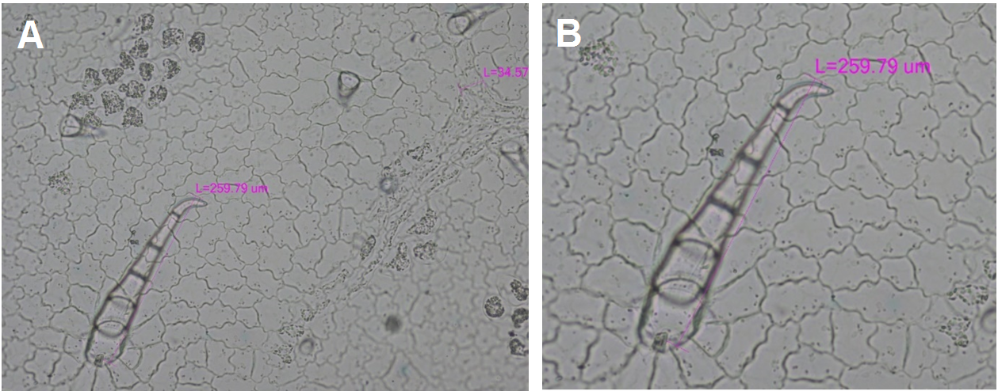

Another example of cropping is shown below for the photo of a human hair. The dirts visible in the uncropped photo (A) may distract the reader from the item of interest, which is the hair (B).

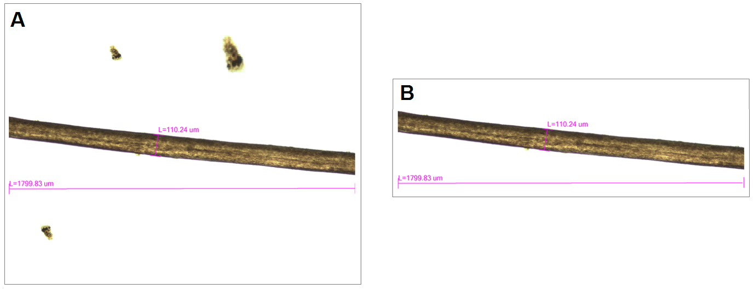

Consideration 2: Assembly of individual photos
Different composite figures of the same three photos of the same hair at different magnifications are shown below. The individual photos should fit inside a regular frame.
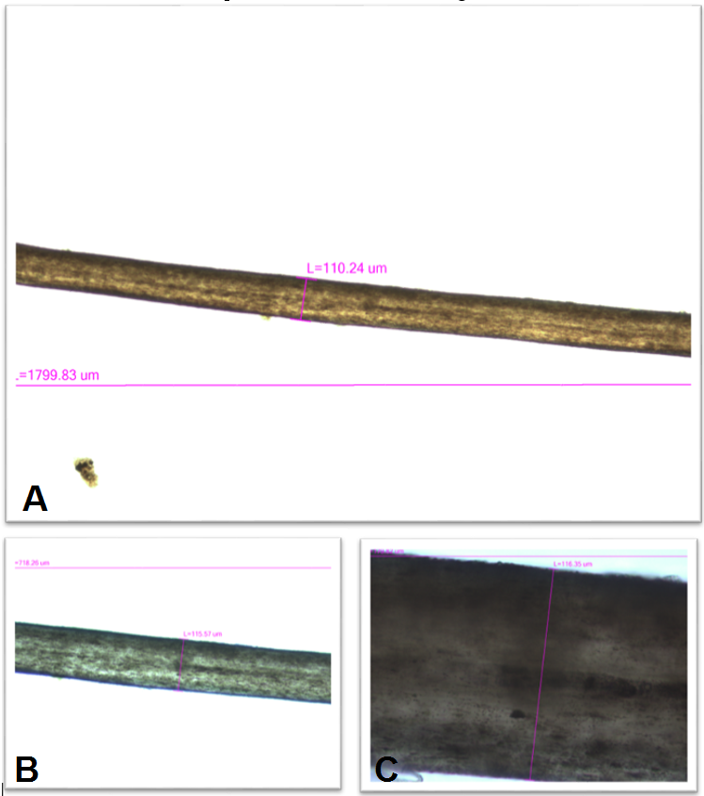
In this first composite figure, the numerical values and lines are barely visible in B and C.
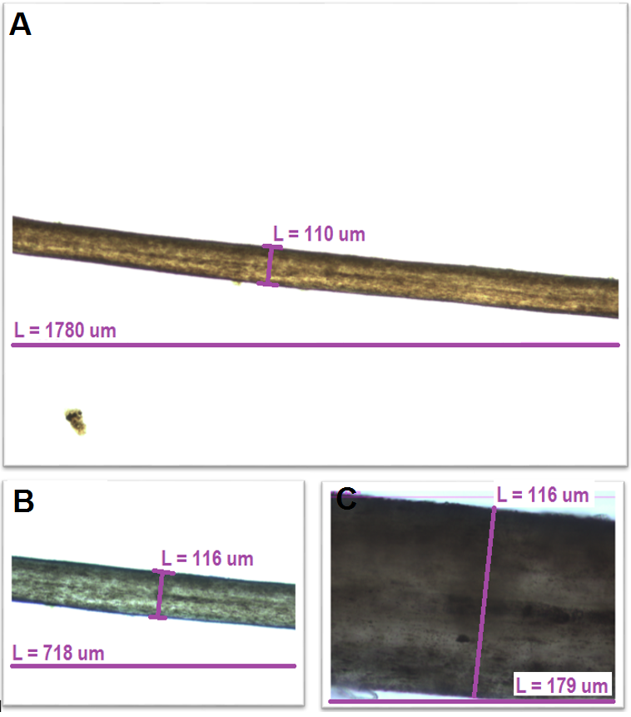
This second composite figure is identical to the first one, except that lines and annotations were made larger and uniform among the three photos. Also note that only significant digits were kept for the numerical values. If some photos are reduced in size, you should manually redraw thicker lines and rewrite annotations to ensure consistent text size and line thickness (the photos B and C were reduced compared to A).

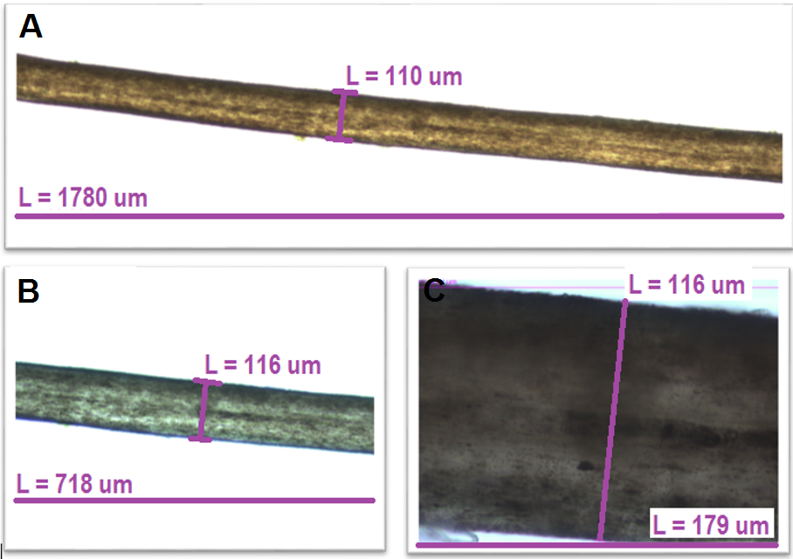
This third composite figure is identical to the second representation, except that the figure in A was cropped to emphasize the displayed hair. The impression is a better emphasis on the item of interest.

Consideration 3: Annotations
Annotations should be made large enough and with an adequate color contrast to make them easy to read.

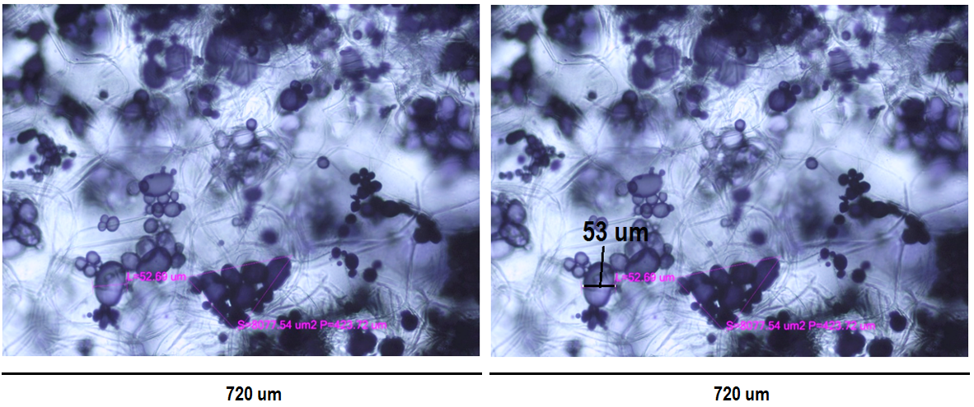
These two figures represent starch grains or amyloplasts in a thin section of a potato tuber. The annotations in the figure at the left are too small. The figure at the right is identical, except that the numerical value was made larger (the original annotations should have been removed). Note that annotations interfere with the microscope photos.

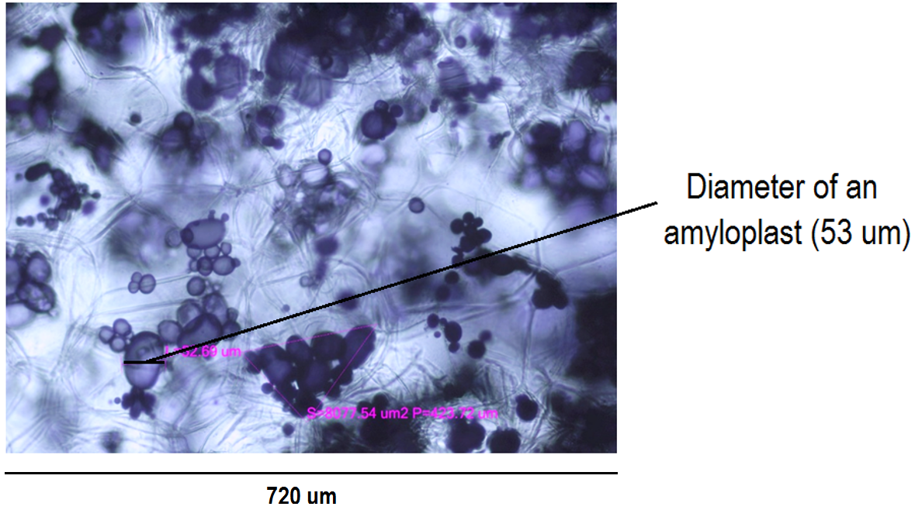
This figure represents the same photo as above, but with the annotation positioned at the right side. Side annotations allow the insertion of short descriptive annotations. Note the long line that crosses the photo.

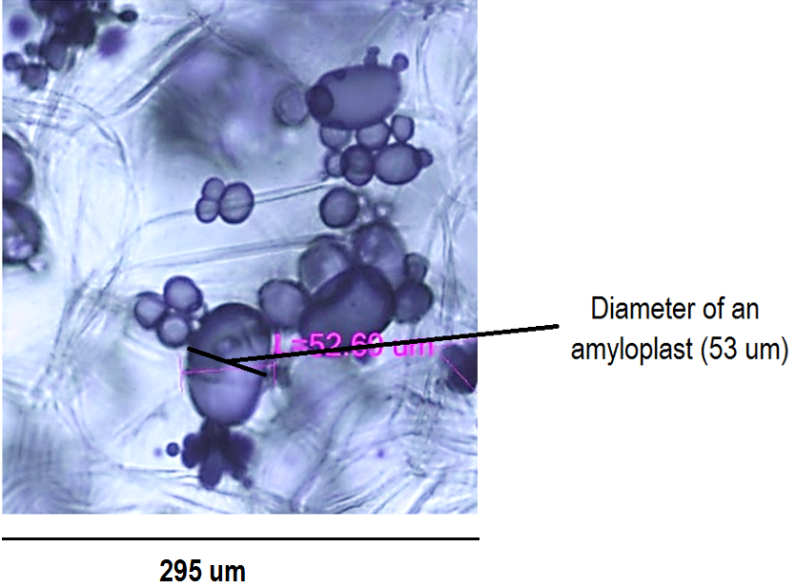
Again the same photo as before, except that it was first cropped to highlight the region of the initial photo that has the best resolution of the amyloplast grains. Note that the scale bar had to be adjusted to take into consideration the vertical cropping that removed unwanted areas on both sides.

APPENDIX 2
Set Up and Use of the Compound Microscope
The dissecting and compound microscopes available in the teaching laboratories are equipped with great quality optics (lenses and ocular eyepieces). Remember, however, that optics can only give good quality images if properly used: ‘Correct … adjustments are critical for the microscope to exhibit its full performance.’ (Manual of instruction for CX41 Olympus microscope). The information below along with this demonstration video clarifies the adjustment procedure to obtain good quality images.

Consideration 1: Parts of the CX41 Olympus Microscope
You may first wish to refresh yourself about the nomenclature of the different parts of the CX41 Olympus microscope (Figure A2.1).

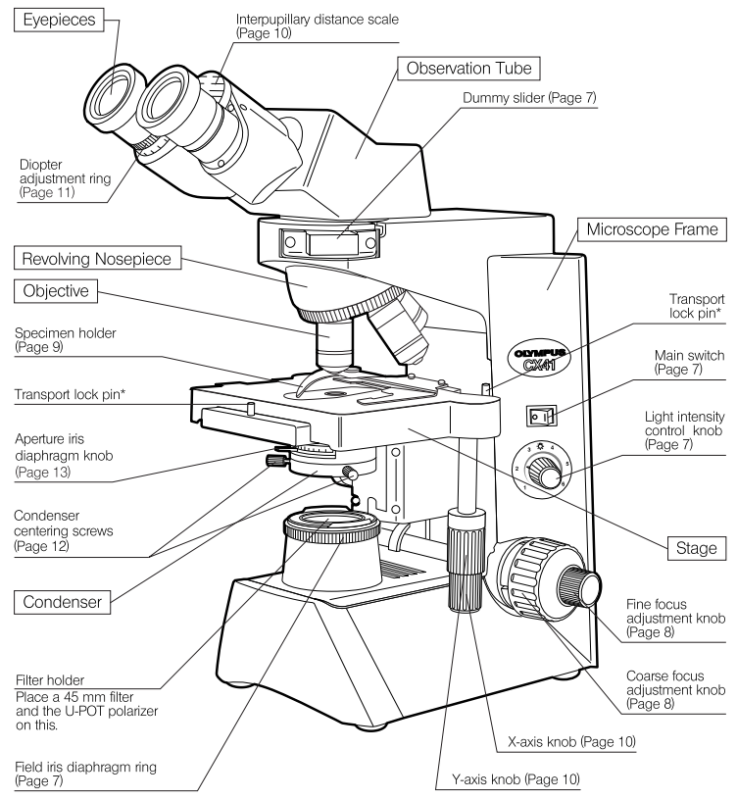
Figure A2.1 Parts of the CX41 Olympus microscope. (Manual of instruction for CX41 Olympus microscope)

Consideration 2: Setting Up of the Microscope
The light emitted from the bulb goes through different parts of the microscope before it can be observed through the eyepieces or the camera. The series of steps for the proper alignment and adjustment of the microscope are shown in Figure A2.2.

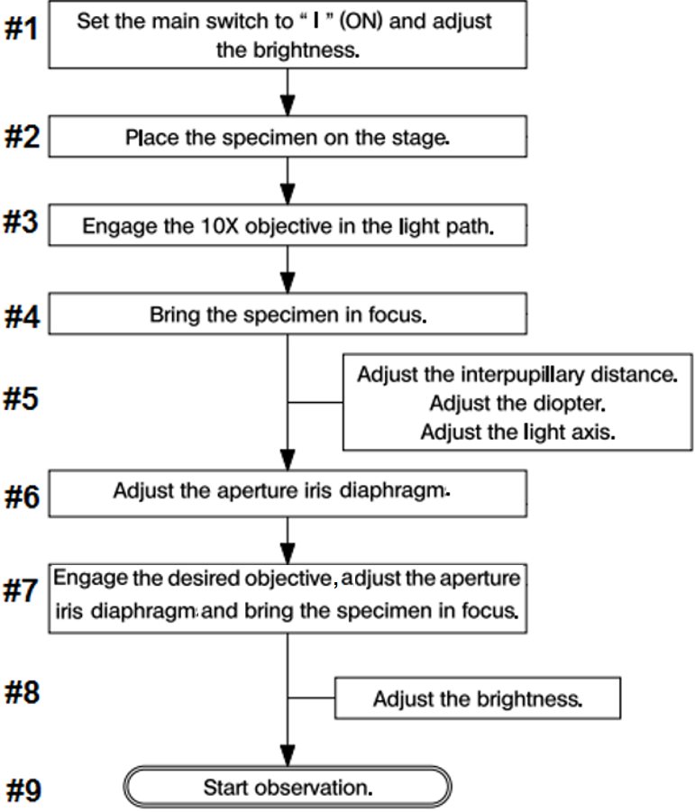
Figure A2.2 Summary of the initial setup procedure before you can make your first observation.

You should be familiar with the setup procedure in Figure A2.2 as it was described in the BIO1130 and BIO1140.

Inappropriate use of the coarse focus knob is a problem frequently observed in the laboratory. The coarse focus knob should be used to bring a specimen in focus only when a new specimen is inserted and with the 10X objective in place. During a subsequent objective shift, some students presume that the stage should first be lowered using the coarse focus knob to avoid damaging the objectives when rotating the revolving nosepiece, but this operation is useless. If you have properly focused the 10X objective, you can directly insert any other objective without the risk of physical contact between the slide and the inserted objective. When changing the objective, use only the fine focus knob.

More information on the adjustment of the field iris and aperture iris diaphragms is provided below since some 2nd year students still have trouble with those steps.

The field or condenser iris is used to collect and focus the light from the source on to the specimen while the aperture iris controls the amount of light reaching the specimen The field iris diaphragm, which is located just above the light source at the bottom of the microscope, controls the size of the illuminated field. An incoming beam light that is excessively large will cause interference and a blurred image may be observed. The field iris diaphragm and the condenser are simultaneously adjusted to ensure the proper alignment of the incoming beam light. The adjustment steps are:

- Engage the 10X objective.
- Insert a microscope slide with a specimen and adjust the focus.
- Turn the field iris diaphragm ring until its image occupies 80-90 % of the field of view.
- Turn the condenser height adjustment knob to bring the field iris diaphragm image into focus.
- Rotate the two condenser centering screws so that the field iris diaphragm image is centered (Figure A2.3).

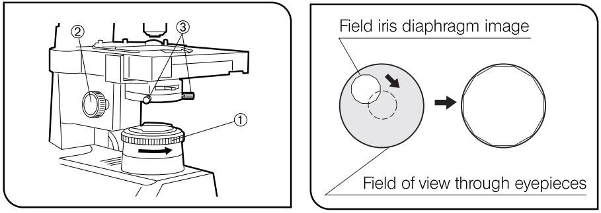
Figure A2.3 Parts to be used for the adjustment of the condenser.

Once the incoming beam light has been properly aligned, its intensity still remains to be adjusted and this can be done with the aperture iris diaphragm located above the condenser and below the stage. Appropriate use of the adjustable aperture iris diaphragm is of significant importance in securing optimal illumination, contrast and depth of field. Good quality microscope objectives should have a mention of the optimal aperture value. For the microscopes available in the teaching laboratories, the recommended aperture values for the 4X, 10X and 40X objectives are 0.10, 0.25 and 0.65, respectively (Figure below). At higher magnification, a higher light intensity is required as observation comes from a smaller area of the mounted specimen.

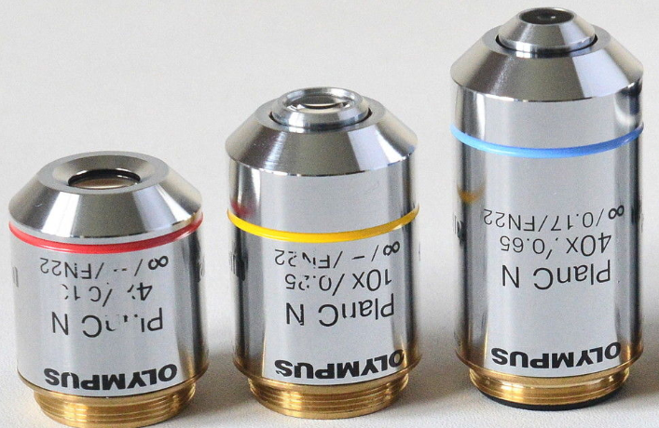

The take-home message is that the microscope should be adjusted each time you use it. All steps listed in Figure A2.2 must be completed first, but the aperture iris diaphragm should be adjusted each time you changed the objective.

