MODULE 3 – RNA AND TRANSCRIPTION

RNA Chemical structure
- very similar to DNA, with 3 key differences:
- Ribose sugar (instead of deoxy). Sugar with 2 OH groups, RNA is much less stable
- Uracil to replace thymine
- Exists as a single polynucleotide chain
However, RNA capable of forming double stranded structures
- Capable of base pairing with itself; RNA-RNA hybrids
- Transient DNA-RNA hybrids
- 2º and 3º structures within a single RNA molecule (bends back on itself to form structures; very flexible)
  - Structures (i.e. stem loop) recognized by many proteins interacting with RNA
  - Impart important functional properties to these molecules (i.e. catalytic activity of ribosymes)
RNA is the intermediate between DNA and protein:
- DNA = archive of genetic information (heritable component of genetic information); maintained as intact as possible
- Proteins are the effector molecule
- mRNA is the transfer of information: intermediary, working copy. Used and degraded very quickly
- However, can also sometimes be the final working product (ribosymes to carry out processes)

Visualization of transcription (Christmas tree)
- Transcription of rRNA genes
- Short branches = beginning of transcription (tells you direction of transcription)
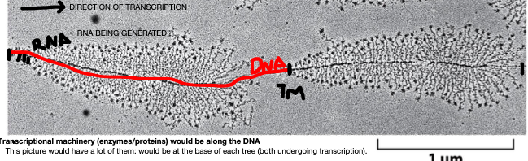
2 separate genes in this picture being expressed, both proceeding in the same direction
Transcription: very similar to DNA synthesis (3 key differences)
- RNA polymerase carries out synthesis of RNA, the enzyme does not need a primer to begin synth.
- RNA transcript does not remain base paired with the template DNA. Transient association; dissociates after catalyzing few bases
- Less accurate, more error prone. RNA is transient working copy. If mistake is made, it can just be degraded
Nomenclature:
- Promoter: upstream the beginning of the gene (on the coding strand), machinery assembly.
- Beginning of the coding region designated +1 (very first base to be incorporated).
- +1 is the location where transcription begins. Every subsequent base is a positive value, and are DOWNSTREAM to the promoter
- Anything before the promoter is negative, and UPSTREAM (no base 0)
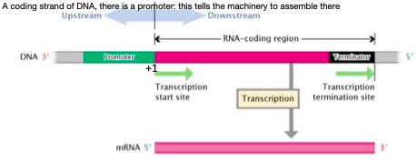
- RNA coding region: DNA which serves as the template for the synth of RNA (sequence located between trans start site, and termination site
- Terminator: DNA sequence which terminates transcription
- Coding strand (gene 5’3’ for mRNA). Non-template strand; its sequence will be the same as the new RNA molecule
- Non-coding strand (3’5’). Template strand, complements the new RNA molecule
- Transcription will yield a copy of the coding strand, RNAP works by base pairing to the template strand
** genes can be found on either strand of DNA. Coding: always written 5’ 3’.
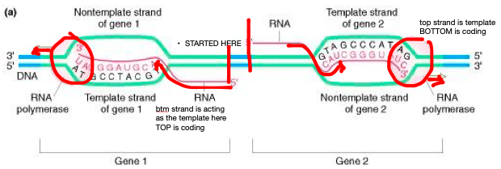

General steps: initiation of transcription (prokaryotes)
- Promoter: DNA sequence found upstream to the transcription start site; binds transcription machinery
- Promoter is not transcribed; only plays a regulatory role (allows the start of the gene to be identified, tells machinery to assemble)
- Consensus sequence: an element conserved in bacterial promoters
  - -35 region and -10 region
- Consensus sequence = the “average” promoter sequence. In a promoter, some bases may vary. The closer a promoter is to the consensus sequence, the stronger the promoter and the more likely transcription will occur (with more mRNA products)
- Strong promoter: one that closely matches the consensus sequence; most likely leads to transcription
- RNA polymerase: a complex (holoenzyme) made up of different proteins, whose aggregate carries out a function.
  - 5 subunits form the core enzyme. CE interacts with the DNA anywhere
  - 1 regulatory subunit that helps the polymerase find the promoter (sigma)
  - Initiation of transcription is the main point at which the cell regulates protein production
- Sigma and the promoter: Sigma factor has several domains allowing it to specifically interact with the promoter of a gene
  - Attaches to the -35 region; keeping the sigma subunit attached and in place
  - On helix-turn-helix binds to the -35 region and allows a tight interaction
  - Second helix melts the DNA double helix at the -10. Opens up the double helix by recognizing the -10 section (rich in A’s and T’s), and inserts itself between a few bases
  - Flips out a few bases and creates a transcription bubble
- Only one RNA polymerase core enzyme, many sigma factors: allows RNAP to regulate different groups of genes
  - different sigma factors used to respond to environmental/nutritional conditions
- Transcription:
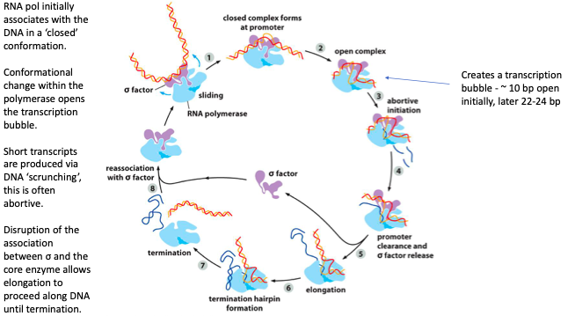
- DNA first interacts with a sigma subunit (core enzyme in blue). DNA not yet melted, closed conformation
- DNA melts, core enzyme moves into open conformation (energetically favorable conformation)
- RNAP attempts to carry out transcription, adds like 10 bases and fails
  - sigma factor holds very tightly at promoter (component binding the -35 and -10 regions)
- RNAP is unable to leave the sigma factor at beginning of gene; DNA scrunched & sigma pulls pol
- Abortive initiation: transcription starts, scrunching causes all bases added to be released
  - sigma factor also blocks the point that the new mRNA is supposed to exit from
- Each round of abortion builds up more energy necessary to dissociate sigma factor, until promoter clearance can occur
- Once that occurs, there is only the core protein attached. Transcription can happen properly
- RNAP shaped like a crab claw, with an exit chamber for RNA to leave.
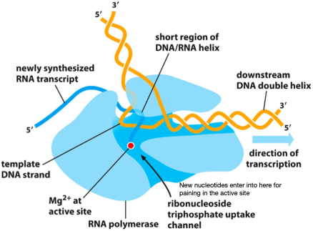
Elongation reaction: similar to DNA elongation
- Ases base pairing rules to add ribonucleotides (sugar with OH at 2’ position)
- Uses RNA pol to catalyze; no primer used. Addition of NTPs (nucleotide triphosphates) onto the 3’ ed of a growing RNA molecule
- Hydrolysis of high energy phosphate bonds drives this process energetically
Termination:
- Rho Independent Termination: Structure dependent. Genes have a sequence that is complementary at the end, and after that there is an A rich region.
  - Transcription proceeds until the end (end complementary sequence transcribed)
  - Complementary sequence forms a stem loop structure (single stranded on RNA)
  - The mRNA is held to the DNA by the A-rich region, which is very easily melted. Once the stem loop has formed, the physical interaction between RNA pol and the stem loop causes them to be forced apart
  - Stem loop pushes the RNAP off
- Rho Dependent Termination: Requires Rho enzyme
  - Similar function to helicase; recognizes the rut sequence, associates with RNA in an ATP dependent manner
  - Travels along molecule to force stuff to detach/dissociate the DNA-RNA hybrid
- Mode of termination depends on the sequence
  - Rut sequence will call for Rho termination
  - Complementary sequence with lots of A’s call for Rho independent

Transcription/translation: paired in prokaryotes
- Both occur at the same time, each structure of mRNA has ribosomes associated for translation
- Colinearity: DNARNAprotein
- Genes are not completely colinear in eukaryotes, due to splicing. Intron are removed, parts of DNA removed and not part of the final product
- Not specifically colinear: they are directly related, just not colinear
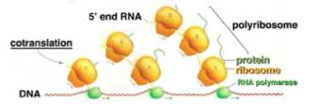
- Sequence hypothesis: the specificity of a piece of nucleic acid is expressed solely by the sequence of its bases, and this seq is a simple code for the amino acid seq of a particular protein
- Colinearity

Eukaryotic genes are discontinuous

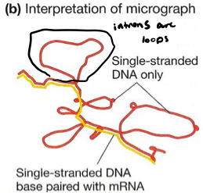
Loops = introns, which do not have a complement in mRNA as they are spliced out
Seen are DNA hybrids, with loops of introns (not colinear)

Transcription in Eukaryotes: same general steps as in prokaryotes
- Prok: only 1 RNAP, 2 beta subunits, 2 alpha subunits, 1 omega subunit
- Euk have 3 different polymerases: 1,2,3.
- Same claw structure, and share several common subunits (structural similarity
- Core subunits are analogous, however euk have additional ones
- Major difference in the CTD: C-term domain, long tail structure
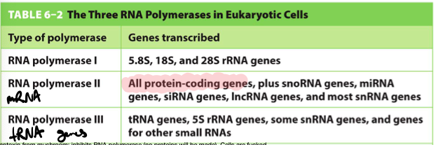
RNAP CTD: in humans, CTD consists of a series of 52 tandem repeats of a 7AA sequence
- Sequence has a lot of serines: these can be phosphorylated, changing the structure and function of the CTD
- Specific phosphorylation events at the CTD lead to (1) a conformational change required for promoter escape and (2) mRNA processing
  - Processing: 5’ cap, proper termination
- When CTD not phosphorylated it forms a compact, globular structure
  - phosphorylated: many times longer

Eukaryotic RNA Pol II core promoters: COMMON ELEMENTS
- TATA box - upstream the transcription start site
- BRE – B recognition element, upstream start site
- INR – initiator motif, falls around +1
- DPE – downstream promoter element, downstream start site (-30)
- Each promoter has a subset of these. Typically INR + either TATA box or DPE
- Many other regulatory sequences play a role
General Transcription Factors
- Rather than a single sigma factor, euk RNAP requires a set of general transcription factors
  - General: they are needed at almost every RNA pol II promoter
  - TFII: transcription factor for RNA polymerase II + a letter which designates identity
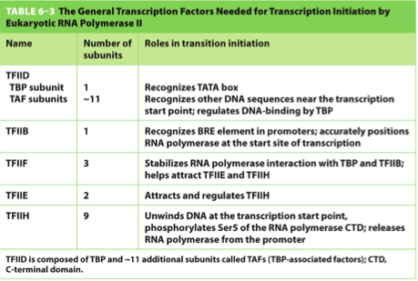
Role: initiation
  - Positions the RNA polymerase on the promoter

  - Separate strands of DNA helix

  - Release RNAP from the promoter, allowing for elongation
Together with RNAP, they make a huge protein complex

Initiation: a stepwise process
- TF’s take the role of sigma factors in prokaryotes
- TATA box: most important DNA sequence for the initiation of transcription by RNAP II
  - TFIID associates with TATA box, serves as a docking site for TFIID
- TATA binding protein (TBP) subunit and TBP-associated factors interact with box.
  - TBP recognizes the box, and inserts a beta pleated sheet into the minor groove of DNA
  - This causes the DNA to bend; this denotes which promoter is active
- Pushes upstream/downstream elements into close proximity (as sometimes distal promoters are far away)
- Bend in DNA are important:
  - Physical landmark to denote an active promoter
  - Increases proximity of DNA sequence on each side of the site (assists in the assembly of the transcription intiation complex)
- When no TATA box: there is a DPE downstream, which TFIIB also recognizes (one or the other)

Assembly of the transcription initiation complex:
- TFIIB is recruited to the promoter, and associates with the BRE domain
- B-recog element of the TFIIB is responsible for placing the RNAP in the right position, at the transcription start site (+1 region)
  - It is essential for anchoring RNAP to the promoter, positioning it over the start site (+1) and ensuring it is oriented such that it will only transcribe in the downstream direction
- RNAP II associates with TFIIF, TFIIE and TFIIH to form the transcription initiation complex
  - this is analogous to the sigma factor and RNA core proteins in prokaryotes
Initiation of transcription:
- TFIIH: large protein that performs several important enzymatic steps necessary for transcription initiation:
  - Has a DNA helicase subunit, which unwinds DNA in an ATP dependent manner. This transiently exposes the template strand
  - Protein kinase subunit phosphorylates serine 5s in the CTD. This induces a conformational change and allows RNAP to escape from the promoter (and the general TFs), to proceed with elongation
  - PK also allows other proteins and enzymes to be brought in close proximity with the RNA being transcribed
- Requires P-recognition element to recognize the promoter
  - TATA box important for initiation, and can have downstream promoters as well (DPE)

Initiation requires assembly of:
- Activators and repressors: bind to sites which may be upstream/downstream, or in introns
  - Euk: usually activators, enhancers that the activator associate with can be far away and the DNA will bend to bring it close
- Mediator: integrates/transmits instructions to the RNAP holoenzyme
  - Mediator complex associates with transcription initiation complex: important for integration of information from all other transcription factors
  - Protein enhancers bind activator proteins and transmit info via a mediator protein
- Chromatin remodeling complex
- Histone modifying enzymes)
- Specific protein constituents & their assembly vary gene to gene

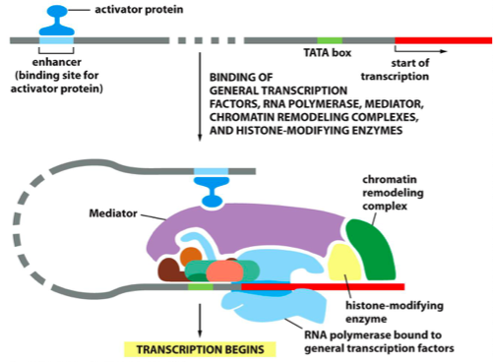
Once RNA has escaped promoter, it must gain access to DNA (unpackage/repackage)
FACT complex: facilitates chromatin transcription
- Displaces one H2A-H2B dimer from nucleosome ahead of RNAP II
- Replaces the H2A-H2B dimer, reforming the nucleosome after RNAP II
- Required for transcription, as it facilitates movement of transcriptional machinery
- Loosens the DNA interaction to allow gene expression (different mod from DNA synth)
- Hist mods occur to allow access to DNA in order for transcription to move ahead

Elongation: RNAP II adds new nucleotides 5’ to 3’
- Initially jerky, requires a set of elongation factors to be associated with the transcriptional machinery
- Decreases the risk of RNAP dissociation: RNAP always tries to dissociate from the template (keep it on for efficiency)
- Primary function of elongation factors is to keep RNAP attached, and also gives a method for the RNA to escape easily (EFs form a tunnel to enter/exit, so molecule less likely to dissociate)
- Accessory proteins keep them associated to the complex
Elongation is tightly coupled to RNA processing
- Maturation of the primary RNA transcript into mRNA requires:
  - Addition of 5’ cap
  - removal of introns via splicing
  - Addition of 3’ polyA tail
- Takes place in nucleus, required for export to cytoplasm
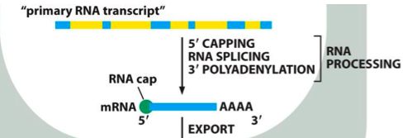
- 5’ cap: G nucleotide, methyl guanine in the 7 position installed backwards on the mRNA strand
- Installed on the 5’ end of the newly synthesized RNA
- Done very early: once 25 nt’s have been added on
- Process facilitated by 3 different enzymes (placed close to RNAP by CTD)
- 3 enzymes bound to RNAP II CTD, when phosphorylated at the serine 5:
  - Phosphatase removes the phosphate from the 5’ end of the RNA (removes 1 phosphate group)
  - Guanyl transferase adds a GMP in a reverse linkage (5’ to 5’) (removes 2 phosphate groups)
  - Methyl transferase adds a methyl group to the guanine
- 5’ cap increases stability of the mRNA
- Distinguishes mRNA from other types of RNA
- Facilitates binding of the mRNA to the ribosome for translation

Splicing: process of removing non-protein coding introns from primary RNA transcript
- Increases genome complexity without expansion of the genome itself (most genes make more than one protein)
  - Different protein transcripts generated by different splicing events (many genes created for very little nt’s)
- Allows for careful regulation/tailoring of required proteins
Recognition of introns
- 5’ end of the intron has a GU
- 3’ end of the intron has an AG
- Branch point sequence: an A nucleotide in the middle of the sequence
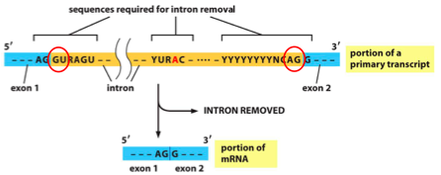
- Once splicing done, 3’ end of exon 1 is joined to 5’ end of exon 2 (yellow portion, intron, removed)
- Sequence for recognition is short, many factors involved to increase specificity

Splicing reaction: consists of 2 sequential phosphoryl-transfer reactions (transesterification)
- Adenine 2’OH attacks guanine at 5’ splice site (sugar phosphate backbone at the intron-exon boundary)
- Phosphate backbone is cleaved, allows 5’ end of the intron and A (branch point) to be covalently linked. Bases are joined at the 5’ end of the intron, with the A residue
  - First exon is attached, but the intron is still attached (looped lariat)
- Free 3’OH of first exon attacks the phosphodiester bond at the 3’ splice site
- Two exons are joined and the intron is released as a lariat
- Reaction conserves energy from the sugar-phosphate backbone (broken).
- Splicing does not require energy
- Splicing is aided by a large complex of RNA and proteins, called sNRPs (small nuclear RNA)
  - sNRPS give rise to spliceosomes

Spliceosome: complex that carries out RNA splicing
- Core of spliceosome made up of small nuclear ribonuclear proteins, small nuclear RNA complexed with seven protein subunits
- U1 sNRP first associates with the 5’ splice site. 2 proteins recognize the branch point, and base pair there (BBP, branch binding protein)
  - U2 auxiliary factor binds which recruits the U2 sNRP once it recognizes the site
  - They gt displaced & you have U1 at the 5’ site and U2 at the branch point (U1/U2 splicing)
- A 3rd sNRP gets recruited (U4,5,6). The 3 come together and draws the intron/exon structure into a physical shape which brings the branch point A into close proximity with the intron/exon boundary (which will be attacked and cleaved)
- Occurs through dissociation of U1 and U4 (leave the complex)
  - Left with a lariat structure, and exon 1 attached to exon 2
  - Remaining sNRPs holding ex 1 in close position so that its 3’OH can attack
- Lariat dissociates, sNRPs dissociate. RNA degraded and sNRPs recycled for more splicing
- Spliceosome also brings along the exon junction complex
  - Deposited on mRNA after splicing, it is a tag that represents the mRNA has spliced and undergone processing (mark of maturity)
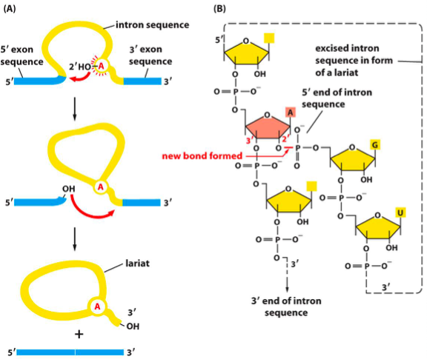
Spliceosome: DOES use ATP
- Transesterification conserves the energy from the phosphate bond, however splicing is driven by conventional base pairing between RNA molecules
- Rearrangement of RNA-RNA hybrids in the spliceosome occur several times during splicing, requires ATP
- i.e. kicking out U1 and U4, replacing with U6
  - U1 recognizes the 5’ end because of the GU sequence, base pairs to attach
  - Energy is needed to break the H bonds with U1, before forming new bonds with U6
- U6 and U2 snRNAs are positioned on the intron loop when it is formed, this creates a catalytic site with the proper orientation of the two exons (facilitates first transesterification reaction)
- U5 snRNP mediates rearrangement. This requires ATP, which facilitates the 2nd transesterification reaction
  - Lots of H-bond involved. Rearrangement involves breaking those bonds (transesterification requires no energy)

Further defining introns/exons
- Introns labelled by the preferential association of heterogenous nuclear ribonucleoproteins (hnRNPs)
- Exon boundaries are defined by SR proteins
  - SR proteins relates to amino acids serine and argenine, also associate with the exon-intron boundary (interacts with exons only)
  - Introns associate with hnRNPs
- The dinucleotide (GU, AG) is common and not specific. Other proteins come into play for this purpose (components brought into position near the mRNA 5’CTD)
  - Transferred right onto RNA as each intron/exon boundary exits the RNAP
- Marks off the first intron/exon boundary (labels them immediately before the other end of the boundary emerges)
  - Scans for and recognizes each one as they happen, helped by the uniform size of exons
- Some splicing occurs right away, as soon as intron/exon boundary is presented, one complete intron is exposed
  - Important that proteins mark the boundary asap, otherwise lose track of the boundaries

Other forms of splicing
- Minor splicing: rare, relies on U11 and U12 snRNA (swaps out U1 and U2 I guess)
- Trans splicing: rare (less than minor); combines 2 separate primary transcripts to form a chimeric RNA
  - New RNA/protein may exert novel function
  - Occurs when human genes are distinct but adjacent (may cause disease)
- Self-splicing: some RNA molecules have capacity to splice themselves without enzymatic activity of other molecules (ribozymes)
  - Group 1 splicing: intron fold into complex secondary structure with 9 loops, employs 2 transester reactions. Has a structure of 9 loops to allow 2 transester reactions to happen. No lariat forms
  - Group2: self splicing introns which produce lariats. No spliceosome machinery, but rather a structure that adopts allows catalysis (internal structure)
Splicing and mutations
- Splicing is flexible: goal is to pair 5’ splice site with 3’ splice site; spliceosomes will just do its best job at this
- A very small mutation can occur and splice site is completely affected
- i.e. single nucleotide change can destroy a normal splice site, causing exon skipping
  - Mutation where BPP cannot be added onto branch point, or U2 will not bind (won’t recognize)
  - As a result it will not be marked and the next boundary will be instead (3’ boundary presented, won’t be marked until end of intron 2)
  - intron 1 and 2 taken out, exon in middle lost
- Mutation may also bring an alternative termination site (causing the last exon to be shorter)
3’ polyA tail
- Termination at end of gene: eukaryotic sequences have AU rich sequence, allows proteins to associate and termination to happen
- CA site 30 nts at end of the gene
  - mRNA will continue to be transcribed beyond the end of the gene (CA sequence), able to continue
  - RNA binding proteins recognize the blue part (mRNA), and recognize the cleavage site
  - CTD brings proteins necessary for the process (separate blue from green, 2 proteins necessary)
- As sequence transcribed into RNA, it is recognized by RNA binding proteins and processing enzymes:
  - Cleavage Stimulation Factor (CstF)
  - Cleavage and Polyadenylation Specificity Factor
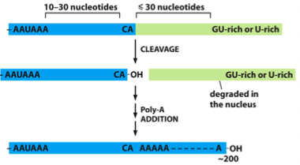
- CTD extends out of the polymerase, approaches AU rich sequence (which is transcribed and becomes a part of the mRNA)
  - CstF and CPSF, which are previously associated with the CTD) are transferred onto the mRNA itself
  - Calls for cleavage factors, enzymes that make cleavage happen. Once cleavage happens, stimulation factor dissociates
  - End up with polyA polymerase associating; adds a polyA tail
- Binding of CstF and CPSF allows for assembly of other proteins, these:
  - Cleave RNA from polymerase
  - Poly-A polymerase (PAP) adds series of 50-200 adenines in template-independent manner
  - In turn, attracts poly-A binding proteins which help regulate the length of the tail
- PolyA polymerase: an enzyme (which is a polymerase)
  - Adds on RNA nt’s (series of A’s)

Termination: how RNAP dissociates from the mRNA itself
- Following cleavage of RNA transcript, RNAP II continues to transcribe for hundreds of nts
- RNA lacks a 5’ cap and is susceptible to degradation by exonuclease
- 2 models of termination: torpedo and allosteric
Torpedo: mRNA dissociated after cleavage, however RNA still generated
- No 5’ cap means exonuclease chews it back; destroys it until it runs into polymerase (which falls off)
Allosteric: processivity of RNAP decreases gradually, until it decreases so mch it falls off
CTD is the RNA Factory
- CTD used as a scaffold for RNA processing proteins. This increases the efficiency/accuracy of mRNA production
- CTD tail carries enzymes for different functions; capable of association at different times thanks to phosphorylation (i.e. allows splicing enzymes to associate at a given time)
- 5’ capping: all 3 enzymes for 5’ capping bind the RNAP II CTD at the P-Ser5, placing them in close proximity needed for capping as mRNA emerges from enzyme
- Splicing: several spliceosome components carried on the CTD, transferred directly onto the newly emerging exons/introns (allows them to be managed one at a time)
- Polyadenylation: CstF and CPSF are carried by the CTD, and transferred to the mRNA as the 3’ processing sequence emerges
- CTD keeps enzymes in right place and organized so they can do the right job at the right time

Nuclear export: transfer the mRNA from the nucleus into the cytosol, via a pore in the nuclear membrane
- Requires recognition by the nuclear export protein
  - Mature mRNAs recognized based on the complement of proteins associated with them, including the nuclear export receptor
- Once initiated, nuclear export proceeds very rapidly
- Complement of proteins associated with mature mRNA are the markers needed in order to be export ready (i.e. 5’cap)
- SR proteins do not make it to the pore as thy are removed before export (important for ID-ing intron-exon boundaries)
- Junction complexes added as splicing is done (after spliceosome removes an intron); they identify that splicing has been completed, and marks a mature mRNA
- hnRNP’s are mostly nucleus restricted, however some found in cytosol

- Profile of proteins associated in nucleus is different than in cytosol
  - If U6 was associated to mRNA, the molecule would not make it across barrier (U6 is a splicing protein, suggests the mRNA is still immature)
- Final proofreading: decays the mRNA that’s not supposed to make it out of the membrane
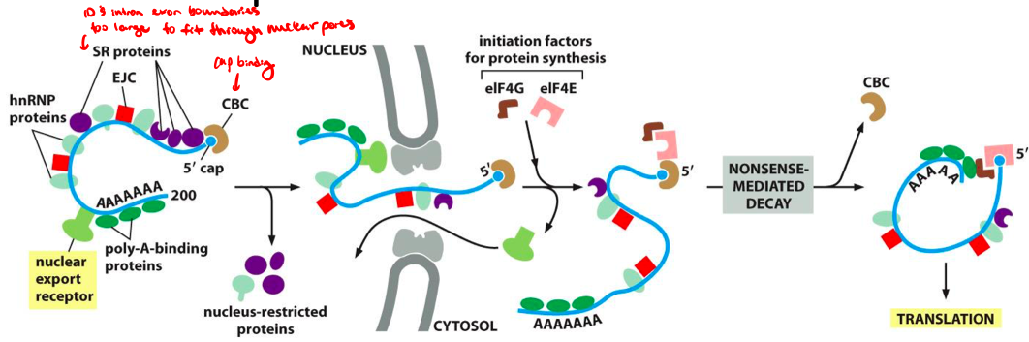

MODULE 4 – RNA AND TRANSLATION

Translation: facilitated by non-coding RNA
- tRNA has an anticodon that recognizes mRNA, matches an amino acid onto it
- tRNA is non-coding; never becomes translated to protein
- non-coding rRNA is also very important in this process (ribosomal RNA facilitates transcription)
- non-coding RNAs also synthesized and processed in the nucleus
Non-coding RNA synth. by different polymerases:
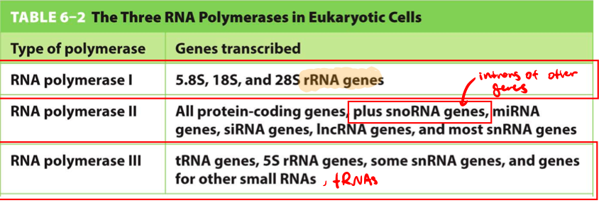
Ribosomal RNA – most abundant type of RNA in cell
- rRNA forms the core of the ribosome: an RNA-protein complex which catalyzes synthesis of protein, based on an mRNA sequence
- RNA portion of the ribosome is the catalytic part (effector)
  - Ribosome is a ribozyme: enzymatic RNA effector molecule
- Euk rRNA have 4 species:
  - 28S, 5.8S, 5S, 18S rRNAs, one of each present per ribosome
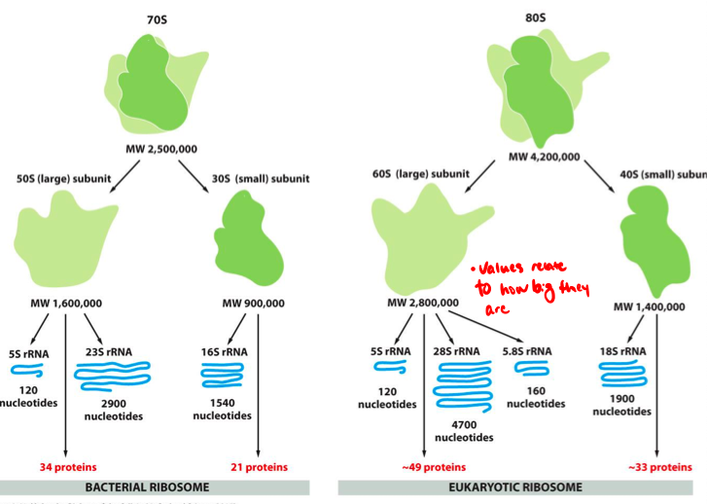
Large subunit in light green: made up of 3 rRNA subunits: 5s, 28s, 5.8s
Small subunit in dark green: only 18s subunit

rRNA Genes – transcription looks like Christmas Tree
- requires over 10 million copies of each type of rRNA
- rRNA is the final product. no opportunity for amplification at the level of translation
- Requires multiple copies of rRNA coding gene
- ~200 rRNA gene copies per haploid genome, found in clusters on the tips of 5 chromosomes
- Individual rRNA genes separated by non-transcribed spacers
  - includes regulatory elements i.e. transcriptional enhancers
- During replicative periods, DNA which encodes rRNA adopts nucleosome free loop structures; a key part of the composition of the nucleolus
  - Nucleolus size varies depending on rRNA production
rRNA synthesis
- 5s transcribed by RNAP II, does not undergo chemical modification
- 18s, 5.8s, and 28s transcribed as part of a 45s precursor, by RNAP I. Precursor undergoes extensive processing in the nucleolus (similar to operons, mult. genes and 1 promoter)
- Since both RNAP I and III lack a CTD, rRNA molecules are not 5’ capped or polyadenylated
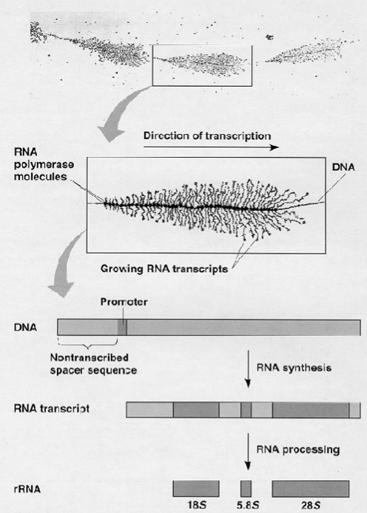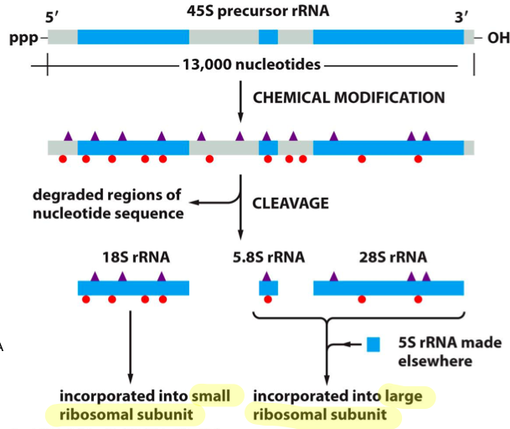

rRNA processing- 5.8s, 18s, 28s rRNAs undergo extensive mods prior to cleavage
- 45s precursor (transcribed by RNAP I) must be modified and then cleaved to generate each subunit of mature rRNA
- Methylation of the 2’OH of ribose sugars
- isomerization of uridine to pseudouridine

snoRNAs – small nucleolar RNAs
- Family of non-coding RNAs found in abundance within the nucleolus
- Transcribed by RNAP II: DNA sequences found mostly within intron so fother genes
- Like snRNAs, they complex with proteins to form snoRNPs (small nucleolar ribonuclear proteins)
  - remains in the nucleus to carry out modifications for rRNAs, by complexing with proteins
- Associated RNA carries out catalysis (by base pairing)
- Possesses both guide sequence and enzymatic activity
  - snoRNPs direct modification of several types of RNA and ribonuclear protein compexes
- 2 main families of snoRNPs:
  - C/D box family: responsible for addition of methyl groups. Sequence complements the rRNA sequence, allowing it to apply a methyl group
  - H/ACA box: mediates isomerization of uridine in immature rRNA molecules. Allows rRNA to interact/isomerase uridine (replace nitrogen with carbon)
- Also important for telomere maturation and tRNA processing
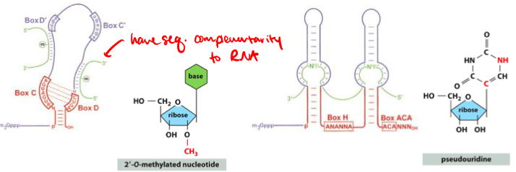
The Nucleolus – ribosome assembly factory
- Purpose: a factory for transcribing. processing and assembling ribonuclear protein complexes (ribosomal subunits)
- A non-membrane bound organelle within the nucleus, which forms/dissociates across the cell cycle
  - size and consistency changes during different phases, relates to position of rRNA genes
- Composed of:
  - Chromosomal DNA (rRNA genes)
  - precursor/mature rRNAs
  - snoRNPs
  - Assembly factors
  - ribosomal proteins
  - partially assembled ribosomes
- rRNA + snoRNPs give mature ribosome in the nucleolus
- Nucleolus composed of rRNA genes, which form dark cluster in centre
  - rRNA transcription occurs in this region
Ribosome assembly:
- Following synth/processing, rRNA molecules complexed with more than 50 ribosomal proteins in the nucleolus
  - Generates large & small ribosomal subunits
- Ribosomal subunits only considered fully matured/functional once exported to cytoplasm
- Subunits remain separate when not synthesizing protein. Come together to form complete ribosome on 5’ end of an mRNA, to carry out translation

Other functions of nucleolus:
- Telomerase (ends replication in euk. genes): assembly of its proteins/RNA components occurs in the nucleolus
- Chemical modification of non-coding RNAs & assembly into complexes
  - snRNPs, tRNAs (tRNA has uridine on one arm)

tRNA – Transfer RNA
- Serves as molecular adaptors, bind to mRNA on one end and carries amino acid into position on the other end
- tRNAs adopt unique structure:
  - 2º: cloverleaf due to several regions of internal complementarity
  - 3º: further compaction into L shaped structure (important for processing of tRNA, and function to allow it to fit the ribosome)
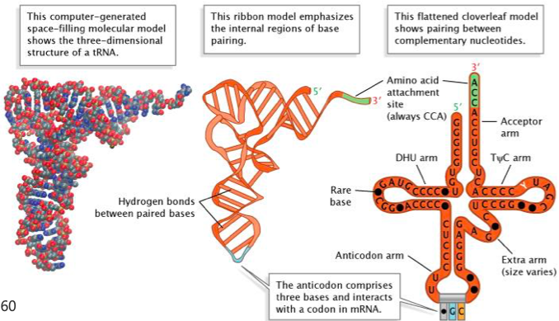
Acceptor arm - double stranded stem that ends in a single stranded sequence, in which the 3’OH of the terminal nucleotide can bind the specific AA
- Single stranded region has the same sequence every time (5’CCA3’), allows amino acid to attach
DHU arm - contains modified base dihydrouracil
- ds regions may have different sequence
TuC arm – contains triplet of bases, where u represents pseudo-uridine
Anticodon arm – contains anti-codon triplet which recognizes the complementary codon on the mRNA at the centre of a loop
- Different sequence for each tRNA here, recognized by tRNA synthetase
- Binds the mRNA sequence (complementarity), matches it with the appropriate amino acid
Variable (extra) loop – length varies between 2 and 21 nucleotides

tRNA genes and their transcription
- 500 genes in genome code for tRNAs representing 48 anticodons (redundancies)
- tRNAs synthesized in the nucleus by RNAP III, in a precursor form, undergoes processing
- tRNA precursor must be processed to generate mature tRNA, which can be exported to cytoplasm to function
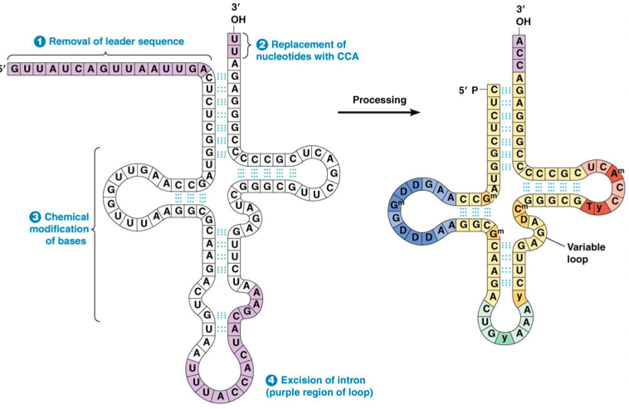
- 5’ end leader sequence removed in mature tRNA
- Must also generate the free 3’ end region (CCA)
- Some splicing in the anticodon arm, introns must be removed
tRNA processing: splicing
- Contrast with mRNA: splicing occurs via sRNPs in the spliceosome (RNA component)
- in tRNA, occurs via cut and paste mechanism. Catalysis is by protein rather than snRNPs
  - Carried out by tRNA endonuclease (tRNA specific)
- Acts on tRNA in its 3D conformation and requires correct folding in order to be recognized
  - recognizes the bulge-helix-bulge structure, to carry out splicing
  - Important step for quality control in tRNA generation
tRNA processing: chemical modification
- 10% of bases in tRNA are variants, 50 types of modifications known to exist (some facilitated by snoRNPs)
- Purpose is to facilitate pairing of mRNA codon, and tRNA anti-codon
  - Also increases accuracy of amino acid loading

Echo question:
- In an image with Christmas tree structures, snRNA would not be seen.
- snRNA is involved with splicing mRNA. rRNA are not spliced
- 45s precursor must be cleaved (after being chemically modified). This is done by snoRNA (chemical mods) and a protein complex (splicing)
- Transcription: both strands of a dsDNA may act as the template strand; depends on the presence of a promoter
  - template 5’3’, transcribe & write mRNA sequence always 5’3’
TRANSLATION

Codon: a sequence of RNA or DNA nucleotides, which code for an amino acid (or stop signal)
- Must be in combinations of 3 (2^3 = 64), any less would be not enough amino acids
- Studied overlap using point mutation: changing 1 nt would change only 1 amino acid (no overlap)
Genetic code: set of rules specifying correspondence between nucleotide triplets and amino acids in proteins
- code is used universally by all present day organisms
- rule used to read clusters of 3; codon table is universal to all organisms
Characteristics of the code:
- Unequivocal: each codon corresponds to one amino acid
  - First two nucleotides of a codon play a determining role in which amino acid the codon codes for
- Degenerate: for a given amino acid, there may be more than one codon
  - More combinations of nt’s than amino acids, meaning multiple codes will call for the same amino acid (difference in the last position)
  - Codons with similar sequences often correspond to amino acids with similar properties/chemical structures
Reading frame:
- Phase in which mRNA sequence is read
- Always 3 possible reading frames, only 1 will yield the correct protein
- Mutations (in/dels) may mess up the reading frame. Use of deletions allowed conclusion to be drawn that there is 3 nt’s per frame
Punctuation:
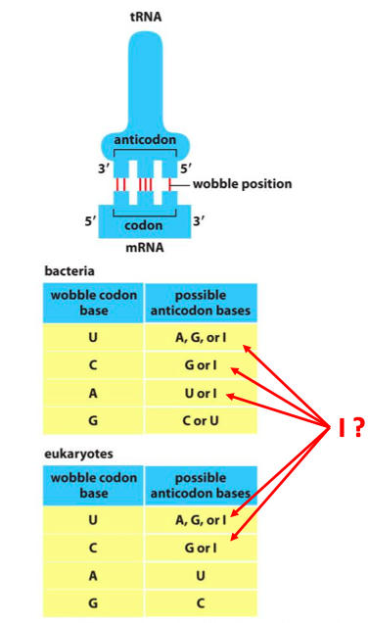
- Codons which specify start (AUG always) and stop (UAA, UAG, UGA) positions for translation machinery
tRNAs and Wobble base pairing
- Imperfect base pairing (tRNA and mRNA pairing imperfect only at the 3rd position)
- Wobble: non-Watson Crick base pairing, only tolerated at 3rd position of codon
- Pairing at the 3rd codon position relaxed; variability in 1st or 2nd position would not be accepted
- tRNAs have redundancies (similar to genetic code)
- In eukaryotes, a U can pair with A, G or I
- Inosine is a unique modified base (deamination of an A); adds redundancy in base pairing
- Wobble occurs at the 3rd position of an mRNA codon, but the 1st position of a tRNA anticodon (since its written 5’3’)
Inosine: non-traditional base pairs (Wobble)
- Formed when A deaminated; has great flexibility in pairing & easily accommodates wobble pairing see in tRNA
G-U pairing: also facilitates wobble
- In general, non-traditional BP-ing plays a role in formation of RNA 2º structures

tRNAs Match Amino Acids to Codons
- Adaptor molecule which has an anticodon on an arm, to base pair with the mRNA (matches amino acid)
- Anticodon: 3 bases
- mRNA 5’3’ recognized by the small subunit
- AUG must be recognized by first tRNA to start translation
- tRNA charged with methionine always starts translation (methionine always first amino acid)
Before tRNAs can be used in synthesis of polypeptide, tRNAs must be linked with designated AA
- Facilitated by a family of enzymes: aminoacyl-tRNA synthetases
- Eukaryotes have 1 aminoacyl-tRNA synthetase per amino acid (20 in total)
- Prokaryotes have fewer, chemically modifies AA to ensure correct pairing
- Charging tRNA is a 2 step process: end up with an AMP, diphosphate and the amino acid linked to the tRNA
  - First step: adenylation, energy transferred to high energy intermediate (tertiary structure must be correct in order for recognition by the synthetase & matching to occur)
  - tRNA synthetase does the proofreading to check for the correct amino acid (if there is a match, whatever is attached to the tRNA anticodon will be added)
Aminoacyl-tRNA synthetase just as important as tRNAs for proper protein synth
- Wobble occurs at 3rd spot of a codon, tRNA would be able to recognize both sequences and the anticodon would pair
- tRNA synthetase is important to ensure correct amino acid sequence added
  - If mistake is made here, even if tRNA does a perfect job the wrong amino acid will still be added to the chain
  - Charcot Marie Tooth disease
- Each synthetase recognizes the proper tRNA by the anticodon, or the acceptor arm where the AA adds on
Recognition of the correct tRNA via:
- Extensive structural/chemical complementarity
- Most specifically recognize the anticodon (as well as other regions throughout the tRNA)
Some recognize the shape of the acceptor arm

tRNA Charging – coupling of tRNA to an AA requires ATP, occurs in 2 step process
- ATP hydrolyzed which provides energy, liberates an AMP. The AA is linked via its carboxyl group (adenylated amino acid) onto the AMP
  - Charged amino acid; has high energy (2 phosphate groups hydrolyzed from ATP)
- The AA is transferred to the 3’OH of the terminal base on the tRNA acceptor arm (aminoacyl-tRNA)
  - Charged AA transferred onto acceptor arm, to the unpaired CCA with free 3’OH (attaches with amino acid)
  - Uses the energy harnessed from hydrolysis of ATP to create a high energy bond between the tRNA and amino acid
- Energy liberated from hydrolysis of ATP remains stored, later used in the formation of the new peptide bond at the ribosome
Accuracy of charging: selection is a 2 step process:
- Affinity for the correct AA for the active site of the synthetase enzyme
  - Effective for excluding larger AAs, not great for distinguishing between similar AAs
- Pairing verified in editing pocket
  - editing site excludes the correct AA, allows incorrect AAs to enter
  - AA which enter the editing site are cleaved from the AMP or tRNA via hydrolysis
- tRNA synthetase responsible for editing/proofreading
  - In translation, editing done before synthesis (as opposed to during like in DNAP)
Peptide bond: fundamental reaction carried out during translation
- Carboxyl group of an AA is attached to the free amino group on incoming AA
- Proceeds in stepwise manner starting from the N terminal end of the protein, progressing towards the C terminal end
- Allows C term of the growing polypeptide chain to remain activated at all times
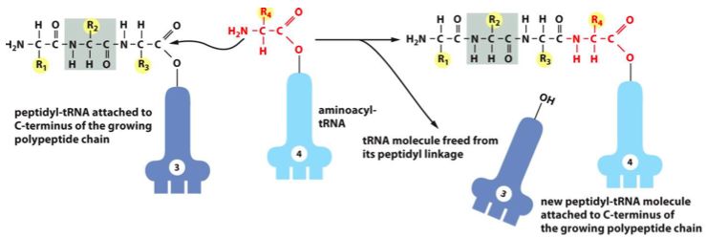
- Brings multiple amino acids together, via peptide bond
- Synthesis of proteins always starts at the N term, peptide sequences always written N to C
- C term attaches to next RNA by the N term

Protein synth carried out by ribosomes
- Process done on ribosome; a complex of 4 rRNAs and 50+ proteins which make up:
  - Small subunit, which has the framework to hold the mRNA; generates the individual sites which are able to interact with tRNA
  - Large ribosomal subunit has the catalytic activity. Catalyzes formation of peptide bond (ribozyme)
- Mature ribosomal subunits found in the cytoplasm. They remain separate until beginning translation at the 5’ end of an mRNA
  - May be free in cytoplasm or associated with the endoplasmic reticulum (eukaryotes)
Structure of ribosome:
- Small subunit has binding site for mRNA (positions it into the right position, relative to the APE sites)
- 3 sites capable of binding tRNAs, each formed by both the large and small subunit together
  - A site: amino acid
  - E site exit
  - P site: polypeptide
- In order for amino acid to be properly added, both small and large units must be associated
- Only 2 sites are ever occupied at one time (always P site)
- RNA component (as alwas) is what carries out the catalytic activity

Initiation of transcription: occurs immediately after export
- Export ready proteins associate, spliceosome dissociates after attachment of nuclear export receptor
- As soon as it makes it out of pore, new proteins associate (eIF, eukaryotic initiation factors)

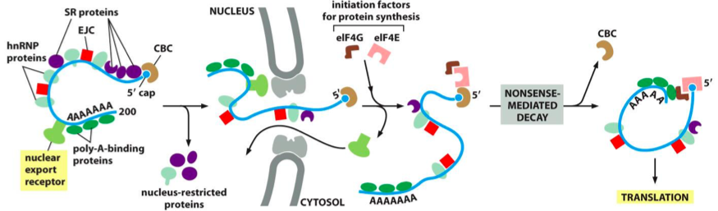
Mature mRNA molecules rapidly associate with eukaryotic initiation factors upon nuclear export:
eIF 4E associates immediately with the 5’ cap/cap binding protein
- Confirms presense of cap, and is required for interaction with the small ribosomal subunit
eIF 4G recognizes polyA tail
- gives the mRNA a circular structure (translation efficiency)
- through its interaction with eIF4E, imparts the RNA with circular shape important for translation efficiency
Through association with these 2 euk initiation factors, have ability to recognize the 2 most important features of maturity
- If not seen, the mRNA will be degraded (not expressed)

Critical regulatory step: last chance to avoid production of a protein
- Last chance to avoid production of a given protein
- Sets reading frame for translation
- Rate of initiation dictates rate of protein production

Start codon: always AUG = methionine
- True in prokaryotes (formylmethionine) and eukaryotes (may sometimes be removed from final protein product)
- met-tRNAi: first tRNA (initiator). Used to identify start & bring methionine.
- Only tRNA capable of binding at the P site; does so in absence of large ribosomal subunit
  - Modifications to tRNAi allows it to associate with a small ribosomal subunit at the P-site, without a large ribosomal subunit
  - Modified from normal tRNA: overall generally the same structure (CCA on acceptor arm, stem, D loop, anticodon, etc)
  - Usually (with a normal tRNA) this association cannot occur until the small/large units are associated
Process of initiation:
- Met-tRNAi is loaded ontot he small ribosomal subunit, along with GTP bound eIF2
  - Small rib. subunit associates with the initiator tRNA, which has been acylated
  - eiF2 is associated and it is in a GTP bound state
- Small ribosomal subunit interacts with the 5’ end of an mRNA via the 5’ cap and initiation factors (eIF4E and eIF4G) associated with it
  - Forms the mRNA into a loop
- Translation requires energy: uses GTP, harvests high energy phosphate bonds
- Small subunit scans for an AUG start codon
  - Requires ATP dependent helicase to facilitate the movement along the RNA
  - Finds AUG to set reading frame, start translation. Once associated with the 5’ end, requires ATP to scan
- Once a start codon is found:
  - GTP is hydrolyzed which releases eIF2 from the structure (initiation factors dissociate)
  - This allows large rib subunit to associate and elongation can proceed

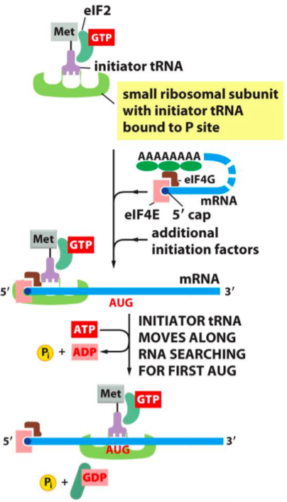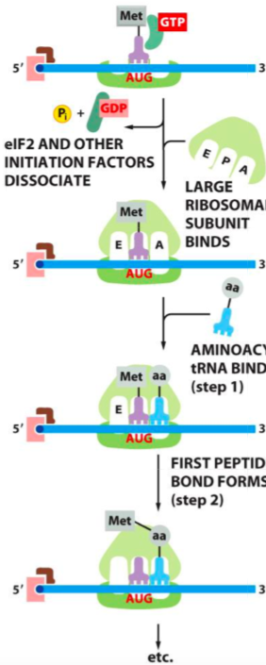
Selecting a start codon: sequence surrounding AUG codon influences the efficiency of the scanning process
- 90% of time, translation begins at first AUG encountered
- Portion of mRNA prior to AUG serves regulatory purpose: 5’ untranslated region (UTR)
- Kozak sequence: strong signal. Sequence just upstream of AUG. Strong Kozak means that AUG will be used
  - 10% of the time Kozak will be weak, which means that AUG will not be recognized (bypassed and next AUG used) leaky scanning, downstream AUG used
- Leaky scanning: allows for more than one protein to be generated with different N-term leader sequences, which can have important consequences
  - Means that a second reading frame is possible (gives 2 proteins with 2 N-term leader sequences)
Prokaryotic initiation: instead of the 5’ cap, prokaryotic RNAs contain a Shine-Dalgarno sequence
- Base pairs with 16S rRNA in the small ribosomal subunit, which positions it over the AUG start codon
- Prokaryotic translation initiation factors (IF1, 2, 3) facilitate this event
- In prokaryotes, transcription happens at same time as translation (genes organized in different way)
- No scanning is done; it gets directly placed over the sequence thanks to base pairing

Prokaryotic mRNA is polycistronic
- Multiple protein coding sequences under control of one promoter (similar to Christmas tree, 45s 5.8s, 5s, 28s)
- Polycistronic = an RNA molecule containing the coding information for more than one protein
  - Produces multiple coding products
- Single promoter, mRNA generates 3 separate protein products
- Each protein has its own Shine-Dalgarno sequence

Elongation reaction (after assembling complete ribosome on mRNA)
- tRNA binding at the A site
  - Requires correct base pairing between codon/anticodon
  - New tRNA come into A site; recognizes correct codon sequence on mRNA
  - If correct, proceeds to 2
- Peptide bond formation
  - C term is released from the tRNA, allowing it to form a new peptide bond with the free amino acid in the A site
  - Joined via peptide bond to the free N terminus of the incoming AA attached to the tRNA (in the A site)
  - Catalyzed by the peptidyl transferase ativity of the ribosome
- Large subunit translocation
  - Polypeptide now attached to the tRNA in the A site, large subunit translocates (moves the tRNA into the E site)
  - tRNA acceptor stems are transferred to the E and P site of large rib subunit
- Small subunit translocation
  - Small rib subunit relocates to catch up, resetting the whole process
  - mRNA is ratcheted along 3 bases, which ejects the tRNA from the E site and resets the ribosome to start again
- Cycle continues until every amino acid added
- tRNA in the P site is where polypeptide attaches
Elongation factors drive translocation of the ribosome
- 2 elongation factors (EFs) enter and leave the ribosome each cycle
  - EF-Tu and EF-G in prokaryotes
  - EF1 and EF2 in euk
- Both hydrolyze GTP to GDP, ensures the directionality of this process and speed

Accuracy of process:
- EF Tu binds the amino acylated tRNA in a GTP bound state
  - When bound to GTP, it doesn’t fit the A site well (which would allow tRNA to check)
- No match: tRNA able to dissociate
- When positioning correct: GTP is hydrolyze, change in shape allows the tRNA to release from the EF-Tu (can now properly fit into the A site of the tRNA)
  - Hydrolysis causes conformation change which allows it to fit ribosome correctly
- Incorrect tRNA/AAs dissociate
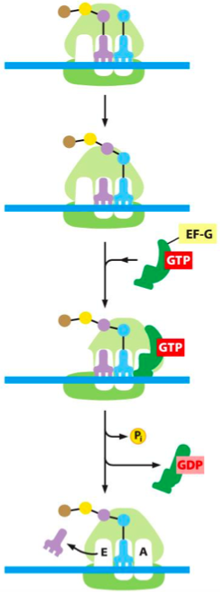
- EF-Tu’s conformation change via GTP hydrolysis:
  - Change in a-helix conformation
  - Causes pocket to open up, release of tRNA
  - Occurs with proper codon/anticodon match
  - Induces a fit of the tRNA into the ribosome
- Kinetic proofreading
  - Time delay as tRNA moves into position for the formation of the peptide bond, following GTP hydrolysis and release from EF-Tu
  - Time delay is longer when pairing is incorrect. Dissociation more likely to be possible (allows tRNA to float out of A site)

Movement of mRNA
- EF-G is a factor that allows ribosomal translocation to happen: with accompanying GTP it moves the mRNA along exactly 3 nucleotides
- Small rib subunit cannot shift right away: binding to GDP changes the shape of the EF-G, which allows the small rib subunit to be ratcheted along
- Large subunit moves first small subunit moves after hydrolysis of GTP
- New AA enters the A site with tRNA + aminoacyl tRNA + GTP (codon must match)
- Elongation factor Tu hydrolyzes GTP, which allows it to dissociate

Protein synthesis requires a lot of energy
- Consumes more energy than any other biosynthetic process
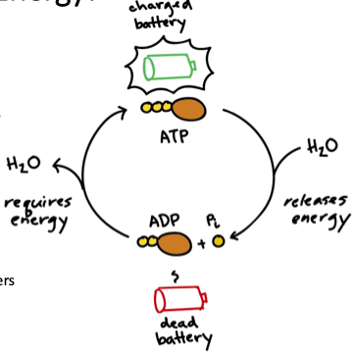
  - At least 4 high energy phosphate bonds split to generate 1 new peptide bond
    - 2 to charge the tRNA
    - 2 to drive the ribosome forward during translation
  - More energy needed if errors occur:
    - Hydrolysis reaction to remove incorrect AAs during tRNA charging
    - Entry of incorrect tRNA into ribosome triggers GTP hydrolysis for rejection

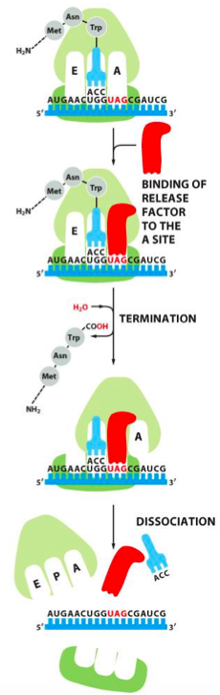
Termination: stop codons
- Recognized by ribosome, trigger the binding of a release factor in the A site of the ribosome
  - Recruitment of a release factor instead of an amino acid
- Leads to addition of water molecule to growing polypeptide chain, releasing it from the final tRNA/ribosome
  - Requires additional energy
- Also triggers the release of the ribosomal subunits

Polyribosomes - cytoplasmic assembly of multiple ribosomes attached to the same mRNA
- Spaced 80 or more nucleotides apart
  - As soon as the ribosome has cleared the initiation site, a new ribosome can be loaded onto it
- Both prokaryotes/eukaryotes use polysomes to increase rate of protein synthesis
- Couples transcription and translation to one another
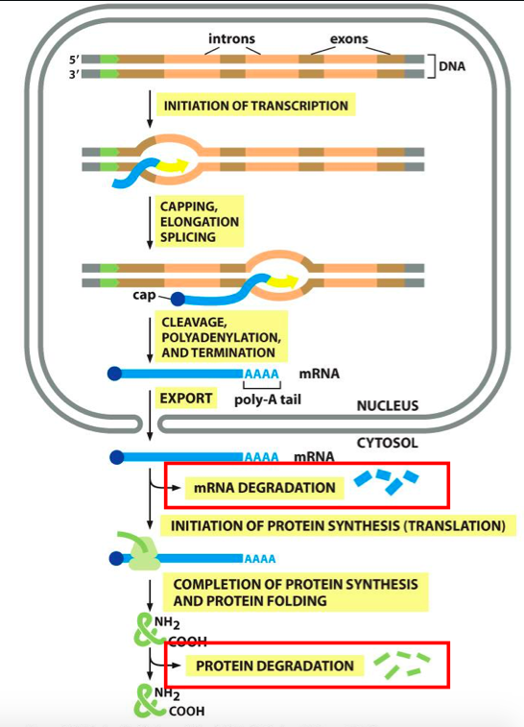
Many steps from DNA to protein, many check/balances to regulate the processes
Inhibition of protein synth: many antibiotics do this (tetracycline blocks ribozyme from adding an amino acid into the A site to restart cycle; site physically blocked)

