Chapter 1: Introduction to Law

What is the Definition of Law?
A system of rules and regulations that govern a community and enforced by a political authority and its legal system.

Origins of Law
- Specialization of skills over time forced greater interaction and dependency between people
- This greater interaction required rules and regulations to maintain order within a community by providing:
  - Security of each member – protecting from harm
  - Certainty and stability for future planning
- In some communities, these rules are developed as customs or traditions
  - Passed on by example of word-of-mouth
- In others, they are written down
  - Therefore more widely known by everyone
  - Ex: Code of Hammurabi engraved in a stone column
- Over time, laws needed to be more complex because:
- Population increased
- Technological advances
- Immigration patterns

Role of Law
- Ensures Security
  - Minimizes disruptions of equilibrium in society by providing punishment to those who disturb social order
  - Enables those who suffer loss or damage because of the conduct of others to obtain compensations
- Enforces standards of conduct
  - Tells people what behavior is acceptable or not
- Maintains status quo
  - Standards of conduct stated in the law remain in force until changed by authority
  - Existing laws may be changed or replaced according to the well-being of society
- Allows people to exercise their right to express themselves as individuals
  - Abuse of rights: laws allow us to use our rights as freely as possible without interfering with the rights of others to do the same thing
Who Decides the Law?
Depends on community, country and culture
- The community through custom and tradition
- An elder or wisest of the community
- A ruler and conqueror of land
- Through democracy by electing people for set terms
Law & Justice
- No system of written law can recognize any principle, which would entitle a person to violate the law, because in his view, the law conflicted with some higher social value
  - Ex: a doctor speeded to work to save his patient but was still fined for speeding
- Why doesn’t law always equal justice?
  - The law is written
    - Difficult to deter from and rigid (objective)
  - Enforced by judges
    - Judge has a discretion in how a law is applied (subjective)
    - Judges might:
      - Apply the words of the law (you were speeding and therefore must pay a fine)
      - Might be compassionate (you were speeding but it was to save a life therefore you can be excused)
      - Might be harsh (you were speeding and therefore endangering lives of others, you must pay a fine and lose your license)
  - Laws are decided upon by a majority
    - Can’t always answer the needs of all, especially the minority
Law & Ethics
- Ethics - a set of principles or moral values of a society, distinguishing right from wrong
  - Law simply reflects these values
  - But law and ethics can conflict (just because it’s legal, doesn’t mean it’s ethical)
- Ethics plays a balancing role to law
  - Law is founded in moral values, so need ethics to apply
  - Law not always clear, so use ethics to develop
  - Law may not exist to address new issues, so ethics must mold
- An ethical value becomes law when:
  - It gains a large consensus amongst the population
  - It addresses an issue considered a serious threat to the well-being of the community

Domains of Law
- Private law – rules that regulate the legal relationship and obligations between individual citizens
  - Contract law – deals with legal relationship in matters such as leases and employment
  - Commercial law – explains how to set up an enterprise and to provide goods/services
  - Property law – helps us settle boundary differences with neighbours
  - Civil liability law – determines consequences of a person’s negligence
  - Uses different terms than public law
    - People are sued (not charged) for not fulfilling an obligation and the person might be responsible or not responsible
- Public law – rules that govern the relationship between the citizens and their state or country
  - Criminal law - sets out type of behavior that we don’t want in our society (murder, arson, theft, rape, etc.)
    - People who engage in these acts commit an offence not only to a victim but to the entire society
  - Taxation law
  - Highway law
  - Language laws
  - Bankrupty laws

Civil Law & Common Law
- Main difference in both approaches depends on who decides the law
- Civil law – fundamental basis for law resides in legislation
  - Codified statutes rule the land
  - Officials codify laws into systematic organization
  - Courts simply apply the law
  - France
- Common law - basis for law is grounded in the principle of precedence and case law or jurisprudence
  - Past legal precedents or judicial rulings are used to decide cases at hand
  - Judge made law
  - England
- Canadian legal system is a combination of both
  - In public law, common law dominates
  - In private, civil law system of Quebec exists along with common law of other provinces

Substantive & Adjectival Law
- Substantive law – the law where we can find the “substance” of our rights
  - Ex: Civil Code of Quebec
  - Tells us what rights we have
- Adjectival law – procedures to protect substantive law
  - Ex: The Quebec Code of Civil Procedure
  - Tells us about how to exercise our rights and the procedures

To Sue – The 5 W’s
- Why sue?
  - Somebody owes you money or an obligation and refuses to perform
- What is involved?
  - Start legal proceedings
  - Convince a judge
  - Starts with an exchange of documents between parties with explanations
  - Follows with court appearance to argue or plead case
- Who are the parties?
  - Before lawsuit is filed:
    - Creditors – person who claims to be owed
    - Debtors – person who owes
  - Inside court proceedings:
    - Plaintiff – creditor who takes legal action against debtor
    - Defendant – debtor who is sued by plaintiff
    - Class action suit – multiple unassociated creditors want to sue a common debtor together
- Where do you sue?
  - The Court of the place where:
1. The defendant lives
2. The defendant has property
3. The cause took place
4. The contract was finalized
5. The property in dispute is situated
- When can you sue?
  - From the moment we become aware
  - This right is limited in time
  - Prescription – legal method which civil law establishes for a person to acquire or lose rights by the mere lapse of time
    - In most cases, it’s 3 years

The Legal System
3 essential elements:
- The legislative mechanism – how laws are adopted
- Law – rules of behavior imposed or accepted by society
- Administration and enforcement of laws – making sure laws are followed by those subject to them

Chapter 2: The Quebec Legal System

- Structure
- Sovereignty – inhabitants have, within their control, the supreme and absolute power to govern themselves in whatever way they choose
  - They can make laws, enforce them, impose/collect taxes, make war/peace
  - Every independent nation is sovereign
  - If structure is too large, they elect representative groups
- Authority to Enact Law
  - With the Constitution Act of 1982, Canada has been a fully sovereign nation with the right to decide its government and make its own laws
  - We adopted the former British North America Act (BNA) as the basis of our constitution and built on it
  - Constitution sets up government structure (federal and provincial)
    - Federal – parliament situated in Ottawa and has the right to pass laws for the “Peace, Order and Good Government of Canada) that apply to all citizens in the country
    - Provincial – legislatures that are given right to pass laws on subjects reserved exclusively for them, having headquarters in capital city of each province
      - Ex: bar, restaurants, language education, health
  - Authority is granted to elected representatives
- The Canadian Legislative Process
  - Cabinet usually introduces laws
  - “Private Member Bills” can sometimes (any politician who is not in cabinet)
    - Rare because they don’t have the majority and elected party won’t allow bills to pass that doesn’t come from them
  - 3 elements in the process (federal government)
    - Legislature (elected members) – House of Commons
    - Senate (appointed members) – abolished in Quebec
    - Queen – Governor general, Lieutenant GG (Royal Assent)
- 1st reading with a vote
- If passes, it goes to a committee with political parties
- Then returns to House of Commons for 2nd reading/vote
- If passed, then goes to another committee and public is invited to vote
- Then, it is ready for Royal Assent (signed into law by Queen or representative)
- Governor General – representative of the Crown in Canada
- Lieutenant Governor – Queen’s representative in each province of Canada

- Law – rules of behavior imposed or accepted in the society
- There are 6 sources of law that develop or restrict new laws
- Constitution
  - Sections 91 and 92 of the Constitution Act, 1867 (Parliamentary Supremacy) tells information on who in Canada can pass laws
  - The Constitution Act, 1982 (Constitutional Supremacy)
    - Charter
    - Amendments formula
    - Own monarchy*, we have our own head of state
  - Section 52 «the supreme law of Canada»
- Statutes – law passed by government
  - Can be changed at any time by simple majority
  - Code – is also a statute except it deals with multiple subjects in a broad area
  - A statute deals with only 1 subject and is interpreted more strictly than a code
- Jurisprudence - found in judgements of past cases
  - Case Law
  - Precedence – courts decide similar cases in a similar manner
  - If there are conflicts, statutes can have overriding ability
  - Doctrine of Stare Decisis – “let the decision stand”
  - Only Supreme Court can change precedence
  - Judicial activism
- Doctrine – written commentaries on the law
  - Study and analysis of Quebec laws by highly respected lawyers and judges
- Custom – a tradition or usage accepted by a community for long period of time
  - Accepted by court provided no conflict with existing statute
- Administrative Laws - Administrative Boards set up by government to take charge of particular law
  - Ex. Canadian Radio-Television Commission, Commission de la santé et de la securité du travail (CSST)

- Administration and enforcement
- People have different opinions of how laws should be applied or interpreted, so we require several court systems
- Forums – levels of jurisdiction
- How do we determine which court will hear a case?
  - Nature of the case (type of case and amount of $ involved)
  - Geography (location of issue or defendant)
- The Court System
  - Municipal Court
- Municipal by-law (ex: traffic, zoning, taxes, noise)
- Minor criminal matters (ex: mischief, theft under $1000, gambling)
- 1 judge
  - Small Claims Court
- No lawyers
- Uses inquisitive method (1 judge hears, asks about facts, renders decision)
- Cases no more than $15,000
- Business must be represented by an employee
- Not available to business with more than 10 employees
- Employee can be a lawyer
- Creditors can reduce debt to sue at this level (forfeits remaining debt)
- No appeals
- 1 judge
- If person suing or being sued can’t come to court in person, a mandate (authority to act for another person) may be given in writing
  - The Court of Quebec
- All cases up to 85 000$
- Except alimentary pension and Federal cases
- 3 divisions: Civil, Youth, and the Criminal and Penal
- 1 judge
- Appeals to Quebec court of Appeal
- No appeals for cases under 60 000$, except if you can prove than the law doesn’t cover this “new subject” that hasn’t been cover
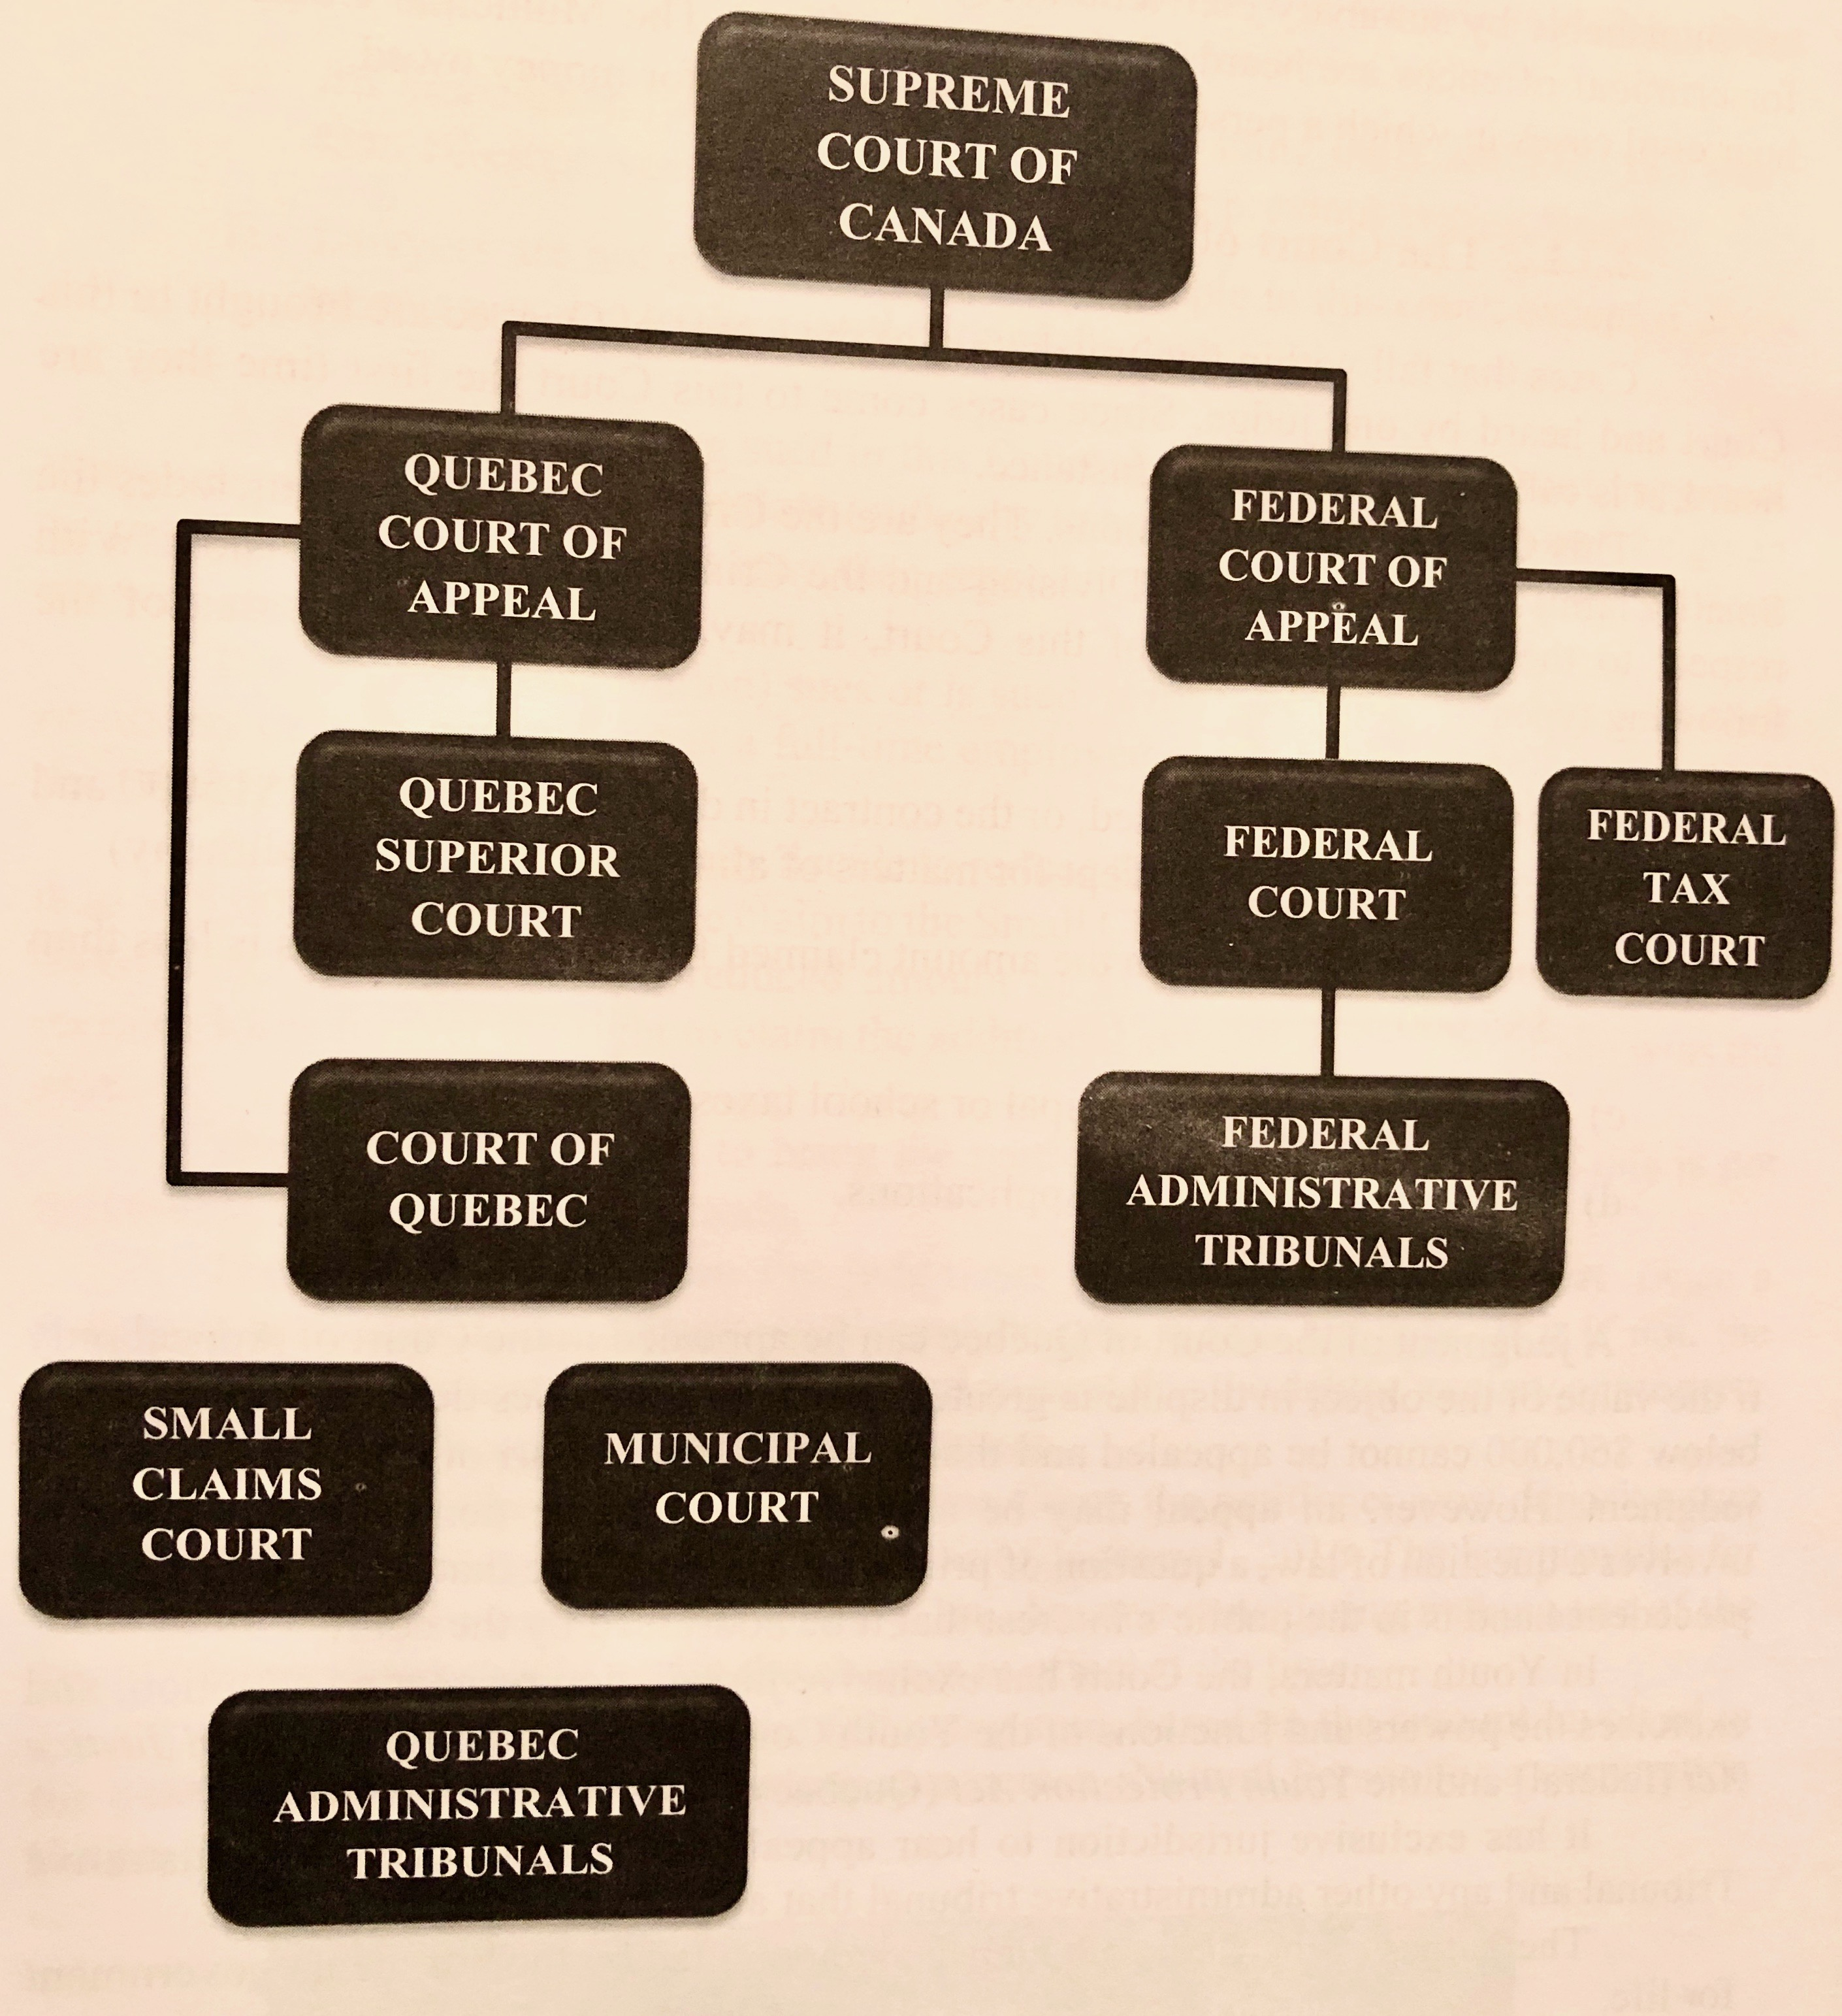
  - Superior Court
- Civil Division of the Court of Quebec
- All cases over 85 000$
- Possibility for a jury if it’s a criminal matter
- Can choose between a jury or 1 judge
- Most decision by them can be appealed by Court of Appeal
  - The Court of Appeal
- Appeals are brought in from Superior Court
- 7 judges (3, 5 or 7 will hear a case)
- Decisions based on majority present
- Can argue error of law (apply the law the wrong way)
- Error of fact
- For leave (permission) to be heard (because the case is new or needs to be clarified)
  - The Supreme Court of Canada
- Highest court in Canada and final court to which one may bring appeals in all matters (civil or criminal)
- 9 Judges (3, 5,7 or 9)
- 3 from Quebec
- With leave (permission)
- Error of Law or Error of Fact
  - Administrative Tribunals (Boards)
- Enacted by administrative regulations
- Internal review mechanism of Administrative decisions
- No appeals usually

The Legal Profession
- Judges
- Selected by government
- Court system is adversarial not inquisitive, except Small Claims Court
  - Both parties present facts and legal arguments, and judge makes a decision on who developed a stronger case
- Federal/Provincial: appointed and paid by Federal/Provincial government
- Minimum lawyer for 10 years and must give up private practice and business relationships
- Retirement age in Quebec: 70
- Lawyers
- Must be a member of the Quebec Bar
- Provide legal advice
- Assists in setting up new businesses
- Prepares contracts
- Has the right to plead cases before the court on behalf of their client
- Notaries
- Can provide legal advice
- Can’t represent in court except non-contested issues
- Exclusive rights to prepare certain contracts
- Produce authentic documents, which “make proof of their own contents”
- Arbitrators / Mediators
- Can’t represent in court
- Objective 3rd party

Chapter 3: Personal Rights
- Democracy has challenges to:
  - Diverge opinions on issues with majority rule over minorities
  - Try to balance individual rights with societal objectives
- Charters aim to keep a balance between individual rights and societal objectives
- The Constitution Act of 1982 included the Canadian Charter of Rights and Freedoms
- The Charter was entrenched in the Constitution, thus protecting rights
  - Entrenched – can be changed only in the same way that the Act can be amended, which is by agreement between federal and provincial governments (neither level can change it alone)
- Changing a statute requires a simple minority, while changing a charter requires constitutional amendment
- Government must respect the Charter
  - Federal
  - Provincial
  - Municipal
  - Any government associated organization and employee
- An individual can use the Canadian Charter only if they’ve been wronged by government
- Violations between private individuals are not protected

Protected Rights
- Fundamental Freedoms – freedom of religion, thought, expression
- Democratic Rights – right to vote and run for office
- Mobility Rights – freedom to travel and work anywhere in Canada
- Legal Rights – right to life, liberty, security and judicial protections
- Equality Rights – protection from discrimination
- Minority Language Education Rights

Limitations
- No federal or provincial government can opt out of Charter, but they can adopt laws that might limit individual rights and freedoms
- The Notwithstanding Clause (Section 33)
  - Government can limit rights found in s2 and s7 – 15
  - Sunset clause - must renew the limitation every 5 years
  - Ex: if a government wanted to limit a religious practice in public, they’d include a notwithstanding clause within the statute
- The Oakes Test (Section 1)
  - Allows government to limit rights if it can demonstrate:
    - The objective of the limit has a strong societal importance
    - Must show that the “means” chosen is the least intrusive
  - Difference from section 33:
    - Has a much broader reach than Section 33 which is just s2 and s7 – 15
    - Unlike section 33, government is obliged to demonstrate why individual rights should be diminished in favor of societal objectives
  - Case:
    - In 1986, Oakes had been caught with 10 vials of hashish oil and $619.45
    - Oakes was charged with possession of narcotic for the purpose of trafficking
    - Oakes argued he’d bought them for his own use
    - He challenged validity of the Narcotic Control Act
    - The reverse onus required him to provide proof of innocence, but he argued it violated the presumption of innocence in the Charter
    - So they created a two-part test

The Quebec Charter of Human Rights and Freedoms
- Quebec vs. Canadian
  - Quebec Charter can also be used for violations between private individuals
  - Quebec Charter not entrenched in a Constitution so it’s easier to change
  - For Quebec Charter, 2/3 National Assembly vote is required to change it rather than simple majority
- Protected rights
  - Fundamental Freedoms and Rights
    - Right to life, security, assistance
    - Freedom of expression, opinion and religion, right to associate
      - Not absolute rights
      - Expression limited in hate, libel, public images
      - Religion also limited for security, order and other’s rights
      - Safeguard of dignity and privacy
      - Ex: You can only take someone’s picture if it’s a public figure, it’s a newsworthy event or you have permission
  - Protection from Discrimination
    - Discrimination – act that nullifies or impairs a right
    - No discriminatory symbols or signs
    - Cannot refuse to contract based on discrimination
    - Discriminatory clauses in contracts are void
    - Can’t deny access to public places unless “undue hardship” is proven
      - Undue hardship – special circumstances that exempt a person from performance of a legal obligation to avoid unreasonable burden/obstacle
    - No employment related discrimination allowed
    - No obligatory questions in application forms and interviews if not related to aptitude and qualification, or if based on an affirmative action program
    - Can’t discriminate against job applicants with criminal record if not related to the job and if they obtained a pardon
    - Equal pay for equal work (except if based on aptitudes and qualifications or pay equity plans)
    - Can discriminate in hiring if it is based on aptitudes and qualifications or if a community or religious organization
    - Insurance and retirement plans can discriminate
  - Political Rights
    - Right to be heard by legislators, right to vote and run for office
  - Judicial Rights
    - Right to a fair hearing by a tribunal if accused of illegal activity, right to be protected from unreasonable search, detainment
  - Economic and Social Rights
    - Not included in Canadian Charter
    - Offers protection, security, free public education, safe work conditions, etc.
- Enforcement
  - Section 49 allows victims to sue for:
    - Injunction - judicial order that restrains a person from beginning or continuing an action threatening or invading the legal right of another, or that compels a person to carry out a certain act (cessation of violation)
    - Material damages
    - Moral damages – psychological distress
    - Punitive damages – preventative role, granted by a court as a means of punishing the defendant to teach them a lesson
- Limitations
  - Section 9.1 allows government to limit rights found between section 1 and 9, but must justify any limit using the Oakes Test

Civil Code of Quebec
- Book on Persons of the Civil Code sets larger principles of rights and freedoms set out by the Quebec Charter
  - Enjoyment and Exercise of Civil Rights (ex: patrimony)
  - Integrity of the Person
  - Care (right to refuse)
  - Respect of Children’s Rights
  - Respect of Reputation and Privacy
  - Change of Name
  - Change of Sex

Case 1: Multani vs. Commission scolaire Marguerite-Bourgeoys
- Court of Appeal (Quebec)
- Legal issues:
      - Fundamental freedoms to practice religion (s.3); Reasonable accommodation (s.9.1)
    - Parties:
      - Singh (Appellant)
        - Appellant – person who applies to a higher court for reversal of decision of lower court
      - Commission Scolaire Marguerite Bourgeoys (Respondent)
    - Facts:
      - 12 year-old boy went to school, carrying his kirpan, when the knife cut through his clothes and fell to the ground
      - The school board told him he couldn’t carry his kirpan with him because it’s a knife, and suggested a symbolic kirpan (pendant)
      - Superior Court said: “You can bring it to school but it has to be worn under your clothes following certain conditions”
      - Court of Appeal: school wasn’t happy with that decision and the boy’s family wasn’t happy with the restrictions
        - Religious is not unique or capricious
        - Even fundamental freedoms are not absolute
      - Question: s.3 of Charter (freedom to practice religion) vs. s.9.1 (balancing your rights against the rights of society and safety of those around you)
      - Evidence: Orthodox Sikhs must wear religious symbols known as 5 K’s
      - Anything can be a weapon in a school setting (even a pencil)
      - Nevertheless, a line must be drawn and an inherently dangerous object falls beyond that line
      - S.9.1 overrides s.3 of Charter No kirpan in school
      - The Court of Appeal agrees with the school board’s commission
      - Reasonable limits are more important than religion
      - School cannot reasonably accommodate you – precedent set

Case 2: Multani vs. Commission scolaire Marguerite-Bourgeoys
    - Supreme Court:
      - Administrative law not relevant because violation of Charter
      - Appeal Court made mistake in applying reasonableness standard
      - Religious tolerance is an important Canadian value
      - Safety Facts + conditions = reasonable limits
    - Facts:
      - Interference with boy’s freedom of religion deprives him of his right to attend public school
      - Sends a message to people that some religious values aren’t important as others
      - Risk of boy using kirpan as a weapon for violent purposes is low
      - Danger to society isn’t high enough to endanger society and prevent him from wearing the kirpan
    - Canada is multicultural by definition; therefore it must do everything possible to accommodate
    - Looked at kirpans in schools vs. sincere religious beliefs
    - Putting a dagger in pouch cannot be opened, therefore safety is no longer a problem (accommodates both rights)
    - Supreme Court overturns Court of Appeals decision can bring in kirpan under specified conditions (precedent set)
    - Appeal granted

Case 3: Syndicat Northcrest vs. Amselem
- Supreme Court of Canada
- Legal issues:
  - Freedom of religion (s.3); Reasonable accommodation (s.9.1)
- Parties:
  - Syndicat Northcrest (Respondent)
  - Amselem (Appellant)
- Facts:
  - Orthodox Jews living in luxury condo want to set up succahs on their balconies
  - Northcrest refused, stating they’d waived their rights when signing co-ownership agreement
  - Northcrest claimed danger and property values, proposing common succah
  - Northcrest claimed signing building by-laws equal to waiving rights
  - Supreme Court:
    - 5 judges said yes to succah, 4 said no succah
    - Majority judgement: s.3 of the Quebec Charter talks about religious freedoms
    - Northcrest argued s.6 (enjoyment of property), safety issue, will block security access
      - No, only 9 days, you can reasonably accommodate
    - Amselem argued s.3 (religious freedom)
      - Court doesn’t think you can waive rights to religious freedom, but even if you could, the contract wasn’t precise enough (would need to be very clear)
  - Decision: Succah allowed to be built on balcony

Case 4: R vs. Kapp
- Supreme Court of Canada
- Legal issues:
  - S.15(1) (prevents discriminatory distinctions that impact disadvantaged groups); s.15(2) (preserve the right of government to implement programs that combat discrimination)
- Facts:
  - Aboriginal bands were granted permission to fish under the Aboriginal Communal Fishing License Registration
  - Had exclusive rights to fish for 24 hours in the Fraser River
  - Kapp was a non-aboriginal fisherman who, along with several others, organized a protest fish during this day
  - Claims issuing of licenses was contrary to S.15 of the Charter (discriminates against them on the basis of race)
  - Appellants were charged with fishing without license and raise the Charter claim in defense
  - S.15(2) preserves the right of the helping government to implement programs that combat discrimination
  - First appeal was allowed stating that the program doesn’t affect human dignity of non-aboriginal and wasn’t saved by 2.1
  - In order for government to show that the program falls under definition of such in s.15(2)
    - Program has an ameliorative or remedial purpose
    - Program targets a disadvantaged group identified by the enumerated grounds
- Decision:
  - Not every distinction is discriminatory
  - Programs designed to ameliorate the disadvantaged doesn’t mean reverse discrimination
  - Appeal dismissed

Case 5: Therrien vs. Minister of Justice
- Supreme Court of Canada
- Legal issues:
  - Discrimination (18.2); Effect of pardon; Criminal record
- Parties:
  - Judge Richard Therrien (Appellant)
  - Minister of Justice (Respondent)
- Facts:
  - In 1970, Therrien sentenced to 1 year in prison for assisting four FLQ members
  - After serving his sentence, he continued his legal studies
  - Practiced law between 1976 and 1996
  - Pardoned in 1987
  - Tried 5 times between 1989 – 1996 to be appointed judge
  - Applied twice and didn’t get job due to criminal past
  - Appointed judge in 1996 (when he did not reveal his past)
  - Once appointed, he is immediately fired
  - Record discovered and removal process started
  - Therrien claims discrimination under section 18.2 of the Charter
  - Therrien argued violation of s. 18.1 and 18.2
    - Court found s. 18.1 not valid because criminal record not in art. 10 list
  - Court found 18.2 not valid because of “the nature, characteristics and requirements of the office.”
    - Charter doesn’t apply because judiciary isn’t employment, it’s considered office
    - Employment requies subordination and supervision and control of employer
  - S.20: there is BFOR because a criminal can’t judge a criminal
  - He wasn’t penalized because he had a criminal record, but that he wasn’t truthful by not disclosing his past
  - This undermined public confidence in the justice system and make him unfit to perform his job
- Decision:
  - Appeal should be dismissed. Court revoked his commission
  - Precedent set: pardon expunges effect for future, but pardon doesn’t prevent you from denying criminal conviction

Case 6: British Columbia vs. BCGSEU
- Supreme Court Canada
- Legal issues:
  - Discrimination; Reverse Discrimination; BFOR; s.20
- Parties:
  - BC Government and Service Employees’ Union (Appellant)
  - Government of Province of BC (Respondent)
- Facts:
  - Tawney Melorin, a female firefighter, couldn’t run fast enough according to her employer
  - Employer allowed her to try 4 times but she kept failing, so she was fired
  - Went to arbitration who sided with her, claiming discrimination
  - Court of Appeal disagreed saying that it’d be reverse discrimination if women were held to a lower standard than men
  - Supreme Court:
    - Was BC government justified in firing Meiorin?
    - Looked at BFOR (bona fide occupational requirement)
      - In order to fire Tawney, they must show it’s BFOR, a minimum qualification that is absolutely necessary to meet the standard of the job
  - Court found need for a 3-step test to determine a discriminatory standard is a BFOR
  - Meiorin Test – an employer can justify the standard in question by establishing a balance of probabilities
- Is the standard rationally connected to job performance?
- Was it adopted in good faith
- Does it demonstrate the standard is reasonably necessary
  - Would accommodating individuals impose undue hardship upon employer
      - Government wasn’t able to demonstrate step 3 that it would experience undue hardship if a different standard was used
      - Men and women have different aerobic capacity, therefore there should be an average score for each gender
    - Decision:
      - Test is flawed
      - Tawney should be restored her position because no BFOR was established
      - BFOR should be different for men and women

