BTM 200: Fundamentals of Information Technology
Cloud computing: Delivery of computing services (servers, strorage, database) over the internet (which is the cloud) to offer faster innovation, flexible resources and economies of scales.
Unit 1: Computer and Information Ethics

Primary issues with technology

1 - PRIVACY ISSUES
- Privacy issues: Very important nowadays as it relates to cloud computing.
- Privacy in the digital world: People need to realise that their information and
characteristics are all over the public domain.
Here are the 7 types of privacy:
  - Of the person: encompasses the right to keep body functions and
body characteristics
  - Of behavior and action: sensitive issues such as sexual preferences and habits, political activities and religious practices
  - Of communication: aims to avoid the interception of communications, including mail interception, the use of bugs, directional microphones, telephone or wireless communication interception or recording and access to email messages
  - Of data and image: concerns about making sure that individuals’ data is not automatically available to other individuals and organisations and that people can “exercise a substantial degree of control over that data and its use”
  - Of thoughts and feelings: the right not to share their thoughts or feelings or to have those thoughts or feelings revealed. Individuals should have the right to think whatever they like
  - Of location and space: individuals have the right to move about in public or semi-public space without being identified, tracked or monitored
  - Of association: people’s right to associate with whomever they wish, without being monitored.

Shifting Privacy standards:
Many users approve a privacy policy without even reading it. In order to access the service, people must however accept it. In fact, their personal data is being collected by companies and are unsure about what it is actually used for.

Google Glass:
For instance, the Google glass is a heads-up display with facial recognition and eye-tracking technology. It then collects information without active permission. These computers can recognise numbers and letters very fast and so all this information is compromised.

Privacy: Intrinsic right or social construct?
Legal systems are trying to catch up with the changes that digital technology has brought bout. Privacy is not a right, but more as an exchange between people and organisations, bound bhy the same principles of trust. Enterprises must recognise the responsibility to protect the privacy of the personal data they have gathered and analysed. Big companies like Google and facebook should educate their consumers by providing them options of all levels for privacy.
https://www.computerweekly.com/opinion/Privacy-concerns-in-the-digital-world

2- INTELLECTUAL RIGHTS
It is defined by the right of a person or company to have exclusive rights wo use its own plans, ideas or other assets without worrying about competition for a specific period of time.

This relates to the context such as a cloud computing deals with the issues of:

- Patent infringement: When another party steals, uses or sells a patented item without permission of the patent holder. The patent holder can sue the infringing party to stop his activities and receive compensation.

- Copyright infringement: The use of work that has a copyright. Uses it without permission, thereby infringing certain exclusive rights by reproducing it, displaying, distribute or perfom it.

- Trade secrets: Confidential information that is protected by a trade secret. It is unknown to the public and provide financial value for the business.

- Confidential information: Information or document that a business or individual wish to not make public.

Smart & Biggar:
- Canada’s leading firm for intellectual property
- Provide clients with clarity on opportunities and solutions to leverage and maximize IP.
- Remain devoted to protecting our clients' intellectual property and technology assets, and advising clients on how to uncover and maximize available opportunities.
- 8,000 Patent and trademark applications filled annually

http://www.smart-biggar.ca/en/articles_detail.cfm?news_id=535

3- COMPUTER ABUSE

The use of the computer to do something improper or illegal.
For instance:
- To expose personally identifiable information (PII)
- Using a computer to modify websites owned by someone else
- Illegally share copyrighted information
- Gaining unauthorized access
- To spy on a company information and plans
- Cyberbullying
- Using a work computer for personal tasks on company time

People who commit computer abuse may be violating:
- University policies
- Company policies
- Federal laws

Responding to computer abuse involves:
- Identifying the offending computers
- Identifying the individual abuser

The law that criminalizes certain types of computer abuse:
The Computer Fraud and Abuse Act (1984) = CFAA
- Law used to prosecute hackers for both civil and criminal matters
- Gives corporations a way to sue employees who steal company secrets.

Examples of computer abuse:
- Creating a fake social media account, since users should be providing accurate information about their identity. And so, they could be prosecuted under the CFAA.
- Aaron Shwartz case for a 35-year prison sentence: He downloaded millions of academic articles to which access was restricted through a subscription service, probably with the intent to freely distribute them.

https://www.investopedia.com/terms/c/computer-abuse.asp

MORALS
Conforming to established ideas of right and wrong

LAWS
- They are formal standards that apply to all
- Enforced by official agencies such as governments
However, Laws to cover all possibilities is impossible. Consequently, ethics would be used as general guidelines to manage the law and for people to follow.

ETHICAL SYSTEMS

System | Definition | Case
Relativism | • No universal moral truth  • Moral principles dictated by cultural tastes and customs | Topless bathing in Europe. This is generally banned on public beaches in the United States.
Divine Command | • God is all-knowing. He is the one who sets morals and ethical standards.  • God’s law is right all should conform to it.  • Breaking God’s law is wrong. | The ten commandments.
Utilitarianism | Actions are judged solely by consequences. In other words, the outcomes of  your actions should be judged.  • Actions that lead to, or produce happiness are considered to be superior to  those that generate unhappiness.  • The greater good is more important than individual’s happiness. | Weapons of mass destruction. It may end war sooner. To that effect, saves lives and misery that would have otherwise been more.
Virtue | Morals are found internally (within the person).  • Every individual should aim to behave well. | Volunteers versus court-ordered community service.  Donating money without having your identity announced.
Duty-Based (Deontology) | • Understanding and adopting a lifestyle in line with moral duties and rights.  • Everyone is expected to follow these moral duties and rights. | Freedom of religion.  Freedom of speech.

Unethical & Amoral Behavior
- Unethical does not mean necessarily illegal.
- Illegal behavior does not necessarily mean unethical
- Amoral behavior means no sense of right or wrong and the lack of awareness or interest in the consequences.

Sources of Personal Ethics
• Religion
• Family
• Experience
• Teachers
• Friends
• Reflection

Ethics & Society
• Social rules of conduct exist.
• Ignoring them can have an impact.
• Considering them may provide health benefits.
• Rejecting them may produce stress.
• See positive psychology
- Causes happiness
- Identifying personal strengths and values
- Negative (cheating, stealing, selfishness, lying) versus positive (generosity, honesty, trust)

Technology challenges
Technology advances continue to challenge the boundaries for ethics and moral behavior.
Examples:
• Social justice: Programming ethics into robots. Who should do it? Who should govern it?
• Intellectual property: 3D printing misuse. Can regulations be imposed?
• Privacy: Human implanted data chips. Societal benefit or privacy violation?
• Property rights: Who owns outer space?
• Computer abuse: Is organized hacking a mode of terrorism

What are the issues about artificial intelligence?
- Unemployment: What happens after the end of jobs?
- Inequality: How do we distribute the wealth created by machines?
- Humanity: How do machines affect our behavior and interactions?
- Artificial stupidity: How do we guard against mistakes?
- Racist robots: How do we eliminate AI bias?
- Security: How do we keep AI safe from adversaries?
- Evil genies: How do we protect against unintended consequences?
- Singularity: How do we stay in control of a complex intelligent system?
- Robot rights: How do we define human treatment of AI?

https://www.weforum.org/agenda/2016/10/top-10-ethical-issues-in-artificial-intelligence/

Computer Ethics Institute (CEI)

What is it?
Nonprofit research, education, and public policy organization focused on the issues, dilemmas, and challenges of advancing information technology within ethical frameworks.

What is their mission?
- facilitate the examination and recognition of ethical issues in the development and use of modern information technologies.
- provides educational resources and governing rules that have been adopted by many schools, organizations, and corporations around the globe.
The ten commandments of computer ethics are:
- Thou shalt not use a computer to harm other people.
- Thou shalt not interfere with other people's computer work.
- Thou shalt not snoop around in other people's computer files.
- Thou shalt not use a computer to steal.
- Thou shalt not use a computer to bear false witness.
- Thou shalt not copy or use proprietary software for which you have not paid.
- Thou shalt not use other people's computer resources without authorization or proper compensation.
- Thou shalt not appropriate other people's intellectual output.
- Thou shalt think about the social consequences of the program you are writing or the system you are designing.
- Thou shalt always use a computer in ways that ensure consideration and respect for your fellow humans.
http://computerethicsinstitute.org/home.html

Anticipate ethical dilemmas that may arise
- Provide users with an understanding of the consequences
- Lay foundation for appropriate use of technology
o Isolating and examining values and ethical imperatives in relation
to use of information technology
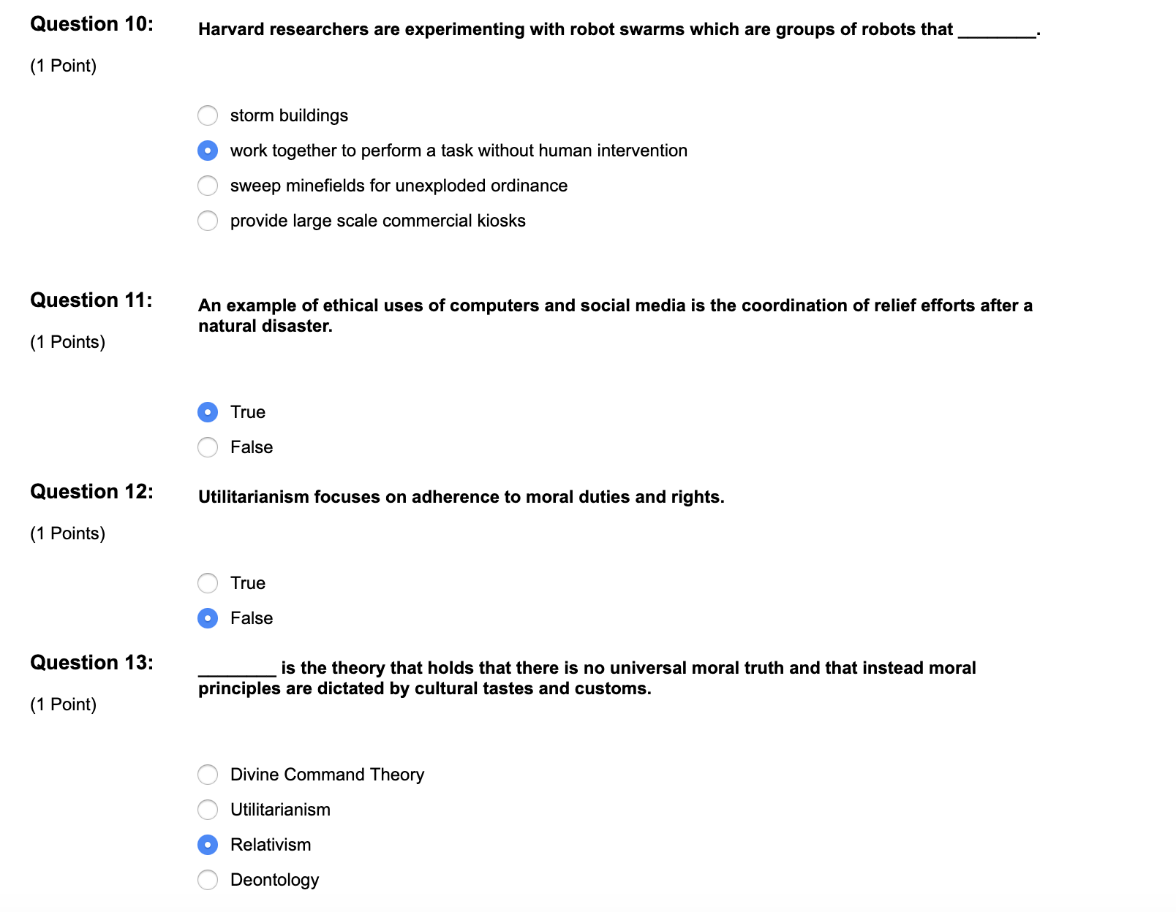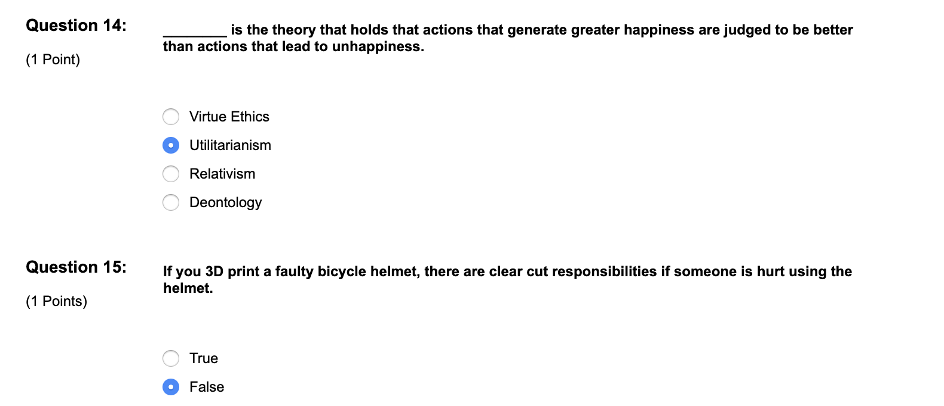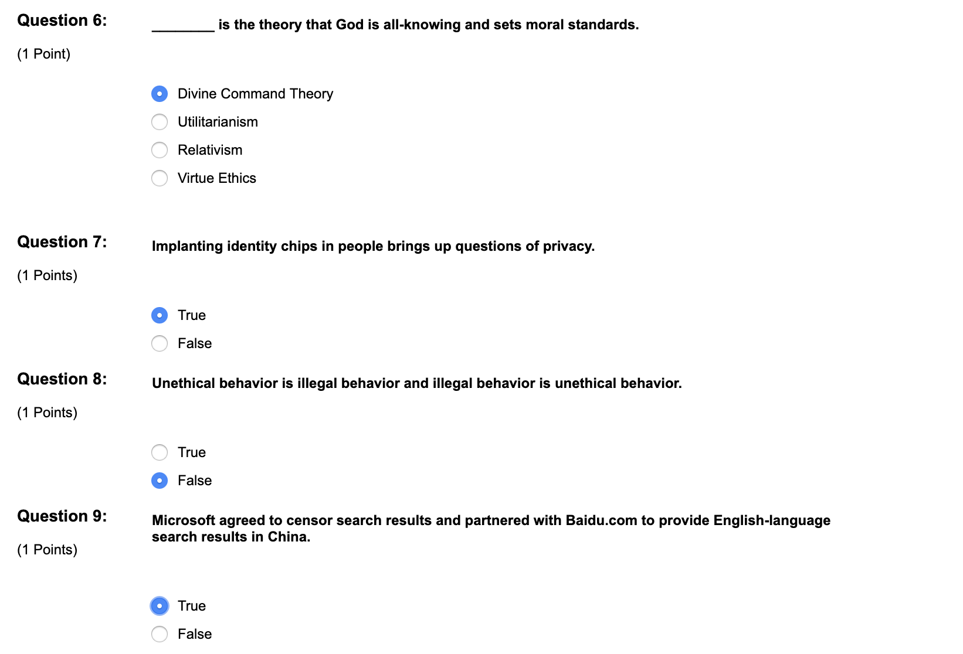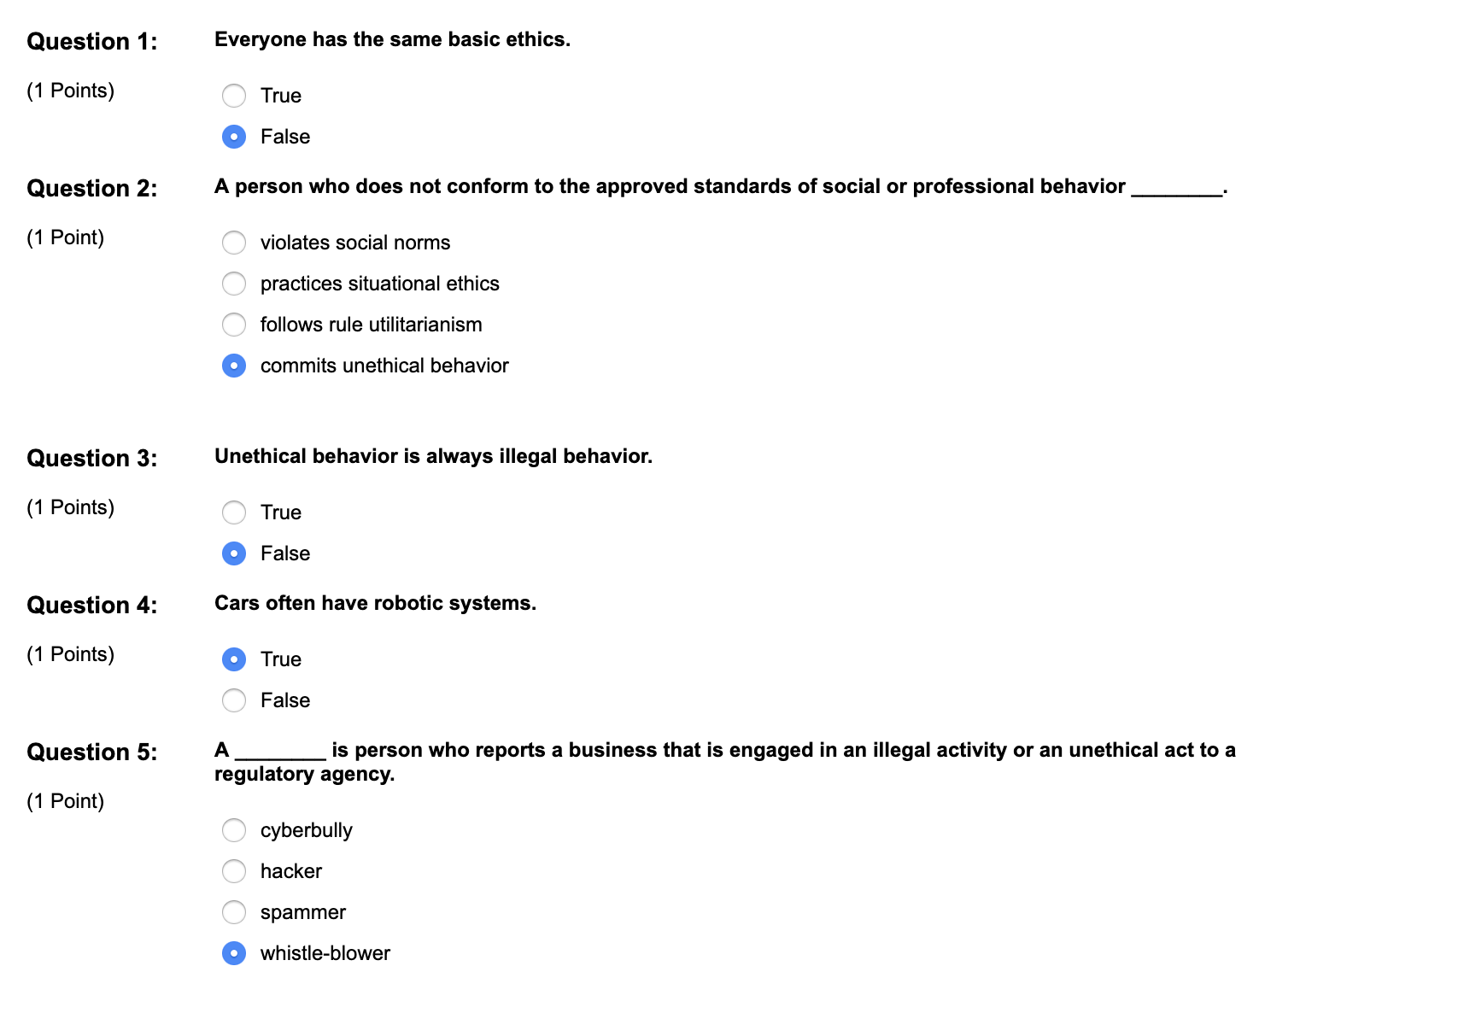
WHAT DO THEY DO?
Identify, assess, and respond to ethical issues associated with information technologies
10 COMMANDMENTS OF COMPUTER ETHICS
Thou shalt not:
1. Use a computer to harm others
2. Interfere with others’ computer work
3. Snoop around in others’ computer files
4. Use a computer to steal
5. Use a computer to bear false witness
6. Copy or use proprietary software unpaid for
7. Use others’ computer resources without authorization or proper compensation
8. Appropriate others’ intellectual output
Thou shalt:
9. Think about the social consequences of the program you are writing or system
you are designing
10. Always use a computer in ways that ensure consideration and respect for your
fellow humans
WHAT IS CEI?
Research, education, and public policy organization focused on the interface of
advances in information technology with ethical frameworks
- Comprised of professionals from the academic, corporate, and public policy,
information technology and religious communities
- Multi-disciplined, multi-cultural, cross generational and international
THE MISSION
Facilitate the examination and recognition of ethics in the development and use of
computer technologies
- Methods (educational resources and governing rules)
o Information dissemination
o Computer ethics education
o Policy analysis
THE ROLE
- Anticipate ethical dilemmas that may arise
- Provide users with an understanding of the consequences
- Lay foundation for appropriate use of technology
o Isolating and examining values and ethical imperatives in relation
to use of information technology
HISTORY OF CEI
- Founded in 1985 as Coalition for Computer Ethics
WHAT DO THEY DO?
Identify, assess, and respond to ethical issues associated with information technologies
10 COMMANDMENTS OF COMPUTER ETHICS
Thou shalt not:
1. Use a computer to harm others
2. Interfere with others’ computer work
3. Snoop around in others’ computer files
4. Use a computer to steal
5. Use a computer to bear false witness
6. Copy or use proprietary software unpaid for
7. Use others’ computer resources without authorization or proper compensation
8. Appropriate others’ intellectual output
Thou shalt:
9. Think about the social consequences of the program you are writing or system
you are designing
10. Always use a computer in ways that ensure consideration and respect for your
fellow humans
WHAT IS CEI?
Research, education, and public policy organization focused on the interface of
advances in information technology with ethical frameworks
- Comprised of professionals from the academic, corporate, and public policy,
information technology and religious communities
- Multi-disciplined, multi-cultural, cross generational and international
THE MISSION
Facilitate the examination and recognition of ethics in the development and use of
computer technologies
- Methods (educational resources and governing rules)
o Information dissemination
o Computer ethics education
o Policy analysis
THE ROLE
- Anticipate ethical dilemmas that may arise
- Provide users with an understanding of the consequences
- Lay foundation for appropriate use of technology
o Isolating and examining values and ethical imperatives in relation
to use of information technology
HISTORY OF CEI
- Founded in 1985 as Coalition for Computer Ethics
WHAT DO THEY DO?
Identify, assess, and respond to ethical issues associated with information technologie

