Experiment Title: "VIOLENT FIRES SOON BURN OUT THEMSELVES SMALL SHOWERS LAST LONG, BUT SUDDEN STORMS ARE SHORT" EQUILIBRIA
Author(s) Name(s):
Submitting Author’s Partner:
TA (Demonstrator)’s Name:
Date Experiment Performed: 09 October 2019
Date Experiment Submitted: 24 October 2019
(The report for Experiment 3 does not require an Introduction)
Procedure - Equilibrium Shift, Multiple Equilibria, Buffer Solution and Blood pH
As outlined in the lab manual
Observations and Discussion:
Equilibrium Shift:
- When 1 mL of CuSO₄ is added with 1 drop of NH_{3,} mixture changed to dark blue and opaque
- 13 drops of HCL, resulted in solution being light blue
  - 25 additional drops the solution is light blue with a little transparency
  - 25 additional drops the solution is light blue, very transparent with no precipitates
- 3 drops of NH₃ added, top half was dark blue and translucent, bottom half clear and transparent
- 25 drops of HCl added, no change
Discussion:
- After the addition of NH₃ the color observed in the solution was dark blue. This was due to the concentration of the H⁺ ion decreasing, whilst the ammonia started to react with the copper to produce [Cu(NH₃)₄]SO₄ (tetraamminecopper(II), a compounds whose property is a dark blue solid. Due to Le Chatellier’s Principle, the solution would produce more product since the reaction would shift to the right as the concentrate was added dropwise.
[Cu(H₂O)₄]²⁺ (aq) + 4 NH₃ (aq) ⇌ [Cu(NH₃)₄]²⁺ (aq) + 4 H₂O (l)
- The addition of HCl dropwise, resulted in the solution being light blue and transparent. The color change occurs because Cu(OH)₂ (Copper (II) Hydroxide) which has the properties of being a light blue substance is formed due to the reaction with HCl
- The color changed back to dark blue to the addition of NH₃. This is because the solution had reached its equilibrium state the first time NH₃ was added. The addition of HCl in the previous reaction broke the equilibrium state as it formed a different ion. Therefore it was expected that the addition of NH₃ would change the color back to dark blue as equilibrium was restored.
Multiple Equilibrium:
- When 0.5 mL of AgNO₃ with 0.5 mL of Na₂CO₃, color changed to beige opaque color
- 2 drops of HNO₃ resulted in the mixture being clear
- 4 drops of HCl added which resulted in mixture being white opaque
- 8 drops of NH₃ solution resulted in white precipitate in the bottom of the tube
- 9 drops of HNO₃ and the precipitate disappeared
- 30 drops of NH₃ added, no change
- 11 drops of KI added, top half was a cloudy and the bottom half was clear
- 3 drops of Na₂S, top half which was cloudy changed color to grey, bottom half stayed clear
Discussion:
- The addition of AgNO₃ resulted in the solution being a beige color. This was due to the reaction
2AgNO₃ (aq) + Na₂CO₃ (aq) ⇌ Ag₂CO₃ (s) + 2 NaNO₃ (aq)
- After the addition of HNO₃ the solution went to being a clear. The equilibrium equation below shows that the carbon dioxide gas was produced and expelled causing this reaction to be irreversible.
2 H⁺ (aq) + CO₃²⁻ (aq) ⇌ H₂CO₃ (aq) ⇌ H₂O (l) + CO₂ (g)
- The addition of HCl resulted in the solution being an opaque white, since a precipitate of AgCl was formed as shown in the equation below.
Ag⁺ (aq) + Cl⁻ (aq) ⇌ AgCl (s)
- When NH₃ was added the solution cleared up a little so that the precipitate could be seen
- When HNO₃ was added the precipitate disappeared and there was no change when NH₃ was added too
- After KI was added the top half of the substance was cloudy. This was due to the formation of AgI(s) which is defined by the equation below
Ag⁺ (aq) + I⁻ (aq) ⇌ AgI (s)
- When Na₂S was added the top half of the solution changed color to a cloudy grey, which was due to the formation of Ag₂S (s) defined by the equation below
2Ag⁺ (aq) + S²⁻ (aq) ⇌ Ag₂S (s)

Buffer solution and Blood pH:
- Starting pH without stirring is 5.7
- pH is 4.9 when stirring speed is set to 7
- 2.50g of NaHCO₃ added, resulted in pH to shift to 8.25
- 30 mL of 0.1 mol/L HCl added, pH at 7.34
- 10 mL of .85% lactic acid added to the beaker, resulted in pH shifting to 7.23
- Stirring rate increased, pH shifted to 7.30
- 0.5g of NaHCO₃ added, pH shifted to 7.91
- 0.5 g of NaHCO₃ added again, pH shifted to 8.17
- CO₂ pellet added, pH shifted to 7.61
- 0.40g of NH₄Cl added, pH shifted to 7.73
Discussion:
- The initial pH of the water was 5.7. Water is expected to have a pH of 7, the reason the water was slightly acidic was due to the possibility that the pH probe was not washed properly affecting the water.
- When NaHCO₃ was added, the pH shifted to 8.25 as it was dissolving the substance resulting in the mixture being basic
- After the HCl was added the pH reduced to 7.34. This happened because HCl is a strong acid and neutralized the base. The pH is close to what the expected value of water should be
- The addition of lactic acid shifted the pH to 7.23. The pH only decreased a minute amount as the buffer solution present is resisting the change by shifting the equilibrium to alkali side.
- The pH increased to 7.30 as the stirring rate was increased. This simulates the human body breathing faster resulting in more carbon dioxide being expelled. This results in the solution being less acidic.
- After the addition of NaHCO₃ THE pH shifted to 7.91. After an additional amount was added the pH shifted to a more basic value of 8.17. This causes alkalosis and the NaHCO₃ neutralizes the metabolic acid present from before.
- The addition of CO₂ pellets was to simulate the respiration rate slowing down. This causes the pH to shift to 7.61, still balancing equilibrium and staying relatively neutral
Conclusion:
Through the three separate experiments performed in the lab, we are able to delve deeper and understand the concepts of equilibrium and multiple equilibria, as well as the operations of a blood buffer and how the pH level of blood can be affected. This along with learning to understand shifting equilibria in regards to production and consumption.
Reference(s):
EQUILIBRIA, General Chemistry Laboratory Manual, Dr. Rashmi Venkateswaran, 2019.
Mcmahon, Patrick E., et al. “Acid/Base Equilibrium, PH, and Buffers.” Survival Guide to General Chemistry, 2019, pp. 473–506., doi:10.1201/9780429445828-26.
Answers to Questions 1-6:
- a) Ammonium ion is used as the acidic substance instead of Hydrogen Chloride as the Ammonium ion is a weak acid in comparison to the Hydrogen Chloride which is designated as a strong acid. This is because a strong acid would result in an unstable and too quickly changing pH level.
b) The compound with Chlorine is chosen as it is is less likely to disassociate with the NH₄ in comparison to compounds with Iodine and Nitrate.
- During the multiple equilibria step, every instance in which an acid was added, the solution either lightened its shade and became more transparent, or turned completely clear.
HA + H₂O → H3O⁺+ OH + A⁺
wherein HA represents an acid
- Acidosis in a patient would result in the equilibrium shifting to the left, and would result in a buildup of H₃O⁺ in the blood.This is because the patient’s blood has become more acidic, and will further result in a decrease in production of oxyhemoglobin.
- When HCl, a strong acid was added to the solution it limits the ability of HbO₂ which then shifts the equilibrium to produce HbH through the hydrogen added, and results in the dark colour change.
- The flat soda would have a lower pH level than the fresh soda, as stirring releases the CO₂ gas which had originally created carbonic acid. Due to the lack of CO₂, and therefore lesser amount of acid the flat soda will have a lower pH.
- Since the chickens hyperventilate (pant), they are exhaling a higher amount of CO₂, which shifts the equilibrium and causes more CO₂ to be produced in the chicken. As chicken eggs are made up of Calcium and Carbon Dioxide, this allows the chicken to have a higher amount of Carbon Dioxide to create the egg. But as the CO₂ is used to create the eggs, the equilibrium shifts back to produce more CO₃⁺, which in turn increases the strength of the egg shell.

Appendix:
Raw Data:

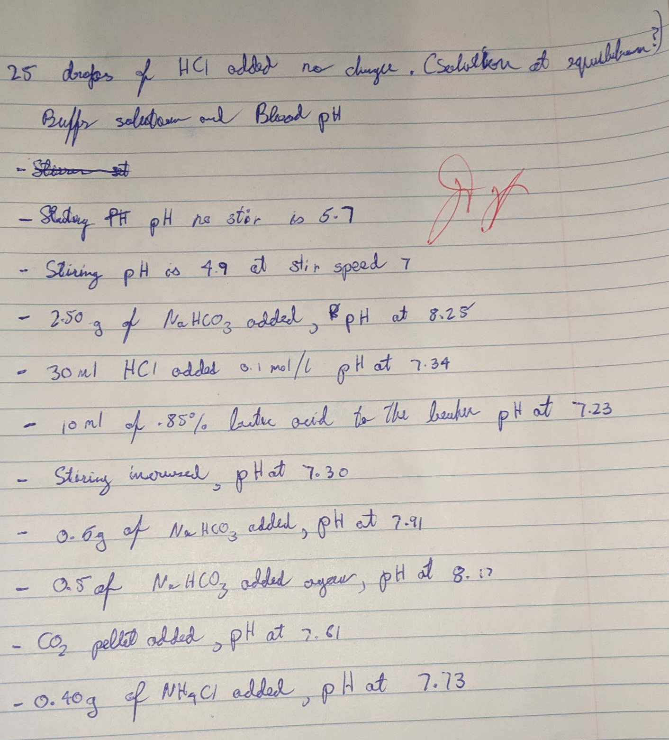
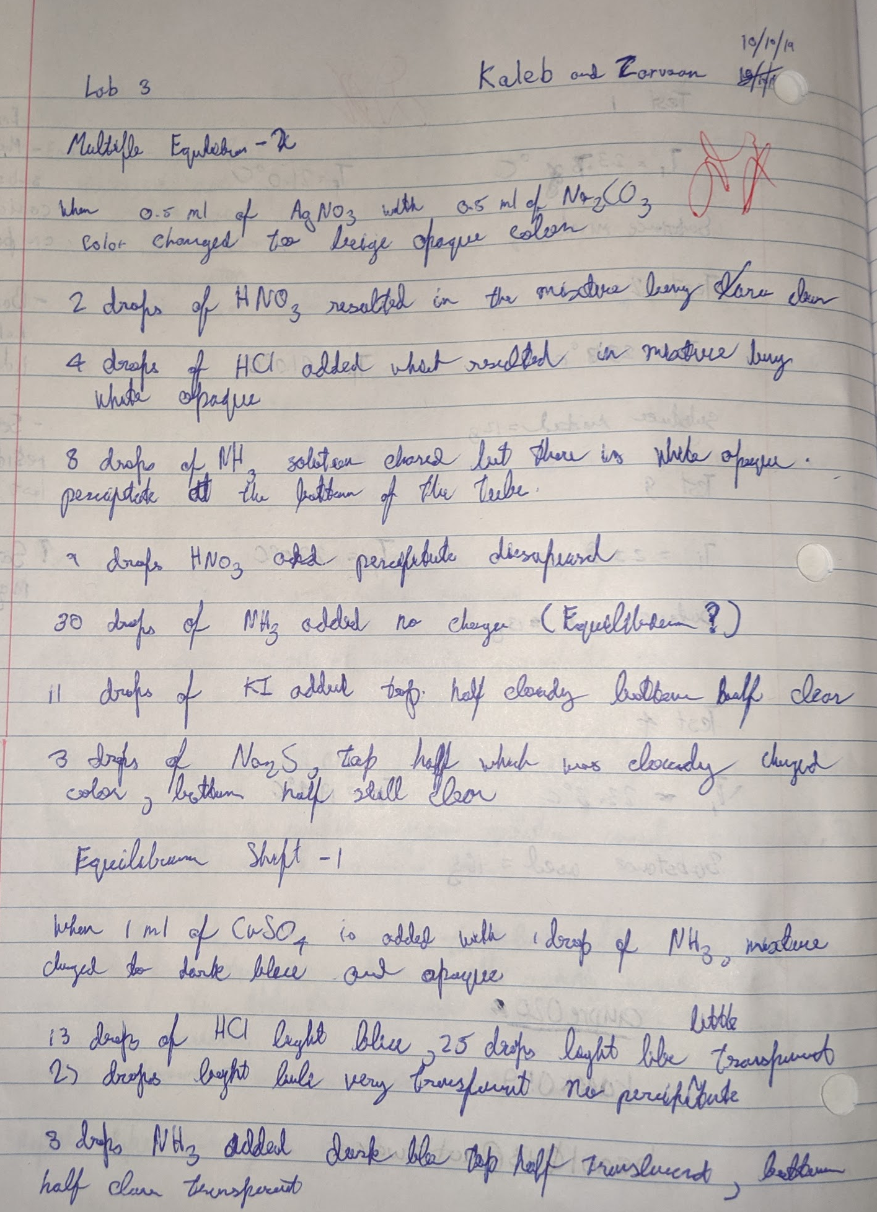

Table 1. Reactions Being Studied

[Cu(H₂O)₄]²⁺ (aq) + 4 NH₃ (aq) ⇌ [Cu(NH₃)₄]²⁺ (aq) + 4 H₂O (l)

2AgNO₃ (aq) + Na₂CO₃ (aq) ⇌ Ag₂CO₃ (s) + 2 NaNO₃ (aq)

2 H⁺ (aq) + CO₃²⁻ (aq) ⇌ H₂CO₃ (aq) ⇌ H₂O (l) + CO₂ (g)

Ag⁺ (aq) + Cl⁻ (aq) ⇌ AgCl (s)

Ag⁺ (aq) + 2NH₃ (aq) ⇌ [Ag(NH₃)₂]⁺ (aq)

H⁺ (aq) + NH₃ (aq) ⇌ NH₄⁺ (aq)

Ag⁺ (aq) + I⁻ (aq) ⇌ AgI (s)

2Ag⁺ (aq) + S²⁻ (aq) ⇌ Ag₂S (s)

2 H₂O (l) + CO₂ (g) ⇌ H₂CO₃ (aq) + H₂O (l) ⇌ HCO₃⁻ (aq) + H₃O⁺ (aq)

