ADM 3301 Resumé

What is Production?
Production is the creation of goods and services

What is Operations management (OM)?
Operations management is the set of activities that create value in the form of goods and services by transforming inputs into outputs

What are the different types of operations?
- Goods producing
Manufacturing
Power generation
Construction
Farming
Mining

- Services
Exchange: Retailing, Wholesaling, Banking, renting, leasing, loans
Entertainment: Films, radio and TV, concerts
Communication: Newspapers, newscasts, Satellites

How do you produce Goods and Services
By:
Marketing: generate demand
Production/operations: creates the product
Finance/accounting: tracks how well the organization is doing, pays bills and collects money

What is added value?
OM function adds value during the transformation process
ADD VALUE: THE DIFFERENCE BETWEEN COST OF INPUTS AND THE PRICE OF THE OUTPUTS

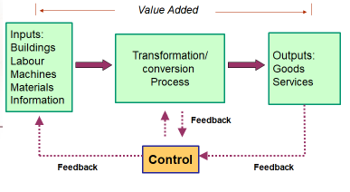

How does transformation work at a food processor:
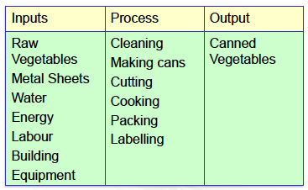

Organizational charts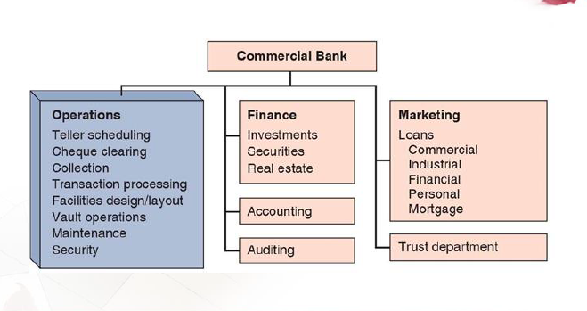

SUPPLY CHAIN
Supply chain is a global network of organizations and activities that supply a firm with goods and services.
Ex: farmer syrup producer –> bottler distributor retailer

Why study OM
- It is one of the three major functions of any organization. We want to study how people organize themselves for productive enterprise
- We want and need to know how goods and services are produced
- OM is such a costly part of an organization

The scope (range) of OM

Designing Decisions | Planning/control Decisions
Capacity | Personnel
Location | Inventory
Equipment | Scheduling
 | Quality

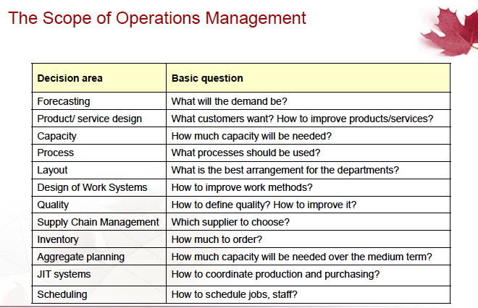

What operations do managers do
Basic Mngt functions: Planning, organizing, staffing, leading and controlling

Ten critical decisions

- Design of goods and services
-What to offer
-how to design these products/services

- Managing quality
-how to define quality
-who is responsible for quality

- Process and capacity design
-what process and capacity will these require
-What equipment and technology is necessary for these processes.

- Location strategy
-where to put the facility
-on what criteria should we base the location decision

- Layout strategy
-how to arrange the facility
-how large does it have to be

- Human resources and job design
-how do we provide a reasonable work environment
-how much can we expect our employees to produce

- Supply chain management
-should we make or buy this component
-who should be our supplies and how can we integrate them into our strategy

- Inventory, material requirement planning (MRP) and Just In Time (JIT)
-how much inventory should each item have
-When to reorder

- Intermediate and short term scheduling
-Are we better keeping people on the payroll during showdowns
-which jobs do we perform next

- Maintenance
-How do we build reliability into our processes
-Who is responsible for maintenance

Where are the OM Jobs

Technology/methods Facilities, strategic issues, response time, people/team development, customer service, quality, cost reduction, inventory reduction, productivity improvement.

New Challenges in OM

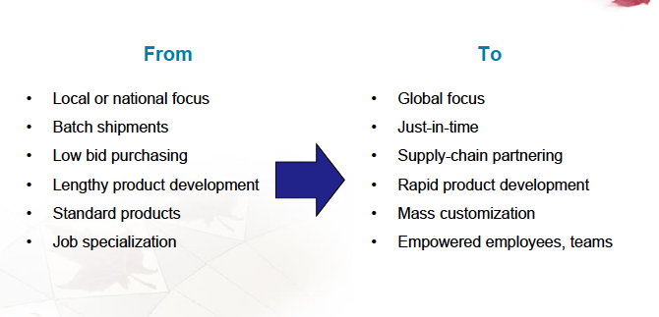
Characteristics of Goods | Characteristics of Services
Tangible product, Consistent product definition, Production usually separate from consumption, Can be inventoried, low customer interaction | Intangible product, produced and consumed at the same time, often unique, high customer interaction, often knowledge-based, frequently dispersed.

Productivity challenge
Productivity is the ratio of outputs (goods and services) divided by the inputs (resources such as labour and capital)
Objectif: always improve productivity
Production is a measure of output only and not a measure of efficiency.

Productivity rations can be computed for:
Workers, a department, and organization and a country.

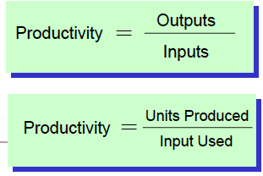

Current period productivity – previous period productivity
Previous Period Productivity
For example: if productivity increased from 80 to 84, the growth rate would be : (84-80)/80 = 0.05 = 5%

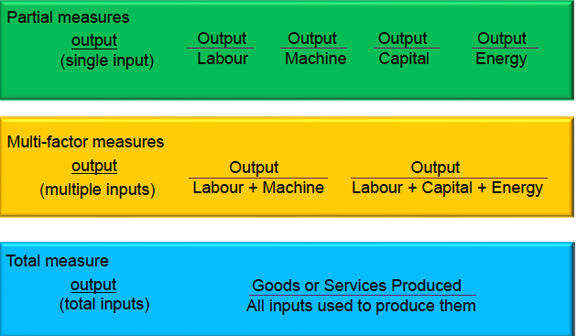

Key variables for improved labour productivity
- Basic education appropriate for the labour force
- Diet of the labour force
- Social overhead that makes labour available
  - Challenge is in maintaining and enhancing skills in the midst of rapidly changing technology and knowledge.

Service productivity
  - Typically labour intensive
  - Frequently focused on unique individual attributes or desires
  - Often difficult to mechanize and automate
  - Often difficult to evaluate for quality

Ethics and Social Responsibility

Challenges facing operations managers
- Developing and producing safe, quality products
- Provide a safe workplace
- Maintaining a clean environment

Reasons to globalize
1. Reduce costs (labor, tariffs) – Foreign locations with lower wage rates can lower direct and indirect costs
2. Improve the supply chain – locating facilities closer to unique resources
3. Provide better goods and services – improved customer service, objectives and subjective characteristics of goods and services such as on-time deliveries
3. Understand markets – interacting with foreign customers and suppliers leads to new opportunities
4. Attract and retain global talent – offer better employment opportunities

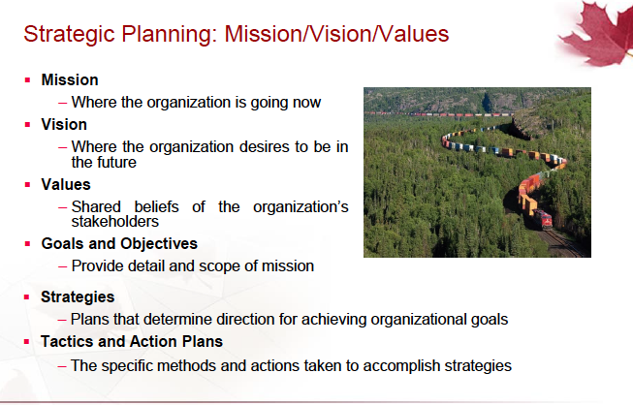

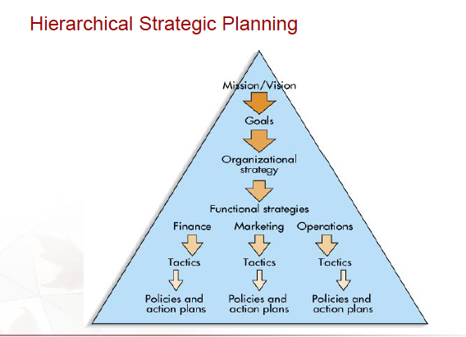
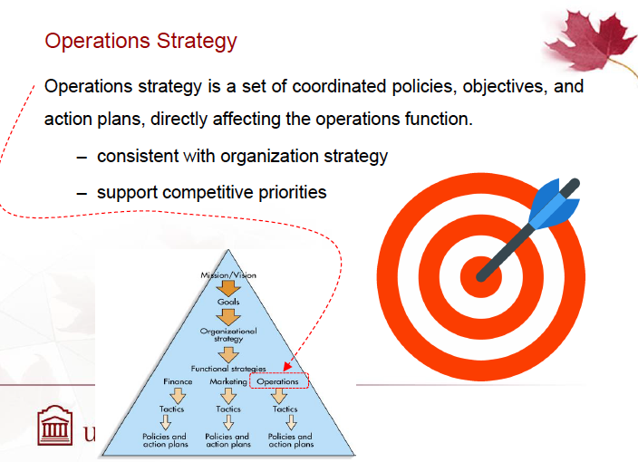

How Businesses compete using operations

Cost: the unit production of a goods/performance of a service to the organization. When organizations compete base off cost, it emphasize lowering its operating costs

Quality from an organization’s perspective means determining customers’ quality requirements, translating them into specifications for goods and services then consistently producing to theses specifications.

Flexibility: produce a variety of goods/services in the same facility including customization. It can also refer to reducing the production of quantities. Flexibility is achieved by having a generate-purpose equipment, multiskilled workers resulting in easy changeover between production of goods and performance of services

Deliveries: flexibility and speed refers to being able to consistently meet promised due dates (producing goods and performing services on time)

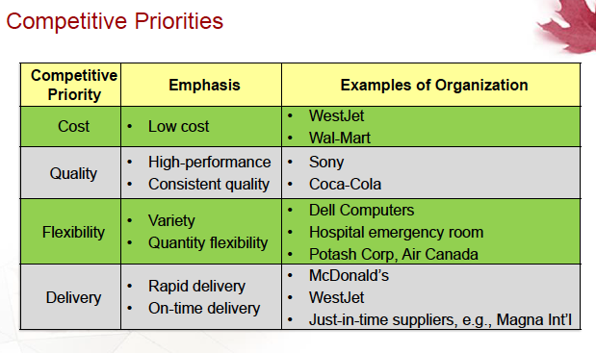

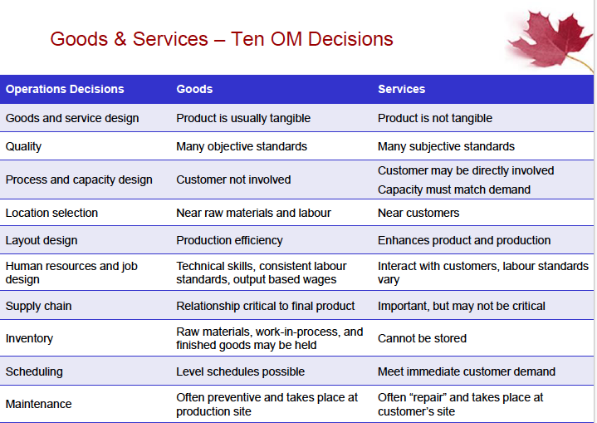

Core competencies: what organizations do as well as or better than their competitors

Outsourcing: transferring activities that have been traditionally internal to external suppliers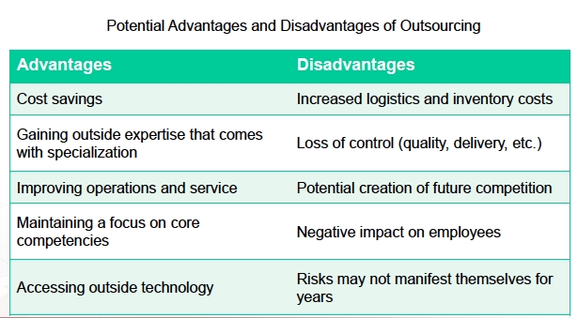

Process, volume and variety
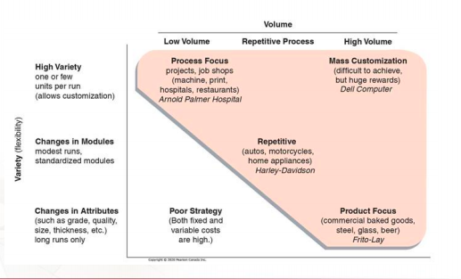

Process strategies

The objective of a process strategy I s to build a production process that meets customer requirements and product specifications within cost and other managerial constraints.
In order to produce a product and provide a service one may:
- Meets or exceeds customer requirement
- Meet cost and managerial goals
Which has long term effects on
- Efficiency and production flexibility
- Costs and quality

4 strategies

Process focus
Same days are different, one day welding next day
Repetitive focus
Car manufacture, repeated process every day
Product focus
Airlines, product is slowly moving and focuses on the product
Mass customization
If you want to order anything from anyone, volume high.

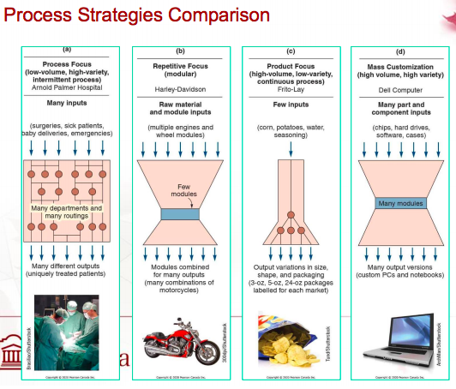

Major characteristics of process types

Dimension | Product focus | Process focus | Repetitive/assembly | Mass  customization
Product variety | customized | Semi-standardized | Standardized | Highly standardized
Volume | Low | Low-moderate | high | Very high
Equipment flexibility | Very high | moderate | low | Very low

A connaitre pour QCM

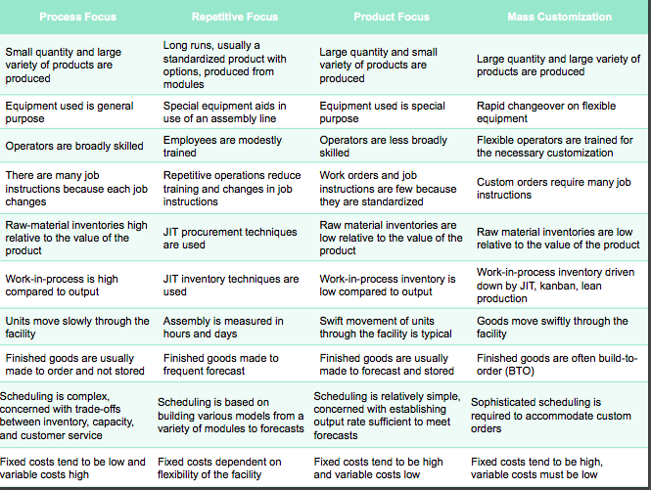

Changing processes
- Difficult and expensive
- May mean starting over
- Important to get it right
- Process strategy determines transformation strategy for an extended period

Process analysis and design (important for group assignment)
Flow charts – shows the movement of materials (BEST ANSWER)
Time-function Mapping – shows flows and time frame
Value-stream Mapping – shows flows and time and value added beyond the immediate organization (DIFFCULT TO DRAW THIS FROM THE START)
Process charts – uses symbols to show key activities, which have 5 typical symbols
Service Blueprinting – focuses on customer/provider interaction (USEFUL FOR SERVICE – HEALTHCARE) also have at least 3 level, here they can predict the behavior of the customer

Improve service productivity (QCM LEQUEL EST UTILIZÉ OU PAS POUR AMELIORER LE SERVICE)
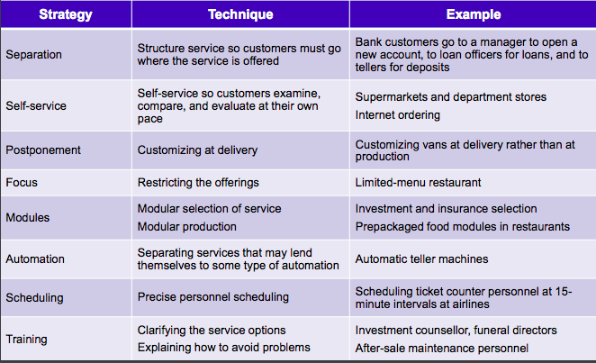

Improving Service Processes
  - Layout
- Product exposure, customer education, product enhancement
  - Human Resources
- Recruiting and training
- Impact of flexibility

Equipment and Technology
- Often complex decisions
- Possible competitive advantage
  - Flexibility
  - Stable processes
- May allow enlarging the scope of the processes
FEDEX is highly process focused and repetitive focus.

Production Technology
Machine Technology –> help us increase productivity, flexibility (use the machine anytime), improve precision, improve the environmental impact and reduced changeover time, decrease size (by using robots).
Ex: Vidéo sur Amazon ou ce sont les robots qui rangent et amènent les commandes

Technology in services

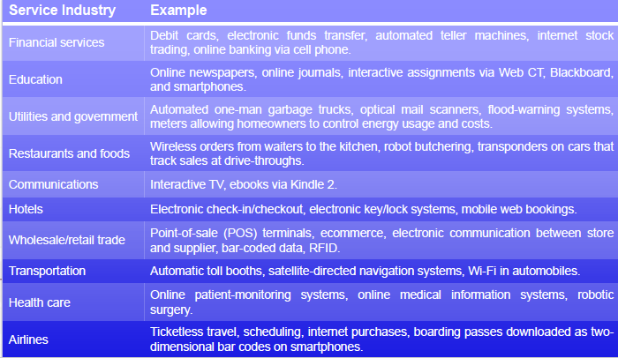

Process Redesign
Significantly improve performances, evaluate purpose of process, focus on activities that cross functional lines. (make sure everyone has access to the online)

Sustainability
If you make changes, make sure you keep it for a long time. Make sure your website is accurate so you can perfectly accommodate everyone.
Sustainability in production processes
- Resources – operations is primary user, reducing use is win-win
- Recycle – recycling begins at design
- Regulation – laws affect transportations, waste and noise
- Reputation - leadership may be rewarded, bad ones gets negative consequences

What is Capacity?
It is the upper limit on the load that an operating unit can handle
Basic question in capacity handling are:
- What kind of capacity is needed?
- How much is needed?
- When is it needed?

Capacity decisions

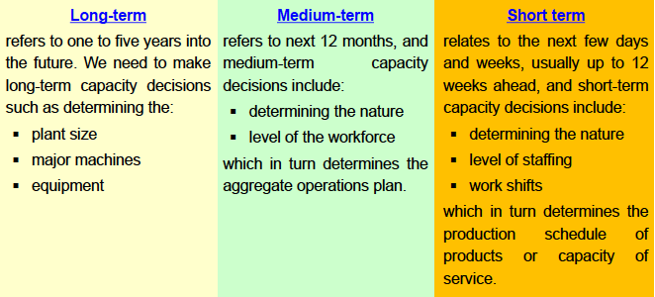

Importance of long-term capacity
- Impacts ability to meet future demands
- Affects operations costs (more capacity more cost)
- Major determinant of initial cost( for some capacity you need investment)
- Involve long-term commitment (longer contracts)

NB: too little capacity loses customers and too much capacity is expensive

Design and Effective capacity
Design capacity is the maximum theoretical output of a system (expressed as a rate)
Effective capacity is the capacity a firm expects to achieve given current operating constraints. (lower than design capacity)
Actual output: rate of output actually achieved – cannot exceed effective capacity (lower than effective capacity)
Design capacity > Effective capacity > Actual output

Utilization and efficiency

Utilization is the percent of design capacity achieved
Utilization = Actual output / Design capacity
= Uptime / Available time

Efficiency is the percent of effective capacity achieved
Efficiency = Actual output / Effective capacity

Design capacity = x/ hours * design capacity/hour
Expected output = Effective capacity * Efficiency (to calculate expected output the EFFICIENCY will be given IN THE PB)
Uptime = effective capacity – downtime
Available time = hours per day * days a week dans certain on multiple avec x nombre de choses utilisée

Uptime is also called productive hour
Une façon de checker si nos calculs sont bons on fait : effective capacity < utilisation*design capacity

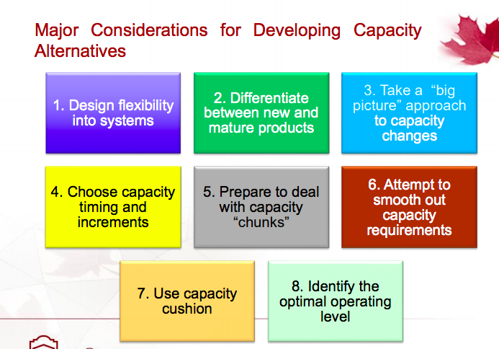

- Design flexibility into systems : provision for future expansion in the original design of a structure can be obtained at a small price compare to what it would cost to remodel an existing structure that did not have such provision.
- Differentiate between new and mature : Mature products tend to be more predictable in terms of capacity requirements and have a predictable life spans. Meaning less risk of choosing incorrect capacity and length of life for the investment
On the other hand, new products do carry a higher risk because of the uncertainty associated with predicting the quantity and duration of a demand. These uncertainties are due to unknown and changing customers reaction, technologies and competition.
- Take a Big Picture approach : the system interrelation is important when developing capacity alternatives (capacity balance). The capacity imbalance results in bottlenecks which restrict the capacity of a system. So increased capacity = increased bottleneck capacity.
- Choose capacity timing and increments: capacity being installed before (leading strategy), after (lagging strategy) and during. Plan to have capacity just before demand occurs because of construction capacity takes a long time. Small expansions are less risky because it allows adjustment of capacity based on demand change over time but it is expensive
- Prepare to deal with capacity chunks: capacity increases are acquired in large chunks rather than smooth increments making it difficult to achieve a match between desired capacity and actual capacity. Ex: Air Canada desired capacity is 75sets but Bombardier CRJ 700 has 70 seats and CRJ 900 has 88 seats. Most airlines would choose a larger aircraft because cost of shortage > cost of excess capacity.
- Attempt to smooth out capacity requirement: best capacity depends again on expected cost of shortage vs expected cost of excess capacity. Think of Canada post video
- Use capacity cushion: When demand is variable, capacity is usually chosen above the average (forecast) demand. The excess of capacity over the average demand is called capacity cushion or safety capacity. The size of capacity cushion again depends on the trade-off between cost of capacity shortage and cost of capacity excess. For vital services such as electricity, the chosen capacity should be larger than normal peak demand
- Identify the optimal operating level : At the optimal operating level, average cost per unit is the lowest for that production unit; larger or smaller rates of output will result in a higher unit cost, i.e., the average cost curve is “u” shaped. The explanation for the shape of the cost curve is that at low levels of output, the investment costs of facility and machines/equipment must be absorbed (paid for) by very few units. Hence, the cost per unit is high.
Managing demand
- Demand exceeds capacity:
        - long term solution is to increase capacity
        - Curtail demand by raising prices scheduling longer lead time
- Capacity exceed demand :
        - Stimulate market
        - Product changes
- Adjusting to seasonal demands
        - Produce products with complementary demand patterns

How to much Capacity to demand
- Making stuffing changes. 2. Adjusting equipment (buying more machinery). 3. Closing facilities. 4. Redesigning products to facilitate more throughput

Demand and capacity management in the service sector:
- Demand management: appointment, reservations, first come first served rule
- Capacity management: full-time, temporary and part-time staff

Process Times for Stations, Systems and Cycles

For station: how much time this station needs to produce one unit of product
For a system: the longest process system (the bottleneck – more time/delay in the system)
Cycle time: how long does it take in total for a product to go through the production process with no waiting (total time)
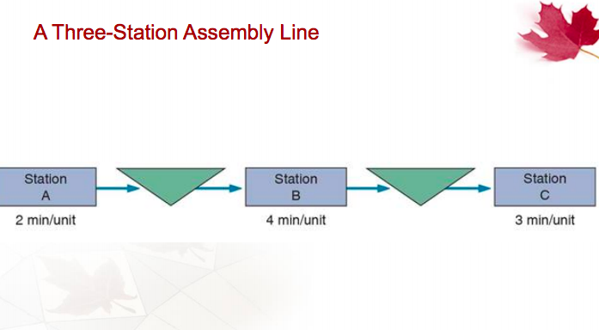
The bottleneck is at station B

Capacity analysis
Exemple 1:

1st order and last delivery
In the meantime we have the process (2lines)
- Toaster is the longer station (bottleneck) – 40sec mais comme on a 2station parallèle on divise le bottleneck par 2 so 40/2= 20second/sandwick the toaster is no longer the bottleneck
- Delivery becomes bottleneck with 37.5sec/sandwich
  - In one hour we have 3,600second
  - So Capacity per hour is 3,600 / 37.5 = 96 sandwiches/hour
  - Process cycle time is: 30+15+20+37.5 = 142.5 seconds

Exemple 2:

On a deux stations parallèle qui n’ont pas la même valeur donc on ne divise pas par 2.
- The bottleneck is Hygienist cleaning: 24min/unit since it’s the longest time
- Cleaning path 2+2+4+24+8+6 = 46 mn
- X-Ray exam path 2+2+4+5+8+6 = 27 mn
- Capacity/hour is
    - 24min for 1 unit how many unit will 60min have?
    - 60/24 = 2.5 patients (capacity/hour)
    - The patient should be complete in 46min process cycle time

Theory of constraints (midterm explain and provide the 5 points)
Step 1: Identify the constraint
Step 2: Develop a plan for overcoming the constraints
Step 3: focus resources on accomplishing step 2
Step 4: Reduce the effects of constraints by offloading work/expanding capability
Step 5: Once overcome, go back to step 1 and find new constraints.

Break-Even Analysis (TC = TR)

Technique for evaluating process and equipment alternatives.
Objective is: to find the point in dollars and unit at which cost equals revenue.
Requires estimation of fixed costs, variable costs and Revenue
- Fixed costs= costs that continue to even if no units are produced in such as depreciation, taxes and debt.
- Variable costs = costs that vary with the volume of units produced such as labour, materials and portion of utilities
NB: notation du prof

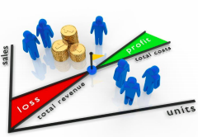

TC = total cost
TR= total revenue
V= variable cost
F= fixed cost
X = number of unit
P = price

Break even Px = F + Vx BEP ou X = F / P-V

Exemple:
FC = 40,000$| Material = 1.50$ |Labour cost = 3$ | Selling price = $10.00 per unit
Break-Even = F /P-V
= 40,000 / 10 – (3+1.50)
= 7273 (no profit no loss)

Example 2:
Rent = 6000$/month
V = 2$/pie
P = 7$/pie

- X = F /P-V
= 6000/(7-2) = 1,200

- Total cost = Fc + Vx
= 6000 + 1000*2 = $8000
TR = X*P = 1000*7 = 7000$
TR-Tc = 8000 -7000 = 1000 loss

- TR – Tc = 4000$
X*P – (F+Vx) = 4000
7x – 6000 - 2x = 4000
5x = 10000
X = 2000 pies

- 1500 > 1200 this is good investment. So we accept the offer

Expected Monetary Value (EMV) and Capacity Decisions
- Determine status of nature
  - Future demand
  - Market favourability
- Analyzed using decision trees
  - Hospital supply company
  - Four alternatives

Decision table
Expected value can help us know what value we can gain. SigmaP must be 1.

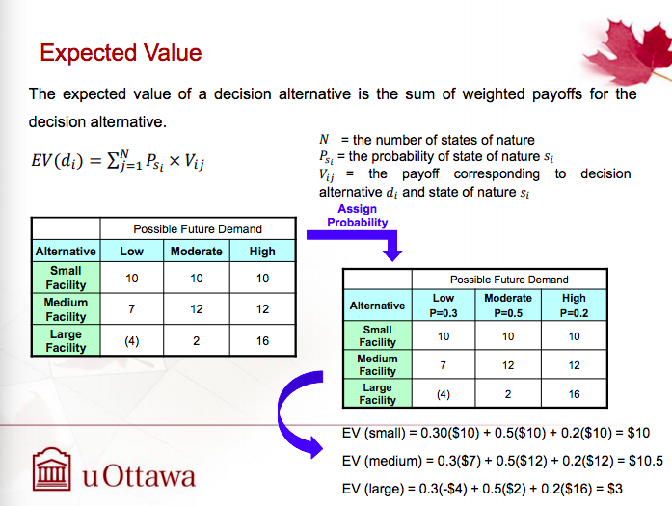

So we select $10.5

Next example

- Are probability nodes and needs to be added
- Decision nodes and need to be chosen

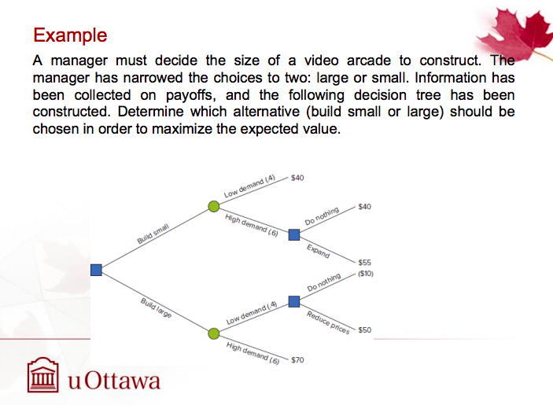

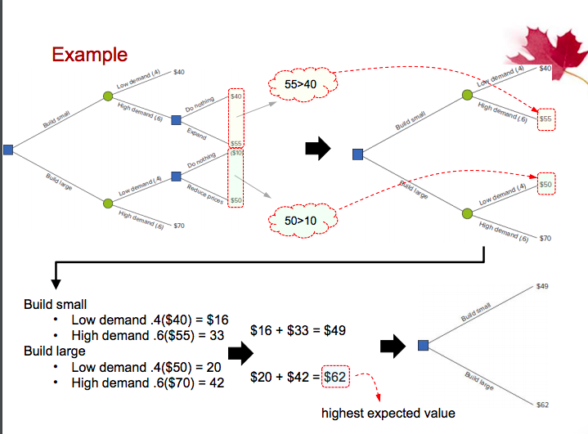
Net Present Value (access)
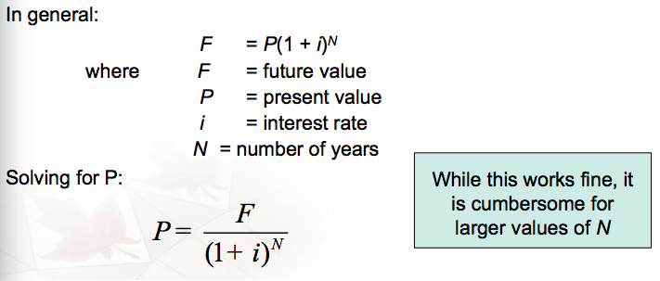

Net Present Value Using factors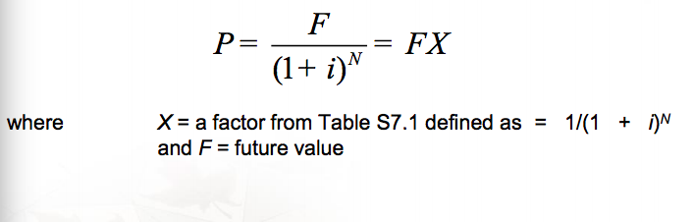
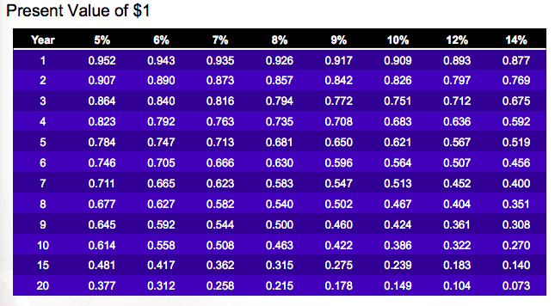
Chapitre 3: forecasting

What is forecasting? Process of predicting a future
Underlaying basis of all business decisions
  - Production
  - Inventory
  - Personnel
  - Facilities
Forecasting is as much of an art as science
Demand forecast is an estimate of demand expected over a future time period

The importance uses for forecasts
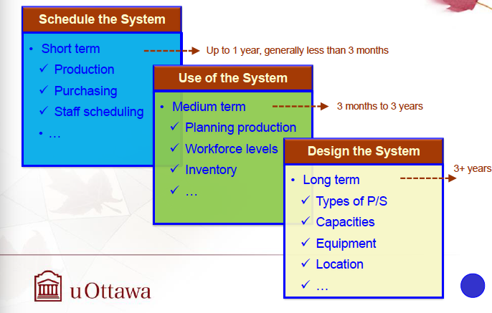
Video: of Boeing 20years 6.1 trillion with 41,000 new airplanes so they need accurate forecasting.

There are three terminology of forecasts (QCM)
- Period: is the basic time unit (week, month, year..)
- Interval: determines when a forecast is to be updated
- Horizon: is the number of periods to be covered by the forecast

Elements of a Good forecast (6)

Reliable, Meaningful units, Cost effective, useful time horizon, easy to understand and use AND Accurate

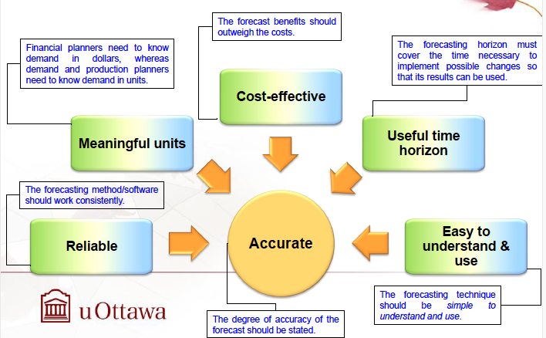

Steps in the forecasting process

- Determine purpose of forecast
- Select items to be forecasted
- Determine the time horizon of the forecast
- Select a forecasting model(s)
- Gather the data
- Make the forecast
- Validate and implement results.

Forecasting Approaches

Qualitative methods | Quantitative Methods
Used when situation is vague and little data exist (new products/new technology)  Involves intuition, experience (ex: forecasting sales on internet) | Used when situation is stable and historical data exist (existing products and current technology)  Involves mathematical techniques

Overview of Qualitative methods (QCM OR SHORT CASE, WILL BE DECISION MAKER)
- Executive opinions: pool opinions of high-level executives long term strategic or new product development
- Expert Opinions (Delphi method): interactive questionnaires until consensus is reached
- Sales force opinions : based on direct customer contact
- Consumer Survey : questionnaires or focus groups
- Historical analogies : Use demand for a similar product.

Overview of Quantitative Methods

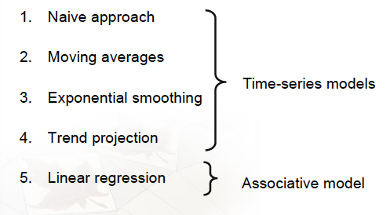

Accuracy
Main objective: better decision making

The decision maker needs a measure of accuracy:
- To know how far off a forecast might be
- To use as a basis for comparison when choosing among different alternatives
- To take corrective action if the forecast errors are not within reasonable bounds.
There are two aspects of forecast accuracy when deciding among forecasting alternatives
- Historical error performance of a forecast
- The ability for a forecast to respond to changes

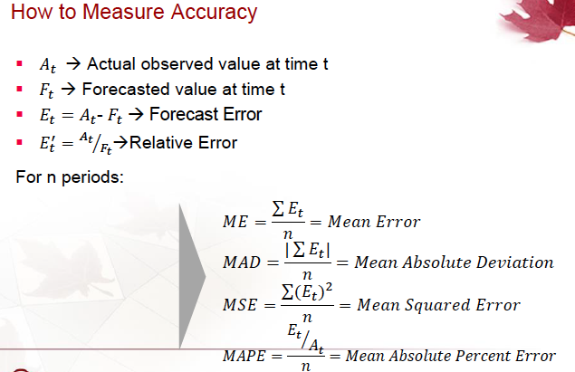

Sur excel: Absolute: ABS. square value (soit power ou valeur^..)

Time-Series Forecasting
get rid of all 4 before forecasting.

Trend : Steady upward or downward movement
Seasonality: Regular variations to a specific time of year/day
Cycles: wave like similar variations lasting more than one year
Random variations: residua; variations after all other behaviour are accounted for.
Naïve Method

Very low cast, next period=last period, simple to use and understand and low accuracy. F = forecast and A = actual

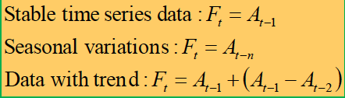

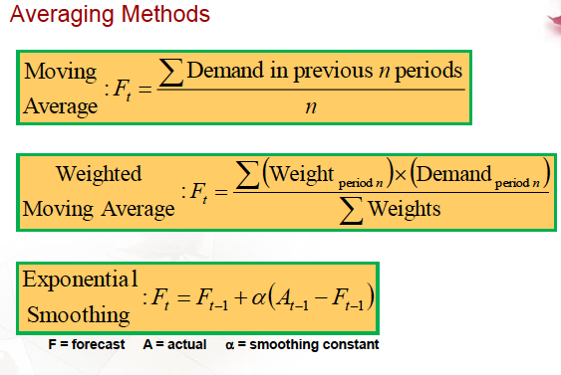
Moving average | Weighted Mov. avera | Exponential smoothing
Average of last few actual data values, updated each period
- Easy to calculate
- Smooth bumps
Choose number of periods to include
- Fewer data points= more sensitive changes
- More data points = smoother

Moving Average (use the LAST three period (better than naïve methode)

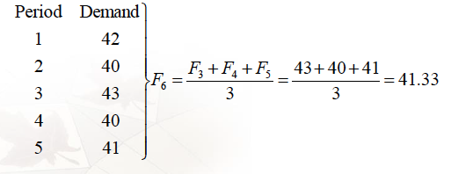

Weighted moving average (more accurate and better than moving average)
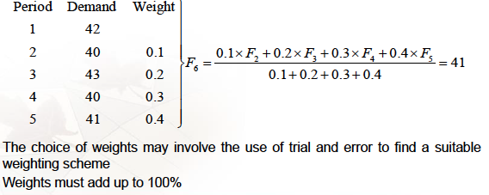
Moving average for period 4

Exponential Smoothing Method Formula

Forecast = previous forecast + part of previous error
Actual – Forecast is the error term
Alpha is the % feedback
If the time series is stable, take alpha close to 0, if not take alpha close to 1.
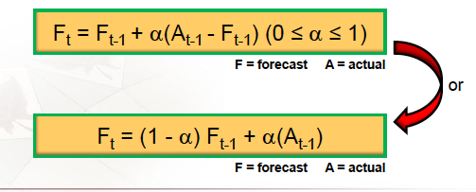

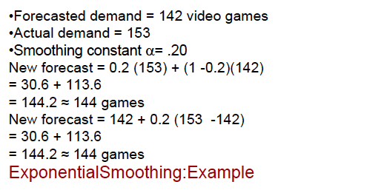

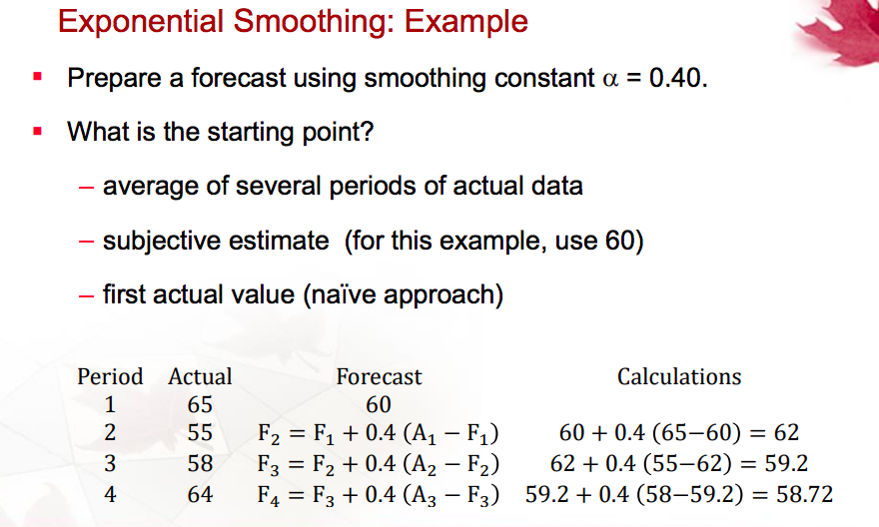
For the 1st period we can take a guess or use naïve method (always use the exact number of demand (actual)).
NB: FAIRE LA PAGE 33-34 DANS EXCELL !!!!! utilisé le signe $ pour blocker le cellule du alpha.

Linear Trend Equation
It is a straight line model with one independent variable. This model also is called first-order linear model. The main objectif of a regression model is to analyze the relationship between two variables x and y.

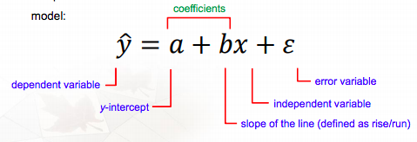
How do you find a et b?

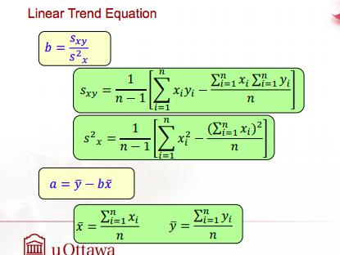

S- standard deviation et s^2 – covariance

Y bar = sum Y/n et x bar = sum X/n

Linear trend exemple

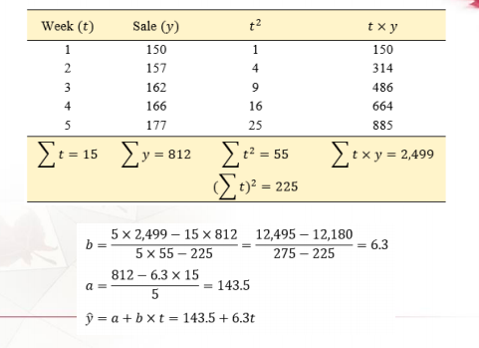

Chap 4 - Supply chain Management

The objective is to build a chain of suppliers that focuses on maximizing value to the ultimate customer

Its important activities:
- Transportation vendors
- Credit and cash transfers
- Suppliers
- Distributors
- Accounts payable and receivable
- Order fulfillment

Supply Chain’s strategic Importance

Definition: Supply chain management is the integration of the activities that procure materials and services, transform them into intermediate goods and final products and deliver them through a distribution system.

Competition is no longer between companies: it is between supply chains

Key term: integration. An effective supply chain management is all about getting all members of the supply chain working together as though they were one vertically integrated company.

Name three strategies for supply chain (short answer)

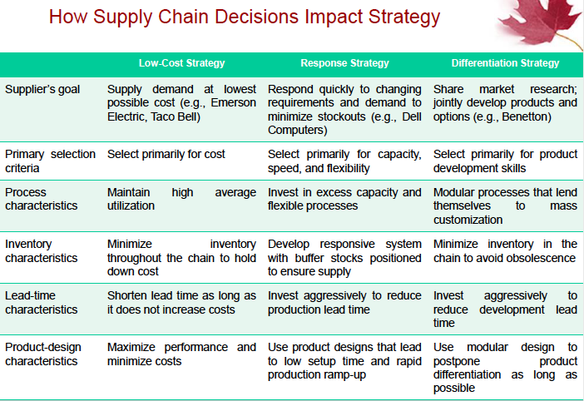

Supply chain Risk

The use of global supply networks compounds the risks by introducing political and currency risk along with the added complexity that managing global networks entails.
Proper risk management becomes crucial to survival. Management must mitigate and react to disruptions in:
- Processes (raw materials and component availability, quality)
- Controls (product designs, management metrics and reliable secure communication for financial transactions)
- Environment (customs duties, tariffs, security screening, natural disaster)

Risk from another aspect
- More reliance on supply chains means more risk
- Fewer suppliers increase dependence
- Political and currency risks
- Vendor reliability and quality risks

Outsourcing

Transfers traditional internal activities and resources of a firm to outside vendors (sign a contract with another vendor Canada post and Purolator)
- Utilizes the efficiency that comes with specialization
- Firms outsource information technology, accounting and legal/logistics

The supply chain strategies (qcm) or problem to solve
- Negotiating with many suppliers, 2. Vertical integration, 3. Joint ventures, 4. Keiretsu and 5. Long term-partnering with few suppliers

- Many to few suppliers (always access to raw materials)
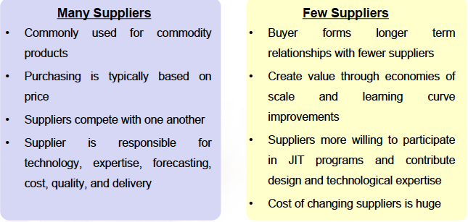

- Vertical integration
- Developing the ability to produce goods and service previously purchased
- Can improve cost, quality, and inventory but requires capital, managerial skills and demand
- Integration may be forward, towards the customer or backward, towards suppliers

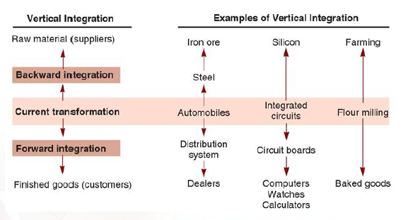

- Joint venture
- Formal collaboration:
        - Enhance skills
        - Secure supply
        - Reduce costs
- Cooperation without diluting brand or conceding competitive advantage

Joint venture is a nice way to gain the benefits of partnering while retaining independence and being in a relationship that is easier to dissolve.

- Keiretsu Networks
- Middle ground between few suppliers and vertical integration
- Often provide financial support for suppliers through ownership or loans
- May extend through several levels of the supply chain

- Virtual companies

- Rely on a variety of supplier relationships to provide services on demand
- Fluid organizational boundaries that allow the creation of unique enterprises to meet changing market demands
Ex: Costco credit cards.

Managing the supply chain
There are significant management issues in controlling a supply chain: Mutual agreement on goals, trust, compatible organizational cultures.

Issues in an Integrated Supply Chain
- Local optimization: focusing on local profit or cost minimization based on limited knowledge
- Incentives – push merchandise prior to sale
- Large lots: low unit cost but do not reflect slaes
  - Bullwhip effect: stable demand becomes lumpy orders through the supply chain

Opportunities in an Integrated Supply Chain
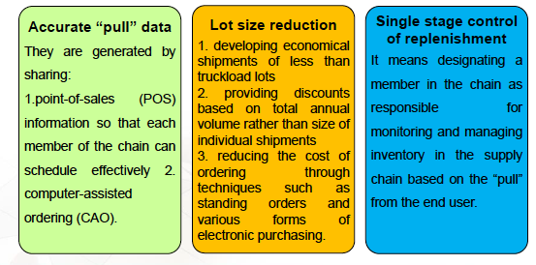
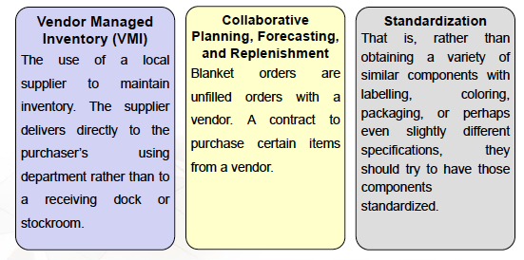
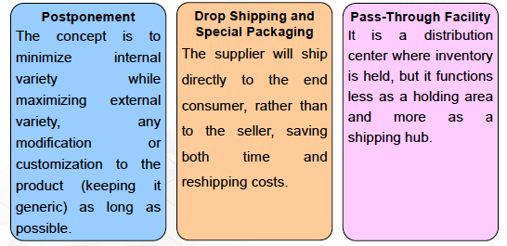
E-Procurement

- Uses the internet to facilitate purchasing
- Electronic ordering and funds transfer
- Real-Time inventory tracking
- Auctions

Vendor Selection

- Vendor evaluation
  - Critical decision
  - Find potential vendors
  - Determine the likelihood of them becoming good suppliers
- Vendor Development
  - Training
  - Engineering and production help
  - Establish policies and procedures
- Negotiations
  - Cost-Based price Model supplier opens books to purchaser
  - Market-Based Price Model price based on published, auction or indexed price
  - Competitive Bidding used for infrequent purchases but may make establishing long-term relationships difficult

Distribution Systems

Chapter 05- Waiting time Models

Queuing Theory ( it is a problem) – it helps us to understand service system and maintenance activities.
Waiting lines models are useful in both manufacturing and service area
Analysis of queues in terms of:
Waiting-line length: Number of people or how much time you have to wait in a queue
Average waiting time: general waiting time.by developing a statistic of distribution
Other factors
Common queuing situations

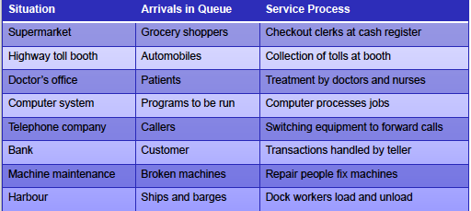

Parts of a Waiting line

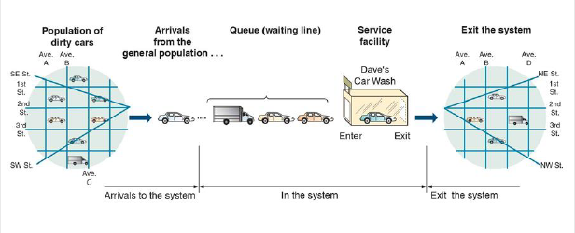

Arrivals: Speed of the input (usually the problem is found here)
In the system: What are you doing? This is predictable
Exit: can be a problem too
NB: Service rate always higher than arrival rate

Arrival Characteristics
- Size of the population
  - Unlimited or limited
- Pattern of arrivals
  - Scheduled or random often a Poisson distribution (# of success in a specific period of time/hr or a time window or a time interval :every 5mn)
- Behavior of arrivals
  - Wait in the queue and do not switch lines
  - No balking or reneging
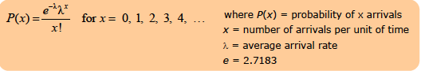

Waiting line characteristics
- Limited or unlimited queue length
- Queue discipline- first in, first-out (FIFO) is most common
- Other priority rules may be used in special circumstances

Service characteristics
  - Queuing system designs
    - Single-channel system, multiple-channel system
    - Single-phase system, multiphase system
  - Service time distribution
    - Constant service time
    - Random service time, usually a negative exponential distribution
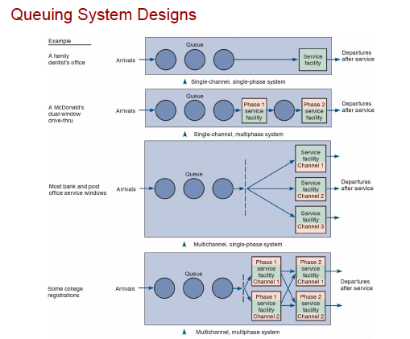

Measuring Queue Performance (indicators)
- Average time that each customer or object spends in the queue
- Average queue length
- Average time each customer spends in the system
- Average number of customers in the system
- Probability that the service facility will be idle
- Utilization factor for the system
- Probability of a specific number of customers in the system

Queue Models

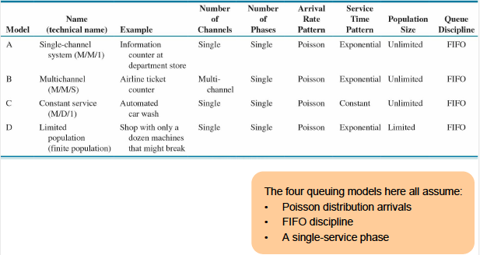

Model A- Single Channel

- Arrivals are served on a FIFO basis and every arrival waits to be served regardless of the length of the queue
- Arrivals are independent of preceding arrivals but the average number of arrivals does not change over time
- Arrivals are described by a poisson probability distribution and come from an infinite population
- Service times vary from one customer to the next and are independent of one another but their average rate is known
- Service times occur according to the negative exponential distribution
- The service rate is faster than the arrival rate

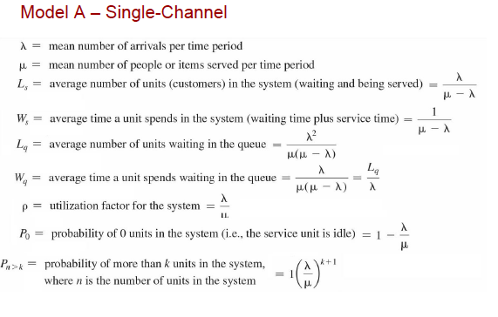
NB: No customer no patiens: idle unit

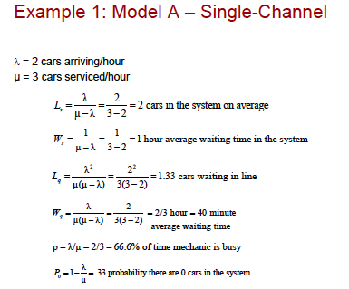
QCM: why is μ greater than λ because if μ is smaller, the answer will be negative and it do not make sense to have a negative number
For Wq we maybe ask to find in second so we multiply by 3600 or in minutes we multiply by 60
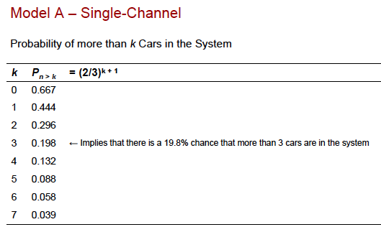
Probability of find k something (k cars) = (λ/μ )^k+1
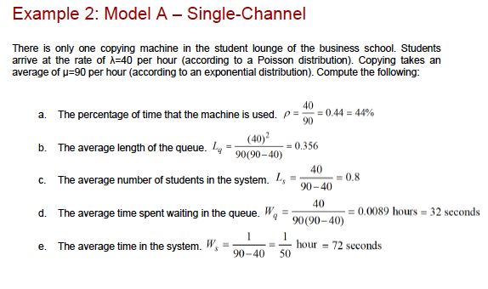
Or there is only one copying machine in the student lounge of the business school. Students arrive at the rate is a poisson distribution with the average of 40 per hours same as just “at the rate of λ=40 per hour”. La question est la même.

Model B- Multiple channel
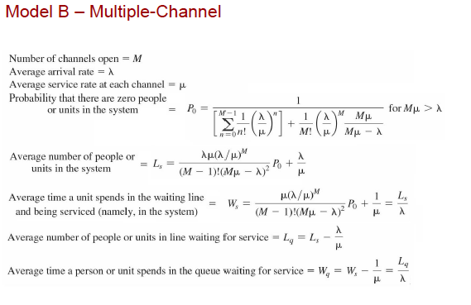
Le tableau en dessous est une façon plus simple de calculer ⇑. Ex : λ/μ = 67%. On check le tableau on choisi p=0.65 et on regarde M channel =2 donc à 65% on a Lq= 0.767 et là on va calculer Ls = Lq = λ/μ ensuite on calcule Ws et Wq
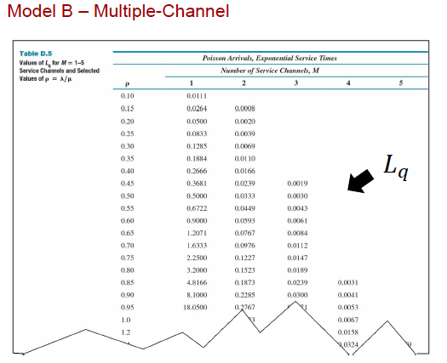
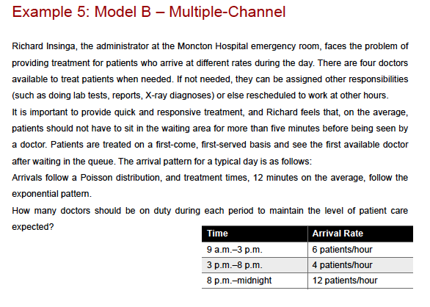
Poisson distribution et μ= 12mn et λ 5patient/hour (60/12), M = 4 doctors
- Lamda/u = 6/5 = 1.2
- 4/5 = 0.8
- 12/5 = 2.4
On regarde a la 4 chainet on lie le resultat Lq à partir du tableau from 9am -- 3pm
For M = 1 on a Lq = infini
M=2 on a Lq= 0.6748
M=3 on a Lq= 0.0904
M=4 on a 0.0158
De Lq on calculi Wq = (Lq/λ)*60 pour avoir le resulat en mn
On fait ça pour chaque intervalle d’heure

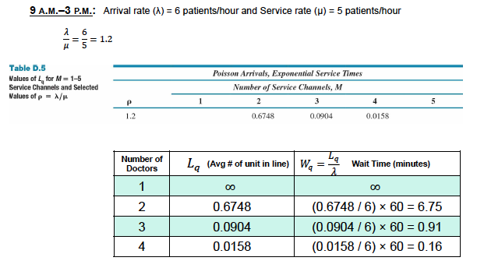

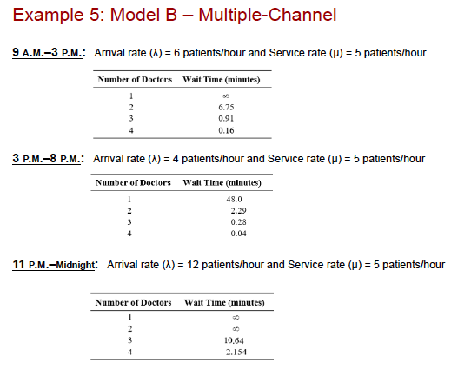

Model C- Constant Service Model
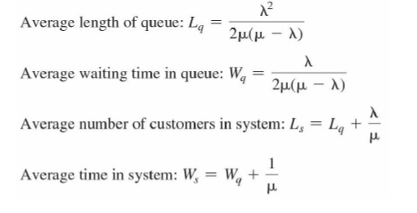

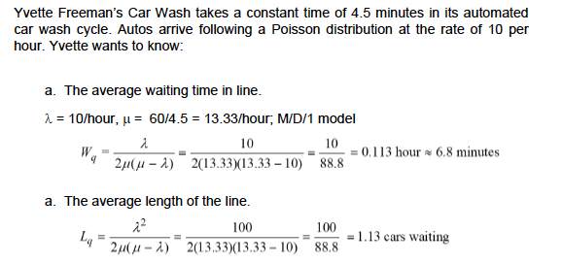

0.113*60 pour avoir 6.8 mn.

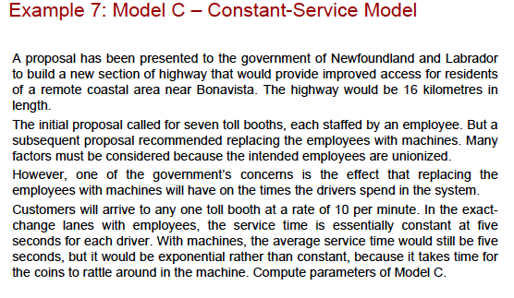
When you see rate of 10 per minute then it’s model C
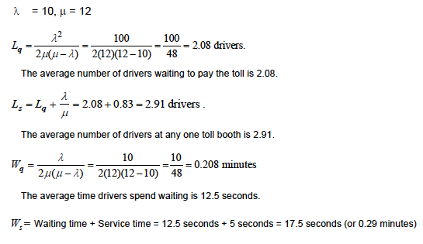
Check example 8 too
Model D – Limited population Model (no question on this model, on this exam)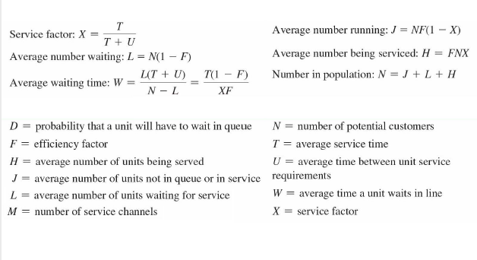

Inventory
What is inventory?
An inventory or stock is any material part or product sitting idle not being used usually in a warehouse and kept for use or sale in the future.
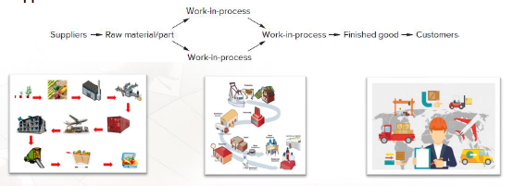

Inventories can be considered any assets that we may use in the future

Inventory Management: how many units to order and when to order.
Its objective is to strike a balance between inventory investment and customer service
- Inventory management is arguably the most important of OM
- Companies that do not have the right goods at the right time and place may incur delays and backorders.

Types of Inventories (QCM)
  - Raw materials and purchased parts
  - Partially completed items called WIP (work in process)
  - Finished goods or merchandises
  - Spare parts, tools and supplies.

Function of Inventory (QCM)
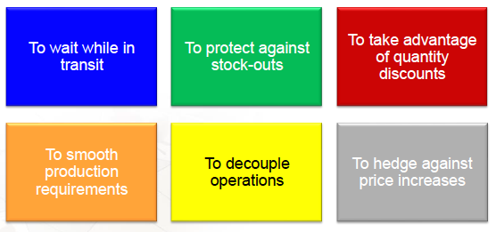

- To wait while in transit
When sending an item from one station to another, somehow we keep inventories in a truck (in-transit inventory)

- To protect against stock outs
Delayed deliveries from suppliers and unexpected increases in customer demand

- To take advantage of quantity discounts
EX; when a buy from costco, I pay less but buy more. You buy in quantity that exceeds your immediate needs

- To smooth production requirement
Saving money for future use. Satisfy overcapacity 3-4 months in advance

- To decouple operations
The work-in process buffers permit other operations to continue temporarily while the problem is solved.

- To hedge against price increases
3 months notice – prices will increase, send your orders now.

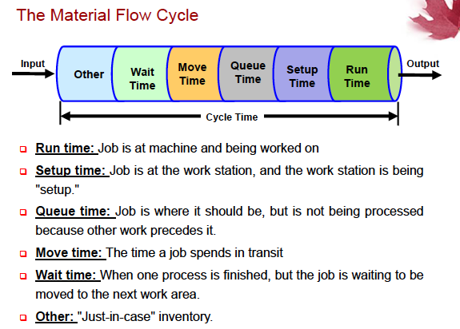

Inventory Counting Systems
If items are not continually tracked then they must be periodically reviewed and counted.

ABC classification system
- A value of 15-20% but amount to 70-80% exemple: engine or body of the car
- a value of 30-50% and amount to 30-50% ex; tires, lights, door
- Value 5-10% and amount to 60-70% ex: nut, shield

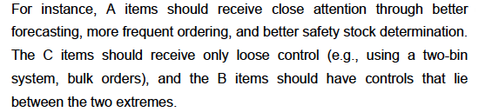

NB: Multiply demand by unit cost to find total annual cost. Then summation of all total cost. 3) in order to find %: demand divided by total annual cost.
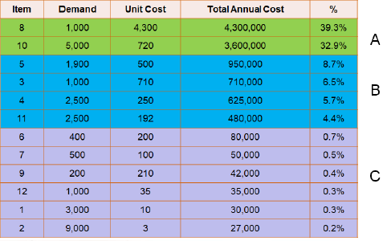
If any item misses from A it should require more attention

Cycle counting (not exam)

Dependent and Independent demands (en cas à l’examen)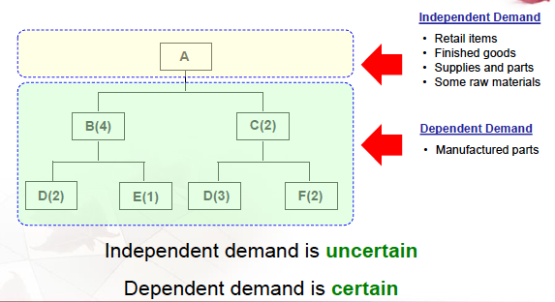

If A has 200 units then B needs 4*200 and C needs 2*200 of A

Associated inventory Costs (example of costs)
3 costs and we add them together:
Holding costs: cost to carry an item in inventory
Setup or ordering cost: need to pay to prepare the machine for the productions
Shortage costs: cannot satisfy the demand, demand > supply. Losing customers here.

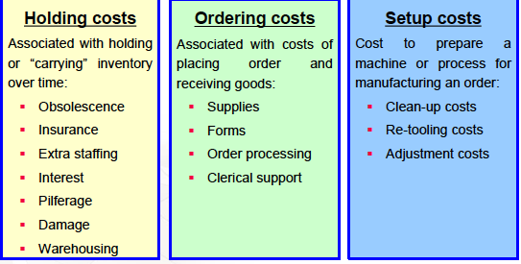

Fixed order quantity models Vs Fixe time period models
Fixed order quantity/Q models: every time you order to order the same amount.
Fixed-period models/P models: order every week (same week interval) but not equal number.
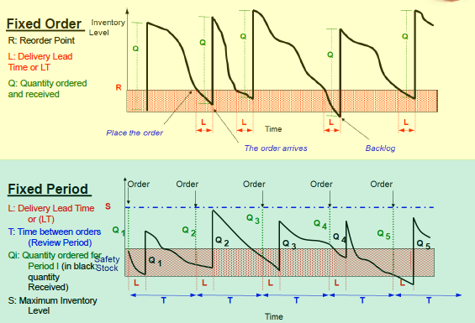

Explanation of the graph:1. Fixed order
Q- how much order, R- reorder point: as soon as inventory reach the R then we release the order. Time between Releasing order and receiving time is L (lead time). L is always the same.
Different T same Q
- Fixed Period
Same concept but the difference is the same T and Different Q and there is a maximum inventory level

