“Enthalpy of Various Reactions” - Dr. Rashmi Ventakeswaran

Written By:

Jackson Vicars (300310761)

CHM 1311 Section Z06

TA: Mahzad Yaghmaei

Tuesday October 8th

Department of Chemistry

University of Ottawa

Introduction:
The following experiment demonstrates theories in thermochemistry such as enthalpy of dissolution, heat of solution, and calorimetry. These are all branches of thermodynamics, which is the study of the transfer and transformation of energy (Olmsted et al., 2016.) Enthalpy can be best described as the energy flow of a system at a constant pressure (Olmsted et al., 2016.) This experiment in particular, looks at the enthalpy of dissolution which is formulated by the sum of the lattice energy (amount of energy required to break apart a compound into its gaseous ions) and enthalpy of hydration, which is the energy released when bonds are formed with water. (Olmsted et al., 2016.)
△H_{dissolution}= △H_{lattice}+ △H_{hydration}
Because heat transfer can work in both directions, the sign of this value (positive or negative) indicates the nature of the reaction: whether it is endothermic or exothermic. A simple device called a calorimeter, can be used to measure and calculate the amount of heat gained or lost during the reaction. There are two types of calorimeters: bomb calorimeters and styrofoam calorimeters. For the purpose of this experiment, a styrofoam calorimeter will be used as it helps maintain a constant pressure, so that other variables (volume of water for the system and the amount of solid) can be manipulated. Calorimeters are assumed to be closed systems as energy, in the form of heat, should not escape the container. The Styrofoam prevents heat loss to the surroundings, which makes it an ideal calorimeter. A styrofoam calorimeter will also be used in the following experiment to take into consideration the law of conservation of energy, as the sum of energy should remain the same during the overall transformation or transfer of the energy inside the closed system (Olmsted et al., 2016.) In the reaction of solid ammonium chloride with water, the surroundings (calorimeter) will absorb energy from the system (the can,) essentially decreasing the system’s temperature. Therefore, the energy absorbed by the surroundings should equate to a resultant decrease in temperature of 5°C for the system.

The equation: $q=mc△t$, will be used to estimate the value of heat transferred, as well as the direction. Where q is the amount of heat transferred (in kJ), m is the mass of the system being heated, c is the specific heat capacity (amount of heat required to raise 1 gram of the substance in question, by 1 degree) and $△t$is the change in temperature experienced by the system (Olmsted et al., 2016.)

Ammonium chloride was used as the cooling agent (solute) due to its cost effective nature and safety benefits, in comparison to ammonium nitrate. Ammonium nitrate is considered to be an explosive chemical, in that it is a strong oxidizing agent and can potentially react in warm environments (Oxiety et al. 2001) Due to the application of the chemical, this is a potential safety hazard, and as a result the chemical should be avoided. Ammonium chloride is also not only safer than ammonium nitrate, it is as mentioned above, more cost effective: the cost ammonium chloride required per can, is less than that of the cost of ammonium nitrate (Venkateswaren, 2019).

It is for the aforementioned reasons, that an aluminum can, containing 100 mL of water surrounded by 100 mL of water in a calorimeter, will attempt to be cooled by the addition of solid ammonium chloride. The results of this experimentation should adequately represent the amount of salt needed for the product to achieve its goal of cooling down 100cm³ of water within 5 minutes by 5°C.

Materials:
- Lab Coat and Safety Goggles
- Ammonium Chloride
- 50.0 mL graduated cylinder
- Styrofoam calorimeter with lid
- Aluminum can
- Thermometer probe (with port that can attach to LabQuest 2)
- LabQuest 2 system
- USB key
- Balance
- Scoopula

Procedure:
- Ensure safety by wearing goggles and a lab coat
- Assemble calorimeter apparatus, using the styrofoam cup and aluminum can
- Turn on and set up LabQuest 2 with the temperature attached into the proper port
  - Make sure to set the time to 300 seconds for the new file
- Measure the mass of the aluminum can and record the results
- Measure out 100.0 mL of water using a graduated cylinder, and record its temperature. Pour this into the aluminum can
- Measure out another 100.0 mL of water using a graduated cylinder, pour this directly into the calorimeter
- Using the value calculated for the mass of ammonium chloride needed, measure out approximately 13.28 g of the salt
  - Do NOT touch substance with bare hands
- Pour the salt into the aluminum can and quickly close the lid of the calorimeter, ensuring that the temperature probe is held inside through a hole in the top
  - Make sure to click “play” in lab quest as soon as the lid is on
- Begin swirling the calorimeter, vigorously for 5 mins. Once the timer on LabQuest 2 has stopped, record the value of the final temperature
- If the difference in temperature is not equal to 5K, repeat steps 5-9 with adjusted masses of the salt
  - Ensure to rinse out the calorimeter and measure out more water after each trial
  - Complete trials until the most precise value for change in temperature is attained
- Once the appropriate final temperature has been attained, dispose of all solvents and materials accordingly and clean up station.

Data & Observations/Results:
The ammonium chloride salt being used was a white, crystalline solid. It dissolved fairly quickly when in water however, some mass remained in the calorimeter for a few trials. Upon completing a trial, the solution inside the calorimeter appeared cloudy and white. It was also observed that water leaked from the bottom and sides of the calorimeter, as vigorous mixing released solutions from the openings of the calorimeter. As seen below, the temperature decreased over time. However, during trial 3, over the course of the 300 seconds, the temperature increased significantly before suddenly decreasing. No overall colour change or odour was observed as well.

Quantitative data:
Figure 1. Mass-Temperature Change Data
Mass of ammonium chloride (g) | Change in temperature (K)
13.27 | -4.3
14.07 | -3.8
14.50 | -4.6
14.71 | -5.1
15.19 | -5.1

Figure 2. Relationship between mass of ammonium chloride (g) and the change in temperature (K)
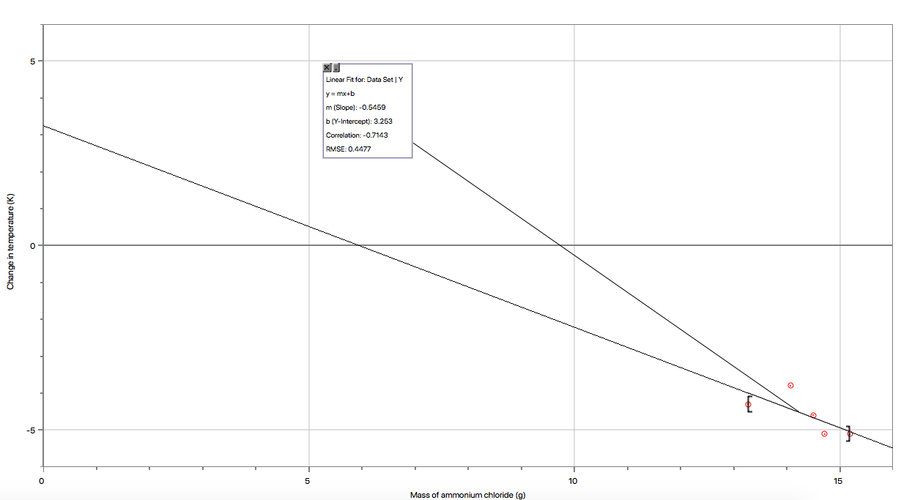

Figure 3. Relationship between mass of ammonium chloride (g) and the enthalpy change (kJ)
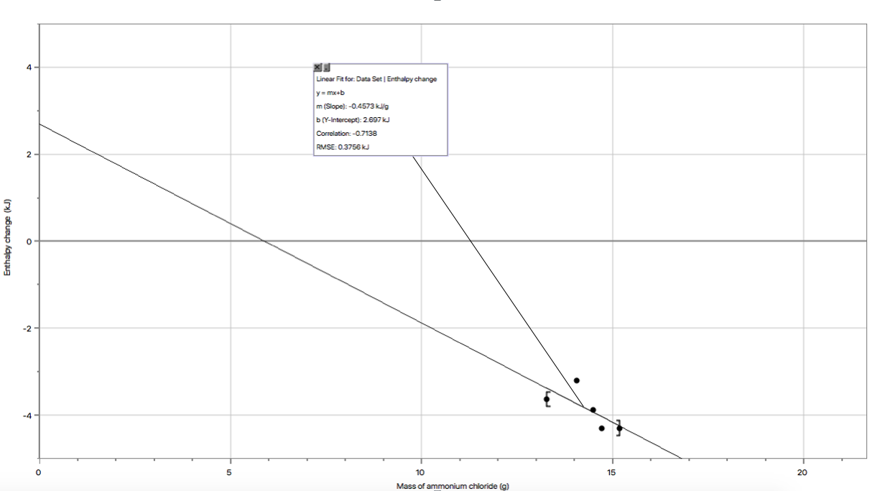

Calculations:
q_{system}= q_{Water}+q_{can}

q_{water}= mCΔT
q_{water} = 200ml (1g/ml)(4.184J/gK)(-5K)
q_{water} = -4.184KJ

q_{can} = mCΔT
q_{can} = 7.92g (0.900J/gK) (-5K)
q_{can} = -0.0356KJ

q_{system}= q_{Water}+q_{can}
q_{system} = -0.0356KJ +(- 4.184KJ)
q_{system} = -4.220KJ

n =$\frac{q system}{ΔHsoln}$
n =$\frac{4.220KJ}{17KJ/mol}$(refer to pre-lab calculations in appendix)
n = 0.2482mol

m_{NH4Cl} 53.50g/mol x 0.2482mol
m_{NH4Cl} = 13.28g

Discussion:
Overall, the design of the experiment resulted in an appropriate temperature change for the previously set condition of cooling down of a drink by 5 degrees celsius. Figure 1 provides the exact data for the change in temperature caused by the different masses of salt tested, while figure 2 represents the exact relationship between the mass, and the resultant change in temperature seen in the experiment. Therefore, as seen in figure 1 and as extrapolated from figure 2, increasing the mass of ammonium chloride resulted in an increase in the change in temperature as well. This is seen in figure 2’s somewhat linear trend.

For each trial, the change in temperature was measured over the desired period of 5 minutes (300 seconds) in which the sports drink should cool down by approximately 5 degrees celsius. As seen in figure 2, the first trial, with a mass of 13.27 g, resulted in a temperature change of only -4.3 degrees celsius. This confirmed the presence of error within the experiment, as 13.28 g was the theoretical mass calculated to ensure an exact decrease in temperature of 5 degrees. During the second trial, the decrease in temperature was unstable in comparison to the rest. This is seen in figure 4 (appendix) as the temperature seems to spike several times through the course of the run, before stabilizing and spiking again. The remainder of the trials seemed to be fairly stable in that the major decrease in temperature occurs towards the beginning of each run and begins to stabilize towards the end. However, it was observed that solution often began to leak out from the bottom of the calorimeter, decreasing the volume of water held as the surroundings, as well as the amount of solute available to cool down the system.

Theoretically, increasing the mass directly affects the amount of heat (q) transferred between the system and the surroundings. With negative values for the change in temperature, the value for heat will be negative for the system and, according to the equation: $q{}_{surrounding}= -q{}_{system}$ the final value for the surroundings will be positive. This validates the idea that the water inside the calorimeter was absorbing the heat from the reaction, allowing the solution inside the can to cool down (through the loss of heat/energy) and forcing its surroundings to heat up through the uptake of energy. (Olmsted et al., 2016.)

Figure 3 describes the relationship between the mass used in the trial, and the corresponding enthalpy change. The non-linear nature of the data, and the lack of consistency in a value close to the theoretical enthalpy change calculated, further validates the presence of error. Figure 3 also represents the second trial in another way by demonstrating its inaccuracy through its value for the total energy remaining in the system (enthalpy.) As extrapolated, the value for the enthalpy change in trial 2 is significantly higher than those for the previous and following trials, again due to the presence of several errors within the experiment. Overall, figure 3 describes the discrepancies between the reactions themselves, and as seen in the additional calculations section of the appendix, the values for the enthalpy of the system using the theoretical mass was off from the theoretically determined enthalpy by a percent error of 16.3%.

As mentioned above, the presence of error within the experiment was confirmed by the lack of consistency in the decrease of temperature and enthalpy change for the trials, as well as the fact that the theoretical calculation for mass that would result in a decrease in temperature of 5 degrees celsius only resulted in a decrease in temperature of 4.3 degrees celsius. An observed source of error during the experimentation process, would be the buildup of salt within the calorimeter throughout the run. Despite ammonium chloride having a relatively adequate solubility in water at 37.2g/100g of water (Venkateswaren, 2019,) clumps of salt were seen to accumulate at the bottom of the calorimeter and remain there throughout certain trials. Therefore, their potential to cool down the solution would be lost and an accurate reading for the change in temperature caused by the exact original mass would not be possible. This also accounts for the inaccuracy seen in trial 3. As seen in figure 4 the temperature spikes at around 100 seconds and quickly falls back down. This would be due to the dissolution of a clump of solid that hadn’t originally been dissolved. The inside crystals of the salt would still be at room temperature and once they were separated by the vigorous stirring, their higher temperatures would influence the solution around them (ie: higher temperature reading.) Once the clumps were fully dissolved the temperature would suddenly drop back to normal (as seen in figure 4.) The presence of these clumps would be the result of an inconsistent method for mixing the solution. The use of a magnetic stir bar would eliminate any inconsistency in the rate of mixing between trials as well as the variability between the ability and mixing strength of each individual mixing the solution. It would also, as a result, stabilize the rate at which the overall temperature of the solution decreased, and provide accurate results for the decrease in temperature and the corresponding mass.

A lack of precision in the instruments used for measurement would also be a source of error in this experiment. When measuring out water to put in the can to act as the system and to put inside the calorimeter to act as the surroundings, 100 mL of water was required in each section. A 50 mL graduated cylinder was used to transfer the water, and inaccurate readings due to the lack of precise increments on the cylinder would result in an inaccurate mass of water which would ultimately result in an inaccurate value for the heat transfer and more importantly an inaccurate value for the actual amount of salt needed for that specific amount of water. The use of more precise volume measurement equipment would increase the overall precision of the experiment, resulting in greater effectiveness of the experiment’s practical application (drink can.) The apparatus being used was also assumed to be a closed system due to the use of a styrofoam cup calorimeter however, the lid often opened up throughout each run, allowing heat to exit the system (affecting the change in temperature,) and no longer qualifying the calorimeter as a closed system. The aforementioned equations and calculations were also all formulated based on the assumption that pressure was kept constant therefore, a lid is required. In order to eliminate this exchange of heat energy and difference in pressure, a larger calorimeter, with a tighter and more personalized fit, could be used so that the can being cooled, fits inside the apparatus properly so that the edges are sealed and no energy can escape. Changing the mechanism by which the salt is introduced to the system to cool it down, would also increase the precision of the experiment, as the current apparatus and procedure includes several steps and areas in which energy is lost before the trial run even begins. A designated opening for the insertion of salt, that could be isolated and blocked off easily would minimize the amount of time spent by the thermometer, not measuring the temperature of the solution but rather measuring the temperature of its surrounding environment. An opening for the salt to be poured in would also double as an opening to insert the thermometer into as soon as the solution is formed, helping to seal the system.

Conclusion:
In conclusion the experiment was a success in that a value for the mass of salt required to cool down 100 cm³ of water, by 5°C was empirically determined. The use of ammonium chloride in the application of the reaction, was the result of its cost-effective and safer nature in comparison to ammonium nitrate. Experimentally, the value for the mass of ammonium chloride required was 15.19 grams. The discrepancy between this value and the theoretically calculated value of 13.28 is ultimately due to the presence of procedural, experimental and human error.
Appendix:
References
National Center for Biotechnology Information. PubChem Database. Ammonium nitrate, CID=22985, https://pubchem.ncbi.nlm.nih.gov/compound/Ammonium-nitrate (accessed on Oct. 7, 2019)

Olmsted, K., Williams, G. M., & Burk, R. C. (2016). Chemistry. Toronto, Ontario: John Wiley & Sons Canada.

Venkateswaran, R. (2019). What in the World Isn’t Chemistry. Exp 2.

Jimmie C. Oxiety, and, Nancy S. Gilson, “Thermal stability and compatibility of ammonium nitrate explosives on a small and large scale.” Chp. 1, Chemistry Department and Research Center for Energetic Materials. New Mexico Institute of Technology, Socorro. Received 22 October 1991. Revised 9 November 2001.

Prelab calculations
ΔH_{sol} = ΔH_{Lattice} + ΔH_{Hydration}
ΔH_{sol} = (705KJ/mol)(-307KJ/mol)(-381KJ/mol)
ΔH_{sol} = 17KJ/mol

Trial 1 sample calculation for enthalpy change as observed:
q = 200ml (1g/ml)(4.184KJ/gK)(-4.3K) + (7.92g)(0.900KJ/gK)(-4.3K)
q = -3.63KJ

% Error calculation:
%error =$\frac{4.220-3.63}{3.63}x100$
%error = 16.3%

Additional figures:
Figure 4. Temperature of solution, upon addition of ammonium chloride, over time.
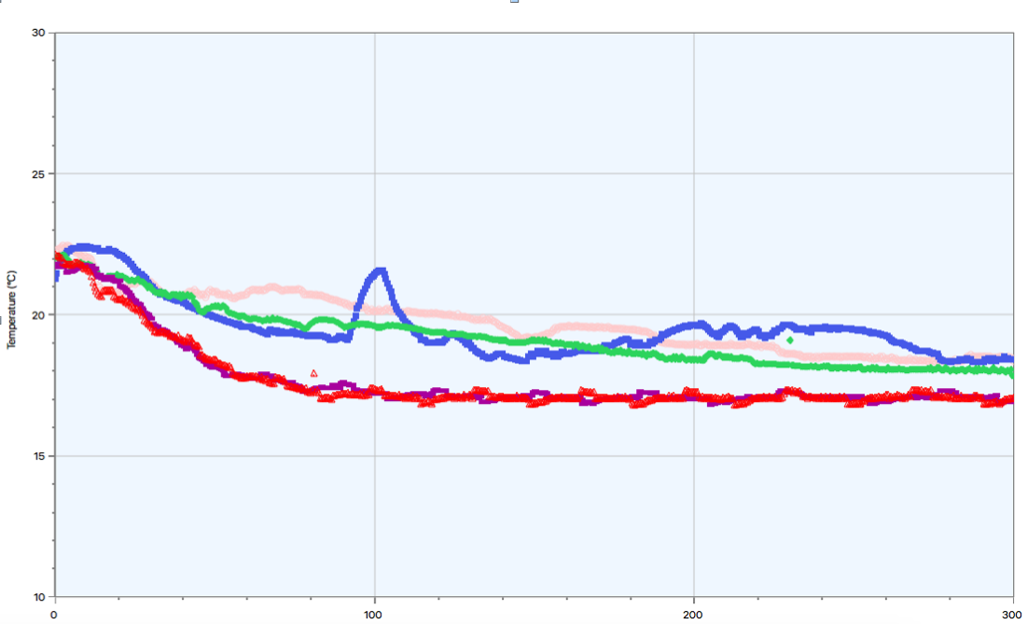

Figure 5. Raw data: initial and final temperatures for each trial and the corresponding mass used
Trial | Mass (g) | T_{initial} ( ℃) | T_{final} ( ℃) | ΔT ( ℃)
1 | 13.27 | 22.7 | 18.4 | -4.3
2 | 14.07 | 22.2 | 18.4 | -3.8
3 | 14.50 | 22.4 | 17.8 | -4.6
4 | 14.71 | 22.1 | 17.0 | -5.1
5 | 15.19 | 22.1 | 17.0 | -5.1

