

Department of Psychology

Adolescence
PSYC 233/2 Lec. A
3 credits

September 3 - December 3, 2019
Tues/Thurs 4:15-5:30 p.m.

Location SGW H654

Instructor

Dr. Jack Hirschberg
Office: SGW H-568
Office consultations after class or by appointment

Email: hirschbjj@gmail.com
DO NOT SEND EMAIL THROUGH MOODLE OR THE CONCORDIA EMAIL ADDRESS
When sending email, be sure to write “adolescence” (without the quotation marks) as the ONLY WORD in the subject area
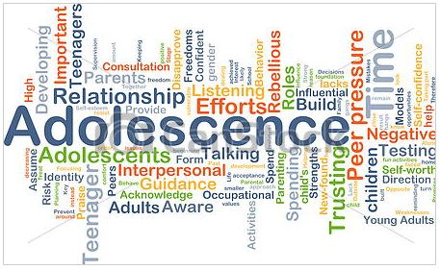

Please note:

Students registered in a Psychology program may not take this course for credit. Students who have received credit for PSYC 280 may not take this course for credit.
This course deals with one of life’s great milestones: the transition from childhood into adulthood. Adolescents are fascinating and confusing, fascinated and confused. The transition period is one of rapid physical and mental changes, all buffeted by social and cultural factors. This course will examine some of the major issues of adolescence such as: physical change, cognitive changes, emotional changes, social behaviour, sexuality, family dynamics, and educational needs.

The course will examine the issues from a multi-cultural approach. Students will be required to critically evaluate their beliefs about adolescence in order to foster an eclectic understanding of this transition period.

Course Objectives

By the end of the course the student will have learned the:

- Definition of adolescence.
- Cross-cultural diversity of adolescence.
- Psychological theories of adolescent development.
- Physical maturation of the body and brain during adolescence.
- Cognitive development in adolescence.
- Moral development during adolescence.
- Personality development during adolescence.
- Social development during adolescence.

Text

Steinberg, Laurence. 2020. Adolescence, 12th edition. New York: McGraw-Hill Education. ISBN: 978-1-260-56567-6. (Available at the Concordia Bookstore). The text gives you a “Connect account”. “Connect” is a study guide.

The text also available as a “Connect” ebook, 180-day etext rental (with or without “Connect”), and loose-leaf edition (with or without “Connect). To see all your buying options, go to https://www.mheducation.com/highered/product/adolescence-steinberg/M9781260058895.html#textbookCollapse. The text is also available from several online booksellers.

For students who are buying a version of the text with the “Connect” study guide, the following table has the information to access and register for the study guide:

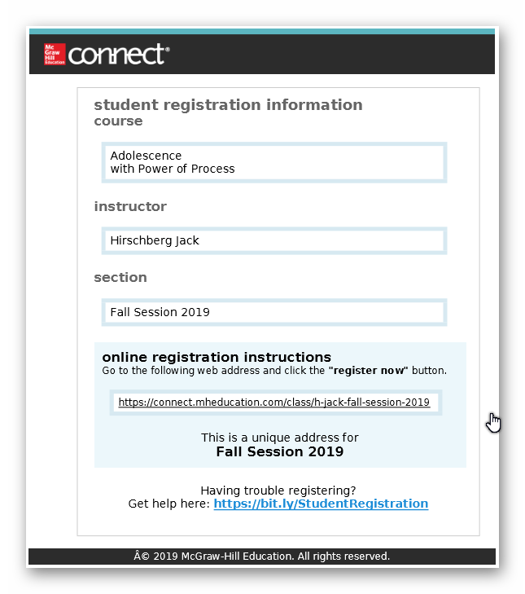

Course Format

Lectures, discussions, and audio-visual presentations will be used. This course presents a moderate workload. In addition to class time, students should expect to devote the same amount of time to reading and study.

Evaluation
Evaluation will be based on three class tests, as follows:
Test 1 25%
Test 2 45%
Test 3 30%

Tests will include material from the text and material presented in class and/or handouts. Test 1 will consist of 50 multiple-choice questions worth ½ mark each. Test 2 will consist of 90 multiple-choice questions worth ½ mark each. Test 3 will consist of 60 multiple-choice questions worthy ½ mark each. Each test will be written in class on the date specified in the course plan below. The time limit for tests will be one hour and 15 minutes. Each test will be based solely on the content covered for that test.

If a student misses class tests, he or she must provide a documented explanation (in addition to medical issues, please also refer to the diversity calendar below) and, if the explanation is accepted by the instructor, he or she may write the make-up test(s) during the test make-up date stipulated in the course plan below. The time limit for make-up test(s) will be a total of one hour and fifteen minutes regardless of whether the student is writing one or more make-up tests. Should the student miss any make-up test(s), the student will receive a grade of zero for the work not done, without further recourse. ONLY STUDENTS WHO MISSED TESTS AND HAVE RECEIVED PERMISSION FROM THE INSTRUCTOR MAY WRITE MAKEUP TESTS. Note that there are no provisions for supplemental exams or extra work to raise one’s grade in this course.in this course.

For the multiple-choice tests, students may challenge questions marked wrong which they believe should be marked correct. Challenges must be based on the material in the textbook for this course or the material presented in class. Challenges must be made by email within 24 hours after the test results are handed out in class (absence from class for any reason when the test results are returned does not extend the 24-hour deadline). Challenges are accepted or rejected at the discretion of the instructor. Challenges that are not accepted cannot be re-challenged. Challenges that are accepted must be kept confidential. If a student is found to have the divulged the result of his/her accepted challenge, the acceptance will be withdrawn and an additional penalty of 1 mark will be deducted from the students test score.

Each part of the course will receive a numerical grade, and these grades will be totaled and rounded to one decimal point to attain the final numerical grade. The grades may be adjusted equally for all students by the instructor to achieve a class average of about 75 to 76.

**PLEASE NOTE THAT THE EXAMPLE GIVEN IN THE STUDENT GUIDES ON HOW TO CONVERT NUMERICAL GRADES TO LETTER GRADES IS ONLY A SAMPLE OF WHAT IS POSSIBLE. EACH PROFESSOR MAY ASSIGN LETTER GRADES ACCORDING TO A SYSTEM DESCRIBED IN HIS/HER COURSE OUTLINE.**

The final grade in the course will be a letter grade based on your cumulative numerical grade and your rank in the class, as follows:

If the total numerical And if your standing Your final
grade is between in the letter group is grade is
---------------------- ------------------- ----------

96 & 100 Any standing A+
86 & 95.9 Top half A
86 & 95.9 Bottom half A-
76 & 85.9 Top third B+
76 & 85.9 Middle third B
76 & 85.9 Bottom third B-
66 & 75.9 Top third C+
66 & 75.9 Middle third C
66 & 75.9 Bottom third C-
50 & 65.9 Top third D+
50 & 65.9 Middle third D
50 & 65.9 Bottom third D-
0 & 49.9 Any standing FNS

Cheating and Plagiarism
Cheating and plagiarism are serious academic offenses. Cheating involves the use of unauthorized material (notes, books, computers, text messaging, etc.) during exams, or the copying of answers from another person’s exam. Cheating will result in a zero for the student’s work. Furthermore, if the instructor judges that the offense was committed knowingly and with premeditation, the student may also be referred to the appropriate university authorities for further action.

Course Plan
Dates Topic in Psychology Text Readings

Sept 3 Introduction:

Definition & boundaries of adolescence

Framework for studying adolescence Introduction, pgs. 2-8
Sept 5 History of adolescence research Introduction, pgs. 11-12
Sept 10 Theories of adolescent development
Sept 10 Biosocial/Organismic Introduction, pgs. 8-10
Sept 12 Learning/Sociological Introduction, pgs. 10-11

Sept 16 DNE withdrawal deadline

Sept 17 Scientific study of adolescent development
Sept 17 Quantitative/ Experimental methods Introduction, pgs. 12-13
Sept 19 Qualitative/Correlational methods Introduction, pgs. 12-13

SEPT 24 TEST 1

Sept 26 Test 1 exams are returned to students

Sept 26 Transitions in adolescence
Sept 26 Biological Transitions Ch. 1, pgs. 14-26

Sept 27, 6:00 p.m. Deadline for submission of challenges to test 1 (challenge by email only)

Oct 1 Class cancelled

Oct 3 Biological transitions Ch. 1, pgs. 26-35
Oct 8 Cognitive transitions Ch. 2, pgs. 42-47
Oct 10 Cognitive transitions Ch. 2, pgs. 47-70
Oct 15 Social transitions Ch. 3, pgs. 71-96
Oct 17 Adolescents in context
Oct 17 Families Ch. 4, pgs. 97-124
Oct 22 Peer groups Ch. 5, pgs. 125-157
Oct 24 Schools Ch. 6, pgs. 158-187
Media Ch. 7, pgs. 202-216

OCT 29 TEST 2

Oct 31 Test 2 exams are returned to students

Oct 31 Psychosocial development
Oct 31 Identity Ch. 8, pgs. 217-240

Nov 1, 6:00 p.m. Deadline for submission of challenges to test 2 (Challenge by email only)

Nov 4, DISC withdrawal deadline

Nov 5 Intimacy Ch. 10, pgs. 272-303
Nov 7 Sexuality Ch. 11, pgs. 304-334
Gender Ch. 8, pgs. 240-245
Nov12 Gender. Video: The Fight to be Male No text reading
Nov 14 Problems in adolescence Ch. 13, pgs. 364-391
Nov 19 Moral development in adolescence No text reading

NOV 21 TEST 3

Nov 26 Test 2 exams are returned to students

Nov 26 Adolescence and Original Canadian Nations No text reading

Nov 27, 6:00 p.m. Deadline for submission of challenges to test 3 (Challenge by email only)

Nov 28, 4:15-5:30 MAKE-UP TESTS (Location: Classroom, H654)

Diversity Calendar

Concordia University is a very large multiethnic community. In keeping with the concepts of mutual respect and reasonable accommodation, a student who must miss a scheduled test due to a holiday that requires an absence from the university, the student may write the make-up test. Permission to write the make-up test will be granted ONLY if the student involved notifies the instructor well in advance of the holiday. The following are a list of some recognized holidays that affect this Tuesday/Thursday course (this list may not be complete):

Date Holiday Name Observance
Oct 1 Rosh Hashana Jewish
Oct 22 Simchat Torah Jewish

