Experiment 1

Thin Layer Chromatography

Written by:
Tala Salaheddin (300063968)
Hiba Yousuf (300069220)

TA:
Michael SL (mslob094@uottawa.ca)
Section: Z08

January 24th, 2019

Procedure
Please refer to the lab manual (Thin Layer Chromatography, Experiment #1, pg 5-6).
Modifications made to procedure:

Part A
- A second trial was performed with the reference solution being benzophenone.

Part B
- Steps 1-3 were repeated to obtain a second TLC developed in ethyl acetate (EtOAc).

Observations
- The various TLC plates obtained for the experiment are thin pieces that have two sides to them: one with silica gel that is white (where solutions were spotted) and one with aluminum.
- Important to handle TLC plates with care to prevent cracking and contamination of silica gel layer.
- Unknown sample #87 appears to be a crystalline, opaque solid that is white in colour and has a pungent smell.
- Sample #87 easily dissolved in dichloromethane, creating a transparent/clear and colourless solution.
- Ethyl acetate, benzophenone, and biphenyl appear to be transparent/clear and colourless liquids with pungent odours
- Unknown sample V appears to be a clear, colourless liquid with a strong smell.
- When TLC plates are placed under the UV light, they appeared to be a vibrant green colour with large dark spots within corresponding lanes (reference, co-spot, and sample).

Data Tables
Part A: Identifying the components of an unknown mixture using TLC
Lane | R_{f} Value
Lane | Biphenyl TLC (1) | Benzophenone TLC (2) Trial #1 | Benzophenone TLC (3) Trial #2
Reference | 0.89 | 0.75 | 0.71
Co-spot (bottom) | 0.89 | 0.74 | 0.72
Co-spot (top) | 0.89 | 0.99 | 0.91
Sample | - | 1.00 | 0.91

Part B: Effect of solvent on TLC
Solvent: EtOAc
Lane | R_{f} Value
Lane | Biphenyl TLC (4) | Benzophenone TLC (5) Trial #1 | Benzophenone TLC (6) Trial #2
Reference | 0.96 | 0.77* | 0.93
Co-spot | 0.97 | 0.77* | 0.93
Sample | 0.96 | 0.76 | 0.93
*spot is large and lines up with both the reference and co-spot lanes.

Solvent: hexanes
Lane | R_{f} Value
Lane | Biphenyl TLC (7) | Benzophenone TLC (8)
Reference | 0.51 | 0.04
Co-spot (bottom) | 0.71* | 0.04
Co-spot (top) | 0.71* | 0.55
Sample | 0.71* | 0.61
*spot is large and lines up with both the co-spot and sample lanes.

Part C: Identification and Separation of unknown
Lane | R_{f} Value
Lane | o-bromonitrobenzene  TLC (9) | m-bromonitrobenzene TLC (10) | p-bromonitrobenzene  TLC (11)
Reference | 0.49 | 0.65 | 1.00
Co-spot (bottom) | 0.44 | 0.25 | 0.66
Co-spot (middle) | - | - | 0.94
Co-spot (top) | 0.68 | 0.45 | 1.25
Sample (bottom) | 0.47 | 0.28 | 0.81
Sample (top) | 0.71 | 0.48 | 1.09

TLCs

Legend:
Ref = Reference spot
Co = Co-spot
Sm = Unknown Sample spot
Rf = Retention Factor
TLC = Thin Layer Chromatography Plate

Part A
TLC 1 TLC 2 TLC 3
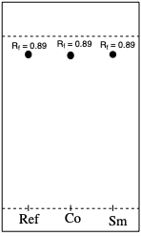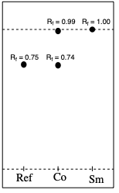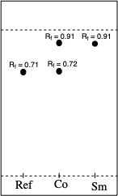
Part B
TLC 4 TLC 5 TLC 6
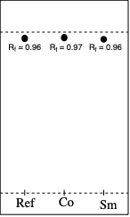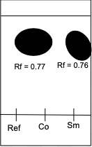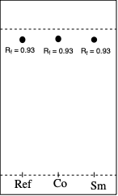

TLC 7 TLC 8
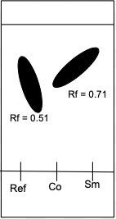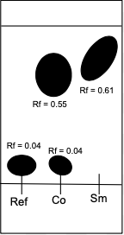

Part C
TLC 9 TLC 10 TLC 11
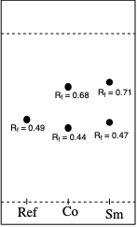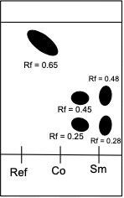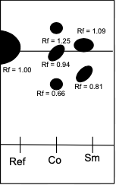

Substance Synopsis:

Part A:

TLC 1:
Ref → Biphenyl
Co → (Biphenyl) + (Dichloromethane + Unknown Sample [87])
Sm → Dichloromethane + Unknown Sample [87]

Developing Jar: 2:8 Mixture of Ethyl Acetate & Hexanes

TLC 2 & 3:
Ref → Benzophenone
Co → (Benzophenone) + (Dichloromethane + Unknown Sample [87])
Sm → Dichloromethane + Unknown Sample [87]

Developing Jar: 2:8 Mixture of Ethyl Acetate & Hexanes

Part B:

TLC 4:
Ref → Biphenyl
Co → (Biphenyl) + (Dichloromethane + Unknown Sample [87])
Sm → Dichloromethane + Unknown Sample [87]

Developing Jar: Ethyl Acetate

TLC 5 & 6:
Ref → Benzophenone
Co → (Benzophenone) + (Dichloromethane + Unknown Sample [87])
Sm → Dichloromethane + Unknown Sample [87]

Developing Jar: Ethyl Acetate

TLC 7:
Ref → Biphenyl
Co → (Biphenyl) + (Dichloromethane + Unknown Sample [87])
Sm → Dichloromethane + Unknown Sample [87]

Developing Jar: Hexanes

TLC 8:
Ref → Benzophenone
Co → (Benzophenone) + (Dichloromethane + Unknown Sample [87])
Sm → Dichloromethane + Unknown Sample [87]

Developing Jar: Hexanes

Part C:

TLC 9:
Ref → o-bromonitrobenzene
Co → (o-bromonitrobenzene) + (Unknown [V])
Sm → Unknown [V]

Developing Jar: 9:1 Hexanes: Ethyl Acetate

TLC 10:
Ref → m-bromonitrobenzene
Co → (m-bromonitrobenzene) + (Unknown [V])
Sm → Unknown [V]

Developing Jar: 9:1 Hexanes: Ethyl Acetate

TLC 11:
Ref → p-bromonitrobenzene
Co → (p-bromonitrobenzene) + (Unknown [V])
Sm → Unknown [V]

Developing Jar: 9:1 Hexanes: Ethyl Acetate

Calculations
*Using the numbers for Part A: TLC 1: Reference point.

R_{f} = d_{Ref} / d_{solvent front}
R_{f} = 4.25mm / 4.75mm
R_{f} = 0.89

**All of the R_{f} values will be calculated using the same equation; distance travelled by spot (length from baseline to the centre of the spot) / distance travelled by solvent front (length from baseline to solvent front).**

Discussion
Part A: Identifying the components of an unknown mixture using TLC

- Thin layer chromatography (TLC) is used to monitor the progression of reactions. During this experiment, the polarity of compounds within substances is determined through the usage of TLC plates. One side of the TLC plate consists of silica gel, which is a polar material and a popular adsorbent. When silica gel comes in contact with polar compounds, the forces of attraction are much greater. Therefore the compounds move up the TLC plate at a much slower rate, ultimately resulting in a smaller R_{f} value.
- Unknown sample #87 is tested with both benzophenone and biphenyl on TLC plates, using a solvent of 2:8 ethyl acetate (EtOAc) and hexanes in the developing jar. The presence of a substance is confirmed when the spots on the reference, co-spot, and sample lanes align. TLC 1 demonstrates an alignment amongst spots, therefore unknown sample 87 is biphenyl. The spots have an R_{f} value of 0.89 respectively. It is concluded that benzophenone is not present in the unknown. The R_{f} values which indicate the presence of biphenyl (co-spot and sample lanes) in TLC 3 are slightly greater than those in TLC 1 but the difference is very minor. Benzophenone was found to be more polar than biphenyl because the Rf value for benzophenone is smaller. Two trials were performed when using benzophenone as the reference sample because in the first trial (TLC 2), it is possible that a large sample was used during the spotting process which resulted in large overlapping spots after the plate was developed. It was not possible to control the sizes of the spots as the capillary tubes had different cross-sectional areas and so that determined the size of the spot even if the capillary was only allowed to touch the plate for a fraction of a second.

Part B: Effect of solvent on TLC

- Ethyl acetate (EtOAc) and hexanes are both used as separate solvents in Part B of the experiment. From Table 2 in the lab manual, ethyl acetate (which has an ester group) is the more polar solvent. Due to this, hydrogen bonding will occur between the unknown substance and the mobile phase (ethyl acetate) and the rate of migrations should be faster (larger R_{f} values). Hexanes are less polar in comparison to ethyl acetate, therefore hydrogen bonding takes place between the compounds in unknown sample #87 and the silica gel, resulting in a slower movement up the plate (smaller R_{f} values).
- This is confirmed when observing the TLC plates in Part B of the experiment.

Solvent: EtOAc
- When testing for the presence of biphenyl in unknown sample #87, the R_{f} values for the spots are all relatively high which proves the idea that migration rate is faster when using EtOAc. Additionally, the spots align on TLC 4 which indicates the presence of biphenyl.
- When testing for the presence of benzophenone, the R_{f} values for the spots are also high, further supporting the fact that migration rate for the spots is faster in a polar solvent. Two trials are carried out: the first resulted in unclear spotting (some spots merged) and the second is done to correct the error.
- When using EtOAc, both biphenyl and benzophenone seemed to be present in unknown sample #87 according to the data obtained in the lab. This might have been due to the fact that two plates had to be put in one developing at the same time and so the plates might have fallen on one another which resulted in cross-contamination of the sample.

Solvent: Hexanes
- Hexanes are a less polar solvent that is used to demonstrate the effects of solvent on TLC plates. The spots have merged together due to possible errors that may have occurred. One of those might be the handling of the TLC plate. Since no gloves were worn, it is possible that sweat/oils from the hands contaminated the plate and resulted in spots at unexpected spots.

Part C: Identification and Separation of unknown

- Unknown sample V is sampled onto three separate TLC plates using isomers of bromonitrobenzene: o-bromonitrobenzene, m-bromonitrobenzene, and p-bromonitrobenzene. The results obtained during the lab experiment were a result of possible errors, but according to the TLC plates obtained o-bromonitrobenzene and p-bromonitrobenzene were present in sample V.. This uncertainty exists simply because the spots on TLC 9, TLC 10, and TLC 11 were quite large and some of them merged, making it difficult to distinguish between aligned and unaligned spots.
- For the results obtained, TLC 10 (meta-bromonitrobenzene) does not show any presence of the compound since none of the spots align.
- TLC 9 (o-bromonitrobenzene) has spots with slight differences amongst R_{f} values in the reference, co-spot, and sample lanes. The values range from 0.49, 0.44, and 0.47, which allows for the assumption that ortho-bromonitrobenzene is present.
- Similarly, TLC 11 (p-bromonitrobenzene) shows a small variation when it comes to R_{f} values. Firstly, the large spot in the reference lane could mean that it is aligned with the spots in the co-spot and sample lanes. With that being said, it is possible that para-bromonitrobenzene is present in unknown sample V. The R_{f} values range from 1.00, 0.94, and 1.09 which do not differ significantly, leading to the assumption that the spots in the reference lane, co-spot lane, and sample lane align.
- Due to experimental errors, it is difficult to confirm the presence or absence of these compounds.

Conclusion
Part A:
Unknown #87 was found to be biphenyl and not benzophenone.

Part B:
The more polar the solvent used to develop the TLC plates, the higher the spots will rise and the greater the Rf values.

Part C:
Sample V is made up of two compounds: o-bromonitrobenzene and p-bromonitrobenzene.

Questions

- Since the co-spot consists of both the reference compound and the unknown sample (analyte), spotting at its allocated region should be done last so as to not cross-contaminate the reference/analyte with each other which would result in unexpected spots on the developed TLC plate for the outer lanes.

- Increasing the polarity of the solvent will make the spots go higher up the TLC plate because there will be more interaction with the mobile phase than the stationary phase which is now less polar than the solvent. In other words, the spots will have a greater retention factor value. This is due to the fact that a more polar solvent copetes better with the stationary phase.

a) b)
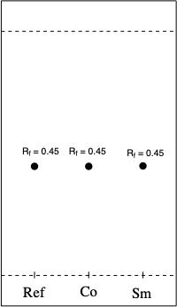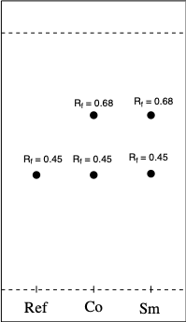

c)
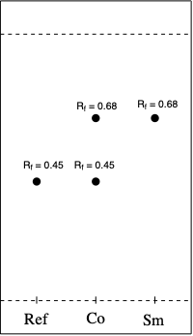

d) In relevance to how the TLC was carried out (with three lanes), using either of compounds A or B would be almost equally sufficient in allowing to keep track of the reaction progress as whether with the use of B as reference (images below), or use of A, it is possible to figure out if the reaction reaches 100% completion or not. In case of A, this can be seen as in the last TLC, no spot for compound A would appear showing that all of it has been converted. In the case where B is used as reference, the sample lane of the final TLC will have no spot at an Rf value other than that at 0.68 and hence again showing that all of compound A has been converted.

TLC plates if compound B was used as a reference:

At start of reaction Half-way through reaction At end of reaction
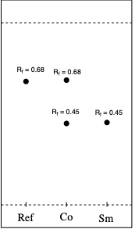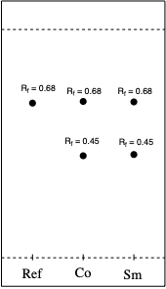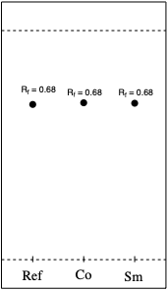

4.
a) b) c)
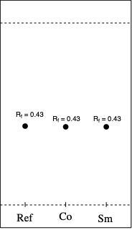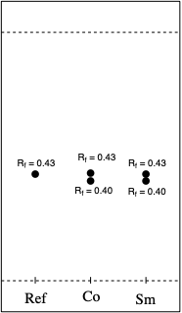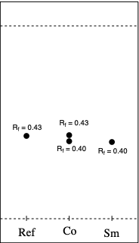

d) A co-spot is useful if the solvent runs with a slight diagonal, resulting in identical compound spots having different heights on the TLC plate. The co spot lane helps keep track of that. In addition, it is helpful in determining whether two seemingly identical spots are actually so. If the spots belong to different compounds, the co-spot lane might have an elongated spot which shows that the spots belong to two different compounds but with very similar Rf values.

5. i) a)
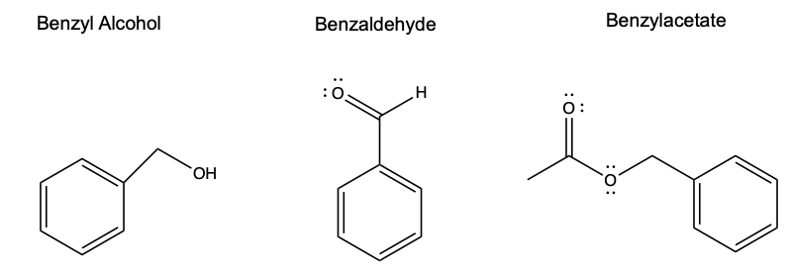

b) Benzyl acetate < benzaldehyde < benzyl alcohol
c) According to table 3 in the procedure (lab manual) and multiple online resources, esters (like benzyl acetate) are less polar than aldehydes (like benzaldehyde) which are in turn less polar than alcohols which have a hydroxyl functional group (like benzyl alcohol). Table 3 lists them in order of mobility - those that rise up the TLC plate faster are less polar because they form hydrogen bonds with the less polar mobile phase. The silica on the other hand, is more polar and so the more polar molecules with interact and adsorb on the it for longer.

ii) a)

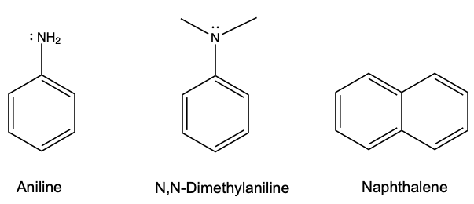

b) Naphthalene < N,N-Dimethylaniline < Aniline
c) According to table 3, aromatic compounds move faster up the plate and since naphthalene has no other functional groups, it is the least polar. Aniline has an amine functional group, while N,N-Dimethylaniline has a amide functional group. Since the nitrogen atom in the amide is surrounded by two no-polar groups (methyl groups), the amide has weaker polarity in comparison to the amine which has its polar group exposed.

iii) a)

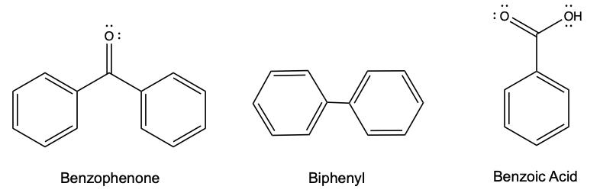

b) Biphenyl < Benzophenone < Benzoic acid
c) Once again, table 3 dictates the correct order. Benzoic acid has two highly electronegative oxygen atoms and so three strong polar bonds(C-O double bond, C-O single bond and O-H single bond), while benzophenone has just one polar bond (C-O double bond) contributing to its polarity. Therefore; benzoic acid is the most polar. Biphenyl has no functional groups adding to is polarity; hence, it is the least polar.

References
- Experiment 1: Thin Layer Chromatography, Dr. Rashmi Venkateswaran
- Santiago M and Strobel S. (January 2013). Thin layer chromatography. Department of Molecular Biophysics and Biochemistry, Yale University, New Haven, CT, USA. https://www.ncbi.nlm.nih.gov/pubmed/24182936
- Briana. “Organic Chemistry.” Functional Group Polarity, 20 April. 2008, http://organicchemistryorganicchemistry.blogspot.com/2008/04/functional-group-polarity.html

Raw Data 

