COMMUNITY DEVELOPMENT
Guest lecture: Dr. Natasha Blanchet-Cohan

Why community ?
- We are social beings
- Community is what provides us with a sense of belonging
- Evidence that strong sense of belonging provides for better physical and social health
- Communities form the basis for collective visions of society
- Community is also a vehicle between State-citizens (i.e. the delivery of government programs and services)
“ Community is an elusive yet frequently invoked concept in Canada and throughout the world.”
(Kelly & Caputo, 2011,1)

What is Community Development?
- Planned evolution of all aspects of community well-being (economic, social, environmental and cultural.
- A process whereby community members come together to take collective active and generate solutions to common problems.
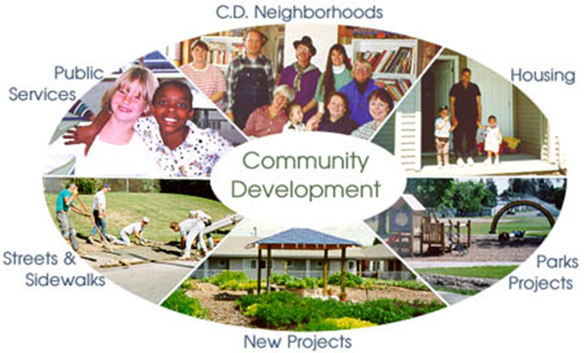
Shifting the Context (P. Block)
- Communities built on capacities and assets
Asset-based community development
- Focus on what are the skills and talents of local residents, as well as the capabilities available or possible through local organizations and institutions…not what is missing and is a problem.
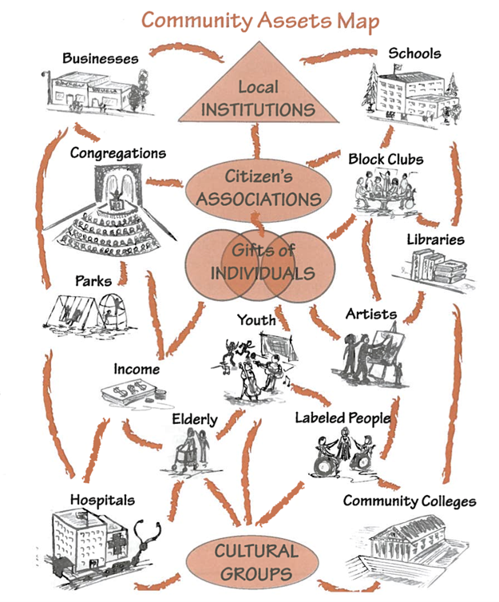 Moore & O’Brien, 2006
Principles for Transformation
- Build social fabric to enable accountability among citizens
- Strong associational life is essential and central
- Citizens using the power to convene creates an alternative future
- The small group is the unit of transformation
- All transformation is linguistic- community as a conversation
Other elements…
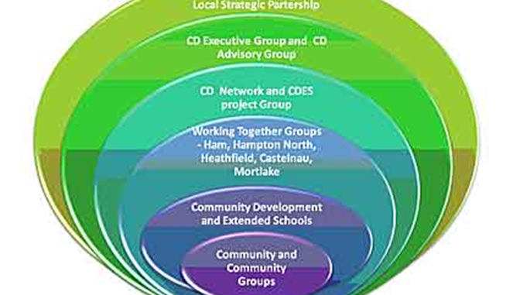
- emphasizes self-help, mutual support, and it also enhances local capacity for problem-solving
- promotes collective action to bring matters to political decision makers
A process of establishing, or re- establishing structures of human community within which new ways of relating, organising social life, promoting human rights and meeting human needs become possible
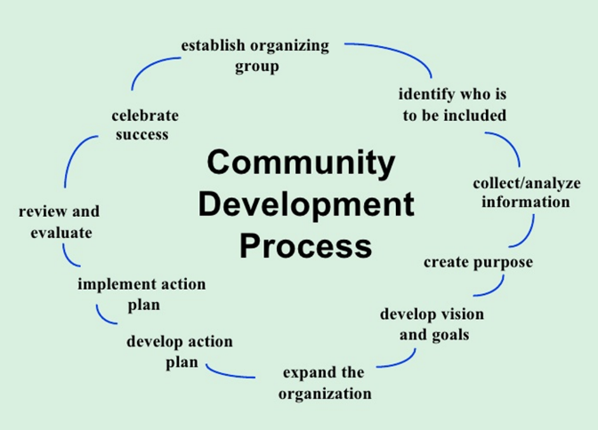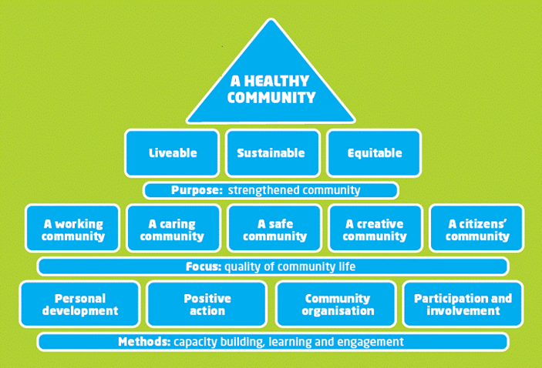

CD Practitioners Work On

- Identifying and strengthening community assets
- Building individual and community capacities
- Increasing community participation
- Facilitating networks
- Implementing a community planning process
- Fostering and facilitating change
- Facilitating change processes with multiple actors: community organization, state actors and civil society.
- Participatory evaluation and measuring social impact

An example of a basic CD project
A group of community members in a downtown urban center asked why women who want to leave the life of prostitution often fail. A CD practitioner helps to design a relevant consultation of women who have successfully made the transition. They asked what was needed and invited input into designing an initiative that would really work.
An example of a more complex CD project
In a community, where very few job opportunities existed in their community for mental health survivors. There were mixed feelings and much ignorance about the abilities these survivors and many doubts about supporting anything that could create a financial dependency. A CD practitioner acted as a catalyst to bring together community people to increase awareness, consider options and develop innovative and community-based solutions to the problems. They discovered that everyone was interested in sustainable and meaningful employment, regardless of other differences. The CD practitioner supported the community to create a cooperative that was run by and for the mental health survivors. This helped improve understanding and enhanced community relations.

Where do we see community developers?
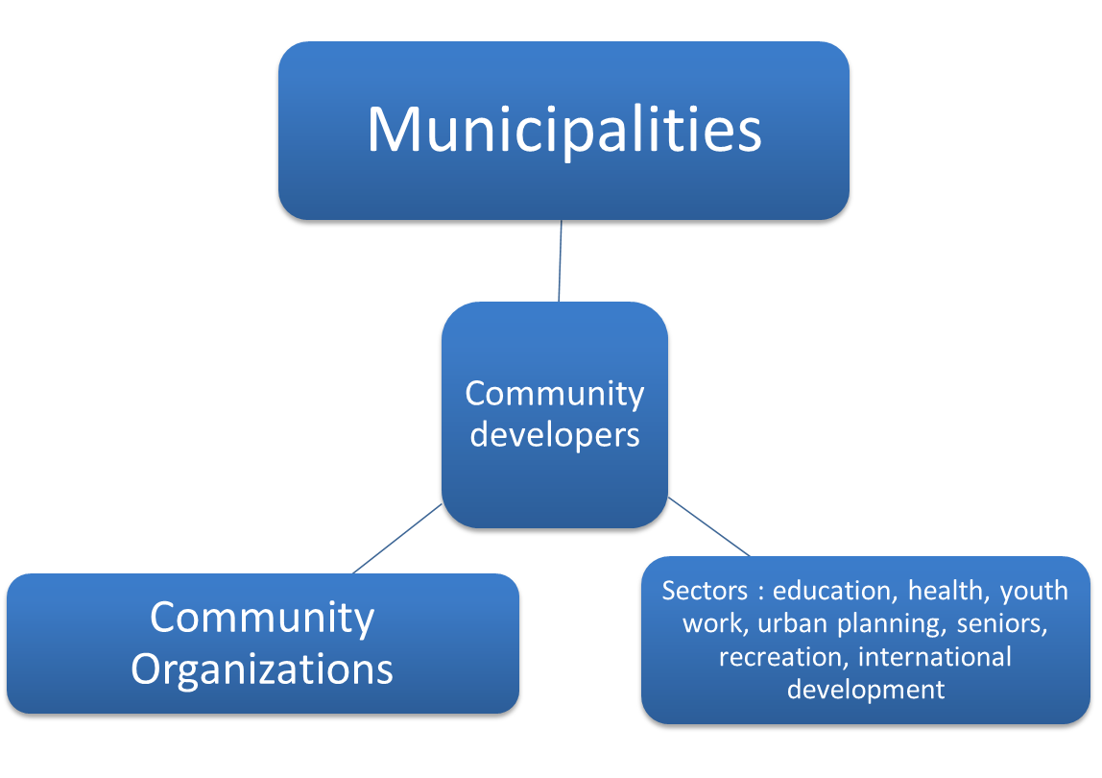
Jobs that need CD lens…
- Community Development Practitioner
- Community Development Officer
- Program Officer
- Volunteer Coordinator
- Youth Coordinator
- Social Entrepreneur/Social Innovation Facilitator
- Community Researcher/Facilitator
- Housing Development Officer
- Community Organizer
- Community Liaison between Municipality and its Citizens
- Environmental Stewardship Coordinator Green Energy Consultant
- Municipal Government/First Nations Government Officer
In the Community Development I course that we teach
- To identify and describe the pros and cons of different community development approaches.
- To recognize and reflect on community and individual capacity building processes in Canada and abroad.
- To demonstrate a critical awareness of the link between social issues and systemic power structures.
- To identify and describe frameworks and practices that enable social change.
- To appreciate the value of and opportunities for involvement in your local community.
- To develop your own perspective and skills in community development.
In the Community Development 2 course
- Apply community development approaches and processes
- Acquire skills in community development work
- Critically assess the relationship between social contexts and underlying systemic structures of power
- Explore and engage in community and individual capacity building
- Participate in the reflection and action necessary for social change
- Expand understanding and critical perspectives on the field of community development

In Summary
- Community development is a concentration for students who want to focus on strengthening communities
- The CD concentration involves gaining skills in the CD process- to acquire skills to bring together, build on assets in order to improve the well-being of community members and society
- The emphasis in community development is on how people can transform the world in ways that are locally rooted and globally informed.

