Chapter 5: Efficiency
- Fundamental idea in economics: voluntary exchange creates value and can make everyone involved better off
  - This principal supports markets (businesses that facilitate the transaction between consumers and producers)
  - Raises the questions of how do we know people are better off and can we say by how much?
    - Surplus: measures the benefit that people receive when they buy something for less than they would have been willing to pay or sell something for more than they would have been willing to accept
      - Best way to look at the benefits people receive from successful transactions
  - Efficiency: maximizing total surplus
- General Idea: demonstrate that a free market equilibrium generated in the S&D model is efficient
  - The quantity is said to be efficient if the welfare of producers on the supply side plus the welfare of consumers on the demand is higher than any other output level

Willingness to Pay and Sell
- Willingness to Pay (reservation price): the maximum price that a buyer would be willing to pay for a good or service
  - Potential buyers want to pay as little as possible additional to this general preference all buyers have a maximum price they are willing to pay
- Willingness to Sell: the minimum price that a seller is willing to accept in exchange for a good or service
  - Sellers want to sell for a price that is as high as possible above a certain minimum
- These two forces determine the shape of the supply/demand curve
Willingness to Pay and the Demand Curve
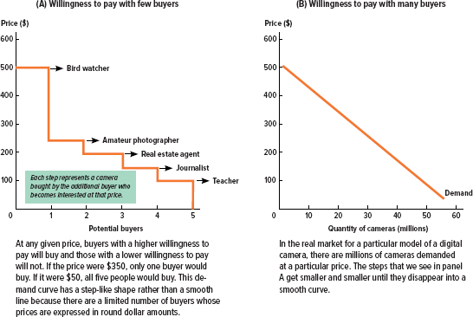

- the shape of the demand curve for is driven by potential buyers willingness to pay
- Willingness to pay is the point at which the benefit that a person will get from a good/service is equal to the benefit of spending the money on another alternative
  - Aka the opportunity cost
  - At prices above the maximum willingness to pay, the opportunity cost is greater than the benefits
  - At lower prices, the benefits outweigh the opportunity cost
- Market price is necessary in determining which consumer actually purchases a good/service
  - To find the market price determining the supply curve is needed
Willingness to Sell and the Supply Curve
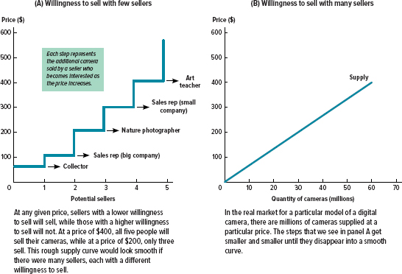
- The shape of the supply curve for digital cameras is driven by potential sellers’ willingness to sell
- Sellers’ willingness to sell is determined by the trade-offs they face, and in particular, the opportunity cost of the sale
- For items that the seller just wants to get rid of, the starting price may be extremely low
- In a market where manufacturers are producing and selling new products, the minimum price will have to be high enough to make it worth their while to continue making new products
  - If the sale price didn’t cover their costs of production, the manufacturers would simply stop making the item—otherwise, they would actually lose money every time they made a sale
  - Occasionally, manufacturers do sell below the cost of production, but only when they’ve made a mistake and have to get rid of already-produced goods.\

Measuring Surplus
- Surplus: a way of measuring who benefits from transactions and by how much
  - Applies to both consumers and producers
  - Surplus is the difference between the price at which a buyer or seller would be willing to trade and the actual price
- Indifference point: the price which matches with an individual's willingness to pay
- Measuring surplus is the most effective way of measuring the value buyers and sellers get from participating in a market than price itself
Consumer Surplus:
- Definition: the net benefit that a consumer receives from purchasing a good or service, measured by the difference between willingness to pay and the actual price (welfare economics)
  - How the allocation of resources affect the economic well being of consumers
- CS = willingness to pay - requirement to pay
  - Requirement to pay = total revenue
  - Graphically: for each unit consumed, it is the height of the demand curve minus the height corresponding to the transaction price
    - For all units consumed, it is the area under the demand curve yet above the transaction price
- Adding up the total consumer surplus describes the overall benefits that buyers receive in a market, known as collective surplus
- As the level of consumption rises, the level of consumer surplus diminishes
  - Consumer surplus at the margin (the very last unit produced) is zero
- A decrease in price will increase consumer surplus and thus make consumers better off
- An increase in price will decrease consumer surplus and thus make consumers worse off
Consumer Surplus
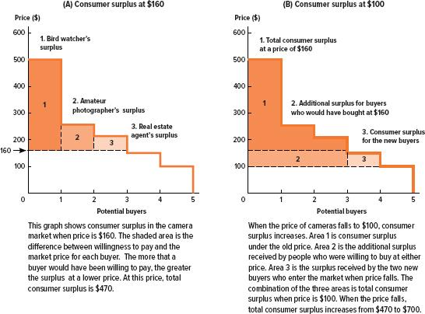

Producer Surplus
- Similarly to consumers, sellers seek to increase the distance between their respective willingness and the market price
- Definition: the net benefit that a producer receives from the sale of a good or service, measured by the difference between the producer’s willingness to sell and the actual price (producer welfare)
- Producer surplus is derived from the supply curve
- Producer surplus = the actual price received - the willingness to produce and sell
  - Graphically: the area below the market price yet above the supply curve
- An increase in price raises the level of producer surplus
- A decrease in price lowers the level of producer surplus
Producer Surplus
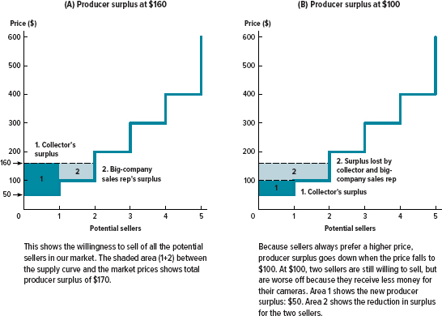

Total Surplus
- Definition: a measure of the combined benefits that everyone receives from participating in an exchange of goods or services
  - Value created by the existence of a market
  - CS + PS = (willingness of demanders to pay - requirement to pay) + (price received by producers - willingness of suppliers to supply)
    - TS = Willingness of D to pay - cost incurred by S
- Contradicts the thought of a zero-sum game which is unrealistic
  - Zero sum game: a situation in which whenever one person gains, another loses an equal amount, such that the net value of any transaction is zero

Using Surplus to Compare Alternatives

Chapter 6: Government Intervention

Chapter 7: Consumer Behaviour
- Economic decisions are based on the concept of maximizing utility

The Basic Idea of Utility
Utility and Decision Making
- Utility: a measure of the amount of satisfaction a person derives from something
- People get utility from the goods and services they consumer and experiences they have
  - Something that is personally likeable increases utility
  - Something that that is personally unpleasant reduces utility
- Utility maximization: the assumption that people are rational utility maximizers
  - Baseline assumption made by economists when analyzing the world
- People make decisions based on comparing trade offs and choosing the option with the most utility
Revealed Preference
- Utility is difficult to measure because it is subjective
- Therefore when assessing other utility of others assume that as rational individuals, they’re doing what gives them the most utility
  - This idea is known as revealed preference: the idea that people’s preferences can be determined by observing their choices and behaviour
  - Specific to a particular person and situation
- Does not involve the idea of comparing utility between people
Utility Functions
- Utility function: a formula for calculating the total utility that a particular person derives from consuming a combination of goods and services

Chapter 12: The Costs of Production
The Building Blocks of Business: Revenues, Costs and Profits
- All businesses operate to generate and maximize profits
Profits is Revenue Minus Costs
- Total revenue: the amount that a firm receives from the sales of goods and services; calculated as the quantity sold multiplied by the price paid for each unit
- Total cost: the amount that a firm pays for all the inputs that go into producing goods and services
- Profit:
Fixed and Variable Costs
- Fixed costs: costs that do not depend on the quantity of output produced
- Variable costs: costs that depend on the quantity of output produced
- A firm's total cost is an addition of a firm's fixed and variable costs
Explicit costs and Implicit costs
- Explicit costs: costs that require a firm to spend money
- Implicit costs: costs that represent forgone opportunities
  - Value of a firm's input in alternative use (opportunity cost)
Accounting and Economic Profits
- Accounting Profit: measure of a firm's solvency
  - Total revenue - Explicit costs
  - Positive accounts mean the firm’s accounts are solvent and no one is pursuing the firm for payment
  - Small and negative accounting profit results in unsatisfied shareholders
- Economic profit:
  - Total revenue - Explicit costs - Implicit costs
  - If economic profits > 0, resources are being used such that the return exceeds that of other uses
    - The rate of return that the firm is reaping from it’s land, labour and capital resources is better than average throughout the economy
  - If economic profits < 0, resources are being used such that the return is lower than other uses
    - It is possible that the firm is still solvent
    - The firm is losing money because the land, labour capital is not being utilized efficiently
  - If economic profits = 0, the return on inputs is the same as it would be in other uses
- Economic profits are lower in magnitude than accounting profit

Firms Behavioural Objectives
- Firms seek to maximize profit (Positive economics)
  - Incorporated, publicly held corporations where the profits are allocated to shareholders
    - Another theory is that Firms objective is to enrich the executives rather than the shareholders
- Normative economic says the most important question is what should these firms do
  - Should they downsize or outsource?
    - One camp (capitalists) believe firms should maximize profits
    - Another camp believe firms are entitled to a corporate social responsibility

Production Function
- Definition: the relationship between quantity of inputs and resulting quantity of outputs

Chapter 13: Perfect Competition:
  - Demand curve relates the output with the prices
    - Market demand curve in a competitive market slopes downward
  - Total revenue= Price x quantity
    - Marginal revenue=change in total revenue ÷ change in output
  - Profit maximizing level of output = marginal revenue equals
  - Determining if a firm is earning a profit
    - Calculate profits (equation: total revenue - total cost)
  - Short run equilibrium:
    - MC intersects the ATC at its lowest point
    - If profits are earned in the short run, firms enter the industry
      - Market supply shifts to the right
        - More producers
        - Firms in perfect competition are similar therefore
    - When economic profits are equal to 0 there is no incentive to enter and leave the market, adjustment process stops
    - Economic profits markets equal to 0 when profit margin equals 0
      - Profit margin=
      - Price = ATC
  - Market quantity is the general lok of all the firms in the industry while firm quantity is an individual firms

Chapter 14: Monopoly
Monopoly
- Short run equilibrium
  - When shifting the demand curve also shift the marginal revenue curve
  - Area of rectangle shows profits
  - Marginal revenue lies below the demand curve
- A form of market failure

- Monopolies
  - Monopoly equilibrium generates a higher price and lower quantity than a perfectly competitive equilibrium
  - Consumer surplus...
  - Economic profits persist in the long run
  - Producer surplus is higher than in a perfectly competitive market
  - Deadweight loss exists
    - Perfectly competitive markets have 0 deadweight loss
  - The ATC is negatively sloping, always decreasing
  - The more the monopolist dricrimanes the higher the profit (the equilibrium output level)
    - Higher producer surplus and lower consumer surplus

Chapter 18:
Externalities
- Negative externality: any negative spillover cost stemming from a production activity that is imposed on a party other than the decision maker
  - Decision maker does not face the external cost
  - Examples: a pulp and paper mill upstream from a fishery
  - Pollution-negative externality
    - What is the optimal level of output for a polluting firm?
      - Zero say the environmentalists
      - Not zero, say the economists
        - Typically, the polluting firm produces something that is valued by consumers, so some output and therefore some pollution, that is the by product, ought to be produced
        - Pollution and the social optimum
(insert graph from slide show)
        - Because social cost>private cost at the free market rate of output, the polluting firm is over producing from a social point of view
          - Assumes that the polluter has the property right to produce as it pleases, and that the affected parties do not have property rights
        - The intersection
- Positive externality: any positive spillover benefit stemming from a production activity that is imposed on a party other than the decision maker
  - The external maker does not reap the external benefits
  - Examples: beekeeper and orchard
- Both positive and negative externalities cause market failure in the form of a inefficient level of output
  - Efficiency means that total surplus is maximized at the level of production
  - Equivalently, the marginal benefit, which is the consumer’s willingness to pay for the last unit equals the suppliers valuation of the last unit, which is the cost of production
  - The implication is that in the presence of an externality that efficient level of output is not attained

