Chapter 8 – Regional Economic Integration

Levels of Integration and the Debate
Regional Economic Integration (Regionalism):
- Process whereby countries in a geographic region cooperate to reduce or eliminate barriers to the international flow of products, people, or capital
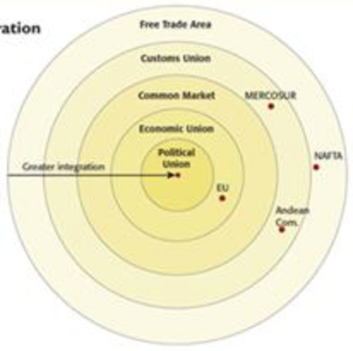

Degrees of Economic and Political Integration
Free Trade Area
- Removes all barriers to trade among members with each nation determining its own barriers against nonmembers
Customs Union
- Adds the requirement that all members set a common trade policy against nonmembers
Common Market
- Adds the free movement of labour and capital and sets a common trade policy amongst nonmembers
Economic Union
- Requires members to harmonize their tax, monetary, and fiscal policies, create a common currency, and concede some sovereignty to the larger organization
Political Union
- Requires members to coordinate their economic and political policies against nonmembers, with a few exceptions

The Case for Regional Integration
- Trade Creation
- Greater consensus
- Political cooperation
- Employment opportunities
- Corporate savings
The Case Against Regional Integration
- Trade Diversion
- Shifts in Employment
- Loss of National Sovereignty

Integration in Europe
European Union: Early Years
- European Steel and Coal Community (1951) – Removed trade barriers in coal, iron and steel
- European Economic Community (1957) – Outlined and took initial steps toward common market
- European Community (1967) – Expanded to other industries including atomic energy
- Single European Act (1987) – harmonized regulations, strived for lower barriers
- Maastricht Treaty (1991) – set single currency targets, outlined eventual political union
- European Union (1994) – final name change and reduced barriers further

European Union: European Monetary Union
- Economic criteria
- Inflammation must be below 3.2 percent
- Inflation must not exceed that of the three best performing countries by more than 1.5 percent
- Government debt must be no higher than 60 percent of GDP
- Government deficit must be no higher than 3 percent of GDP
- Interest rates on long-term government securities must not exceed, by more than 2 percent, those of the three with the lowest inflation rates
- Eighteen EU member nations adopted the single currency, the euro
- Management implications of the euro:
- The euro removes financial obstacles created by the use of multiple currencies
- The euro makes pricing among markets more transparent

Enlargement of the European Union
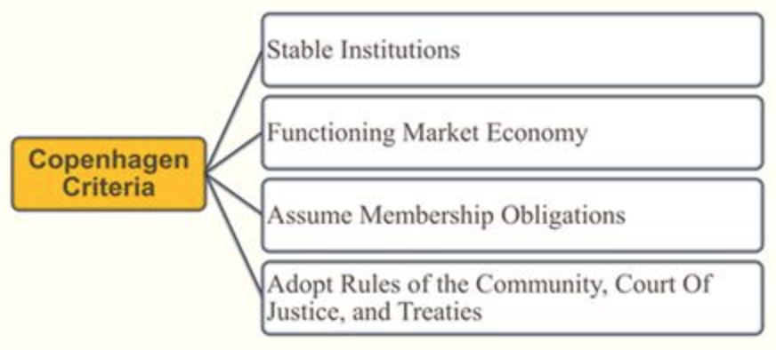
Structure of the EU
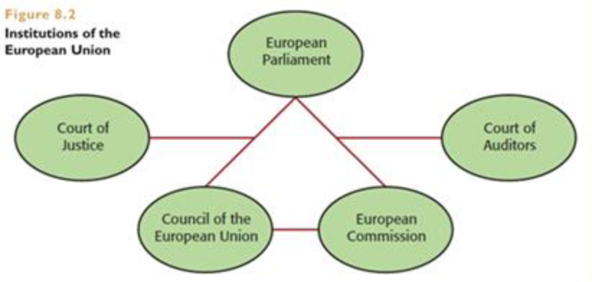

European Free Trade Association (EFTA)
- Feared a loss of national sovereignty
- Feared destructive rivalry
- Desired free-trade gains
- Cooperates with the EU

Integration in the Americas
North American Free Trade Agreement (NAFTA)
- Effective in January 1994
- Comprises a market with 450 million consumers
- A GDP of around $17 trillion
- Free trade agreement
- Provisions:
- Government procurement practices
- Subsidies
- Countervailing duties
- Trade in services
- Intellectual property rights
- Standards of health
- Safety
- Environment

Local Content Requirements and Rules of Origin
- Local content requirements
- NAFTA certificate of origin
- NAFTA rules of origin
Effects of NAFTA
- Growing trade among the three participating nations
- Effect on employment and wages is not as easy to determine
- Claims of environmental damage
- Environmental protection efforts
- Delays in NAFTA expansion

Central American Free Trade Agreement (CAFTA-DR)
- Established in 2006 to include seven countries
- USA, Costa Rica, El Salvador, Guatemala, Honduras, Nicaragua, and the Dominican Republic
- Combined value of goods traded is around $39 Billion
- Benefits to the united states:
- Reduced tariff and nontariff barriers against US exports to the region
- Ensure that US companies are not disadvantaged by central American nations trade agreements with other countries
- Reforms of central American nations legal and business environments
- Support the US national security interests

Andean Community (CAN)
- Comunidad Andina de Naciones, or CAN
- Four south American countries located in the Andes Mountain range – Bolivia, Ecuador, Columbia and Peru
- A market of around 97 million consumers
- A combined GDP of about $220 billion
- Rocky beginning
- Internal tariff reduction
- Common external tariff
- Common transport policies
- Incomplete customs union
- Ideological conflict

Southern Common Market (MERCOSUR)
- El Mercado Comun del Sur, or MERCOSUR
- Established in 1988 between Argentina and Brazil but expanded to include Paraguay and Uruguay in 1991 and Venezuela in 2006
- Associate members include Bolivia, Chile, Columbia, Ecuador and Peru
- Mexico has been granted observer status in the bloc
- A market of more than 275 million consumers
- A GDP of around $3.5 trillion
- A customs union
- Emerging as the most powerful trading bloc in all of Latin America
- Worldwide export appeal

Central America and the Caribbean
- Caribbean Community and Common Market (CARICOM)
- Was formed in 1973
- 15 full members, 5 associate members, and 8 observers active
- a combined GDP of nearly $30 billion
- a market of almost 16 million people
- Do not have the imports one another needs
- Central American Common Market (CACM)
- Was formed in 1961 (Costa Rica, El Salvador, Guatemala, Honduras, Nicaragua)
- A market of 30 million consumers
- A combined GDP of about $200 billion
- The common market was never realized

Free Trade Area of the Americas (FTAA)
- Would be the largest free trade area on the planet
- From northern tip of Alaska to southern tip of Tierra del Fuego in South America
- Comprise 34 nations and 830 million consumers
- Protests by many groups is slowing progress

Integration in Asia and Elsewhere
Association of Southeast Asian Nations (ASEAN)
- Formed in 1967
- Ten ASEAN (www.aseansec.org) countries
- Indonesia, Malaysia, the Philippines, Singapore, Thailand, Brunei, Vietnam, Laos, Myanmar, and Cambodia
- A market of nearly 600 million consumers
- A GDP of nearly $2.4 trillion
- Main objectives:
- Promote economic, cultural, and social development in the region
- Safeguard the region’s economic and political stability
- Serve as a forum in which differences can be resolved fairly and peacefully
- China, Japan and South Korea accelerating efforts to join ASEAN

Asia Pacific Economic Cooperation (APEC)
- Formed in 1989
- Now has 21 members
- Account for more than 40 percent of world trade
- A combined GDP of about $32 trillion
- Aim to strengthen the multilateral trading system
- Liberalizing trade and investment procedures among member nations

Closer Economic Relations (CER) Agreement
- Completely eliminated tariffs and quotas between Australia and New Zealand

Gulf Cooperation Council (GCC)
- Evolved to become as much a political entity as an economic one

Economic Community of West African states (ECOWAs)
- Progress on market integration is almost nonexistent

African Union (AU)
- To strengthen cohesion among the peoples of Africa

