CC102

Thursday, September 6th , 2018
Expectations, Overview and Requirements

Concept Chart Example
Concept/Term | Important Date(s) | What it Says | Reference | Examples/Discussion
Rule of Law | Magna Carta 1225 | No person is above the law, all persons are bound by the law and the law should be enforced equally | Text- p.5 | Admiral principal but difficult to apply
Canadian Charter of Rights and Freedoms | First part of Constitutions Act - 1982 | Guarantees the Rights and Freedoms which are only subject to specific limits | Text – p.6-7 | Supreme Law of Canada

Tuesday, September 11, 2018
The Foundations of Criminal Justice
The Rule of Law
- The requirement that governments, as well as individuals, be subjected to and abide by the law
- Didn’t apply to women

Principles of the Rule of Law
Accountability | Government, individuals, and private entities are accountable under the law
Public and Clear | Laws ae clear, publicized, stable and just, applied evenly, and protect fundamental rights
Fair and Efficient | - Processes for enacting, administering, and enforcing laws and fair and efficient  - Judges are meant to be impartial
Timely and Ethical | Justice is delivered timely by competent, ethical, and independent, we;;-resourced, and neutral representatives
Charter of Rights and Freedoms
The primary law of the land:
- Guarantees fundamental freedoms, legal rights, and equality rights for all citizens of Canada, including those accused of crimes
- Provides protection for individuals and ensures fairness during legal proceedings
- All components of the criminal justice system must conform to the Charter

Deviance
- Deviant behaviour
Poll
A 2012 survey showed 53% of Canadians believe cannabis should be legal.
  - Violates social norms
  - Is subject to social control
  - Not all crime is deviant
    - E.g. Marijuana use
  - Not all deviance is criminal
    - E.g. Bystander apathy
- Crime is behaviour that breaks the law, deviance is behaviour that is contrary to the norms and values of the larger society
- Ex. Dressing goth is not against the law but it may be seen as deviant because it is against norms and may be frowned upon in the greater society

What is a Crime?
- An act or omission that is prohibited by criminal law
Act | Omission
Assault | Failing to report child abuse
Robbery | Failing to provide necessities of life
- A crime occurs when a person
  - Commits an act or fails to commit an act when under a legal responsibility to do so
  - Has the intent, or mens rea, to commit the act
  - Does not have a legal defence or justification for committing the act
  - Violates a provision in criminal law

Components of Crime
Actus Reus
- Criminal action
Mens Rea
- Guilty intent
To be convinced of most crimes, a person must have done something criminal and usually must have intended to do it

Criminal Law
- The body of law that deals with conduct considered so harmful to society as a whole that it is prohibited by statute and prosecuted and punished by the government
Social Constitution of Crime
- The same behaviour in one society is considered a crime while an act of honour in another
- It’s not the behaviour that makes it a crime it’s the social response (actions from the public)

The Types of Canadian Law
- Substantive Law – Law that sets out the rights and obligations to each person in society, includes the Criminal Code
  - Ex. Criminal Code and other legislation that defines criminal offences
- Procedural Law – The legal processes that protect and enforce the rights set out in substantive law
  - Ex. Procedures for arresting a person or selecting a jury in a criminal trial

Principles of Law
- Only law can define crime and punishment, and laws cannot be changed in the idle of the game
- Ignorance of the law is no excuse
- No one is compelled to incriminate himself or herself
- No one should be tried twice or the same crime

Functions of Criminal Law
- Mechanism of social control
- Maintains order
- Defines acceptable behaviour
- Reduces risk of personal retaliation
- Assists in general and specific deterrence
- Criminalizes behaviour
- Protects group interests

The System of Criminal Law
Common Law | Statute Law | Case Law
Law that is based on custom, tradition, and practice and is generally unwritten | Written laws that have been enacted by a legislative body, such as the Parliament of Canada | Law that is established by previous court decisions and based on the rule of precedent

The System of Criminal Law
- Criminal Law – that body of the law that deals with conduct considered so harmful to society as a whole that it is prohibited by statute, prosecuted and punished by the government

Stare Decisis
- To stand by what was decided
- The principle by which higher courts set precedents that the lower courts must follow
- It is the idea that like cases should be treated alike

Precedent
- A judicial decision that may be used as a standard in subsequent similar cases
- A judge’s decision that acts as a rule to guide other judges in resoling similar cases

Criminal Law vs. Civil (Tort) Law
 | Criminal Law (Procedural) | Civil Law (Substantive)
Category | Public law | Private law
Subject | Criminal offenders liable for wrongdoing | Private disputes
Responsibility | Government assumes responsibility for prosecution and punishment | Disputes between individuals, where the “loser” may be required to pay damages
Standard of Proof | Guilt beyond a reasonable doubt | Balance of probabilities
Example | OJ Simpson criminal trial; prosecution did not prove beyond a reasonable doubt that he was guilty of murder | OJ Simpson civil suit; preponderance of evidence sufficient to show that his conduct resulted in the deaths of the two victims

Categories of Criminal Offences
 | Summary | Indictable | Hybrid
Definition | Generally less serious offences | Generally more serious offences | Offences that may be summary or indictable, based on the Crown’s decision
Penalty | Fine not exceeding $5000 or six months’ incarceration or both | Maximum prison sentence of life | Depends on whether summary or indictable
Example | Causing a disturbance, a minor assault | Murder, robbery | Assault, sexual assault

Thursday, September 13, 2018
Origins and Application of the Criminal Law
In Canadian society, politics often play a role in defining what behaviour is a crime and what the response will be.

Value Consensus Model
- The view that what behaviours are defined as criminal and the punishment imposed on offenders reflect commonly held opinions and limits of tolerance
- Mala in se-wrong in itself (generally agreed upon)
- Mala Prohibita – wrong by law

Conflict Model
- The view that crime and punishment reflect the power some groups have to influence the formulation and application of law

What’s Against the Law?
Historical Analysis of Law
- Effort to understand
  - Factors involved in the definition of behaviour as criminal
  - Increases and decreases in the severity of law
  - Responses of the criminal justice system
  - Factors influencing the repeal of criminal law resulting in decriminalization

Computers and Crime
- With computer comes crime, identity theft (fastest growing crime in the world), dark web, sex offenders

Polygamy
- In some communities polygamy is quite common
- Smuggling woman over boarders where polygamy is legal to force them to marry (stat rape)

Violence in Sports
- Are playing fields “criminal law-free zones”?
- Should athletes be subject to different rules of conduct?
- Does participation in some sports imply consent to violence?

Summary
- The rule of law, exemplified by the Charter, forms the foundation of the criminal justice system
- Criminal law has several functions, principles, and categories
- There are different views on the origins of criminal law, exemplified by the value consensus and conflict models
- Criminal law is dynamic and contingent on social, economic, and political environments

Tuesday, September 18, 2018
The Structure and Process of Criminal Justice

Criminal Justice
- The study of social control and the agencies that are involved in the apprehension, prosecution, defence, sentencing, incarceration, and supervision of those suspected or charged with or convicted of criminal offences

Criminal Justice System
- All the agencies, organizations, and personnel that are involved in the prevention of, and response to, crime and to persons charged with criminal offences and persons convicted of crimes

The Flow of Class through the Criminal Justice System
Incident – not all incidents are reported (dangerous driving)
Police
Courts
Corrections and Parole

Adversarial System
- A system of justice that is based on two opposing sides – the prosecution and the defence- arguing the guilt or innocence of a person before a judge or jury

Basic Principles of the Adversarial System
Presumption of Innocence | Burden of Proof | Doli Incapax | Insanity | Attempts
- Innocent until convicted beyond a reasonable doubt | - Task of Crown to prove guilt | - Children under 12 cannot be criminally responsible | - Not criminally responsible if incapable of knowing the act was wrong | - Those who attempt crimes are subject to half the penalty

Influences on the Criminal Justice System
- Legislation
- Religious Beliefs
- Fiscal Pressures
- Cultural Values
- The Task Environment
- Interest Groups/ Moral Entrepreneurs
- Research
- Ideology
- Politics
- Diversity
- Media

Models of Criminal Justice Administration
Crime Control and Due Process
- Crime control
  - An orientation to criminal justice in which the protection of the community and the apprehension of offenders are paramount
- Due Process
  - An orientation to criminal justice in which the legal rights of individual citizens, including crime suspects, are paramount

 | Crime Control | Due Process
Purpose of the Justice System | Protection of the public | Ensure equal justice for all citizens
Administration of Justice | Swift, certain, efficient | Deliberate, ensure procedural fairness
Focus | Right of the victim | Rights of criminal defendants
Presumption | Strong presumption of guilt | Presumption of innocence
Values | Conservative | Liberal

Discretion in the Criminal Justice System
Discretion
- The freedom to choose between different options when confronted with the need to make a decision
- Gives informal power to those in positions of authority
- Ex. What would you do if we were a Police Officer and caught someone with marijuana? Caught 2 people fighting
- What influences your decision?

Ethics in Criminal Justice
- Ethics
  - The foundation of knowledge that describes right/wrong or better/worse, and applies to harm/care and fairness/reciprocity
- Ethical Issues
  - “Broad social questions, often concerning the government’s social control mechanisms and the impact on those governed, for example, what laws to pass, what sentences to attach to certain crimes”
- Ethical Dilemmas
  - Situations in which criminal justice personal must decide what to do – these will be challenges for you

Evidence-Based Policies and Programs
- Evidence-Based Practice
  - Policies, strategies, and programs that have been shown by evaluation research to be effective in achieving specified objectives

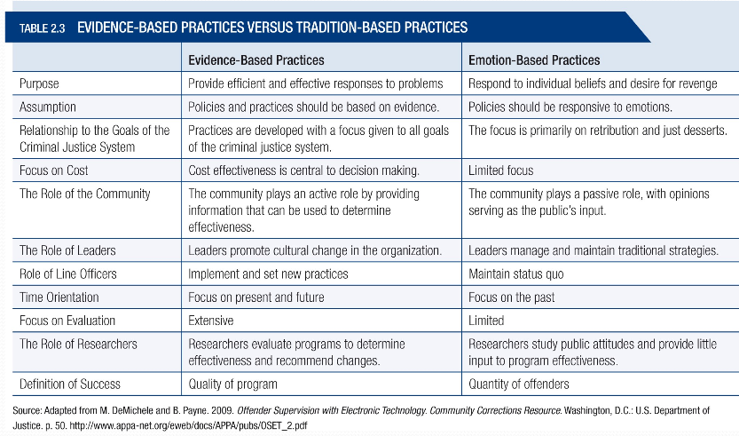
Why our Justice system Works
David Butt – Toronto Criminal Lawyer – uses Duffy Trial
- Independence of Justice Machine – no political interference
- Long Reach of Police Search and Seizure – vital especially dealing with the powerful
- Right to Disclosure – allows defence full access
- Right to Cross Examination – stop evasive answers
- Open Court Principle – allows the public to know
Increasing Centralization of Authority
- Informal control gives way to formal control
- Responsibility for justice concentrated into the hands f the state and highly trained criminal justice professionals
- Such formal controls are, in some class, less effective than the informal community controls they supplant

Discretion, Formal Controls vs. Informal Controls
- FHRITP ~ Fuck Her Right In The Pussy
- Shauna hunt – reporter for City News outside
- Verbal abuse…

Emergence of Conversation Penal Populism
Penal Populism
- Corrections policies that are formulated in pursuit of political objectives, often in the absence of an informed public or in spite of public option
- Often results in ineffective tough on crime legislation and policies, and in significant increases in prison populations, especially of minorities
- Shift in Canada (Bill C-10, mandatory minimums, Victim Bill of rights) under former government, Will it continue?

Changing Boundaries of Criminal Justice Agencies
- Shift from silos to integrated multi-agency teams
- Holistic approach to problem solving that targets underlying issues contributing to crime and disorder
- May blur the mandates of individual components of the justice system
  - Parole and police officer teams may create an inordinate focus on surveillance and control of releases

Rise of the Surveillance Society
- Use of surveillance technology to ensure safety and security
- Mediated by concerns about privacy and rights
- Use of technology by citizens, such as cell phone photos taken during the Vancouver riots

Downloading onto the Justice system
- Downloading of responsibilities by governments
- Cuts in funding for shelters or specialized facilities for people with mental illness have had direct impacts on police resources
- Police spending more time responding to high-risk and vulnerable

Challenges of diversity
- Challenges to accommodate Canadian diversity in the criminal justice system
- Legacy of colonization of Aboriginals has led to overrepresentation in the justice system, and efforts to address the significant challenges caused by this
- Criminal justice accommodation of diversity, such as Sikh members of the RCMP

Summary
- The CJS is a human enterprise involving all agencies and personnel who respond to crime, and it is exemplified by two models – due process and crime control
- A number of external influences on the CJS
- Discretion plays an important role in the CJS
- A number of key criminal justice trends in the early 21st century including penal populism, surveillance, and escalating costs, among others
Tuesday, September 25, 2018
Considerations in the Study of Criminal Justice

Crime Rates
- The number of incidents known to the police expressed in terms of the number of people in the population – Uniform Crime Reports
- (criminal incidents / total population) x 100,000
- Each crime has a value
Crime Rates in Canada in 2011
- Crime tends to be higher up north and amongst the younger population
- Places out west have less crime
Dark Figure of Crime
- The difference between how much crime occurs and how much crime is reported to or discovered by the police
Crime in First Nations and Inuit Communities
- High rates of crime and victimization, and overrepresentation of Aboriginal people in all stages of the CJS
- Particularly acute north of 60, where crime rates ae 5x higher than for Canada as a whole
- First Nations women are particularly vulnerable
** Name a time, location and group:
They believe that they are right and superior to other cultures and that any acts including violence are acceptable to force others to conform
- ISIS in present day Iraq and Syria
- Nazis in 1930s/1940s Germany
- Christians in late 1800s Canada
- All of the above

Residential Schools
- They believe that they are right and superioir to other cultures and that any acts including violence are acceptable to force others to conform
- ISIS in present day Iraq and Syria
- Nazis in 1930s/1940s Germany
- Christians in late 1800s Canada
- All are Wrong
- Effect on First Nations
The Experience of Certain Groups
- Poll in 2016 found that 43% of respondents identifies diversity as an attribute that made Canada unique
- However some fault lines have developed and some say multiculturalism is incompatible with Western Values
- A key feature of Canadian society is inequality including how some experience the justice system
$$$
- Top 1% earn 39% of the income for the country
- 1 Million children in Canada live in low-income homes
- Women earn 74.2% of that male workers
Some Important Terms and Considerations
- Racism – prejudice, discrimination, or antagonism directed against someone of different race based on a belief that one’s race is superior
- Prejudice – is the unsubstantiated negative prejudgement of individuals or groups generally on the basis of ethnicity, religion or race
- Discrimination – an action or decision that treats a person or a group negatively for reasons such as their race, age or disability
What this Means in the Justice System
- How can people “buy in” to the Justice system if they think they are treated fairly?
- Survey conducted by the Ontario Human Rights commission found 93% of Blacks believed they were profiled because of their colour and 79% of Muslims believed they were profiled because of their religion
The Costs of Crime
- $3.5 billion per year in personal property claims
- $2 billion in claims for commercial property
- Auto theft accounts for 13% of property crime
- Also, loss productivity, medical costs, insurance premiums, security/surveillance costs
- Does not include costs of white-collar crime
  - E.g. tax evasion, stock market manipulation
Cost of Domestic Violence
Criminal and Civil justice systems > Pain and suffering and loss of life > Health care > Third Party = $7.4 billion

The Victims of Crime
Victimization Profile
Prevalence | Reporting | Demographic | At-risk Groups
- Over ¼ of Canadians report victimization  - Highest in Western Canada | - High rates of non-reporting  - Only 1/3 reported to police  - Majority of sex assaults (88%) not reported | - Majority of victims under age 30  - Males 18-24 most likely victims of violence  - Single women more likely victims of violence than married women | - Aboriginals victimized at higher rate  - Aboriginal women 3x more likely to report spousal abuse
Perception of Risk
- Fears of victimization exceed actual risk
- E.g. in 2003 43% of Torontonians are very worried about child abductions
- E.g. in 2004 605 of people in BC worried about a home breaking
- Media focuses on sensational crime
- Thomas Fleming – Media creates fear
  - In a poll of 11 countries a majority of citizens said the world has become more dangerous
Fear of Crime
- Greater in areas where there is a high proportion of low income families, visible minority residents, and lone-parent families
- Residents who identify social disorder in their neighbourhood also report higher levels of fear of crime
- Citizens 65 and older tend to be more fearful of crime, as are those persons who have been previously victimized
Victims in the Criminal Justice system
- Role of victim is set out in federal and provincial legislation
- Typically, notifying victims if the offender is being released
- Critiques: psychological harm not adequately addressed, too much emphasis on the rights of offenders
Revictimization
- The negative impact on victims of crime caused by the decisions and actions of criminal justice personnel

Addressing Victim Needs
Programs and Services
- Growth of services over the last two decades
- Criminal justice-based services, such as victim services, available in most communities
- Community-based services, such as shelters, crisis lines, hospital and mental-health services, self-help groups, and translation services
- Few victims (3%) take advantage of services
- Barriers to access
  - Failure of police to provide information to crime victims
  - Language and access difficulties for immigrant or visible minority women
  - Pressure from family who fear the police if from some contries (may fear being deported)
However…
- Adversarial system and victims are often an afterthought
- 2014 survey of sex violence survivors found 50% had no confidence in the police and 66% had no confidence in the CJS and the courts
Compensation
- Criminal Injury Compensation: financial remuneration paid to crime victims
- Restitution: a court-ordered payment that the offender makes to the victim to compensate for loss of or damage to property

The Community and the Criminal Justice System
NIMBY ~ Not in my backyard
- The resistance that communities display in response to correctional systems’ efforts to locate programs and residences for offenders in a specific area
Media
- Popular crime shows oversimplify complex issues of crime and justice
- New media focus on negative rather than positive criminal justice outcomes
- Media tendency to focus on sensational cases, while criminal justice agencies fail to educated an uninformed or misinformed public about crime
Social Media
- Forms of electronic communication allow users to post and share ideas, information, videos, and photographs
Summary
- Determining the true scope of crime is challenging, particularly because of the dark figure of crime due primarily to non-reporting of crimes to police
- The costs of crime are extensive, and there are many consequences of crime that affect victims and the community
- Some groups, such as Aboriginal women, are more likely to be victims of crime, and crime victims often experience challenges in the criminal justice system
- The community was, until recently, excluded from the justice system, but this has changed with the advent of social media and the Internet, with significant implications
Thursday, September 27, 2018
The Structure and Roles of the Police
History of Policing
- Pre-Confederation
  - Mostly informal policing by community residents
- First police officers
  - Quebec City, mid 17th century
  - Upper Canada, early 19th century
- Mandate
  - Police conflicts between ethnic groups and employers/labourers
  - Maintain moral standards (drunkenness, alcoholism)
  - Apprehend criminals
Provincial Police Forces
- Often set up in response to disorder resulting from gold strikes in 19th century
- Replaced by RCMP during 20th century
- Currently Ontario, Quebec, and parts of Newfoundland have their own provincial police force
History of RCMP
- North-West Mounted Police founded in 1873
  - Maintain law and order
  - Ensure orderly settlement in Prairies
  - Many problems; desertion, resignation, and improper conduct
- Replaced by Royal Canadian Mounted Police
Police Today
- About 70,000 police officers across Canada
  - 199 police officers per 10,000 population
  - Lower than Scotland (337), England (244), U.S. (238)
- Number of police officers increased over the past decade
- Number of female officers increased
- 1/5 officers is a woman
Contemporary Policing
Structure of Policing
- Four levels:
  - Federal, provincial, municipal, and First Nations
  - Also public transportation police (railway, airport, and transit)
- Some municipalities have their own forces
  - E.g., Hamilton, Brantford, Region of Waterloo
  - Others use provincial force detachments or RCMP detachments
RCMP
- Governed by Royal Canadian Mounted Police Act (1985)
- Broad range of policing activities, including federal policing and international peacekeeping
- Contract policing
  - Provincial, territorial, and municipal level
  - Concerns about local oversight and fiscal accountability
  - In but not of communities – difficult to ensure that RCMP detachments are responsive to communities
Provincial Police
- Three forces
  - Ontario Provincial Police
  - Sûreté du Quebec (SQ)
  - Royal Newfoundland Constabulary (RNC)
  - Other provinces use contract with RCMP
- Responsibilities
  - Police rural areas and areas outside municipalities
  - Enforce provincial laws and Criminal Code
Regional Police
- Amalgamated forces
  - E.g., Waterloo Regional Police combined from various communities – e.g. Kitchener, Waterloo
  - Provide police services to over half of Ontarians
- Advantages
  - Cheaper, more services
- Disadvantages
  - Too centralized, not in touch with community
Municipal Police
- Responsibilities
  - Enforce Criminal Code, provincial statutes, municipal bylaws, some federal statues (e.g., drugs)
- Largest number of officers of any level
  - May be contracted to RCMP or provincial force
  - Costs are paid by the municipality
First Nations
- Two types:
  - Private security firms (e.g., mall or hospital security)
  - In-house company security personnel (e.g., university police)
- Uncertainty about powers
- Parapolice
  - Extension of activities
  - Lack systems of oversight like traditional police

Police Work
Policing
- The activities of any individual or organization acting legally on behalf of public or private organizations or persons to maintain security or social order

Pluralization of Policing
- The sharing of responsibility for safety and security in the community between public and private security
Values within which to examine Police Work
Justice ~ Maintain peace while ensuring fair treatment and human rights
Equality ~ All citizens entitled to police services
Accountability ~ Actions of police are subject to review
Efficiency ~ Services must be cost-efficient

Governance
- Government and judicial oversight of police activities
- Balance between operational autonomy and due process rights
Police Acts ~ Legislative framework
Policing Standards ~ Provisions for maintaining and delivering police services
Police Boards and Commissions ~ Bodies that provide oversight of police

Roles and Activities of Police

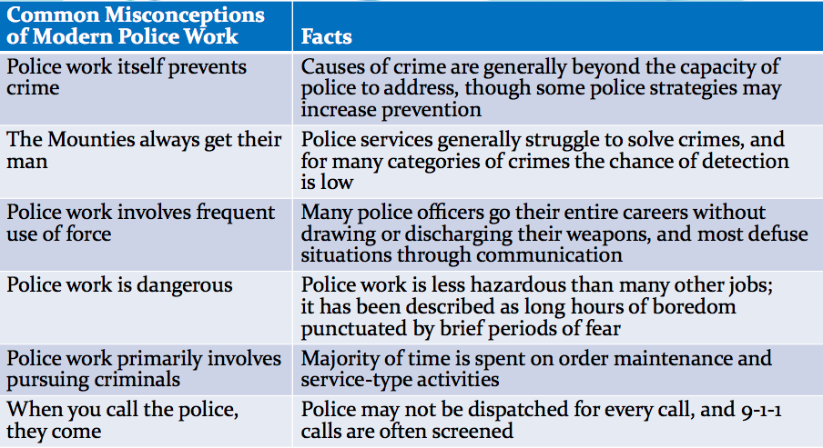

Categories of Policing
Crime Control | Order Maintenance | Crime Prevention and Service
- Responding to and investigating crime  - Patrolling | - Controlling behaviour  - Intervening in conflicts | - Collaborating with community partners to prevent crime  - Service to community
Factors Influencing the Roles and Activities of Police
- Diversity
- Community
- Funding
- Legislation
- Government
- Geography
- Crime and Disorder
- Economic, Political, and Cultural Trends
Recruitment and Training of Police Officers
Police Recruitment
- Basic Qualifications
  - Canadian citizen, at least 19, physically fit, grade 12 education
  - No criminal conviction or pending charges
  - Common sense and good judgement
- Preferred Qualifications
  - Second language or culture, volunteer experience, post-secondary education, work/life experience
  - Women and visible minorities are actively recruited
Recruiting Visible Minorities and Aboriginal People
- Special initiatives and programs for youth, women, and visible minorities
  - PEACE (Police Ethnic and cultural Exchange)
  - OPPBound (participate in a variety of activities with officers)
  - Toronto police recruitment of Somali officers
  - Edmonton police uniforms that include hijab

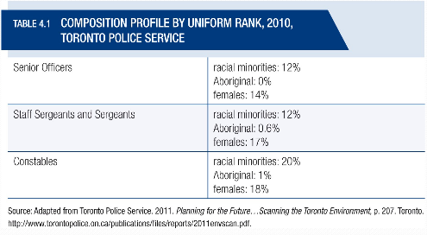
Police Training
- Residential and non-residential academies, centralized and decentralized training
- Physical and academic instruction, as well as socialization into the police occupation
- Operational field training
  - Hands-on application of principles learned in the academy
  - Mentorship from senior officer
Working Personality of Police
- A set of attitudinal and behavioural attributes that develops as a consequence of the unique role and activities of police officers
Challenges of Police Work
- Work environment
  - Long hours and shift work
  - Exposure to stressors, especially in high-demand environments
  - PTSD and burnout
- Work organization
  - Harassment of female officers
  - Cumbersome system of internal redress
Summary
- Four levels of policing: federal, provincial, municipal, and First Nations, each with different responsibilities
- Natural tensions exists between the power and authority of police and the values of a democratic society, and several structures of police governance are in place
- A number of misconceptions around police work, including the notion that most police work involves crime control
- A variety of influences on the roles and activities of the police
Tuesday, October 2, 2018
Police Powers and Decision Making
Police Powers
- Use of Force
- Obtain DNA
- Search
- Arrest
Limits to Police Powers
- Charter limits police powers
  - Certain investigative techniques (electronic surveillance, jail informant, warrantless searches)
  - Gathering and disclosing evidence
  - Abuse of process defence
Detention and Arrest
Formal Arrest
Requirements
- Reason for arrest, right to counsel, right to remain silent

Arrest warrant
- Document that permits a police officer to arrest a specific person for a specific reason
Information
- A written statement sworn by an informant alleging that a person has committed a specific criminal offence
Lawful Arrest
- Police officer should:
  - Identify himself or herself
  - Inform the suspect that they are being arrested
  - Give the reason for the arrest or show the warrant
  - Touch suspect on the shoulder
Arrest without a Warrant
- Caught committing an offence
- Belief that person has committed an indictable offence
- Belief that a person is about to commit an indictable offence
- Anti-terrorism Act: arrest on suspicion rather than reasonable grounds
Rights of the Arrested or Detained
- To be informed of the reason (s.10 of Charter)
- To retain and instruct counsel and to be informed of this right without delay
  - Legal aid is discretionary
- To be informed of a toll-free number (24-hour service) for legal counsel if needed
- To remain silent

Issues in Detention and Arrest
Search and Seizure
- Evidence obtained during illegal search may be excluded from trial if it would bring justice into disrepute
- Search must be reasonable
  - Authorized by law
  - Law must be reasonable
  - Manner of search must be reasonable
- Normally requires a search warrant

Search Warrant
- Document that permits the police to search a specific location and take items that might be evidence of a crime
Required if search involves | Not required if
- Secret recording of conversations  - Video surveillance  - Perimeter searches  - Installation of tracking devices  - Search of automobile | - Suspect is under arrest  - Officer self-protection  - Prevention of evidence destruction  - In an emergency situation

Entrapment
- A person ends up committing an offence that he or she would not otherwise have committed as a result of pressure or cunning on the part of the police
Efficiencies
- Proactive techniques can be effective and cost-effective
- Prevent victimless offences (drug possession, prostitution
- Reasonable suspicion (non-random)
Controversies
- Catching habitual vs. situational criminals
- Enticing otherwise law-abiding people into crime
- No defence of entrapment in court
Right to Remain Silent
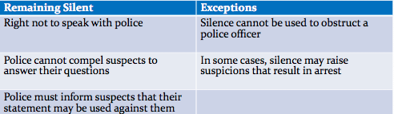

Confessions
- Must be made freely and voluntarily
- Controversies around police trickery to obtain confessions
  - Undercover officer placed in a cell with the accused
  - “Mr. Big” strategy
- False confessions
  - Mental illness, stress, fatigue, withdrawal symptoms
Use of Force : One plus One
- The generally accepted use-of-force standard that police officers have the authority to use one higher level of force than that with which they are confronted
Force Options
Officer Presence ~ Mere presence may control the situation
Dialogue ~ Verbal and nonverbal communication may resolve conflict
Empty Hands ~ Physical force is used to gain control
Compliance Tools ~ Equipment or weapons are used to gain control
Lethal Force ~ The situation requires the complete incapacitation of the subject in order to gain control, and lethal force is the only option available to reduce the lethal threat

Less-Lethal Force Option
- Highly unlikely to cause death or serious injury when properly applies by a police officer
- Conduct energy weapons (Tasers)
  - Expanded use credited with reducing number of deaths and number of officers injured
  - Concern about use on those in a state of excited delirium
  - Incidents resulting in death lead to more stringent requirements for use
Most Common Types of Officers to Use Force
- Inexperienced
- Lower Education
- Male
- Young
- Previous Shooting

Police Discretion
Discretion
- Freedom to choose among different options when confronted with the need to make a decision
Typifications
- Constructs based on a patrol officer’s experience that denote what is typical about people and events routinely encountered
Recipes for Action
- The actions typically taken by patrol officers in various kinds of encounter situations
Encounters
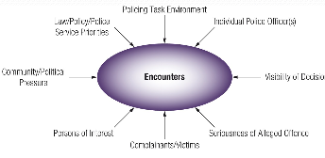

Discrimination and Racial Profiling
Discrimination
- Making a distinction in favour of or against a person or thing based on the group, class, or category to which that person or thing belongs rather than on individual merit
Bias-free Policing
- The requirement that police officers make decisions based on reasonable suspicion or probable grounds rather than stereotypes

Racial Profiling
- The targeting of individual members of a particular racial group on the basis of the supposed criminal propensity of the entire group
Carding
- Major issue in Toronto
- Good police tactics or inflammatory?
Police and Aboriginal Peoples
- High rates of Aboriginal overrepresentation in criminal justice system
  - Serious incidents where police have been discriminatory against Aboriginals
  - Starlight Tours in Saskatchewan
- Police-Aboriginal Relations Initiatives
  - Aim to improve delivery of police services to Aboriginal peoples
Police Accountability
Principle of Accountability
- “The actions of police officers and police services are subject to review [and] there are formal channels that individuals can use to lodge complaints against the police”
  - Legal
  - Administrative
  - Public
  - Ad Hoc
  - Political
Summary
- Police derive their powers from statute law, case law, common law, and bylaws
- The Charter of rights and Freedoms has had a significant impact on police powers
- Police have considerable discretion in the execution of duties, which is itself influenced by several factors
- Police are held accountable through a variety of means
Thursday, October 4, 2018
Police Strategies and Operations

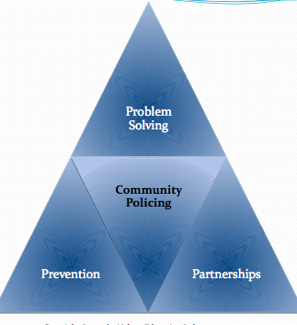
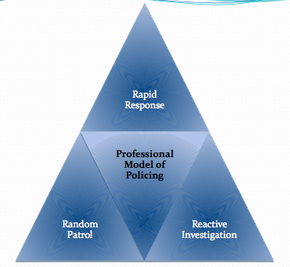

Community-Based Strategic Policing
Compstat (Computer Statistics)
- A strategy designed to increase the effectiveness and efficiency of police services while holding police personnel accountable for achieving crime reduction objectives
Environmental scans
- Studies designed to identify community, legislative, policy, and other forces in the community that will result in demands on the police
Intelligence-Led Policing
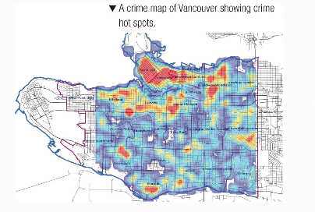

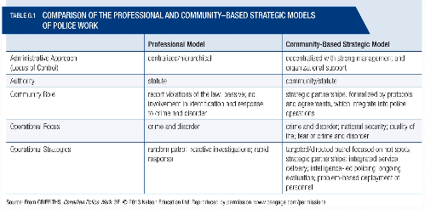

Crime Prevention, Response, and Attack
Crime Prevention
- Primary
  - Programs that identify opportunities for criminal offences and alter those conditions to reduce the likelihood that a crime will be committed
- Secondary
  - Programs that focus on areas that produce crime and disorder
Challenges in Crime Prevention
- The public often are not aware of police crime prevention initiatives
- Few citizens participate in crime prevention initiatives
Effectiveness of Primary Crime Prevention Strategies
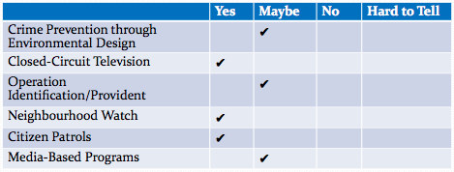

Measuring the Effectiveness of Police Strategies and Responses
Clearance Rates
- The proportion of the actual incidents known to the police that result in the identification of a suspect, whether or not that suspect is ultimately charged and convinced
Crime Displacement
- The relocation – because of effective crime prevention and crime response initiatives – of criminal activity from one locale to another
Economics of Police Strategies
- High cost of police services is not sustainable
- Money diverted from corrections to policing would buy significant crime reduction
- Decrease in police forces related to increases in crime
Vulnerable and At-Risk Groups
Persons with Mental illness
- Government downloading issue onto police
  - De facto community health workers
- Cost to policing
  - Waiting times, away from patrol
- Training
  - High police empathy, crisis training, lack of available community resources
Marginalized Woman
- Concerns that police have not acted to protect these women
- Vulnerabilities of Aboriginal women
- Robert Pickton and the murder of 65 women
Summary
- The police use various strategies to prevent and respond to crime, with emphasis on efforts to build partnerships with communities
- Traditional models of policing have evolved into community-focused strategies that use data and intelligence
- Aggressive policing criticized for its focus on racial minorities
- Challenges in policing vulnerable at-risk groups
Tuesday, October 22, 2018
The Structure and Operation of the Criminal Courts
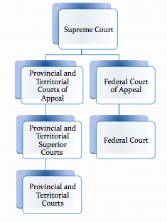

Criminal Courts
- Responsibilities
  - Determine guilt or innocence
  - Impose appropriate sentence
  - Protect the rights of the accused
- Judicial independence
  - Fair, impartial trials
  - No political interference

Specialized Problem-Solving Courts
Attributes of Problem-Solving Courts
- Focus on addressing underlying problems
- Interagency and interdisciplinary collaboration
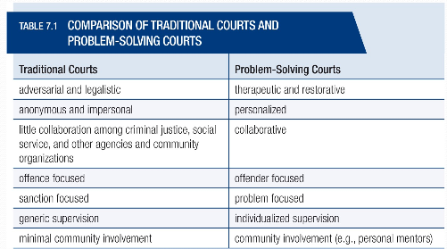
- Accountability to community

Court | Objective/Process | Outcomes
Mental Health | Reduce criminalization | Reduce offending, use of acute care, and time in custody; improve life circumstances
Drug | Address addictions and reduce recidivism with treatment | Cost-effective; can help long-term offenders; but high rates of non-completion
Aboriginal (Gladue) | Address circumstance of Aboriginal offenders; reduce overrepresentation | More detailed documentation of offenders, but effectiveness inconclusive; overrepresentation continues
Provincial, Territorial, and Federal Courts
- Travelling court
  - In remote areas
- Problems
  - Backlog of cases
  - Time constrains – limits case preparation
  - Language and cultural barriers
- Difficulties sentencing
  - Balance between culturally/community-relevant approaches and the rights and protection of victims
Provincial/Territorial Superior Courts
- Highest courts in a province/territory
- Hear about 10% of criminal cases
- Trial and appeal courts
  - Trial: serious criminal offences, may involve juries
  - Appeal: criminal appeals of verdict or sentence
Supreme Court of Canada
- Established under Constitution Act (1867)
- Nine judges appointed by governor in council from different regions of Canada
- Court of last resort, decisions are final
- Eligible to appeal to the federal level only when at least one appellate court judge dissents
Criticisms of Supreme Court
- For engaging in social activism on one and being deferential to law enforcement on the other
- E.g. Former Federal government – criticism of court decisions that it perceived to have undermined antiterrorism efforts and drug policy
The Courtroom Workgroup
Court Personnel
- Judge
- Crown Counsel
- Defence Lawyers
- Other Personnel
Features of the Courtroom Workgroup
- Power differentials
- Inability of courts to address the needs of those with special challenges
Where Do Judges Come From?
- Provincial/territorial and federal judges are appointed for life by respective governments
- Supreme Court judges appointed by Prime Minister
- American Judges are elected
- Concerns
  - Appointed, not elected
  - Importance of political affiliation and patronage
  - Lack of diversity in judiciary
The Flow of Cases
Summary Offence
- Only provincial courts
- Judge only
Indictable
- Absolute jurisdiction of provincial courts
  - For less serious offences, judge only
- Absolute jurisdiction of superior courts
  - Very serious offences, usually by jury
  - Beings with preliminary hearing
- Hybrid (electable) offences-Determination is by the Crown
  - Accused may choose type of trial
  - Maximum sentence of 5 years or more, accused may have a jury
Judicial Ethics and Accountability
Ethical Principles
- Equality
- Impartiality
- Judicial Independence
- Integrity
- Diligence
Judicial Conduct
- Accountability
  - Canadian Judicial Council
    - Most complaints from public
    - Complaints – displays of gender, racial, and religious bias; cultural insensitivity; conflict of interest; undue delay e.g. recent cases regarding sexual assaults
- Responses
  - Reprimand, leave of absence, removal (rare)
  - More serous cases, judges may choose to resign before council completes inquiry
Independent Oversight
- Judicial Independence
  - The notion that judges are not subject to pressure and influence, and are free to make impartial decisions based solely on fact and law
  - Self-regulated profession, no oversight
Summary
- Four levels of courts that deal with criminal cases
- Problem-solving courts have emerged as an alternative to the traditional adversarial model of justice
- The courtroom workgroup is composed of professionals who work in the criminal justice system, including judges, Crown counsel, and defence lawyers
- Increasing attention is being given to judicial ethics and accountability, with concerns over the lack of independence and transparency

Tuesday, October 30, 2018
The Prosecution of Criminal Cases
Crown Counsel
- Represents the Crown (government) in court
- Prosecutes criminal cases and proves beyond a reasonable doubt that accused is guilty
- Representative of justice
  - Not to win cases but to present evidence
Crown Activities
- Appeal Sentences
- Advise Police
- Prepare for Trial
- Negotiate Pleas
- Develop strategies
- Manage Witnesses
- Argue Bail Conditions
- Recommend Sentences
Laying an Information
- Information
  - Usually falls under police responsibility
  - Document that outlines the allegation of criminal law breaking
  - Brought before a justice of the peace (JP)
  - May be used to issue warrant or summons
  - May be used after suspect is arrested or issued an appearance notice, or before
Laying a Charge
- Police and Crown discretion
- Charges not laid in many cases
  - Victim refuses to cooperate
  - Suspect or important witness dies
  - Suspect is referred to psychiatric facility
  - Suspect was under the age of 12
  - Reliability and admissibility of evidence
  - Crown workload
  - Expense too much for severity of crime
- NB, Quebec, BC
  - Police need Crown approval before laying charge

Judicial Interim Release (Bail)
- The release by judge or JP of a person who has been charged with criminal offence pending a court appearance
Show Cause | Crown must demonstrate that the detention of the accused until their trial is necessary
Reverse Onus | Accused must justify their release
Recognize | Forfeit money if they fail to appear in court
Surety | Friend or relative who ensures the accused person will appear in court; forfeit money

Bail Decisions and Conditions
- Influenced by
  - Number of charges pending
  - Whether accused has a fixed address
  - Concerns provided by police
- Bail conditions
  - Conditions for release
  - Abstinence, house arrest, non-association
  - Increase in conditions, set up for failure
Pretrial Remand
- By warrant of committal by JP or judge
- For violation of release conditions
- Individuals not released
  - Fear will not show up for court
  - Reoffend before court
  - Have not arranged bail
Security Certificates
- A process whereby non-Canadian citizens who are deemed to be a threat to the security of the country can be held without charge for an indefinite time

Defendant’s Access to Legal Representation
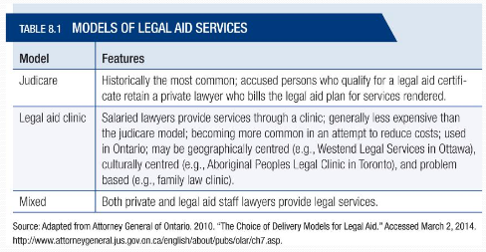

Legal Aid
- No blanket right to state-paid legal representation
- Problems
  - Underfunding
  - Lack of coverage
  - Lack of access for marginalized populations
Arraignment and Plea
- Charges
  - Read in open court
- Guilty plea is very common
  - Proceed directly to sentencing
- Reasons for not-guilty pleas
  - Plausible defence and want to exercise right to trial
  - Lawyer’s advice
  - To strengthen position in any plea bargaining that may occur
Plea Bargaining
- An agreement whereby an accused pleads guilty in exchange for the promise of a benefit
- Pleas
  - Withdrawal of some charges
  - Reduce charge
  - Proceeding summarily
  - Concurrent vs. consecutive sentences
  - Joint submission about sentencing
  - Guilty plea discount
Plea Bargain
- Victims
  - May be consulted about plea bargain
  - Are spared
    - Trauma of testifying
    - Prolongation of trial
- Judges
  - May not accept plea bargain
  - May be overruled on appeal
The Trial
Disclosure of Evidence
- Also known as “discovery”
- Crown must release all relevant evidence to the defence, especially exculpatory evidence
- Defence is not required to disclose evidence

The Trial
Stay of Proceedings | Act by Crown to terminate or suspend court proceedings after they have commenced
Closed Courtrooms | Trials must be public in the interest of justice, and only rarely are courtrooms closed to the public
Publication Bans | Identification of complainant or witness and any identifying information is not published
Rape Shield Provisions | Provisions that make the sexual history of victims of sexual assault inadmissible as evidence

Not Criminally Responsible
- If someone doesn’t know what they were doing or didn’t know it was wrong
- Declared Not Criminally Responsible and placed in a psychiatric facility
Criminal Code of Canada
- Sec 16(1) No person is criminally responsible for an act committed or an omission made while suffering from a mental disorder that rendered the person incapable of appreciating the nature and quality of the act or omission or of knowing that it was wrong
- Sec 16(2) Every person is presumed not to suffer from a mental disorder… until the contrary is proved on the balance of probabilities
- Sec16(3) the burden of proof… is on the party that raises the issue
- The person is not acquitted
- If the person “becomes sane” they can stand trial
- Fitness to stand trial means understanding the proceedings and to instruct a lawyer
The Jury
- Essential attributes of a criminal jury
  - Impartiality, competence, representativeness
- Representativeness and Aboriginal peoples
  - Lack of representation of jury rolls
  - Distrust and lack of knowledge of the CJS
Jury Decision Making
- No direct information on jury deliberations
- Concerns
  - Lack of understanding of evidence
  - Lack of understanding of law
  - CSI effect
  - Instruction to jurors by a judge

Crime Victims and the Court Process
Victims
- Ensuring victim safety from retaliation or intimidation
  - Non-association conditions
- Witnesses
  - Emotional and arduous
  - Secondary victimization by CJS
  - Diversity (niqab)
Wrongful Convictions
- Consequence of a series of events
Tunnel vision on the part of police and crown
Mistaken eyewitness identification and testimony
False confessions
Testimony of in-custody informers
Defective, unreliable, and unsubstantiated expert testimony

Wrongful Conviction
- Police
  - False confession through interrogation
- Crown
  - Failure to abide by law and professional ethics
- Expert witness
  - Reluctance to examine independence, validity, and reliability of experts
Summary
- Several events occur before a trial that can affect the outcome, such as bail, conditions, or remand
- While all accused have a right to legal representation, there is no obligation that the provinces pay for it, and many do not qualify
- Plea bargains are controversial because they lack any legislative guidelines
- Despite reforms, the court process continues to face challenges such as delays and wrongful convictions

Tuesday, November 5, 2018
Quiz 2 Review
Cases Completed in Adult Criminal Courts
Judicial Conduct
- Accountability
  - Canadian Judicial Council
    - Most complaints from public
    - Complaints – displays of gender, racial, and religious bias; cultural insensitivity; conflict of interest; undue delay e.g. recent cases regarding sexual assaults
- Responses
  - Reprimand, leave of absence, removal (rare)
  - More serious cases, judges may choose to resign before council completes inquiry
Independent Oversight
- Judicial Independence
  - The notion that judges are not subject to pressure and influence, and are free to make impartial decisions based solely on fact and law
  - Self-regulated profession, no oversight
Laying an Information
- Information
  - Usually falls under police responsibility
  - Document that outlines the allegation of criminal law breaking
  - Brought before a justice of the peace (JP)
  - May be used to issue warrant or summons
  - May be used after suspect is arrested or issued an appearance notice, or before
Laying a Charge
- Police and Crown discretion
- Charges not laid in many cases
  - Victim refuses to cooperate
  - Suspect or important witness dies
  - Suspect is referred to psychiatric facility
  - Suspect was under the age of 12
  - Reliability and admissibility of evidence
  - Crown workload
  - Expense too much for severity of crime
- NB, Quebec, BC
  - Police need Crown approval before laying charge
Judicial Interim Release (Bail)
- The release by judge or JP of a person who has been charged with criminal offence pending a court appearance
Show Cause | Crown must demonstrate that the detention of the accused until their trial is necessary
Reverse Onus | Accused must justify their release
Recognize | Forfeit money if they fail to appear in court
Surety | Friend or relative who ensures the accused person will appear in court; forfeit money
Disclosure of Evidence
- Also known as “discovery”
- Crown must release all relevant evidence to the defence, especially exculpatory evidence
- Defence is not required to disclose evidence

Not Criminally Responsible
- If someone doesn’t know what they were doing or didn’t know it was wrong
- Declared Not Criminally Responsible and placed in a psychiatric facility
Criminal Code of Canada
- Sec 16(1) No person is criminally responsible for an act committed or an omission made while suffering from a mental disorder that rendered the person incapable of appreciating the nature and quality of the act or omission or of knowing that it was wrong
- Sec 16(2) Every person is presumed not to suffer from a mental disorder… until the contrary is proved on the balance of probabilities
- Sec16(3) the burden of proof… is on the party that raises the issue
- The person is not acquitted
- If the person “becomes sane” they can stand trial
- Fitness to stand trial means understanding the proceedings and to instruct a lawyer
General Principles
- Sentences should reflect
  - Seriousness of the offence
  - Degree of responsibility of offender
  - Aggravating or mitigating factors
- Sentences should be consistent
- Consecutive sentences …
Aggravating Factors
- Crimes motivated by hate
- Spouse and Child abuse
- Abusing a position of trust or authority
- Crimes connected with a criminal organization (gangs)
Goals of Sentencing
Utilitarian | Retributive | Restorative
- General Deterrence  - Specific deterrence  - Rehabilitation  - Incapacitation | - Denunciation  - Retribution  - Proportionality | - Crime harms victim, offender, community  - Victim – offender mediation, circle sentencing
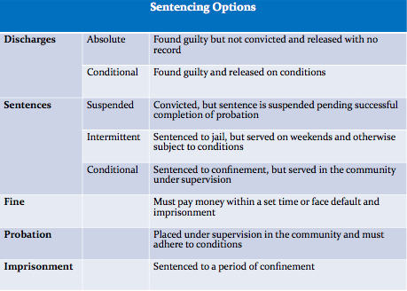
Sentencing Options

Extraordinary Measures: Dangerous Offenders
- A designation made by judge after conviction that results in an indeterminate term of imprisonment
- Offender shows pattern of violent behaviour and likelihood of serious harm in future
- Application by Crown post-conviction, pre0sentence
- Charter challenge
Dangerous Offender threshold
Current Offence | Past Behaviour
- At least one personal injury offence  - Use of violence, endangering life, or inflicting severe psychological harm | - Persistent, aggressive behaviour  - Failure to control sexual impulses or other behaviours
Mandatory Minimum Sentences 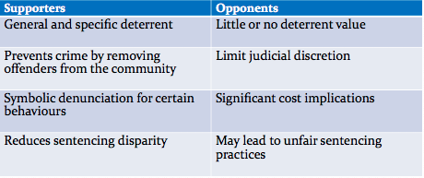
Bail Decisions and Conditions
- Influenced by
  - Number of charges pending
  - Whether accused has a fixed address
  - Concerns provided by police
- Bail conditions
  - Conditions for release
  - Abstinence, house arrest, non-association
  - Increase in conditions, set up for failure
Pretrial Remand
- By warrant of committal by JP or judge
- For violation of release conditions
- Individuals not sentenced
  - Fear will not show up for court
  - Reoffend before court
  - Have not arranged bail

Thursday, November 7, 2018
Sentencing
Purpose and Principles
- Denunciation
- Deterrence
- Protection
- Rehabilitation
- Reparation
- Accountability
General Principles
- Sentences should reflect
  - Seriousness of the offence
  - Degree of responsibility of offender
  - Aggravating or mitigating factors
- Sentences should be consistent
- Consecutive sentences should not be unduly harsh
- Imprisonment should not be given unnecessarily
  - Consider alternatives, especially for Aboriginal peoples
Aggravating Factors
- Crimes motivated by hate
- Spouse and child abuse
- Abusing a position of trust or authority
- Crimes connected with a criminal organization
Goal of Sentencing
- Utilitarian
  - General deterrence
  - Specific deterrence
  - Rehabilitation
  - Incapacitation
- Retributive
  - Denunciation
  - Retribution
  - Proportionally
- Restorative
  - Crime harms victim, offender, community
  - Victim – offender mediation, circle sentencing

Sentencing Options

Types of Sentences
- Concurrent
  - Sentences that are amalgamated and served simultaneously
- Consecutive
  - Sentences that run separately and are completed one after the other
- Intermittent
  - Sentences that are served on a part-time basis, generally on weekends
  - Usually also have probation
Options
- Judicial Determination
  - On order by the sentencing judge that the offender serve one-half of the sentence before being eligible to apply for parole
- Judicial Restraint Order
  - Granted to control person who may inflict harm
  - Refusal to comply and condition violations may result in imprisonment
Extraordinary Measures: Dangerous Offenders
- A designation made by the judge after conviction that results in an indeterminate term of imprisonment
- Offender shows pattern of violent behaviour and likelihood of serious harm in future
- Application by Crown post-conviction, pre-sentence
- Charter Challenge

Dangerous Offender Threshold
- Current Offence
  - At least one personal injury offence
  - Use of violence, endangering life, or inflicting severe psychological harm
- Past Behaviour
  - Persistent, aggressive behaviour
  - Failure to control sexual impulses or other behaviours
Extraordinary Measures: Long-Term Offenders
- A designation in the Criminal Code that requires the offender to spend up to 10 years under supervision (in the community) following the expiry of his or her sentence
- Only for federal inmates
- Administered by parole board
Additional Sentencing Options
- Prohibitions
  - Stay away from children, no possession of firearms, no driving
- Forfeitures
  - Counterfeit money, narcotics, weapons, hate propaganda
- Proceeds of crime
  - Government can seize accumulated money, property, or goods acquired from criminal activity
Decision Making of Judges
Three steps in Decision Making
- Identifying the relevant factors in the case
- Identifying the relevant law
- Combining the relevant facts and law to produce the correct outcome
Sentencing Considerations
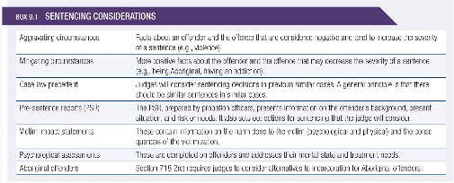

Sentencing Aboriginal Offenders
- Gladue decision
  - A decision by the SCC that held that when a term of incarceration would normally be imposed, judges must consider the unique circumstances of Aboriginal people
How Judges Decide
- Discretion
  - May result in non-legal factors impacting decision making
  - May contribute to sentence disparity
- Political party, region, interest groups, and gender influence decision making (They shouldn’t but do)
- Limits of discretion:
  - Criminal Code maximums
  - Decisions in similar cases
Statutory Guidance
- Included in Criminal Code, Controlled Drugs and substance Act
- Maximum sentences are specified
- Some mandatory minimum sentences
  - E.g. murder, using a firearm
Mandatory Minimum Sentences
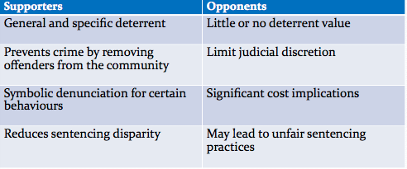

Appellate Decisions and Precedent
- Appellate courts can change sentences of trial judges if too lenient or severe
- Appellate courts set guidelines for judges
- Legal precedent establish sentencing norms
Sentencing and Victims
Victim Impact Statement
- A submission to a sentencing court explaining the emotional, physical, and financial impact of the crime

Victim Fine Surcharge
- Unless it creates undue hardship for the offender or their family:
  - Order offender to pay 15% of any fine, or up to $10,000 if no fine
- Not a sentence, and not paid to the victim
- Money goes to provincial fund for victim services
Effectiveness of Sentencing
 | Yes | Maybe | No | Hard to Tell
Severity of Punishment |  |  | √
Consistency in Sentencing |  | √
Sentences Effectively Matched |  |  | √
Continuity from Courts to Corrections |  | √
Summary
- Judges can select from among a number of sentencing options, and can impose a number of conditions or designations on offenders, such as with dangerous offenders
- Judges consider a wide range of factors when determining a sentence, and they can be influenced by extralegal factors
- Efforts have been made to address the overrepresentation of Aboriginal peoples, particularly through Gladue courts, but they are applied unevenly or not at all in cases of violent offending
- Recent proposals promise greater victim involvement, through restorative approaches seem to hold more potential for this

Tuesday, November 13, 2018
Corrections in the Community: Alternatives to Confinement
Diversion
- Programs that are designed to keep offenders from being processed further into the formal justice system
Concerns over Diversion
- Net Widening
  - Potential, unanticipated consequence of diversion in which persons who would otherwise have been released outright by police or not charged by Crown counsel are involved in the justice system
- Coercion
  - Offenders surrender basic procedural rights to access programs
Intermediate Sanction
- A wide range of correctional programs that generally fall between probation and incarceration
Probation
- A sentence imposed that provides for the supervision of the offender in the community by a probation officer, either as an alternative to custody or in conjunction with a period of incarceration
The Uses of Probation
Adult offenders can be on probation for the following reasons:
- As part of conditional discharge (mandatory)
- As a condition of a suspended sentence (mandatory)
- As part of an intermittent sentence (mandatory)
- A sentence on its own (the most common)
- Following a prison term of two years or less
- In conjunction with a conditional sentence
- For a federal offender who received a sentence of exactly two years (little known)
Activities of Probation Officers
- Officers of the Court
- Investigation
- Counselling
- Surveillance and Enforcement
- Assessment
- Service Coordination
Dual Role of Probation Officers
- Assistance and Support
  - Address issues that contribute to crime
  - Identify resources in the community
- Enforce Conditions
  - Ensure compliance with general and specific conditions of probation order
Effective Case Management
- Identification of risks and needs of offender, and appropriate level of supervision
- Risk management and protection of the public
- Use the LSI-OR in Ontario
- Core role of probation officer in completing assessments
  - Identify risks and needs
  - Supervision plan
  - Determine parole
Risk, Need, Responsivity
Risk Principle
- Correctional interventions are most effective when matched with the offender’s level of risk, and higher-risk offenders benefit most from interventions
Need Principle
- To be effective, correctional interventions must address the criminogenic needs of offenders

Responsivity Principle
- Correctional interventions should be matched to the learning styles of individual offenders
Application of RNR
- Level of Service Inventory – Ontario Revision – (LSI-OR)
Intensive supervision Probation (ISP)
- An intermediate sanction that generally includes reduced caseloads for probation officers, increased surveillance, treatment interventions, and efforts to ensure that probationers are employed
Experiences
- Probationers
  - Positive experiences
  - Deterrent
  - Pains of probation
  - More punitive than prison
- Probation officers
  - High stress
  - Safety issues
  - High need clients
  - High caseload
Electronic Monitoring
- Correctional strategy that involves placing an offender under house arrest and then using electronic equipment to ensure the conditions of supervision are full filled
- Recent US example – Paul Manafort
- Front-end
  - EM as condition of early release
  - EM used to support an alternative
  - Ensures public safety
- Back-end
  - EM used by sentencing judge
Summary
- Alternatives include traditional practices, such as probation, as well as more recent innovations, such as EM
- Concern that use of alternatives may widen the net
- Problem-solving courts are an effort to provide alternatives are effective, particularly those based on the principles of risk, need, and responsivity

Thursday, November 15, 2018
Restorative Justice: An Alternative Approach to Crime, Victims, and Offenders
Our Traditional System…
- Just one of many
- Roman Law
- Ecclesiastical Law (eg. Canada Baptist Church 1810-1880)
- Dark Ages – trial by ordeal
- Code of Hammurabi – Iraq 2000BC
- Israelites – Mosaic Code
Rule of Law
- The requirement that governments, as well as individuals, be subjected to and abide by the law
Restorative Justice
- A problem-solving approach to responding to offenders based on the principles that criminal behaviour injures victims, communities, and offenders, and that all these parties should be involved in efforts to address the causes of the behaviour and its consequences
Principles of Restorative Justice
- Addressing harms and needs
- Confirming obligations of offenders, families, communities, society
- Inclusive and collaborative
- Involving stakeholders
- Righting wrongs
Restorative Justice Approaches
Victim-Offender Mediation
- Provides an opportunity for a crime victim and the offender to communicate and address the impact of the offence, and for the offender to take responsibility for the offence and its consequences
Circle Sentencing
- Involves collaboration and consensual decision making by community residents, the victim, the offender, and justice system personnel to resolve conflicts and sanction offenders
Restorative Justice Settings
Collaborative Justice Project
- Urban setting (Ottawa-Carleton)
- Pre-sentence approach
- Considers cases of serious offending, such as robbery, break and enter, assault causing bodily harm
Restorative Justice in Aboriginal Communities
- Increasingly involved in developing RJ services, which can vary widely by community
Tsuu T’ina Nations Court | Community Holistic Circle Healing Program
- Aboriginal judge, Crown, clerks  - Peacekeeping program  - Elders, victims, offenders, others, in circle healing  - Completion ceremony | - Community response to high rates of sexual and family abuse  - Traditional healing practices  - Restore peace and harmony

Circle of Support and Accountability
- Developed by Canadian Mennonite Community based on Indigenous practices of healing circles
- Support for sex offenders released from federal institutions with little or no supervision
- Extend restorative contract with offender
  - Housing
  - Employment
  - Spiritual and moral support
  - Financial management
  - Significant Budget Cut by Federal Government avoided
Challenges in Restorative Justice
- Resistance by criminal justice personnel
- Limited community interest or capacity
- Perception that RJ approaches are soft
- Lack of public awareness
- Revictimization
- Victims and offenders understand objectives
- Victims and offenders are equal participants
Effectiveness of Restorative Justice

Summary
- Dissatisfaction with the traditional CJS has led to a variety of restorative justice approaches designed to better address the needs of victims, communities, and offenders
- Principles of restorative justice focus on repairing harm and addressing underlying causes
- Restorative programs operate at all stages of the justice system and in a variety of settings
- Research supports restorative programs, through numerous challenges remain

