F2018 STUDY GUIDE FOR THE MIDTERM

The following is a list questions about topics covered in each week. The answers can be found in the C/P, textbook chapters, BABOK Guide, Moodle posts, and your class notes. The study guide is intended only to guide you as you prepare for the exam. To perform well in the exam, you need to know the concepts, be able to apply them and give an example of each when applicable.

WEEK 2: THE SYSTEMS ANALYST
- What is the systems/business analyst’s role in the SDLC?
The systems analyst plays a key role in the SDLC, analyzing the business situation, identifying opportunities for improvements, and designing an information system to implement the improvements

- What are the differences between systems analysts and business analysts?
The systems analyst role focuses on the IS issues surrounding the system. This person develops ideas and suggestions for ways that IT can support and improve business processes, helps design new business processes supported by IT, designs the new information system, and ensures that all IS standards are maintained. The systems analyst will have significant training and experience in analysis and design and in programming.
The business analyst role focuses on the business issues surrounding the system. This person helps to identify the business value that the system will create, develops ideas for improving the business processes, and helps design new business processes and policies. The business analyst will have business training and experience, plus knowledge of analysis and design.

- Who are the system stakeholders?
a person, group, or organization that can affect (or can be affected by) a new system.
System stakeholders are anyone who has a vested interest in the information system, anyone from the systems user, systems designer, system builder and the systems analyst.

- What is Business Analysis approach according to BABOK® Guide?
• Purpose
• Description
• Inputs
• Elements
• Guidelines/Tools
• Techniques
• Stakeholders
• Outputs
- Where do systems/business analysts work?
Systems Analysts can work within departments supporting each of the business units of a firm, they can work in the IT department or with executive management.
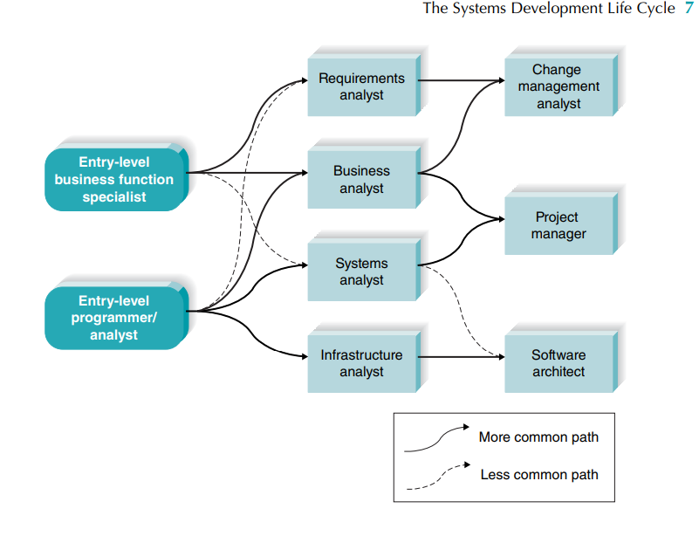
- What are the career paths for systems/business analysts?

- What skills/knowledge/attributes do successful systems/business analysts have?
These skills can be broken down into six major categories: technical, business, analytical, interpersonal, management, and ethical.
Often, analysts need to communicate effectively.
Finally, analysts must deal fairly, honestly, and ethically with other project team members, managers, and system users.
Understanding and commitment to the organization
- Creative thinking
- Decision making
- Learning
- Problem solving skills
- System thinking
- Conceptual skills
- Visual thinking
Behavioral characteristics
- Ethics
- Personal accountability
- Trustworthiness
- Organization and time management
- Adaptability
Business Knowledge
- Business acumen
- Industry knowledge
- Organization knowledge
- Solution knowledge
- Methodology knowledge
Communication skills
- Verbal communication skills
- Non-verbal communication skills
- Written communication skills
- Listening
Interacting skills
- Facilitation
- Leadership and influencing
- Teamwork
- Negotiation and conflict resolution
- Teaching
- What are system analyst’s roles and responsibilities?
The systems analyst role focuses on the IS issues surrounding the system. This person develops ideas and suggestions for ways that IT can support and improve business processes, helps design new business processes supported by IT, designs the new information system, and ensures that all IS standards are maintained. Th e systems analyst will have significant training and experience in analysis and design and in programming.

Week 2: SYSTEMS THEORY
- What is a system?
Organized, interrelated, and interacting entities or ideas that work together to achieve a common goal.
- What are the components of systems?
- Boundary
- Entities
- Subsystems
- Input
- Output
- Interface
- Buffers
- Feedback and control
- Constrains
- What is systems approach?
The system approach is the way of thinking about the job of managing. It provides a framework for visualizing internal and external environmental factors as an integrated whole. It allows recognition of the function of subsystems, as well as the complex supersystems within which organizations must operate.
- What makes a system open rather than a closed system?
Feedback and control.

WEEK 3: USE CASE MODELING
- Know how to identify actors
An actor represents a role. It is someone or something that interacts with the system; sending or receiving messages to and from the system.
- Know how to identify use cases
- Represented by horizontal oval shapes
- It represents a single functionality/sub-goal of the system. Thus, it is a description of a sequence of steps
- It is complete therefore; it should NOT be broken into subparts. It is not complete until the end value is produced
- It is always initiated on behalf of an actor
- It provides a value to an actor
- The corresponding narrative describes a series of activities and user interactions trying to accomplish the goal

- Know how to develop a use case model given a narrative description of a system
- Identify business actors
- Identify business requirements use cases
- Construct use case model diagrams

WEEK 3: INFORMATION SYSTEMS DEVELOPMENT
- What is CMM?
The Capability Maturity Model Integration (CMMI) is a globally-recognized set of best practices that enable organizations to improve performance, key capabilities, and critical business processes.

- Distinguish between levels of CMM.
- Level 1 - initial
- Level 2 - Managed
- Level 3 - Defined
- Level 4 - Quantitatively managed
- Level 5 – Optimizing

- What is SDLC?

The systems development life cycle (SDLC) is the process of determining how an information system (IS) can support business needs, designing the system, building it, and delivering it to users.
- What are the phases of SDLC? Describe each phase and its tasks.
- Planning phase
- Analyze feasibility
- Develop workplan
- Staff project
- Control and direct
- Analysis phase
- Develop analysis strategy
- Determine business requirements analysis
- Create use cases
- Model processes and data
- Design phase
- Design physical system
- Design architecture
- Design interface
- Design program
- Design databases and files
- Implementation & support & maintenance phase
- Construct system
- Install system
- Maintain system
- Post-implementation
- Fact finding
- Documentation and presentation
- Feasibility analysis
- Project and process management
- What is system development methodology? What are its advantages and disadvantages?
A methodology is a formalized approach to implementing the SDLC.
Advantages:
- requirements are identified long before programming begins,
- requirement changes are limited as the project progresses.
Disadvantages:
- the design must be completely specified before programming begins
- testing may be treated almost as an afterthought in the implementation phase
- What are the reasons to purchase systems development methodologies?

- What are the project characteristics that affect the methodology selection process?
- Clarity of User Requirements: How well do the users and analysts understand the functions and capabilities needed from the new system?
- Familiarity with Technology: How much experience does the project team have with the technology that will be used?
- System Complexity: How much complexity is anticipated in the new system? Does the new system include a wide array of features? Will the system have to integrate with many existing systems? Does it span multiple organizational units, or even multiple organizations?
- System Reliability: Will this system need to be highly reliable or is some downtime tolerable?
- Short Time Schedules: Is the project time frame tight?
- Schedule Visibility: Are the project sponsors, users, or organizational managers anxious to see progress?

- What are the principles underlying systems development?
- Get the owners and users to participate in systems development
- Use a problem-solving approach
- Establish phases and activities
- Document throughout development
- Establish standards to ensure system integration involving
  - Database technology
  - Software technology
  - Interface technology
- Manage the process and projects
  - Process management
  - Project management
- Justify information system as capital investments
- Don’t be afraid to cancel or revise scope
  - Creeping commitment approach to systems development
- Divide and conquer
- Design systems for growth and change
- Where do system development projects come from?
A project is identified when someone in the organization identifies a business need to build a system.
- Be able to analyze an information system using PIECES framework
- Which activities overlap much of the SDLC (cross lifecycle activities)?
- Fact finding Documentation
- Presentation Feasibility analysis
- Project management

WEEK 4: REQUIREMENTS DISCOVERY METHODS
- What is a requirement statement?
A requirement is simply a statement of what the system must do or what characteristics it need to have.
- What is the purpose of requirements discovery?
- Understanding problem or opportunity: needs of the client
- Gathering information from the stakeholders
- Collaboration with the stakeholders in order to interact and rely on their expertise
- Gain a better understanding of how the client uses the current system

- Consequences of failing to correctly identify system requirements
Errors made in a particular phase cost more to fix the longer they are left undetected.
- What are the factors that contribute to the failure of projects?
- Lack of user participation
- Incomplete requirements
- Changing requirements
- What are the activities in requirements discovery process?
- Problem discovery and analysis
- Requirements discovery
- Documenting and analyzing requirement
- Requirements management
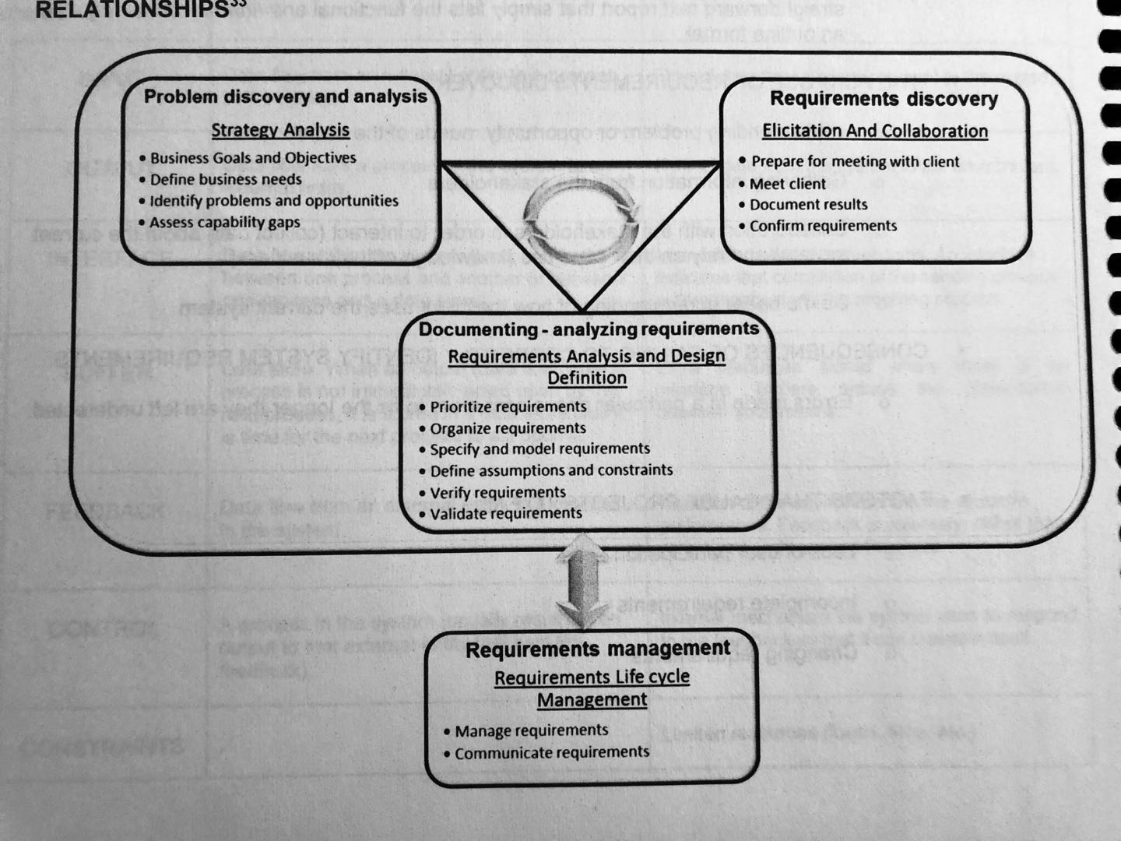
- What are the knowledge areas involving requirements discovery according to the BABOK® Guide and what are their relationships?

- What is “Elicitation and Collaboration” according to BABOK® Guide?
The tasks that business analysts perform to obtain information from stakeholders and confirm the results. It also describes the communication with stakeholders once the business analysis information is assembled
- What is “Requirements Lifecycle Management” according to BABOK® Guide?
the tasks that business analysts perform in order to manage and maintain requirements and design information from inception to retirement. These tasks describe establishing meaningful relationships between related requirements and designs, and assessing, analyzing and gaining consensus on proposed changes to requirements and designs.
- What is “Strategy Analysis” according to BABOK® Guide?
the business analysis work that must be performed to collaborate with stakeholders in order to identify a need of strategic or tactical importance (the business need), enable the enterprise to address that need, and align the resulting strategy for the change with higher- and lower-level strategies.
- What is “Requirements Analysis and Design Definition” according to BABOK® Guide?
The tasks that business analysts perform to structure and organize requirements discovered during elicitation activities, specify and model requirements and designs, validate and verify information, identify solution options that meet business needs, and estimate the potential value that could be realized for each solution option.
- Fact-finding techniques: Advantages and disadvantages, Do’s and Don’ts of each
See course pack Pg. 33-39 -_-
- Which documents should you collect, which documents should you not collect?
Collect:
- Contributes to cross validation of interviews and observations
- Helps understand the current system
Not collect:
- Documentation that may be outdated, incomplete or blank should not be included in this review
- Useful for the current system only

- What types of questions are used in interviews?
- Open- ended
- Closed ended
- Probe
- What kind of information is sought in interviews?
- Opinions
- Goals
- Feelings
- Informal procedures
- Interviews: how to prepare for them, how to conduct them, what tasks are done post-interview, questions to avoid, etc.
- Dress appropriately
- Be respectful and courteous
- The introduction is critical. Do not rush into questions. Set the stage
- Briefly present the agenda
- Give the client your full attention
- Take notes
- Find the root cause, not the symptom
- Be sincere in your efforts to help the client. They will be fore forgiving if you make any mistakes
- Maintain self-control
- Start and finish on time
- What is the recommended fact-finding strategy?

- Learn all you can from existing documents, forms, reports and files
- If appropriate, observe the system in action
- Design and distribute questionnaires if needed
- Conduct interviews
- Optional – build discovery prototypes
- Follow up and verify
- Use the five W’s
  - Who did that
  - What happened
  - Where did it take place
  - When did it take place
  - Why did that happen
  - How did it happen

WEEKS 4 & 5: PROCESS MODELING – 1 & 2
- Differentiate between logical and physical DFDs
- Logical DFD: “what the system does”
- Physical DFD: “How the system does what it does”
- DFD syntax – components of DFD, their labelling and numbering
- Process
- Data flow
- Data store
- External entity
Labelling:
- Imperative phrase with an active verb followed by an object clause
- No subject in the imperative sentence
- The simpler. The better
Numbering:
- Unique for each process
- From left to right and top to bottom
- Be able to create a process model using DFD given a mini case
- Understand frequently encountered DFD modeling challenges
- Pg. 24-27
- Know the correspondence between systems terminology and DFD representation
- What are the differences between use case modeling and process modeling in terms of what information is being captured in each?

