Lecture 7
- Mendelian Inheritance
  - Gregor Mendel was the founder of genetic
  - He was most known for creating the law of heredity in 1866, this was published through a book and it wasn’t read until the 1900 meaning, his work was not recognized until then.
  - Mendel has a lot of data to back up his theory as well as mathematical calculations to verify his hypotheses
  - Mendel used peas to do his experiments on because they have:
    - Many varieties available
    - Possibility of crossbreeding
    - Fairly cheap
    - Generate in a very short time
    - Create a lot of peas from regeneration
  - Mendel talks about hereditary factors because genes where still unknown at the time
  - Mendel talked about the variation of genetic traits and how they can be explained by the different shapes that genes can have.
  - Different genes are found in different areas (called locus) which are found on each chromosome’s alleles. This means that there is two locus for one gene.
    - For example, the alleles for white flowers and the alleles for purple flowers are situated on one of the peas’ chromosomes
  - All organisms inherit two copies of a genes, one from the father and one from the mother each copy is called a locus
  - An individual possesses two alleles for one gene (hereditary factor)
  - If both alleles of a locus are different, one of them, the dominate allele determines the appearance of organism; whereas the other recessive allele, has no notable effect on the appearance
    - This was known as the law of uniformity hybrid
    - The experiment behind the theory was performed on plants where Mendel observed that the dominate trait was passed down
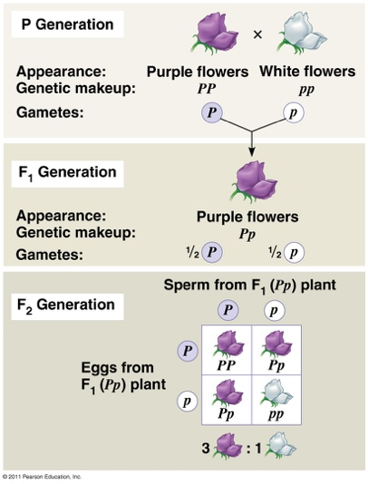
  - Law of segregation
    - Two alleles for a heritable character segregate (sperate from each other) during gamete formation and end up in different gametes
    - This is purely separation of sex cells
    - It results in Punnett squares
  - Definitions
    - Phenotype
      - The physical appearance or biochemical characteristic of an organism as a result of the interaction of its genotype and the environment
    - Genotype
      - The set of genes in its DNA that is responsible for a particular trait
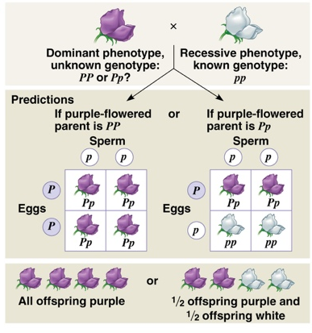
    - Homozygous
      - Refers to an individual has two of the same allele regardless of whether its recessive or dominate
    - Heterozygous
      - Refers to an individual has two different alleles for a specific trait
  - Mendel would test cross to identify the unknown genotype
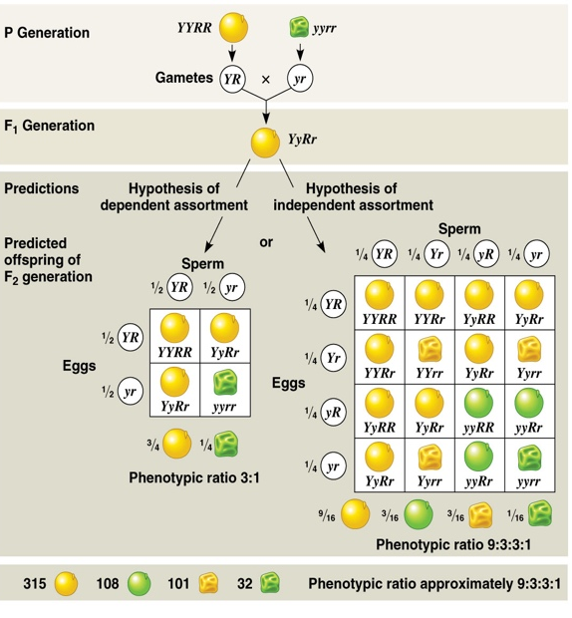
  - The law of independent assortment
    - This is when every pair of allele separates independently from the other pairs when the gametes are formed
    - In humans some examples are hairline or the earlobe

- Initial impact of Mendel’s theory
  - Mendel’s work ended up resurfacing by three geneticists in the early 1900s almost 35 years post Mendel’s work
    - Coreen’s, Tschermack and Hugo De vries
  - The discovery of Mendel’s work had, initially a negative impact on the theory of natural selection
  - Hugo de Vries (1838-1935)
    - Formulated a theory of mutation which indicated that new species can be formed in one or multiple steps through mutation that would cause substantial morphological modifications
    - In the 1920s it was discovered that mutations are generally harmful or neutral and that only a few seemed to influenced although lightly, an organism traits.
    - He worked with primrose, they where complex but a mutations occurs and keeps occurring
    - It doesn’t make sense because there is no environmental impact
    - Mutations are harmful or neutral but vary positive
- Neo-Darwinism and Modern Synthesis
  - The 1920s and 1960s genetics and the theory of natural selection were reconciled
  - Lamarckism was finally refuted
  - We started to understand the effect of chance in the transmission of allele from generation to generation also known as genetic drift
  - The genetic basis of evolutionary changes was established
  - The study of genetics shows the existence of an important and persistent variation (continuous or discrete) which created the hereditary material on which evolution can act
  - This continuous variation has a mendelian basis, that is to say that it implies the segregation of hereditary particles having a minimal phenotypic effect
  - The effect of change was not natural selection
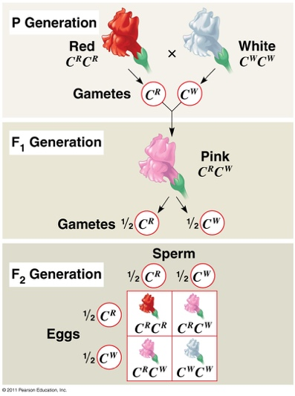
  - The emergence of population genetics and of microevolution offered a new perspective in regards to the relative significance of the factors producing evolutionary changes in populations
  - The biological and genetic basis of the formation of species (speciation) and the study of the evolution about the species level (macroevolution), including elaboration of the tree of life (phylogenies)
- Incomplete dominance
  - Crosses are a mix of colour which is due to the fact that ever allele can produce protein.
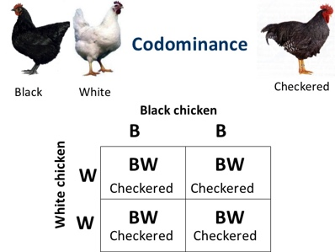
  - It is found in plants such as snap dragon and animals like horses
- Codominance
  - Is when both alleles express themselves
- Modern additions to Mendel’s law
  - Polygenism
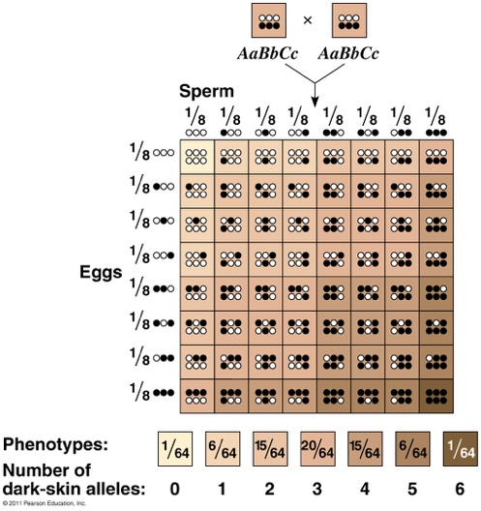
    - When a phenotypic trait us under the combined action of two or multiple genes (very common)
    - Is a very common phenomena with regards to expression of the gene. It occurs when serval genes express one trait
  - Epistasis
    - When the effect of a gene hides or blocks the expression of another gene
    - Example:
      - Labradors (3 colour)
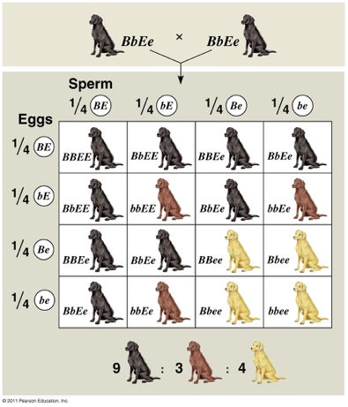
      - Two small ee’s block the expression of colour which is why they appear as golden
  - Pleiotropy
    - When a gene influence more than one trait
    - Example
      - Manx cats
      - The Manx gene which is represented as M shows a incomplete dominance compared to the normal gene m
      - The gene responsible for the lack of tail is lethal when homozygous therefore there is no cats with MM
      - The heterozygous cats do not have tails or have short tails
      - This occurs because there is something wrong with the development of the tail/ vertebral column

Chapter 5 – evolution of population
Chapter 23
- Hardy Weinberg’s principle
  - In 1908 biologist Weinberg and mathematician Hardy made the same discovery:
    - They demonstrated that, under certain conditions, allele frequencies in a population stay constant from one generation to the next which causes there to be no evolution
    - By selecting alleles at random from a gene pool they could calculated the frequencies of allies and these would not change
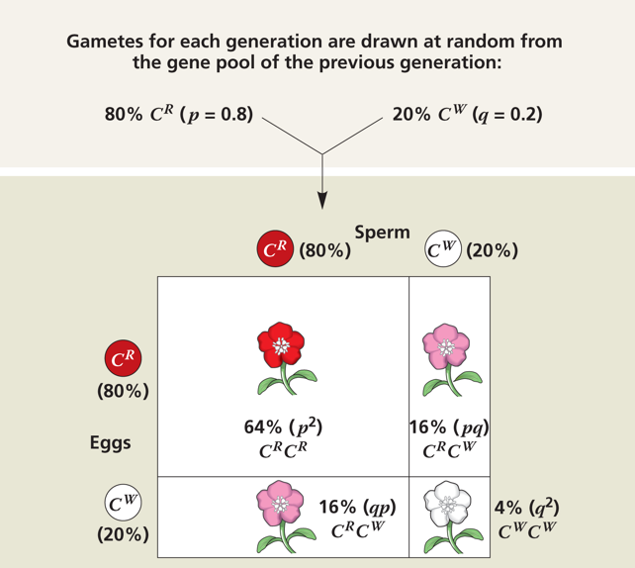
    - Examples:

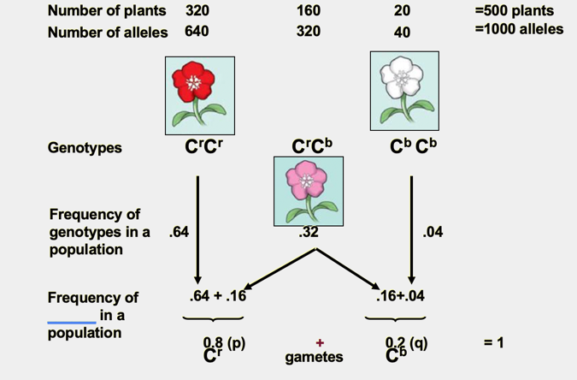
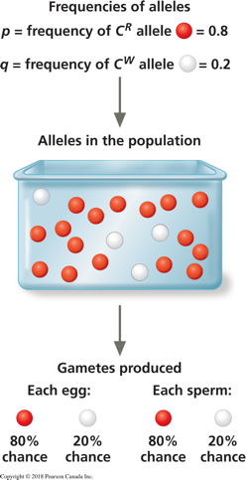

  - A population is in Hardy – Weinberg’s equilibrium when:
    - The frequencies of alleles and genotypes within a population will remain constant from generation to generation as long as the following conditions are respected:
      - There are no mutations
      - Mating is done randomly
      - The size of the population is extremely large
      - There is no genetic flow
      - There is no natural selection
    - The formula is p²+2pq+q²=1
  - The Hardy-Weinberg principle describes a hypothetical population that does not evolve
  - Example 

