Lecture 8
- Mutations
  - Mutations are changes in the DNA sequence of an organism
  - It is a source of genetic variability. Mutations are:
    - Random
    - Transmissible (only if they are in the gamete)
    - Frequency throughout the gene pool, but rare at each locus
    - Rate of mutations wary greatly among groups of living beings
    - Will influence allele frequencies but is a weak evolutionary force from generation to generation especially in large population
  - Point mutations
    - The addition, deletion of substitution of a base A-C instead of A-T
    - Effects
      - Negative effect
        - Ehlers- Danlos Syndrome
      - Lethal effect
        - Will cause death
      - Neutral effects
        - Synonymy of condones doe the formation of amino acids particularly in the 3rd position
        - Non coding part (protein) of the genetic code
      - Positive effect (when the effect enables the individual to be better adapted to their environment)
  - Sickle cell anemia
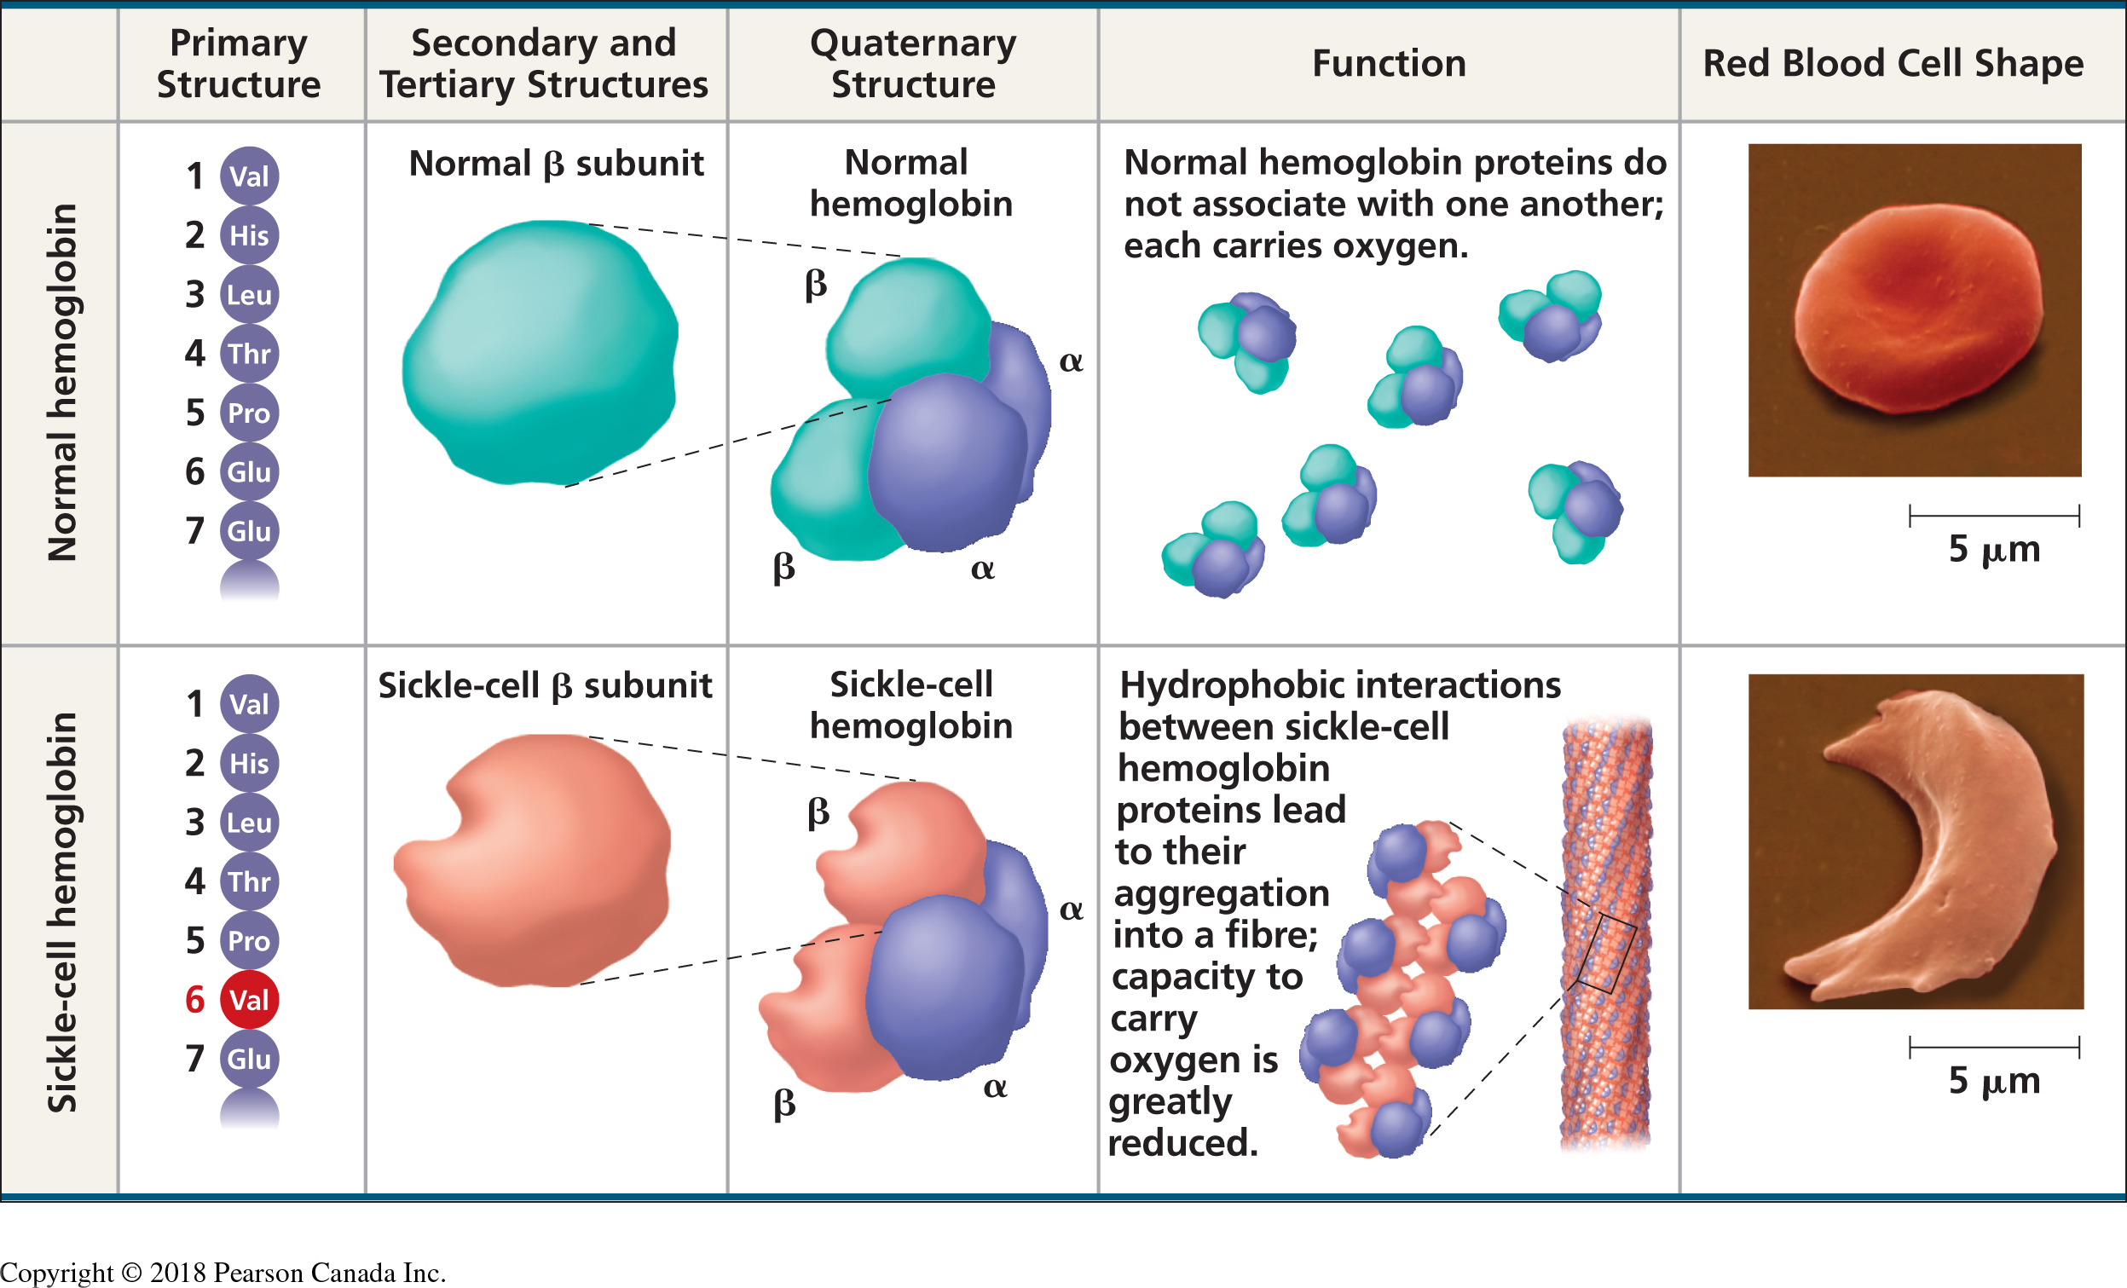
  - Mutations can be chromosomal (DNA segment loss, repetition of DNA segment, addition or loss of chromosomes)
- Assortative mating
  - Random mating: panmixia
    - Example: American eel
      - Species found in all large rivers and lakes on the Eastern coast of North America. Spawning ground: somewhere in the Sargasso’s sea
      - Is a considered a panmictic population
  - Assortative mating: choice of partners in relation to the phenotype (modifies H.W. equilibrium)
    - Positive assortative mating
      - More frequent mating between similar individuals than expected change
      - Effect: increase homozygosity
      - Autogamy or selfing of plants (pure lineages of Mendel)
      - Geographical proximity of individual (e.g. population of mice in a barn)
      - In humans: mating according to eight and skin colour
    - Negative assortative mating
      - More frequent mating between individuals that do not look alike than expected by chance
      - Effect: increase heterozygosity
      - Examples flowers and bees
    - Assortative mating does not change allele frequencies; it changes genotypic frequencies
    - When paired with natural selection positive assortative mating can lead to an increase in homozygosity and a loss of genetic variability:
      - Phenomena of endogamic depression since the harmful alleles will express themselves
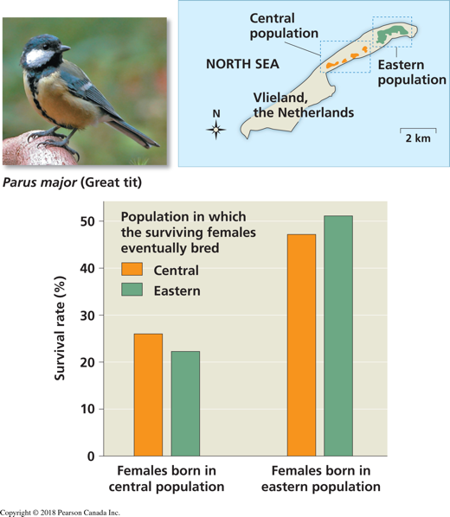
      - Natural selection will purge the population of a portion of its harmful alleles
    - Example: Black guppy
- Gene flow
  - Migration: exchange of genes between populations
  - Has a tendency to standardize the genetic pool of the populations involved
  - Can play a similar role as mutations by introducing new genes in one of the populations
  - Example of gene flow
    - Eastern population 11% of first time breeder are new migrants
    - Central population: 43% of first time breeders are new migrants

