Receptor tyrosine kinases (RTKs)
- Before binding with the insulin, the receptors exist as individual monomers, with an extracellular ligand binding site, and alpha helix spanning the membrane and a cytoplasmic tail containing many tyrosine
- The binding of the insulin causes the receptors to associate closely with each other, forming a dimer
- Dimerization activates tyrosine kinase region of each monomer, each tyrosine kinase adds a phosphate from ATP to a tyrosine on the tail
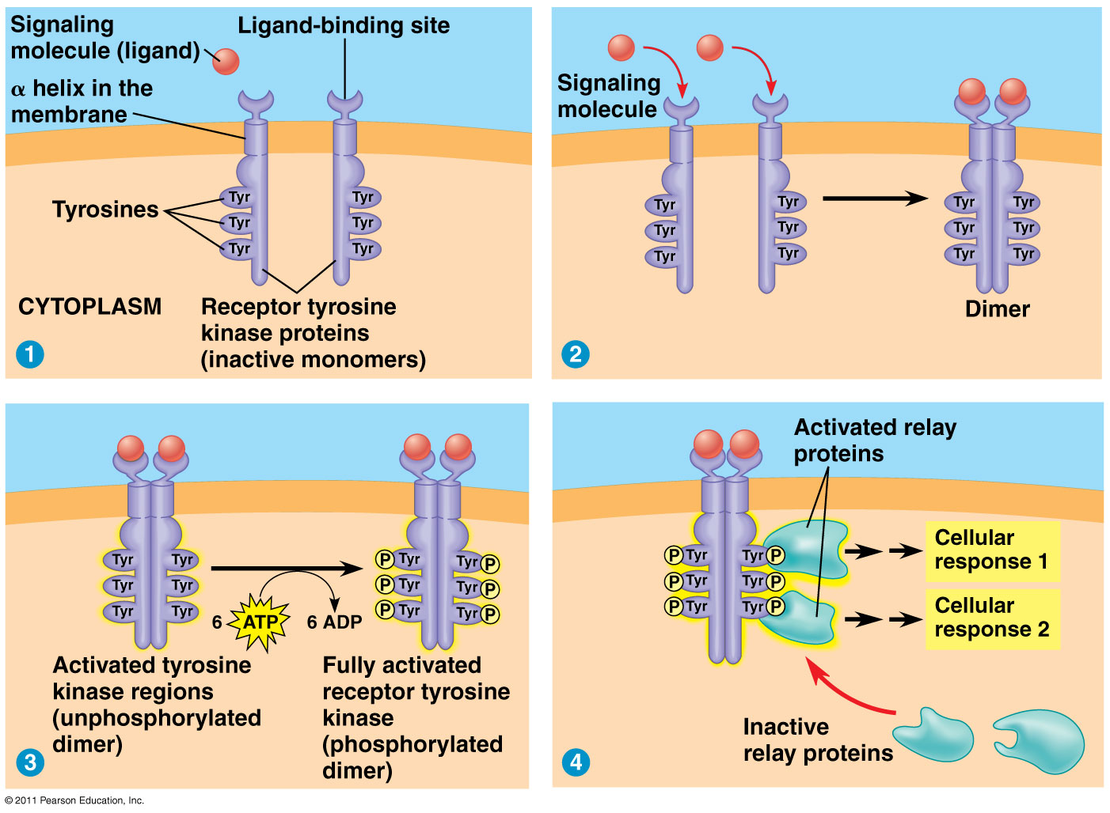
- The receptor tyrosine kinase is fully activated, it is recognized by specific relay proteins inside the cell, which bind to phosphorylated tyrosine and undergo a structural change. Activated proteins trigger a transduction pathway, leading to a cellular response
Topics of human interest
GPCRs represent the largest family of genes encoded by the human genome. Their importance in human biology is reflected by the fact that over one third of all prescription drugs act as ligands that bind to its huge superfamily of receptors.
The following inherited disorders have been traced to defects in GPCRs and G proteins;
- Hyperthyroidism, familial male precocious puberty
- Retinitis pigmentosa, colour blindness and spectral sensitivity variations
- Short stature and obesity, early onset severe obesity, decreased fertility

Diabetes mellitus – a defect in insulin signalling
There are two types;
- Type I
  - 5-10% - caused by the inability to produce insulin – an immune system disorder
- Type II
  - 90-95% - result of lifestyle and eating habits
  - A high calorie diet combined with sedentary lifestyle leading to chronic increase in insulin secretion
  - Elevated levels of insulin over-stimulate target cells in the liver and elsewhere in he body, leading to a condition known as insulin resistance – the target cells stop responding to the presence of the hormone
  - The nonresponse of cells to the insulin in turn leads to a chronic elevation of blood glucose levels, which stimulates the pancreas to secrete even more insulin
  - Can lead to the death of insulin secreting beta cells of the pancreas
  - Increasing sugar levels cannot be utilized by cells, which become deprived of fuel energy
  - Resulting health risks are cardiovascular disease, blindness, kidney disease, reduced circulation – all due to damage to the body’s blood vessels

Lecture 13: Cellular proliferation and Apoptosis

Cell division allows the organism to add new cells for its growth and repair. The functions of cell division include;
- Reproduction
- Growth and development
- Tissue removal

Every few (5) months, all of the skin cells on the surface of our body are sloughed away and replaced by new cells. The epithelial line of our lower intestine is renewed every three to five days.
- These epithelial cells are terminal or post-mitotic, meaning that they will no longer divide to give rise to new cells
- As they get older and damaged, they are continuously replaced by the work of stem cells
- Other cells in the body do not get replaced at all
Stem cells* and cancer cells are known for their ability to undergo cell division rapidly, often with consequences.

- Liver cells maintain their ability to divide but only when there is a need (for wound repair)
- Most specialized cells do not divide at all in a mature human (nerve and muscle cells)

Stem cells: constantly dividing (ex. stem cells will become the epithelial cells that constantly need to be replaced, also common in bone marrow to produce white and red blood cells)

Germ cells: undergo meiosis to produce sex cells (haploid cells)

The instructions for cell division is a part of our genes
- Multicellular organisms begin as a single cell (the fertilized egg), and all cells undergo cellular division to create the final product of the organism
- The process of cell division is highly regulated – specific proteins contribute to its regulation
  - Example: the CDKN2A gene is a tumour suppressor gene (also responsible for cell cycle control). When the gene mutates because of UV exposure, a loss of the cell cycle control results and can cause cell division to occur continually (cancer)

Cell division and genetically identical daughter cells
During mitosis, chromosomes are distributed evenly to two daughter cells – the chromosomes move and behave actively.

Chromosomes in eukaryotes
- Responsible for inheritance of genetic traits from parents to offspring
- Involved in the equal distribution of genes among two daughter cells that are produced through cell division

Chromosome structure
They are located in the nucleus of eukaryotic cells.
The fundamental unit of a chromosome is the chromatin fiber (cf)
- The cf is composed of a DNA double helix associated with various proteins including histones
- Before replication, a chromosome is composed of only one chromatin fiber
- After its replication, it is composed of two chromatin fibers called chromatids

Chromosome structure depends on a certain degree of chromatin fiber coiling and condensation.
- Before mitosis begins, chromosomes become coiled and compact (condensed)
- This is especially important before a cell division in order to bring about an equal distribution of genes to the two daughter cells, each with a copy of the same genes

The cell cycle
A set of events that a cell undergoes between the time it is formed and the time it is divided into new cells.
The cell cycle is composed of an interphase and a cell division.

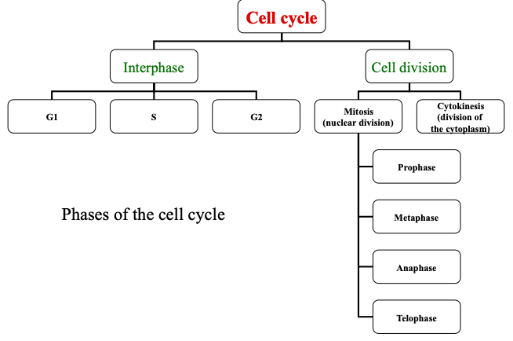
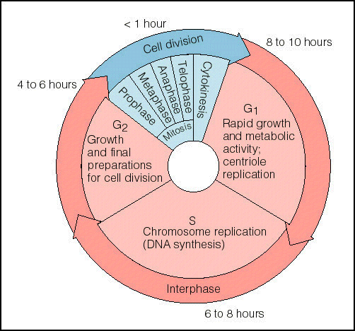
G1: cell volume is increasing, synthesis of organelles/proteins/RNAs, high metabolic activity
S: DNA replication (chromosome duplication)
G2: growth, synthesis and metabolism, but less so than in G1

Regulation of the cell cycle
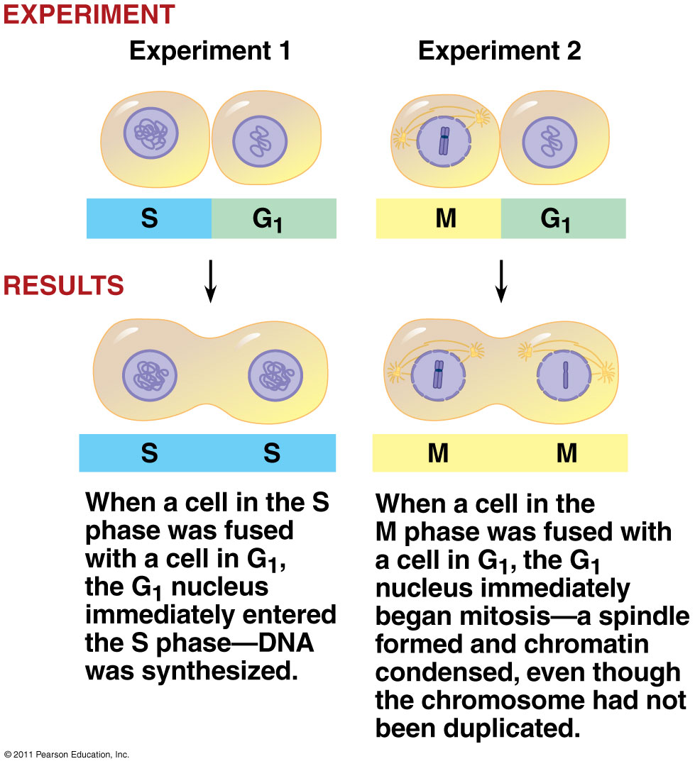
The study of the cell cycle allows us to understand cancer (a disease that results from a breakdown of the cell’s ability to regulate its own division).

Rao and Johnson experiment
- Aim to discover if the cytoplasm of cells contains regulatory factors that affect the cell cycle activities
- Experimental procedure: fused mammalian cells that were in different stages of the cell cycle and studied the level of chromatin compaction.
- They discovered that the mitotic cell always induced premature compaction of chromatin in the nucleus of the non-mitotic cell. During the S phase, compaction gave rise to pulverized chromosomal fragments
- They concluded that;
  - The cytoplasm of a mitotic cell contains diffusible factors that could induce mitosis in a non-mitotic cell (in interphase)
  - The transition from G2 to M is under positive control, induced by the presence of some stimulatory agents

Biochemical properties of factors that promote entry of a cell into division
Through experiments with oocytes, frogs and invertebrates, we discover that the entry of a cell into M phase is initiated by a protein called maturation promoting factor (MPF). It consists of two subunits;
- A protein kinase, or a cyclin dependant kinase (CDK): an enzyme that activates or inactivates other proteins by phosphorylation.
  - Their concentration in the cell stays constant, only the activity of the molecule varies
  - When bound to cyclin, they are active
- A regulatory subunit called cyclin, whose concentration rises and falls in a predictable pattern with each cell cycle
  - When the cyclin concentration is low, kinase is inactive (lacks the cyclin subunit)
  - When the cyclin concentration is high, kinase is active, causing the cell to enter the M phase
    - Progression of cells into mitosis depends on an enzyme that phosphorylates other proteins
    - The activity of this enzyme is controlled by a subunit whose concentration varies from one stage of the cell cycle to another
  - Cyclin both triggers and coordinates key events in the cell cycle – it proceeds on its own according to a built-in clock
  - Concentration rises during the S and G2 phases, then falls during mitosis

MPF is a molecule known as a CDK complex (cyclin dependant kinase associated with cyclin).

The cell cycle control system
The cell cycle is regulated at certain checkpoints by both internal and external signals (to stop or restart a process).
These checkpoints function as a mechanism that can stop the progress if;
- Any of the chromosomal DNA is damaged
- Certain critical processes have not been properly completed (ex. DNA replication during S phase or alignment of chromosomes during the M phase)
The checkpoints are found in G1, G2, and the M phase.

The cell cycle clock: cyclin and cyclin-dependent kinases
There is a rhythmic fluctuation in the abundance and activity of molecules that regulate a cell cycle.
MPF activity corresponds to cyclin concentration.
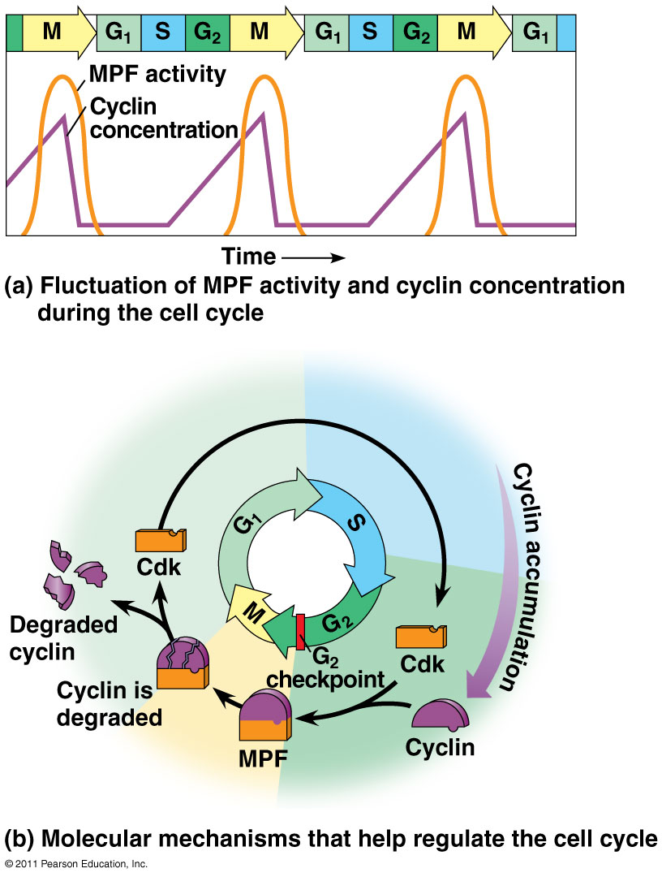
The role of the MPF complex is to activate other proteins, such as ones responsible for DNA repair, mitotic spindle formation, etc. This is why MPF concentration acts as a checkpoint, because they must be in high concentration in order for division to begin.

Steps between G2 checkpoint into M phase
- Synthesis of cyclin begins in late S phase and continues through G2. Because cyclin is protected from degradation during this stage, it accumulates
  - When cyclin concentration is at its maximum during G2, CDK binds
- Cyclin combines with CDK, producing MPF. When enough MPF molecules accumulate, the cell passes the G2 checkpoint and begins mitosis
  - The MPF can also be called the M-phase promoting factor, because it triggers the passage from G2 to M phase
- The MPF promotes mitosis by phosphorylating various proteins. MPF’s activity peaks during metaphase – it acts as a kinase or activates other kinases with the following effects;
  - Fragmentation of the nuclear envelope
  - Chromosome condensation
  - Spindle formation
- During anaphase, the cyclin component of MPF is degraded, terminating the M phase – the cell now enters the G1 phase and MPF helps switch itself off
- During G1, the degradation of cyclin continues, and the CDK component of the MPF is recycled – it regains its inactive form until it becomes part of the MPF again

Internal and External signals at the checkpoints
There are 3 important checkpoints that register signals from inside and outside the cell in the G1, G2 and M phases.

- The G1 checkpoint (involves a CDK complex)
  - If a cell receives a go-ahead signal at the G1 checkpoint, it will usually complete the G1, S, G2 and M phases and divide
  - If a cell does not receive a go-ahead signal at that point, it may exit the cycle to enter the non-dividing state G0
    - Most cells of the adult human body are in the G0 phase:
    - Muscle and nerve cells never divide
    - Liver cells can be called back from the G0 phase by growth factors during an injury

- The M checkpoint (involves a complex made up of different proteins)
  - When all chromosomes are attached to the spindle fibers from both poles, a go-ahead signal allows the cell to proceed into anaphase
    - Kinetochores must attach sister chromatids to the spindle fibers
    - Appropriate regulatory protein complexes become activated, once activated the separase enzyme cleaves the cohesins, allowing the sister chromatids to separate
  - When any of the cell’s chromosomes are not attached to the spindle fibers, the cell receives a stop signal

Internal signals
Signals are registered at checkpoints and come from cellular surveillance mechanisms located inside the cell

External signals
Signal can be transmitted within the cell by a signal transduction pathway. External factors, both chemical and physical, can influence a cell division;
- Nutrients
- Growth factors (proteins that stimulate other cells to divide)
- The density of a cell population (density-dependent inhibition) – crowded cells will stop dividing
- Anchorage dependence – cells must be attached to a substratum (in cell culture it is a culture dish, in a living cell it is the ECM).

Apoptosis – programmed cell death

A normal process that is unique to animal cells, occurs through a sequence of events that lead to the death of the cell. Cells that have reached the end of their functional life span often undergo a programmed cell death – controlled cell suicide.

The apoptosis process
Cellular agents chop up the DNA and fragments the organelles and other cytoplasmic components – the cell shrinks and becomes lobed (blebbing). The cell’s parts are packaged up in vesicles that are engulfed and digested by specialized scavenger cells, leaving no trace.

The process of apoptosis protects neighbouring cells from damage, since a dying cell that leaks out its contents would release digestive enzymes that would damage other cells.
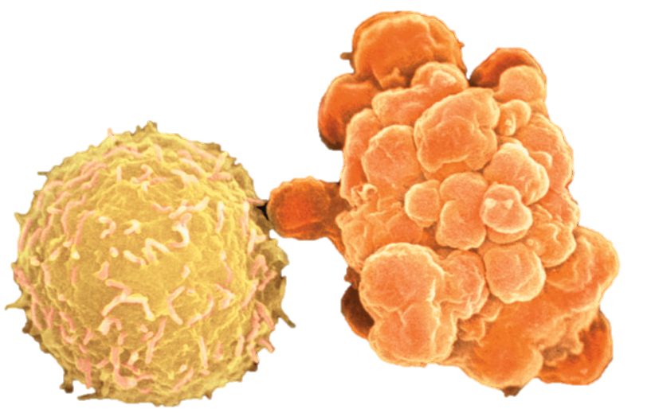

The right cell is one that is in the process of apoptosis. It is blebbing so it can be digested.
The left cell is a normal white blood cell.

The signal that triggers apoptosis can come from;
- Outside the cell: signalling molecules released from other cells initiate a signal transduction pathway that activates the genes and proteins responsible for carrying out cell death
- Inside the cell: within a cell whose DNA has been damaged, a series of protein-protein interactions pass along a signal that triggers cell death
  - In animal cells, pathways involve about 15 different caspases (enzymes) that carry out apoptosis
  - One other major pathway involves mitochondrial proteins that form pores in the outer membrane and cause the release of other proteins (such as cytochrome c), acting as cell death factors

The molecular basis of apoptosis
In worms and other species, apoptosis is triggered by signals that activate a cascade of suicide proteins (Ced-4 and Ced-3) in the cell destined to die. These Ced (which stands for cell death) molecules start a cascade which activates proteases (for digesting proteins), or nucleases (which digest and breakdown genetic material).
The main proteases of apoptosis are called caspases. In the nematode, the main caspase is the Ced-3 proteins.
- Ced-9 (in the outer mitochondrial membrane) acts as a break in the absence of the signal promoting apoptosis. When a cell receives a death signal, a signal transduction involves a change in Ced-9 that disables the break and activates suicide proteins Ced-3 and Ced-4

Lecture 14: Continuation of Signal Transduction: the signal pathway involving calcium, IP3 and DAG

Calcium ions and inositol triphosphate (IP3)
Many of the signalling molecules that function in animals - including neurotransmitters, growth factors and some hormones – induce responses in their target cells via signal transduction pathways that increase the cytosolic concentration of calcium ions.
- Ca²⁺ is even more widely used than cAMP as a second messenger
- Increasing the cytosolic concentration of calcium ions causes many responses in animal cells such as;
  - Muscle cell contraction
  - Secretion of certain substances
  - Cell division

Cells use Ca²⁺ as a second messenger in pathways triggered by both the G protein coupled receptor and tyrosine kinases.

Location of calcium and its effect there
Although cells always contain some Ca²⁺, the ion can work as a second messenger because its concentration in the cytosol is normally much lower than the concentration outside the cell.

Because cytosolic Ca²⁺ level is so low, a small change in absolute numbers of ions represents a relatively large percentage change in calcium concentration.

Calcium ions are;
- Actively transported out of the cell
- Actively imported from the cytosol into the endoplasmic reticulum, and sometimes into the mitochondria by various protein pumps (causing the calcium concentration in the ER to be usually much higher than that in the cytosol)

Maintenance of Ca²⁺ concentration in an animal cell
Protein pumps in the plasma membrane and the ER (driven by ATP) move Ca²⁺ from the cytosol into the extracellular fluid and into the lumen of the ER.

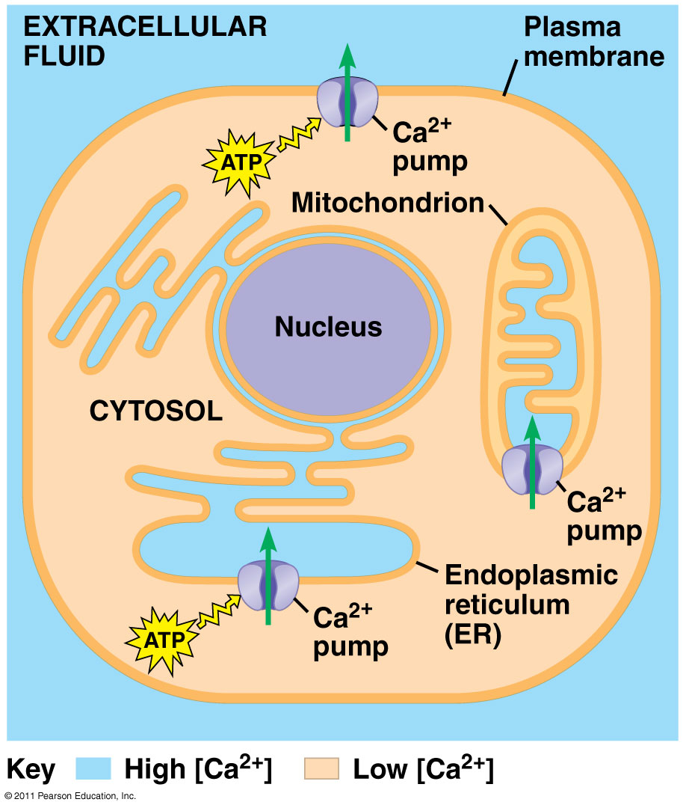
Mitochondrial pumps, driven by chemiosmosis, move Ca²⁺ into the mitochondria when the calcium level in the cytosol rises significantly.

The involvement of IP₃ and DAG
In response to a signal relayed by a signal transduction pathway, the cytosolic calcium level may rise, usually by a mechanism that releases Ca²⁺ from the cell’s ER. The pathway leading to calcium release involves two other messengers;
- Inositol triphosphate (IP₃)
- Diacylglycerol (DAG)

These two messengers are produced by the cleavage of a certain kind of phospholipid located in the plasma membrane.
- Because IP₃ acts before calcium in these pathways, calcium could be considered as a third messenger
- However, scientists use the term second messenger as a general term for all small, non protein components of signal transduction pathways

Steps of a signalling pathway involving calcium, IP₃ and DAG

- A signalling molecule binds to a receptor leading to the activation of phospholipase C
- Phospholipase C cleaves a plasma membrane phospholipid called PIP₂ into DAG and IP₃
- DAG functions as a second messenger in other pathways
- IP₃ quickly diffuses through the cytosol and binds to an IP₃ gated calcium channel in the ER membrane, causing it to open
- Calcium ions flow out of the ER down their concentration gradient. This raises the cytosolic level of CA²⁺
- The calcium ions activate the next protein in one or more signalling pathways
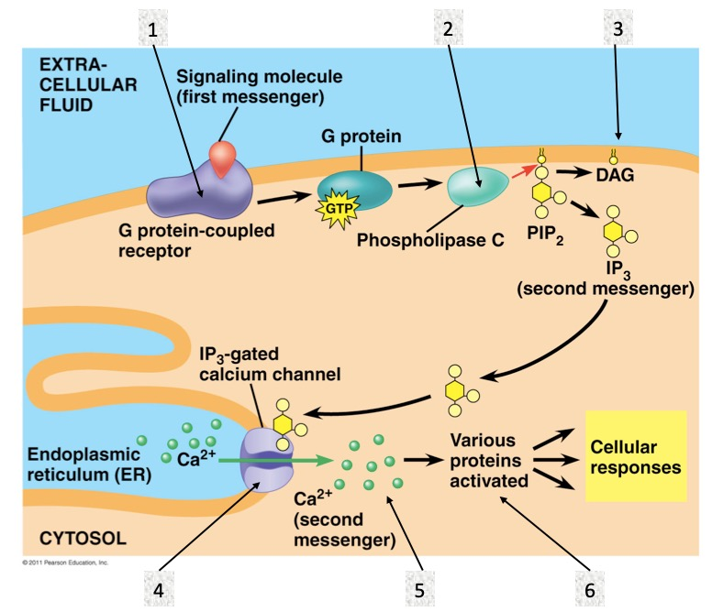

Calcium ions and IP₃ work as second messengers in many signal transduction pathways. In the figure above, the process is initiated by the binding of a signalling molecule to a GPCR. A receptor tyrosine kinase could also initiate this pathway by activating phospholipase C.

Molecular biology of cancer

Henrietta Lacks and the HELA cells
A woman who died from cervical cancer, while she was under treatment a tissue sample of her cancer was removed and provided to a biologist – George Gey.
- His research aimed at establishing a human cell line that might provide insights into cancer – his research here helped to provide a distinction between the normal cell and the cancer cell
- Started a tissue culture facility to culture and study cells – they would survive and grow for 20-50 generations before dying
- Once cultivated, samples from Henrietta’s tumour were observed. Gey found a new discovery, that cells grew abundantly to form a thick sheet inside the tube.
- When transferred, they continued to divide and grow. Gey came to the conclusion that he had created the first human immortal cells.
- These same cells have been used for countless research studies, although the Lacks family never consented

Basic properties of a cancer cell
Cancer can be thought of as a genetic disease since it can be traced to alterations within specific genes, but it is not an inherited disease. We do not inherit cancer from our parents.
- An inherited disease is one where the genetic defect is present on the chromosome of a parent, and is transmitted to the zygote
- A genetic disease arises in the DNA of a somatic cell during the lifetime of the affected individual
Because of genetic changes, cancer cells are not subject to many of the restraints to which normal cells are;
Normal cells;
- Do not divide unless they are stimulated to do so by homeostatic mechanisms
- Do not survive if they have incurred irreparable damage
- Do not wander away from a tissue to start new colonies elsewhere in the body
Cancer cells;
- Experience a breakdown of their regulatory influences
- Proliferate uncontrollably
- Can wander away to produce a malignant tumour that invades surrounding healthy tissue

Localized tumour: as long as the growth of a tumour remains localized, the disease can usually be treated and cured by surgical removal of the tumour.
Malignant tumour: one that tends to metastasize, it will spawn renegade cells that break away from the parent mass and enter the lymphatic or vascular circulation. Then, they spread to distant sites in the body where they establish a lethal secondary tumour. It is no longer able to be surgically removed.

Research efforts on cancer
Prognoses for many types of cancer remain unchanged, although death rates have dropped significantly due to earlier diagnoses and treatment for breast, prostate, and colon cancer.

The issues with current treatments: chemotherapy and radiotherapy;
- Lacks the specificity needed to kill cancer cells without damaging normal cells
- Therefore causes serious side effects
- The patients cannot be subjected to high enough doses of chemicals or radiation to kill all the tumour cells in their body without first killing the patient

Study on cancer cells by cell culture
- Obtained by a sample of a growing malignant tumour
- Cells kept in storage are done so using liquid nitrogen
- Normal cells can also be converted to cancer cells by treatment with carcinogenic agents (chemicals, radiation, tumour viruses). These cells can then cause tumour when transferred to a host

Characteristics of cancer cells at the cellular and genetic level – types of cancer differ, but all cancer cells share the following similarities in terms of characteristics;

- Lost a capacity of controlling its growth and division;
  - Normal cells when grown in tissue culture will proliferate at the same rate as malignant cells. However, when they cover the bottom of a petri dish, their growth decreases and they tend to form a single layer (monolayer) of cells. The growth rate decreases due to contact between cells and depletion of growth factors.
  - Cancer cells under the same conditions will continue to grow and pile on top of one another to form a clump. They do not respond to the signals that cause normal cells to stop their growth and division

- Continues to grow in the absence of stimulatory growth signals that are required by normal cells;
  - Normal cell growth in culture depends on epidermal growth factors (insulin)
  - Cancer cells can grow without insulin because their cell cycle does not depend on the interaction between growth factors and their receptors

- In culture, they seem immortal because of continual division due to the presence of telomerase. In normal cells, there is no telomerase;
  - In the cancer cell, the enzyme maintains telomeres at the ends of the chromosomes, thus allowing the cell to continuously divide
  - In a normal cell, there is no telomerase as a defense to protect against tumour growth
    - See below for explanation of telomerase

- A highly aberrant chromosome complement: aneuploidy (a result of the defect in the mitotic checkpoint)
  - Normal cells will replicate their DNA at a very low error rate
  - Cancer cells are genetically unstable and their aneuploidy may occur as a result of defects in the mitotic checkpoint, or the presence of an abnormal number of centrosomes
    - The growth of cancer cells is much less dependent on diploidy than the growth of normal cells
    - When the chromosome content of a normal cell is disturbed, a signal pathway is activated that leads to apoptosis
    - Cancer cells typically fail to elicit the apoptotic response event when their chromosome content is highly disturbed
  - Aneuploidy in cancer cells is common because of the lack of the M checkpoint, which checks if kinetochores are attached to mitotic fibers, a process essential for equal division of the chromosomes
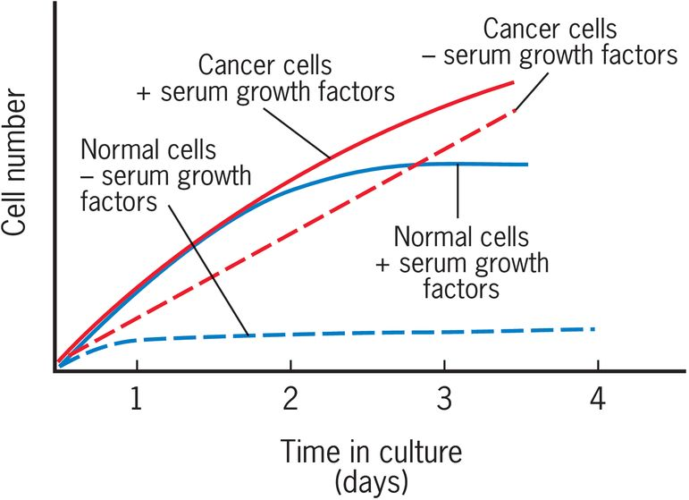

Telomeres
- Unusual stretch of repeated sequences, that together with specialized proteins will form a cap at each end of a chromosome.
- Humans contain the sequence TTAGGG repeated thousands of times
- The role of the telomere;
  - Required for complete replication of the chromosome
  - Forms a cap that protects the chromosome from nucleases and other destabilizing factors
  - Prevents the end of chromosomes from fusing with one another
- In summary, a telomere forms a protective cap on a chromosome, and gets shorter with each division. When it gets too short, the cell signals for apoptosis. Telomerase maintains the length of the telomere between divisions so that it never shortens – which is a feature of cancer cells.

Behaviour of normal cells in culture, in relation to telomeres;
- Even if the cells are dividing at a high rate at the beginning of the culture, cells stop dividing after about 50-80 population doublings and enter a stage of replicative senescence.
- Dramatic decrease in telomere length over time in culture
- Telomeres shrink because most cells lack telomerase and are unable to prevent the loss of their chromosome ends
- Telomere shortening continues so that physiological response is triggered within each cell, causing the cell to stop growth and division

Behaviour of cancer cells in culture, in relation to their telomeres
- Are able to reactivate telomerase and resume growth and cell division so as to become immortal

The causes of cancer

The first correlation between the environment and the development of cancer;
- A high incidence of cancer of the nasal cavity and the skin of the scrotum in chimney sweeps was due to a chronic exposure to soot
Within the past several decades, hundreds of carcinogenic chemicals have been isolated and shown to cause cancer in animal laboratories. All the cancer-causing agents have one property in common: they alter the genome.

List of cancer causing agents;
- Chemicals: (soot, cigarette smoke) they are directly mutagenic or converted to mutagenic compounds by cellular enzymes
- Ionizing radiation: from UV light, strongly mutagenic
- DNA tumour viruses or RNA tumour viruses (tested in cell cultures), which can transform normal cells into cancer cells;
  - They carry genes whose products interfere with the cell’s normal growth regulating activities and increase the person’s risk of developing cancer
  - Example: HPV which can be transmitted through sexual activity, is present in about 90% of cervical cancer
  - Example: Hepatitis B virus is associated to liver cancer
  - Example: Epstein-Barr virus is associated to Burkitt’s lymphoma in areas where malaria is common
  - HHV-8 is associated to Kaposi’s sarcoma

Obvious causes of certain cancers and risk factors in cancer development

Despite a large number of studies, we are still uncertain as to the causes of most types of human cancer. Humans are living in complex environments and are exposed to many potential carcinogens in a changing pattern over a period of decades.

Obvious causes;
- Smoking causes lung cancer
- Exposure to UV light causes skin cancer
- Inhaling asbestos fibers causes mesothelioma
Risk factors;
- Calorie rich diet: a calorie-restricted diet would protect against cancer
- Obesity: cancer rate is higher among obese people, connected to high levels of insulin and insulin-like growth factor
- Certain ingredients in the diet: animal facts and alcohol, for example. Some compound in food would reduce the risk, isoflavone in soy, sulforafanes in broccoli, EGCG in tea

Prescribed drugs having a preventing effect
Those that interfere with the action of oestrogen or the metabolism of testosterone would reduce the incidence of breast and prostate cancer;

Long-term use of non-steroidal anti-inflammatory drugs NSAID (ex. aspirin) would decrease the risk of colon cancer;
- They would inhibit cyclooxygenase-2
- This enzyme catalyzes the synthesis of hormone-like prostaglandins, which promote the growth of intestinal polyps
- This cancer-suppressing action or NSAIDs indicate that inflammation plays a major role in the development of various cancers

The use of anti-diabetes (metformin) would reduce the risk of developing cancer as a result of the drug’s action in lowering the blood insulin and IGF-I

Cancer as a genetic disorder
Levels of cell differentiation and the occurrence of cancer;
- Stem cell: unlimited potential of proliferation
- Progenitor cells: derived from stem cells, limited ability to divide
- Differentiated cells: lack the capability to divide

Tumour formation requires that a cell be capable of extensive division;
- Cancer would arise from a small population of stem cells in adult tissue
- Cancer would also arise from progenitor cells by acquiring certain properties

General features of cancer cells;
All cells of a cancerous tumour arise from a single cell;
- Result from uncontrolled proliferation of a single wayward cell, cancer is said to be monoclonal
- There are two types of genetic alterations that make humans more likely to develop cancer;
  - Alterations that we inherit from our parents (germ-line mutation) – but not the major factor in the occurrence of most cancers
  - Alterations that occur during our own lifetime (somatic mutation) – genes that we inherit have a significant influence on our risks of developing cancer, but the greatest impact comes from genes that are altered during our lifetime
- Most common solid tumours (breast, colon, prostate, lung) arise in epithelial tissues that are normally engaged in a high level of cell divisions
- Leukemia develops in rapidly dividing blood-forming tissues

Tumour suppressor genes and oncogenes
The two types of genes are implicated in carcinogenesis.

- Tumour suppressor genes (cancer preventing)
  - Genes that encode proteins which restrain cell growth and prevent cells from becoming malignant
  - Allow a cell to divide only if they are ready, otherwise they will signal for division to stop
  - They were discovered after experiments on rodents where normal cells and malignant cells were fused to one another
  - It was discovered that some of the cell hybrids formed from this type of fusion lose their malignant characteristics, suggesting that a normal cell possesses factors that can supress uncontrolled growth of a cancer cell

- Oncogenes (cancer causing)
  - Genes that encode proteins which promote the loss of growth control and the conversion of a cell to a malignant state. These genes have the ability to transform cells
  - Most oncogenes act to accelerate cell proliferation
  - They may lead to genetic instability, prevent a cell from apoptosis or promote metastasis
  - Cells possess a variety of genes, called proto-oncogenes, that have the potential to be activated into oncogenes and push the cell toward the malignant state
    - They encode proteins that have various functions in a cell’s normal activities
    - But – they can be activated into oncogenes, by three principal mechanisms (below)
  - Viruses transporting oncogenes can transform a normal cell into a malignant cell
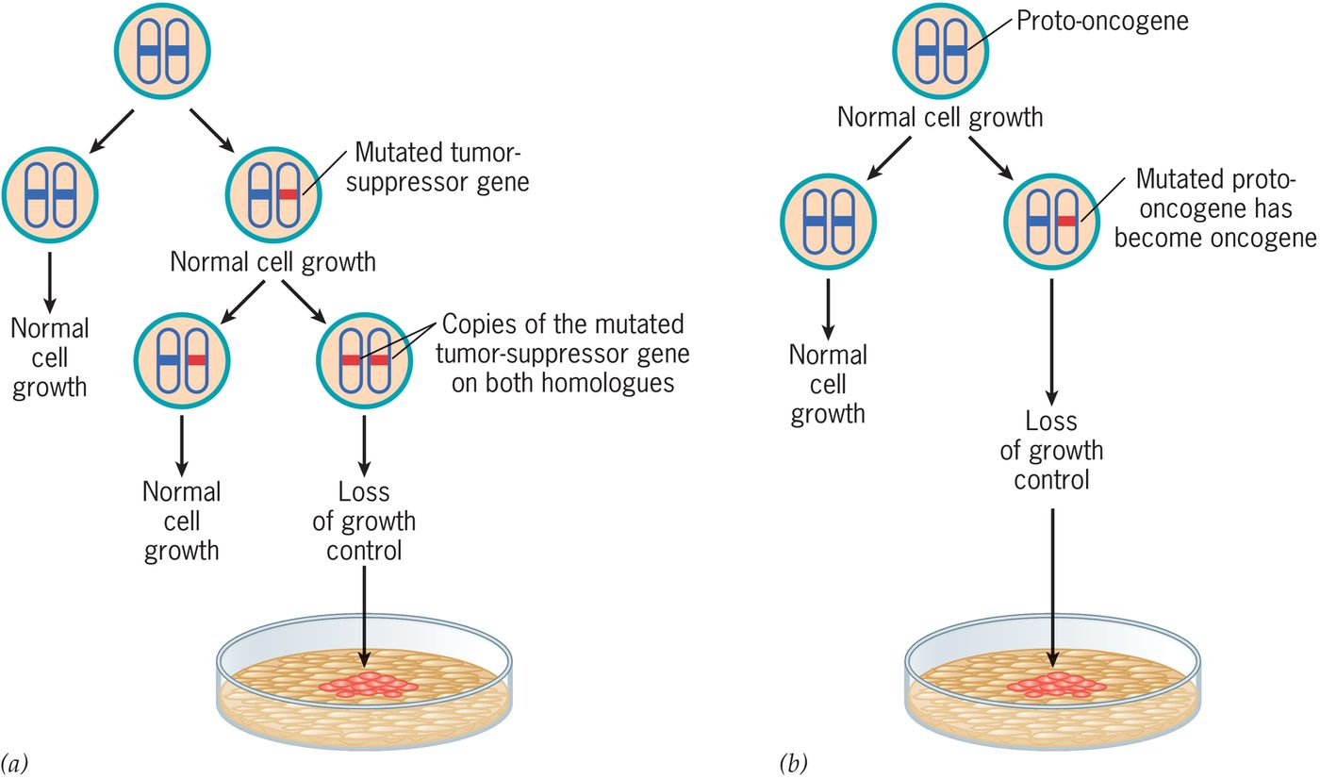

(Above) differences between the effects of mutations in tumour suppressor genes and oncogenes
- Follows a recessive mutation pattern (both chromosomes need to be affected)
- Follows a dominant mutation pattern (only one mutation on one proto-oncogene is enough to cause it to become malignant and transform into an oncogene)

Three ways to activate proto-oncogenes into oncogenes
- Mutation and deletion
  - The gene is mutated in a way that alters the properties of the protein so that it no longer functions normally
- Gene duplication
  - The gene can become duplicated one or more times, resulting in gene amplification and excess product of the encoded protein
- Chromosome rearrangement
  - A chromosome rearrangement can occur that brings a DNA sequence from a distant site in the genome into close proximity of the gene altering either the expression of the gene or the nature of the encoded protein

Any of these genetic alterations can cause a cell to respond less to normal growth control.
Oncogenes act dominantly, a single copy of an oncogene (only one allele of the oncogene) can cause a cell to become malignant, no matter if there is a normal non-activated copy of the gene on the homologous chromosome.
Tumour-suppressor genes must have both copies mutated to make a normal cell as malignant.

Angiogenesis and tumour growth
As a tumour grows in size, it stimulates the formation of new blood vessels, a process known as angiogenesis.
- Blood vessels are required to deliver nutrients and oxygen to the rapidly growing tumour cells and to remove their waste products
- They also provide ducts for cancer cells to spread to other sites in the body

Cancer cells promote angiogenesis by secreting growth factors such as VGEF, that act on the endothelial cells of surrounding blood vessels, stimulating them to proliferate and develop into new vessels.
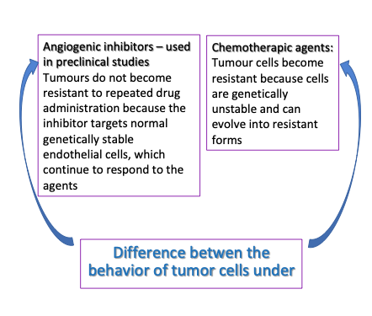

The transformation of a normal cell to a cancer cell is accompanied by the loss of function of one or more tumour-suppressor genes. Some of the best characterized genes include those that encode;
- Transcription factors: TP53 and WT1
- Cell cycle regulators: RB and INK4a
- Components that regulate G proteins: NF1
- Phosphoinositide phosphate PTEN
- A protein that regulates protein degradation

*All act as negative regulators of cell proliferation, which is why the elimination promotes uncontrolled cell growth.

Examples of well known cancers;

Prostate cancer
- A benign (non cancerous) enlargement of the prostate occurs in more than half of men over age 40 and in almost all men over 70
- Prostate cancer afflicts men of 65 years and older, and is one of the most common human cancer

Retinal cancer
- The development of retinoblastoma requires that both copies of the RB gene of a retinal cell be wither eliminated or mutated before the cell gives rise to retinoblastoma
- In sporadic retinoblastoma, the tumour develops from a retinal cell which both copies of the RB genes have undergone successive spontaneous mutations

Breast cancer
- The tumour-suppressor gene which is mutated is the BRCAI
- The genetic and cellular changes contribute to the tumour becoming malignant
- The cells of the malignant tumours grow in an uncontrolled way and can spread to neighbouring tissues, via lymph and blood vessels, to other parts of the body
- When cancer cells spread beyond their original site they form metastasis
- Breast cancer is a prime example of a disease where abnormal behaviour of cancer cells can be catastrophic; a first cell in the tissue undergoes the first changes that convert it into a cancer cell
  - This cell has altered proteins on its surface which the body’s immune system usually recognizes as non-self or abnormal and destroys it
  - Sometimes the cell may escape destruction, then proliferate to form a tumour

Colorectal cancer
One of the best understood and most common types of cancer
Develops gradually;
- The first sign is a polyp (small benign growth in the colon lining)
- The cells of the polyp look normal although they divide unusually frequently
- The tumour grows and may eventually become malignant, invading other tissues
- The development of a malignant tumour occurs when an accumulation of mutations convert proto-oncogenes into oncogenes and wipe out tumour suppressor genes
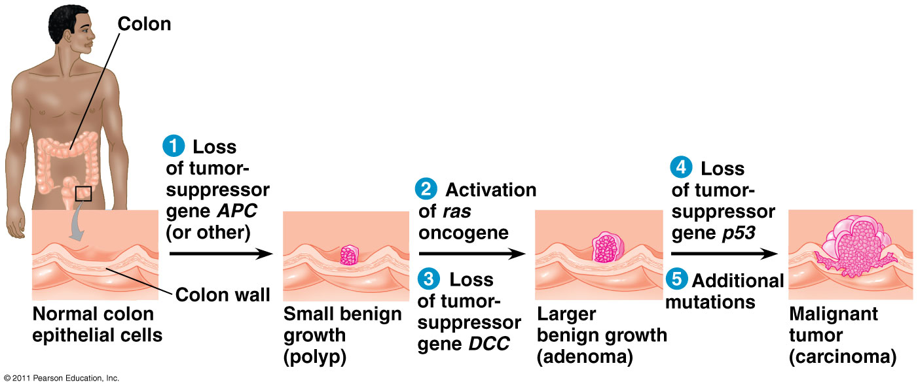
- Processes involved: both the Ras oncogene and the mutated p53 tumour suppressor gene (mutated recessively)

