Lecture 6: Gene transcription and translation

From genes to proteins

Transcription: synthesis of complementary RNA from a DNA template in the nucleus. Required machinery are RNA polymerase and transcription factors, with an end product of messenger RNA (mRNA)
Translation: synthesis of proteins in the cytoplasm using information encoded by mRNA. Required machinery is ribosomal RNA, ribosomal proteins and transfer RNA. The end product is a polypeptide

RNA polymerase: enzyme that binds to DNA and incorporates nucleotides into a strand of RNA whose sequence is complementary to one of the DNA strands

**RNA polymerase II is concentrated on mRNA, small nuclear RNAs, most microRNAs and telomerase RNA

- Promoter region: site on DNA to which RNA polymerase binds prior to initiation of transcription, determines which strand is template. It is large and variable, the core elements are listed below;
  - TATA element: (TATAAA sequence) recognized by transcription factor TATA-binding protein (TBP)
  - B recognition element: (BRE) recognized by transcription factor TFIIB
  - Initiator element: (INR) recognized by TBP-associated factors (TAF 1,2)
  - Downstream promoter element: recognized by TBP-Associated Factors (TAF 1,2)

Transcription Factors: proteins that combine with RNA Pol II at promoter site to form a pre-initiation complex that can initiate transcription as soon as nucleotides are available. They serve to;
- Regulate gene expression
- As general and specific transcription factors, where the general transcription factors (GTFs) are;
  - TATA-binding protein
  - TBP associated factors (TAF 1,2,5,6)
  - Transcriptional pre-initiation protein complexes for RNA Pol II (TFII A B D E F H and TFIID – which is TBP+TAF)
- These are basal transcription factors: they will position RNA polymerase in response to signals from activators. This occurs at the start of transcription to initiate the process

Pre-initiation complex: Composed of activators, repressors, co-activators and the basal transcription factors listed above. It helps position RNA polymerase II over gene transcription start sites. It denatures the DNA and positions the DNA in the RNA polymerase II active site for transcription.

- TFIID (TBP+ TAFs) binds to TATA box
- Binding of TFIIA and TFIIB to the complex (of TFIID and TATA)
  - TFIIA stabilizes the pre-initiation complex
  - TFIIB provides the specific binding site for RNA Pol II
- The RNA Pol II: TFIIF complex binds to TFIIB in the PIC
  - TFIIF plays a role in elongation
- TFIIE and TFIIH bind to the pre-initiation complex
  - TFIIE helps with DNA unwinding
  - TFIIH contains 3 enzymatic subunits as listed below;
    - Kinase: phosphorylates RNA Pol II
    - Helicase: unwinds DNA at the promoter start site
    - Hydrolysis of ATP by TFIIH can form the transcription bubble and leads to an open formation

Transcription Initiation
Carboxyl-terminal domain (CTD)
7 amino acid repeating domain of RNA Pol II subunit
- Tyr-Ser-Pro-Thr-Ser-Pro-Ser (polar, uncharged amino acids)
Becomes phosphorylated by TFIIH (goes from hydrophobic to more hydrophilic)
- Ser-5 triggers the uncoupling of RNA Pol II from the pre-initiation complex, promotes 5’ capping of mRNA
TFIID remains bound to TATA and can initiates formation of an additional pre-initiation complex when given the signal

Transcription Elongation
Transcription bubble: unwound section of DNA of approximately 13 bp regions
- DNA in front of RNA Pol are unwound, compensatory positive supercoils
- DNA behind RNA Pol are rewound and negative supercoils are present
- These conditions are relieved by topoisomerases
DNA-RNA hybrid: around 8 or 9 bp, stabilizes the elongation complex

- Complementary nucleotides are incorporated by RNA Pol II in a 5’ > 3’ direction
- Incoming adenosine-triphosphate pairs with the thymine containing nucleotide of the template (H bonds)
- 3’ OH of the previous nucleotide sugar binds to the 5’ alpha-phosphate of incoming nucleoside triphosphate
- Pyrophosphate (PPi) is released and hydrolyzed to 2 inorganic phosphates (Pi). This releases a large amount of energy and is an irreversible process

Elongation transcription factors

P-TEFb: phosphorylates the CTD at Ser-2 leading to recruit factors that help elongation or RNA modifications (splicing and polyadenylation)

ELL and TFIIF: weakens interactions between RNA Pol II and nonspecific binding sites of DNA, suppressing transient pausing of the polymerase

TFIIS: stimulates elongation, helps get RNA Pol II moving after pauses, proofread and correction of mistaken nucleotides

Transcription Termination
In bacterial cells, there are well defined termination sequences.
In eukaryotic cells, there is no well defined sequence.
- It is not well understood, but the length of mRNA (from the 3’ end) is determined by processing steps
- AATAAA sequence is well past the end of the coding region – poly A tail
- Cleavage of the new transcript is followed by template-independent addition of As at its new 3’ end (polyadenylation)

mRNA
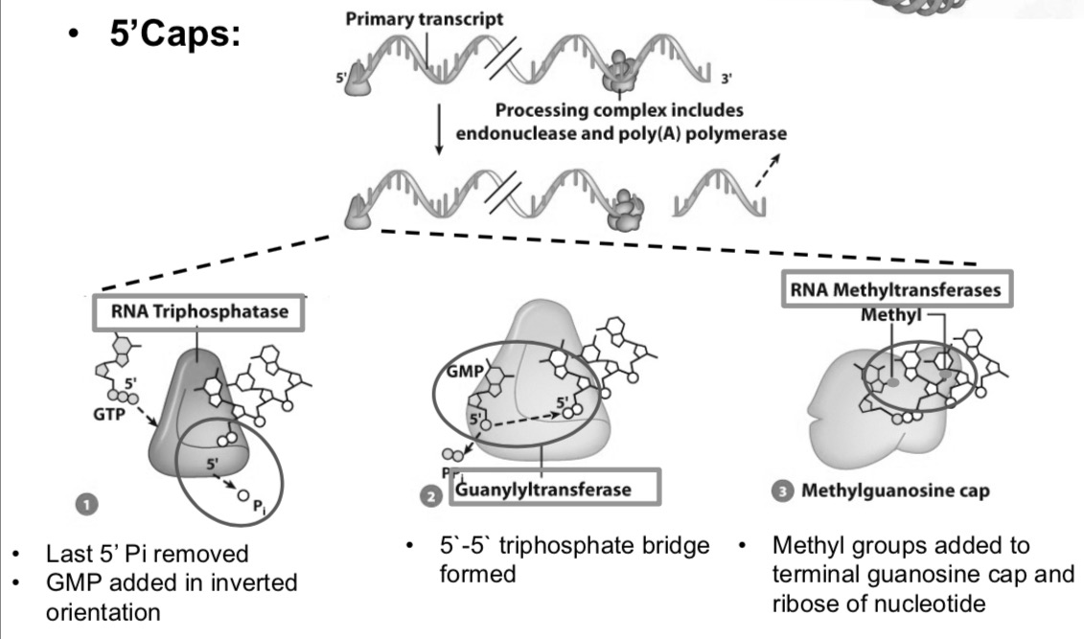
Primary transcript: initial precursor RNA, equivalent in length to the full length of DNA transcribed – transcriptional unit
- Always associated with proteins
- Have a fleeting existence
Processing mRNA
Capping enzymes are recruited by phosphorylated CTD (Ser-5 by TFIIH)
Functions;
- Prevents digestion of 5’ end from exonucleases
- Aids in transport of mRNA out of nucleus
- Plays important role in initiation of translation

A 5’ methylguanosine cap and a 3’ poly A tail are features of mRNA processing that are added to protect the mRNA during transport, among other things.

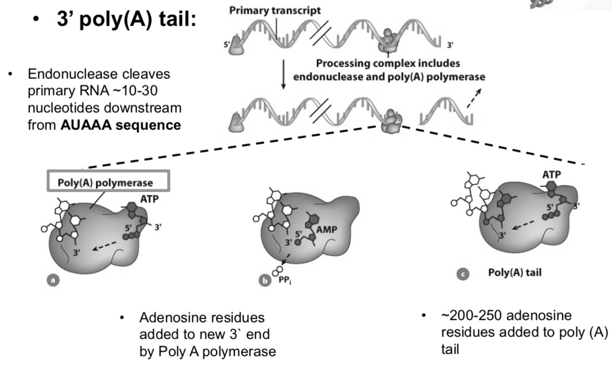

Poly A tail enzymes are recruited by phosphorylated CTD (Ser-2 by P-TEFb)
This protects mRNA from premature degradation by exonucleases

RNA splicing
- Exons: parts of the gene that contribute to mature RNA product
- Introns: intervening, noncoding sequences. They are not included in the mature RNA product

In RNA splicing, breaks are introduced at the 5’ and 3’ ends (splice sites). The sequences between exon/intron boundaries are highly conserved;
- 5’ splice site (G/GU)
- 3’ splice site (AG/G)
- polypyrimidine tract
- Branch point sequence
Exonic splicing enhancers (ESE): within exons, help recruit snRNPs. They are composed of small nuclear RNAs bound to specific proteins
Small nuclear ribonuclear proteins (snRNPs): particles that consist of small nuclear RNAs and 12+ associated proteins. They play an active role in splicing and ligating pre-RNA into final mRNA product

Spliceosome: macromolecular machine that associates with and processes an intron. Composed of a number of snRNPs and associated proteins

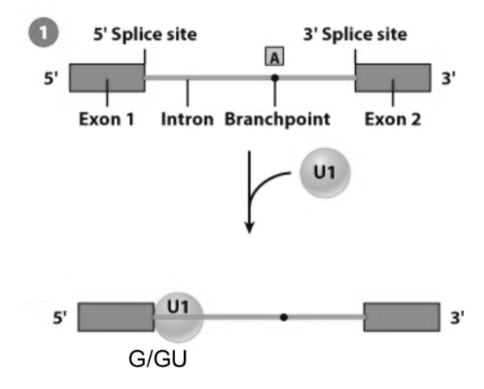
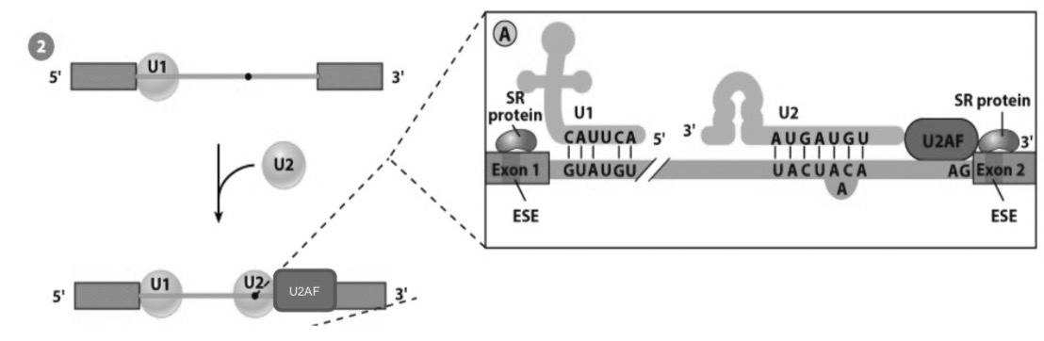
U1 snRNP attaches to the 5’ splice site

The nucleotide sequence of U1 snRNA is complementary to the 5’ splice site or the pre-mRNA (g/GU)
U2 snRNP attaches to intron causing a specific adenosine residue to bulge out – it will become the branch point of the lariat

U2 is recruited by U2AF protein (on polypyrimidine tract)

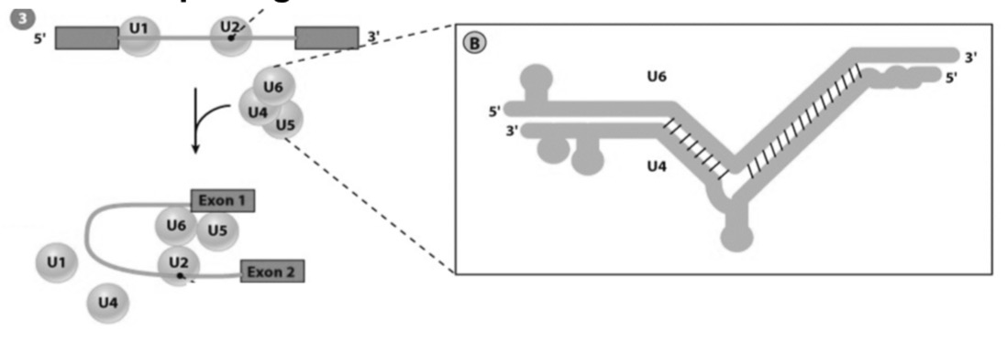
U4/U6 and U5 snRNPs bind to pre-mRNA

U4 and U6 snRNAs begin paired to one another. The U4 snRNA is stripped away from the duplex, and U6 pairs with U2 snRNA.

The other portion of U6 displaces U1 and becomes associated with the 5’ splice site

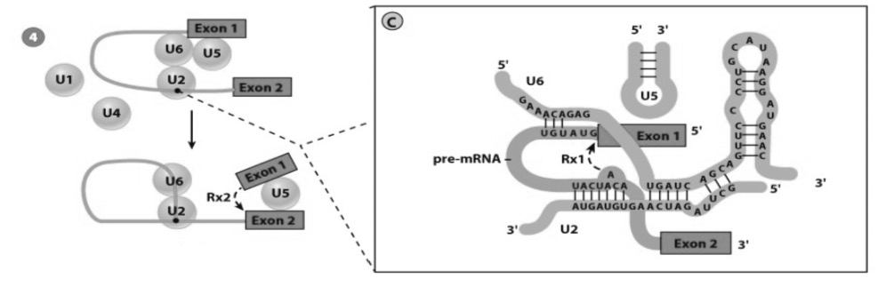
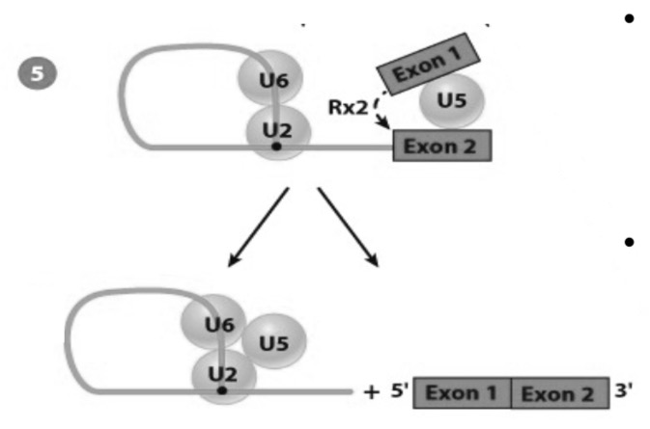
Second cleavage reaction at the 3’ splice site – excises lariat intron and ligates two neighbouring exons

snRNPs are released from pre-mRNA, and reassembled at the sites of other introns
U6 is a ribozyme – it catalyzes the cleavage of the 5’ splice site, forming a free 5’ exon and a lariat intron-3’ exon intermediate

The free 5’ exon is held in place by its association with the U5 of the spliceosome, which also interacts with the 3’ exon

Alternative splicing
The same gene code for more than one polypeptide (relevant in health and disease)

Coordination of events in transcription
- The C-terminal domain of RNA polymerase serves as a scaffold for the organization of factors involved in processing pre-mRNAs
- Processing includes capping, polyadenylation, and intron removal
- Machinery for mRNA processing travels with the polymerase as part of a giant mRNA factory

rRNA (ribosomal RNA)
- Provides structural support
- Catalyzes the chemical reaction in which amino acids are covalently linked to one another
- There are four distinct ribosomal RNAs;
  - Large subunit: 5S, 5.8S, 28S
  - Small subunit: 18S
  - There are 5 known rDNA clusters (hundreds of repeats encoding rRNA each on different chromosomes). These clusters are gathered in the nucleoli (factories for ribosome production)
Synthesis of rRNA;
- Nontranscribed spacer (NTS) separates transcription units in a ribosomal gene cluster
- rRNA is transcribed by RNA Pol I (and RNA Pol III for 5S)
- rRNA transcription follows a Christmas tree pattern
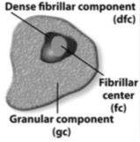
- Proteins that convert rRNA precursors into mature rRNA become associated with pre-rRNA during transcription

Processing of rRNA takes place in the nucleolus;
- The fibrillar center contains rDNA, dense fibrillar center contains the pre-rRNA transcripts
- Granular component contains ribosomes at various levels of assembly
- A single pre-RNA gets spliced into 3 rRNAs (28S, 18S and 5.8S)
- The 5S rRNA genes are located outside the nucleolus, they get transported to the nucleolus and are assembled there along with other rRNAs into ribosomal subunits
- Unlike pre-mRNA, pre-rRNA contains large numbers of methylated nucleotides and pseudouridine residues
- Small nucleolar ribonucleoproteins (snoRNPs) are particles that consist of snoRNAs and associated proteins.
  - They play an active role in processing pre-rRNA in the nucleolus.
  - Their role in H/ACA is to determine which uridines will be converted to pseudouridines
  - Their role in C/D is to determine which nucleotides in the pre-rRNA will have ribose methylated

tRNA (transfer RNA)
- Required to translate the information in the mRNA nucleotide code into amino acids of polypeptide
- Each tRNA is capable of binding a specific amino acid and also recognizing a particular codon in the mRNA
  - They are between 73-93 amino acids in length
- tRNA genes are located in small clusters scattered around the genome, they are arranged alongside one another
- A non-transcribed spacer (NTS) separates transcription units in each cluster
- tRNAs have promoter sequences within the coding region of the gene, transcribed by RNA pol III
- During processing, the tRNA precursor is trimmed and numerous bases are modified

Encoding Genetic Information
The sequence of amino acids in a polypeptide are specified by the sequence of nucleotides in the DNA of a gene (mRNA acts as an intermediate). Each amino acid encoded by non-overlapping nucleotide triplets is the codon.
Clustering of amino acid codons minimizes changes to amino acid sequences following spontaneous mutations

Translation

Amino acid activation
- Amino acids are covalently linked to the 3’ end of their respective tRNA by aminoacyl-tRNA synthetases (aaRS)
  - There is one for each of the 20 amino acids – an acceptor arm and anticodon are important for enzyme recognition
- ATP is used to activate the amino acid, which is then transferred to the tRNA molecule
  - ATP + amino acid > amino acyl-AMP + PPi
  - Amino acyl-AMP + tRNA > aminoacyl-tRNA + AMP

Translation Initiation
The steps are different between prokaryotic and eukaryotic cells

- About 12 initiation factors (eIFs) bind to 40S subunit
- Initiator tRNA-Met enters P site of 40S rRNA subunit in association with eIF2-GTP
- 43S complex finds and binds to 5’ methylgyanosine cap of mRNA. This is aided by several eIFs bound to mRNA;
  - eIF4E is bound to 5’ cap
  - eIF4A removes mRNA double stranded regions
  - eIF4G links 5’ cap to 3’ poly A tail
- The 43S complex scans mRNA in search of the initiation codon AUG
  - In eukaryotes ribosomes scan for the Kozak sequence: 5’ ACCAUGG 3’
- GTP bound to eIF2 is hydrolyzed and large 60S rRNA subunit associates with complex. This releases all initiation factors from the complex
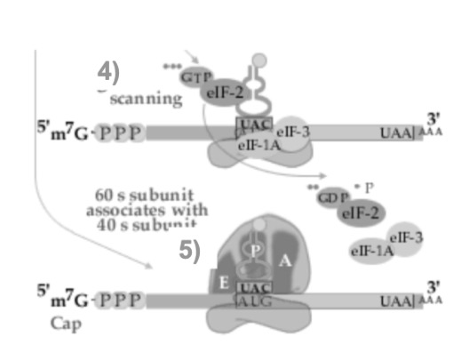
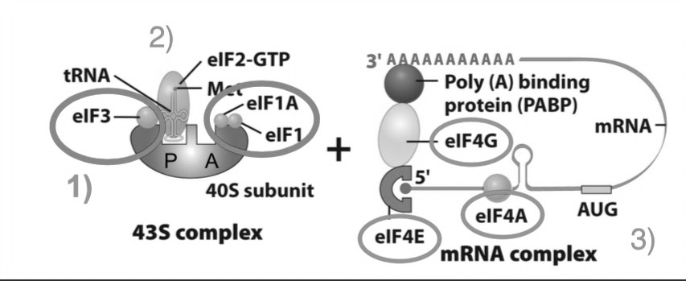
  - Anticodon of initiator tRNA bound to AUG start codon in P site of ribosome

Structure of the ribosome
Ribosomes have three sites for tRNAs;
- A (aminoacyl) site
- P (peptidyl) site
- E (exit) site

Ribosomes receive each tRNA in successive steps of the elongation cycle. The mRNA is situated in a narrow groove that winds around the neck of the small subunit, passing through the A, P, and E sites. A tunnel runs completely through the core of the large subunit beginning at the active site.

Translation Elongation
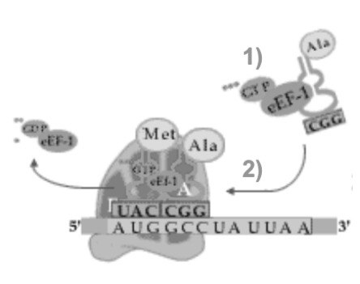
The elongation cycle is the process of adding subsequent amino acids to the growing polypeptide chain. A ribosome can catalyze the incorporation of approximately ten amino acids into a growing polypeptide per second.

- Second aminoacyl-tRNA combines with elongation factor eEF1α-GTP
- Aminoacyl-tRNA is delivered to and placed within the A site of the ribosome. GTP is hydrolyzed and eEF1α-GTP is released – only tRNA with the correct anticodon will trigger conformational changes within the ribosome
- Amine nitrogen on A site tRNA carries out nucleophilic attack on carbonyl carbon of P site tRNA
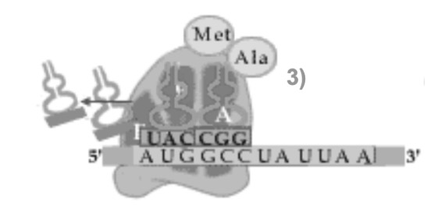
  - Peptidyl transferase (a subunit of rRNA) catalyzes the formation of this peptide bond and no energy is required (it is a combination enzyme)
- Translocation: small rRNA subunit ratchets relative to large subunit, moving ribosome 3 nucleotides along the mRNA in the 5’ to 3’ direction
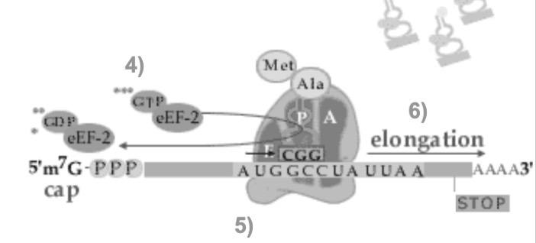
  - Dipeptidyl-tRNA in A site to P site
  - Deacylated tRNA in P site to E site
  - Driven by conformational changes in eEF2 following hydrolysis of bound GTP

- Deacylated tRNA leaves ribosome, emptying the E site
- Elongation: a repeat of steps 1-5

Translation Termination
Occurs at one of the three stop codons; UAA, UAG, UGA.
No tRNA have anticodons complementary to a stop codon. Termination requires release factors, which recognize stop codons (eRF1 and eRF3 work together to recognize stop codons).
- eRF1 tri-peptide interacts with stop codon in A site
- ester bond linking the nascent polypeptide to the tRNA is hydrolyzed
- hydrolysis of eRF3-GTP releases eRF1 from A site
- release of Deacylated tRNA from P site, dissociation of mRNA from ribosome, disassembly of ribosomal subunits (requires several protein factors)

Polyribosome (polysome) : complex of multiple ribosomes on mRNA, allowing simultaneous translation. Increases the rate of protein synthesis

Lecture 7: Control of Gene Expression
Cells are different because only a subset of genes are expressed at any given time in a certain cell. Several sophisticated mechanisms regulate this gene expression – and the transcriptional state can change depending on environmental cues.

Nucleus – the site of transcription
IN: all proteins needed for transcription
OUT: all RNA products of transcription (through the nuclear envelope using pores)
- Nuclear envelope: Around 60 different transmembrane proteins are utilized – and several thousand nuclear pore complexes exist. The outer membrane is studded with ribosomes, and is continuous with the rough ER. Lamina on the inner membrane provides mechanical support and chromatin anchoring
Nuclear trafficking

Nuclear Pore Complex (NPC) – the gateway across the barrier (RNAs and proteins)
- Has octagonal symmetry
- Around 30 different nucleoporins
- Nucleoporins lining the central channel have FG domain (phenylalanine-glycine repeats), which functions to block free diffusion of large macromolecules as they form a hydrophobic mesh

Transport of Proteins Across Nuclear Envelope
Proteins contain an amino acid sequence that can be recognized by transport receptors and the nuclear pore complex;
- Nuclear Localization Signal (NLS)
- Nuclear Export Signal (NES)
Transport receptors ferry proteins across the envelope (importins, exportins, Ran-GTP and Ran-GDP)

Transport of RNA Across Nuclear Envelope
RNAs move through NPC as ribonucleoproteins (RNPs). Transport receptors/proteins associated with mRNA interacts with the FG domain of nucleoporins, allowing passage. Only mature mRNAs are capable of nuclear export.

Overview of Gene Regulation
- Transcriptional-level control
General transcription factors: bind to core promoter sites, associate with RNA Pol (TBP, TAF, TFIIA-H)
Sequence specific transcription factors: bind to regulatory sites of particular gene
- Activators: stimulate transcription via recruitment of protein complexes that promote transcription
- Repressors: inhibit transcription

A single transcription factor can bind to and regulate expression of several different genes. Single genes are usually controlled by several DNA regulatory sites and combination of transcription factors.

The extent to which a gene is expressed depends on the particular combination of transcription factors. Cells exposed to different stimuli respond by synthesizing different transcription factors, which bind to different sites on DNA and alter gene expression.
- There are 4 transcription factors whose expression can turn a differentiated cell into a pluripotent ES-like cell (epigenetic programming) – as cells become programmed these factors become silenced

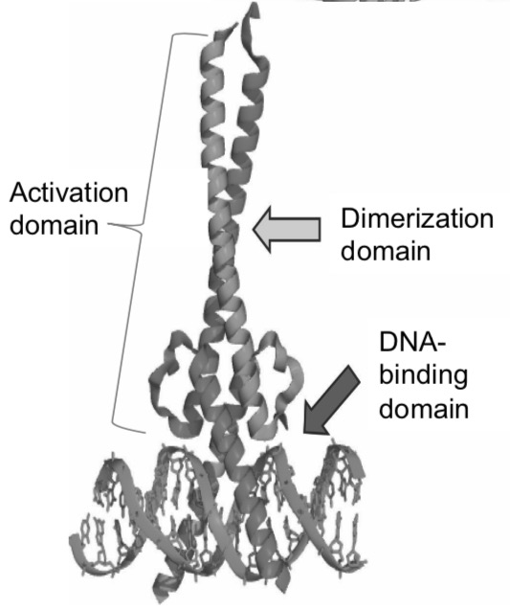
Structure;
- DNA –binding domain: binds to specific sequences of base pairs on DNA
- Activation domain: site of interaction with other proteins
- Dimerization domain: surface that promotes binding with another protein of identical or similar structure (dimer). Below are listed the DNA-bind motifs;

DNA Binding Motifs
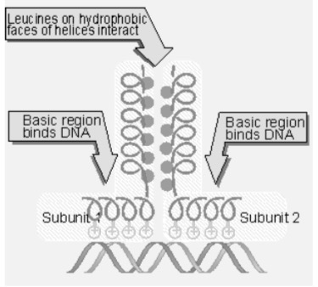
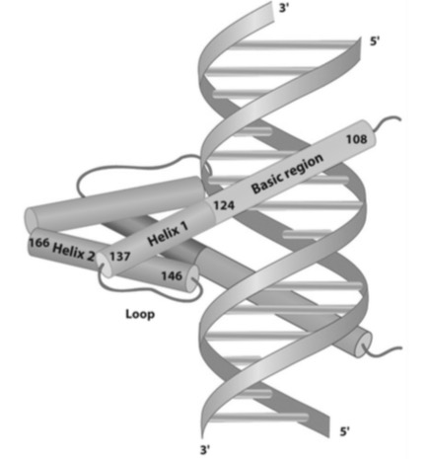
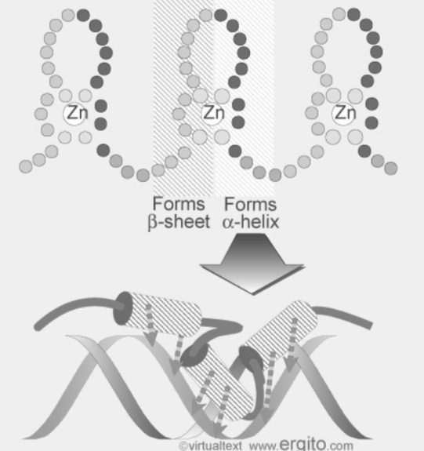

1. Zinc fingers: zinc ion of each finger coordinated between 2-cysteines (beta sheet) and 2 histadines (alpha helix). They project into successive major grooves in target DNA. The alpha helix is the recognition domain. Zinc finger proteins have therapeutic potential to alter gene expression
2. Helix-Loop-Helix (HLH): 2 alpha helical segments separated by a loop. It is often proceeded by a stretch of highly basic amino acids whose positively charged side chains contact DNA. They always occur in dimers
3. Leucine Zipper: Leucine (a non polar amino acid) exists every 7th amino acid along a stretch of alpha helix, all in the same direction. There is a stretch of basic amino acids on one side of the helix that recognizes a specific nucleotide sequence on the DNA (basic Leucine zipper domain). This forms two helices capable of zipping together – a coiled coil, and exists as dimers

DNA sites
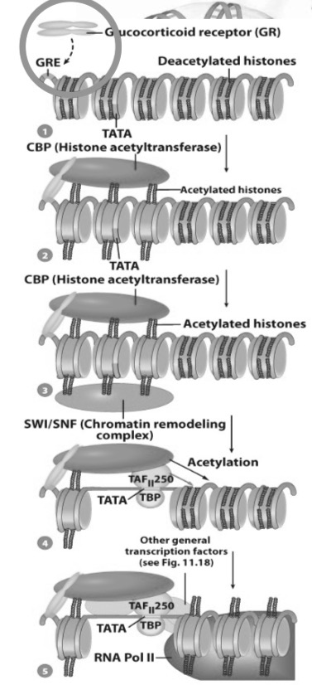
Specific DNA regulator sites upstream or downstream of a gene can act as docking sites for transcription factors or co-activators as a mechanism of altering gene expression. The response element is the DNA site of transcription factor binding, it is composed of;
- Core promoter
- Proximal and Distal promoter elements
  - Bind transcription factors
  - Regulate frequency of transcription
  - CAAT, GC boxes
- Enhancer sites
  - Up to 50k base pairs upstream (or downstream) of the start site
  - Bound transcription factors/co-activators can bind enhancer regions of the pre-initiation complex or chromatin (eurochromatin – means chromatin that is active)
  - Can alter level of transcription by 100+ times
- Alternative promoters

Co-activators: a protein that increases gene expression. There are two types;
- Direct interactions with PIC: a mediator (multi-subunit complex interacts with RNA Pol II of pre-initiation complex). It is essential to almost all protein-coding genes, its mechanisms of actions are unclear
- Interactions with Chromatin:
  - Histone acetyltransferases (HATs): acetyl groups are added to lysine residues of core histone proteins. This exposes a binding site for chromatin remodelling complexes

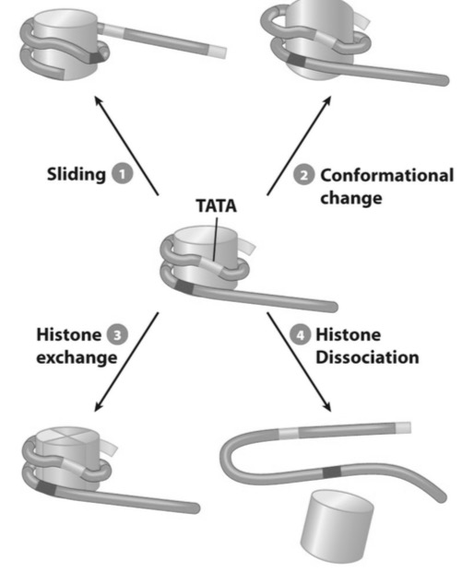
  - Chromatin remodelling complexes: increases the accessibility of the promoter to transcription machinery. They use energy released from ATP hydrolysis to alter nucleosome structure and location. This promotes the sliding of the histone along DNA, causing a conformational change of the nucleosome which leads to an exchange for variant histones that promote transcription. After, the histone is displaced from DNA completely

In some cases, enhancer type regions can be localized on different chromosomes (inter-chromosomal interaction)
Transcription factory: distal active genes are dynamically organized into shared nuclear sub-compartments with common transcriptional proteins (co-localized into active gene transcription units)

- mRNA processing-level control

RNA transcripts must undergo processing in order to produce an mRNA that is able to leave the nucleus. This is achieved via splicing, using snRNPs. Different splice sites can be repressed or activated, depending on nearby binding proteins;
- SR proteins: activate splice sites by binding to exon/intron splicing enhancers
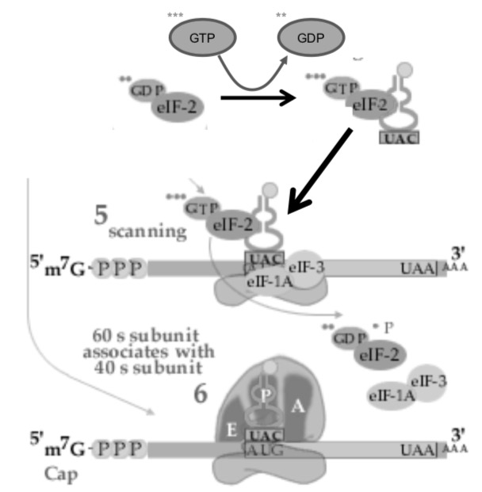
- hnRNP: repress splice sites by binding to exon/intron splicing silencers
These proteins alter the binding localization of U2AF, U1, and U2 snRNP to transcript

- Translational-level control

Once mRNA leaves the nucleus, several regulatory mechanisms are present;

- Initiation and progression of translation
  - Global regulation: affects the translation of all messages - phosphorylation of initiation factors;
  - Phosphorylation of eIF2
  - eIF2 cannot exchange GDP for GTP
  - Initiating tRNA cannot bind to mRNA

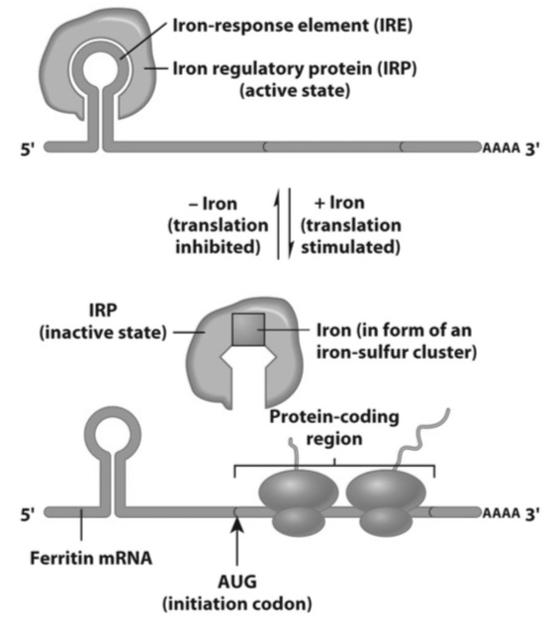

  - Specific regulation: affects translation of specific messages only.
  - Ferritin (sequester iron in the cytoplasm of the cell) – it is regulated by an iron regulatory protein (IRP), whose activity is dependant on the concentration of unbound iron in the cell.

When there is low iron, IRP binds to the iron response element in 5’ UTR. The ribosome cannot bind to mRNA

When there is high iron, IRP loses affinity for the iron response element, causing dissociation and initiation of translation
- Localization of mRNAs to certain sites within the cell
  - Specific mRNAs are sequestered to functionally distinct cytoplasmic domains (polarized cells)
  - The localization is dictated through RNA binding proteins that recognize “zip codes” within the 3’ UTR
  - Microtubules transport the mRNA to specific locations within the cell
  - Microfilaments anchor mRNA once they have arrived at their destination
  - mRNAs are subsequently translated in these discrete locations and new protein accumulates in this area
  - During the process of localization, translation is inhibited by associated proteins
  - Drosophila embryogenesis: 70% of mRNA is localized within a cell prior to translation (effect on subsequent protein localization and function)

- mRNA stability within the cytoplasm
  - The longer mRNA is present in the cytoplasm the more times it can be translated into a protein
  - The lifespan of mRNA is variable – it is related to the length of the 3’ poly A tail, which starts with about 200 adenosines and is continually shortened by deadenylase
  - Nucleotide sequences in 3’UTR play important roles in the rate at which the poly A tail becomes shortened
  - Unless protected, mRNA with short poly A tails are rapidly degraded

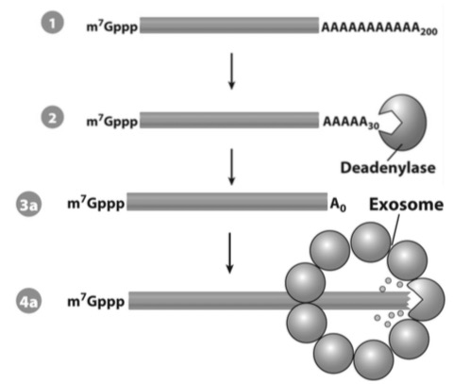
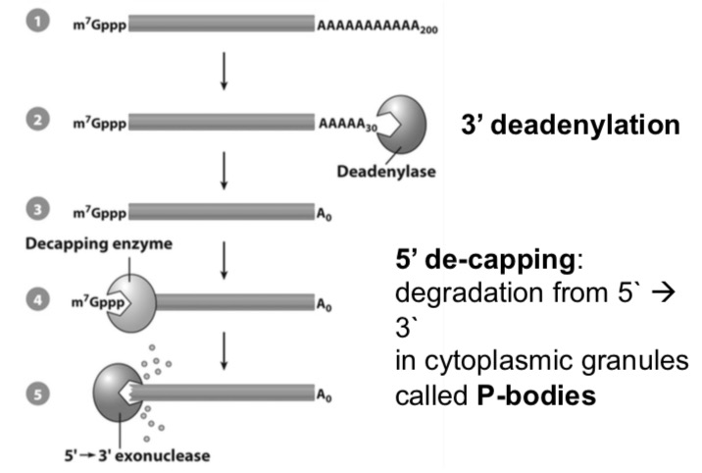

*5’ and 3’ untranslated regions of mRNA play important roles in regulation

RNA interference (RNAi): RNA molecules can inhibit gene expression via destruction of specific mRNA molecules. Several types have been discovered;
- Small interfering RNAs (siRNAs)
  - dsRNA cleaved by Dicer to 21-23 nucleotides siRNA with 3` overhangs
  - Binds to Argonaute, removes one strand of siRNA duplex
  - With RISC complex, siRNA binds to target mRNA
  - mRNA cleaved by Argonaute and subsequently degraded
- microRNAs (miRNAs)
  - Single stranded RNA precursor that folds back on itself
  - Initially cleaved by Drosha to pre-miRNA
  - Cleaved by Dicer à miRNA with 3` overhangs
  - Binds to Argonaute, removes one strand of miRNA duplex
  - With RISC complex binds to target mRNA and inhibits translation OR causes deadenylation leading to degradation

  - They are important regulators of almost every biological process. Abnormalities in miRNA play a major role in the development of many common diseases
  - They act primarily by binding to sites in 3’ UTR of their target mRNAs
Clinical applications of siRNAs;
Designing siRNA that can specifically and effectively silence a disease-related gene. There are strategies being developed for;
- HIV: siRNAs can inhibit HIV replication effectively in culture. HIV infection can be blocked by targeting genes involved in the HIV life cycle
- Hepatitis: siRNA targeting Fas intravenously into two models of autoimmune hepatitis in mice, protecting cells against liver injury from apoptosis
- Cancer: current generation of a large library of human cells which each contain a silenced gene. The aim is to uncover all overexpressed genes in human cancers and find targets for the siRNAs
There are however obstacles for these treatments – delivering genes for siRNAs can lead to complications (triggering of non-specific interferon responses). Viral genes mutate rapidly, making some siRNAs ineffective for treatment against viral diseases

- Posttranslational-level control

Cells can also control the rates at which proteins survive once they are functional (protein degradation).
Proteasomes: protein degrading machines, found in nucleus and the cytosol;
- A stack of 4 rings of polypeptide subunits capped on each end
- Central beta subunits (proteolytic enzymes)

- Proteins to be degraded tagged by string of ubiquitin by ubiquitin ligases
  - Abnormal proteins
  - Degron – internal sequence of amino acid
  - Phosphorylation of certain amino acid residues in N terminus
- Polyubiquinated target protein binds to a cap of proteasome
- Ubiquitin chain removed, unfolded polypeptide fed into the central chamber
- Catalytic activity of beta subunits degrades polypeptide into small peptides
- Peptide products released into cytosol – degraded into amino acids

Levels of control in gene regulation – review;
Transcriptional – transport of proteins in/out of the nucleus, transcription factors and DNA sequences
Processing – splice site variations
Translational – translation, localization of mRNAs, mRNA stability
Posttranslational – protein stability

Lecture 8: Epigenetics

DNA packaging
Chromosome: the organized structure of DNA and associated proteins; each is a single, continuous piece of DNA
The mechanism to package large amount of DNA into a small space.
Every human diploid cell contains 23 pairs of chromosomes (46 in total – 22 pairs of autosomal chromosomes and 1 pair of sex chromosomes)

Histones
Chromatin is the combination of DNA with associated proteins
A histone is a specialized protein that associated with and packages DNA. The positive charge of histones interacts with the negatively charged back bone of DNA. The N-terminal segment can be modified by key enzymes, having a profound effect on DNA compaction and gene transcription.
Nucleosome: a complex of histone proteins and supercoiled DNA

One histone (H1) is called a linker histone. It is not involved in the octomer but is instead on the outside. It binds to linker DNA and connects nucleosomes.

Histone code hypothesis: activity of chromatin region depends on the degree of chemical modification of the histone tails. There are docking sites to recruit non-histone proteins, they alter the interactions of neighbouring nucleosomes.

Histones and gene expression: non genetic modifications to histones have a profound impact on what genes are transcribed

Nature-nurture debate
Our genetic make up (inheritance) dictates health and disease – gene and protein expression
Nurture is our lifestyle choices (environment)
Our lifestyle choices can alter gene expression on a different level than inheritance. Our environment causes constant coding for which genes are expressed (not the actual genetic code).

Heredity: the passing of traits to offspring

Epigenetics: the study of heritable changes in gene expression or phenotype caused by mechanisms other than changes in the underlying DNA sequence.
Epigenome: overall epigenetic state of a cell
- Functionally relevant modifications to the genome that do not involve a change in nucleotide sequence (can turn genes on or off by activating or silencing)
- Epigenetic changes are preserved when the cells divide, meaning this state can be maintained throughout the lifetime
- Epigenetic changes can be preserved in the generation of germ cells (meaning they can be transferred to the next generation)
Causes of epigenetic changes
- Diet
- Exercise
- Stress
- Toxins
- Biochemistry/physiology (hormones for example)
- Inheritance
Epigenetic changes are the means by which genetic material responds to changing environmental conditions.

Twin studies
Monozygotic twins have an identical genetic makeup at birth and death, but they can differ in environmental exposures across a lifespan. Therefore they share a genome but not an Epigenome – and these differences become more apparent the longer they are exposed to these differences in environment.

This theory was proven using the Agouti mouse model: mice are genetically identical, but the agouti gene when activated produces mice that have a yellow fur coat and are obese. When the gene is silenced, they have a brown fur coat and normal weight.
- Agouti mice are given a maternal diet with an excess of methyl rich supplements

DNA Methylation
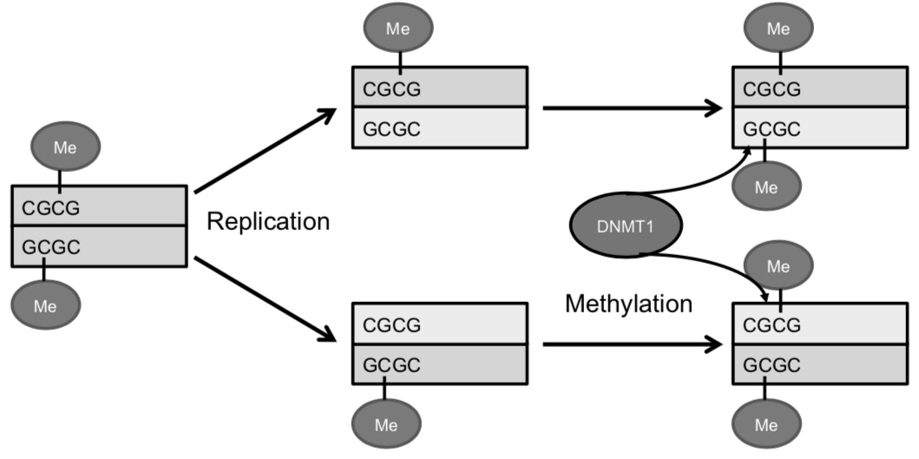
- No methylation of CpG – gene is on (tissue specific genes, housekeeping genes)
- Methylation of CpG – gene is off (non tissue specific genes, silent DNA) – prevents RNA polymerase from doing its job, which occurs on the CpG island
- Methylation of CpGs is done through DNA methyltransferases (DNMTs)
- Methyl groups are acquired through diet (folate, methionine, selenium)
- Incorporation of methyl groups can be influenced through environmental toxins (Bisphenol A is a chemical found in plastics that affects how the methyl groups are incorporated – a high exposure is not healthy)
- Methylation pattern is maintained through cell replication (mitosis)

Histone modification – methylation of histones
Addition of methyl groups to lysine or arginine residues on histone tails (methyl attaches to lysine or arginine only). There is typically a marker for gene silencing, and sometimes a marker of gene activation. Methylation of histones is done through histone methyltransferases (HMTs/KMTs). This can influence DNA methylation patterns.

Histone modification – acetylation of histones
- Acetylation of lysine (only on lysine) residues on histone tails – this removes the positive charge of the histone tail, loosening the histone-DNA complex. This serves as a marker of gene activation.
- Regulated by histone acetyltransferases (HAT/KAT) and histone deacetyltransferase (HDAC/KDAC) – the activity of these enzymes can be regulated by several environmental factors
- Acetyl Co-A is a donor for acetyl groups, and can change rapidly within a cell cycle
- Acetylation “opens things up” for the beginning of transcription

*Some epigenetics are more permanent than others – depending on the type of cell affected. There are for example, differences in the permanence in a liver cell vs. muscle cell

Mechanisms of Epigenetics – Long noncoding RNAs (lncRNA)
Sequence specific molecules that can guide protein complexes to specific sites in the chromatin and orchestrate transcriptional repression. They play an important role in X-chromosomes inactivation and imprinting.

Establishment of the Epigenome
Epigenetic reprogramming: erasure and remodelling of epigenetic marks
There are two crucial developmental stages in which the Epigenome undergoes profound reprogramming;
- Gametogenesis
  - De methylation – allows for reactivation of certain genes
  - X chromosome reactivation
  - Imprinting
- Pre-implantation
  - De methylation
  - X chromosome inactivation
  - Tissue specific methylation (morphogenesis)
Imprinting: Gene expression occurring from 1 allele only. Parents contribute equally to the genetic content, imprinted genes are not equally expressed.
- Activation and silencing due to epigenetic modifications (DNA methylation and histone modification)
- Occurs in less than 1% of all genes (approximately 80) – embryonic and placental development, growth and metabolism
- Genetic conflict hypothesis – competition between males for maternal resources
Established in germ line and maintained in somatic cells;
- Erasure
- Imprint established according to the sex of the individual
- Imprint is maintained during fertilization and pre-implantation
- Imprint is maintained in somatic cells for a lifetime
Imprinted genes are especially sensitive to environmental signals – which can also affect the imprinting process itself, impacting gene expression in the next generation.

X chromosome inactivation
One copy of X chromosome is inactivated by epigenetic modification in female offspring (we only want 1 copy of X chromosome gene products). X chromosome selection for silencing is random in each cell. It will remain silenced across the lifespan.
Blocking protein protects one chromosome from being the target for epigenetic modification.
Non-coding RNA coat other than X chromosome will be silenced. Around 25% of human genes on the X chromosome escape inactivation – also on the Y chromosome (X inactivation center – XIC)

- Basically, cells have to decide which x to shut off because there can only be one. Tortoiseshell cats occur when cells turn off different x chromosomes which call for different characteristics – some genes can escape inactivation

Epigenetics across a lifetime
- Prenatal smoke is associated with : reduced birth weight, poor developmental and psychological outcomes, risk for diseases and behavioural disorders later in life.
  - Global and gene specific differences in CpG DNA methylation patterns are associated with in utero exposure to maternal smoking – genes related to cancer progression and immune response

- Adversity and stress in childhood is associated with : psychiatric disorders (depression, anxiety), drug and alcohol abuse
- Animals with low levels of maternal care present with increased methylation of the glucocorticoid receptor (GR) gene and exaggerated hormonal and behavioural responses to stress
- A disruption/lack of adequate nurturing leads to increased CpG methylation of the GR gene
- A high fat diet is associated with metabolic disturbances and obesity, cardiovascular disease, and cancer
  - Affects genome wide DNA methylation
  - Methylation is only partly reversed after 6-8 weeks
Different environmental factors have different effects – can cause methylation or acetylation to a certain degree

Epigenetics and disease – cancer
Most cancers are adult onset (the genome is static, epigenome is not). Mechanisms of epigenetic modification in cancer;
- DNA methylation
  - Hyper-methylation: tumour suppressor genes and repair genes
  - Hypo-methylation: oncogenes (promote cell division and growth, leading to cancer)
  - Therefore, methylation balance is key
- Histone modification – methylation and acetylation
- Disruption of the epigenetic machinery – DNMTs, HDACs
- Loss of imprinting – IGF-2: Wilms Tumour. It is a growth factor, if it is not imprinted on one chromosome then too much expression and signal exists for cell growth
  - Bi-allelic expression of a normally imprinted gene (two times the amount of gene is expressed)
Cancer therapy and epigenetics
- Epigenetic profiles for screening and prognosis
- Pharmacological targeting of epigenetic machinery
- Increased sensitivity to traditional chemotherapy

Lecture 9: DNA replication and repair

DNA replication
During DNA replication, each DNA strand of the parental double helix serves as a template for a new strand in a daughter molecule. After replication, each daughter DNA double helix contains an old strand from the parental DNA and a new strand.

Semi-conservative replication (Watson and Crick) – the accepted model today
- Gradual separation of the strands of the double helix (zipper)
- Synthesis of two daughter strands complementary to the two parental templates
- Each daughter duplex contains one strand from the parent structure

- Unwinding
  - The old strands that make up the parental DNA are unwound and unzipped
  - The weak hydrogen bonds between the paired bases are broken, due to the enzyme helicase
- Complementary base pairing
  - New complementary nucleotides are positioned by the process of complementary base pairing
  - The enzyme DNA polymerase carries out this pairing
- Joining
  - The complementary nucleotides join to form new strands
  - The enzyme complex DNA polymerase carries out this joining
  - Nucleotides on the old strand bind to nucleotides on the new strand
  - Each daughter DNA molecule contains an old strand and a new strand

Previous theories from history;
Conservative Replication
- Two original strands would remain together after serving as templates
- One daughter duplex is the parental DNA, the other is the new DNA

Dispersive Replication
- Parental strands broken into fragments, new strands synthesized in short segments
- Both daughter duplexes that contain old fragments and new fragments

Eukaryotes: replication of DNA is confined to the S phase of the cell cycle. They replicate their genome in small portions called replicons. Each one has its own origin, known as the replication initiation site.
- Once initiated, replication proceeds outward from both origin in both directions (bi-directionally)
- Replication fork: the site where the parental double helix is undergoing strand separation and nucleotides are being incorporated into the newly synthesized complementary strand
- The two replication forks move in opposite directions, and replication bubbles eventually fuse, causing synthesis of the daughter strands to be complete

The model for DNA replication
The parental model has two complementary strands of DNA, each base is paired by hydrogen bonding with its partner;
A-T
G-C
The two DNA strands are separated, each parental strand can now serve as a template for a new complementary strand. Nucleotides complementary to the parental strands are connected to form the sugar-phosphate backbone of the new daughter strands.

DNA polymerase: a series of enzymes that are responsible for new DNA synthesis. There are 3 requirements needed by this enzyme to perform;
- Template DNA strand to copy
- Primer strand to which nucleotides can be added
- Only synthesizes DNA in a 5’ > 3’ direction
The 3’ OH group carries out a nucleophilic attack on a 5’alpha phosphate of incoming nucleoside triphosphate.

The process of DNA replication is semi-discontinuous:
- Leading strand: the strand that grows continuously towards the replication fork
- Lagging strand: grows discontinuously away from the replication fork
  - Okazaki fragments: small DNA fragments that require a small RNA primer to reduce mismatch error

Initiation

Helicase: the DNA unwinding enzyme, it uses energy released by ATP hydrolysis to break hydrogen bonds, exposing single-stranded DNA.

Bacterial cells:
- DnaB helicase binds to origin (OriC), separates DNA strands
- DnaB travels along lagging strand in 5’ > 3’ direction, unwinding the helix
- Unwound DNA is coated in single-stranded DNA-binding (SSB) proteins
- Primase periodically binds helicase and synthesizes short RNA primers (Okazaki fragments)
- RNA primers are extended by DNA polymerase

Eukaryotic cells:
- Origin recognition complex recognizes the origin of a replicon
- Licensing factors Cdc6 and Cdt1 are recruited to the ORC complex
- Licensing factors recruit MCM proteins (MCM2-7)
- Pre-replication complex (pre-RC): ORC complex, licensing factors, and helicase
- Protein kinases (Cdk, DDK) phosphorylate and activate pre-RC
  - High activity in S phase
  - Inhibits formation of new pre-RC
  - New pre-RC happens in M and G1
- Primase periodically binds helicase and synthesizes short RNA primers (Okazaki fragments)

Supercoiling: tension is built up as DNA begins the unwinding process – DNA is positively supercoiled
- Topoisomerase I and II (DNA Gyrase) relieves the tension by changing the DNA into negatively supercoiled DNA, using ATP hydrolysis (topoisomerase relieves strain caused by unwinding)

Proteins involved in initiation;
- Topoisomerase already described
- Primase synthesizes RNA primer, using the parental DNA as a template
- Single-strand binding proteins: stabilizes the unwound parental DNA strands
- Helicase

Elongation
Helicase unwinds, and primase synthesizes RNA primers.
DNA polymerase extends the RNA primers by attaching to the 3’ OH of RNA primer and incorporates deoxynucleotides. The lagging strand is looped so that 2 DNA polymerases can travel together.

Polymerase releases the lagging strand once it encounters a previously synthesized Okazaki fragment. It will bind to the lagging strand template further along its length and elongate DNA from the next RNA primer.

- DNA polymerase I: exonucleases activity (5’ > 3’) removes RNA primers of the Okazaki fragment, polymerase activity fills the gap with dNTs
- DNA ligase: covalently joins dNT to the 5’ end of the Okazaki fragment
- DNA polymerase III holoenzyme
  - 2 core polymerases to replicate DNA
  - Beta clamps allow polymerase to remain associated with DNA (there is one on the leading strand and one on the Okazaki fragment of the lagging strand)
  - Y-clamp loading complex: loads sliding clamp onto DNA, also bound to helicase
- Replisome: complex of active proteins at replication fork
  - DNA pol III holoenzyme, helicase, SSBs, primase

Nuclear structure: replication foci
Localized sites within the nucleus in which several replicons have become active
- There are around 50-250 replication foci per replicating nucleus
- Around 10-100 active replication forks per replication foci
- The mechanisms for coordinating replication of adjacent replicons

Chromatin structure
Movement of replication machinery along DNA thought to displace nucleosomes. Reassembly of nucleosomes on daughter strand is very quick
- Histone molecules from parental chromosomes and newly synthesized
  - (H3H4)2 tetramers – remain intact
  - H2A/H2B dimers – separate and bind randomly to new and old tetramers

DNA repair

High fidelity
Spontaneous mutation rate: error rate of incorporation of an incorrect nucleotide during DNA replication. Incorporation of a particular nucleotide depends upon geometry
- Only one dNT forms a proper geometric fit with template
- Fit into a binding pocket within DNA polymerase

Mismatch repair
DNA polymerase has a 3’-5’ exonucleases function to remove mispaired nucleotides from the 3’ end of the growing DNA. This function is key to maintaining the accuracy of DNA synthesis

DNA damage
DNA is most susceptible to environmental damage – ionizing radiation, common chemicals, UV radiation and thermal energy from normal metabolism cause spontaneous alteration in DNA.
Cells have a number of mechanisms to repair genetic damage;
- Accurate selection of nucleotides
- Immediate proofreading
- Post-replicative mismatch repair

Nucleotide excision repair
Removes bulky lesions derived from UV (pyrimidine dimers, nucleotides and chemical groups)
- Transcription-coupled pathway:
  - Template strand of genes being transcribed are repaired
  - Presence of lesion signalled by stalling of RNA polymerase
  - Genes of greatest importance are fixed first
- Global genomic pathway:
  - Corrects bulky lesions in remainder of genome (slower pathway)
- Recognition
- Helicase activity – strand separation (XPB/XPD), incision by XPG
- Stabilize
- Excise
- Repair

- Xeroderma pigmentosum (XP): dry scaly skin, abnormal pigmentation in sun-exposed skin areas. X1000 increased risk of developing UV-induced skin cancer because there are commonly deficiencies in the XPC complex (transcription-coupled NER intact).
- Cockayne syndrome (CS): photohypersensitivity of the skin (not associated with sun-induced pigmentation of increased skin cancer risk)
  - Distinct characteristics: deep sunken eyes, prominent ears and bird-like face, short stature, arrested sexual development, thin hair, osteoporosis, neurological symptoms
  - There are often defects in two genes: CSA and CSB (but fully functional global genome NER)

Base excision repair
Removes altered nucleotides generated by reactive chemicals (diet, metabolism)
- Uracil: formed from the hydrolytic removal or amino group of cytosine
- 8-oxoguanine (oxoG); ROS
- 3-methyladenine (transfer of methyl groups from donor)
There is a DNA glycosylase for each type of alteration.

- DNA glycosylase scans nucleotide base pairs looking for alterations and excising them
- AP endonuclease cleaves DNA backbone at site of excision
- DNA polymerase beta phosphodiesterase activity removes the sugar-phosphate remnant (previously attached to excised base)
- DNA polymerase beta fills in gap with complementary DNA
- DNA ligase III seals strand

- Alzheimer’s disease: increased oxidative DNA damage is observed in brain tissue from Alzheimer’s patients. There are significant BER deficiencies in brains of AD patients due to limited DNA base damage processing by DNA glycosylases and reduced DNA synthesis capacity by DNA polymerase beta

Double strand breakage repair
Ionizing radiation and some chemicals (chemotherapy, ROS) cause double-strand DNA breaks
- X-rays, gamma rays
- Chemotherapy, ROS

- Nonhomologous end joining (NHEJ): complex of proteins bind to broken ends and catalyze the rejoining of the two strands
  - Lesion is detected by heterodimeric ring-shaped protein (Ku70/80)
  - Ku recruits catalytic subunit of DNA-dependant protein kinase (DNA-PKcs)
  - Synaptic complex – 2 DNA ends, 2 Ku70/80, 2 DNA-PKCcs
  - Synaptic complex becomes phosphorylated, bringing 2 ends of broken DNA together
  - End of DNA are joined by DNA ligase IV/ XRCC4 complex
- Homologous recombination: requires a homologous chromosome to serve as a template for repair of the broken strand. This is a more accurate method, but must take place during late S/G2 phase of the cell cycle
  - DNA ends processed to create single-strand overhangs – MRN complex (endonucleases)
  - Rad51, Rad52 and RPA associate with overhangs, forming a joint molecule between damaged and undamaged strands
  - Template guided DNA synthesis

- Radon and lung cancer
  - One consequence of unrepaired/misrepaired double stranded DNA breaks
  - Radon is a radioactive isotope formed during disintegration of uranium
  - Houses built in areas with high levels of uranium in the soil can be exposed to high levels of radon gas
  - Radon breathed into the lungs caused double stranded breaks in DNA and leads to an increased risk of lung cancer

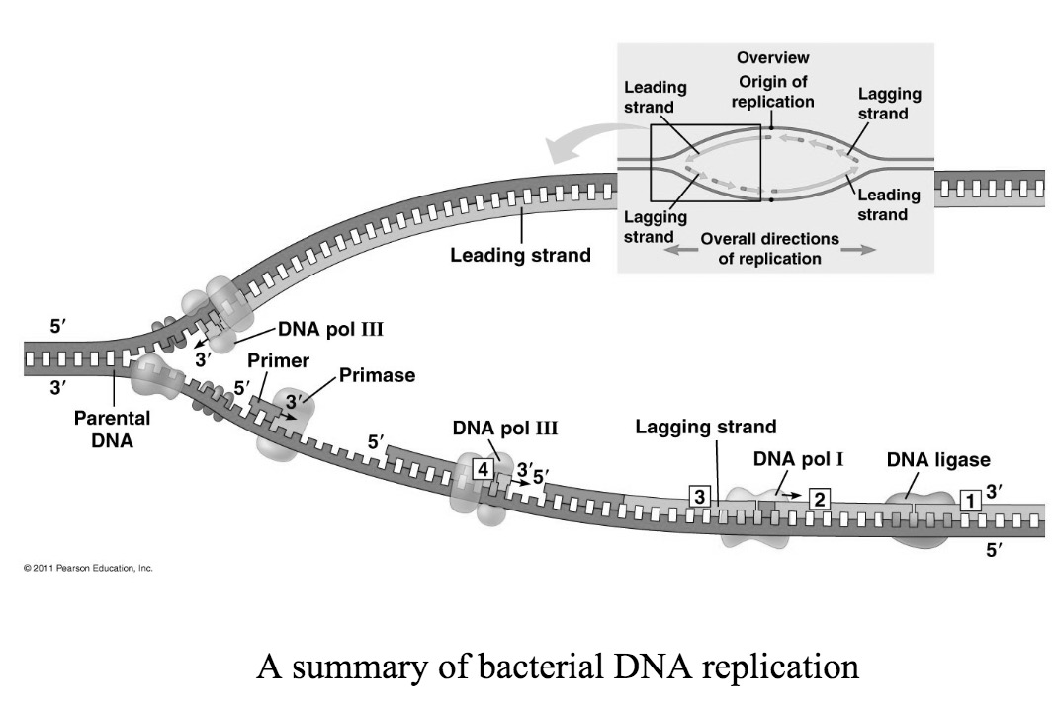
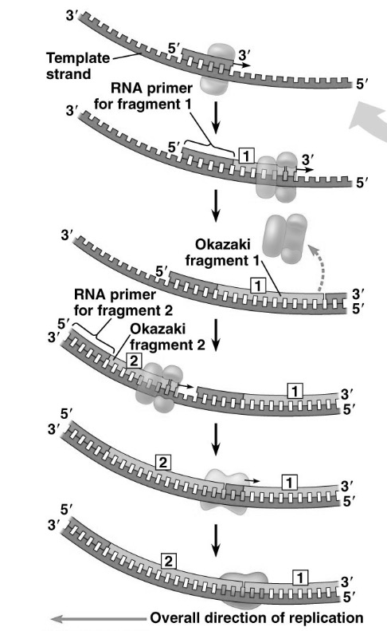
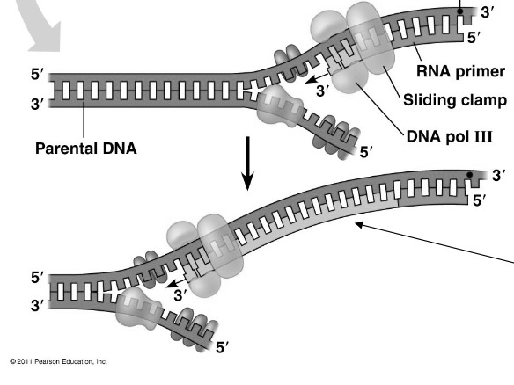
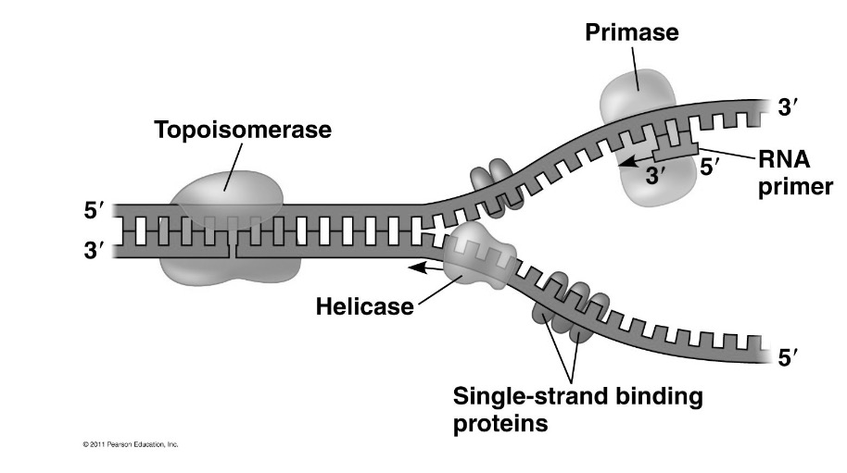

Genetics and Diseases

**Inheritance: each cell contains 2 meters of DNA. There are 25 000 genes that code for proteins.
- 46 chromosomes where 44 are autosomal chromosomes (22 pairs) and 2 are sex chromosomes (1 pair, X/Y)

Allele: alternative or variant forms of a gene
Homozygous: two alleles of a given gene are identical
Heterozygous: two alleles of a given gene are different
Dominant allele: always produces its trait when inherited
Recessive allele: only produces its trait when homozygous

Single gene disorders occur with abnormal or missing genes. They can also be inherited through autosomal dominant/recessive genes, or through sex-linked inheritance;

- **Autosomal dominant
  - Transmission of a dominant allele
  - There is a 50% chance of being affected
  - The disease appears in every generation
  - Males and females are equally affected

**Example: Huntington’s Disease
- Inherited brain disorder
- Caused by mutations in the HTT gene – neuronal huntingtin protein
- Each child of a parent with Huntington’s has a 50% chance of inheriting
- The symptoms are;
  - Personality disturbances, depression, apathy, irritability, anxiety and obsessive behaviour
  - Cognitive loss, inability to focus or plan/make decisions
  - Physical deterioration, weight loss, involuntary movements, difficulty walking and talking
  - Complete incapacitation and eventually death
- Symptoms usually appear between 30-45 years, and there is no cure

- Autosomal recessive
  - The disease manifests when an individual is homozygous for the defective allele
  - Parents are carriers and do not have the disease
  - A child has a 25% chance of being affected
  - The recessive allele appears more frequently in close intermarriages

Example: Cystic Fibrosis
- The child inherits two defective copies from the gene (one from each parent)
- It is caused by a mutation in cystic fibrosis transmembrane conductance regulator (CFTR) gene – a protein required to regulate the components of sweat, digestive fluids, and mucus
- Symptoms are;
  - Difficulty breathing; severe chronic lung infections
  - Wet, rattling cough
  - Permanent lung damage disease
  - Difficulty digesting food and failure to grow

- **Sex-linked
  - Defective gene on the X chromosome
  - The defective X on the male is unmasked and the trait is expressed
  - The female is the carrier for the disease, which is heterozygous
  - The male transmits the defective allele to his daughters
  - The father never transmits to the son since only the Y chromosome goes to the son

**Example: colour blindness
- The inability/decreased ability to see colour or perceive colour differences
- Mutations in genes that produce photopigments (located on the X chromosome)
- 1 in 10 males are affected by some form of colour blindness

