Assignment 1
Question 1
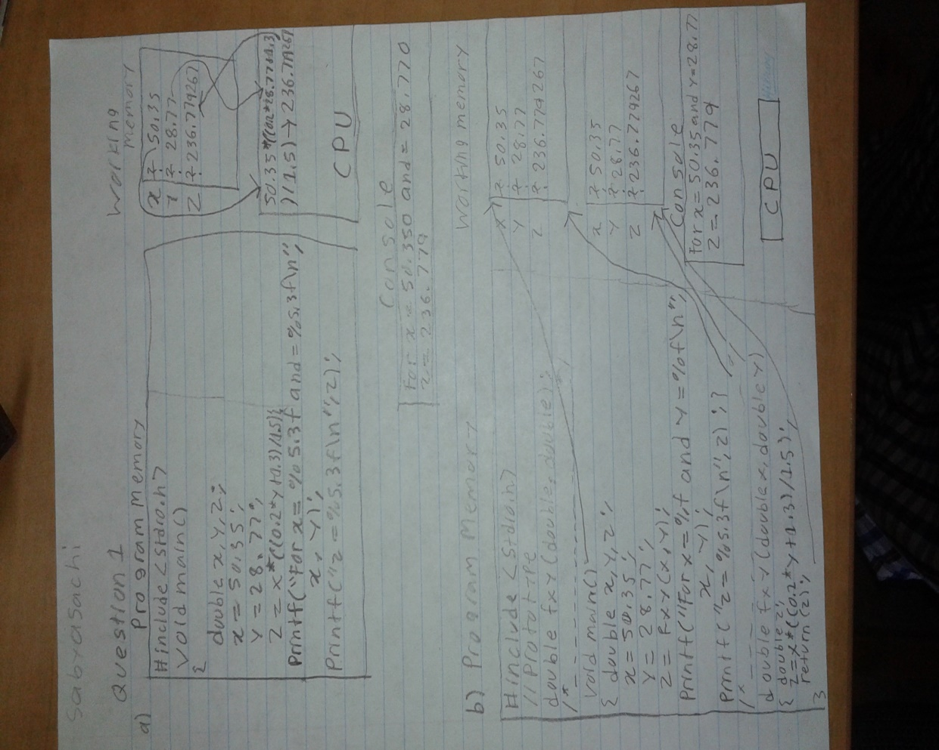
This image contains answers to both parts for question 1.
Question 2
Source code
#include <stdio.h>
#include <math.h>
double calculatevolume(double,double);

void main()
{
double v;
double r;
double h;

printf("please give the reservoir radius R(m)");
scanf("%lf",&r);
printf("please give the water depth h(m)");
scanf("%lf",&h);

v= calculatevolume(r,h);

printf("For a resovior of radius %fm\n",r);
printf("and water depth %fm\n",h);
printf("the water volume is %fm^3\n",v);
}
double calculatevolume(double r,double h)
{
double v;
v =((M_PI/3)*(h*h))*(3*r-h);
return(v);
}
Outputs from question 2
Output 1
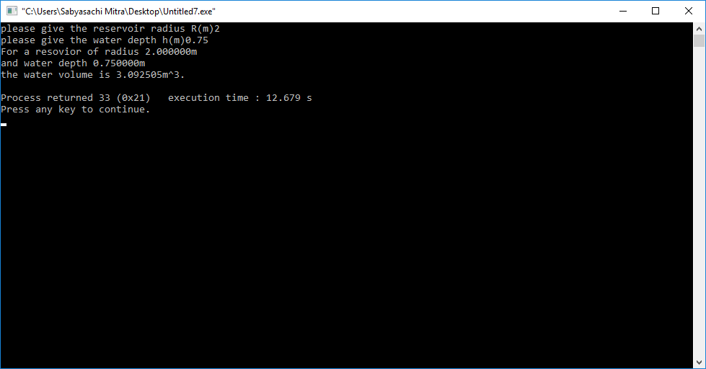
Output 2
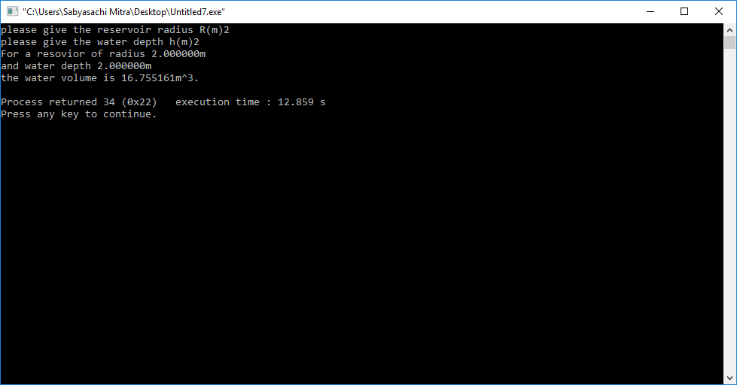
Output 3
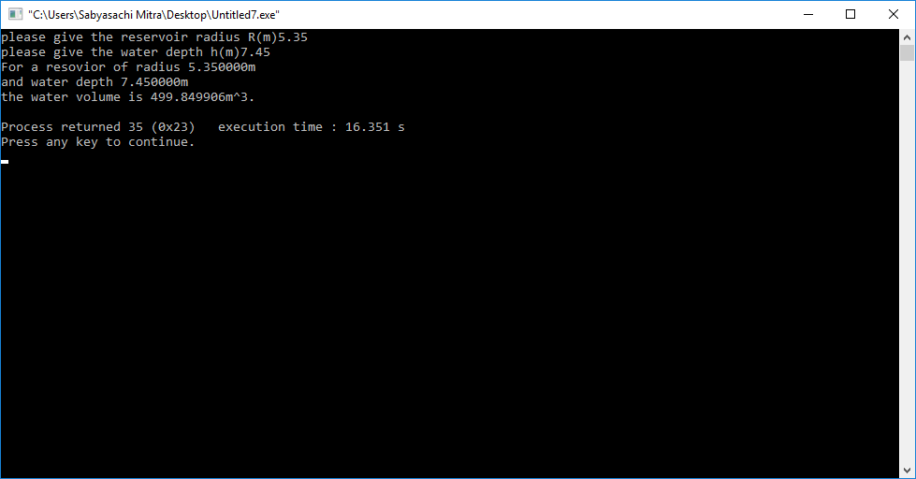

Output 4
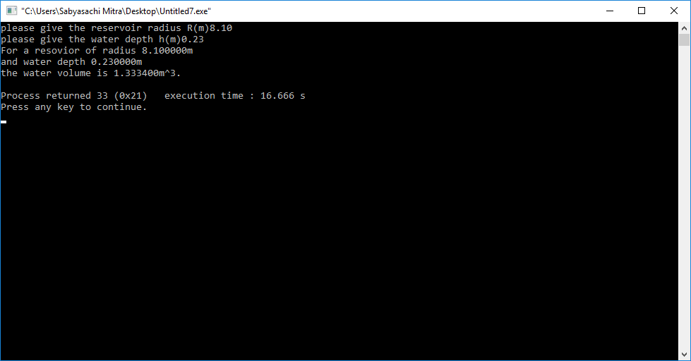
Output 5
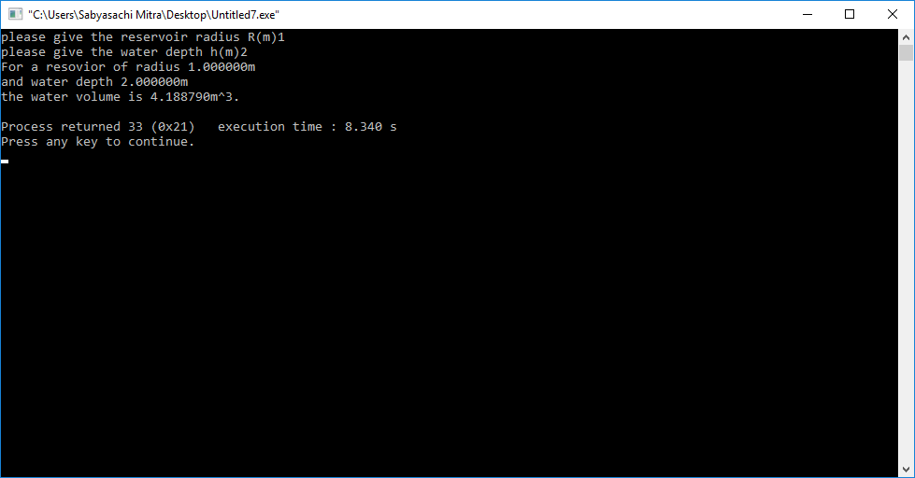
Question 3
Table of test cases
Length(m) | Width(m) | Emissivity | Temperature(°C) | Radiation(Watts)
20 | 10 | 0.10 | -100 | 1020.480253
5 | 2 | 0.05 | -50 | 70.360647
2 | 1 | 0.03 | 0 | 18.952089
80 | 20 | 0.97 | 25 | 695833.498116
250 | 100 | 0.85 | 50 | 13147022.363709
10000 | 30 | 0.20 | 100 | 65993452.523767

Source code

/*
File: A1
Description: Find the radiation in Watts using Stefan-Boltzmann law formula*/

#include <stdio.h>
#include <math.h>
double calculatearea(double,double);
/*
Function: main
Description: Takes the values of length, width, emissivity, and degree celsius inserted by the user, converts degree celsius into Kelvin,
and calculates the radiation in Watts.*/

void main()

{ double H;
double L;
double W;
double A;
double e;
double c;
double DegreeC;
double DegreeK;

printf("Please enter length(m):");
scanf("%lf",&L);
printf("Please enter Width(m):");
scanf("%lf",&W);
printf("Please enter emissivity:");
scanf("%lf",&e);
printf("Please enter temperature in Celcius:");
scanf("%lf",&DegreeC);
c = 5.67e-8;
A = calculatearea(L,W);

DegreeK = (DegreeC + 273.2);

H =A*e*5.67e-8*pow(DegreeK,4);

printf("H= %f W\n",H);
}
/* Function: calculatearea
parameters: double L, double W
Double L is the length, Double W is the width
Return: The return value is the area required for the equation of radiation
Description: This function calculates the area from the values of length and width, and returns the value to main function.*/

double calculatearea(double L, double W)
{
double A;
A= (L*W);
return (A);
}
Outputs for question 3
Output 1
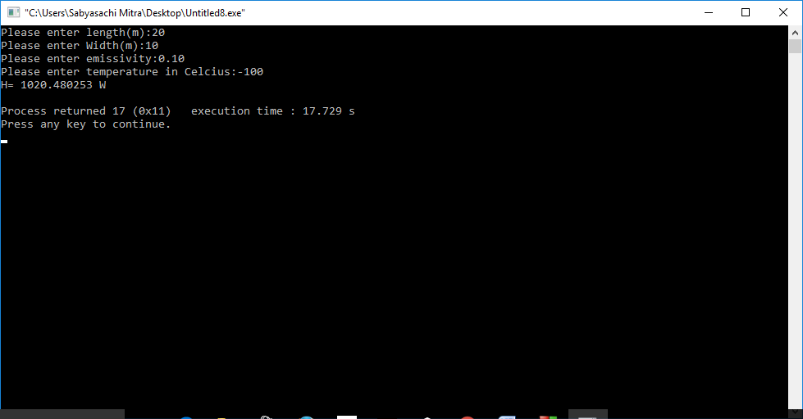
Output 2
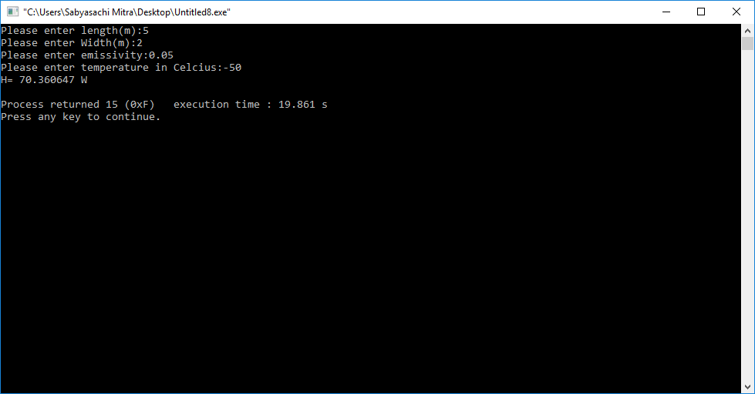
Output 3
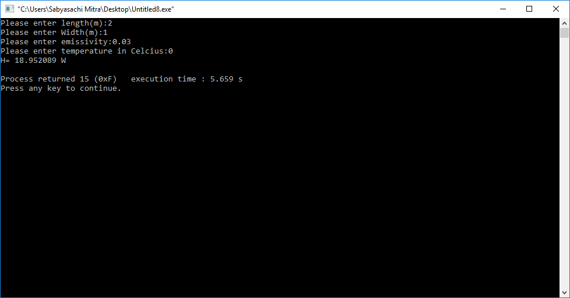

Output 4
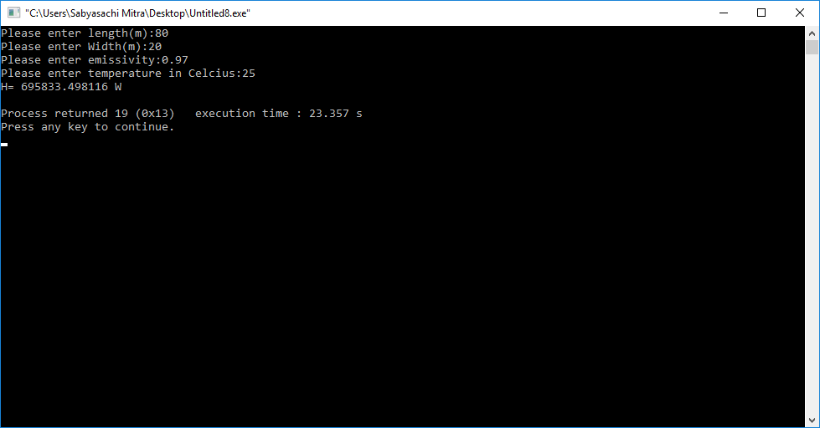
Output 5
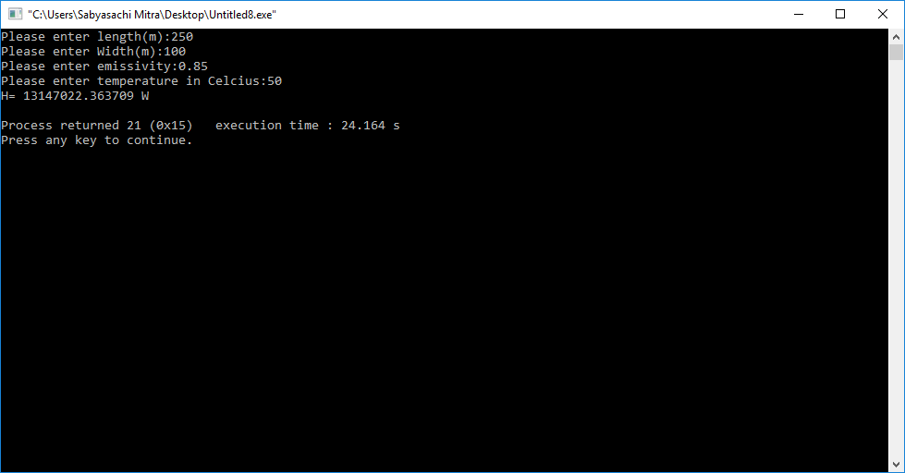
Output 6


