Chapter 4.2 - The Heart

- The heart is a transport system consisting of two pumps

The Pulmonary and Systemic Circuits
- Pulmonary Circuit
  - The blood vessels that carry blood to and from the lungs
  - Right side of the heart receives oxygen-poor blood from body tissues
  - Then pumps this blood to the lungs to pick up oxygen and dispel carbon dioxide
- Systemic circuit
  - The blood vessels that carry blood to and from the all body tissues
  - Left side of the heart receives oxygenated blood returning from the lungs
  - Then pumps this blood throughout the body to to supply oxygen and nutrients to other tissues
- Heart has 2 receiving chambers
  - The right atrium and left atrium
  - Receive blood returning from the pulmonary circuit
- Heart also has 2 main pumping chambers
  - The right ventricle and left ventricle
  - Pump blood around the two circuits

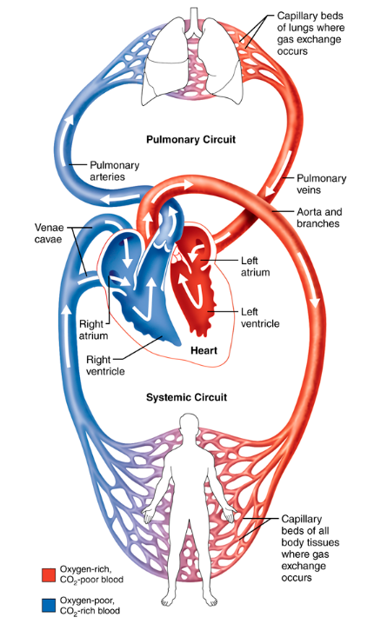

Size, location and Orientation of the heart
- The heart is enclosed within the mediastinum -- the medial cavity of the thorax
- Extends obliquely for 12-14cm from the 2nd rib to the 5th intercostal space
- ⅔ of the hearts mass lies on the left side
- Broad, flat base (approx. 9 cm) is directed towards the right shoulder
- Apex points towards the left hip
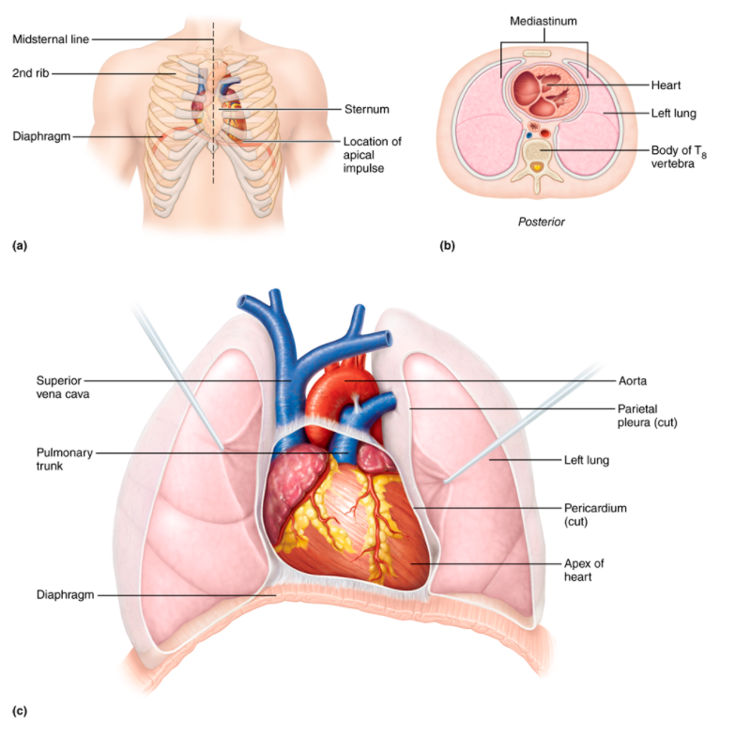

Coverings of the Heart

- Heart is enclosed in a double-walled sac called the pericardium
  - The loosely fitting superficial part is called the fibrous pericardium
    - Made of tough dense connective tissue
    - Protects the heart
    - Anchors it to surrounding structures
    - Prevents the overfilling of the heart
  - Underneath that is called the serous pericardium
    - Thin, slippery, two-layer membrane
    - Made of parietal and visceral (epicardium) layers
    - Between these two layers is the pericardial cavities which contains serous fluid
    - These serous membranes glide past one another allowing the heart to work in a low friction environment
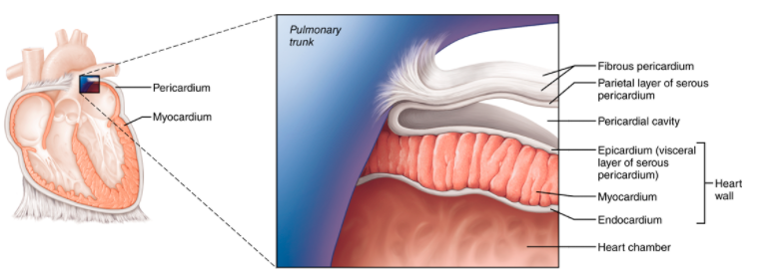
- Pericarditis: Inflammation of the pericardium
  - Serous membrane gets rough which causes a creaking sound (pericardial friction rub)
  - Can lead to adhesions causing visceral and parietal pericardia to stick together which impedes heart activity
  - This can cause inflammatory fluid to seeps into the pericardial cavity
  - This compresses the heart and limits its pumping ability -- called cardiac tamponade
  - Treated by draining the excess fluid from the pericardial cavity with a syringe

Layers of the Heart Wall
- The heart wall is composed of 3 layers
- Epicardium
    - Most superficial layer
    - Is the visceral layer of the serous pericardium
- Myocardium
    - The middle layer
    - Composed mainly of cardiac muscle and forms the bulk of the heart
    - This is the layer that contracts
    - Branching cardiac muscle cells are tethered together by criss-crossing CT and are arranged in spiral/circular bundles

- This dense network of CT fibres is called the “cardiac skeleton”
  - Anchors cardiac muscle fibres
  - Supports great vessels and valves
  - Limits the spread of action potentials to specific paths
- Endocardium
  - Innermost layer
  - Made of squamous epithelium resting on thin CT
  - Lines the heart chambers and covers the valve’s fibrous skeletons
  - Continuous with the endothelial linings of the blood vessels leaving/entering the heart

Chambers and Associated Great Vessels

- Heart has 4 chambers
  - 2 superior atria
  - 2 inferior ventricles
- Interatrial septum divides the two atria
- Interventricular septum divides the two ventricles

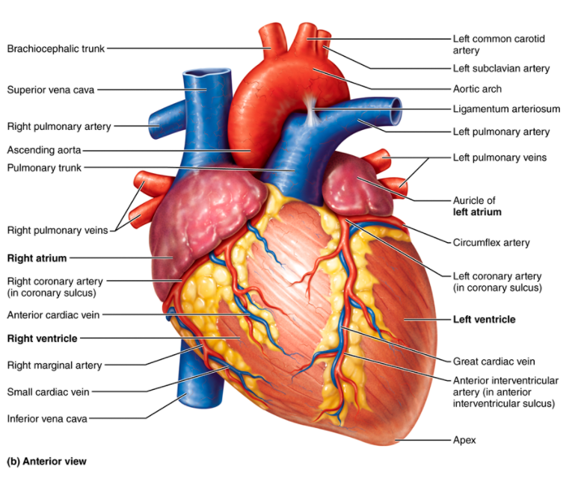
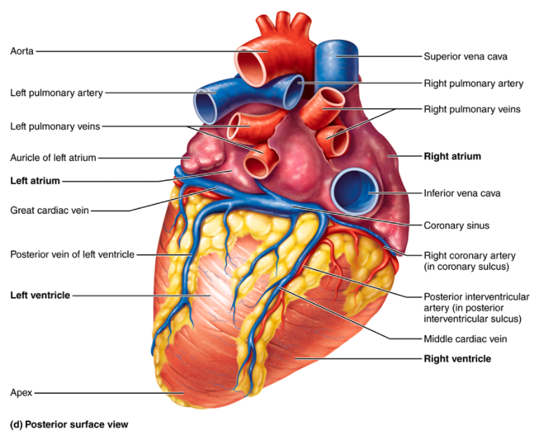
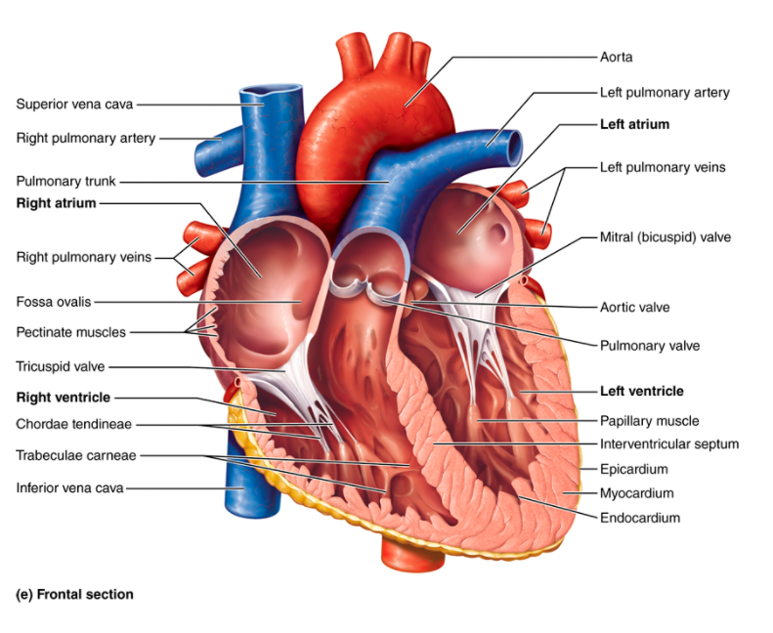

- Two grooves on the heart indicates chamber boundaries
  - The coronary sulcus (atrioventricular groove) encircles the junction of the atria and ventricles
  - The anterior interventricular sulcus separates the right and left ventricles anteriorly
  - The posterior interventricular sulcus also separates the ventricles but on the anterior side

Atria: The Receiving Chambers

- Have appendages called auricles that somewhat increase atrial volume
- The right atrium has 2 parts
  - A smooth walled posterior part
  - And an anterior portion that has ridges in the walls (called pectinate muscles)
- Left atrium is mostly smooth
- The fossa ovalis marks the spot where the foramen ovale existed in the fetus (the shallow depression in the interatrial septum)

- Functionally, the atria are receiving chambers for blood returning to the heart
- Relatively small & thin-walled, only contract minimally to push blood down
- Blood enters the right atrium via 3 veins
  - Superior vena cava - returns blood from body regions above diaphragm
  - Inferior vena cava - returns blood from body regions below diaphragm
  - Coronary sinus - collects blood draining from myocardium
- 4 pulmonary veins enter the left atrium

Ventricles: The Discharging Chambers

- Make up most of the heart’s volume
- Trabeculae carneae (irregular muscle ridges) mark the internal walls of the ventricular chambers
- Papillary muscles (role in valve function) project into the ventricular cavity
- Pumps of the heart
- Walls are much bigger than atrial walls
- Right ventricle pumps blood into the pulmonary trunk (routes to lungs)
- Left ventricle ejects blood into the aorta (the largest artery)

Heart Valves
- Blood flows through the heart in one direction
- Four valves enforce this blood flow in response to pressure changes

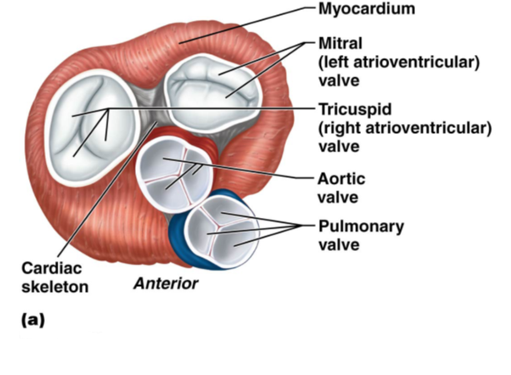

- Atrioventricular (AV) valves
  - Separates the atria and ventricles
  - Prevents backflow into the atria when ventricles contract
  - The right AV valve is called the tricuspid valve (has 3 flexible cusps)
  - Left AV valve is called the mitral valve or bicuspid valve (has 2 cusps)
  - Chordae tendinae (white collagen cords) are attached to each AV valve flap which anchors the cusps to the papillary muscles
  - When heart is relaxed, AV valves are limp, letting blood flow into the atria and then the ventricles
  - When the ventricles contract, interventricular pressure rises which pushes the flaps together
  - The chordae tendinae and papillary muscles anchor the flaps in the closed position so they don’t become everted

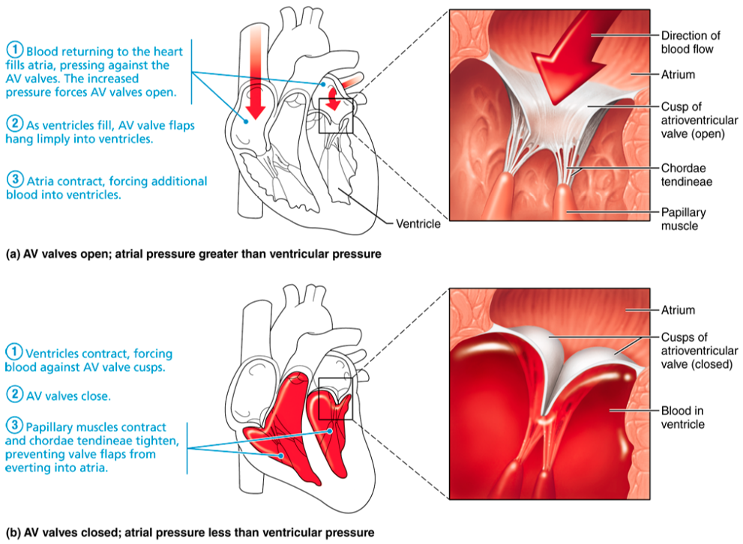
- Semilunar (SL) valves
  - Guard the bases of the large arteries from the ventricles and prevent backflow
  - Aortic SL valve separates the left ventricle and the aorta
  - Pulmonary SL valve separates the right ventricle and pulmonary trunk
  - Each SL valve is fashioned from 3 cusps shaped like crescent moons
  - When ventricles contract, pressure rises and SL valves are forced open
  - When ventricles relax, blood flows back and fills the cusps to close the valves

- Left side of the heart is the systemic circuit
- Right side is the pulmonary circuit
  - Pulmonary circuit is unique in that veins carry oxygenated blood and arteries carry deoxygenated blood
- Equal volumes of blood are pumped into the pulmonary and systemic circuits but the two ventricles have unequal workloads
- Pulmonary circuit
  - Short pathway
  - Low-pressure circulation
- Systemic circuit
  - Long pathways through the entire body
  - Encounters 5x more friction/ resistance to blood flow
- Thus, walls of the left ventricles are 3x thicker than the right and is a much more powerful pump
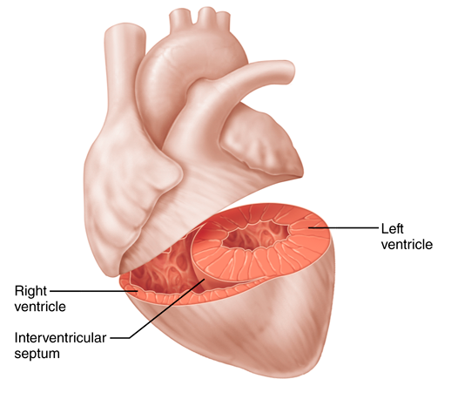

Coronary circulation
- The functional blood supply of the heart; shortest circulation in the body
- Coronary arteries
  - Right and left coronary arteries arise from the aorta and encircle the heart along the coronary sulcus
  - Left coronary artery runs down left side and branches into the
    - Anterior interventricular artery
    - Circumflex artery
  - Right coronary artery runs down the right side and also branches, into the
    - Right marginal artery
    - Posterior interventricular artery
  - Many anastomoses (junctions) to provide additional routes for blood delivery
  - Delivers blood when heart is relaxed, otherwise they are compressed when the ventricles contract

- Coronary veins
  - Path roughly follows the coronary arteries
  - Join to form an enlarged vessel called the coronary sinus (empties blood into right atrium)
  - Sinus formed from the merging of 3 cardiac veins
    - Great cardiac vein
    - Middle cardiac vein
    - Small cardiac vein

- Angina Pectoris
  - Severe suffocating chest pain caused by brief lack of oxygen supply to heart muscle
  - Can be caused by stress-induced spasm of the coronary arteries or increased physical demands
  - Myocardial cells are weakened
- Myocardial infarction (heart attack)
  - Characterized by dead tissue areas in the myocardium
  - Caused by interruption of blood supply to the area
  - Areas of cell death are repaired with non-contractile scar tissue

Cardiac vs. Skeletal muscles
- Both muscles are striated and contract by the sliding filament mechanism
- Skeletal muscle cells are long, cylindrical, multinucleated cells
- Cardiac muscle cells are short, fat, branched, interconnected and have 1-2 centrally located nuclei
  - Intercellular spaces are filled with loose CT (endomysium), containing many capillaries
  - Matrix is connected to the cardiac skeleton
- Skeletal cells are independent from one another while cardiac cells interlock at junctions called intercalated discs, which contain
  - Desmosomes - prevent cells from separating during contraction
  - Gap junctions - allow ions to pass from cell to cell → electrically coupled cardiac cells → myocardium behaves as a single coordinated unit (functional syncytium)
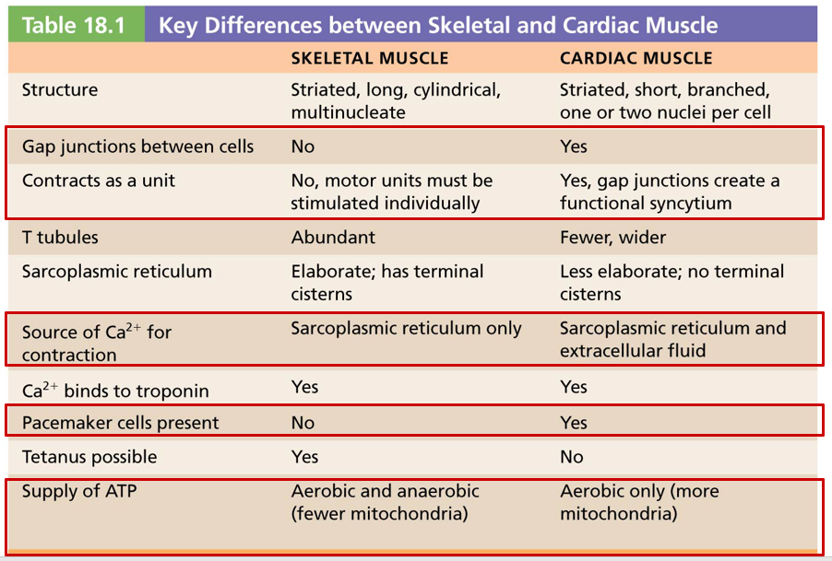
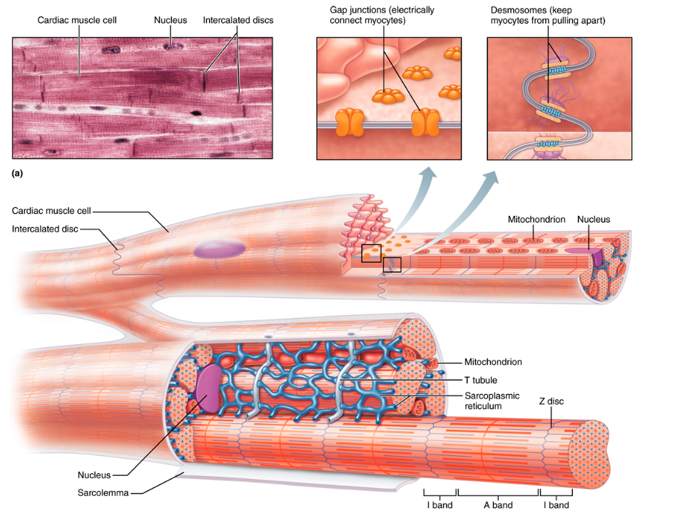
- Physiological differences
  - Both types of muscles have contractile tissues
  - Contraction in both muscles is preceded by depolarization in the form of an action potential
  - Some cardiac muscles are self-excitable
  - Heart contains two kinds of myocytes
    - Contractile cells: responsible for heart’s pumping activity
    - Pacemaker cells: non-contractile cells that spontaneously depolarize
  - No neural input is required unlike skeletal muscles
  - Heart contracts as a unit (either all fibres of the heart contract as a unit or not contract at all)

- The absolute refractory period in the heart is almost as long as the contraction itself in order prevent tetanic contractions (which would make the heart unable to relax/fill)

Setting the Basic Rhythm: The Intrinsic Conduction system
- The heart depolarizes and contracts without a neural stimulus
- ANS can alter its rhythm
- The coordinated heartbeat of the heart is a function of
  - The presence of gap junctions
  - The intrinsic cardiac conduction system
    - Consists of non-contractile cells that initiates and distributes impulses which depolarize and contract the heart

Action Potentials from pacemaker cells
- 1% of cardiac fibres are autorhythmic which are called cardiac pacemaker cells
  - These cells have the special ability to depolarize spontaneously to pace the heart
  - Part of the intrinsic conduction system
  - Have unstable resting potentials that continuously depolarize, drift slowly towards threshold
  - The spon. changing thresholds are called pacemaker potentials (prepotentials) and trigger action potential
    - Pacemaker potential
      - Hyperpolarization closes K and opens Na
      - Causes the interior to become more positive
    - Depolarization
      - At threshold (-40mV), causes explosive entry of Ca
      - Influx of Ca causes the rising phase of the action potential
    - Repolarization
      - Ca channels inactivate
      - K channels open in the falling phase
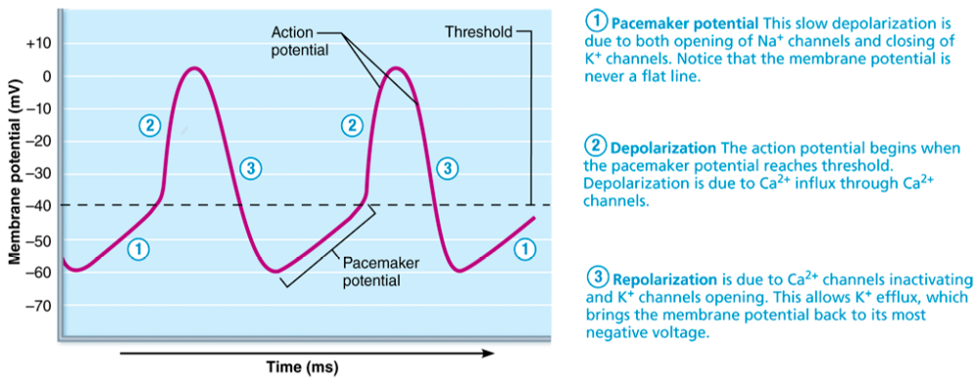

Sequence of excitation

- Cardiac pacemaker cells are found in the sinoatrial (SA) and atrioventricular (AV) nodes
  - Sinoatrial (SA) node
    - Located in right atrial wall
    - Impulses 75 times per minutes
    - Sets the pace of the heart because it has the fastest depolarization rate
    - Called the heart's pacemaker
    - Its characteristic rhythm is the sinus rhythm
  - Atrioventricular (AV) node
    - From the SA node the depol. wave spreads via the internodal pathway to the AV node
    - Impulse is delayed 0.1 seconds allowing the atria to contract before the ventricles start contracting
    - Conducts impulses more slowly
  - AV bundle (Bundle of His)
    - The only electrical connection between the atria and ventricles
    - Atria and ventricles not connected by gap junctions
  - Right and left bundle branches
    - AV bundle splits into the left and right bundle branches
    - Carry impulses towards the apex
  - Subendocardial conducting network (Purkinje fibres)
    - Completes the pathway by penetrating the apex and turning into the ventricular walls
    - More eleborate on teh left side of teh heart
    - Process from SA node to completion takes approx. 0.22 seconds
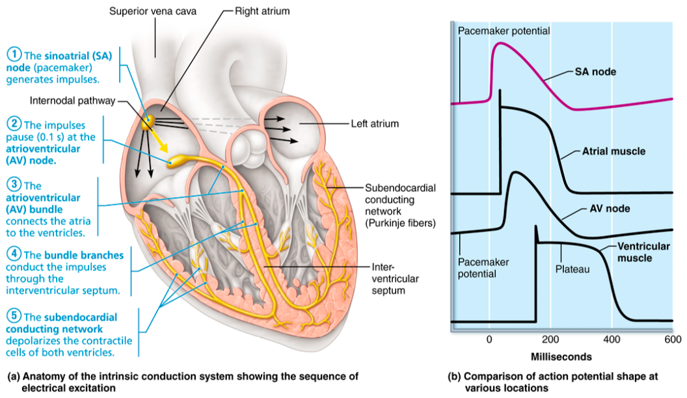

- Parasympathetic nervous system decreases depolarization rate
- Sympathetic increases depolarization/repolarization rate
- Intrinsic conduction system defects can cause irregular heartbeats (arrhythmias) or even fibrillation (rapid/irregular/out-of-phase contractions)

Action Potentials of Contractile cardiac muscle cells
- Depolarization open Na channels
  - Positive feedback = rising phase of action potential (-90mV to +30mV)
- Slow Ca channels open, prolonged depolarization, producing a plateau
- After ~200ms action potential falls
  - Result of Ca closing and K opening
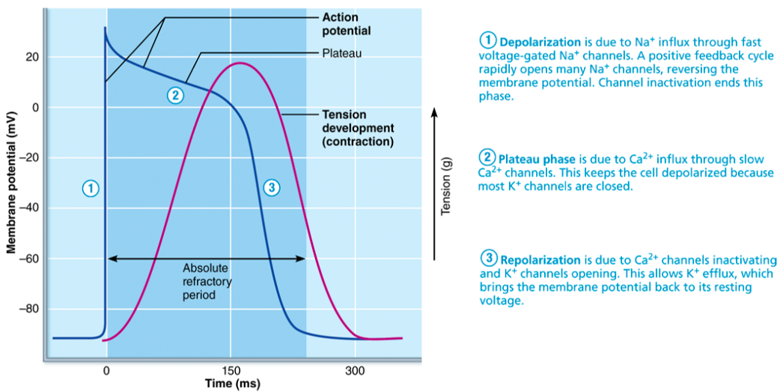

ELECTROCARDIOGRAPHY
- Electrocardiograph can detect electrical currents in the heart
- An electrocardiogram (ECG/EKG) is a graphic recording of heart activity
- LEAD: Right arm to left leg is most common

- P wave - Depolarization of the SA node/atria
- QRS complex - Ventricular depolarization and atrial repolarization
- T wave - Ventricular repolarization
- P-R segment - Beginning to atrial excitation to beginning of ventricular excitation
- S-T segment - Entire ventricular myocardium depolarized
- Q-T interval - Beginning of ventricular depolarization to end of ventricular repolarization
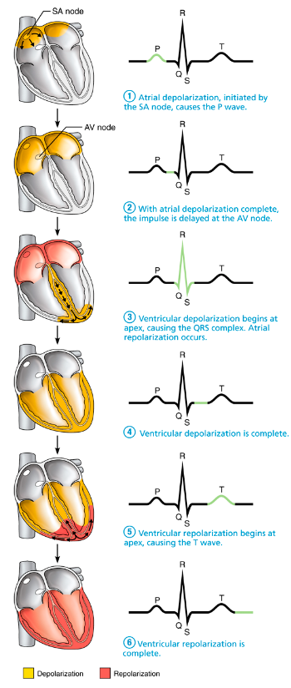

- Tachycardia - Fast resting heart rate
- Bradycardia - Slow heart rate

- Systole - Period of contraction
- Diastole - Periods of relaxation
- The cardiac cycle includes all events associated with blood flow during 1 heart beat
- Atrial systole and diastole are followed by ventricular systole and diastole
- Mechanical events follow electrical events seen on ECG



