PSYC 200 PROGRAM 08 JAN 2018

Chapter 1
- Introducing Psychology and Research Methods (p.14)

What is psychology ??
- Defining psychology : psych =mind (soul)
Logos=studies
- Definition: The scientific study of behavior and mental processes.
- Overt Behaviour: An action or response that is directly observed (crying
- Covert Behaviour: A response that is internal or hidden from view (thoughts or emotional reactions).

p.15
Empiricism

- Empirical evidence: facts or information based on direct observation or experience
- Data: observed or evidence

Psychological research
- Scientifics observation :an empirical investigation that is structured to ansewer question about the world
- Research method: a systematic approach answering scientific questions.

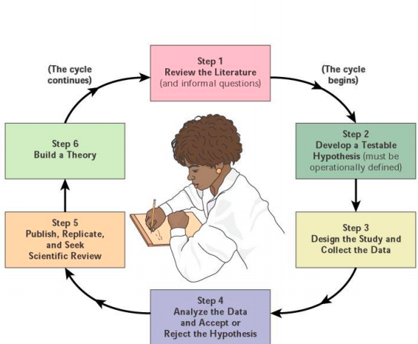
Research cycle

Psychologist cycle
Usually
Come up with a question
Testing it
Collecting data
Many studies
Theories come out

Video 1
People not help a person who was suffering like a homeless , since none did it they were looking just on him without helping him.. people do what others do ,,,
A well dressed man did same he got helped in just 10 second
Even people want help they don’t help because none else does it
If there are more people - less chances you have to be helped
Bystander effect

P.15-16
What Might a Psychologist Research?
- Developmental Psychologist: interested in human growth and development from conception until death
- Learning Theorist: interested in variables affecting learning and in theories of learning.
- Personality Theorist: studies personality traits, dynamics, and theories.(how personality changes)
- Sensation and Perception Psychologist: – Studies sense organs and the process of perception.
- • Comparative Psychologist: – Studies and compares behaviour of different species, especially animals.(compare animal and humans )
- Biopsychologist: – Studies relationship between behaviour and biological process, especially activity in nervous system
- Social Psychologist: Interested in human social behaviour.
- Cultural Psychologist: Studies the ways in which culture affects human behaviour.
- Gender Psychologist: Studies the difference between males and females.
- Evolutionary Psychologist: Studies the ways that human behaviour has evolved throughout the history of humankind.

Animals and Psychology (P. 17)
- Psychologists are interested in the behaviour of any living creatures.
- Animal models are used to discover principles that apply to human behaviour.

Psychology’s Goals (P. 17)
• Description of Behaviours: Naming and classifying various observable, measurable behaviours (What is the nature of the behaviour? Trying to figure out what is going on )
• Understanding: The causes of behaviour(s) (Why does it happen?)
• Prediction: Predicting behaviour accurately (Can we forecast when it will occur?)
• Control: Altering conditions that influence behaviours Psychology’s(What conditions affect it? After prediction we need to control it )
psychologist want to improve healthy well being and society

PSYC 200 10 JAN 2018

CHAPTER 1

- History of Psychology

- Wilhelm Wundt “Father of Psychology” (P. 18)
---The first one that made Psychology in independent science mostly about the emotions
• 1879: Set up first lab to study conscious experience. • How do we form sensations, images and feelings? • Observed and measured stimuli of various kinds.
- Stimulus: Any physical energy that has some effect on an organism and that evokes a response.( Examples: noise, light etc.)
- Titchener (P.19) ------ Titchener brought Wundt’s ideas to the U.S. and renamed it: Structuralism
- Introspections: Looking inward ,within (i.e., examining and reporting thoughts, feelings, etc.) was not that good
- Structuralism: was hoped to analyze experience into basic “elements” or “building blocks,” using introspection as their primary tool. ( analyze sensations thoughts and experience into basic elements) ------( Examples: – what makes chocolate chips taste amazing? – Describe your experience when holding an apple?)
- William James (p.19 ) ------- was the son of philosopher Henry James and brother of novelist Henry James was at Harvard university studying and teaching anatomy , philosophy and psychology he thought that ideas should be judged
- Functionalism: the study of PSYC that concerned “how the mind functions to adapt us to the environment” how the behavior and mental abilities of people help them to adapt in their environments-- Mostly your senses ------• Experience was not made out of building blocks BUT rather it was an ever-changing stream of sensations/images. ------ finding out how the mind , habits and emotions help us adapt and survive ------ Functionalists admired Darwin - survival of fittest
- Natural selection: physical characteristics that help animals adapt to their environments are retained in evolution. How evolution helps animals and plants to adapt into living conditions
- John B. Watson ---- was a professor at Hopkins uni 1908 ---he advanced the theory of behaviorism He observed the relationship between stimuli (events in the environment) and any animal’s responses • S ⇒ R responses = any muscular action glandural activity or other identifiable aspects of behaviour ------ Watson adopted Pavlov’s(Russian psychologist ) concept of conditioning to explain most behaviour ( conditioned response that is learned reaction to a particular stimulus )
- Behaviorism: Emphasizes the study of overt, observable behaviour (Goes with psychological perspective and may with sociocultural perspective)
- There are two ways that can control people’s behaviour by punishment so if someone has bad behaviour can take the right way and by rewards that B.F. Skinner believed that our behaviour is controlled by rewards
- Women is psychology : Mary Calkins 1863-1930, Christina Ladd –Franklin 1849 -1930 , and Margaret Washburn 1871- 1939
- Max Wertheimer - Gestalt Ψ • German psychologist, was the first to advance the Gestalt viewpoint. “the whole is greater than the sum of its part”
- Gestalt psychology :the study of psychology that emphasizes on thinking , learning and perception in whole units by not analysis into parts

- Psychoanalytic Psychology and Sigmund Freud

- Sigmund Freud was an Austrian doctor
- Feud theory : - small part of mental life is exposed to view
- Unconscious: the region of the mind that is beyond awareness (Area of mind that lies outside personal awareness is call the unconscious)
- Freud believed our behaviour is deeply influenced by unconscious thoughts, impulses, and desires
- Freud theorized that many unconscious thoughts are repressed
- Repression the Unconscious process by which memories, thoughts or impulses are held out of awareness

- Psychoanalysis: – A Freudian approach to psychotherapy emphasizing the exploration of unconscious conflicts.

- Psychology Today Three Perspectives of Behaviour (P. 23)

1)Biological Perspective
• Biopsychological View: – Behaviour is result of internal physical, chemical, and biological process.
• Evolutionary View: – Behaviour is result of processes of evolution over long periods of time
2) Psychological Perspective
• Behaviouristic View: – Behaviour is shaped and controlled by one’s environment. – Emphasizes study of observable behaviour and effects of learning.
• Cognitive View: – Much human behaviour can be understood in terms of mental processing of information. Concerned with thinking, knowing, perception, understanding, memory, decision making, and judgment.( human thinking and information processing )
• Psychodynamic View: – Behaviour is directed by forces within one’s personality that are often hidden or unconscious. --– Emphasizes internal impulses, desires, and conflicts.----– View behaviour as the result of clashing forces within personality.
• Humanistic view : emphasizes on human problems ,potentials , ideas self-actualization to explain behaviour positive philosophical view of human nature
3) Sociocultural Perspective:
• Sociocultural View: – Behaviour is influenced by one’s social and cultural context.(How social and cultures effect human’s behaviours ) ------– Emphasizes the role of environmental influences on our development.
- Positive psychology the study of human strengths , virtues ,and optimal behaviour .
- Cultural relativity the idea that behaviour must be judged relative to values of the culture in which it occurs
- Cultural differences, age, gender and ethnicity … affect the norms ( norms are the rules that define acceptable and expected behaviour form members of a group

Psychologist :is a person highly trained in methods, factual knowledge and theories of psychology

Photoooo p27

RESEARCH METHODS

The Scientific Method (P. 29)

- The Scientific Method: testing the truth of a proposition by careful measurement and controlled observation
- Hypothesis: the predicted outcome of an experiment or as educated guess about a relationship between variables
- Observation: collecting data directly by recording facts or events
• Six Basic Elements
– Observing--- looking for what’s going on .. literately, daily
– Defining a problem---ask a question
– Proposing a hypothesis (an educated guess that can be tested)—make an hypothesis about it and collecting data
– Gathering evidence/testing the hypothesis
– Publishing results ---if u come up with an answer
– Theory building

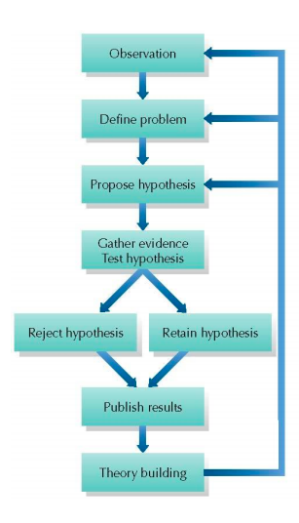

Operational definitions: defining a scientific concept be stating the specific actions or procedures used to measure it
(The goal of research you have to define your study in your concept so none else can say anything about it )
- States the exact procedures used to represent or measure a concept.
- Operational definitions allow for abstract ideas to be tested in real-world terms.
– Frustration = prevented from playing with favorite toy
– Aggression = number of time child hits punching bag

Research Methods (P.31-32)
1. Naturalistic observation
2. Correlation method
3. Experimental method
4. Clinical method
5. Survey method

- Naturalistic observation (P. 32-33)
• Observing behaviour as it unfolds in natural settings.
• Observational record: A detailed summary of observed events or a videotape of observed behaviour.

Problems with naturalistic observation
– observer Effect: Changes in behaviour caused by an awareness of a person or animal being observed (------if there is any experiment we have to lie to participants that we are looking for one thing but indeed we are looking for more things or something else )
– observer Bias: Occurs when observers see what they expect to see or record only selected details
– Anthropomorphic Fallacy: Attributing human thoughts, feelings, or motives to animals, especially as a way of explaining their behaviour (e.g., “Maverick my dog is acting like that because he is feeling depressed today.”) if an animals are away from each other it may be because the don’t like each other
- Correlational Method(P. 33)
• A non-experimental study designed to measure the degree of relationship (if any) between two or more events, measures, or variables. ( YOU CANNOT have cause and effect since is not an experimental method you can dependent

•Correlation Coefficients (P. 33-34) : when sing and the number look differently --- this shows the strength the direction of a relationship and also the number shows how strong the strength between them is … and you can have positive and negative

•Correlation Coefficient:
– Statistic ranging from –1.00 to +1.00; the sign indicates the direction of the relationship.
– Closer the statistic is to –1.00 or to +1.00, the stronger the relationship.
– Correlation of 0.00 demonstrates no relationship between the variables.

• Positive Correlation: Increases in one variable are matched by increases in the other variable.
• Negative Correlation: Increases in one variable are matched by decreases in the other variable.
• Correlation does not demonstrate causation: Just because two variables are related does NOT mean that one variable causes the other to occur
• correlation method is not a solution ….

EXAMPLE
What would the correlation coefficient look like: IQ of identical twin 1 and 2 = +0.9_______ Playing video games and test scores =-0.9 ____ Length of hair and intelligence=0________
Hours of video games | Grades | Strength of correlation | There is no
↑ | ↓ | -0.9 | cause
↑ | ↑ | +0.9 | and
↓ | ↓ | 0 | Effect
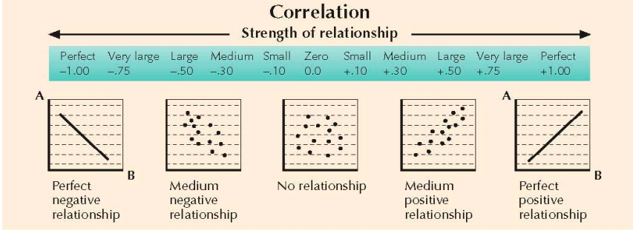

- Causation the act of causing some effects

- Experimental method
• Experiment: A formal trial undertaken to confirm a fact or principle.
• To identify cause and effect relationships, we conduct experiments.
– Directly vary a condition you might think affects behaviour.
– Create two or more groups of subjects, alike in all ways except the condition you are varying.
– Record whether varying the condition has any effect on behaviour.
You manipulate what you need and you look into 2 or more deferent groups and you can see their results how they are different
- Experimental subject: humans or animals whose behaviour is investigated in an experiment

Variables (P.35-36 ): any condition that changes or can be made to change ,measure, event or state that may vary
• Independent variables: – Conditions altered by the experimenter; suspected causes for behavioural differences. ( in an experiment the condition being investigated as possible cause of some change in behaviour , the values that this variable takes are chosen be the experimenter manipulate it )
• Dependent Variables: – Demonstrate results of the experiment. Condition is affected by independent variable.
• How does X affect Y where X is the independent variable and Y is the dependent variable.
• Extraneous Variables:
– Conditions or factors that a researcher wants to prevent from affecting the outcomes of the experiment (e.g., number of hours slept before the experiment).
– Should be similar in both conditions

- Groups (P. 36)
• Experimental Group: – The group of subjects that gets the independent variable.
• Control Group: – The group of subjects that does NOT get the independent variable. • Random assignment: – Subject has an equal chance of being in either the experimental or control group. – Balances personal differences in the two groups e.g same amount of people in each group

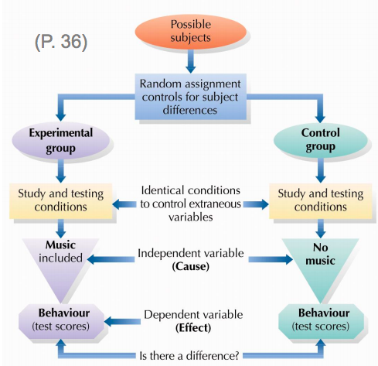
- participants have to be in same conditions ( we need to find out if there is an important variable that will effect our results and we need to keep this variable out of the experiment so It will NOT impact our results and also participants don’t need to know what the experiment is about because we don’t want them to change their behaviours

- experimenters do not need to know who is in each group to be fear without influencing by anything

- Placebo Effects Sugar Pills and Saltwater (P. 37)
• Definition: – A fake pill (sugar) or injection (saline)
• Placebo Effect: – Changes in behaviour that result from expectations that a drug or other treatment will have some effect

- Controlling Placebo Effects (P. 37-38)
• Single Blind: – Subjects have no idea whether they are in the experimental or control group
• Double Blind:
– Neither the subjects NOR the experimenters know whether the subjects are in the control or experimental group
– Best type of experiment if properly set up 35 Experimenter Effect (P. 37-38)
• Definition: – Changes in behaviour caused by the unintended influence of the experimenter
•Self-fulfilling Prophecy: – A prediction that leads people to act in ways to make the prediction come true

- The Clinical Method
• Case Study: – In-depth focus of all aspects of a single case
• Natural Clinical Tests: – Natural events, such as accidents, that provide psychological data
case studies are done when is necessary and possible and vary few people

- Survey Method (P.39-40) does not represent everyone because none is taking part in this method
– Use of public polling techniques to answer psychological questions.
• Representative Sample: – Small group that accurately reflects a larger population (same proportion of men, women, young, old, ethnicity etc.)
• Population: – Entire group of animals or people belonging to a particular category (e.g., all employed women)
• Biased Sample: – A subpart of a larger population that does not accurately reflect characteristics of the whole population.
- Internet Surveys:
– Psychologists have recently started doing surveys and experiments on the Internet.
– Web-based research has advantage of low cost and can reach very large groups of people.
– However, samples obtained through websites are not representative but do provide interesting information about topics such as anger, decision making, religion, racial prejudice and sexual attributes.
- Problem with survey method
• Courtesy Bias:
– Tendency to give “polite” answers
– especially the tendency to alter answers so as not to hurt the interviewer’s feelings.
- Pseudo-Psychologies (P.43-44)
• Pseudo means “false.” Any unfounded “system” that resembles psychology and is NOT based on scientific testing
– Palmistry: Lines on your hands (palms) predict future and reveal personality
– Graphology: False system based on belief that handwriting can reveal personality traits.
– Astrology: False system based on belief human behavior is influenced by position of stars and planets.
• Uncritical Acceptance:
– Tendency to believe generally positive or flattering description of oneself
– Fallacy of Positive Instances:
– Tendency to remember or notice information that fits one’s expectations, while forgetting discrepancies. (p. 44 of text)
- Barnum Effect:
– Tendency to consider a personal description accurate if it is stated in very general terms.

- Critical thinking : an ability to evaluate , analyze , critique and synthesize information

- Psychology in the News Separating Facts from Fiction (P.46-49)
1. Be skeptical.
2. Consider source of information – Psychics, mentalists
3. Ask yourself if there was a control group
4. Look for errors in distinguishing between correlation and causation
5. Be sure to distinguish between observation and inference – Crying does not mean sad!
6. Beware of oversimplifications, especially those motivated by monetary gain – New personality in 3 sessions
7. Remember, “for example” is not proof. – Cigarettes and lung cancer

