ADM 3318
Questions from which the midterm exam will be drawn
The exam will be based on chapters 1 to 6.

- What are the principal factors that explain the sustained growth in globalization we have seen since the WWII?
Declining Trade and Investment Barriers
- Before WWII, international trade had high tariffs on imports of manufactured goods. This resulted in countries progressively raising trade barriers against each other. This depressed world demand and contributed to the Great Depression in the 1930s
- After WWII, the Western nations committed themselves to removing barriers to the free flow of goods, services and capital between nations. This lead to the creation of the General Agreement on Tariffs and Trade (GATT), which caused the member states to lower barriers to the free flow of goods and services.
Technological Change
- Major advances in communication, information processing and transportation technology.
- This resulted in a “shrinking globe” (i.e. it takes less time to communicate a letter across the country than it used to)
- The creation of microprocessors enabled the explosive growth of high power, low cost computing which vastly increased the amount of information that can be processed by individuals and companies. This helped lead to the development of many developments in technology, driving down the time and cost of global communication, which leads to lower cost of coordinating and controlling a global organization.
- Major innovations in transportation technology, such as jet aircrafts and super freighters, reduced the time needed to get from one location to another and has shrunk the globe as well.
- Containerization has revolutionized the transportation business, significantly lowering the costs of shipping goods over long distances. This made the transportation costs plummet, making it much more economical to ship goods around the globe, thereby increasing the globalization of markets and production

- What indications can one use to demonstrate the increase in globalization since WWII?
Data has shown that the volume of word trade has grown consistently faster than the volume of world output since 1950. From 1950 to 2000, world trade expanded almost 20-fold.
- The average tariff rates since 1950 have decreased significantly. For example, France’s tariff rate was 18% in 1950 and by 1990, it was 5.9%
- Firms across the world are increasing their cross-border investments. The average yearly outflow of foreign direct investment increased from $14 billion to $1.3 trillion.
- The average charges per ton of US export and import fell from $95 to $29 between 1920 and 1990.

- “While the term “culture” is commonly used it is very difficult to get an agreement on just what it means.” Explain briefly why this is so?
It is difficult to get an agreement on what culture means because it is a very abstract term. Culture is made up of many beliefs, values, actions, norms, etc. and because it is extremely complex and abstract, it is difficult to understand exactly what someone means when they use the term “culture”, thus leading to a variety of meanings to try to pinpoint a perfect explanation of what it truly represents.

- Why is it important for person engaged in international business to be aware of the “culture” of those they intend to do business with?
- Culture affect the way business is practiced
- Culture can affect the way relationships are built. e.g. in china, giving gifts to build relationships = bribery, which is somewhat legal in china.
-Culture can affect people's preferences in food, clothing
- The value systems and norms of a country influence the costs of doing business. .
- Culture can affect people's view on ethics, which is mostly determined by religion. Most important business implications of religions centre on the extent to which different religions shape attitudes toward work and entrepreneurship and the degree to which the religious ethics affect the cost of doing business in a business.
- Culture affects the values found in the workplace. Hofstede isolated five dimensions that he claimed summarized different cultures - power distance(high PD = inequalities of power and wealth), individualism(ties between individuals were loose, individual achievements and freedom were highly valued.) vs collectivism(ties between individual s wee tight), uncertainty avoidance(high = taking less risks, premium on job security, career patterns, retirement benfits.), masculinity(sex roles were sharply differentiated) vs. femininity(little diffeentiation was made between men and women in the same job), and longterm(thrift, perseverance) vs short term orientation(respect for tradition, fulfilling social obligations, and protecting one's face).
- Doing business in different cultures requires adaptation to conform to the value systems and norms of that culture. This may involve the way deals are negotiated, the appropriate incentive pay system for salespeople, the structure of the organization, the name of a product, the tenor of relations between management and labor, the manner in which the produce its promoted, all of which are sensitive to cultural difference.

- Cite a law in Canada or the USA that attempts to bring about more ethical conduct in international business. How does it intend to do this?
Canada's Bill S21, also known as the Corruption of Foreign Officials Act that entered into force on February 14, 1999. It features three offences: bribing a foreign public official, laundering property and proceeds, and possession of property and proceeds. In addition, the Act would make it possible to prosecute.
It sets out a lawful exception that an accused could use as a defense, namely, that the payment was lawful in the foreign state or public international organization for which the foreign public office performs duties or functions. It also sets out an additional defense, regarding loan rewards, advantages, or benefit. It is similar to the U.S. foreign Corrupt Practices Act.

- Are there any international codes that attempt to bring about a more ethical conduct of international business? What are its contents?
There are international codes established, but are not effectively implemented.
A wide variety of corporate codes of conduct now exist on paper. The OECD has published guidelines for multinational enterprises, and many nongovernmental organizations have publicized sets of global principles. Besides being largely unknown in the corporate world, these various declarations all have another thing in common — they lack teeth.
Many countries established its own legislations to prevent unethical behaviors in the corporate world in its own country. Although all the legislations dose affect the international business. However, there is no well established and implemented legislations or international codes that have significant influence in a global scale.

- Protecting “whistle-blowers” through legislation is now common in all western countries. Do such legislation apply to international business?
No, because there are three main types of legal systems in use around the world: common law, civil law, and theocratic law. Not only will legislation differ, the strength of the legal system is also a determinant factor.

Common Law: a system of law based on tradition, precedent, and custom. When law courts interpret common law, they do so with regard to these characteristics

Civil Law: a system of law based on a very detailed set of written laws and codes

Theocratic law: a system of law based on religious teachings

Private Action Example
Private Action: theft, piracy, blackmail, and the like by private individuals or groups
Theft, piracy, blackmail occurs in all countries, but a weak legal system allows for a much higher level of criminal activity in some than in others.

Public Action and Corruption Example
Public Action: The extortion of income or resources from property holders by public officials.
The government of the late Ferdinand Marcos in the Philippines was famous for demanding bribes from foreign businesses wishing to set up operations in that country
(Other possible methods: levying excessive taxation, requiring expensive licences or permits from property holders, taking assets into state ownership without compensating the owners)

Legal Risk Example
The legislation for protecting people, places, things (such as intellectual property) vary and thus, there is legal risk that international businesses may experience in a foreign country. For example, in the 1970s when the Indian government passed a law requiring all foreign investors to enter into joint ventures with Indian companies, U.S. companies such as IBM and Coca-Cola closed their investments in India. They believed that the Indian legal system did not provide for adequate protection of intellectual property rights, creating the very real danger that their Indian partners might expropriate the intellectual property of the American companies.

So, just because protecting whistle-blowers is common in all western countries, it doesn’t apply to international businesses in fear of the legal risks or lack of legal systems in some countries.

- Define and explain the difference between absolute and comparative advantage in international economics? Use diagrams to illustrate your answer.
Definition
Absolute Advantage: A country has an absolute advantage in the production of a product when it is more efficient than any other country at producing it
Comparative Advantage: The theory that countries should specialize in the production of goods and services they can produce most efficiently. A country is said to have a comparative advantage in the production of such goods and services

Difference
Entities with absolute advantages can produce something using a smaller number of inputs than another party producing the same product. As such, absolute advantage can reduce costs and boost profits.
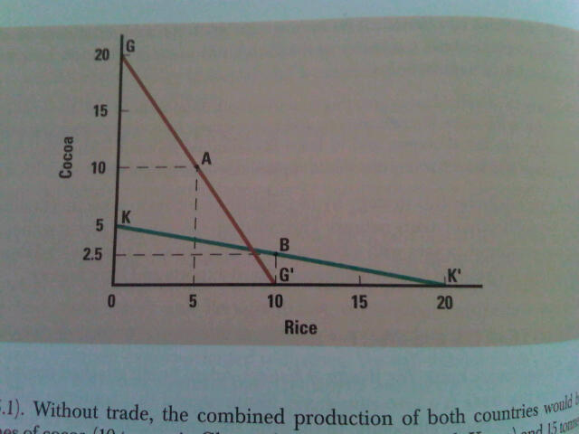

Production Domestically
Ghana (A) 10 Cocoa, 5 Rice (Point A)
Korea (B) 2.5 Cocoa, 10 Rice (Point B)
Total 12.5 Cocoa, 15 Rice

Production with Specialization (Absolute Advantage)
Ghana 20 Cocoa, 0 Rice (Point G)
Korea 0 Cocoa, 20 Rice (Point K’)
Total 20 Cocoa, 20 Rice
Increase +7.5 Cocoa, +5 Rice

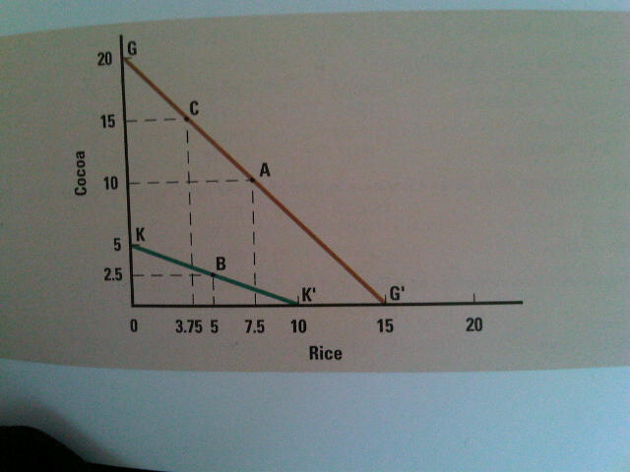

CALCULATIONS FOR PROOF…not really important
Resources Required to Produce 1 Tonne of Cocoa and Rice
 | COCOA | RICE
Ghana | 10 | 13.33
South Korea | 40 | 20
Production and Consumption Without Trade
 | COCOA | RICE
Ghana | 10 | 7.5
South Korea | 2.5 | 5.0
Total Production | 12.5 | 12.5
Production with Specialization
 | COCOA | RICE
Ghana | 15 | 3.75
South Korea | 0 | 10
Total Production | 15 | 13.75
Consumption after Ghana Trades 4 Tonnes of Cocoa for 4 Tonnes of South Korean Rice
 | COCOA | RICE
Ghana | 11 | 7.75
South Korea | 4 | 6
Increase in Consumption as a Result of Specialization and Trade
 | COCOA | RICE
Ghana | 1 | .25
South Korea | 1.5 | 1

Although Ghana has an absolute advantage in the production of both cocoa and rice, it has a comparative advantage only in the production of cocoa: Ghana can produce 4 times as much cocoa as South Korea, but only 1.5 times as much rice. Ghana is comparatively more efficient at producing cocoa than it is at producing rice.

Another example
- Suppose two firms both produce two products: A and B.
- Company 1 must spend a lot of money to make A, whereas Company 2 spends way less to produce the same amount.
- The two firms are dead even in their production costs for B.
- Because the Company 2 has a comparative advantage with production of A, it should probably consider turning exclusively to A.
- Company 1 should probably give up the production of A and focus on the product in which it is the least disadvantaged (B).

- What is the Heckser-Ohlin theorem and which assumptions underlie the theory?
The Hecksher-Ohlin theorem is a hypothesis that comparative advantage arises from differences in national factor endowments.

ASSUMPTIONS

- Assuming a simple world
- Assumed away transportation costs between countries
- Assumed away differences in the prices of resources in different countries
- Assumed that resources can move freely from the production of one good to another within a country
- Assumed constant returns to scale; that is, that specialization by a country has no effect on the amount of resources required to produce a good or service
- Assumed that each country has a fixed stock of resources
- Assumed away the effects of trade on income distribution within a country

- What is the “new trade theory” and explain its significance?
New trade theory stresses that in some cases countries specialized in the production and export of particular products not because of underlying difference in factor endowment, but because in certain industries the world market can support only a limited number of firms. Those firms that enter the world market first may gain an advantage that may be difficult for other firms to match. Thus, a country may dominate in the export of a particular product where scale of economies represents a significant proportion of world output, because it is home to a firm that was an early mover in this industry.

- What are the effects of a tariff on the domestic economy and on the (affected) foreign economy?
Tariff is a tax levied on imports. A tariff raises the cost of imported products. In most cases, tariffs are put in place to protect domestic producers from foreign competition. By putting tariffs, the government gains because the tariffs increase government revenues. Domestic producer gain because the tariff affords them some protection against foreign competitor and the restriction of supply also raises domestic prices. Consumer loses because they must pay more for certain imports. For foreign economy, tariffs reduce the overall efficiency of the world economy. They reduce efficiency because a protective tariff encourages domestic firms to produce products at home that, in theory, could be produced more efficiently abroad.

- What are the effects of quotas on the domestic economy and the (affected) foreign economy?
An import quota is a direct restriction on the quantity of some good that may be imported into a country.
A variant on the import quota is the voluntary export restraint (VER). A voluntary export restraint is a quota on trade imposed by the exporting country, typically at the request or the importing country’s government. Both import quotas and VERs benefit domestic producers by limiting import competition. As with all restrictions on trade, quotas do not benefit consumers. An import quota or VER always raises the domestic price of an imported well.
If domestic industry lacks the capacity to meet demand, an import quota can raise prices for both the domestically produced and import good.

- Cite the various objectives of trade policies?
There are 2 trade policies what are administrative trade policies and antidumping policies.
Administrative policies, typically adopted by government bureaucracies, that is used to restrict import and boost exports. Antidumping policies use to punish foreign firms that engage in dumping and thus protect domestic producers from unfair foreign competition.

- What is a “countervailing duty” and when is it justifiable?
- Countervailing duty is antidumping duties.
- Dumping: selling goods in a foreign market at below their costs of production, or as selling goods in a foreign market at below their “fair” market value.
- Antidumping policies: designed to punish foreign firms that engage in dumping. The objective is to protect domestic producers from “unfair” foreign competition.
- It is justifiable when a domestic producer believes that a foreign firm is dumping productions in the market. The domestic firm would file a petition with two government agencies, the Commerce Department and the International Trade Commission. The government agencies then investigate the complaint. If they find it has merit, the Commerce Department may impose an antidumping duty on the offending foreign imports.

- “Free trade, without exception, means that there will be winners and losers”. Who are the winners and the losers from free trade in Canada and explain how or why they win or lose.
- The winners are the Government and the domestic producers and the losers are the consumers.
Trade Policy | Definition | Winners | Reason | Losers | Reason
Tariffs | Tax levied on imports | Government, Domestic Producers | Tariff increases government revenues.  Tariff affords producers some protection against foreign competitors by increasing the cost of imported goods. | Consumers | They must pay more for certain imports.
Subsidies | Government payment to a domestic producer | Domestic producers | Help producers compete against foreign imports and help them gain export market | Individuals | Government pays for subsidies by taxing individuals
Import Quota | A direct restriction on the quantity of some good that may be imported into a country | Domestic producers | Limiting import competition | Consumers | Import quota always raises the domestic price of imported goods
Local content requirement | Demands that some specific fraction of a good be produced domestically | Producers | Limit foreign competition | Consumers | Restrictions on imports raise the prices of imported components, so the high prices are passed on to consumers of the final product in the form of higher final prices.
Administrative Policies | Informal or administrative policies to restrict imports and boost exports | Producers | Limit foreign competition | Consumers | Denied access to possibly superior foreign product
Antidumping policies | Policies designed to punish foreign firms that engage in dumping and thus protecting from unfair competition | Producers | Protect producers from “unfair” foreign competition

- How does the textbook define the term “political economy”?
- Political economy: the political, economic, and legal systems of a country.
- Stresses that the political, economic, and legal systems of a country are not independent of each other. They interact and influence each other, and in doing so they affect the level of economic well being in a country.

- Does the textbook seem to favor a particular “political economy”?
The textbook seems to favour a political economy that has a market economy and follows a democratic political system.
In a market economy, any individual who has an innovative idea is free to try to make money out of that idea by starting a business. Existing businesses are free to improve their operations through innovation. To the extent that they are both successful, both individual entrepreneurs and existing businesses can reap in the high profits. Thus, market economies contain enormous incentives to develop innovations.
The other economic system is a planned economy. The state owns all means of production, which leaves little incentives for individuals to develop valuable innovations.

Westerners believe democracy with a market economic system, strong property rights protection, and economic progress is the best political system. Democratic regimes are far more conductive to long-term economic growth than dictatorships. Economic growth often leads to establishment of a democratic regime. While democracy may not always be the cause of initial economic progress, it seems to be one consequence of that progress.

