Chapter 1 – An Introduction to the Canadian Domestic Macro-environment: A Business, Government and Civil Society Perspective

The Federal Government
- Their source of money is generally taxpayers

Civil Society
- Has a number of rules including:
  - Advocating for public rights and representing the right and concerns of smaller, and in some cases, disenfranchised stakeholders
  - Making the actions of the govt. and business transparent
  - Preserving and enhancing social relations with the overall goal of making society a better place, with a higher quality of life for all its members
  - A persistent challenge to them is funding
  - Civil society collectively represents a wealth of intellectual capital, ideas, and capacity that could be harnessed to further govt. policy
  - Yields considerable influence over public opinion that can affect the public’s perception of the integrity of govt. and business

Business
- A strong business segment is profitable, ethical, and socially responsible
  - To be profitable, they must establish a sustainable competitive advantage that’s requires continuous innovation, learning and adapting that is only possible through synergistic relationships with other businesses, govt., and civil society orgs.
  - Profitability must derive from efficient, effective, and ethical business operations
  - Both public and investors expect business to be socially responsible and to be committed to sustainability actions

Introduction
- Insufficient to view Canada’s macro-environment through the lens of the interaction between govt. and business
  - Civil society provides significant contributions and continues to demonstrate the greatest relative increase in its ability
    - Civil society often viewed as the “neutral broker”
      - Decisions by govt. or actions by businesses endorsed by civil society would often be perceived appropriate
- Modification of Kenneth Boulding’s triangle can be applied to Canada’s macro-environment
  - Business segment
    - Generally includes all forms of “for-profit” business ownership
      - Includes corporations, franchises, partnerships, and sole proprietorships
  - Government segment
    - All levels of govt.
      - Fed, prov, municipal
  - Civil Society segment
    - Generally includes organized and unorganized social networks, non-govt. organizations (NGOs), volunteer organizations, charities, philanthropic efforts

  - Each segment features different rules, arrangements, or mechanisms of coordination, or sorting mechanisms
    - Business: mechanisms take the form of supply and demand or quid pro exchange
    - Government: coercion and redistribution are the prevalent mechanisms
    - Civil Society: mechanisms include solidarity, reciprocity, collaboration, and trust
  - Segments in each sector are very different and are based on different principles
  - Boundaries between each sector are fluid and continually evolve through interaction and interdependency

Changes in Canada’s Domestic Macro-environment
- Changes in social context have been driven by several developments
  - Ex. Ageing population, diminishing labour pool, multi-culturalism and globalization
- Business applies pressure to govt through lobbying in an attempt to influence public policy
- Business also significant supporter of civil society, through financial and in-kind contribution, encouraging employees to participate in third-sector activities, and by offering expertise through the transfer of knowledge that would be the inevitable result of business working closely with civil society organizations
- Govt also has a wide range of policy instruments to influence business and civil society
  - Can regulate, subsidize, tax, loan money and invest in certain activities, procure goods and services, and take ownership of the delivery of products and services to influence business
  - Can offer funding for certain activities, modify its tax policy, collaborate to develop alternative service delivery mechanisms, or work to develop national third-sector strategies that would in turn bolster the govt’s policy direction
    - Ex. Social Finance Fund (beginning of chapter)
- Civil society can also affect the other two sectors
  - As the trusted “neutral broker”. They can influence both segments to move in a specifies direction in delivering programs, services, contracts, and other matters
  - Can bring public credibility to the actions of both business and govt by being closer to stakeholders serve as an important conduit on public opinion in matters of business activity and public policy

Stakeholders in the Canadian Domestic Macro-environment
- Definition: one that has a stake in an enterprise
  - Generally the concept of “stakeholders” is addressed in the context of the activities of a corporation of other business entity
  - However definition goes beyond the confines of a corporate stakeholder
  - Corporate stakeholder concept provides arguably the most intuitive approach to understanding the role of the stakeholder
  - Corporate stakeholders can be classified in many ways – direct, indirect, primary, and secondary among others
    - But all stakeholders have some degree of influence/are influenced by the company, business, or corporation
  - Most common stakeholders are shareholders, employees, suppliers, unions, competitors, and govt
- Every citizen is a stakeholder to the govt
  - Less intuitive than business
  - Further complicated when one expands stakeholder concept to include not only individuals but also the combinations or individuals into more organized forms
    - Ex. Sole proprietorships, partnerships, corporations, cooperatives; civil society groups, charitable organizations, volunteer organizations, hospitals, universities, and NGOs
- Managing stakeholders of the govt means attempting to satisfy as many potential voters as possible
- Stakeholders from perspective of civil society
  - Even less intuitive
    - Group is comparatively the most fragments and least understood
  - Have enormous power to influence both business and govt
  - Like the govt sector, every citizen is a potential civil society stakeholder since it represents the social consciousness of the people

Stakeholders and Boulding
- Modified triangle implies the need for a stakeholder approach targeted to each segment
  - When this perspective is applied to Canadian society, there’s a wide diffusion of power among members of a society characterized by diverse ethnic and social groups
    - What emerges if the existence of a pluralistic society, a society in which power is distributed, not centralized; a society that consist of a multitude of stakeholders directly or indirectly influencing each other through a range of social relationships
    - Pluralistic society involves a deepening interdependence or all facets in the wake of increasing interconnectedness, complexity, and uncertainty

Canada at a Glance
Population
- 37,412,852 mil
  - About 500,000 increase from year before
- Ontario, Quebec, Alberta, and BC account for 86%
- Canada’s unemployment rate in May 2019 was 5.6% as compared to 7% in February 2013, and the lowest since 1976
- May 2019 – more people were working health care and social assistance, professional, scientific and technical services; and employment decreases were being experienced in the fields of business, building and other support services, accommodation and food services, and public administration
- While unemployment rates have decreased over past few years, attendances at university of the 20-29 age group has increased slightly
- Number of graduates has also increased

Geography
- Canada is the largest country in the world (??????????)

Style of Government
- Canada features a modified Westminster style of govt in which legislation ca be advanced either federally or provincially
- Govt’s influence on the Canadian socio-economy is significant
- 93% of revenue generated through some form of taxation in 2017-2019
- Govt a key player in Canada and an understanding of how it works is essential for a manager

Civil Society
- The Canadian civil society exemplified by the volunteer sector and charitable organizations is also a formidable force
- Ex. In 2010, over 22mil made a financial donation to a charitable or other non-profit with amount totalling to $10.6 mil
  - Majority of donations given to religious organizations, health organizations, and social services organizations
  - Overall Canadians gave 1.5% of income
- Donation rates dropped by 5% from 2006 to 2015
- Third segment is equally as important for a manger to know

Chapter Summary
- Canada’s domestic macro-environment can be described as consisting of three key segments
  - Each with its own unique characteristics and membership, and holding equal value in terms of importance
- Canada’s society is pluralistic with no single segment holding exclusive power
- As the simultaneous and harmonious interaction of all three segments is necessary, the domestic macro-environment is essentially a set of ongoing relationships between persons and organizations with a deepening interdependence and in increasing interconnectedness
- In order to create a sustainable competitive advantage, managers require a full understanding or each of the three segments
- Given the complexity of society it is simply not possible to “go it alone”

Chapter 2 – The Canadian Business Segment

Introduction
- Business drives the economy of a nation
- Canadian labour force of almost 19mil
- GDP estimated to be approximately USD$1709bil, representing 2.76% of the world economy
- Over 67% live in one of 33 metropolitan areas with Toronto, Montreal, and Vancouver accounting for about 1/3 of Canada’s populations
- Economic system is a private enterprise system where firms are rewarded for effectively and efficiently meeting the wants and needs of customers
- Characteristic right of a private enterprise system includes private property, freedom of choice, profit, and competition
- Business is conducted in a well-diversified economy with the goods sector and service sector employing 21% and 79% of Canadians respectively
- Businesses have transitioned from parochial trade to one of the major international trading economies
- Earliest trade with the Indigenous to trade in fur and fish
- Canadian business has transitioned from a period of significant govt regulation to the prevailing period of govt deregulation

The Current Canadian Business Environment
- Today’s Canadian business environment can be described as a private market system anchored in the doctrines on capitalism that provide for the private ownership of the factors of production with profits determined through the laws if supply and demand in a generally unrestricted market
- Atlantic Canada feature companies involved in marine-based energy, oceans tech, aquaculture, aerospace and defence, and renewable energy
- Central Canada companies are involved in aerospace, manufacturing, financial services, multi-media, and artificial intelligence
- Western Canada is the home to Canada’s digital tech and protein superclusters, with companies involved in clean tech and agricultural tech
- Northern Canada is home to companies involved in oil and gas, mining and exploration, and mineral and resource development, as well as film, video, and digital media
- Aerospace, agri-food, biopharmaceuticals, digital media, machinery and equipment, mining, renewable energy, and software

Aerospace
- Over 700 companies + 85,000 people
- $29bil in revenue (2017)

Agri-food
- Largest Canadian manufacturing sector
- 2.3mil employees
- Contributing $110bil to Canadian economy

Biopharmaceuticals
- Industry generates $20bil in production revenues
  - App. Half is exported

Digital Media
- Canada a world leader in development if video games, animation and visual effects
- Sector employs 120,000 persons + generates rev of over $42 bil in 2015

Machinery and Equipment
- Sector features over 10,000 establishments
- Employs 160,000 persons
- Generated revs over $42bil in 2015

Mining
- Canada’s mining operations occur in gold, copper potash, iron ore, and cola
- Employs over 370,000 persons
- Contributed over $60bil to Canada’s GDP

Renewable Energies
- Canada boasts the world’s fifth largest capacity for renewable energy, and is the sixth largest consumer of electricity in the world
- Sector features the presence of a number of the largest wind energy companies

Software
- Several global companies are operating and conducting R&D in this important sector in Canada
  - Includes IBM, Microsoft, Adobe, and Samsung

Business in Canada: Importance of Small Business
- 97.9% of the 1.2mil employer establishments in Canada 2017 are small businesses (1-99 employees)
- 1.9% medium sized (100-499)
- 0.2% large businesses (more than 500 employees)
- App. 8mil Canadians or almost 70% of total private sector labour forces are employed in small businesses
- 78% of Canadians employed in small businesses are in the services sector

Canada’s Workforce
Key Challenges for Business
- Building a sustainable competitive advantage is a key to business success
  - While Michael Porter’s five forces models still very relevant, businesses face challenged that aren’t always directly related to competitors

An Aging Population and the Labour Pool
- For the first time, seniors outnumbered children in Canada in 2016
- By 2031, nearly 25% of Canadians will be over 65years
- Longer life expectancies now as well as lower fertility rates
- Older Canadians continuing to work longer
  - in 2016, individuals over 55 accounted for 36% of the working population
  - increased from 24% in 1996
- many boomers still continuing to work beyond retirement age
  - many reasons
    - to preserve health benefits that exist under employer benefit plans
    - to maintain a salary to deal with unexpected costs of supporting adult children
    - to build a private pension plan to maintain a current standard of living
  - not unusual to see retired persons re-enter workforce
- today’s manager would need to understand how to manage workers of every age
  - need to understand expectations, work ethic, and motivators

Increasingly Diverse Workforce, Flexibility and Mobility
- immigrants accounted for almost 25% of workforce in 2016
  - language a challenge but multiculturalism in the workplace requires considerable cultural sensitivity in areas such as verbal and non-verbal communication, superior-subordinate relations, individualism vs. collectivism, the perception of time and deadlines, work-life balance, and gender differences

The Changing Nature of Work
- notwithstanding the continuing outsourcing of manufacturing jobs, the third highest share of employment occurred in the manufacturing sector in 2016, although compared to 2006 employed 20% less people
- health care and social assistance industry representing the main employer
  - followed by retail trade; combining to represent over 23% of all workers

Innovation through Collaboration
- businesses must create a sustainable competitive advantage at a time when competition is fierce and can come from anywhere
- innovation by itself is not enough
  - must be commercialized in order to provide society with the perceived benefits of the product or service offering and to generate revenues
    - to commercialize, innovate, and provide competitive products/services requires specialization, whereas most of today’s businesses don’t have the resources to have in-house specialization in every area necessary
      - businesses making use of collaboration with strategic partners that could include support business, competitors, and supply chain members

Business Ownership
- useful to consider the forms of business ownership in Canada
- given the importance of small businesses to Canada, a special consideration of the Canadian entrepreneurs is warranted

Entrepreneurship and Entrepreneurs
- defined in several ways
  - people who risk their time, money, and other resources to start and manage a business
  - people who accept the opportunities and risks involved in creating and operating businesses
- entrepreneurs are self-confident risk-takers with the capacity to convert an idea into a tangible product/service that people want and will pay for
- involves innovation and/or improvement
  - key components of the backbone of the Canadian business segment
- Start-up Canada did a 780-respondent census
  - main challenges faced are funding, sales, and cash flow
  - respondents perceive that there are limited funding options in Canada and that investors and lenders are too conservative

Forms of Business Ownership
The Sole Proprietorship
- a form of business owned and operated by one person such that “the sole proprietor’s status as an individual is not legally separate from his/her status as a business owner”
- fall sunder jurisdiction of provincial and municipal govts and is available to anyone legally able to enter a binding contract

Advantages | Disadvantages
Simple and inexpensive | Unlimited liability (to satisfy business liabilities, creditors can turn to the proprietor’s personal assets as well as any business assets
Minimal investment required | The proprietor is usually the sole manager which could limit the available management talent
Control of the business rests completely with the proprietor | SPs perceived as higher risk than other forms of business ownership and I’s comparatively more difficult to obtain financing from lending institutions
No need to share income | Staffing can be difficult since the proprietorship usually can’t afford to remunerate employees at the level and with the benefits that larger businesses can offer thus limiting the talent pool
no separate “business tax” as the profits become part of the proprietor’s individual tax return | Enormous time commitment  Can’t delegated accountability for decisions made by those hired and remained liable for outcome/results
Easy to terminate | The SP dies of the owner dies  However, the “business” is an “asset” and can be inherited by a beneficiary if legally designated by the proprietor
Freedom from govt. regulation

The Partnership
- 2 or more people share ownership of a single business
- As with SP, law doesn’t distinguish the owners from the business
- However, provincial laws require that a partnership must legally register its name and give info about the partners
- Two types of partnerships
  - General partnership
    - All partners manage the business and are jointly responsible for partnership liabilities
    - General partners also personally liable for the consequences of the actions of the other partners
      - They are said to be jointly and severally liable
  - Limited partnership
    - Some member are general partners (at least one) who control and manage the business while other partners are “limited” – typically to the extent of their investment in the partnership
    - Limited partners take no part in control or management
    - In Canada, a Limited Liability Partnership (LLP) is often used by groups of professionals such as public accountants, lawyers, and physicians
    - LLPs are governed by prov. Legislation
- Several types of partners
  - Silent partners
    - Known to public but have no active role in management
  - Secret partners
    - Unknown to public but take an active role in management
  - Nominal partners
    - Lend their name for public relations purposes but aren’t involved in the operations
  - Dormant partners
    - Neither know the public nor active in management

Advantages | Disadvantages
While more involved than a sole proprietorship to establish, simpler than a corporation | As a general partner, unlimited liability and jointly and severally liable
Different specialties that combine to enrich the managerial expertise | When a partner dies/withdraws, the partnership dies  A “partnership agreement” would likely address and spell out the right and obligations of the surviving partner
More funds available than sole proprietorship | Authority typically must be shared between partners
The potential to become a partner in the organization can serve as an enticement to high-calibre talent | The ability to raise capital is restricted to the partners  Highly restricted compared to the corporation
Flexibility | Profits are shared
No special “business” taxes  Profits become part of each partner’s person income | Inter-partner conflict may be difficult to resolve
Limited regulation

The Corporation
- A business that us recognizes as legal distinct from its owners with most of the rights of an individual person under the law
- Can enter into agreements, be taxed, sue, and be sued
- Normally, if there’s more than one shareholder, a “shareholders’ Agreement” would set out what would happen in the event of the shareholders, for a breakdown in communication between shareholders, etc.
  - Example of time with only one shareholder would include “private” corporations such as a medical or legal practice
- Owners of a corporation are called shareholders and ownership of a corporation is in the form of shares or stock
- Shareholders elect a board of directors to oversee the governance of the corporation can be incorporated under provincial laws or under federal laws
- Provincial govt can’t prevent a federally incorporated company from exercising those powers conferred on t by federal authority, including conducting business in that province
- Can be public or private
- A private corporation can be formed by one or more persons, but cannot sell shares or securities to the general public
- A public corporation is one that sells ownership shares to the public through a public stock exchange
  - Ex. TSX
  - Generally, a public corporation is subject to stricter regulations for filing financial reports, must follow specified audit procedures, and must file a prospectus if shares are being sold to the investing public
- Board of directors is responsible for corporate governance
  - Elected by the shareholders, they are accountable for how the organization steers itself
  - They don’t generally manage the day-to-day operations of the corporation: this is the responsivity of senior management whom the board hires for this purpose
  - However, in smaller corps. (ex. Private corporations such as a medical practice) directors may indeed by shareholders, and be directly involves in the day-to-day operations

Advantages | Disadvantages
Limited liability | Double taxation – pay taxes on corporation’s earnings (separate legal entity) and shareholder pays taxes on any dividends received
Continuity – if a shareholder dies, the corp continues and the shares owned by them can be willed of sold | More closely regulated by govt in terms of filing requirements and other legal requirements
Greater access to capital – they can raise funds by selling more share  This may result in the dilution of interest of current shareholders | More complex and costly than SPs and partnerships
Greater resources can provide for retaining higher-calibre managers and employees | To meet the reporting requirements of shareholders, stock exchanges, and government, corporations must maintain extensive records in proper form

Cooperatives
- A legally incorporated corp. that is owned by an association of persons seeking to satisfy common needs such as access to products or services, sale of their products or services, or employment
- Several types of cooperatives including:
  - Financial (ex. Credit services)
  - Retail (ex. Food, hardware)
  - Service (ex. Daycare, funeral)
  - Producer (ex. Farm supply, fisheries)
  - Worker (ex. Construction, forestry)
  - Multi-stakeholder (different categories of members such as employees, clients, and other interested individuals and organizations ex. Homecare services)
- In Canada, a co-operative must incorporate under a specific co-operative Act at the provincial, territorial, or federal level
- Important form of business ownership in Canada, with over 9000 cooperatives, credit unions and mutual, employing over 150,000 persons

Advantages | Disadvantages
Owned and controlled by members | Potential conflict between members
Member’s liability limited to the ownership share | More extensive record keeping compared to SPs or partnerships
Profits are distributed to members only | Being managed by members could result in a longer decision-making process than founds in SPs or partnerships

Franchises – A Specialized Form of Business Ownership
- Can be defined as a business established or operated under an authorization to sell or distribute a company’s goods or services in a particular area
- Make up important and significant part of the Canadian macro-economic environment
  - According to Franchise101 Inc.:
    - Canada has the 2nd largest franchise industry in the world, led only by the USA
    - There are between 1200 and 1300 franchise companies operating approximately 76,000 franchised outlets in Canada
    - App. $1 or every $5 is spent on goods or services at franchise
    - Franchise business in Canada represents over $100 bil in sales annually and continues to grow
    - Franchising employs over 1.5 mil in Canada
    - Of all franchises opened in Canada within the last 5 years, 86% are under the same ownership and 97% are still in business
    - In the restaurant sector, 35% or all sales are from franchise operations
    - In the retail sector, 45% of all sales are from franchise operations. Franchising is active in over 30 businesses, retail, and service sectors

Advantages | Disadvantages
A proven operating methodology with a widely recognized product, service, or name | Can require significant investment to establish
Extensive franchisee training and support | The same common training and support can also restrict freedom in operations – to depart from the standard way of doing business bay not be possible, even if it seems like a good idea
Supplies are sourced from an established supply chain with reliable suppliers who meet quality requirements | Reporting requirements to the franchisor can be extensive

- Dominant form of business ownership in Canada is the corporation
  - May seem incongruent with earlier claims of small business being the most frequently encountered business size in Canada, but should be noted that a private corporation can consist of one or two shareholders who are also employees of the corporation
    - Therefore, business size not a reliable indicator of form of business ownership

Key Issues for the Business Segment: Governance and Social Responsibility
- While small business provides considerable employment, services, and product the form of business that garners the greatest interest from stakeholder groups is the corporation
- While not all corporations are giant multinationals, corporations are typically viewed as having the greatest resource base and therefore the greatest ability to wield influence on other segments of the macro-environment
- Two key issues in Canadian business segment
  - Governance
  - Social responsibility

The Governance of Business Organization
What exactly is governance?
- Not restricted to business organizations but are germane to all segments of both the domestic and global macro-environment
- “framework of rules, relationships, systems and processes within and by which authority is exercised and controlled”
- Several definitions/perspectives
  - Unlikely that one acceptable definition could be advanced
- Common theme that emerges is that essentially governance is concerned with how an organization steers itself

Corporate Governance
- “helps to build an environment of trust, transparency and accountability necessary for fostering long-term investment, financial stability and business integrity, thereby supporting stronger growth and more inclusive societies”
  - According to Organization for Economic Cooperation and Development (OCED)
- Rexzaee defines it as “a set of contracts and relationships between the company, its directors, its officers, and its stakeholders”
  - Describes effective corporate governance as it “ensures corporate accountability, enhances the reliability and quality of public financial information, enhances the integrity and efficiency of the capital market, and, this, improves investor confidence”
- One of the simplest definitions of governance is “how an organization steers itself”
Shareholders
- They are the de-facto owners of a corporation and hold significant stake in corporate governance
- Primarily interested in receiving a return on their investment in the corporation
- all corps required to have at least one class of shares
- common shares have three basic rights:
  - the right to attend a shareholders’ meeting and vote
  - the right to share residual assets of the corporation, if any, at dissolution
  - the right to receive any declared dividend
- corps may also issue preference shares or special or hybrid shares

- investors becoming more “governance concerned”
  - some may prefer to invest in corps that are socially responsible, concern for sustainability, and a positive media presence
    - reasons for why may include a genuine concern for mankind, upholding a position of profitability but on if profit is generated in a matter consistent with their beliefs/practices, and to protect their investment
    - unethical corps with poor governance structure and practices can face significant financial penalties that ultimately are felt by investors in a diminishing investment value

Board of Directors
- steering of a corporation has long been the purview of the BoD or those elected by shareholders to represent shareholder interests
- responsible for hiring the senior management team who are responsible for managing day-to-day operations of the corporation
- corporate directors have many roles and responsibilities that are not related to day-to-day management of the operations of the corporation, and include those associated with
  - management of control systems, required disclosure, financial reporting, accountability to shareholders, respect of shareholder rights, recognition, and management of risk and performance
- The CCH Canadian Corporate Secretaries Guide highlights two important and overarching duties imposed on directors at common law:
  - Fiduciary duty
    - The duty to act honestly and in good faith with a view to the best interests of the corporation, to exercise powers properly for the purpose for which they were conferred, to avoid conflicts of interest, and to prevent improper payments
  - Duty of care
    - The duty to act prudently and on a reasonably informed basis
- Exposed to substantial liabilities – to the corporation of the state for any breaches of duty
  - Can also be held liable for obligations arising from improper financial dealings
- The CCH ---- provides that the BoD may delegate many of its powers to committees of directors who are members of the BoD possessing the necessary skill, experience, and independence to discharge the responsibilities pf the committed
  - Common committees include the audit committee and the nominating committee

Officers
- Directors may delegate their duties to officers of the corporation who are senior employees overseeing the day-to-day operations
  - Many of the same duties and liabilities

Examples of Corporate Governance Failures
- Norbourg
  - Quebec-based trust fund company
  - CEO, Vincent Lacroix, found guilty of diverting investors’ funds for personal interests
  - $130 mil of investors’ money was unaccounted for

- WorldCom
  - In an attempt to offset declining share values, fraudulent accounting masked financial reality
    - Costs expensed were improperly capitalized and revenues were reported that weren’t actually revenues
  - Filed for bankruptcy protection
  - 20,000 put out of work

- Enron
  - Filed for bankruptcy
  - Share price dropped from US$90 to pennies
  - Made accounting errors
    - Inflated income by $586mil

Principles of Good Governance – Learning from Fiascos
- One of the characteristics of the corporate form of business ownership that has contributed to governance challenges is the separation of ownership from control
- In large corps, ownership may become so dispersed that not one shareholder or group of shareholders has voting control of the corporation, and the only viable control available to shareholders is the election of the BoD who would watch over management and protect shareholder interests

- Australian Stock Exchange published a doc titled Principles of Good Corporate Governance and Best Practice Recommendations
  - Included a discussion of ten basic principles:
- Lay foundation for management and oversight
- Structure a board of directors that adds value
- Promote ethical and responsible decision-making
- Safeguard integrity in financial reporting
- Timely and balanced disclosure
- Respect the right of shareholders
- Recognize and manage risk
- Encourage enhanced performance
- Remunerate fairly and responsibly
- Recognize the legitimate interest of stakeholders

Guiding Principles of Corporate Governance
- The board approves the corporate strategy, appoints the CEO and senior management, and set the “tone” for ethical conduct
- Management develops and implements corporate strategy and operates company’s business
- Management produces financial statements and makes timely disclosures to investors
- The audit committee manages the relationship with the external auditor, oversees the company’s annual financial audit and internal financial controls, and oversees the company’s risk management program
- The corporate governance committee strives to build an engaged and diverse board whose composition is appropriate in light of the company’s needs and strategy, and actively conducts succession planning for the board
- The compensation committee develops an executive compensation philosophy, adopts and oversees the implementation of compensation policies
- The board and management should engage with long-term shareholders on issues and concerns that are of widespread interest to them and that affect the company’s long-term value creation
- In making decisions, the board may consider the interests of all of the company’s constituencies, including stakeholders such as employees, customers, suppliers, and the community

Corporate Social Responsibility
- Crane and Matten claim corps have some level of moral responsibility
- 1) corps have an organized framework of decision-making that transcends and individual’s framework of responsibility
- 2) corps manifest a set of beliefs and values
  - An organizational culture that among other things prescribes what is right or wrong
- Therefore, the level of a corp’s moral responsibility is more than the responsibility of the individuals who constitute the corporation

Corporate Social Responsibility defined
- Can be framed in many ways
  - “the social responsibility of business encompasses the economic, legal, ethical, and discretionary expectations that society has or organizations at a given point in time”
  - “CSR is about business and other organizations going beyond the legal obligations to manage the impact they have on the environment and society”

Pros and Cons
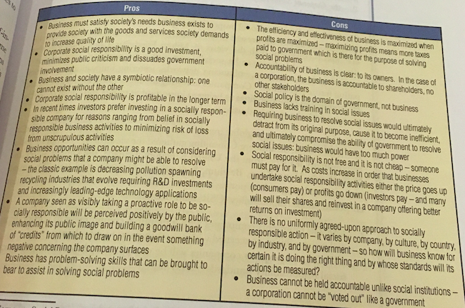

- Up for debate what degree of CSR is appropriate
- Lantos identifies 3 levels
  - Ethical
    - Mantra is “avoid harm to society”
  - Altruistic
    - Companies should give back to society regardless of whether a firm will recognize any gain from doing so
  - Strategic
    - Invests in corporate responsible activities/ventures that are good for both the company and society
- Redman advances three models of CSR
  - The Traditional Conflict model
    - Proposes that “private expenditures on environmental or social objectives represent dollars stolen from either employees or stockholders” and is consistent with the views of Milton Friedman
  - The Corporate Social Responsibility Brings in the Cash model
    - Choose to be responsible for profit-oriented reasons
    - Attracting new consumers, enhancing networks, fostering innovation, and anticipating future legislation
  - The Multiple Firm Goals, All Created Equal model
    - They identify social and environmental responsibilities as being as important as profits and which should be pursued with the same enthusiasm

- CSR Lite
  - Represents companies with a marginal commitment to CSR, concerned with responsiveness to complaints
- CSR Compliant
  - Expects companies will be compliant with prevailing CSR standards but no more
- CSR Strategic
  - Predicts companies will develop business strategies within certain aspects of CSR that can offer a competitive advantage
- CSR Integrated
  - Expects companies will fully integrate c\CSR throughout their business, but will not be by a view to develop a strategic advantage but by a genuine concern of social responsibilities
- Deep CSR
  - Describes examples of companies who will adopt business models whose goal is to improve social conditions

Corporate Social Responsibility Theory
- Another view of CSR proposed by Klonoski
  - Considers 3 theories
    - The amoral view
      - Aka traditional view
      - An activity such as profit maximization lacks a moral quality
      - Neither moral nor immoral
      - Corp is a profit-making entity and not about being socially responsible or not
    - The personal view
      - Proposes corps are like people and can be held accountable for their actions
      - Corps are either moral persons or moral agents
        - If moral persons, corporation can be blamed in the same way a natural person can be
        - If a moral agent, it’s exempt from moral punishments
    - The social view
      - Corps are social institutions with social responsibilities
      - Corp is a social institution because it provides goods/services demanded by society and because society, through its prevailing laws, implicitly sanctions the corporation to operate in that form
- Another view by Archie Carroll
  - Corp must be economically, legally, ethically, and philanthropically responsible to demonstrate CSR
  - In order to be socially responsible, corps should strive to be profitable, not break any laws, proactively embrace the emerging values and norms that society expects, and participate in activities or program to promote human welfare

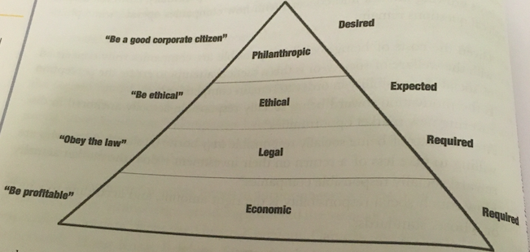

Contemporary Social Responsibility Concepts
Corporate Sustainability
- Occurs when social, environmental, and economic activities are considered in the context of their impact on stakeholders
- 5 levels
  - Compliance-driven
    - Occurs when a corporation meets the requirements of the law, and supports charity to the min level viewed acceptable by society
  - Profit-driven
    - Occurs where a corporation invest in social, ethical, and environmental areas only to the extent that such investment improves the corp’s bottom line
  - Caring
    - Occurs where initiatives exceed min legal requirements and transcend concern for profit with a view to taking a balanced approach to economic, social, and environmental concerns
  - Synergistic
    - Occurs when well-balances and realistic solutions are derives that generate economic, social, and environmental value that results in gains for all stakeholders
  - Holistic
    - Reflects fully integrated corporation sustainability into every corporation activity
- These 5 levels of corporation sustainability, when considered from the perspective of a publicly traded company with shareholders demanding a competitive rate of return on investment, raise some interesting questions:

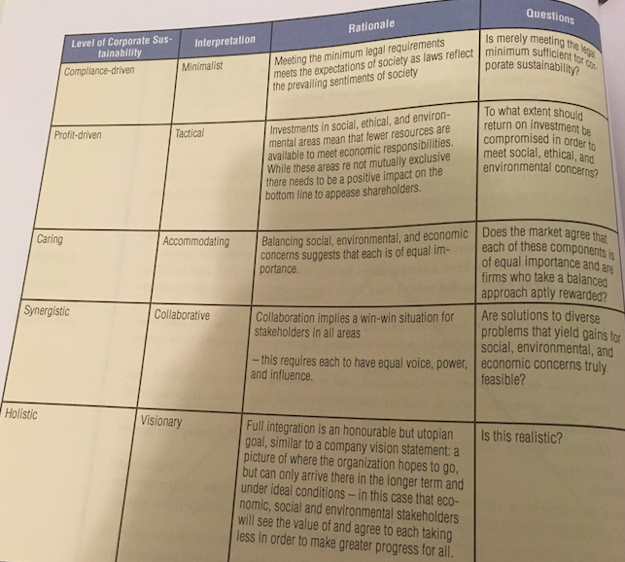

Reputational Management
- Management of a comp’s reputation involves any focused effort to improve the comp name in the eyes of its key stakeholders
  - Can involve both proactive and reactive approaches

Social Impact Management
- Defined by Aspen Institute as “the field of inquiry at the intersection of business needs and wider social concerns that reflects and respects the complex interdependency of the two”
- From a CSR perspective, this view emphasized that society and business can’t exist without each other and that both must recognize that while business influences society, society also influences business, and both must work together to max the returns for each

Triple Bottom Line
- Advocates that performance should be evaluated not only by a corp’s economic success, but also by the value it creates/destroys environmentally and ethically
- Goal is corporation sustainability
- Acknowledges full cost of operations

Community Investment
- Generally concerned with strategic philanthropic efforts in communities affected by operations of the organizations
- One definition is a comp’s long-term strategic involvement in community partnerships to address social issues chosen by the comp to protect corporation interests and enhance reputation
  - The notion that community investment accrues benefits to both comp and community
- Involves giving back to the community
- Regarded as a sound investment that produces measurable returns for the organization
- Top four reasons for organizations to engage in community investment
- To create trust and a positive reputation
- To enhance brand awareness and media attention
- To help with employee retention and motivation
- To nurture strategic relationships

The Natural. Environment and Business
- In any discussion of CSR, natural environment must be considered
- Env issues present serious risks to business
- Key debate has always been productivity vs. pollution
  - Pollution inevitable cost of increases in productivity
- How should environmental protection and environmental responsibility be financed?
  - 1. Govt intervention require to ensure company compliance (standard environmentalism)
  - 2. Market forces will result in companies choosing to protect the env without govt intervention (market environmentalism)

Standard Environmentalism
  - Occurs when govt regulation or intervention is required to remedy the market’s failure to provide sufficient env protection
  - Implies govt intervention or regulation is needed to protect the environment

Market Environmentalism
  - Occurs when economic incentives created by the market are more effective at protecting the env than govt intervention
  - Contrary to standard, it implies there is a sufficient profit incentive, or cost incentives, to protect the environment without govt intervention

Challenges of Corporate Social Responsibility
- Debate on whether businesses are genuinely interested in social responsibility or if it’s an effort to create the perception of social responsibility under the guise of “public relations”
- Questions to contemplate
  - Has governance fully embraced social responsibility, or does it continue to reflect the interests of shareholders as the most important stakeholder?
  - Do markets truly reward socially responsible companies and, in order to reinforce the importance of social responsibility, should the market not recognize more than the financial bottom line – to include, for example, social responsibility, and env responsibility as having equal importance in determining the value of a company?
  - Is there any consensus regarding the meaning of CSR?

Toward a Model of Social Responsibility
- Pava and Krausz propose four characteristics for the ideal social responsibility program that could apply to any program
- The program is informed by a significant degree of local knowledge
- It is designed to deal with problems for which the company is directly responsible
- All stakeholders are informed, invalid, an agree about means and ends
- The program will have a positive effect on the company’s financial bottom line

Chapter 3 – The Government Segment

Introduction
- Def: the system by which a state or community is governed
- Understanding of the govt critical for business success

Government versus Business
Areas of Common Ground
- Both strive to maximize the wealth of their stakeholders
  - Socially responsible and ethical businesses seek a shareholder-stakeholder balance that maximizes wealth of shareholder owners as well as their key stakeholders that include employees, suppliers, and the community
  - Govt seeks to maximize the wealth of its constituents ensuring safety and security, social equality, economic prosperity, and a decent quality of life
- Both strive to implement best practices
  - For business, look for more efficient and effective measures
  - Govt must find the most appropriate use of tax-payer money and strive to support and invest things deemed to be in the best interest of the greatest number of constituents
- Both seek the best and brightest way to populate their ranks and compete with each other for highly trained professionals and new graduates
  - Younger workers: highly mobile, more risk-tolerant, indifferent toward job security
- Both operate in an increasingly transparent enc
  - Actions of govt and business leaders can be exposed on social media
  - Easy for stakeholders to contact govt and business leaders and able to expect timely responses
  - Easier to get info in issues + more difficult for business and govt to bury unpopular outcomes
- CSR
  - Business often not criticized for not doing enough
    - But what is enough?
  - Govt criticized for implementing policies that meet the requirements of some stakeholders and not others
- Both deal with phenomena such as climate change, global warming, energy issues, and globalization and multiculturalism that can further complicate already complicated issues

Differentiation Business and Government
- Stakeholder management
  - From govt perspective: every eligible voter is an involuntary stakeholder
  - From perspective of comp: shareholders typically voluntarily invest in a company in anticipation of a return on their investment and can usually pull their investment at any time if expectations aren’t met
- Society generally expects businesses to fix social problems it has caused, but also expect the govt to fix problems it hasn’t caused, which may not have an obvious, immediate or simple solution
  - Ex. Unemployment, artic sovereignty, aging population, climate change
- Size
  - Federal general govt employed 380,700 individuals in 2006
  - In 2018 the Canadian federal service (excludes RCMP and Canadian Forces) had 273,571
  - Largest private sector employer, RBC, employed 84,000 individuals in 2019
- Sources and uses of money
  - Investors choose which company to invest in
  - Taxpayers have no choice
- Elections

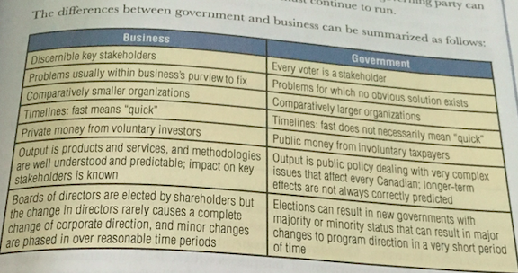

From Whence We Came
- The British North America Act (1867) created the division of powers between the federal parliament and the provinces and the recognition that the federal parliament could assume powers not specified and had the power to act for “peace, order, and good government”

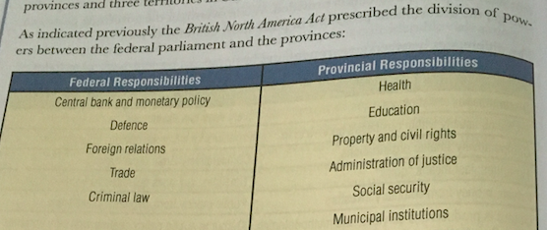

- The Constitution Act of 1982 had the effect of Britain surrendering the power to make laws affecting Canada, including the Constitution
  - Didn’t give Canada a new constitution, but provided important amendments to it, including the Charter of Right and Freedoms and the democratic rights including the right to vote and mobility rights for Canadian citizens

Canadian Government
- Each level of govt have their own area of exclusive power
- Municipal govts have no constitutional standing
  - Municipal govts responsible for
    - Fire protection
    - Garbage collection
    - Local roads
    - Local land use
    - Local recreation
    - Activities that affect parochial regions
- Internal organization and structure pf municipalities are governed by the Ontario municipal Act
- Provincial govts responsible for
  - Direct taxation in the province for provincial purposes
  - Natural resources
  - Prisons (excluding federal penitentiaries)
  - Hospitals (excluding marine hospitals_
  - Health care (excluding Indigenous peoples, Canadian forces, and veterans for whom the federal govt has responsibility)
  - Incorporation of provincial companies
  - Creation of courts and the administration of justice
  - Education
- Federal govt responsible for
  - Taxation
  - Regulation of trade and commerce
  - Public debt and property
  - The post office
  - National defence
  - Patents, copyrights
  - Money and banking
  - Incorporation of Canadian corporations

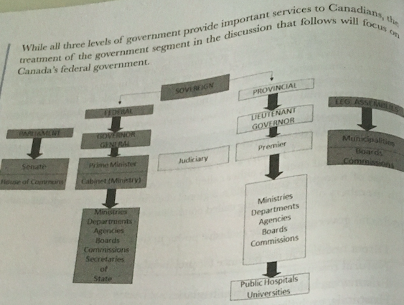

The Westminster Model
- Prescribes a representative and responsible govt of which members are elected by citizens and responsible to Parliament for their actions
- Model was adapted in Canada to recognize two sources of law:
  - Federal parliament
  - Provincial legislatures

- Canada described as a constitutional monarchy, a federation, and a democracy
- Queen Elizabeth II is Canada’s Head of State represented federally by the Governor General and provincially by Lieutenant Governors
- Three branches of the federal govt
  - The legislative branch
    - Consists of the Queen, the House of Commons, and the Senate
  - The executive branch
    - Consists of the PM, Cabinet, and the Public Service
  - Judicial branch
    - Costs of the court system

The Legislative Branches
House of Commons
  - 338 seats held by members elected by their constituents
  - General election held at least every 5 years at the call of the PM
  - May 2007, Parliament passed a law requiring the establishment of fixed dates for federal general elections
    - Third Monday in October in the fourth calendar year following the previous general election
  - # of seats generally based on population (can be affected by redistricting)

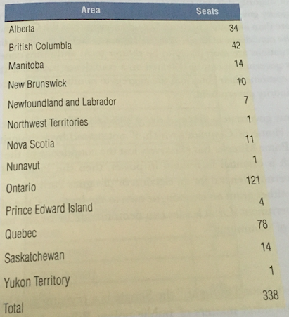

  - MPs participate in debates, bring forth concerns of their constituents in matters of public policy, undertake committee work, participate in caucus meetings, and maintain both a parliamentary and constituency office

  - Majority govt occurs when a political party holds more than half of the available seats in the HoC
  - House approves legislation on the basis of majority vote, not consensus
  - In instances where a party receives less than half the seats, but more than any other party and can demonstrate to the Governor General that is has the confidence of the HoC, the party leads the govt
    - Such situations more likely to be shorter term and more conciliatory since a minority govt can be defeated on a confidence motion if other parties agree to combine their votes and the aggregate number of votes exceeds the votes of the minority govt
  - If a minority govt falls on a vote of confidence (a vote on a piece of legislation which, if not passed by a majority of Members, means the PM has effectively lose the confidence of the HoC, which is essential to stay in power, then the PM typically asks the Governor General for an election or pirogues Parliament)
    - GG can either grant an election or turn to the leader of the opposition to form a govt if that leader can demonstrate they have the confidence of the HoC
The Senate
  - A place of “sober second thought”
  - the revising and investigatory body for legislation and other matters of public policy
  - Bills or legislation tabled in the HoC pass through the Senate and Senate Committees for discussion, amendment, and recommendation before receiving Royal Asset in the HoC
  - Senators are appointed by the Governor General on the recommendation of the PM
    - Key Criteria:
      - At least 30 years old
      - Must have real estate worth $4,000 net
      - Total net assets of at least $4,000
      - Must reside in the province/territory where they’re appointed
  - Hold office until age 75 unless they miss two consecutive sessions of Parliament
  - PM Trudeau began the process of appointing Senators through an independent panel and removed existing “Liberal” Senators from the Government Caucus

Breakdown of 105 seats in Senate
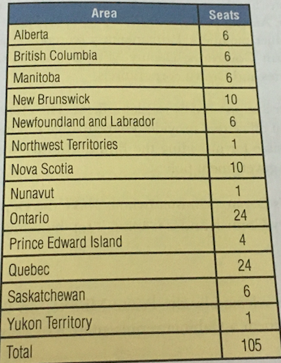
  - Several of the formerly Liberal independent senators created the Independent Senate Group (ISG), which is now recognized by the Senate rules as something with the same rights as a political party
    - Distribution of senators by political affiliation

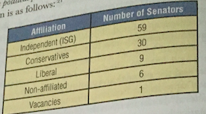

The Executive Branch
The Prime Minister
  - Has the strongest policy voice, immense responsibility, and power
  - Responsibilities include appointment of Senators, Cabinet members, Parliamentary secretaries, judges, the Governor General, Lieutenant Governors, Deputy Ministers, ambassadors, and head of govt agencies and Crown corporations

  - Supported by two key offices
    - The Prime Minister’s Office (PMO) is the political office that provides political advice
    - The Privy Council Office (PCO) is responsible for providing the PM with advice concerning the coordination of government policy
  - The PM’s Deputy Minister (NOT the Deputy PM) is the Clerk of the Privy Council and is Canada’s top bureaucrat

Cabinet
  - Cabinet Ministers are selected by the PM on the basis of experience as well as the need to form a Cabinet representative of Canada’s geographic and ethnic diversity

  - Cabinet Ministers have responsibility for a department and are accountable to the people of Canada through the HoC for all the actions of the department
  - Currently 35 Ministers, including the PM

The Federal Public Service
  - Consists of approximately 259 orgs including departments, agencies, Crown corporations, and other organization for which departments and agencies are responsible
  - Public servants bring tangibility to public policy outcomes by designing and managing programs to serve the public and to meet their needs
  - Crown corporations are established and run by the govt that have no competitors and receive govt funding or that operate competitively and receive no govt funding
    - Ex. Bank of Canada, the Canadian Broadcasting Corporation, Canada Post, the Royal Canadian Mint
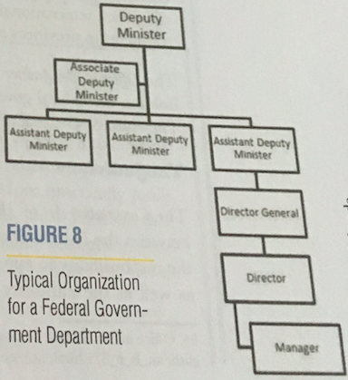

Some Key Central Federal Government Offices
  - Some of these offices include:
    - The Privy Council Office
      - Supports development of the govt’s policy agenda and the effective operation of Cabinet
    - Treasury Board of Canada Secretariat
      - Supports the Treasury Board by providing support to Ministers int their role of ensuring prudent financial management and value-for-money
    - Finance Canada
      - Responsible for providing advice and analysis to the govt on the economic, fiscal, and tax implications of its policies
    - Office of the Auditor General
      - Independent office responsible for holding the federal govt accountable for its stewardship of public funds

The Judiciary

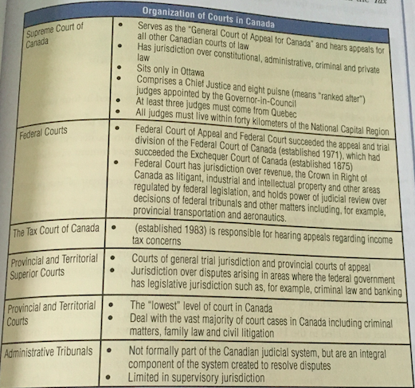

Public Policy and the Legislative Process
- Public policy def: Whatever governments choose to do or not to do
- Public policy is the govt’s response to a social problem that affects a significant number of Canadians

- Public policy can be categorized in four ways:
- Distributive
  - Benefits are solicited by and award to specific groups, but the costs are distributed equally by general population (tariffs and subsidies)
- Regularity
  - Behaviour is modified throughout govt sanction (environmental controls)
- Redistributive
  - Wealth is transferred from one segment of the population to another (income tax)
- Constituent
  - Benefits and costs are widely dispersed (monetary and fiscal policy)

Legislative Process (aka government bills)

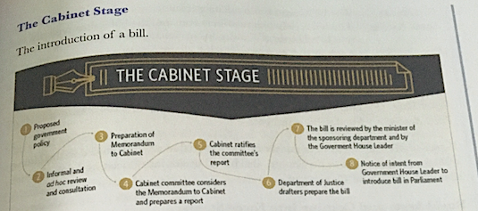

- Main purpose is to review and decide which measures the govt wants to implement through legislation

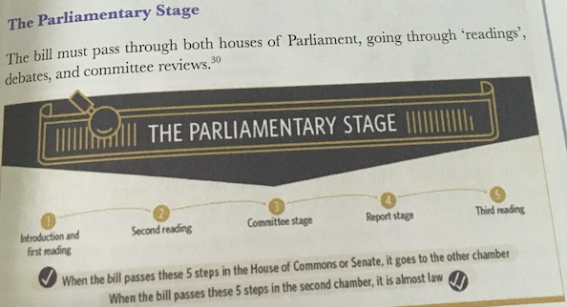

First Reading
  - Bill is read but not debate ensues
Second Reading
  - Bill is debated, members vote, and it’s then typically sent to a HoC of Senate committee
Committee Stage
  - Analysis that examines the bill, consults with interested stakeholder experts and witnesses, and produces a report that either recommends approval as submitted, amendments, or that it not proceed further
Report Stage
  - Debate on further amendments
Third Reading
  - Final debate and vote

Royal Assent and Coming into Force Stages
- Royal Assent: Bill receives Royal Assent once passed by both chambers
- The bill becomes a law
  - Can occur when it receives royal assent, on a day specified in the bill, or on a day set by the Governor General

Parliamentary Committees
- Usual outcome at the second reading is referral to a govt committee
- Types of committees:
  - Standing Committees
    - Permanent committees established by standing orders of the HoC, focused on an area of govt policy, and reporting to the HoC
    - Ex. Public Accounts Committee
  - Subcommittees
    - Report to the main committee, but not to the HoC
  - Legislative Committees
    - Examine specific govt bulls after they have passed second reading
  - Special Committees
    - Temporary committees focused on specific issues
  - Joint Committees
    - Compose of members from the HoC and the Senate
  - Committees of the Whole
    - Composed of all member of the HoC or the Senate

Other Commonwealth Governments
- Model in the context of the Australian policy experience that suggests eight steps occurring in a cycle

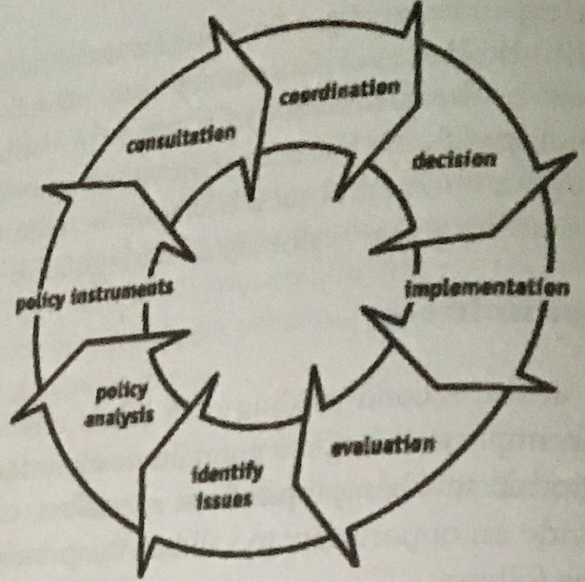

Provincial Government
- Responsible for matters such as education, health care, and the police
- Ontario govt looks after:
  - Business and vehicle registration
  - Courts
  - Health reports and organ donation registration
  - Property and land registration
  - Education and training
  - Employment standards, including workplace safety and insurance
  - Retail sales tax
  - Identification and certification records
  - Outdoor services, including provincial parks

Municipal Governments
- Encourages policy innovation, matches policies with citizen preferences, and works closely with citizens’ groups
- Head of local municipal council either called the mayor or the reeve
- Members of council are called councillors or aldermen
  - Can be elected at-large of by ward
    - If elect at-large, councillors represent the entire municipality in which candidates with the largest number of votes in a municipal elect are elect to the council
    - Each ward may have more than on representative on council

The Government versus Business Paradigm
- Businesses are motivated by profit while the govt is motivated by providing the most for the greatest number
- Businesses seek economic efficiency while he govt seeks political efficiency
- Possible to differentiate govt from business along three key lines:
  - The political process
    - Govt elections are held every 4/5 years
      - Businesses don’t have elections within the same time constraints
    - Govt must treat members of the public consistently in its delivery of government programs
      - Businesses have no such obligations except to target markets necessary to sustain a competitive advantage
  - The nature of government activity
    - For business, its goals are typically well-defined and tis activities are congruent with its objectives
    - For govt, they have a large variety of goals and the lack of any clear distinction between means and ends
    - Business can relate its activities to a return on the bottom line while the govt is unable to do so
    - Business typically partakes in areas it knows well and where a sustainable competitive advantage can be developed
  - The Institutional Context of Government
    - In this area, three key characteristics
- Activities of govt are increasingly transparent and its activities are subject to public review by an enormous range of stakeholders
- Every voter is a stakeholder
  - in politics, every vote matters and it’s difficult for the govt to take interest of every stakeholder into account
  - in business, they can just focus on key stakeholders
- govt as an institution is more complex than even the largest business enterprise
  - no other organization in Canada that comes close to the federal govt’s 200,000 employees or its geographic distribution of those employee
    - aka the fourth key characteristic
  - demands of stakeholders, the broad effect of policy decision, and the time necessary to implement legislation all combine to produce a system that necessarily operated by design more deliberately than business

Key Challenges for the Federal Government
Decline in Voter Participation
- 40% of eligible voters didn’t vote on May 2, 2011
- In 1958, voter turnout was almost 79.4%, and has steadily declined since
- Lowest point in October 2008 with a 58.8% voter turnout

Implications for Business
  - In business’ best interests to ensure as many voters vote as possible
    - Particularly like-minded key stakeholders (ex. Employees, key suppliers)
  - A low number of voters may not truly represent the true sentiments of a community or business environment

Expectations for greater efficiency, cost-effectiveness, and accountability
- Common for federal govt to receive criticism for improper spending of resources
- The Federal Accountability Act represents an attempt to dispel the perception of the growing mistrust that exists between the public and the govt by:
  - Instituting a number of reforms including:
  - The financing of political partiers
  - Toughening the Lobbyists Registration Act
  - Cleaning up the procurement of govt contracts
  - Providing protection for whistle-blowers
  - Strengthening the power of the Auditor General
  - Auditing and accountability within departments

Implications for Business
  - Greater accountability means a more effective use of corporate tax dollars which could possibly lead to tax reduction
  - Increasing accountability will result in additional systems of check and balance and there will be a cost to implementation
  - As more systems and rules emerge, bureaucrats will spend more time ‘feeding the beast’ and this will slow the business of the govt

- Scandals on page 90

The horizontal management of issues that cross departmental borders
- Many issues in govt involve more than one department

Effective stewardship of the public purse
  - In order to ensure accountability from a program perspective, each federal department must manage program results and report them to the public
  - Policy on Results
    - put into effect in 2016 to provide the federal govt and its departments a means to manage financial and non-financially info related to programs and corporate services
  - The Head of Evaluation is a neutral function, reporting directly to the Deputy Head
    - A five-year rolling Evaluation Plan is updated and presented annually to ensure that programs and performance is properly monitored and reported

Planning and reporting
  - involves the integration of many components, including:
    - an environmental scan
      - what’s happening in the macro-environment that could impact govt department’s ability to achieve its strategic outcomes
    - senior management strategic and program priorities
    - risk profile
    - human resources planning
    - Business planning
    - Capital planning
    - Resource allocation

  - Departmental Plans are part of the Estimates documents which support the appropriation of funds to be spent by the govt
    - Estimates document has three parts:
- Part I provides overview of federal spending
- Part II lists the financial resources required by individual departments, agencies, and Crown corporations for upcoming fiscal year
- Part III consists of the Departmental Plan and the Departmental Results Report
  - The Departmental Plan describes the strategic outcomes, programs, expected results, and resource requirements for a 3 period
    - *** doesn’t say whether it’s three months or three years; it just said “three period”
  - The Departmental Results Report are the accounts of actual performance for most recent fiscal years against the plans, priorities, and expected results set out in the Departmental Plan
  - Financial info in the Departmental Plan is drawn from the Main Estimates, which represent the approved budgetary expenditures for the upcoming fiscal year
    - The Main Estimates comprise the documents used by the govt to estimate what it will cost to run the govt for the fiscal year
  - The Policy on Results aligns the performance info in the Departmental Plan, with the Estimates documents and the public Accounts of Canada

Performance measurement
  - For business, performance is relatively easy to measure and report to key stakeholders
    - Because primary performance indicators are financial ones such as profit and rate of return on investment

  - More difficult for govt public sector to measure because performance measures for govt organizations tend to be non-financial (ex. Sustainable fishers, reliable roadways, safe food supply)
  - Efficiency and staying within budget are important for meeting stewardship obligations, but the goals an objective of government are much more diverse and the definition of success is more complex

Risk Management
  - It’s the process of seeking to be prepared for serious eventualities that can affect the achievement of goals and objectives
  - More difficult for govt than business
    - Due to the difficulties that can be encountered in government into developing useful performance indicators to track progress against objectives

Becoming more citizen-centric, engaged, and accessible to the public
- e-government has become popular
  - Use of electronic communication tools to engage citizens, business, and civil society stakeholders
- When expectation are manages, technology does offer considerable capacity for greater citizen engagement, although not without certain challenges
  - Four challenged associated with effective e-government:
    - Service
      - Challenges include the ability to act effectively and reliably with Canadians
    - Security
      - Concerns may compromise a philosophy of efficient customer service
    - Transparency
    - Trust

Implications for Business
    - Greater citizen engagement by govt has a number of implications for business
      - Access to politician and govt decision-makers is no longer the cloistered domain of business
    - Greater need on the part of business for increased transparency and stakeholder engagement since business stakeholders can more easily whistle-blow
    - Less face-to-face exchanges with business
    - Can present opportunities for business to work with govt to innovate solutions to the communications challenges associated with a more citizen-centric govt

Issues Facing Government
The Economy
- 2008 Financial Crisis
  - Global meltdown of the financial markets resulted in unprecedented actions of national govts to stem the wave of uncertainty and risk
    - In some cases by nationalizing banks and in other cases providing unprecedented injections of taxpayers’ money as guarantees against shaky bank debt instruments
      - Resulted in bankruptcies of otherwise stable financial institutions and the evaporation of retirement finds for countless Canadians
      - Also caused a meltdown in the automotive and manufacturing sectors

Infrastructure
- Increasing population and economic growth were combining to tax Canada’s infrastructure
  - Ex. Useful life of roads and highways

National Security
- 9/11
  - April 2006 – National Security Policy was released

Free Trade between Canada’s Provinces
- Recognizing internal trade barrier detrimental to development
- In 1994, the Agreement on Internal Trade (AIT) was signed by all provinces/territories
  - Goal of agreement was to eliminate barriers to trade and investments in Canada and to establish an open, efficient, and stable domestic market

Issues Facing Government in 2019
- Social issues including abortions, gay marriage, LGBTQ adoption right, gender workplace diversity, women in combat, euthanasia, the death penalty, and the wearing of the Niqàb
- Environmental issues including renewable energy, pipelines, fracking, plastic product bans, animal testing, GMOs
- Domestic policies relating to gun control, funding of native projects, social media regulations
- Immigration, deportation of criminal immigrants, immigration bans, skilled immigrants, citizenship testing
- Healthcare, marijuana, prescriptions
- Foreign policy issues including military spending, mandatory military service, foreign aid funding
  - Canada’s relations with the UN, Syria, North Korea, Iraq, Israel, and the political climate of the US all impact us as Canadians
- The economy
  - Govt must continually be aware of concerns in regards to taxes, wages, free trade, spending, tariffs, jobs, and pensions
- Electoral issues regarding reform, voters’ rights, campaign financing
- Crime
  - Prison overcrowding, parole hearings, private prisons, and drug trafficking penalties
- Education
  - University tuition, should education be a provincial or federal responsibility, etc. are becoming more volatile
- Transportation issues
  - Public transit, including the light rail, and the use of drones for commercial purposes all have implications for the way in which govt and business influence each other

Chapter 4 – The Canadian Civil Society Segment

Civil Society in the News
Canada’s new food policy aims to improve enforcement
- $134mil budget for the Food Policy for Canada will come from 2019 budget
- Additional funding for the Canadian Food Inspection Agency intended to support the enforcement of the compliance of labelling and other requirements by food companies
- Aim is to protect consumers from deception and to protect companies from unfair competition
- Agri-food is an important business for Canadians
  - Has the potential to be world leader in this area

Introduction
- Discusses the 3rd segment off the Canadian macro-environment - civil society
  - arguable the least intuitive and the most misunderstood of the three segments

What Exactly is Civil Society?
- Could be considered as any organization that are independent of business and govt and can’t be classified as part of the business or govt segments

