GNG 1103 – Engineering Design
Faculty of Engineering – University of Ottawa
Final Design Report

Sift It Out, Bowl-ie
Group A3

Shuyang Zheng
James Rhydderch
Junqi Ren
Mohamed Eldaba

December 2, 2018

Abstract

Bowie, an environmentally-friendly beach-cleaning robot, recently needed upgrades to help improve its performance on collecting debris on beaches. There were several problems it had encountered during earlier tests. One problem related to sand-garbage separation. A new design was required to help reduce the amount of sand that would be collected into the robot’s hopper. We tried to solve this problem by developing a rotatable basket, which would utilize centrifugal force to achieve the function, to replace the current hopper, using 3D printed plastic materials. We also applied an Arduino board and a remote controller to achieve remote control ability.

Table of Contents

List of Figures 5
List of Tables 6
1. Introduction 7
2. Empathize 8
2.1 Background 8
2.1.1 Client Information 8
2.1.2 Major Focus Areas 8
2.1.3 Need Interpretation 8
3. Define 9
3.1 Problem Statement 9
3.1.1 Problem Statement Justifications 9
3.2 Design Criteria 10
3.3 Target Specifications 11
4. Ideate 11
4.1 Conceptual Design 12
4.1.1 Subsystem - The Arm 12
4.1.2 Subsystem - The Hopper 13
4.1.3 Global Designs 14
4.1.4 Comparison 17
4.1.5 Final Decision 18
4.2 Benchmarking 18
4.2.1 Comparing Different Concepts 19
5. Prototypes 20
5.1 Prototype I 20
5.1.1 Purpose 20
5.1.2 Test Plan 20
5.1.3 Results 21
5.2 Prototype II 21
5.2.1 Purpose 21
5.2.2 Test Plan 21
5.2.3 Results 22
5.3 Prototype III 22
5.3.1 Purpose 23
5.3.2 Test Plan 23
5.3.3 Developing Progress 24
5.3.4 Results 25
6. Conclusions and Recommendations for Future Work 27

List of Figures

Figure 1 ······································································································ 12
Figure 2 ······································································································ 12
Figure 3 ······································································································ 13
Figure 4 ······································································································ 13
Figure 5 ······································································································ 14
Figure 6 ······································································································ 14
Figure 7 ······································································································ 15
Figure 8 ······································································································ 15
Figure 9 ······································································································ 15
Figure 10 ····································································································· 16
Figure 11 ····································································································· 17
Figure 12 ····································································································· 19
Figure 13 ····································································································· 19
Figure 14 ····································································································· 19
Figure 15 ····································································································· 22
Figure 16 ····································································································· 23
Figure 17 ····································································································· 26
Figure 18 ····································································································· 27

List of Tables

Table 1 ······································································································· 8
Table 2 ······································································································· 10
Table 3 ······································································································· 10
Table 4 ······································································································· 18
Table 5 ······································································································· 20

1. Introduction

In the beginning of this term, we met our client, Erin. She was from Robot Missions, a company aiming at creating low-cost robotics for environmental applications. We were asked to build attachable components and mechanisms to improve the performance of their robots. At that time, they were focusing on one of their environmental robots, Bowie, whose main function is to collect debris from beaches. Erin stated several problems they were facing, and she emphasized one of them -- Bowie was unable to remove the sand it collects. We decided to work on this particular problem and started to generate our design through the “Design Thinking” method, which includes five phases: empathize, define, ideate, prototype and test.

The concept of our design is a rotatable basket which utilizes centrifugal force to sift out sand: when the basket starts spinning, both sand and debris will move towards the walls due to the movement tendency of objects in circular motion; the debris will be held back by the walls, whereas the sand will leak through the holes. Therefore, the function of sifting out sand is achieved. Besides, Erin has told us that Bowie is an excellent educational tool that engages children in the scientific and environmental fields, so we chose to build a rotational structure considering that its visual effect could grab children’s attention.

In this report, we will display the progression of our design step by step following the principles of “Design Thinking”.

2. Empathize

2.1 Background

2.1.1 Client Information
Robot Missions is a company that aims at creating low-cost robotics for environmental applications, including observation, cleanup, and restoration. They have done municipals trials in summer 2018 to reduce the amount of litter and pollution on the beach. They need help to build attachable components and mechanisms to improve the performance of their robots.
Bowie is the robot designed by Robot Missions that is used to obserserve, cleanup, and restore environment at recreational beaches. It has being on duty since Summer 2018 and has succeed to reduce the amount of trash and pollution on Sunnyside beach at Toronto and Waterboro beach at Ottawa.
Erin was the actual person we met during our client meeting, who stated the problems they were facing and the end goals for our project.

2.1.2 Major Focus Areas
The key focus areas this semester could cover:
1) Continuous intake of soft sand
– As a faster alternative to scooping debris, take all the sand and filter through it
2) Secure storage
– As an automated location Bowie can dock and recharge at when deployed in the
field
3) Wildlife monitoring and remote surveillance
– With a camera pivot mount and software
4) Open ideas for mitigating an environmental challenge your group is passionate about

2.1.3 Need Interpretation

Priority  (Low) 1 to 5 (High) | Customer Statement | Interpreted Need
5  (main objective) | Continuous intake of sand | The component can filter out sand that is being collected during the operation of the robot.
4  (major characteristic) | Low-cost | The component uses cheap materials and is easy to manufacture.
4 | Low-risk | The component is safe to use in the nature, producing no pollution.
3 | Lightweight and portable | The component is lightweight and can be attached on or taken off the robot.
2 | Operate quietly | The component produce little noise during its operation.
3 | Use rechargeable batteries | The component has a low power cost.
3 | Operate autonomously | The component can work autonomously, controlled by the robot.
2 | Engage children | The component looks attractive and interesting.
Table 1 Need Interpretation and Prioritizing

From Erin, we gathered plenty of raw data relating to the requirements of improving Bowie’s performance on collecting debris. However, because our client was from an engineering background, her statements were very clear and precise, so that they could be regarded directly as the needs we could put in the table without additional interpretations.

3. Define

3.1 Problem Statement

Based on the interpreted customer needs, we derived our problem statement:
Our client wants an attachable component for Bowie that helps the robot reduce the sand while it’s collecting debris. The component operates quietly and autonomously and is low-cost, environmentally friendly, lightweight, energy saving and easy to use/control.

3.1.1 Problem Statement Justifications
- An attachable feature was needed because we were modifying the robot itself to obtain a better performance rather than building a separate structure, such as an storage, to support it externally. The robot was an assembling of multiple subsystems that could be modified or replaced. Because of this, the idea of a new attachable feature was able to be realized. In the meanwhile, the feature was thus required to be, at least partly, attachable to the robot, so that it worked as a whole system.
- To reduce the sand was the main objective of our concern. It justified itself since it was the ultimate goal.
- Operating quietly and autonomously was required by our client. Operating quietly means the robot won’t disturb the public while it is on its duty to clean the beach. Operating autonomously can reduce the complexity of using the feature.
- Low-cost is a feature that characterizes Robot Missions’ robotics.
- Bowie is an environmentally friendly robot. Therefore our product should do no harm to nature as well.
- Bowie is made of light materials, to maintain the consistency and not to impair its balance, the new part should be light as well. In addition, a lightweight component is easier to carry.
- As for energy saving, during operation time, Bowie relies on its rechargeable battery, so the new part shouldn’t consume too much power. Otherwise the duration time for Bowie to work will be decreased.
- Because our users can be people from public, including children, the feature should be easy to use and control.

3.2 Design Criteria

According to the interpreted needs of the client and the problem statement, we listed the design criteria that should be taken into account in our design process.
NO. | Need | Design Criteria
1 | The component can filter out sand that is being collected during the operation of the robot. | Ability to separate sand and debris  Sand remaining (%)
2 | The component enhances the storage of debris | Portion of debris (%)
3 | The component has a low power cost. | Maximum operation time (h)
4 | Low cost | Low cost ($)
5 | The component produce little noise during its operation. | Low noise (dB)
6 | The component can work autonomously, controlled by the robot. | The features of control systems  (Yes or No)
7 | The robot inspires children | Appealing, interesting, engaging  (Yes or No)
Tabel 2 Translating Needs to Design Criteria

3.3 Target Specifications

NO. | Need | Target Specifications
1 | The component can filter out sand that is being collected during the operation of the robot. | Effective (minimum residual sand < 20% of the total space in the hopper)
2 | The component enhances the storage of debris | Capability of storage (maximum residual debris >80% of the total space in the hopper)
3 | The component has a low power cost. | Maximum operation time (> 1h)
4 | Low cost | Low cost (< $100)
5 | The component produce little noise during its operation. | Low noise (< 40dB)
6 | The component can work autonomously, controlled by the robot. | Control systems (Yes)
7 | The robot inspires children | Appealing, interesting, engaging (Yes)
Table 3 Translating Needs to Target Specifications

4. Ideate

After empathizing with our client’s needs and defining the problem, we came to the stage of ideation. In “Design Thinking”, there are four methods we can apply to generate our ideas: Sketch, Brainstorm, block diagram, and further benchmarking. In this section, we will display the early concepts that we created in the beginning, and then the three global designs that were derived from multiple ideas.

4.1 Conceptual Design

These are the very early concepts that came into our minds. Ideation is a divergent process, following the principle of “quantity over quality”. In this early stage, we used brainstorming to generate the concepts and then used sketches to depict them within the group.

4.1.1 Subsystem - The Arm
When first generating our ideas, we thought of different applications that we could do concerning different parts that we could focus on.

1) Concept 1
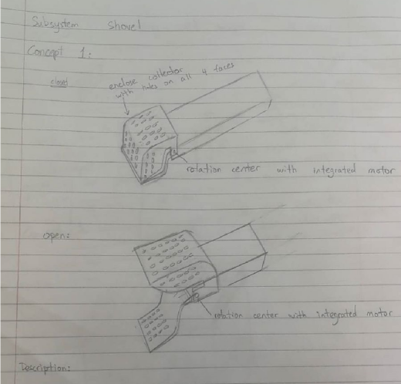
Figure 1 Arm Concept One
This concept attempts to reduce the sand collected by creating a collector with closable claws. Each claw have holes on all phases. Upper claw will be opened, using its integrated motor in rotation center, while collecting debris, and closed afterward. While transporting debris to the hopper, Bowie may shake the collector up and down multiple times to shake away the sands, the enclosed collector in this case will ensure the garbage are kept inside the collector while shaking.
At the end, less sand will be collected and leave more space to garbage in storage.

2) Concept 2
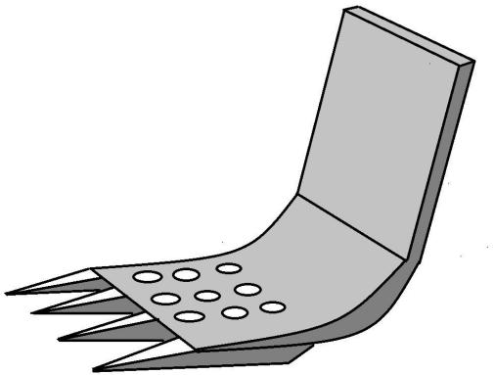
Figure 2 Arm Concept Two
This idea is taken from shovel on excavator. In case the sand is moist, the pikes will allows the shovel to dig through the sand easily and prevent to pick up large pile moist sand.

3) Concept 3
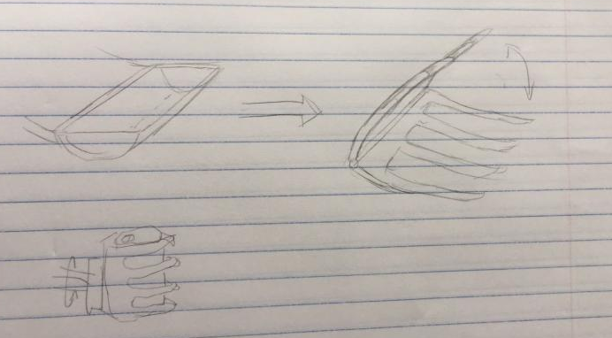
Figure 3 Arm Concept Three
i) Replace the shovel with two pedals of claws.
ii) The claws grabs an object and can rotate at the end of the arm.
iii) In this way, the robot collects less sand.

4.1.2 Subsystem - The Hopper
1) Concept 1
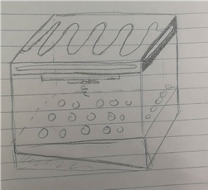
Figure 4 Hopper Concept One
i) the heater layer with an electrical heater
ii) Air hole allow intake of air.
iii) fan
iv) the filter surface
v) An inclined surface which will guide the sand backward.

2) Concept 2
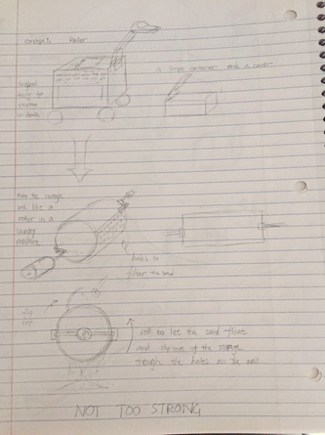
i) The original hopper on Bowie is merely a box with a lid.

ii) Make the hopper into a cylinder with a shaft, so that it can rotate regularly.

iii) With holes on its wall, the cylinder enables the sand inside it to flow around and fall out by conducting continuous rotation.

Figure 5 Hopper Concept Two
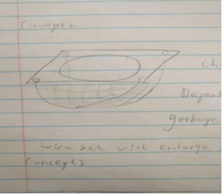
3) Concept 3
By utilizing the stretch property of the nylon material, we can build a basket like this one. when heavy, large garbage is poured into the nylon wire net, the nylon wire net will extend due to the weight of the garbage. Therefore sand will flow through the meshes. Besides, nylon is a light material. It contributes to reducing the weight of the robot.

Figure 6 Hopper Concept Three

4.1.3 Global Designs
After the process of brainstorming and sketching, we had gain a bunch of creative ideas. Next step was to compare them with each other and to choose, or to merge the ideas to create, the top 3 concepts.

- Concept 1
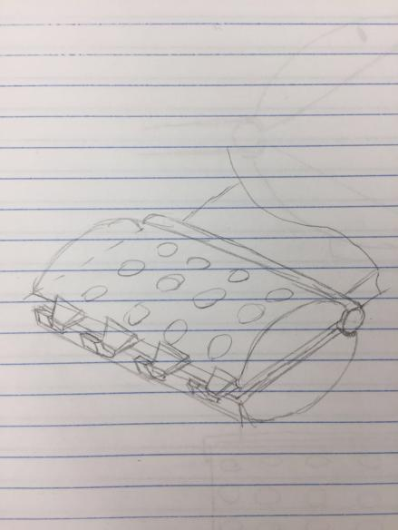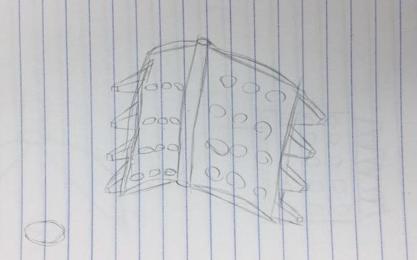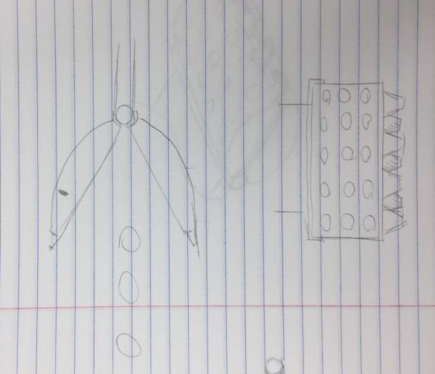
Figures 7, 8, 9 Global Design One
General Description:
The jaw has two pedals. Each pedal has teeth in the front and holes on the body.
Having teeth is to make it easier to insert into the sand.
Holes are for the leakage of the sand after collecting the litter.
Steps of collecting:
i) At the beginning, the jaw is open. The lower part works as a shovel when starting to collect the debris.
ii) After it has captured the object, the jaw closes and lifts a little bit.
iii) The jaw shakes up and down depending on a rotatable joint to get rid of the sand.
iv) The arm lifts higher and backwards to be over the storage.
v) The lid opens.
vi) The jaw opens to let the litter drop into the container, the move back down.

- Concept 2
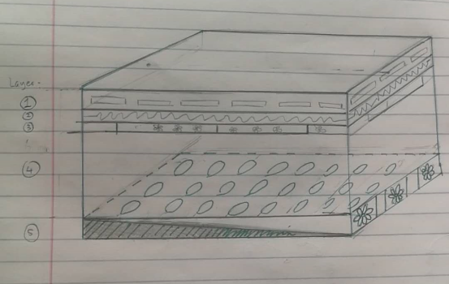
Figure 10 Global Design Two
General Description:
The idea has been taken from Mohamed and Yan. The concept of this design is to give the storage the ability to ‘self-clean’, which mean the storage is installed with sand filter and has certain means to make sand (by either compressing or blowing) move away.
Layers:
i) Air holes: Taken from Yans design. Used to allow maximum air flow into the storage area
ii) Heating pad: Taken from Yans design for the storage subsystem. To dry wet sand making it easier for them to be broken down and blown away
iii) Fans: Intake fans to blow cool air in are from Yans design.
iv) Garbage storage with perforated bottom to release sand
v) Ramp and exhaust fans to aid in the sand being removed from the garbage storage
Note: Layer 1, 2, 3 is integrated inside the lid of the storage, the actual storing dimension is determined by layer 4 and 5.

- Concept 3
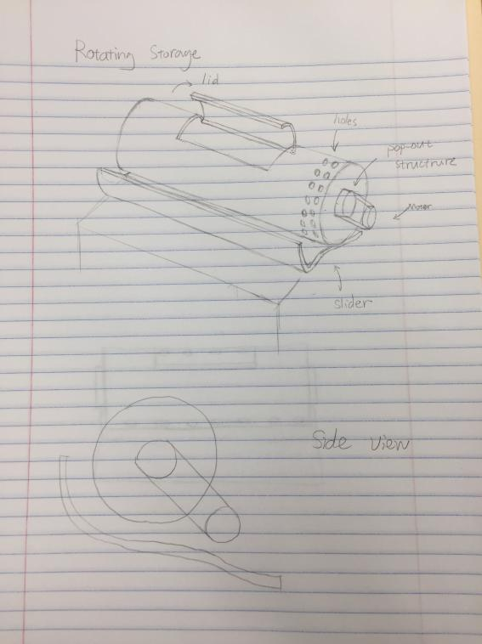
Figure 11 Global Design Three
General description:
The storage box consists three parts. One part is a rotatable cylinder box and the other two parts are a small motor and a slide. The container and the motor are connected with a belt, which transmits the motion. There are holes on the wall of the cylinder, letting the sand fall out. And we also put a slide beneath the cylinder to guide the sand to flow outside Bowie without disturbing the circuits.
Working process:
i) When Bowie are not processing the collecting sequence, the cylinder box rotates regularly allowing the sand to flow around so that it can be separated from the garbage.
ii) During the process of collecting litter, the roller stops at a certain position where the lid is on top of it. Then the lid opens to let the garbage fall in. After the storage has received the garbage, the lid closes, and Bowie continues to search for other debris.

4.1.4 Comparison

 | General | Global Design 1 (The Jaw) | Global Design 2 (The heater and fan) | Global Design 3 (The Roller)
1 | Reduce proportion of sand in storage | yes | yes | yes
2 | Storage size compared to original design (higher the  better) | No change | Approximately larger | Approximately same
3 | No significant impact to bowie's overall design | Yes | No (Adding heater and  fan)  (increasing power consumption) | No (Adding a motor, belts)  ( extra weight, extra structure)
4 | Energy consumption (Lower the better)
5 | Weight (Lighter the better) | less than 0.5kg added | less than 1 kg added | adding approximately 1kg
6 | Cost (Lower the better) | $~3 for the Jaw  (Price on market for PLA is $~0.05/g, and a pedal weights ~60g) | less than 50$ | about 40$
7 | user friendly toward non-engineers | Adding an extra movement (close and open the jaw) | no impact (self control) | no impact (The  roller rotates on its own)
8 | Attractive aesthetics | no much impact | no impact | looks more vibrant
Table 4 Comparison Among Global Designs
Legend:
best-1
2
3
worst-4

4.1.5 Final Decision
Due to lacking some of the exact statistics, we referred to our experience on a few points.
- All of the global designs are able to achieve our ultimate goal -- to reduce sand in the storage of Bowie (the reason for choosing them). And they’re cool, too.
- We do not intend to change the storage size in each design, however a few of them will require a slight change.
- For GD1, it is not likely to change the whole structure of Bowie, for only the arm is concerned. However both GD2 and GD3 have a significant change on its storage, with GD applying additional exterior structures.
- For energy consumption, GD1 simply added a joint for the jaw to open and close. GD2 requires energy for hearing and functioning the fans. GD3 requires constant energy consumption to rotate the roller.
- GD1 is most likely to add the lightest weight to Bowie.
- GD1 costs the least among the three designs.
- GD1 is adding an additional operation due to the movement of the jaw, while others are design to function automatically.
- Aesthetic, there is no significant impact toward aesthetic for all 3 Global Designs

After analysing the concepts by ourselves, we went to Erin for feedbacks on these ideas. What she commented upon these concepts helped us make the final decision.
- For global design 1: Erin said the jaw structure would require a great deal of extra operations from the control unit of the arm system, which might cause a dysfunction. Thus it was turned down.
- For global design 2: It was unrealistic to install so many energy consuming components onto a robot which relies on a rechargeable battery. So it was a ‘no’.
- For global design 3: Erin was interested in the concept of a rotating structure and approved of it. She also mentioned some additional potential ways for the structure to work. Therefore we decided to work under this direction.
However our work was not going smoothly during the entire project. Later we made a few significant changes in the initial design. This part will be covered in the following text.

4.2 Benchmarking

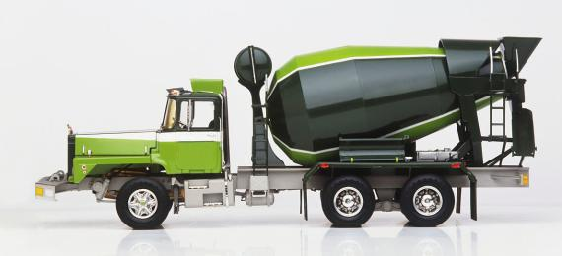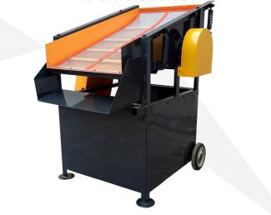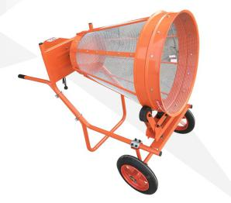

Figure 12 Cement Mixer Figure 13, 14 Sand Sifters

4.2.1 Comparing Different Concepts
During benchmarking, we mainly found two types of sand sifters. They used either vibration or rotation to trigger movement of sand and sifted it out through a net structure. The two designs both seemed to function well and did not have major deficiencies. We chose to stay on our very first path to make a sifter based on rotational motion. Also we considered the visual effect between these two types of sifters, and we thought the rotational one would have a stronger influence on the publics.
 | Vibrational Sand Sifter | Rotational Sand Sifter
Mechanism | Vibration | Rotation
Efficiency | High | High
General Cost | $200 | $180
Stability | Slight movement | Center of gravity slightly sways
Level of Noise | Medium | Low
Power Consumption | 3 kw | 1.8 kw
Control System | Yes | Yes
Ease of Use | Yes | Yes
Aesthetics | Normal | Looks more interesting
Table 5 Comparing Different Concepts

5. Prototypes

After benchmarking in the ideation process, we tried to follow the concept that were generated about a rotational sand sifter. Also, we followed the principles of prototyping and developed our prototype I, II, and III.

5.1 Prototype I

The first prototype was intended to show the basic structure of a rotating storage for Bowie, replacing its original one, in order to filter the sand being collected in the storage and give more space to actual debris. To build the first prototype, we used some thrown-away 3d printing parts, 2 pieces of abrasive iron nets and iron rods, with glues for fixing. This report will show our test plan and the actual steps we did for developing prototype I.

5.1.1 Purpose
The purpose of this prototype was to display our concept in a physical way and to learn more about the functionality of our design through creating a preliminary model using cheap and easily obtainable materials, such as card boards and steel. This prototype allowed us to see the obstacles within our design, as well as its functionality. For example, does it actually realize the function of filtering the sand; or is the shape of the frame suitable for installing on Bowie.

5.1.2 Test Plan
- Purpose of the test
The purpose of the test was to see a few different things. One thing we tried to figure out from this prototype was how effective could the design work, and to see how the size of the holes affected its performance. Another thing that was tested was the inclination of the rotating storage. We tested how adding an incline to the storage could improve the amount of sand removed. Finally, from prototyping, we tried to figuring out what dimensions/shape actually worked best in the removal of sand.

- Target specifications
The specific test objectives include:
i) The ability to store small objects
ii) The capability of sifting sand
From the test with the prototype, the features above will be determined.

- Testing methods
The methods used to test the prototype were through physical testing. It allowed us to see the physical properties of the prototype and observe structure during its operation.

5.1.3 Results
Our prototype I was a basic demonstration for our design concept. Although it was not perfectly made and lacked aesthetic satisfactions, it was tested through physical methods and proved its capability of storing small objects and filtering out the sand. We deemed this outcome as a success of our first prototype. The next step was to design a circuit to control a servo motor to drive its rotation and to find out a way to connect the storage with the drive system.
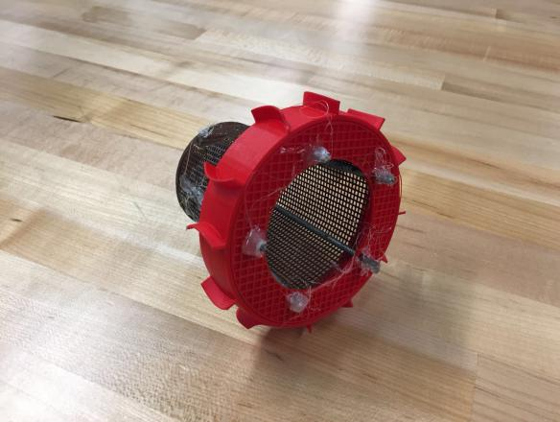
Figure 15 prototype I

5.2 Prototype II

The sifting structure was proved functional for sand sifting through our first prototype. Thus our second prototype was to build the drive system which consists of a servo motor and Arduino control circuits. A servo motor has the features of light weight, big starting torque, steady rotation ability and low rotary inertia. It is well suited for driving rollers with heavy garbage.
In addition, through the control of Arduino, free speed adjustment of servo motor can be achieved, which was beneficial for us to find the proper speed for rotation, so that the movement enables sand leakage and causes no damage to the stability of Bowie.

5.2.1 Purpose
The purpose of this prototype was to build and test the operation of the drive system. It also allowed us to learn more about the functionality of a servo motor and its capability of carrying loads of different weights, as well as its reliability and adaptability. In the meanwhile, the prototype enabled us to find a way to achieve a successful control of the rotation through Arduino.

5.2.2 Test Plan
- Purpose of the test
The purpose of the test was to learn more about whether the drive circuit functions operated normally and how much weight could be loaded.

- Target specifications
Target objectives include:
  - Connecting servo and container together successfully and firmly
  - Achieving continuous rotation of the servo motor and container
  - Achieving speed control with manual inputs
- Testing methods
Analytical: Derive the program on Arduino IDE and test it using the built-in verify function. Use Multisim to build the control circuit. Give initial parameters and then measure the current and voltage in each part of the circuit.
Physical: First, following the original designed circuit, we connect the components and test whether the driving circuits works properly. And then use a light rope to suspend different weights on the servo motor to test load capability and overload capability.

5.2.3 Results
We learned from the repeated experiments that the servo motor could operate properly, and if we want to keep both the circuit working properly and the servo motor regulation of output, the power voltage should be more than 6V.
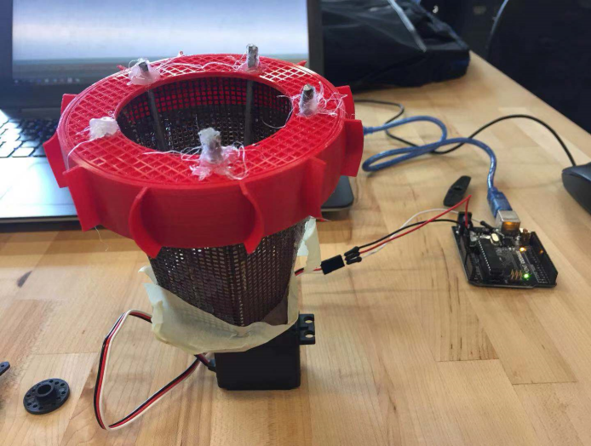
Figure 16 prototype II

5.3 Prototype III

Considering that our previous prototypes were constructed by using rough materials, we decided to build a refined prototype to showcase our design. However, facing uncertainty with construction methods, we changed the shape and structure of the original idea in order to enable 3D printing and also to meet aesthetic requirements. In addition, the modification on the prototype should not be destructive to the performance of sand sifting. The testing was conducted in the same way as the previous prototypes. The basic function of reducing the amount of sand in the container was tested through a physical experiment, and we stopped the test when the function was achieved and when no failure was observed.

Also, feedbacks from our client were taken into account, but only undertaken if they were manageable within time constraints. However, we added an remote control function into our design.

5.3.1 Purpose
According to the feedback from our client, there were two major problems that needed to be improved other than our own objectives:
1) to avoid wet sand blocking the holes of the filter;
2) to install the structure onto Robot Bowie.
Thus, the purpose of this third prototype was to refine our previous prototypes and give it an improved look, as well as to figure out a way for the structure to be attached onto Bowie and to deal with wet sand in the collection.

5.3.2 Test Plan
- Purpose of the test
The purpose of testing includes four different aspects:
  - Assure that the modification won’t affect the performance of the container in terms of dry-sand sifting.
  - Find out the ability of our design to break we sand blocks.
  - Ensure that the structure can be successfully installed on Bowie.
  - Learn about the features (eg. scale of the wall) that can affect the performance of the design and how they affect it.
  - Test the functionality of the remote control system.
  - Test the effectiveness of filtering at different speeds of rotation.

- Target objectives of the test
The target specifications include:
- The new structure’s ability to store small objects (> 300g).
- The capability of sifting dry sand (< 20% of the space of the container).
- The ability to break wet sand (volume of each piece < 1cm³).
- Attachable to Bowie.
- Find out the receivable distance for the infrared signal.
- Looks good (aesthetic and non functional).

- Testing methods & results
The results of the test were obtained from visual inspection:
  - We put two cell phones (around 150g each) and a calculator (around 80g) to test the ability to store small objects (> 300g), which was successful.
  - To test the remote control function, we simply pressed buttons. We observed that the signal can be received within a distance of roughly 20 cm.
  - We poured a bag of dry sand (around 250g) into the basket and used the remote to start the basket’s rotation. The capability of sifting dry sand (< 20% of the space of the container) was confirmed by the result that no more than 1 cm height of sand remained in the basket after a one-minute rotation.
  - However, wet sand is still a problem. After pouring in approximately 300g wet sand (adding the weight of water) five times, we gained inconsistent results. The sand sometimes stuck on the walls and blocked the holes, but was gradually broken to small portions at the other times. The testing had to be terminated. We have to admit that we currently don’t have an effective solution for this problem.
  - We printed casings for both the Arduino board and the servo motor, which had holes on the bottom platform for screwing, so that our structure can be attached on Bowie.
  - By direct observation, the aesthetic of the prototype is acceptable and within the scope of the project.

5.3.3 Developing Progress
Different from our previous prototypes, the new structure we decided to use, to replace the roller, was a rotating basket. In this way, we could easily install our sand filter on Bowie with no damage to the original structure of Bowie. In addition, the rotation of the basket would accelerate the drying process of the sand and garbage.
To build this prototype, we chose to 3D print. In the modeling process, to maintain the 6 cm height of the container and to keep the width of the upper side of the basket within the distance between the border of the arm and the back of Bowie (which would be 20 cm), we set the diameter of the base to 6 cm and the angles from the walls to the horizontal plane to 55 degrees. However, the total volume of the basket was only approximately 900 cm³ (almost half of the original hopper, which is 30 x 10 x 6 = 1800 cm³). But considering that the reduction of the amount of the sand in the basket gives more space to actual debris, the lighter weight of the container could be achieved, and the concept of a rotating structure is remained, we decided to give it a try. So then we modeled the base and the six pieces of walls for assembling the basket. However, we didn’t realize how time-consuming 3D printing could be, and we encountered a lot of failures during the printing. Therefore, the development of our production was not consistent. As a result, we did a lot of repetitive work and spent a large amount of time. Finally, we assembled the parts and connected the basket to the motor.
The final step was to develop a remote control function. The function relies on the Arduino board, an infrared (IR) remote controller and an IR receiver. The code was written by Shuyang, and the circuit was connected by Drinky.

5.3.4 Results
As mentioned, the main objective of this prototype was to produce a more complete look of our design. However, we significantly changed the former structure and, thus, needed to do much additional work in order to achieve the 3D printing. Only after later did we realize that the prototype didn’t have to be 3D printed, and we might have been too committed to this method. This unwise time consumption taught us to improve our time management. However, now that it is our final prototype, although not meeting all the exact specifications, we are able to say that our idea is practical. This might not be the most efficient way to sift sand, but it is a creative solution that can be further explored with a larger budget and timeframe.
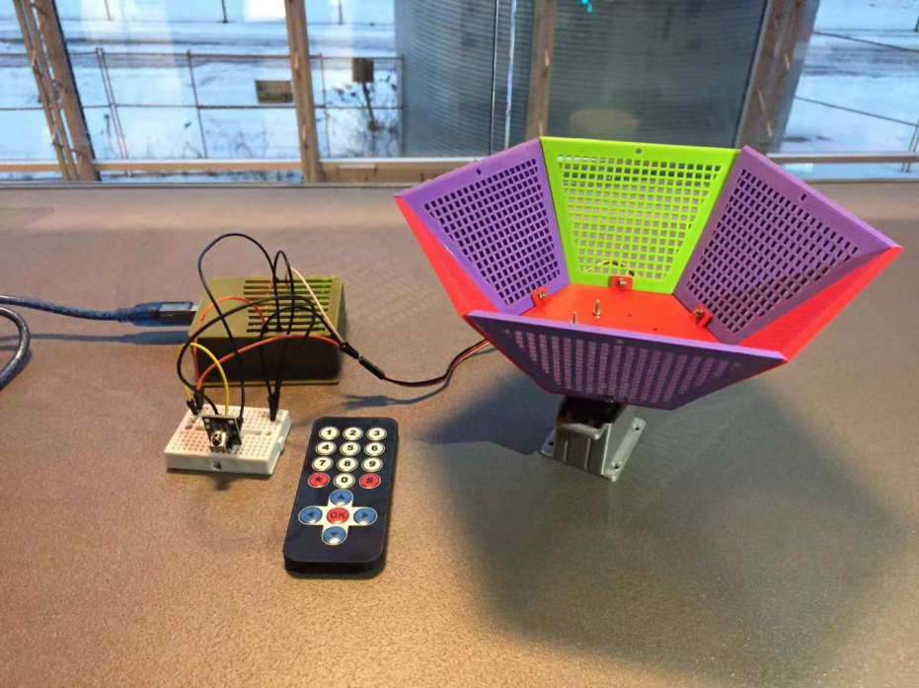
Figure 17 Prototype III
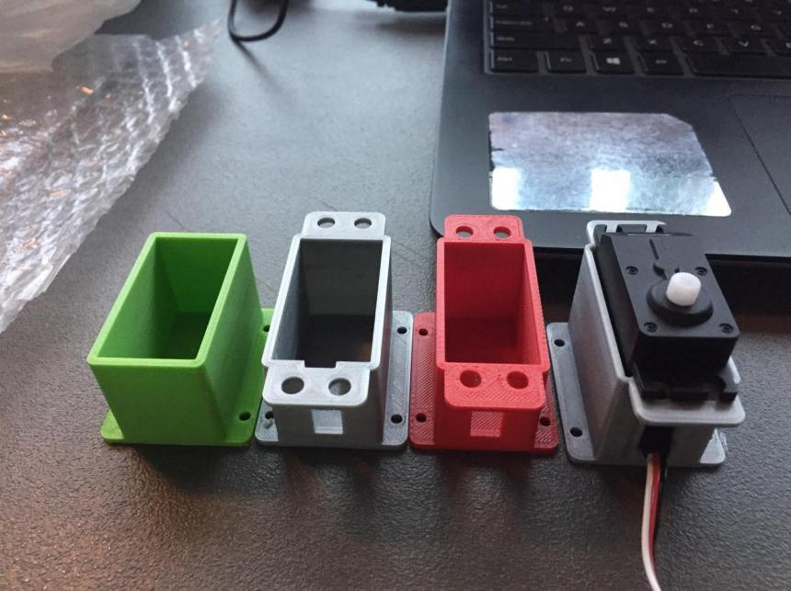
Figure 18 Types of Design Failures


6. Conclusions and Recommendations for Future Work

Our final prototype showcased our design of this rotational basket. It was a tough journey. The process of our work was slightly disorganized. At the beginning, we didn’t think of such a big change to the previous prototypes. But somehow we were obsessed with the idea of 3D printing and thought it was required to make the third prototype using 3D-printed parts, regarding it would be consistent with Bowie itself because it was mainly made out of 3D printing. Therefore we underwent a heavily time-consuming process—each piece of our printing took about 4 hrs or more to print. And we encountered a large number of failures. They were either random printing failures or technical failures. For example, the heated material would sometimes stick to the hot end and thus made an unexpected accumulation of material somewhere on the piece, causing further disorders of the whole printing process. Another example is when modeling a casing for the servo motor, we did it several times to finally get the perfect one.

One lesson we learned from it was the importance of time management. Because we spent too much time on printing, we were not able to modify the prototype after we had tested out a couple of failures. For instance, the device could not get rid of wet sand due to a lack of speed to overcome the friction of sand. Another lesson was that we should have done more research before we got our hand down to making the prototype. We bought our servo motor without knowing its power output and maximum rotation speed, and the shipment took a long time as well.

Future improvements could be focused on enlarging the capacity of the basket, as well as the maximum speed of rotation. We might also apply an inclination to the basket, so that the sand won’t have a horizontal plane to stay on, making it easier to trigger the movement of the sand.

Bibliography

1. Kennedy, E. (2018). Robot Missions - University of Ottawa class (fall 2018). Retrieved from https://uottawa.brightspace.com/d2l/le/content/83924/viewContent/1971020/View

2. https://detail.tmall.com/item.htm?id=543887113526&skuId=4006579775312

3. https://detail.tmall.com/item.htm?spm=a220m.1000858.1000725.21.b92677eayzwW1g&id=534498538744&user_id=2456823406&cat_id=50068874&is_b=1&rn=8dbf88aa6e8aaa7b42dc213906963bb6

