Work Sheet – Experiment 1

Experiment Title:
“DO I DARE DISTURB THE UNIVERSE?” Validation of Gas Laws.
Author(s) Name(s): R.D.
TA (Demonstrator)’s Name: Ali Mansour
Date Experiment Performed: September 12th, 2019
Date Experiment Submitted: September 19th, 2019

(The report for Experiment 1 does not require an Introduction)

Procedure – Charles’ Law:
As Outlined in the lab manual.
Procedure – Boyle’s Law:
Safety Precautions
Wear approved eye protection and lab coat at all times.
Equipment
LabQuest 2
Vernier Gas Pressure Sensor
20 mL gas syringe
USB key (flash drive)

- Position the syringe with the bottom-most line of the plunger at 10 mL.
- Attach the 20 mL gas syringe to the valve of the Gas Pressure Sensor. IMPORTANT: About a half-turn of the syringe will lock it into place on the sensor.
- Plug in the Gas Pressure Sensor into Lab Quest 2 to begin collection of data.
- After the pressure reading stabilizes, tap “Keep” and enter the gas volume + 0.8, in mL.
- Increase plunger by 2 mL (to 12 mL) . After the pressure reading stabilizes, tap Keep.
- Decrease plunger by 4 mL, then increase by 3 mL, then decrease by 2 mL, then decrease by 1 mL to conclude at 10 mL. Make sure to record the stabilized pressure readings following each measurement.
- Repeat procedure at least two more times to ensure accuracy.
- Insert USB into Lab Quest 2 to collect data and save.
Note: Assume that the temperature is constant. Also note that some resistance may be experienced.
Discussion:
Charles’ Law
Temperature vs Volume Data:
$T_{1}$ ($℃$) | $T_{2}$ ($℃$) | $T_{1}$ (K) | $T_{2}$ (K) | $V_{1}$ (mL) | $V_{2}$ (mL) [$V_{1}- V_{cw}]$ | $V_{cw}$ (mL)
100 $℃$ | 12.5 $℃$ | 373.15 K | 285.65 K | 148.9 mL | 121.6 mL | 27.3 mL

Charles’ Law experiment is intended to reveal a relationship between the temperature and volume of gas. The equation of Charles’ Law is V = m$T_{K}$, as stated in laboratory manual, with the temperature (in Kelvins) being directly proportional to the volume. In the experiment conducted, a – 6.681% error was calculated using the given percent error formula, suggesting that the results acquired were less than the actual value of Charles’ Law. An error most likely occurred due to the pressure being inconsistent. In addition, the water being heated may not have come to a complete boil, leading to a loss in the time the gas had to heat up; hence, this might’ve prevented the gas from expanding to its maximum capacity. These errors can be improved by being more cautious of the temperature of one’s surroundings and timing each step in the procedure correctly.
The procedure was performed based on the controlled variable of pressure. The independent variable is temperature and the dependent variable is volume; this simply refers to the fact that temperature cannot be changed and the volume is dependent on its correlation with the temperature. The relationship between volume and temperature can be represented with a linear graph, where the volume of gas increases as temperature increases, and vice versa. This relationship can also be represented mathematically by the formula $\frac{V_{1}}{T_{1}}=\frac{V_{2}}{T_{2}}$. Using this formula, a value of approximately 0.4 has been calculated (as shown in sample calculations), therefore, Charles’ law has been verified in the experiment conducted since $V_{1}$ divided by $T_{1}$ and $V_{2}$ divided by $T_{2}$ were proportional to one another.
Boyle’s Law
Volume vs Pressure data.
Independent Variable: Volume (L) | Volume + 0.8 (L) |  |  | Dependent Variable: Pressure (kPa)
0.01 | 0.0108 |  |  | 101.75
0.012 | 0.0128 |  |  | 86.60
0.008 | 0.0088 |  |  | 123.43
0.011 | 0.0118 |  |  | 94.23
0.009 | 0.0098 |  |  | 114.64
0.01 | 0.0108 |  |  | 103.83

Boyle’s Law: Pressure vs Volume
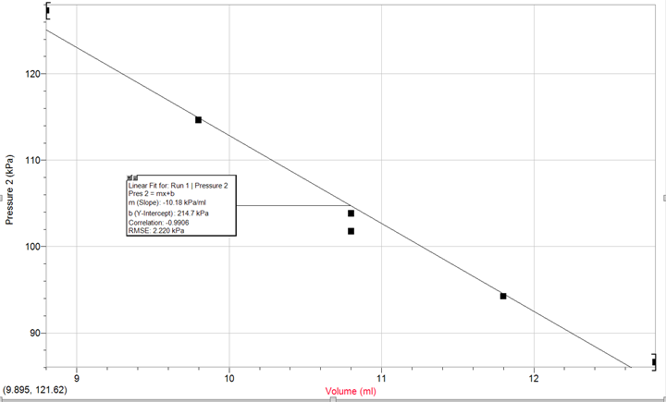
Assuming that the temperature must remain constant, Boyle’s law expresses the relationship between pressure and volume; stating that volume and pressure share an inversely proportional relationship. Considering their inversely proportional relationship, a curve was expected to be seen but unfortunately that was not the outcome.
Using the pre-determined formula PV = k, a value for the constant k can be calculated. The independent variable of volume needs to be in units of litres, while the dependent variable of pressure must be in units of kPa. By simply multiplying the obtained value for pressure with its corresponding value of volume, a value of k can be calculated. By multiplying the initial values, we get the equation:
$$P_{1}V_{1}=k$$
$\left(101.75 kPa\right)\left(0.01 L\right)=$ 1.0.
By repeating these steps once again with the experimental values, we get the equation:
$$P_{2}V_{2}=k$$
(86.60 kPa)(0.012 L) = 1.0.
Therefore, by combining the two equations above, a mathematical relationship of Boyle’s Law can be illustrated as:
$P_{1}V_{1}=$ k = $P_{2}V_{2}$
$${P_{1}V_{1}=P}_{2}V_{2}$$
The constant k was repeatedly calculated to be 1.0, verifying Boyle’s Law. Nonetheless, there were errors present, and this is shown by the change in pressure that occurs at the 0.01 L mark which was set to be the first and last measurement in the procedure. Initially, a reading of 101.75 kPa was noted, but by the final measurement, a reading of 103.83 kPa was obtained. This might be due to an unbalanced syringe which might’ve allowed for gas to escape, or perhaps a consequence of the resistance experienced while adjusting each interval. The change in the dependent value (volume) also suggests that the temperature was not constant, as it should’ve been. Equipment such as an incubator would be ideal to maintain constant temperature, to ensure that the data collected is as accurate as possible.

Conclusion:
The purpose of this lab was to verify Charles’ Law and Boyle’s Law. Despite the errors, the laws were successfully verified. Ultimately, the lab served as a tool to experiment with gases to observe the reactions and learn about its properties.
Reference(s):
“What in the World ISN’T Chemistry”, General Chemistry Laboratory Manual, Dr. Rashmi Venkateswaran, 2019.

“Gas Law - Boyle's Law.” ChemTeam, https://www.chemteam.info/GasLaw/Gas-Boyle.html.
Appendix:
Raw Data:
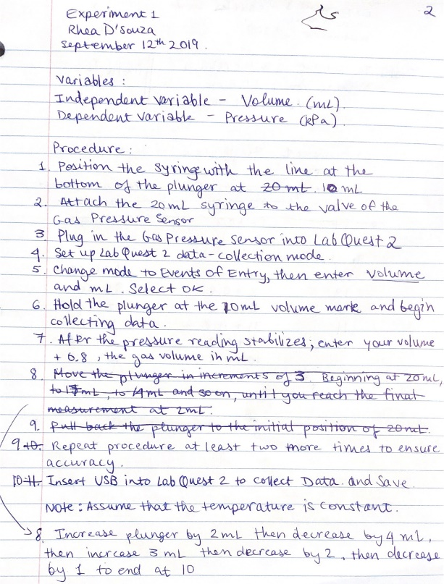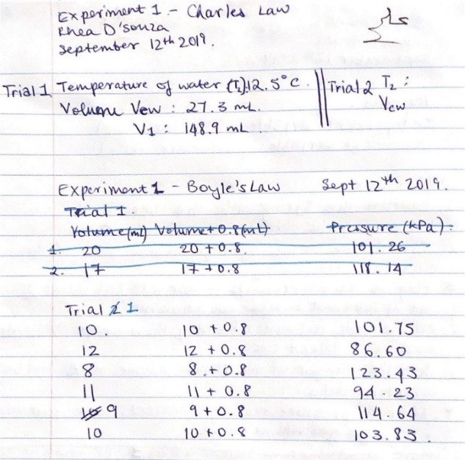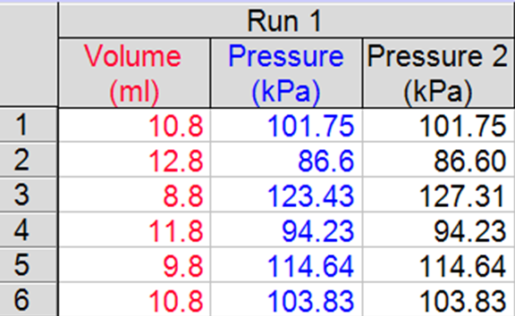

Sample Calculations, Charles’ Law
$\frac{V_{1}}{T_{1}}$ = $\frac{148.9 mL}{373.15 K}$= 0.3990
$\frac{V_{2}}{T_{2}}$ = $\frac{121.6}{285.65}$ = 0.4257
% error = $\frac{\frac{V_{1}}{T_{1}}-\frac{V_{2}}{T_{2}}}{\frac{V_{1}}{T_{1}}}$ x 100%
= $\frac{\frac{148.9 mL}{373.15 K}-\frac{121.6 mL}{285.65 K}}{\frac{148.9 mL}{373.15}}$ x 100%
= - 6.681%

Sample Calculations, Boyle’s Law
Determining Boyle’s Law Constant
PV = k
(101.75 kPa)(0.01 L) = 1.0
(86.60 kPa)(0.012 L) = 1.0
(123.43 kPa)(0.008 L) = 1.0
(94.23 kPa)(0.011 L) = 1.0
(114.64 kPa)(0.009 L) = 1.0
(103.83 kPa)(0.01 L) = 1.0

Assessment Criteria Sheet


