BU 111- Midterm Notes
External Analysis: process of scanning and evaluation the external environment – how mangers determine opportunities or threats
- Predicts environment around you
- Provides information used in planning
- Helps organize to get needed resources
- Helps organization cope with uncertainty
- Improves consistency and performance
- Managers make meaning of external trends to determine if something is an opportunity or threat for the organization
Challenges:
- Rapidly changing environment; hard to keep up with
- time consuming
- forecasts and trend analysis’s are imperfect
How to conduct and external analysis:
- General environment – PEST
- Specific environment – Porter’s Five Forces analysis
- Use databases (on library website for laurier students)
Critical Success Factors
What | How | Why
Achieving Financial Performance | - generating income/revenue | -required for business to be sustainable
Meeting Customer Needs | - reliability, variety, timeliness, quality, safety | - customers provide revenue and sales
Building Quality Products and Services | - quality assurance | - encourages customers to buy products/services  - builds reputation
Encouraging Innovation and Creativity | - training programs, incentives, open forum | - business should be constantly changing and adapting to environment
Gaining Employee Commitment | - incentive plans, training, participate in management decision making | - employees are driving force behind a business
Creating a Distinct Competitive Advantage | - adding value | - encourage customers and out compete competitors

Diamond- E Framework
- Focal point = strategy (opportunities the business is pursuing); directly links to environment
- Management- conservative or risk taking
- Choices must depend on what resources are available
- Organization to management preferences- managers may have certain ideas but must follow set culture in which the organization permits
The components of the Diamond-E Framework are all of the little boxes within it. The most important linkage within it is strategy.
Diamond- E Critical Success Factors
- Develop strategy that benefits environment to achieve financial performance
- Meet customer needs- understand organization
Diamond-E framework – helps identifies the most important variables and the relationships between those variables. A manager would use this when designing a new strategy or on an ongoing basis they use this to revise their existing strategy. They can compare the strategy to the internal/external environment.
- Management Preferences: acknowledging that managers are human beings and that they have natural bias, approaches, desired outlooks. The better aligned the management preferences are with each other/strategy, the more successful the strategy will be. Managers decide the 3 main parts of resources.
- Organization: How is the organization structured, what are the abilities of the organization and what is the culture like (leadership style). The organization is very well suited to certain strategies and not so suited to others.
- Resources: 1. Human Resource component (people and their skills). 2. Capital Resources (assets). 3. Financial Resources ($$).
- Strategy: your plan for competing. What opportunities should you pursue, this should define what opportunities you should avoid. Strategy is the critical link, connects internal resources and things happening outside the business. It has to fit into both.
*** All these are connected, all influence each other

Strategy-environment linkage: Creating a strategy based on whats going on in the environment.
External Environment – PEST factors make up the external environment
Internal Environment – marketing, operations, finance, and human resources.
Strategy – determines what opportunities the business is pursuing.
  - determines needed resources, organizational capabilities, and management preferences
Critical linking variable
Each variable related to the rest – any variable can drive or constrain the strategy
Principle logic – the goal is to have all factors above aligned with one another – consistency between variables – external/internal environment must be aligned
ie- P&G (Proctor and Gamble) Strategy in 2000: inconsistency – new manager comes in, reads the environment, followed his bias too much and stretched their resources. The external and internal environments were not aligned.
ie- IKEA Strategy: Consistent – he believed in producing well made, affordable furniture products.
First task – deal with the strategy-environment linkage. Access forces at work and their implications.
- ie; canon vs Kodak – canon took the leap and invested in the digital technology. Kodak was slow and waited, so they lost a large chunk of market share. Canon was right for taking a risk going on what they saw in the environment.

PEST Factors: uses these 4 factors to identify trends and changes
What | How | Why | Examples
Political | - laws, regulations, taxes, trade agreements, political systems, political stability | - effects how a business can operate (i.e. wages, laws, product labelling)  - taxes create incentives  - political environment (capitalist- consumerism vs. socialist- best for everyone) | law, regulations: governments create incentives, they regulate and they play many roles. In Canada there are several regulations as to what the product label must look like (ie: cigarettes), minimum wages, laws for banking industries, laws about how many taxis can be in a city, etc.  taxes: are in place to get money for the country. The gov can tax things more than others if they don’t want people doing something or to follow their own strategy (ie; high taxes on tobacco)  Trade agreements or conditions: Canada applied tariffs (taxes) on cars that are imported from outside of Canada. This helped out Canadian car manufactures. This made TOYOTA set up a factory here in Canada. Tariffs either boost their own manufacturing rates or make outside companies come to Canada to produce their goods.  Political system: Capitalistic – business supportive. Socialistic – Not business supportive.  Political stability – companies don’t want to build factories in countries that are politically unstable.
Economic | - economic growth, trade balance, national debt, economic stability, interest rates, exchange rates | - influences costs, potential sales and financial uncertainty  - more government borrowing=less funds for businesses=higher interest rates and taxes  - exchange rates affect trade balance | Economic growth - GDP and standard of living: GDP is measuring the total value of all the goods and services that the country is producing within a period of time. The GDP can be misleading (ie; usa had a high GDP only because they spent so much money on cleaning up the oil spill) 70% economic growth comes from consumer spending.  Economic Stability – In canada are economy has been fairly stable, but not strong. It isn’t very volatile.  Trade balance – in march 21, 2012 we have a 351 million dollar trade surplus. We export more than we import. Exporting more is POSITIVE.  National Debt – the more debt, the more money the governments have to pay back the less money for the country. If the gov’t borrows a lot of money it takes away from businesses because it makes it harder for them to get loans.  Interest rates – we have very low interest rates in North America. In theory, low interest rates should make consumers/businesses spend more but they don’t because they are worried about the economic conditions. When interest rates go up, people don’t want mortgages, loans, etc.  Exchange Rates – it will either help or hurt the attractiveness of your products. In Canada our dollar was much lower than the USA, but then it rose up to about par with the USA within a short period of time. If you are buying stuff from the USA(imports) it’s a big opportunity, if you are in the USA and you are buying from Canada(exports), it’s a threat because they won’t be able to buy/spend as much due to the exchange rate.
Social | - customs, values, attitudes, demographics | - influence customer preferences, worker attitudes and behaviours, standards of business conduct | Customs, values, attitudes, etc – our values and what not change over time. They r important because they influence what be choose to buy/not buy.  - Managers should pay attention to demographics of population  Ethics – their business behaviors and how they carry it out to their management decisions.  - Bribe is not acceptable, but not in some countries... Therefore, international trade is difficult at times.  - Ethics are important, it’s not ALL about the net profit, decisions managers make do have repercussions  A lot of large companies don’t do research - MCD – sold burgers in parts of India where they don’t eat meat lol!!!
Technology | - internet | - affects buying, selling, communication, information access (good + bad)  - bad press spreads quickly | Internet – has changed how we buy and sell things dramatically. The problem with the internet is that EVERYONE has all this info at the tip of their fingers.  Inter-firm cooperation – companies now are working super closely with their suppliers, opening up their data so that everyone can work more closely together and be EFFICIENT.  Designing a product – is now so easy than anyone can do it if they truly want to.  TECHNOLOGY – has sped up every single process in terms of marketing, production, etc. Technology effects MORE than high-tech companies. It changes every kind of industry.. Farming etc!!

Questions to answer from PEST:
- Do the economic conditions support my business?
- What legal protection do I have or laws do I have to consider?
- What demographic and social trends affect my business and how?
- What technological forces affect me now and in the future? How do they assist or constrain?
- What opportunities or threats does the environment possess?
Social affects critical success
- determines customer needs
- employees have different values- must adapt to those
Porter’s Five Forces
- Determines how competitive industries are and if there is profitability available. Analyzes five important sources of competitive pressure.
- Suppliers
  - Provide resources for production
  - Strategic alliance: internal supply, create own goods= invest in more capital
  - the lower the power of the supplier, the more attractive the industry. Ie; if there are only a few suppliers than they have a lot more power because you have to buy from them. IF there are a lot of suppliers than the companies have a lot more power. More options=more power. In order to switch from one supplier to another it could be very costly (ie; switiching phone companies, or switching a manufacturing supplier would cost a ton of money as well). If suppliers have a lot of power it puts pressure on expenses. Sometimes you can simply buy out your supplier if you want to control the input (ie; apple invested 1 billion into their touch screen suppliers because they were worried about the screens not being made fast enough). an industry with low supplier power=tons of options (food retail). High supplier power=small amount of options (car part manufacturers).
- Potential Entrants
  - How easy to get in
  - Need money to start
  - High barriers of entry
  - they can cause big changes (drive down price, have new/better products in your market). The more competitors affects how much you can charge per product (revenue). Existing companies will try to create barriers (captial intensity – it will take a ton of capital to be able to compete with them, ie; designing a new motorcycle, it would be easily to sell the idea to an existing company rather than start your own plant). Patents are also barriers. If you have special “know-how” (special training), than it can be a barrier because competitors wont be able to match your method. Brand loyalty is definitely a barrier.
- Buyers
  - Take product and sell it for you (Walmart)
  - Buyer: large and only one= bargaining power
  - Close substitutes, choose what want
  - Strategic alliance
  - we like to have more power than our buyers. Ie; Sony the company, switched their whole focus. They started off making satellites that only governments were really interested in them. They walked away from that focus because the buyer had all the power. Buyers have more power: wal-mart (they will squeeze you if you finally earn shelf space in a wal-mart), buyers have more power if there are similar products/ easier to switch. Also, if it’s a discretionary purpose (if they decide IF and when they are going to buy your product because its not a crucial product that they need). More power for the buyer, than we don’t have a lot of ability to increase prices, etc.
- Substitutes
  - Companies offering products similar to yours
  - – if a consumer can be satisfied by a substitute product (other products that achieve the same thing as your own, could be from a completely different industry). There are not many substitutes for prescription drugs. The more substitutes, the more competition, this affects how high you can price your product. If the substitutes product goes down, than yours typically will need to as well. Laser eye surgery is a threat to glasses, as the price of laser eye goes down, so must the price of glasses. Substitutes affect the expenses too because you have to do more marketing to reach your customers.
- Rivalry: Industry competitors
  - Pressures to control
  - Gain more customers; engage in price war
  - it will make the companies spend more money to differentiate themselves, pay more for shelf space, marketing costs raise, etc. It affects the pricing of your products. If there arent any clear market leaders than the rivalry intensifies. The growth rate of a product will help determine how competitive it is. When the product is new there is plenty of market share for everyone but As the growth slows down, it becomes way more competitive. If the products are perishable (can go bad whether its going out of style or physically rotting), this intensifies competition/rivalry.
Why use Porter’s five forces analysis?
- Predicts industry profitability
- Whether to enter industry or not
- Whether and/or how it can carve out an attractive position in industry- impact
Questions to answer when doing Porters’ five force analysis:
1. Is the industry a realistic place for a new venture to enter? If yes, then...
2. Can we do a better job than incumbents (existing companies) at avoiding or diminishing factors (forces) that suppress industry profitability?
3. Is there a unique position we can pursue (look for a positive sum competition)?
4. Is there a superior business model that incumbents would find hard to duplicate? (a better way of doing things)
Entrepreneurship: Identifying opportunity and accessing resources to capitalize on it:
- Characteristics of a small business= consists of less than 100 employees, generally owner-managed, small NOT dominant impact
- New Venture: recently formed commercial organization, sells goods and services
- Paradigm Shift: abandoning traditional assumptions about how things work or ought to be and seeing what others do not
Three Main Steps in Entrepreneurial Process: PEST influences it.
- Entrepreneur- must match knowledge, experiences and interest. Entrepreneur, resources, and opportunity must match!
- Begins with the entrepreneur recognizing the opportunity- good idea
- Than accessing resources.

Opportunity recognition:
  - Often is from paradigm shifts (apple believed that simplicity is beautiful and changed the way people felt about computers. Took owning a computer from being complex and only for businesses, to something that every individual would be able to use easily and be proud to have)
  - Screening: 3 step process:
- Does the Idea creates or adds value for the customer- satisfies previously unmet or resolves problems that customer is willing to pay for
- Idea= sustainable competitive advantage (how is it different from similar products, will the difference be enough to make people pay for it over the competitor, can the advantage be easily imitated-can it be protected legally?)
- Idea= marketable and financially viable.:
  - Are there enough customers who are willing to buy it? What is the market demand likely to be?
  - Who are the key competitors and what are the forces that affect profitability?
  - Is the market growing, shrinking, concentrated, fragmented?
  - Safety point – does the idea have low exit costs?
  - Fragmented market – no dominant market leader
  - Safety point – exist costs – how much would you lose if you had to close it all (if it was a fail)
  - - it shouldn’t be an idea with an expensive start up or it requires a lot of money.
  - Concentrated market – opposite of fragmented market – means there are a few dominant companies in that market.
How to screen:
- Use PEST factors to assess the environment – is it supportive of your idea?
- Use five forces to determine ease of entry and profitability of the industry.
- Use PEST, five forces and market exploration to ensure uniqueness of your idea.
- Use data bases (library resources) to determine the size of your market, whether or not its growing, shrinking, or stagnant.
- Research the expert opinions in the industry.
- Identify the key trends in the environment and how this affects your idea/represents an opportunity for you.
Evaluating your business opportunity:
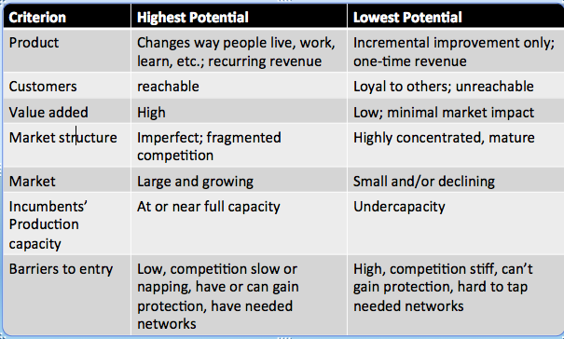
Developing an opportunity:
- incorporate research, information, experience and customer feedback. Your business concept will often change about from the original idea.
- Develop your business plan
Accessing resources:
- bootstrapping – do more with less. Make do with as few of resources as possible. Use other peoples resources when possible and locate/use free stuff.
- Financial resources – Debt vs Equity financing:
Debt Financing | Equity Financing
- Obtaining resources with the promise to pay back principle and interest (ex. Financial institutes, suppliers) | - Obtaining resources using savings, love money, private investors, selling shares, venture capitalists.
- adv. Maintain control of business  - dis. Legally required to pay back principle interest; must put up goods for collateral | - adv. No interest  - dis. Must share control and profit of business

Social entrepreneurs/enterprises:
- society’s change agents: creators of innovations that disrupt the status quo and transform our world for the better.
- generate social value while operating with the financial discipline, determination & innovation of private sector businesses.
- Key facets:
- Overcome market inequalities/failures – be innovative when approaching these inequalities (the market doesn’t meet societies needs, ie; a number of people cant afford the basic products/services they need)
- These organizations need to create economic value to achieve their primary objective. The economic value (the profit that is generated) is to achieve the END goal. That’s why it’s different than a traditional business because usually the profit is the only thing that matters. But here the economic value is a by-product, they need it to keep the company going so they reach there social goal.
- Form of business can vary - Some social enterprises are set up as a charitable organization or not-for-profit (for tax purposes it makes more sense, it allows them to reach their social goals)
- Accountability to community stake holders - The investor is often just getting their capital out, than beyond that they r not looking for profits. The money is used to achieve that social goal.
- Bootstrapping – squeeze everything out of your resources. Be resourceful!!

Normal business – all about making money
Social business (enterprise) (entrepreneurs) – dedicated to a social objective (to help people), the owner doesn’t reek any benefits from a money standpoint
Microcredit – give poor people money to pay off their debt, start a business and make a little bit of money and they don’t have to pay collateral/outrageous interest rates. The social benefit is that 17 million people are currently boring from Grameen Bank which runs by using microcredit.
Charity dollar – has only one life, if u use it, its done. If you can define this dollar in a social business, that money can be recycled so you touch many more lives and it keeps helping people (ie; selling the yogurt to break even, they can keep making more yogurt and keep selling it at par)
Examples of Social Entrepreneurs:
- Muhammed Yunus – Grameen Bank - started off with 42 people they loaned money too, now is at 17 million. Prof. Muhammed Yunus was an economic major. He did a joint venture with Danone, a yogurt company, they made cheap yogurt, put the nutrients bangladesh kids werent getting, than sold the yogurt for so cheap to bangladesh people that it just breaks even, the company doesn’t make money off this one sector of their business.
- Greg Overholt – SOS – social value is to fund educational development projects in latin America. It’s self-sustainable because volunteers run SOS sessions and the fees from them go to funding the social value.
Social enterprises vs traditional businesses:
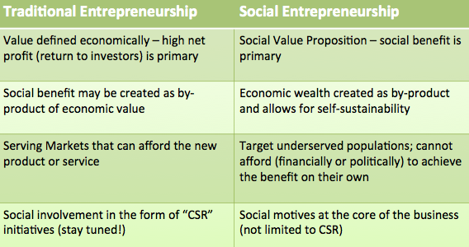

Ethics:
- individual standards or beliefs regarding was is good and bad (wrong or right).
- Business or managerial ethics – standards of behaviour that guide individual mangers in their work.
Categories of Ethical Behaviour
- Towards Employees- wages, opportunity for advancement, working conditions
  - Example of not being ethical: Two equally able applicants, but one applicant is female and is getting married- do not hire her because she mentioned hopes of starting a family
- Towards the organization
  - Not ethical: Accepting gifts from suppliers
- Towards other economic agents (i.e. customers, shareholders, competitors, suppliers, dealers)
  - Not ethical: Bribing a competitors employee for inside information
- Must act ethically- public relations- reflect public image
- affect organizations culture
Assessing ethical behaviour: Managers can follow this process when facing ethical decisions:
- Gather facts (check out laws/policies that may apply)
2. Analyze situation (manager usually focuses on one approach)
  - Utilitarian Approach = create good for the majority
  - Rights Approach = rights cannot be taken away (the manger shouldnt make a decision that violates someone's rights)
  - Fairness/Justice Approach = equitable distribution of burdens and rewards
Manage Ethical Behaviour: make it clear to employees that ethics do matter
- Hiring criteria – u can ask questions/back round checks, etc, to see if you are hiring someone with good ethical values/ hasn’t done anything fucked up in the past
- Managerial role modeling - The managers need to lead by example !!!!!!
- Core value statement – broad statement – the companies mission, almost like an essay that states what there number one value/main responsibilities/guidelines to run their business by (ie; Johnson&Johnson, someone put cyanide in their pills, they took full responsibility and dished out millions to fix the problems because there customer satisfaction is their main goal).
- Code of conduct – says what to do, and what to not do. Is clearer than the core value/mission statement.
- Ethics booklets and training – keep reminded them of ethics, have refresher courses (training)
- Goals and evaluation – set goals but not so high that they must break the code of ethics to reach them.
- Reward systems – recognize HOW people get to the goals, not just whether or not they get there. Reward the people that reach their goals in a great/positive/helpful way.
- Employee protection mechanisms – a company “spy” or someone/some thing that makes sure ethics are not getting fucked.
Stakeholders
Stakeholders | Expectations | Importance
Owners and Creditors | ROI- return on interest | Provide capital
Customers | Quality choice, communication, safety, respect | Provide business, financial performance
Employees | Fair pay, meaningful work, safety, fair treatment | Driving force of business
Board of directors | Responsible for management | In charge of management; set general tone for business
Natural environment | Responsible stewardship | Reputation, resources needed to run business

Why manage stakeholders?
- keep pace with societal changes: stakeholders want a voice, that’s reality these days.
- To avoid stakeholders talking shit or filing lawsuits against the organization
- To have better control of external environment
- To improve % of successful new product/service announcements
- To promote higher levels of operational efficiency
- To promote favourable legislation (the green gym guy)
- To promote higher entry barriers leading to a better competitive adv.
- To promote higher levels of trust (if they are happy, they will trust you more)
- To potentially improve profitability (increase profits if you treat stakeholders right)
- To increase media power
- To align companies with societal values
How to best manage stakeholders:
- identify main organizations stakeholders
- Determine the potential for threat and potential for cooperation. Depends on if they need you to benefit from you, than they will want to cooperate. If they have something to gain from having a good relationship with you than that’s a positive.
- Develop strategies to ensure key stakeholders are happy and implement them.

Strategies for managing high/low potential for threat/cooperation:
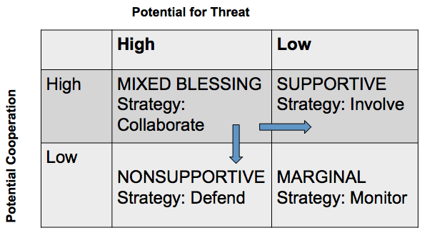
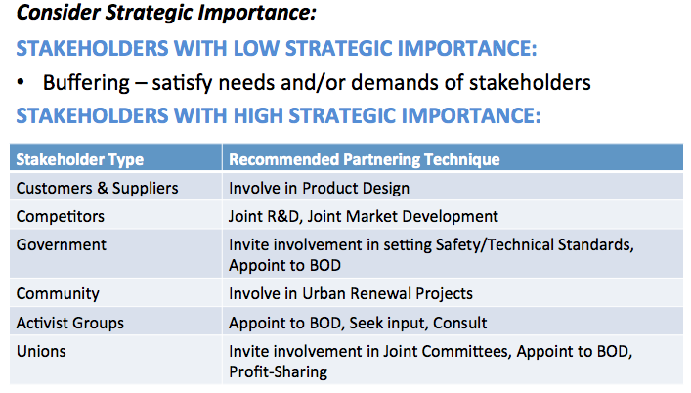

Corporate Social Responsibility
- Business tries to balance its commitments to its organizational stakeholders
- How business addresses ethical conduct at organizational level- “collective code”
- Two opposing views
  - Focus only on profits
  - Actively consider other stakeholders
- 5 Areas
  - Natural environment, society, customers (health and safety), employees, investors
Areas of social responsibilities:
- To the Natural environment: must focus on sustainable development. Watch this: http://www.youtube.com/watch?v=oagmlbhobnY The economy is the driver of our society/environment but you can have an economy with out them. They are all dependant on one another. Our system doesn’t take into affect the impact of the economy on the society/environment.
- To society: analyze economic growth. Economic growth is not always good!! Usually it is not good for the poor. Its important to look at individual regions because there are plenty of situations where growth is not benefitting the poor. Look beyond the aggregate figures. Consider income inequality. Ie; in Detroit its very sketchy as soon as you get off the bridge (by 8 mile, etc) but than as you get closer to Auburn Hills it becomes beautiful (very regional). There are rural areas that have worse access to good health care and education. Innovative business models can contribute to social development (helping/starting a social enterprise within the business). Bigger business and community partnership can help solve social inequalities.
- To Customers: have fair prices, ethical advertising and consumerism (right to be heard, to choose, to education, safety, etc)
- To employees: responsible hiring/promotion, treat them with respect, safety, protect the whistleblower, allow opportunities for advancement (you can’t expect employees to stay their forever).
- To investors: make decisions that will benefit them in the long-run. The BOD must have a certain percentage of independent members (don’t own share in any other company) because they protect the rights of the shareholders.
Approaches to social responsibility:
1. Obstructionist Stance: Do as little as possible to meet ethical and legal requirements
2.Defensive Stance: Do everything that is legally required but nothing more. Do what they have to (tobacco industry-labeling requirements)
3. Accommodative Stance: Doing everything that is legally required and expected of them. In order to go the extra mile somebody must first approach them, they may accommodate the request when asked.

4. Proactive Stance: Absolutely do everything that is legally required. Go above and beyond the requirements on their own, constantly looking for pro-active solution.
Imple
Demographics: the study of human populations
- Importance
  - Basis for any market is people-as business people we need to use any tools we can get our hands on to help us understand people
  - Powerful predictor of human behavior-generally the activities that people do are based on their age
  - Certainty and simplicity of age data-if you are marketing to 20 year olds now, demographics will give you a pretty good idea of how many 20 year olds their will be 5-10 years from now.
Cohorts: economic conditions during time
- Smaller cohort
  - Adv: less competition-more jobs
  - Disadv: little of you- voice not heard
- Larger cohort
  - Adv: majority of pop – your voice is heard
  - Disadv: lots of competition – less jobs
- Key factors in predicting behavior of economy
  - # people in each age group
  - “activity participation rate”
- Factors affecting size of cohorts
  - fertility rate - avg. # children/women
  - birth rate - total # births/size of population

Make sure to study:
- all the APA shit
- watch and read on the material listed on exam review that L. Hagarty made.

