ADM 1301 Social Context of Business Midterm 1

Chapter 1: Canadian Macro Environment
- Business exists to satisfy the wants and needs of society
- The consequences of businesses are good/bad (winners/losers); every product in use has consequences
- Business influences and is influenced by other businesses, government and civil society
- Business affects and is affected by the society in which it operates
- Society expects business to be profitable, ethical and social responsible
- Expectations are driven by a more informed, affluent, connected and litigious society
- Technology advances communication (social media) and puts businesses & government under society’s spotlight (expect to deal with civil society issues)

- Canadian macro-environment consists 3 key segments:
- Business
Equally important
No exclusive power
Ongoing relationships (interdependence and interconnectedness)
- Government
- Civil society
The apex:
- Pure exchange (business)
- Pure coercion (government)
- Pure reciprocity (civil society)

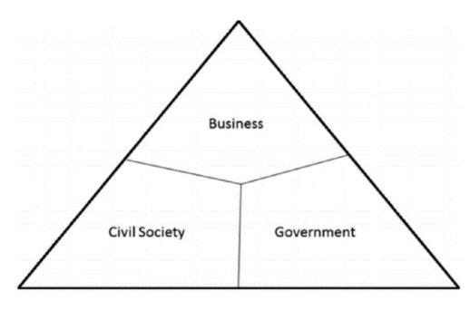
Business segment: (supply & demand force)
Boulding Triangle
- All forms of “for profit” business ownership (corporation, partnership, proprietorship)

Government segment: (redistribution/coercion)
- All levels of government (federal, provincial, municipal)
Inner territory: variety of socioeconomic and governance relationships

Civil segment: (cooperation/reciprocity/solidarity)
- Organized/unorganized social networks (community, Chasity, volunteer)

*the boundaries are not well-defined (no rigid frontiers); zone of overlap, interaction and interdependency

Exchange: trading things
Coercion: the act or process of persuading someone forcefully to do something
Reciprocity: the exchange of something between people or groups of people when each person or group gives or allows something to the other; to help teach other

Developing a sustainable competitive advantage requires:
- strategic partnerships and collaborations
- understanding of the macro-environment

Chapter 2: Business segment
- business drives the economy of a nation
- Canadian economic system:
- Private enterprise
- reward firms for effectiveness and efficiency
- characteristic rights: private property, freedom of choice, profit, competition

- Canadian business system:
- Private market
- capitalism
- hallow private ownership to exchange in a generally unrestricted market

- Canada’s workforce:
- Aging population & shrinking labour pool: baby boomers are retiring (a significant # continue to work beyond retirement); different generations (different views/backbones) in labour pool
- Increasing diversity, flexibility, mobility: increasing immigrants (multiculturalism)
- Changing nature of work & outsourcing: more employment in manufacturing sector
- Innovation through collaboration: sustainable competitive advantage, strategic partners

- Business ownership:
- Entrepreneurship:
- starring point of an idea
- risk-taker/self-confident
- convert an idea into a tangible product/service

- Sole Proprietorship (SPs):
- Simplest from of business organization
- Falls under provincial and municipal jurisdiction
- Owned and operated by 1 person, no distinguish between owner and business
- Available to anyone legally able to better into a binding contract
- Easy and cheap to start; Flexible and control; No government regulation
- Limited financial resources; Limited growth; Limited skill pool

- Partnership:
- 2/more people share ownership
- No distinguish between the business and its owner
- Must legally register name and provide information about the partners (provincial laws)
- Shared management; Combined knowledge; More financial resources
- Unlimited liability (general); Division of profits; Disagreement among partners

- General partnership:
- all partners manage the business
- jointly responsible for partnership liability (liable in equal share for the debts)
- jointly & severally liable (liable for the consequences of the actions of others) each member is liable for the full amount
- each member can bind the partnership without consent of the others

- Limited partnership:
- several types of partners (see below)
- composer of 1/more general partner (control/manage the business)
- mother partners are limited (take no part in control/management)
- limited partner: only liable for the amount of cash contributed to the partnership

1. Silent partner: know to the public; no active role in management
2. Secret partner: unknown to the public; take active role in management
3. Nominal partner: lend their name for public relation purpose; not involved
4. Dormant partner: neither known to the public nor active in management

- Corporation:
- A separate legal entity under the law (legally distinct from its owner)
- Can be incorporated federally or provincially
- Federally incorporated: can carry business in all parts of Canada; cannot be prevented by provincial government from exercising the power that federal gave
- More money for investment; Limited liability; Separation of ownership/manag.
- Initial cost; Paperwork; Taxation; Greater expectation for social responsibility

Private corporation:
- # of shareholders: max 50
- May not sell share/debentures to public
- Right to transfer share is restricted

Public corporation:
- Sell share to public (stock) have shareholders
- Stricter regulations for filling financial reports
- File prospectus if shares are being sold to the investing public

- Co-operatives:
- Legally incorporated corporation
- Owned by an association of persons seeking to satisfy common needs
- Limited liability; owned/controlled by members; profits only to members
- Potential conflict; more management required; long decision making process

- Franchises:
- A business established/operated under an authorization to sell/distribute a company’s goods/services in a particular area
- Supplies are sourced from supply chain; extensive franchisee training/support
- Require investment; restrict freedom in operation

- Governance:
- how society/groups within it, organize to make decision
- Corporate governance:
- how an organization steers itself
- a set of contracts and relationships between the company, directors, officers,
stakeholders
- ensure corporate accountability; enhance liability, quality of public financial information; enhance integrity and efficiency of the capital market; improve investor confidence
- help to build an environment of trust, transparency and accountability

Governance failures adversely affect directly/indirectly:
- Shareholders; employees; suppliers; pension; community; government; civil society

- Key player:
- Shareholders:
- De-facto owner of the corporation
- Hold a significant amount of share in corporate governance (effective control)
- Interested in return of investment (expecting a reasonable grow of their invested money)

- Board of Directors
- Responsibly for governance
- Elected by the shareholders (represent shareholder interests)
- Fiduciary duty (see below)
- Duty of care (to do what is reasonable)
- Responsibilities: accountability; management/control risk & performance; disclosure; financial report; project shareholder/stakeholder right; hiring senior management team

- Fiduciary duties: (given in trust)
- Obligations to shareholders (prescribed by law)
- In the best interest of the corporation (May not be in the best of shareholders)
- Equal consideration to all shareholders
- No personal profits at company expense
- Declare conflicts of interest
- to act in good faith; to properly exercise power; to avoid conflict of interest; to prevent improper payments

- Officers/senior employees
- Oversee daily operation of the corporation
- subject to many of the same duties/liabilities imposed on directors
- President; Chief Operating Officer; senior management team

- Social Responsibility
- Include the economical, legal, ethical and discretionary expectations that society has of organizations
- Corporate social responsibility: going beyond the legal obligations to manage the impact they have on the environment/society

- Social responsibility of corporation (CSR):
- Corporations have an organized framework of decision-masking that transcends an individual’s framework of responsibility
- Corporation manifest a set of beliefs/values – an organizational culture that among other things prescribes what’s is right/wrong
- Therefore, the level of a corporation’s moral responsibility is more then the responsibility of the individuals who constitute the corporation

- Case for social responsibility:
- Business must satisfy society’s needs
- Business and society are interdependent
- CSR prevents public criticism and government regulation
- Social actions improve public image
- Investors/consumers support CSR
- Businesspeople are also concerned citizen

- Case against corporate social responsibility:
- Profit maximization is the primary purpose of business
- Business is responsible to shareholders
- Social policy is role of government
- Business lacks training in social issues
- Involvement in social matters increased costs
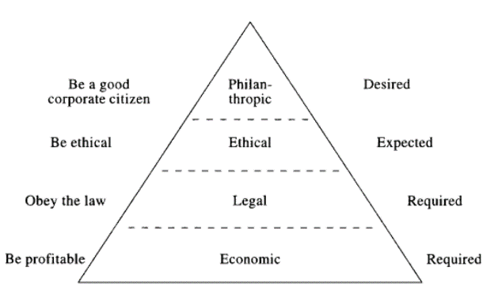
- No reliable guidance in CSR matters

- Corporate Social Responsibility Theory:
- Amoral view:
- traditional view of business (profit maximization)
- Personal view
- corporations are like people, can be held responsible for their actions
- Social view
- corporations are social institutions with social responsibilities

- Contemporary Corporate Social Responsibility Concepts:
- Corporate sustainability:
- the inclusion of social, environmental, economical responsibilities in the context of their impact on stakeholders
- 5 levels:
- compliance-driven: meets the requirements of the law (minimalism approach)
- profit driven: only invests in social, ethical, environmental areas as they
contribute to the bottom line (tactical approach)
- caring: initiatives exceed minimal legal requirements (accommodate approach)
- synergistic: well-balanced solution that generate economic, social,
environmental values that results in gains for all stakeholders (collaborative)
- holistic: fully integrated corporate sustainability into every corporate activity
(utopian)

- Reputational management:
- any effort to enhance the corporation’s image and good name in eyes of stakeholders
- stages: 1. Identify the desired perception
2. recognize the significance of image with all stakeholders
3. be aware of the influence of interaction with stakeholders on reputation
4. manage relationships with stakeholders continuously
* focus on developing relations with all stakeholders

- Social impact management
- complex interdependency between business and society
- society and business cannot exist without each other; must work together to maximize the returns for beach
- evaluate 3 aspects of business: 1. Its purpose (social/business)
2. Social context (are stakeholders considered)
3. Metrics (how is performance/profit measured)

- Triple bottom line:
- evaluates a corporation’s performance according to the economic, social, ethical, environmental value the corporation created/destroyed

- Natural Environmental and Business:
- Pollution vs. Productivity

- Standard environmentalism
- Government intervention is required to protect environment
- Occurs when government regulation/intervention is required to remedy the market’s failure to provide sufficient environmental protection

- Market environmentalism
- There is sufficient profit incentive to protect the environment without gov intervent.
- Occurs when economic incentives created by the market are more effective at protecting the environment than government intervention

Chapter 3: Government segment
- Canada is a democracy, a constitutional monarchy and a federal state (Westminster)
- Head of state: Queen Elizabeth II (represented by governor general – federal, Lieutenant governor – provincial)
- A federal state: constitute of provincial governments
- a common government for common purposes and separate provincial governments for particular purposes of each community
- 3 levels of government (municipal, provincial, federal): each having its own area of exclusive power

- Constitution Act (1982):
- establish 4 legal formulas for amending the constitution
- first 3 formulas give more power to the Parliament and provincial legislature
- set out the Canadian Charter of Rights (democratic, fundamental freedom, mobility, legal, equality, majority language education)
- Give provinces powers over their natural resources
- Areas of common ground:
- Both the government and the business segment strive to maximize the wealth of their stakeholders
- Strive to implement best practices in what they do
- Seek the best and the brightest to populate their ranks
- Operate in an increasingly transparent environment

- Differentiating business and government:
- stakeholder management in government: the actions to meet the needs and expectations of the greatest # of stakeholders will come at the expense other stakeholders who arguably would have the same access to elected officials.

- Canadian federalism:
- Canada: governor by a system of parliamentary democracy: powers divided along the various levels of government that constitute the federal state
- Federalism: a system of political organization; the activities of the state are divided between at least 2 levels of government; each level has certain areas in which it is empowered to make final decision

- Cross-over areas:
- provincial & federal: power over agriculture and immigration; natural resources
* Parliament cannot transfer power to provincial and vise versa; can only delegate the administration of a federal/provincial Act

- Westminster model:
- 3 branches:
- Legislative: House of Commons, Senate
- Executive: Prime Minister, Cabinet, Public Service
- Judicial: independent

- House of Commons
- Legislative
- 338 seats
- Majority government: more then 1/2 of the seats
- Vote of confidence: if minority government; can’t pass a law
- General election at least every 5 years
- Legislation and debates

- Senate
- Not elected; appointed by Governor general on the recommendation of PM
- At least 30, until 75 (unless has messed 2 consecutive session of parliament)
- 105 seats
- Revising and investigatory body for legislation
- Bills from House of Commons pass through Senate for discussion and Royal Assent
- Most senates are affiliated with a political party

- Legislative process
- Introduction
- First reading
- Second reading
- Third reading
- Senate - Royal assent

Introduction:
- The Cabinet
- To preview and decide which measured the government wants to implement through legislation
- Prepare the bill

Reading:
- House of Commons/Senate
- First: the bill is read but no debate
- Second: the bill is debated and voted; sent to a special committee
- Committee stage: analysis/examines the bill clause by clause; report (approve/not)
- Report stage: debate on further amendments
- Third: final debate and vote

Senate:
- Discus and vote
- Royal assent by the governor general

Private bill: matters of particular interest or benefit to a person/corporation
Public bill: introduced/sponsored by a minister; only introduced by a Minister

- Parliamentary committees:
- Standing: focus on an area of government policy (ex. Public accounts)
- Legislative: examine specific government bills after 2nd reading
- Special: examine special issues (ex. Childcare)
- Subcommittee: report to the main committed not to House
- Joint: composer of members from House and Senate
- Committees of the whole: all members from House and Senate

- Executive branch
- Prime Minister: strongest voice in Canada
- Cabinet: selected by PM on the basis of experience from elected members of his party
- Public service: translate what the elected official wants to do
- Departments & Agencies: PM decided on #; responsible for designing policies
- Central agencies: Privy Council Office; Treasure Board; Secretariat; Finance Canada
- Judiciary: judges/Supreme Court are appointed by GG on the advice of Cabinet (75s)
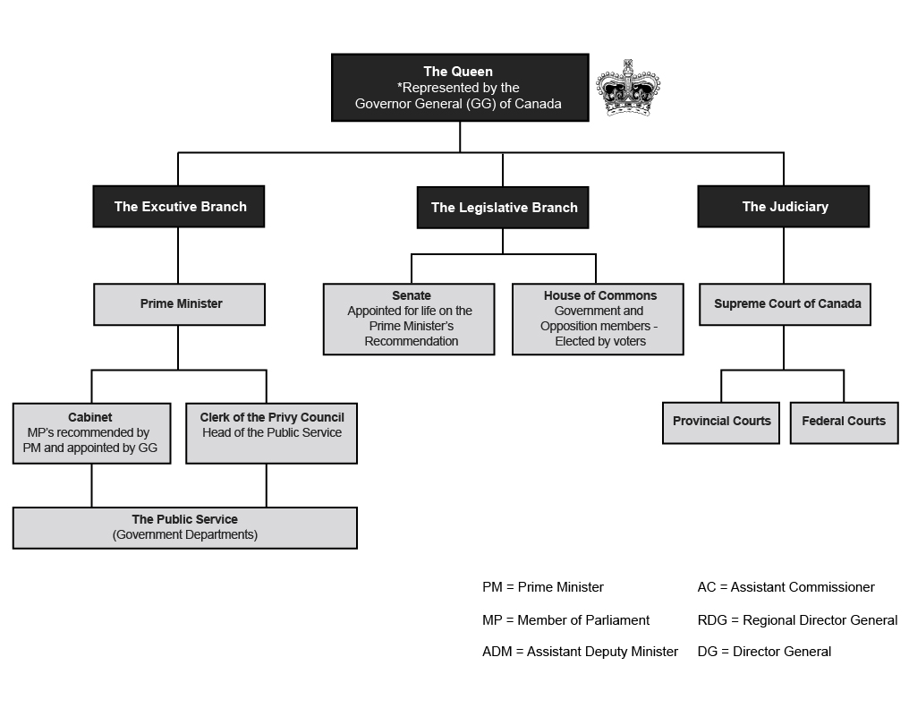

- Public Policy:
- Whatever governments choose to do or not do
- Government’s response to an existing social issue
- Key influencers:
1. Public
2. Government
3. Public service
4. Judiciary

- Process:
1. Identify the problem
2. Setting the agenda
3. Formulating the policy
4. Implementing the policy
5. Evaluating the policy
exchange
private goods
economic values
self-interest
invisible hand
producers-consumers
consumer sovereignty
profits as rewards
business firms
efficiency principles
political
public goods
diverse values
public interest
visible hand
politicians-citizens
citizen sovereignty
power as reward
government agencies
justice principles
Business Segment
Political Segment
Chapter 4: Civil Society Segment
- Any organizations that are independent of business and government and that cannot be classified as part of the business or government segments
- Include less format organizations much as a group of neighbours, co-workers
- The community, volunteer sector, civic sector, civil society
- Activity mainly instituted through forms of reciprocal relationship/solidarity
- Generate low levels of revenue on which the rely to further their cause
- Key terms:
- community
- reciprocity-biased value system
- trust & collaboration
- social arrangement
- social capital
- civic engagement

- Common characteristics: the totality of voluntary civic/social organization/institution
- non-governmental
- non-profit; not-for-profit
- independent
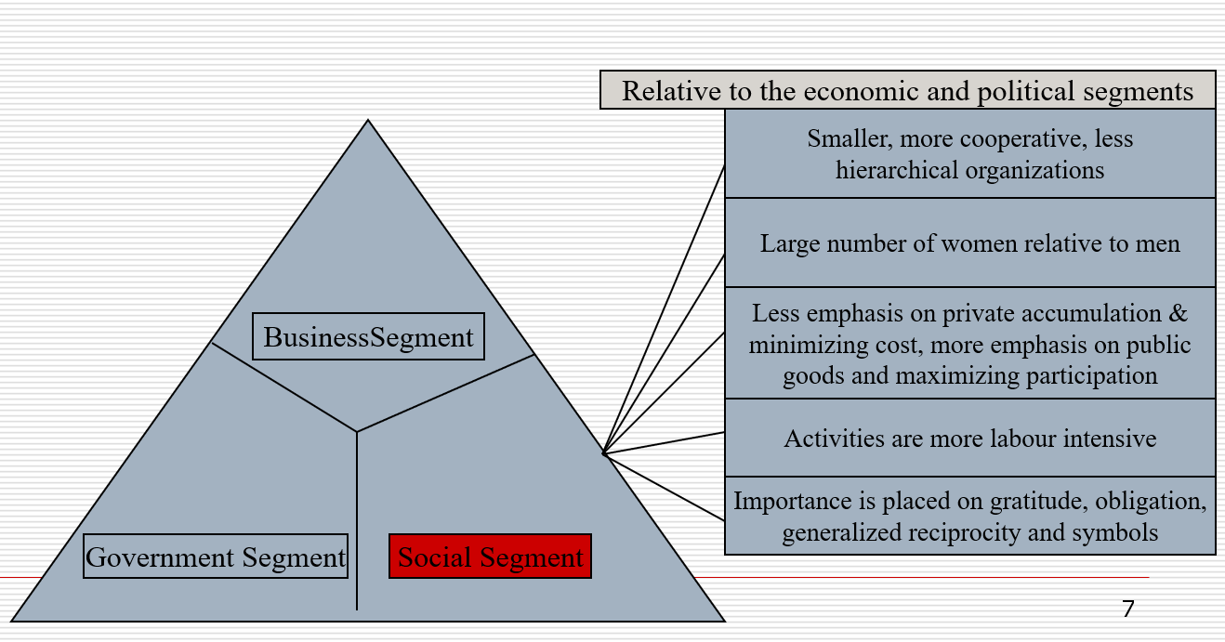
- voluntary
- community

- Overall characteristics:

- Dynamic of the Civil society segment
- Different from economic/political segments
- Business: sorting mechanism is supply/demand in the context of competition
- Political: sorting mechanism is redistribution and coercion
- Social: a set of social arrangement that are continually evolving into active networks of non-market and non-state arrangement

- Social capital:
- Defined as the relationships, networks, norms that facilitate collective action;
- Connections among individuals;
- Social/civic participation with networks of co-operation and solidarity;
- It is difficult to define in tangible terms
- Key characteristic that differentiates it from the operation of the business and government segments
- Civil society is both produce/user of social capital (collective wealth)
- It reflects the sorting mechanism of civil society

*social capital is not human capital
Human capital: knowledge, experience, skills, personal attributes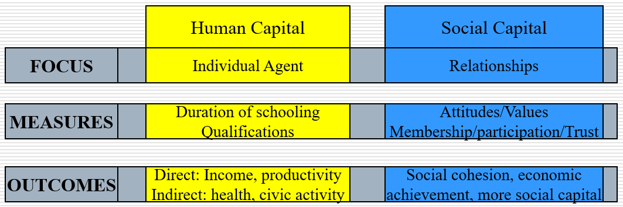
- 4 types of personal capital:
- Social capital: who you know
- Economic capital: what you have
- Cultural capital: legitimate knowledge
- Symbolic capital: your status in the eyes of others

- How social capital forms:
- Individual based economic model of social capital investment
- The set of social attributed possessed by an individual that increase the returns to that individual in his dealing with others
- It is individual and not communities who decide to invest in social capital

- Highly formal forms: formally organized (hierarchy), membership dues
- Highly informal forms: ex. a group of people gathering at a restaurant
- Densely interlaced/comparatively invisible: known people with whom you often do the same activity (ex. co-worker, club friends)

- Roles of civil society
- Monitoring through which policy is kept honest
- Advocacy through which policy options can be supported/not supported
- Innovator through which different way of doing things are developed and demonstrated
- Service provider through which a particular need is fulfilled
- Capacity builder through which support is provided to bother civil society organizations

- Contributions of civil society:
- Alternative service delivery models based on inter-sectoral partnership
- Employment generation and recognition
- Valuing/conceptualizing the importance of community
- Civic engagement

- Challenges/Issues:
- Segment fragmentation:
- a large # of organizations serving a multitude of interests/causes resulting in difficult in bring heard by government/business
- difficulty for small organizations to be heard and get partnering with gov/business
- challenging to influence public policy development

- Funding
- a finite amount of money to be shared amongst the fragmented segment
- the government needs to endure that funds provided are used appropriately
- overhead costs not founded, but more reporting
- founding provided for specific issues and cause “mission drift”

- Attracting and retaining volunteers & strong non-profit board members
- Aging population: more people available for volunteering; more demand for services
- Changing volunteer paradigms (5 styles)
1. employee volunteerism: employee participation is lined with philanthropic dollars
2. episodes volunteerism: one-time volunteer, short duration
3. virtual volunteerism: off-site volunteer activities through use of technology
4. cross-national volunteerism: undertake volunteer activities cross national borders
5. voluntourism: volunteer take volunteer vacation
- Crowdfunding
- A fast-growing method of helping, allow people to instantly feel good about doing so
- Raising too much money instantaneously for a cause; legal issue of management
- Measuring outcomes
- Demonstrate to stakeholders that what they do matter and makes a difference

- Recommendation
- The government could create a secretariat on the charitable and non-profit sector to:
• establish and convene regular meetings of an interdepartmental working groups
• convene meetings of appropriate groups of federal/provincial ministers with responsibility for various aspects of regulating and relating to the charitable and non-profit sectors
• publish an annual report on the state of the charitable and non-profit sector
- develop and implement a national volunteer strategy to encourage volunteerism
- government (minister of finance) support the development of pensions for the charitable and non-profit sectors

- Connection: (business, political, social)
- Continued commitment and cross-sectoral collaboration
- No one sector can tickle complex social problems alone
- The communities we serve feel direct impact of political climate

- Influence
- Government
  - Non-profit are valuable service providers
  - Policy advisors
  - Collective voice for change

- Business
  - Volunteerism
  - Corporate social responsibility: a company's commitment to environmental and economic effects of its operations responsibly
* Corporate Social Responsibility is a company’s commitment to manage social, environmental and economic effects of its operations responsibly.

- Foundations of our misconstruction:
- Constraints on competition
- Advertising and marketing
- Taking risk
- Time
- Profit
Chapter 5: Stakeholders and Stakeholder Management

- Stakeholders:
- Any group/individual who is affected by/can affect the achievement of an organization’s objective
- Pluralism:
- A condition in which there is diffusion of power among society’s many groups and organizations – a wide decentralization and diversity of power concentration
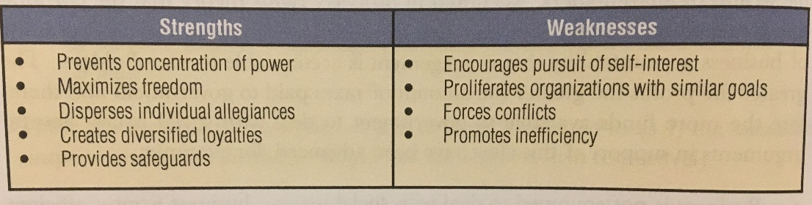
- Shareholder vs. Stakeholder:
  - Stakeholder:
- individuals/groups with a multitude of interests, expectations, demands as to what business should provide to society
- business’s purpose goes beyond simple profit maximization
- business has a responsibility to do more than maximize profit
- it is to make a profit so that the business can do something more or better
- business has caused several problems so it must fix them
- social institution theory (society provides the very existence of business through legal frameworks)

  - Shareholder:
- the only social responsibility of business is to use its resources and engage in activities designed to increase its profit
- a business exists to make money – greatest efficiency is achieved through profit maximization
- profits > taxes paid to government for use in dealing with social issues
- property rights theory (corporation owned by shareholders)

- Key Q in stakeholder management:
1. Who are stakeholders?
2. What are stakeholders’ stakes?
- the nature/legitimacy of a group’s stakes
- the power of a group’s stakes
- the specific groups within generic group)

3. What opportunities and challenges do stakeholders represent?
- productive working relationships within stakeholders
- challenges and action on how the form handles stakeholders

4. What economic, legal, ethical, and philanthropic responsibilities does a firm have?
- deal directly/indirectly with stakeholders
- take the offence/defense in dealing
- accommodate, negotiate, manipulate, resist stakeholder overtures
- employ a combination of the above/singular strategies

5. What strategies or actions should firms take to manage stakeholders’ opportunities
and challenges?

- Key stakeholder
- Who can exert and sustain a positive/negative affect on the organization
- High interest, high power to influence
  - Primary stakeholder
- those that have a direct interest in the organization & its success
  - Secondary stakeholder
- those that have a public/special interest in the organization

  - Core stakeholder: essential to the firm’s survival
  - Strategic stakeholder: directly affected by threats and opportunities the organization faces
  - Environmental stakeholder: all other in the organization’s environment
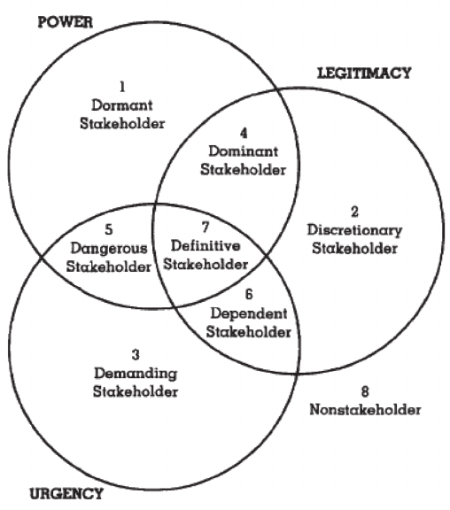
- Stakeholder attributes
- Power: stakeholder’s ability to product an effect
- Legitimacy: the perceived validity of stakeholder’s stake
- Urgency: the timeliness with which the business must address the stakeholder’s claim

- Identifying stakeholders
- To identify and individual, group, organization, inanimate object that have a stake in the organization’s operation
- Any party possessing at least one of attributes is a stakeholder

- Stakeholder capacity
- An approach to identifying the capacity for a stakeholder to exert positive/negative influence on an organization with the level of risk tolerance the organization is willing to assume
- Risk:
- 2nd aspect proposed in the stakeholder capacity model
- A possibility of adverse consequences
- A possibility of exposure to loss

- Stakeholder capacity model
- Evaluate:
  - The capacity of a stakeholder to affect the organization (P/N)
  - The risk of them doing so
  - The risk tolerance level of managemnt in term of the stakeholder doing so

- Steps:
1. Develop an initial stakeholder list
2. Rate each stakeholder on a scale of Low, Medium, High in terms of their capacity to affect the organization (positively or negatively)
3. Assign a numerical value to Low, Medium and High (such as, for example, 1,2 and 3)
4. Compute the overall score for each stakeholder
5. Associate each stakeholder’s score with a predetermined stakeholder relevance interval
6. Determine how each stakeholder will be managed: partner, dialogue or passively observe
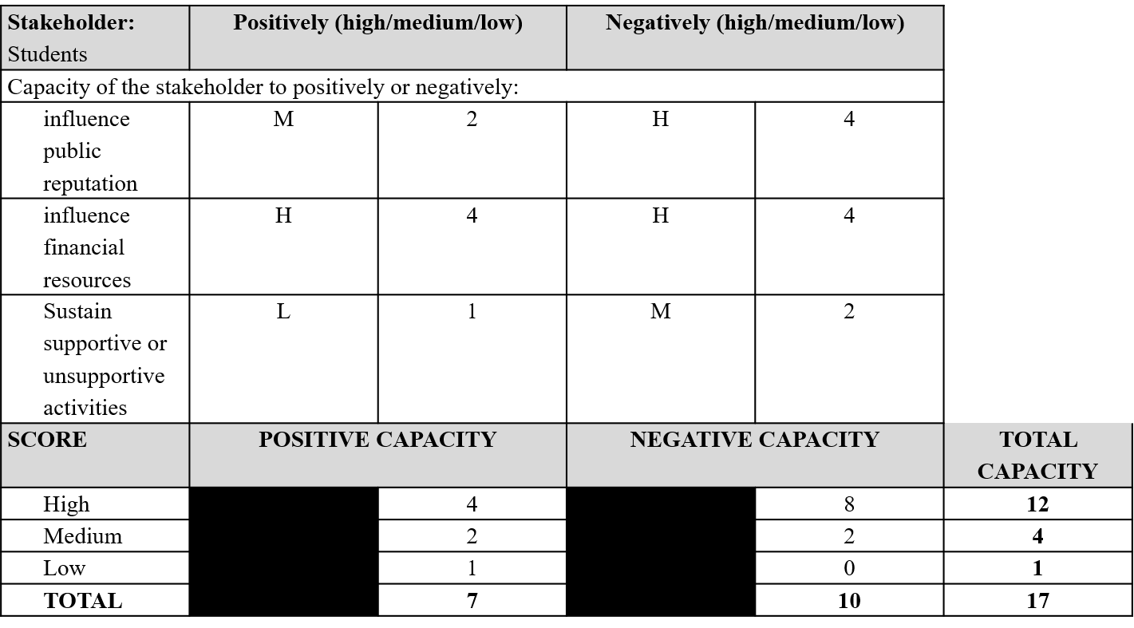
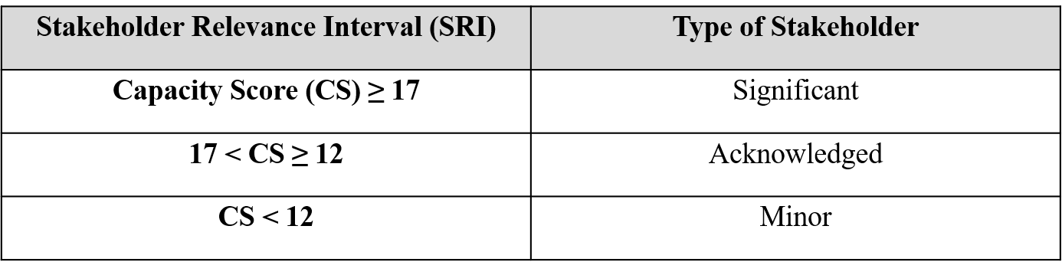

- Important Considerations:
- Senior management decides which areas of stakeholder influence are most important and applies these to every stakeholder in the analysis
- Senior management decides the numerical value or “weight” to associate with each scale amount Low, Medium, or High
- Senior management decides the amount of each Stakeholder Relevance Interval and this is risk-informed
- All these attributes can change based on strategic analysis; at the discretion of senior management

