Procedure – Charles’ Law: As outlined in the lab manual. (1)

Procedure – Boyle’s Law:
- Put LabQuest into data collection mode.
- Remember that there is a little bit of volume in the pressure sensor to account for so add .8ml to all original volumes.
- Set volume on LabQuest to 10.8 mL or what was determined the starting volume should be.
- Choose 7 other set volumes to test at.
- Adjust syringe to starting value.
- Connect pressure sensor and record pressure at your starting value.
- Adjust syringe to other pre-determined values and record pressures.
- Go back to your initial volume and record it as a second point to compare to your other initial pressure.
- Repeat so that each volume has 2 trials.
Limitations:
- Hands cannot keep the volume at a consistent measurement on the syringe for a long time.
- Pressure could leak out of the syringe and an unsecure labquest connection.
- The measurement of the volume being slightly off on the syringe since the plunger is hard to measure.
- Gases in this experiment are assumed to be ideal gases.
Discussion:
Charles’ Law
V1 = 151 mL T1 = 373K
V2 = 127 mL (refer to sample calculations) T2 = 280K
With these values Charles’ Law can be verified.
Verification of V1/T1 = V2/T2: 151mL/373 K = 127mL/280K. .404 is about .454
The percent error for this experiment was 12.0%(refer to sample calculations), this is a very low number but it’s also because there is little room for error in measurement. This allows the experiment to be carried out easily, Charles’ Law states that p1/v1 = p2/v2, this was verified by finding the volume of an empty flask and heating it. It was then cooled, and the volume of the flask afterwards was determined by finding the amount of water that would occupy the flask and subtracting that from the original volume. The reason why the ratio isn’t the same could be because of the experimental limitations listed above, chiefly that the V2 found was too large or the T2 was too small due to measurement errors with the thermometer. V2 could have been found wrongly due to inaccuracy of measurement of the Erlenmeyer flask when finding out how much water occupied the empty space.

Boyle’s Law
Data table of Volume(mL) vs Pressure(kPa) of trial 1 of Boyle’s Law
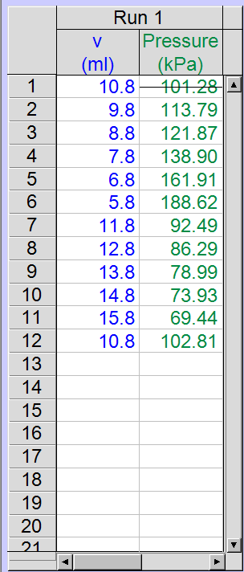
- Using the data, a Boyle’s Law constant was found to be 1095.65. The constant was determined by the fact the product of pressure and volume will stay constant if the temperature and amount of gas is kept the same. This constant can then be found and manipulated with Boyle’s law to find pressure.
- Boyle’s law states that p1v1 = p2v2 which was originally found by Robert Boyle in his J-tube of mercury experiment (2). With this constant another equation can be written as P = c * (1/v)(2). C is just the constant found earlier and the new v is v2 from earlier, P is also just P2 from the earlier equation. This equation is to find the new pressure of a gas if the original pressure and volume is known as well as the new volume.
- A second measurement of the same initial mark was taken firstly because this can help validate that the experiment was carried out correctly and that pressure did not leak out or somehow come in, the initial reading in this case should be the same or very close as the final at the same volume. Secondly, this can help prove consistency and confidence to the results. The measurement that was stricken through on both trials was the initial measurement taken. In both cases the measurement fit better with the rest of the data most likely due to the pressure readings being more stabilized by the end of the trials.
- Boyle’s law only works when it is applied to an ideal gas, an ideal gas is a gas whose pressure, volume, and temperature are related by PV= nRT. (the ideal gas law). It also requires that temperature and the amount of gas in the space is not altered. Temperature was ensured to not be altered because the syringe was kept in room temperature the entire time, the only other variable that could have been changed would be if air leaked out of the syringe or pressure sensor. This would then decrease the constant found since it would cause a decrease in pressure. Graph of Volume(mL) Vs Pressure(kPa) for trial 1 of Boyle’s Law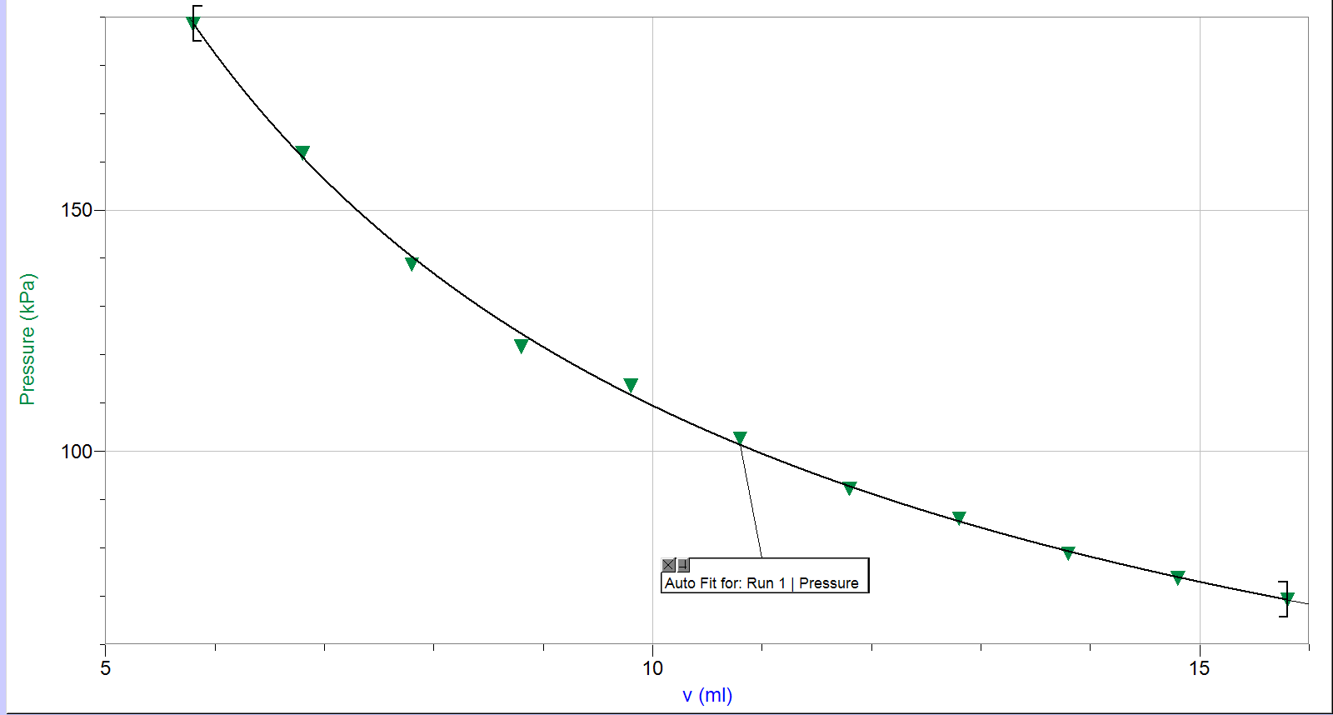
Through this graph, the relationship of Boyle’s law can be easily seen, as the volume goes up the pressure goes down.

Conclusion:
Charles’ law (v1/t1 = v2/t2) was verified by experimentally finding v2 in that there was only a 12% error between v1/t1 and v2/t2.
Boyles’ law (p1v1=p2v2, p=c(1/v))(2) was verified by experimentally finding pressures of independent volumes of air. A constant was then found by the averages of each PV.

Reference(s):
(1): (“What in the World ISN’T Chemistry”, General Chemistry Laboratory Manual, Dr. Rashmi Venkateswaran, 2019.)
The laboratory manual used to carry out this experiment and to verify these laws.
(2): https://www.britannica.com/biography/Robert-Boyle, Lawrence M. Principe, Encyclopedia Britannica
This source provides an explanation on how Robert Boyle used the J-tube of mercury experiment to prove his law: p1v1= p2v2 and an outline of the experiment he performed. Not only is this very important to understand Boyle’s law, it’s also important to understand on how the constant of Boyle’s law works and came about.

Appendix:
Raw Data:
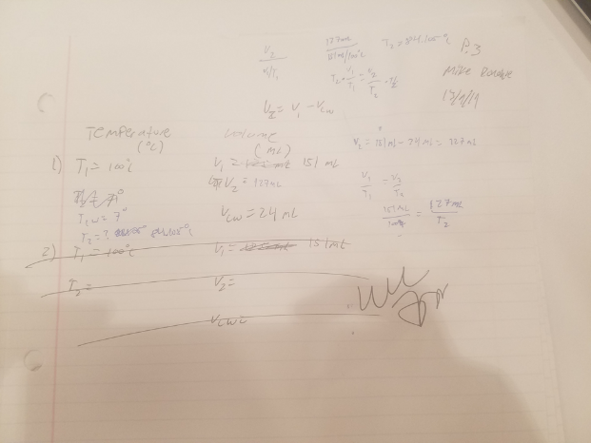 (Charles law data)
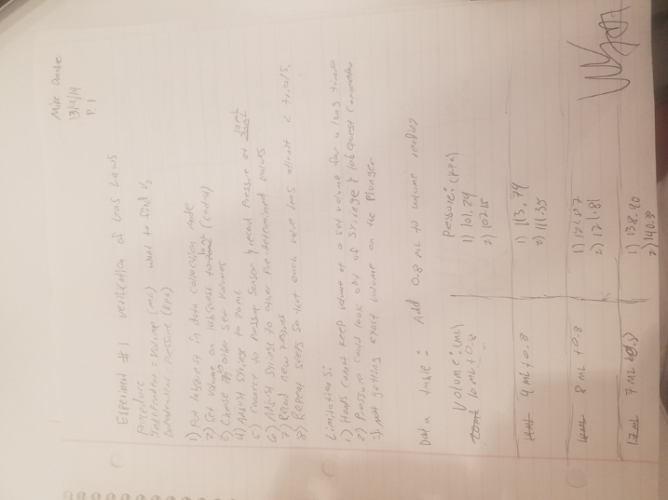 (Boyle’s law data p.1)
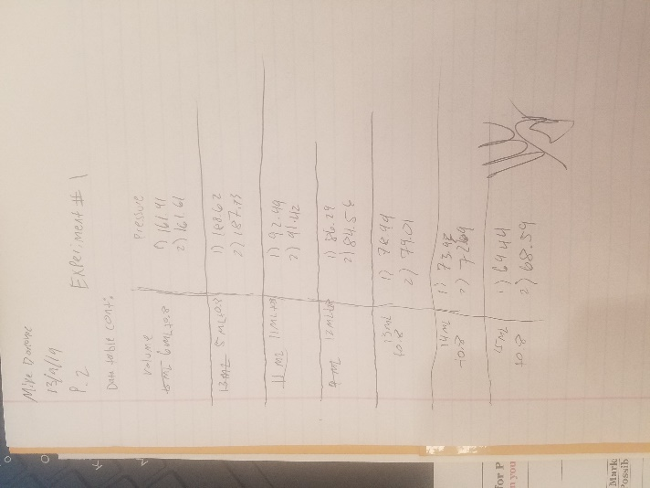(Boyle’s law cont)

Additional Data, Charles’ Law
None
Additional Graphs, Charles’ Law
None
Sample Calculations, Charles’ Law
Sample calculation to find V2: V2 = V1- Vcw
V1= 151 mL Vcw = 24 mL. 151 – 24 = 127 mL
T1 = 100C + 273 = 373K
T2 = 7 C +273k = 280K
Percent error: ((v1/t1)-(v2/t2))/(v1/t1) X 100= ((151mL/373k)-(127mL/280K))/(151mL/100C) X 100 = 12.0 %

Additional Data, Boyle’s Law
Data of Volume(mL) vs Pressure(kPa) of trial 2
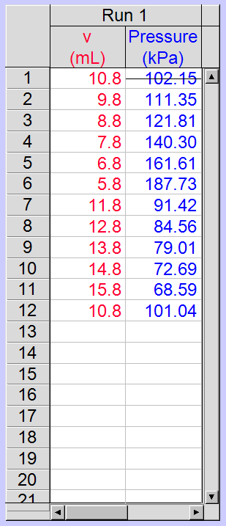

Additional Graphs, Boyle’s Law
Graph of Volume(mL) vs Pressure(kPa) of trial 2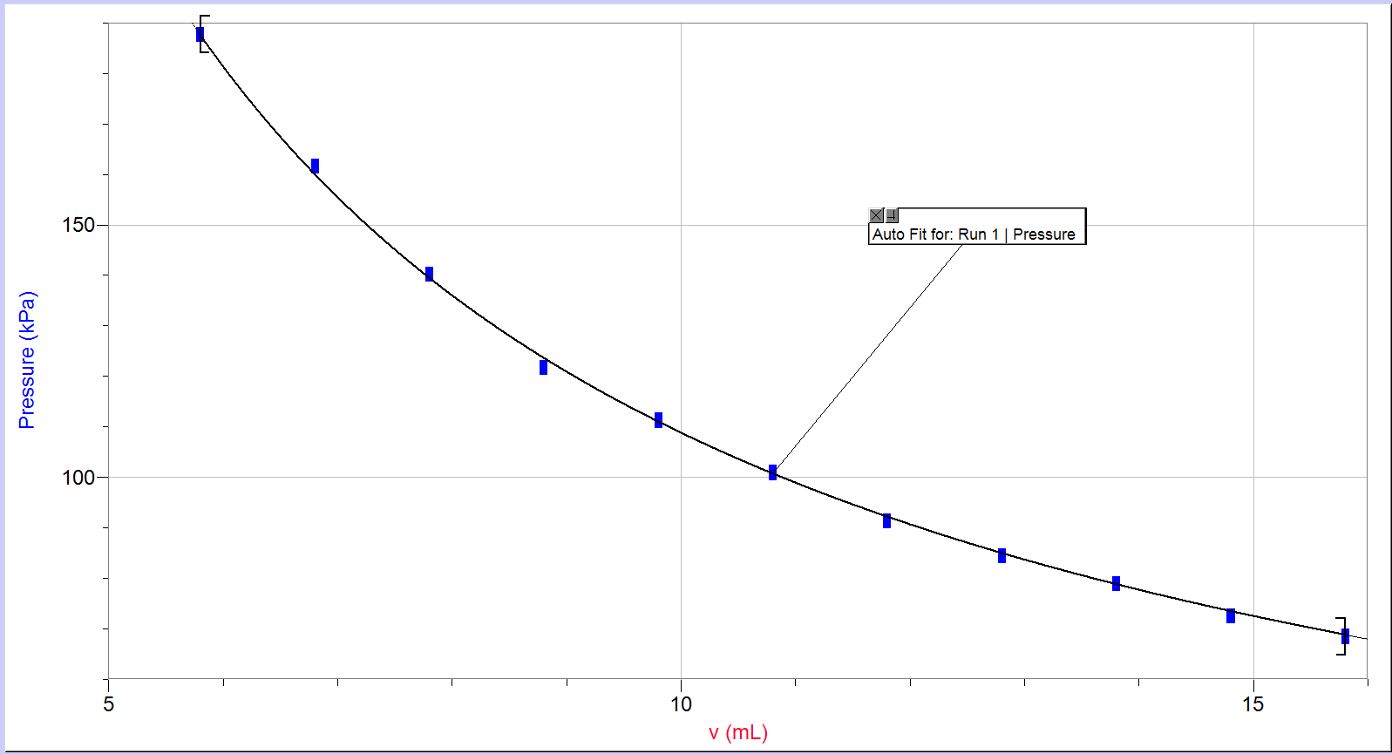

Sample Calculations, Boyle’s Law
Finding Boyle’s Constant:
PV = C
101.28kPa*10.8mL = 1093.82
113.79 * 9.8 = 1115.14
121.87 * 8.8 = 1072.46
138.90 * 7.8 = 1083.42
161.98 * 6.8 = 1101.47
188.62 * 5.8 = 1093.99
92.49 * 11.8 = 1091.38
86.29 * 12.8 = 1104.51
78.99 * 13.8 = 1090.06
73.93 * 14.8 = 1094.16
69.44 * 15.8 = 1097.15
102.81 * 10.8 = 1110.35
Take the average = 1095.66
Assessment Criteria Sheet

