Purpose:
Demonstrate the ability to backup and restore Oracle database using RMAN.

Submission:
Submit via Brightspace a Word document containing the specified output for each question. Submission and demonstration is due before the end of the next scheduled lab session. This lab is worth 2 marks towards your lab grade.

Deliverable:

Part 1: Read Portions of the RMAN Document and Answer Questions:

Read the sections identified below of the oracle documents. You can find the document at: https://docs.oracle.com/cd/B10501_01/server.920/a96566/rcmcnctg.htm

Starting RMAN: Overview;

Starting RMAN without connection to a database;

Connecting to a database without a Recovery Catalog;

Connecting to a database and Recovery Catalog;

What are the basic options a DBA has to start RMAN:

Start the RMAN executable at the operating system on CMD while connecting to one or more databases, as in below examples.

% rman TARGET / CATALOG rman/cat@catdb

% rman TARGET SYS / oracle@trgt NO CATALOG

% rman TARGET / CATALOG rman/cat@catdb AUXILIARY SYS/oracle@auxdb

What are the types of databases that you can connect to:

Target database: - RMAN connects you to the target database with SYSDBA privilege. If do not have this privilege, then the connection fails.

Recovery catalog database: - This is optional. We can also use RMAN with the default NOCATALOG option.

Auxiliary database: - We can connect to a standby database, duplicate database or auxiliary instance).

- How to start RMAN?

- In batch mode by specifying a command file that contains a series of RMAN commands.
- In interactive mode.
- With a command pipe.
- With a log file that redirects RMAN output.

Part 2: Unlocking an oracle account:

Connect to oracle (using cmd running as administrator & then invoking sqlplus) as the SYSTEM user and unlock the SYSBACKUP user. Moreover, alter the password of the SYSBACKUP user and change it to 1.

Connect as the unlocked SYSBACKUP user. Take a screen shot of your work and paste it below:
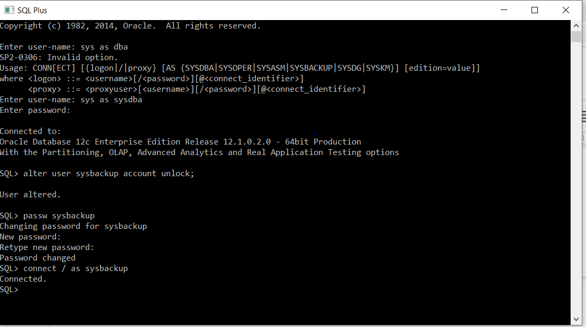
- Log in to RMAN as SYSBAKUP. Remember, you have to exit the SQL command prompt and return back to operating system cmd in order to start RMAN.
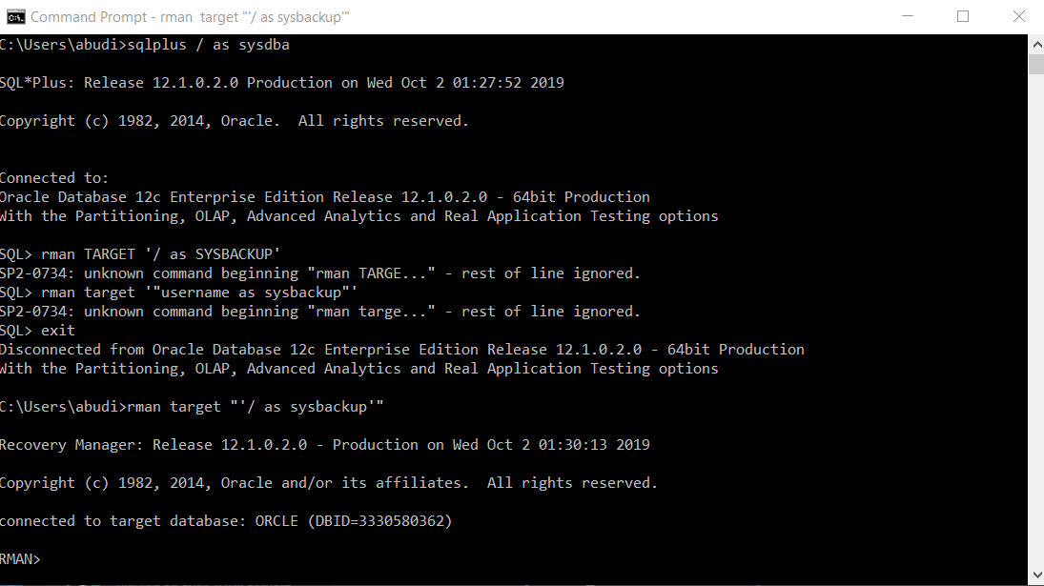
- Open a new SQL session and log in as SYSTEM. Use the show parameter recovery command to show the settings of all recovery parameters. Take a screen shot of your work and paste it below.
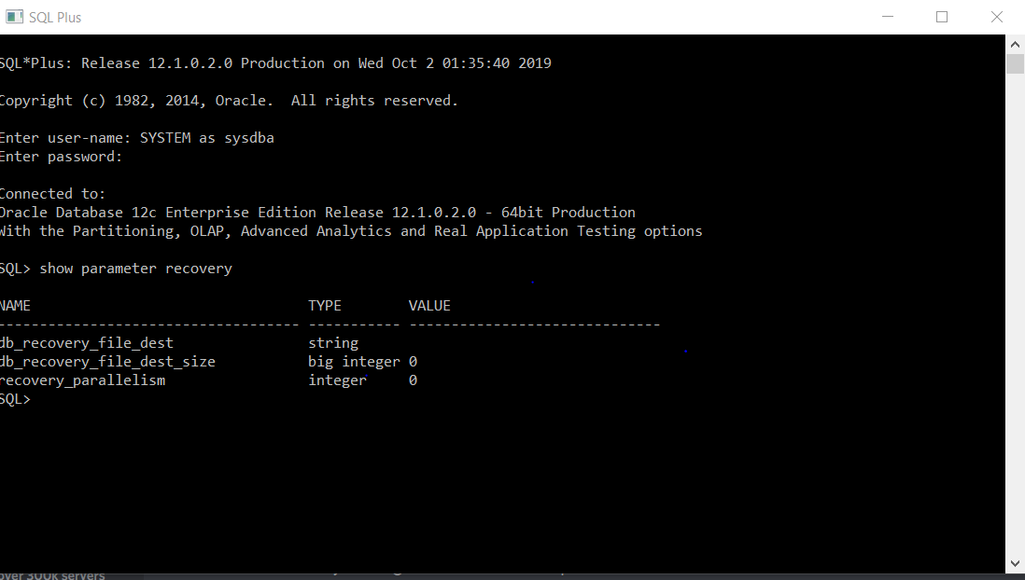
- Now we want to configure the fast recovery file destination and size. Set the fast recovery file destination size to be 4G (use: sqlplus> alter system set db_recovery_file_dest_size=4G; ) and then set the file destination to be ‘C:\app\yourname\fast_recovery_area\orcl’. Change the path depending on your computer setting. Run the show parameter recovery command again and take a screen shot of your work and paste it below.
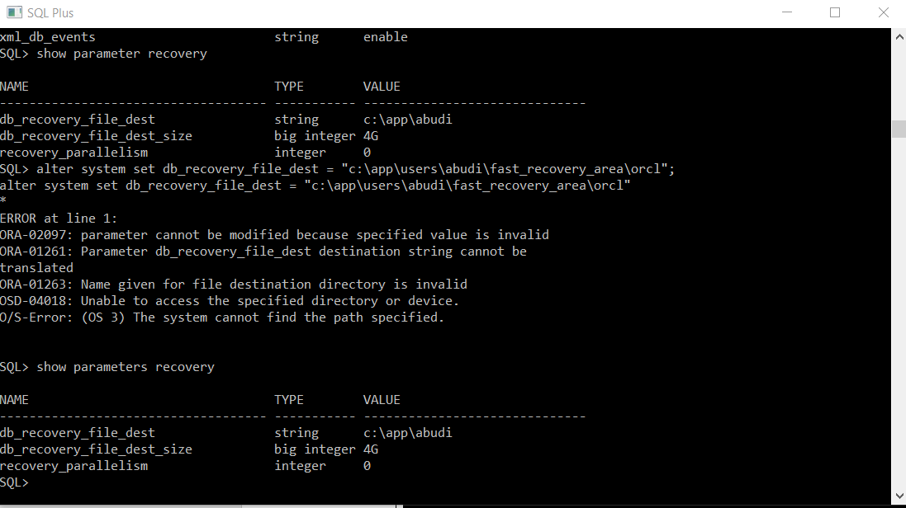
- Open a new SQL session and log in as sysdba user ( > SQLPLUS / AS SYSDBA). Check if the database is in the archive mode by executing the archive log list command. Take a screen shot of your work and paste it below.
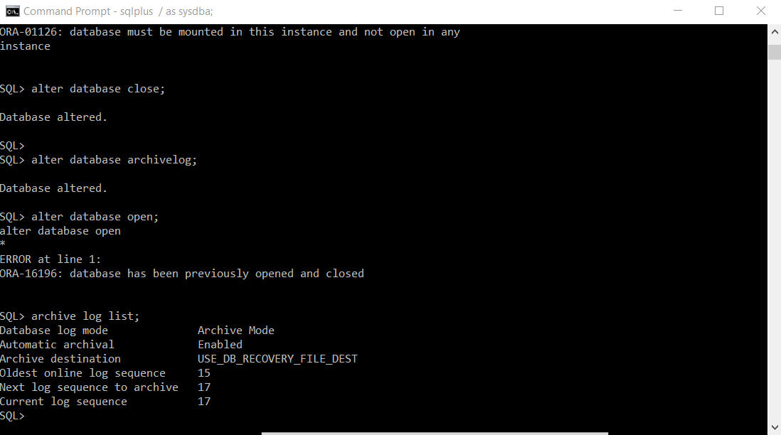
- Open a new terminal and invoke RMAN and connect as SYSBACKUP user. Then execute the shutdown immediate command to shutdown the database instance. After that startup the instance and mount the database (startup mount). Take a screen shot of your work and paste it below.
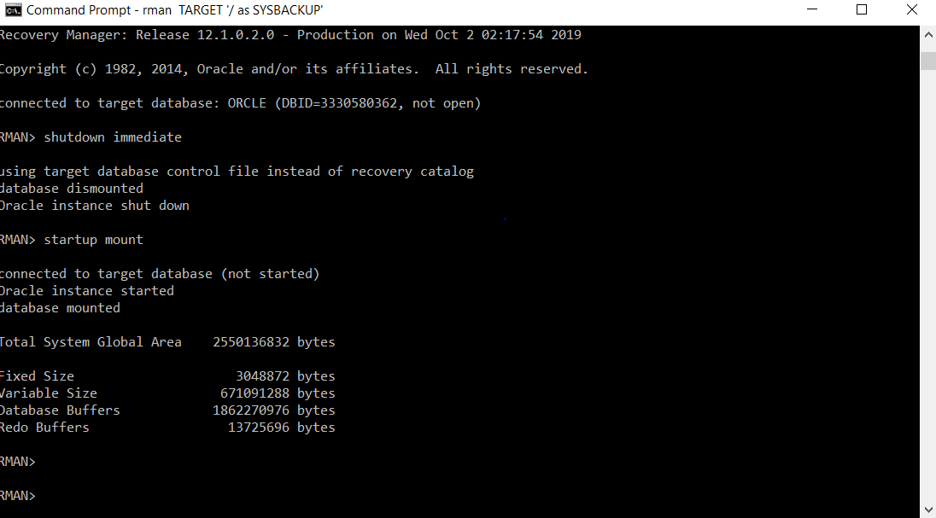
- Execute the backup database command to create a backup before you change the archivelog mode. Take a screen shot of your work and paste it below.
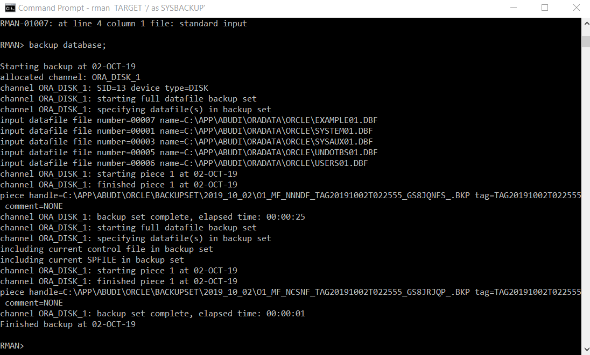
- Use the command List backup; to list the backups. After that, use the delete backup; command to delete the backups. List again the backups that you have. Take a screen shot of all the commands that you have executed in this part.
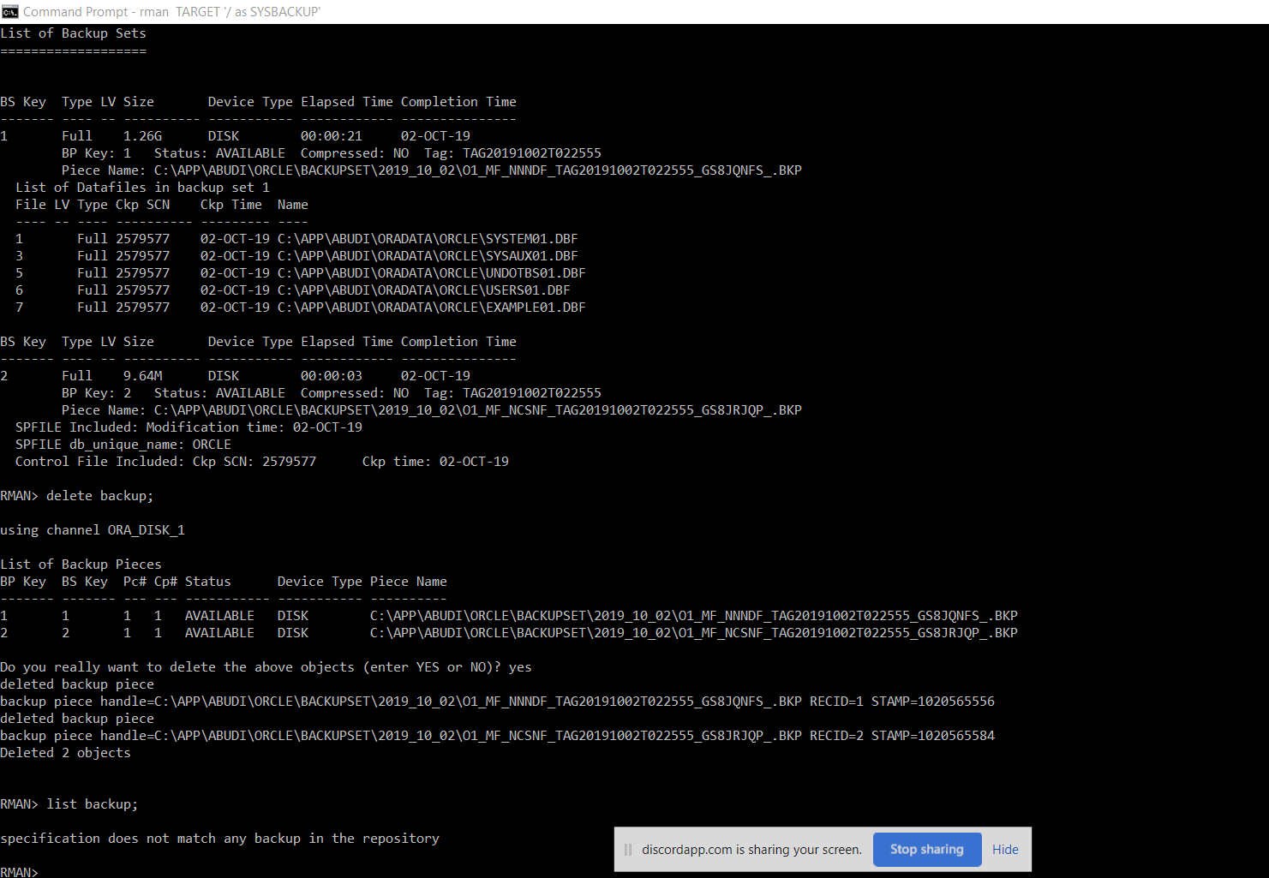
- Execute the alter database archivelog command to put the database in ARCHIVELOG mode. Then open the database (alter database open). Take a screen shot of your work and paste it below.
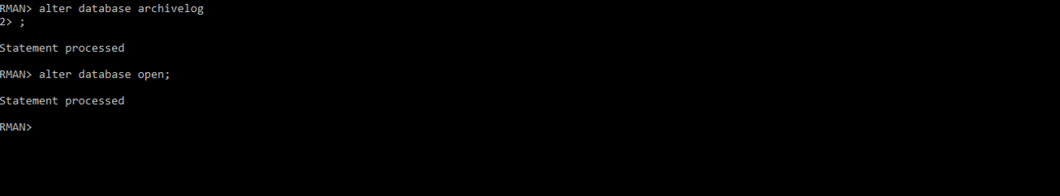
- Now return to the SQL session, you may need to connect as sysdba again, and execute one more time the archive log list command. Take a screen shot of your work and paste it below and then exit the SQL session.
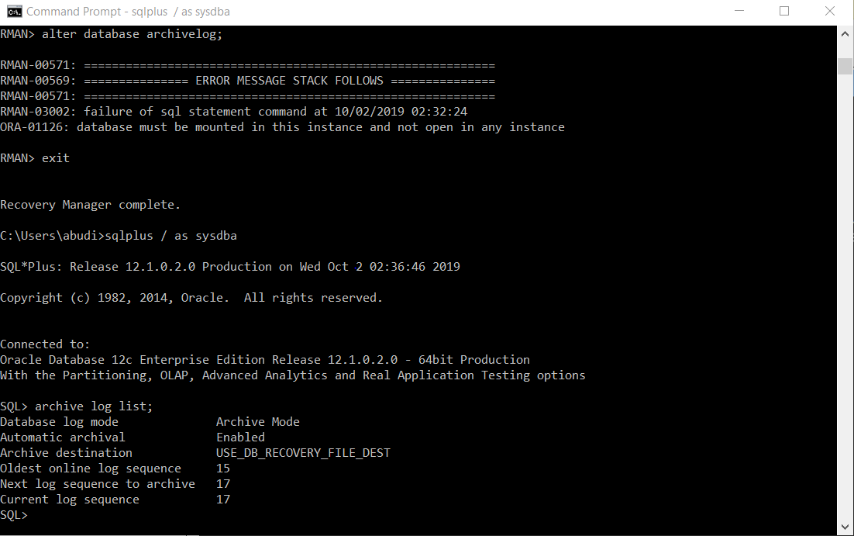
- Return to your RMAN session. Back up the database by executing the BACKUP DATABASE PLUS ARCHIVELOG command. Take a note of the name of the control file. Take a screen shot of your work and paste it below
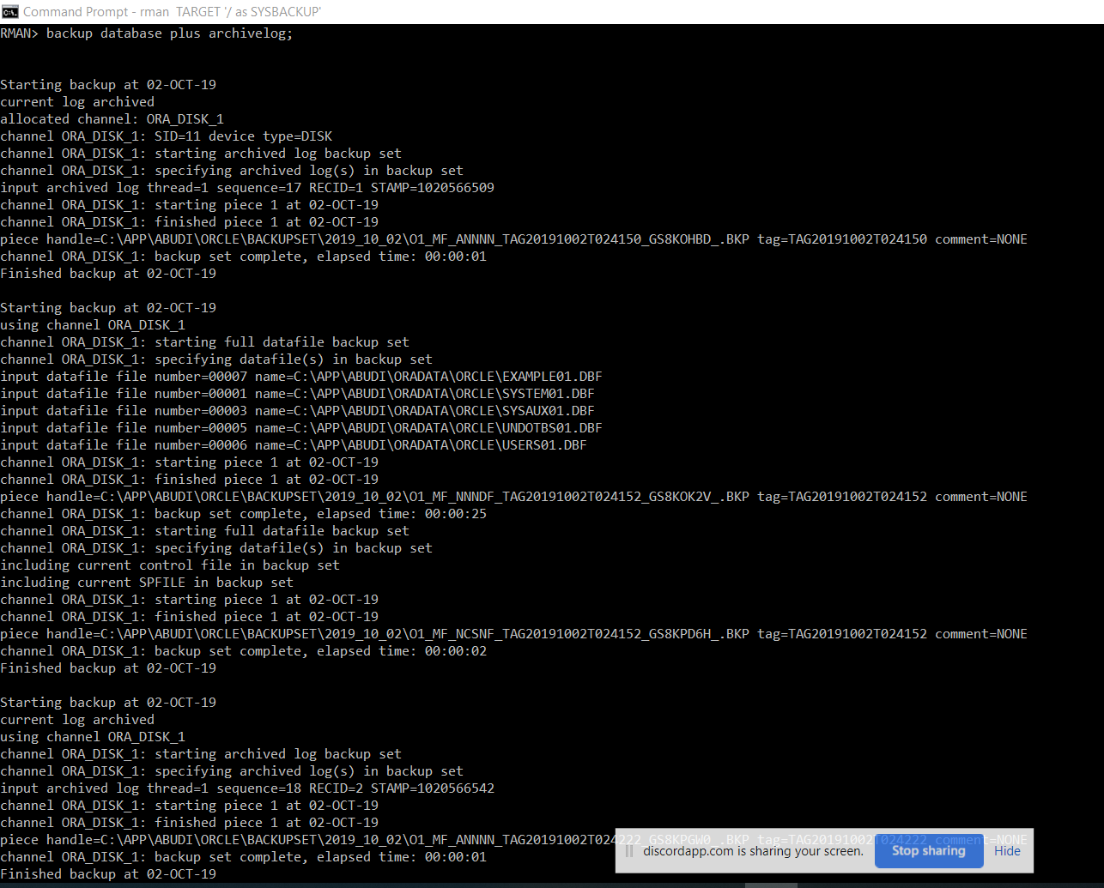
- Use the SHOW ALL command to view the RMAN configuration settings, including backup settings.
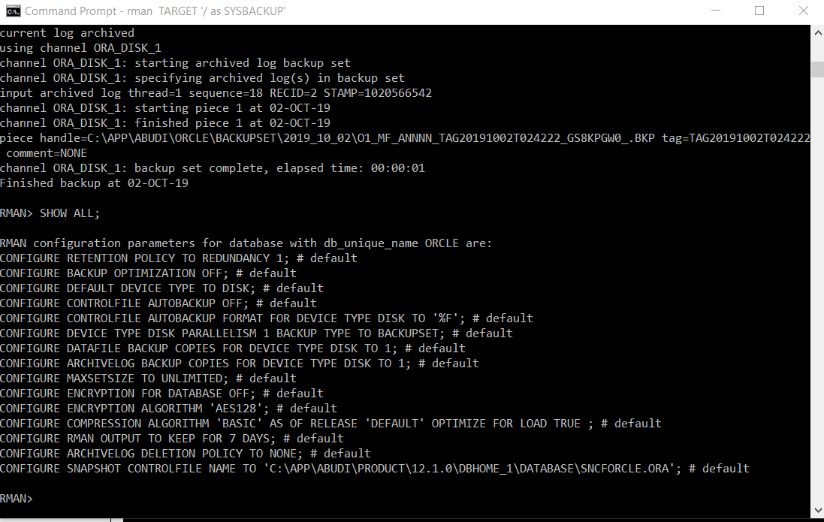
- If the default device for backups is not set to disk (the default), use the CONFIGURE DEFAULT DEVICE TYPE TO DISK command to set it.
- Verify the setting by using the SHOW DEFAULT DEVICE TYPE command. Take a screen shot of your work and paste it below.
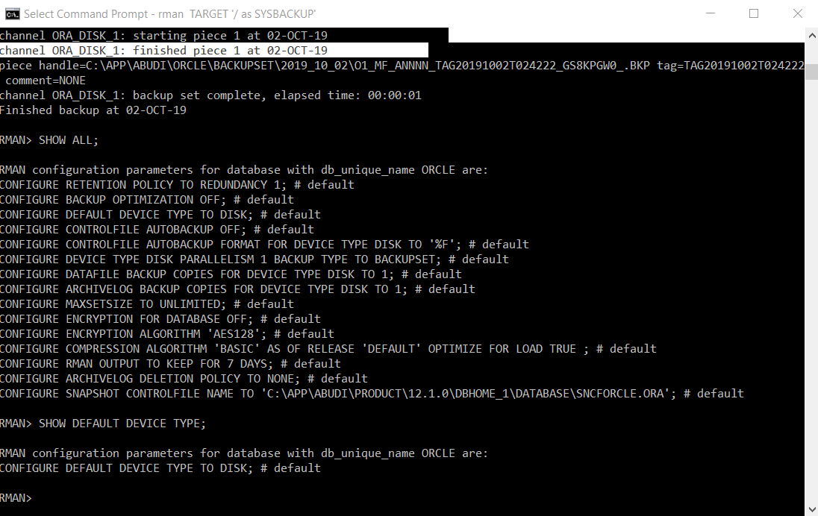

- Enter the LIST BACKUP SUMMARY command to display backup information stored in the RMAN repository. Take a screen shot of your work and paste it below.
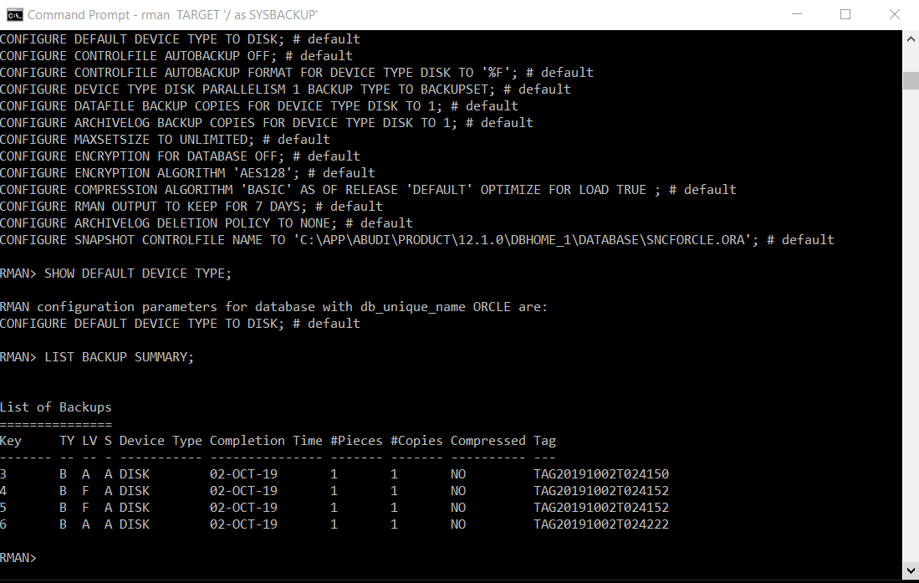
- Execute the LIST BACKUP OF DATAFILE specific_datafile_ID; command to view detailed information stored in the RMAN repository about the backup of a specific datafile. Take a screen shot of your work and paste it below.
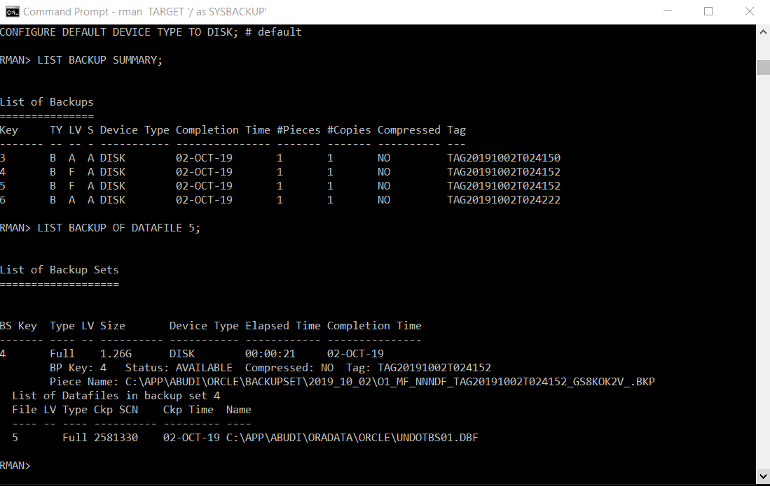
- Execute the VALIDATE DATAFILE specific_datafile_ID; command to validate the backup for a specific datafile. The VALIDATE command determines whether the backup exists. Take a screen shot of your work and paste it below.
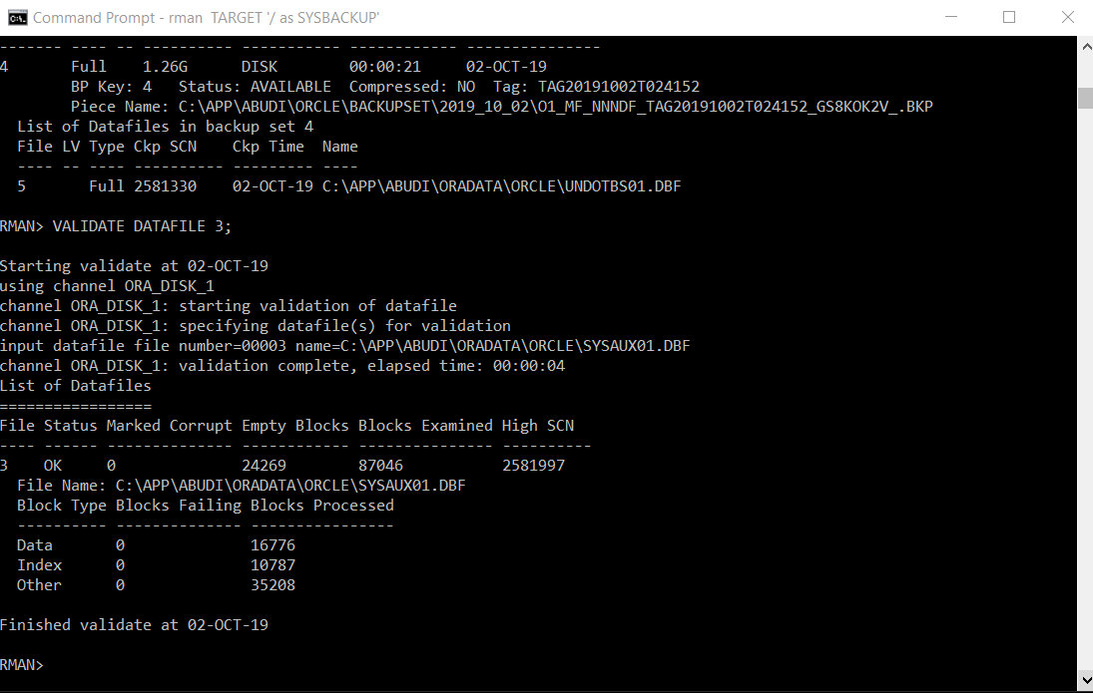
- Execute the RESTORE TABLESPACE tableSpaceName VALIDATE command to validate that the datafiles for the specified tablespace named ‘tableSpaceName’ can be restored. Take a screen shot of your work and paste it below.
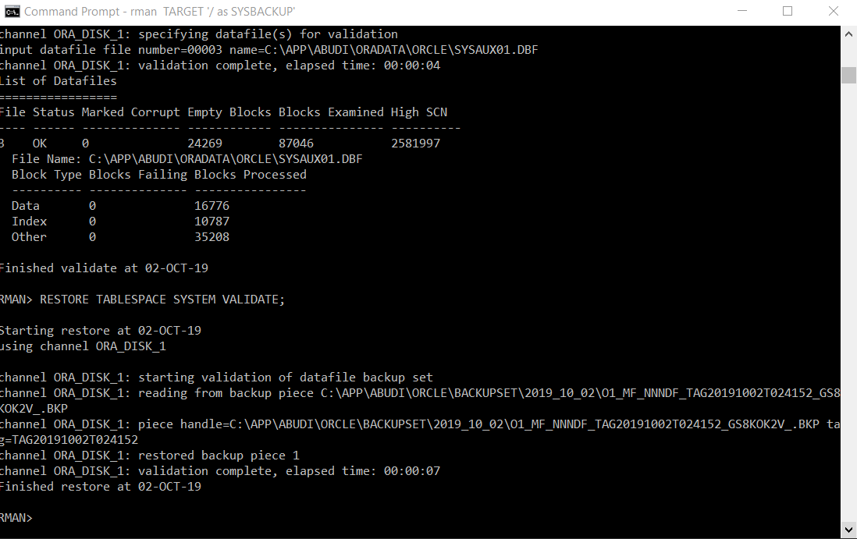
- Shutdown the database and then exit RMAN. Take a copy of the physical files of the database. Make sure to do so before the following steps. Delete these files after you have taken the copy.
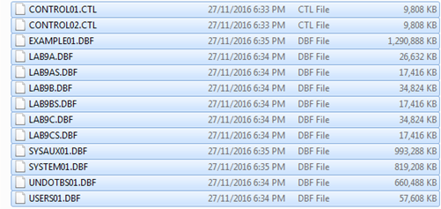
- Try to connect to the database as sysdba and then startup your database. Take a screen shot of what you have got and paste it below.
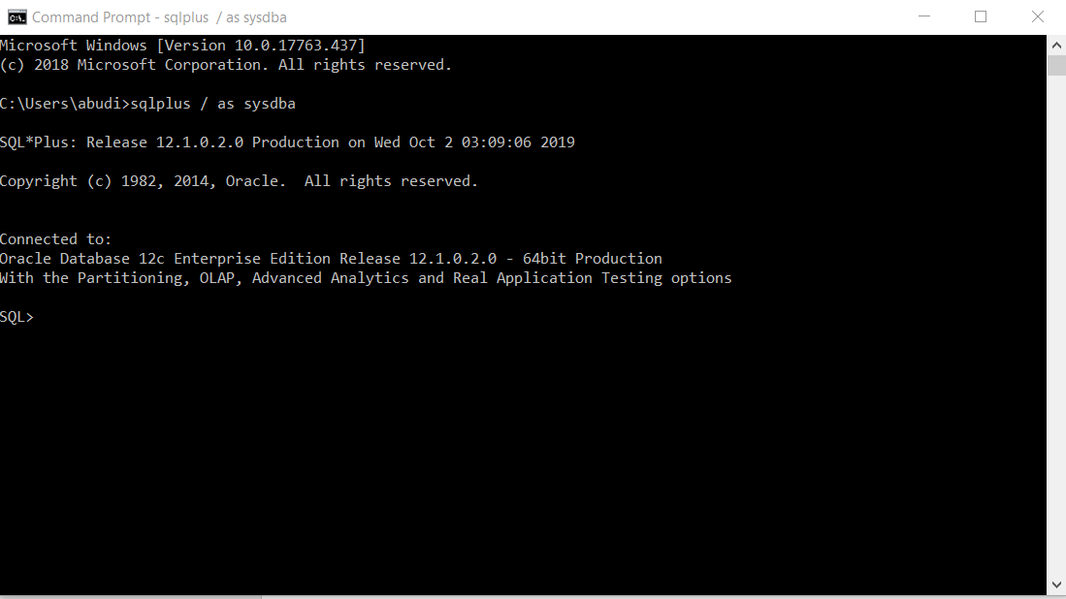
- Start a new cmd session. Invoke RMAN (RMAN target sysbackup ). Then start up with no mount ( RMAN > STARTUP NOMOUNT;)
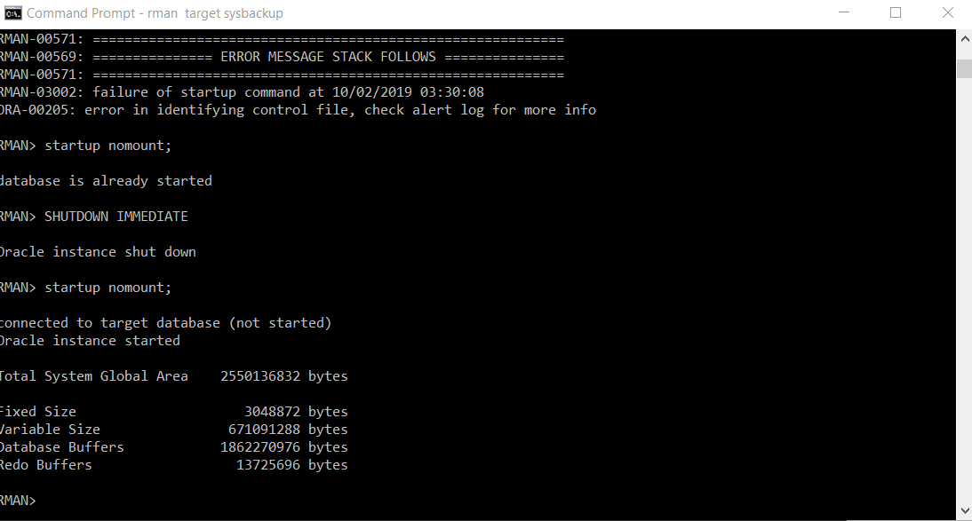
- It is time now to restore the control file from backup. The location of my backup control file is at:
‘C:\app\oracle\fast_recovery_area\orcl\ORCL\BACKUPSET\2019_09_18\ O1_MF_NCSNF_TAG20190918T194440_GR5JCS1J_.BKP’
Execute the following command, taking into consideration the location of your backup control file:
RMAN> restore controlfile from ‘C:\app\oracle\fast_recovery_area\orcl\ORCL\BACKUPSET\2019_09_18\O1_MF_NCSNF_TAG20190918T194440_GR5JCS1J_.BKP’;
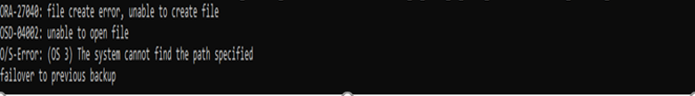
R. To restore the database, execute the following commands:
RMAN> Alter database Mount;
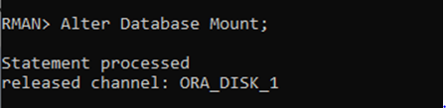
RMAN> Restore Database;
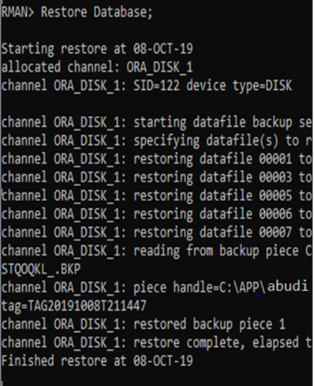
RMAN> Recover Database;
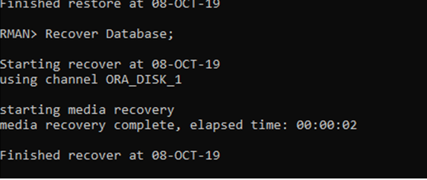
RMAN> Alter Database open resetlogs;
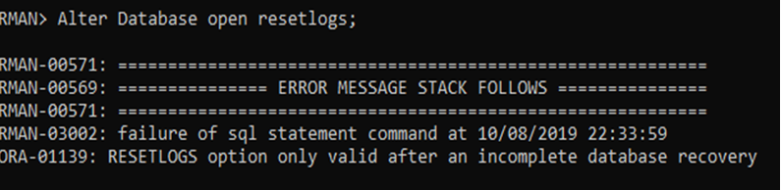
S. log on as sysdba and execute the following command. Take a screen shot of your work.
SQL> select name from V$database;
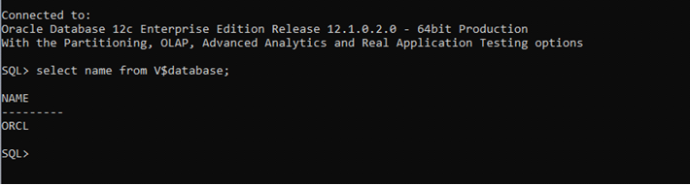
SQL> select open_mode from V$database;
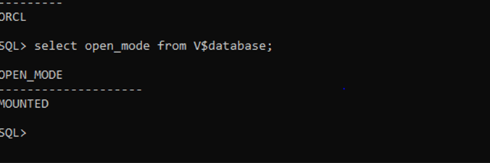

That’s it – you’re done!

