Two Types of Conditioning
- Ivan Pavlov
  - Won a noble prize for studying digestion but is much more famous for working with a dog, a bell, and a bowl of saliva
    - Pavlov's dog
- Classical (or Pavlovian) conditioning: the procedure in which an initially neutral stimulus (the conditioned stimulus, or CS) is paired with an unconditioned stimulus (or US)..the result is that the conditioned stimulus begins to elicit a conditioned response (CR)
  - Nowadays considered important as both a behavioral phenomenon and as a method to study simple associative learning
  - Is one of the fundamental ways we learn about the world around us
  - Arguably a theory of identity
  - In the experiment, Pavlov rang a bell and then gave a dog some food
    - After repeating this pairing multiple times, the dog eventually treated the bell as a signal for food, and began salivating in anticipation of the treat
  - Classical conditioning is still widely studied today for at least two reasons:
    - It is a straightforward test of associative learning that can be used to study other, more complex behaviors
    - It is always occurring in our lives, its effects on behavior have important implications for understanding normal and disordered behavior in humans
  - Classical conditioning occurs whenever neutral stimuli are associated with psychological significant events
    - Ex. Food poisoning: although having fish or dinner may not normally be something to be concerned about (i.e., a "neutral stimuli), if it causes you to get sick, you will now likely associate that neutral stimuli (the fish) with the psychologically significant event of getting sick
- Unconditioned stimulus (US): in classical conditioning, the stimulus that elicits the response before conditioning occurs
- Unconditioned response (UR): in classical conditioning, an innate response that is elicited by a stimulus before (or in the absence of) conditioning
- The dog food in Pavlov's experiment is called the unconditioned stimulus because it elicits an unconditioned response
  - That is, without any kind of 'training' or 'teaching,' the stimulus produces a natural or instinctual reaction
  - The food (US) automatically makes the dog drool (UR)
  - More examples:
    - Loud noises (US), startle us (UR)
    - Hot shower (US) produces pleasure (UR)
- Conditioned stimulus: an initially neutral stimulus (like a bell, light, or tone) that elicits a conditioned response after it has been associated with an unconditioned stimulus
  - A signal that has no importance to the organism until is it paired with something that does have importance
    - Ex. The bell in Pavlov's experiment is the conditioned stimulus
      - Before the dog has learned to associate the bell (CS) with presence of food (US), hearing the bell means nothing to the dog
      - However, after multiple pairings of the bell with the presentation of food, the dog starts to drool at the sound of the bell
      - This drooling in response to the bell is the conditioned response (CR)
- Conditioned response: the response that is elicited by the conditioned stimulus after classical conditioning has taken place
  - The conditioned response is always the same as the unconditioned response
  - It is called the conditioned response because it is conditional on (or depends on) being paired with the conditioned stimulus (e.g. the bell)
  - Ex. Salivating when seeing a fast food restaurant logo
    - Although it is the actual eating of the food (US) that normally produces salivation (UR), simply seeing the restaurant's logo (CS) can trigger the same reaction (CR)
- More examples
  - Alarm clock
    - Waking up early (US) produces a natural sensation of grumpiness (UR)
    - Psychologically pairing the alarm tone (CS) with the feeling of grumpiness in the morning (UR)
    - After enough pairings, this tone (CS) will automatically produce a natural response of grumpiness (CR)
    - This linkage between the unconditioned stimulus (US; waking up early) and the conditioned stimulus (CS; the tone) is so strong that the unconditioned response (UR; being grumpy) will become a conditioned response (CR; e.g., hearing the tone at any point in the day—whether waking up or walking down the street—will make you grumpy)
- Instrumental/operant conditioning: the process in which we learn about the relationship between their behaviors and their consequences
  - Occurs when a behavior is associated with a significant event (as opposed to a stimulus)
  - Ex. a rat in a laboratory learns to press a lever in a cage (called a “Skinner box”) to receive food
    - Because the rat has no “natural” association between pressing a lever and getting food, the rat has to learn this connection
    - At first, the rat may simply explore its cage, climbing on top of things, burrowing under things, in search of food
    - Eventually while poking around its cage, the rat accidentally presses the lever, and a food pellet drops in
    - This voluntary behavior is called an operant behavior, because it “operates” on the environment (i.e., it is an action that the animal itself makes)
    - Now, once the rat recognizes that it receives a piece of food every time it presses the lever, the behavior of lever-pressing becomes reinforced
    - That is, the food pellets serve as reinforcers because they strengthen the rat’s desire to engage with the environment in this particular manner
  - Reinforcer: any consequence of a behavior that strengthens the behavior or increases the likelihood that it will be performed it again
    - Intended to increase behavior
  - Operant conditioning research studies how the effects of a behavior influence the probability that it will occur again
  - Law of effect: the idea that instrumental or operant responses are influenced by their effects. Responses that are followed by a pleasant state of affairs will be strengthened and those that are followed by discomfort will be weakened. Nowadays, the term refers to the idea that operant or instrumental behaviors are lawfully controlled by their consequences
    - When a behavior has a positive (satisfying) effect or consequence, it is likely to be repeated in the future
    - When a behavior has a negative (painful/annoying) consequence, it is less likely to be repeated in the future
    - Effects that increase behaviors are referred to as reinforcers, and effects that decrease them are referred to as punishers
  - Punisher: a stimulus that decreases the strength of an operant behavior when it is made a consequence of the behavior
    - Intended to decrease behavior
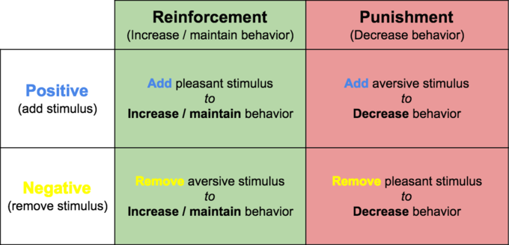

- Operant conditioning provides a method for studying how consequences influence “voluntary” behavior
  - The rat’s decision to press the lever is voluntary, in the sense that the rat is free to make and repeat that response whenever it wants
  - Classical conditioning, on the other hand, is just the opposite—depending instead on “involuntary” behavior (e.g., the dog doesn’t choose to drool; it just does)
  - Voluntary behavior is strongly influenced by its consequences
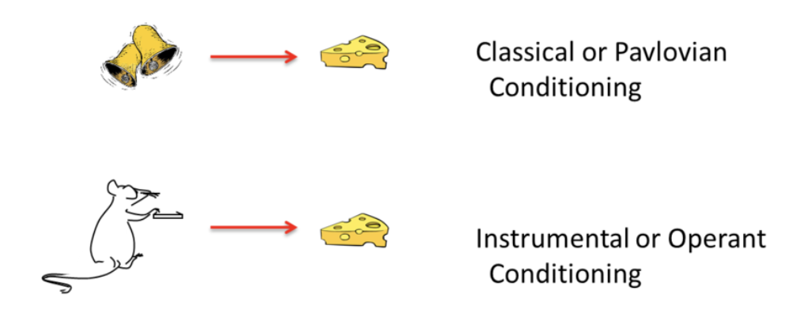

- In classical conditioning, the animal behaves as if it has learned to associate a stimulus with a significant event.
- In operant conditioning, the animal behaves as if it has learned to associate a behavior with a significant event
- Another difference is that the response in the classical situation (e.g., salivation) is elicited by a stimulus that comes before it, whereas the response in the operant case is not elicited by any particular stimulus
- Instead, operant responses are said to be emitted. The word “emitted” further conveys the idea that operant behaviors are essentially voluntary in nature

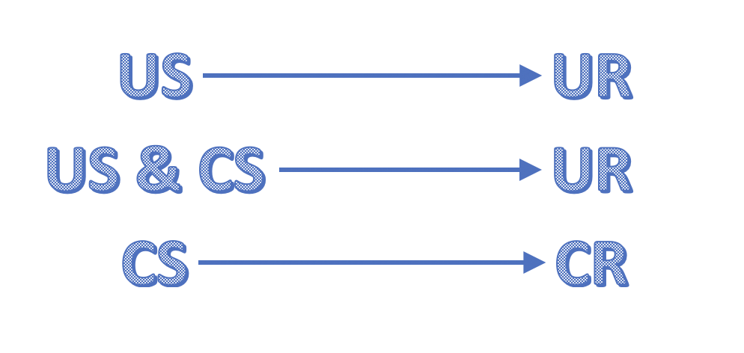

Useful Things to Know about Classical Conditioning
Classical Conditioning Has Many Effects on Behavior
- A classical CS (e.g. the bell) does not merely elicit a simple, unitary reflex
  - Pavlov emphasized salivation because that was the only response, he measured
  - But his bell almost certainly elicited a whole system of responses that functioned to get the organism ready for the upcoming US (food)
  - For example, in addition to salivation, CSs (such as the bell) that signal that food is near also elicit the secretion of gastric acid, pancreatic enzymes, and insulin (which gets blood glucose into cells)
    - All of these responses prepare the body for digestion
- Classical conditioning is also involved in other aspects of eating
  - Flavors associated with certain nutrients (such as sugar or fat) can become preferred without arousing any awareness of the pairing
    - Ex. Protein is an US that your body craves more of once you start to consume it (UR)
    - Since proteins are highly concentrated in meat, the flavor of meat becomes a CS, which perpetuates the cycle of craving for yet more meat (this automatic bodily reaction now a CR)
- In a similar way, flavors associated with stomach pain or illness become avoided and disliked
  - Ex. A person who gets sick after drinking too much tequila may acquire a profound dislike of the taste and odor of tequila
    - Taste aversion conditioning: the phenomenon in which a taste is paired with sickness, and this causes the organism to reject—and dislike—that taste in the future
    - Most people report at least 1
    - Ex. Drugs in chemo make patients sick, patients acquire aversions to food eaten before chemotherapy
- Fear conditioning: a type of classical or Pavlovian conditioning in which the conditioned stimulus (CS) is associated with an aversive unconditioned stimulus (US), such as a foot shock…as a consequence of learning, the CS comes to evoke fear
  - Plays a role in creating many anxiety disorders in humans, such as phobias and panic disorders, where people associate cues (such as closed spaces, or a shopping mall) with panic or other emotional trauma
- Conditioned compensatory responses: in classical conditioning, a conditioned response that opposes, rather than is the same as, the unconditioned response. It functions to reduce the strength of the unconditioned response
  - Often seen in conditioning when drugs are used as unconditioned stimuli
    - Decrease the impact of the drug on the body—because the body has become more sensitive to pain
    - For example, morphine itself suppresses pain; however, if someone is used to taking morphine, a cue that signals the “drug is coming soon” can actually make the person more sensitive to pain
  - Has many implications
    - Drug addiction and dependence
    - For example, some people grab a beer or pour a drink immediately after getting home from work. When the body is accustomed to this pattern it will start to prepare itself for an influx of alcohol and start producing a chemical response that keeps the individual from feeling drunk immediately. This is considered the "conditioned compensatory response"

The Learning Process
- Pairing a CS and a US together is not sufficient for an association to be learned between them
  - Consider an effect called blocking: in classical conditioning, the finding that no conditioning occurs to a stimulus if it is combined with a previously conditioned stimulus during conditioning trials
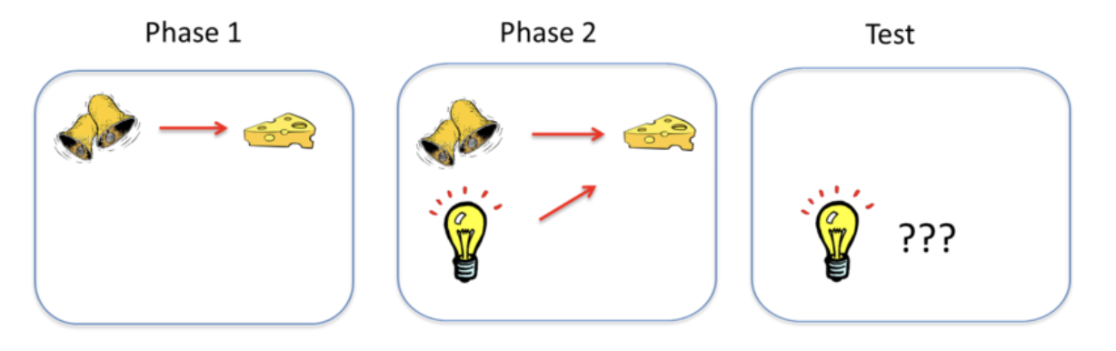

- In this effect, an animal first learns to associate one CS—call it stimulus A—with a US
- The sound of a bell (stimulus A) is paired with the presentation of food. Once this association is learned, in a second phase, a second stimulus—stimulus B—is presented alongside stimulus A, such that the two stimuli are paired with the US together
- A light is added and turned on at the same time the bell is rung
- However, because the animal has already learned the association between stimulus A (the bell) and the food, the animal doesn’t learn an association between stimulus B (the light) and the food
- That is, the conditioned response only occurs during the presentation of stimulus A, because the earlier conditioning of A “blocks” the conditioning of B when B is added to A
- The reason? Stimulus A already predicts the US, so the US is not surprising when it occurs with Stimulus B
- To learn something through classical conditioning, there must first be some prediction error: the chance that a conditioned stimulus won’t lead to the expected outcome
  - When the outcome of a conditioning trial is different from that which is predicted by the conditioned stimuli that are present on the trial (i.e., when the US is surprising)
  - Prediction error is necessary to create Pavlovian conditioning (and associative learning generally)
  - As learning occurs over repeated conditioning trials, the conditioned stimulus increasingly predicts the unconditioned stimulus, and prediction error declines
  - Conditioning works to correct or reduce prediction error
    - Ex. because the bell always leads to the reward of food, there’s no “prediction error” that the addition of the light helps to correct
    - However, if the researcher suddenly requires that the bell and the light both occur in order to receive the food, the bell alone will produce a prediction error that the animal has to learn
- Classical conditioning is strongest if the CS and US are intense or salient
- It is also best if the CS and US are relatively new and the organism hasn’t been frequently exposed to them before
- It is especially strong if the organism’s biology has prepared it to associate a particular CS and US
- Preparedness: the idea that an organism’s evolutionary history can make it easy to learn a particular association. Because of preparedness, you are more likely to associate the taste of tequila, and not the circumstances surrounding drinking it, with getting sick. Similarly, humans are more likely to associate images of spiders and snakes than flowers and mushrooms with aversive outcomes like shocks

4 Things to Know about Classical Conditioning
- CC generates multiple responses
- CC establishes preferences AND aversions
- CC underlies various psychological conditions
- Pairing the US and CS is NOT sufficient for conditioning to occur

Erasing Classical Learning
- Extinction: the response to the CS can be eliminated if the CS is presented repeatedly without the US
  - The response is said to become "extinguished"
  - Ex. if Pavlov kept ringing the bell but never gave the dog any food afterward, eventually the dog’s CR (drooling) would no longer happen when it heard the CS (the bell), because the bell would no longer be a predictor of food
  - It is important for many reasons, one being that it is the basis for many therapies that clinical psychologists use to eliminate maladaptive and unwanted behaviors
  - However, extinction does not necessarily destroy the original learning
    - Spontaneous recovery: following a lapse in exposure to the CS after extinction has occurred, sometimes re-exposure to the CS can evoke the CR again
      - Recovery of an extinguished response that occurs with the passage of time after extinction…can occur after extinction in either classical or instrumental conditioning
    - Renewal effect: After extinction, if the CS is tested in a new context such as a different room or location, the CR can also return
      - Ex. the action of entering a new building—where you don’t expect to smell chalkboards—suddenly renews the sensations associated with detention
      - Recovery of an extinguished response that occurs when the context is changed after extinction, especially strong when the change of context involves return to the context in which conditioning originally occurred…can occur after extinction in either classical or instrumental conditioning

Useful Things to Know about Instrumental Conditioning
- The 'bigger' the reinforcer (or punisher), the stronger the learning
- If an instrumental behavior is no longer reinforced, it will be extinguished
- Most of the rules of associative learning that apply to classical conditioning also apply to instrumental learning

Instrumental Responses Come Under Stimulus Control
- Stimulus control: when an operant behavior is controlled by a stimulus that precedes it
  - Although you know that green means go, only when you have the green arrow do you turn
- The stimulus controlling the operant response is called a discriminative stimulus
  - Does not elicit the response the way a classical CS does, instead, it is said to 'set the occasion for' the operant response
  - Ex. a canvas put in front of an artist does not elicit painting behavior or compel her to paint, it allows, or sets the occasion for, painting to occur

Operant Conditioning Involves Choice
- The response always requires choosing one behavior over others
- Quantitative law of effect: acknowledges the fact that the effects of reinforcing one behavior depend crucially on how much reinforcement is earned for the behavior’s alternatives
  - In general, a given reinforcer will be less reinforcing if there are many alternative reinforcers in the environment

Cognition in Instrumental Learning
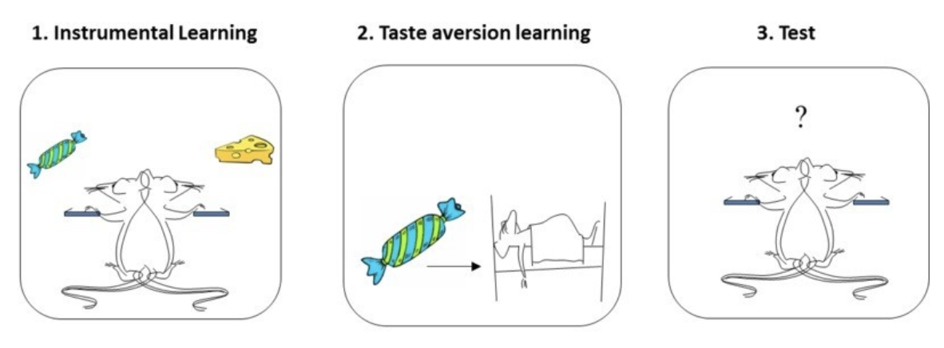
- Animals learn about the specific consequences of each behavior, and will perform a behavior depending on how much they currently want-or 'value'-its consequence

- Reinforcer devaluation effect: an animal will stop performing an instrumental response that once led to a reinforcer if the reinforcer is separately made aversive or undesirable
- Goal-directed: instrumental behavior that is influenced by the animal’s knowledge of the association between the behavior and its consequence and the current value of the consequence
- Habit: instrumental behavior that occurs automatically in the presence of a stimulus and is no longer influenced by the animal’s knowledge of the value of the reinforcer…insensitive to the reinforcer devaluation effect

3 Things to Know about Operant Conditioning
- Instrumental responses can occur under stimulus control
- Operant conditioning involves choice
  - Quantitative law of effect
- Reinforcers are not made equal
$$- Behavioural Potential=Expectancy+Value$$

Putting Classical and Instrumental Conditioning Together
- Classical and operant conditioning are always intertwined
- Generally speaking, any reinforced or punished operant response (R.) is paired with an outcome (O) in the presence of some stimulus or set of stimuli (S)
- The types of associations that can be learned
  - Learn to associate the response and the outcome (R-O)
    - Operant (instrumental) conditioning
    - Once R-O is learned, the organism will be ready to perform the response if the outcome is desired or valued
    - The value of the reinforcer can also be influenced by other reinforcers earned for other behaviors in the situation
  - Learn to associate the stimulus with the reinforcing outcome (S – O)
    - Classical conditioning
    - Many consequences on behavior
    - For one thing, the stimulus will come to evoke a system of responses that help the organism prepare for the reinforcer
    - In addition, the stimulus will evoke approach (if the outcome is positive) or retreat (if the outcome is negative)
    - Presenting the stimulus will also prompt the instrumental response
  - Learn to associate the stimulus and the response (S – R)
    - After a lot of practice, the stimulus may begin to elicit the response directly
    - This is habit learning, whereby the response occurs relatively automatically, without much mental processing of the relation between the action and the outcome and the outcome’s current value
  - Link between stimulus and the response-outcome association [S – (R – O)]
    - More than just entering into a simple association with the R or the O, the stimulus can signal that the R – O relationship is now in effect
    - This is what we mean when we say that the stimulus can “set the occasion” for the operant response: It sets the occasion for the response-reinforcer relationship
      - Through this mechanism, the painter might begin to paint when given the right tools and the opportunity enabled by the canvas
      - The canvas theoretically signals that the behavior of painting will now be reinforced by positive consequences
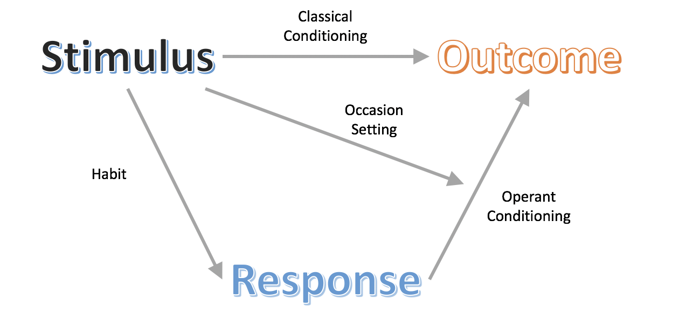

Observational Learning
- Social Learning Theory: individuals can learn novel responses via observation of key others' behaviors
  - Observational learning: learning by observing the behavior of others
    - Does not necessarily require reinforcement, instead, hinges on the presence of others, referred to as social models
    - Social models: typically, of higher status or authority compared to the observer (ex. Parents, teachers, and police officers
- Observational learning consists of four parts:
- Attention- one must pay attention to what s/he is observing in order to learn
- Retention- to learn one must be able to retain the behavior s/he is observing in memory
- Initiation- acknowledges that the learner must be able to execute (or initiate) the learned behavior
- Motivation- to engage in observational learning
- Bobo doll experiment
  - In this experiment, Bandura had children individually observe an adult social model interact with a clown doll (“Bobo”)
  - For one group of children, the adult interacted aggressively with Bobo: punching it, kicking it, throwing it, and even hitting it in the face with a toy mallet
  - Another group of children watched the adult interact with other toys, displaying no aggression toward Bobo
  - In both instances the adult left and the children were allowed to interact with Bobo on their own
  - Bandura found that children exposed to the aggressive social model were significantly more likely to behave aggressively toward Bobo, hitting and kicking him, compared to those exposed to the non-aggressive model
  - The researchers concluded that the children in the aggressive group used their observations of the adult social model’s behavior to determine that aggressive behavior toward Bobo was acceptable
  - While reinforcement was not required to elicit the children’s behavior in Bandura’s first experiment, it is important to acknowledge that consequences do play a role within observational learning
  - A future adaptation of this study demonstrated that children in the aggression group showed less aggressive behavior if they witnessed the adult model receive punishment for aggressing against Bobo
  - Bandura referred to this process as vicarious reinforcement, as the children did not experience the reinforcement or punishment directly, yet were still influenced by observing it

