- Selective breeding: also known as artificial selection, is a process used by humans to develop new organisms with desirable characteristics
  - Breeders select two parents that have beneficial phenotypic traits to reproduce, yielding offspring with those desired traits
  - Mate two aggressive dogs—angry Chihuahuas—together, and mate two nonaggressive dogs—happy beagles—together, then switch half the puppies from each litter between the different sets of parents to raise
  - Puppies born to aggressive parents (the Chihuahuas) but being raised by nonaggressive parents (the Beagles), and vice versa, in litters that mirror each other in puppy distribution
  - The big questions are:
    - Would the Chihuahua parents raise aggressive beagle puppies?
    - Would the beagle parents raise nonaggressive Chihuahua puppies?
    - Would the puppies’ nature win out, regardless of who raised them?
- Being born or being raised?
- Children act like their parents due to genetic (nature) or environmental (nurture) reasons?
- Ethical restrictions with setting up human-based experiments: we can’t assign babies to parents at random, or select parents with certain behavioral characteristics to mate, merely in the interest of science
- Behavioral genetics: how genes and environments work together to influence behavior
- Adoption study: a behavior genetic research method that involves comparison of adopted children to their adoptive and biological parents
  - if the biological child of tall parents were adopted into a family of short people, do you suppose the child’s growth would be affected?
  - What about the biological child of a Spanish-speaking family adopted at birth into an English-speaking family? What language would you expect the child to speak?
- Twin studies: a behavior genetic research method that involves comparison of the similarity of identical (monozygotic; MZ) and fraternal (dizygotic; DZ) twins
  - Monozygotic twins, also called 'identical' twins result from a single zygote (fertilized eegg0 and have the same DNA
    - Are essentially clones
  - Dizygotic twins, also known as 'fraternal' twins, develop from two zygotes and share 50%of their DNA
    - Are ordinary siblings who happen to have been born at the same time
  - To analyze nature-nurture using twins, we compare the similarity of MZ and DZ pairs
    - Identical twins, unsurprisingly, are almost perfectly similar for height
    - The heights of fraternal twins, however, are like any other sibling pairs: more similar to each other than to people from other families, but hardly identical
    - This contrast between twin types gives us a clue about the role genetics plays in determining height
- Variability of genetic influence rather than the quantity of genetic influence
- Heritability ≠ Inherited
- Quantitative genetics: the scientific discipline in which similarities among individuals are analyzed based on how biologically related they are
- Quantitative genetics produces a number called a heritability coefficient, varying from 0 to 1, that is meant to provide a single measure of genetics’ influence of a trait
  - An easily misinterpreted statistical construct that purports to measure the role of genetics in the explanation of differences among individuals
  - In a general way, a heritability coefficient measures how strongly differences among individuals are related to differences among their genes
    - h² = 2(r_{mz} - r_{dz})

- The more genetically-related people are, the more similar they are—for everything: height, weight, intelligence, personality, mental illness, etc.
- You can’t leave genes out of the equation. But keep in mind, no behavioral traits are completely inherited, so you can’t leave the environment out altogether, either
- When your subjects are biologically-related, no matter how clearly a situation may seem to point to environmental influence, it is never safe to interpret a behavior as wholly the result of nurture without further evidence
  - Correlation does not imply causation
- Everything has turned out to be at least somewhat heritable (passed down), yet nothing has turned out to be absolutely heritable, and there hasn’t been much consistency as to which traits are more heritable and which are less heritable once other considerations
- Genes and environment are both crucial to every trait; without genes the environment would have nothing to work on, and too, genes cannot develop in a vacuum
- The classic example of the heritability coefficient defying intuition is the trait of having two arms
  - No one would argue against the development of arms being a biological, genetic process
  - But fraternal twins are just as similar for “two-armedness” as identical twins, resulting in a heritability coefficient of zero for the trait of having two arms
  - Normally, according to the heritability model, this result (coefficient of zero) would suggest all nurture, no nature, but we know that’s not the case
  - The reason this result is not a tip-off that arm development is less genetic than we imagine is because people do not vary in the genes related to arm development—which essentially upends the heritability formula
  - In fact, in this instance, the opposite is likely true: the extent that people differ in arm number is likely the result of accidents and, therefore, environmental
  - For reasons like these, we always have to be very careful when asking nature–nurture questions, especially when we try to express the answer in terms of a single number
  - The heritability of a trait is not simply a property of that trait, but a property of the trait in a particular context of relevant genes and environmental factors
- Another issue with the heritability coefficient is that it divides traits’ determinants into two portions—genes and environment—which are then calculated together for the total variability
  - It is more complex than that
- Epigenetics, a process in which the DNA itself is modified by environmental events, and those genetic changes transmitted to children
  - Environment can alter gene
    - Pigment in Himalayan rabbits' fur gene is influenced by temperature
    - Gene that has been altered is passed on

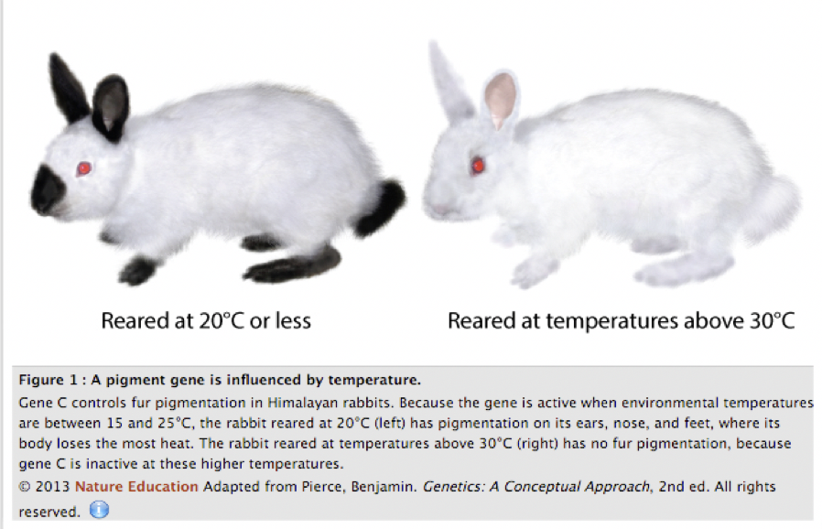

- How susceptible is a trait to change?
  - Caused by a single gene
    - Eye color
    - Phenylketonuria (can lead to mental retardation)
      - An inborn error of metabolism caused by a single gene; it prevents the body from metabolizing phenylalanine
      - Untreated, it causes mental retardation and death
      - But it can be treated effectively by a straightforward environmental intervention: avoiding foods containing phenylalanine
    - Height (environmental conditions have also shown to affect height)
      - The average height of many populations in Asia and Europe has increased significantly in the past 100 years, due to changes in diet and the alleviation of poverty

