Scientific Versus Everyday Reasoning
- Conclusions represent hypotheses (tentative explanations that are subject to testing) about the world: best guesses as to how the world works
- Scientific and everyday (non-scientific) reasoning both employ induction: drawing general conclusions from specific observations
  - The process of induction, alone, does not seem suitable enough to provide trustworthy info. --given the contradictory results
- In research, a number of people selected from a population to serve as an example of that population is a sample
- Need an understanding of science and the nature of scientific reasoning to appreciate the difference between personal opinions and scientific statements
- There are features that distinguish scientific thinking- and the theories and data generated by it-from everyday thinking
  - Accuracy- explanations and theories match real-world observations
  - Consistency- a theory has a few exceptions and shows agreement with other theories within and across disciplines, consistency in findings
  - Scope- extent to which a theory extends beyond currently available data, explaining a wide array of phenomena
  - Simplicity- when multiple explanations are equally good at explaining the data, the simplest should be selected, the more complex, the less power the theory has, Ockham's Razor
  - Fruitfulness- the usefulness of the theory in guiding new research by predicting new, testable relationships, generates more new hypotheses
  - Falsifiable- what evidence would crumble theory, could be proven wrong
    - In the early 20th century, Karl Popper (1902-1994) suggested that science can be distinguished from pseudoscience (everyday reasoning, a collection of beliefs or practices mistakenly regarded as being based on scientific method) because scientific claims are capable of being falsifiable
    - More or less it means that for a theory to be a good theory, it must be testable
    - If there's no way to disprove it, then it is unscientific
    - Popper was dissatisfied with Freud's explanations for mental illness, Freud's theory failed to meet the principle of falsifiability
    - Popper argued against statements that could not be falsified, saying that they blocked scientific progress, there was no way to advance, refine, or refute knowledge based on such claims
    - Popper's solution was: if science showed all the possibilities that were not true, we would be left only with what is true, we need to be able to articulate-beforehand-the kind of evidence that will disprove our hypothesis and cause us to abandon it

The Interpretation of Research Results
- We don’t say that a study proves a hypothesis, instead, we say the results of the study offer evidence in support of the hypothesis
  - This is because inductive reasoning (a form of reasoning in which a general conclusion is inferred from a set of observations (e.g., noting that “the driver in that car was texting; he just cut me off then ran a red light!” (a specific observation), which leads to the general conclusion that texting while driving is dangerous)) is based on probabilities
  - Probabilities are always a matter of degree; they may be extremely likely or unlikely
  - Science is better at shedding a light on the likelihood-or probability- of something than at proving it
  - Proof is more associated with deductive reasoning, the reverse of inductive reasoning, (a form of reasoning in which a given premise determines the interpretation of specific observations (e.g., All birds have feathers; since a duck is a bird, it has feathers))
    - When the general principles, or premises, are true, and the structure of the argument is valid, the conclusion is, by definition, proven
    - A deductive truth MUST apply in all relevant circumstances
      - For example, all living cells contain DNA, from this you can reason deductively that any specific living cell (of an elephant, or a person, or a snake) will therefore contain DNA
    - It is nearly impossible to make these types of broad statements with certainty
- Representative, in research, is the degree to which a sample is a typical example of the population from which it is drawn
  - This is one of the defining differences between conclusions drawn from personal anecdotes and those drawn from scientific observations
- Anecdotal evidence (a piece of biased evidence, usually drawn from personal experience, used to support a conclusion that may or may not be correct)-derived from personal experience and unsystematic observations (e.g. common sense)- is limited by the quality and representativeness of observations, and memory shortcomings
- Well-designed research, on the other hand, relies on observations that are systematically recorded, of high quality, and representative of the population (in research, all the people belonging to a particular group (e.g., the population of left-handed people)) it claims to describe

Why Should I Trust Science If It Can’t Prove Anything?
- Correlation (in statistics, the measure of relatedness of two or more variables)
- Null-hypothesis significance testing (NHST, statistics, a test created to determine the chances that an alternative hypothesis would produce a result as extreme as the one observed if the null hypothesis were actually true) assesses the probability that the collected data (the observations) would be the same if there were no relationship between the variables in the study
- NHST involves a null hypothesis, a statement that two variables are not related
- NHST also involves an alternative hypothesis, a statement that two variables are related
- The researcher then compares what they expect to find (probability) with what they actually find (the collected data) to determine whether she can falsify, or reject, the null hypothesis in favor of the alternative hypothesis
  - How is this done? By looking at the distribution (in statistics, the relative frequency that a particular value occurs for each possible value of a given variable) of the data
  - The researcher can use a probability table to assess the likelihood of any distribution
- Outcomes are determined by two factors
  - Reality
  - What the researcher finds
- The best possible outcome is accurate detection, meaning the researcher's conclusion mirrors reality
- Type I error: when the researcher concludes there is a relationship between two variables but, in reality, there is not
  - In statistics, the error of rejecting the null hypothesis when it is true
- Type II error: when the data fail to show a relationship between variables that actually exists
- Probability values (p-values) are used to set a threshold for type I or type II errors
  - Most common thresholds in science: .05 (5% chance), .01 (1% chance), and .001 (1/10th of 1% chance)
  - Psychological science doesn't rely on definitive proof; it’s about the probability or seeing a specific result
    - That’s why it’s so important that scientific findings be replicated in additional studies
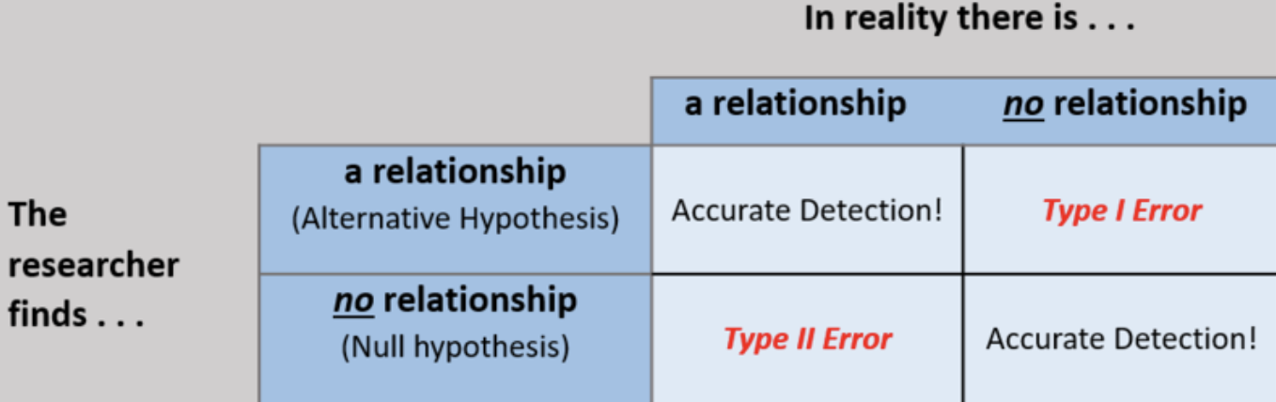

EXAMPLE
- Hypothesis: mature students are more likely to be responsible about studying and completing homework and, therefore, will do better in their courses
- Correlation: relationship between student age (her measure of maturity) and points earned of course (her measure of academic performance)
- NHST would test the probability that the researcher would find a link between age and class performance if there were, in reality, no such link
- Null hypothesis: student maturity and academic performance are NOT related in a meaningful way
- Alternative hypothesis: student maturity and academic performance go together
- Distribution: the numeric values of students' scores in the course, the researcher will test her hypothesis by comparing the observed distribution of grades earned by older students to those earned by younger students, recognizing that some distributions are more or less likely, your intuition tells you, for example, that the chances of every single person in the course getting a perfect score are lower than their scores being distributed across all levels of performance
- Type I error: there’s no relationship between maturity and grades, but the researcher still finds one
  - Sample
  - Coincidence
- Type II error: maturity is —in reality—associated with academic performance, but the researcher doesn’t find it in her sample

Scientific Theories
- Scientific theory- a comprehensive framework for making sense of evidence regarding a particular phenomenon, an explanation for observed phenomena that is empirically well-supported, consistent, and fruitful (predictive)
- Theories are open to revision if new evidence comes to light that compels reexamination of the accumulated, relevant data

Is Science Objective?
- Tomas Kuhn
  - Science is an activity conducted by humans, a social activity
  - It is subject to the same psychological influences of all human activities
  - No such thing as objective (being free of personal bias) theory or data; all of science is informed by questions they ask and how they make sense of what they find in their research
  - An important distinction between facts (information about the world) and values (beliefs about the way the world is or ought to be)
- Social sciences like psychology involve values and interpretation
  - As a result, science functions best when people with diverse values and backgrounds work collectively to understand complex natural phenomena
- Science can benefit from multiple perspectives
  - One was to achieve this is through levels of analysis, the idea that a single phenomenon may be explained at different levels simultaneously
  - Levels of analysis suggests that one level is not more correct than another, their appropriateness depends on the specifics of the question asked
  - Ultimately, levels of analysis would suggest that we cannot understand the world around us, including human psychology, by reducing the phenomenon to only the biochemistry of genes and dynamics of neural networks, but, neither can we understand humanity without considering the functions of the human nervous system

Science in Context
- Science is systematic, using testable, reliable data, it can allow us to determine causality and can help us generalize our conclusions
- By understanding how scientific conclusions are reached, we are better equipped to use science as a tool of knowledge

