Lecture 17- Biogeochemical Cycle

Biogeochemical cycles
- Many chemical reactions take place in abiotic components of the ecosystem:
  - Atmosphere
  - Water
  - Soil
  - Rock
- The biogeochemical cycle is the cyclic flow of nutrients from the nonliving to the living and back to the nonliving components of the ecosystem; e.g. N-fixation + decomposition
  - Cycling makes the nutrients free or enclosed somewhere within the system; i.e. it’s either absorbed or released into the atmosphere

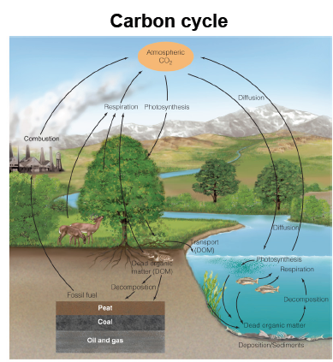
Two crucial cycles of life on earth
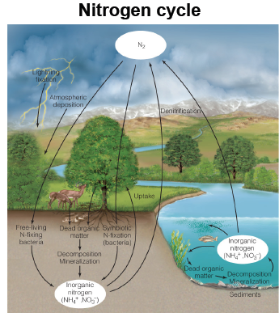

- The carbon cycle has an implication for the regulation of global climate
- We can use mechanisms of the carbon cycle to predict how global warming goes
  - Combustion of fossil fuel is a key player

Type of cycles
- There are 2 type of biogeochemical cycles—gaseous and sedimentary
  - Gaseous- the main pools of nutrients are the atmosphere and the oceans; nutrients are exchanged through gas
    - Global scale cycle- the oceans and atmosphere are well connected worldwide; e.g. N, C, O
  - Sedimentary- the main pools of nutrients are the soil, rocks and minerals
    - More local cycle—involved in rock weathering where rocks are broken down into smaller parts which breaks down into smaller nutrients
    - Inorganic sources of minerals are released to living animals through weathering (wind/water breaks down bigger chunks that fall into water) and erosion (degradation of mineral soils into smaller parts)
    - E.g. P
- Hybrids of gaseous and sedimentary cycles occur such as suffur
- Both gaseous and sedimentary cycles:
  - Involve biological and non-biological processes
  - Are driven by the flow of energy through the ecosystem such as photosynthesis and respiration
  - Are tied to the water cycle either through rain, leaching, wetfall, or percolation
- Biogeochemical cycles could not exist without the water cycle

Inputs and outputs
- All biogeochemical cycles have a common structure:
  - Input- can be carbon dioxide or nitrogen being by the plants from the atmosphere
  - Internal cycling
  - Outputs- can be through percolation when nutrients are flushed out of the system into the river
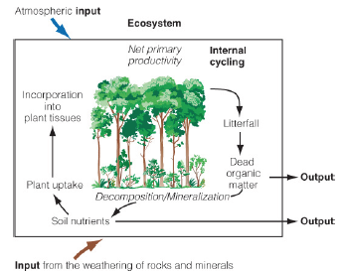
- The input of nutrients depends on the cycle
  - Nutrients with a gaseous cycle enter the ecosystem via the atmosphere such as O and N
  - Nutrients with a sedimentary cycle enter the ecosystem via the weathering of rocks and minerals such as Ca and P
- Supplementing soil nutrients of terrestrial habitats are carried by rain, snow, air currents, and animals
  - Wet fall- nutrients supplied by precipitation
  - Dry fall- nutrients brought in by airborne particles and aerosol
- Sources of nutrients for aquatic ecosystems:
  - From the surrounding land in the form of drainage, water, detritus, sediment
    - A leaf litter that falls into a stream is an input for the water ecosystem vs it falling onto the ground which is an output for terrestrial ecosystem
  - From the atmosphere in precipitation
- The output/export of nutrients depends on the cycle such as the release of CO₂ from respiration by heterotrophic organisms (input would be done by plants)
- OM can be carried out of an ecosystem through water via surface flow or underground flow (abiotic through percolation)
  - Or by herbivores (biotic); e.g. moose feeding on aquatic plants in the river
- Nutrients are released slowly from OM as it’s decomposed
- Human harvesting such as farming and logging
  - Nutrient loss must be replaced by fertilizers, otherwise the system becomes impoverished
    - Need to keep adding nutrients to the soil since the plant is dependent on humans in a farm ecosystem since farms make plants less sustainable on their own
- Fire converts a portion of the standing biomass and soil OM to ash known as pyro-mineralization—results in leaching and erosion of soil
  - This causes an accelerated rate of mineralization—since trees are being burned down, there’s a release of minerals
    - If it rains so much after many nutrients are released to the soil, this will cause the nutrients to be leached awaymakes the ecosystem impoverished

Local carbon cycle
- Carbon is so closely tied to energy flow that the two are inseparable
  - Ecosystem productivity = grams C fixed/m²/year
- Inorganic CO₂ is the source of all C
  - The inorganic C is fixed into the living component through photosynthesis
  - CO2₂ is again released following respiration
- Terrestrial cycling of carbon
  - The main input is photosynthesis
  - The outputs are respiration, decomposition, and combustion
- NPP = carbon uptake (photosynthesis) – carbon loss (autotroph respiration)
  - This is primarily used vs NEP
- Net ecosystem productivity (NEP) = carbon uptake (photosynthesis) – carbon loss (autotroph + heterotroph respiration)
- The rate of carbon cycling is determined by the rates of primary productivity and decomposition which are directly affected by temperature and precipitation
    - In order to have a lot of productivity, the nutrients needs to be available so that there can be an increased rate of decomposition
  - In warm, wet ecosystems—tropical rain forest—production and decomposition (microbes love this environment) rates are high and the carbon cycles through the ecosystem quickly
  - The opposite is true in cold and dry ecosystems
    - Low litter quality since the needle leaf dominates this area; high ligninlower rates of decomposition since it’s harder to decompose

Global carbon cycle
- The earth’s C budget is linked to the atmosphere, land, and oceans as well as to the mass movements of air currents
- The earth contains 10²³ grams (100 million gigatons, Gt) of C
  - All but a small fraction is buried in sedimentary rock and is not actively involved in the global C cycle
- Carbon pool- involved in the global carbon cycle amounts to 55,000 Gt
  - Fossil fuels accounts for 10,000 Gt
  - Oceans- 38,000 Gt but mostly as bicarbonate and carbonate ions
    - DOM- 1650 Gt
    - Living matter but mostly as phytoplankton- 3 Gt
  - Terrestrial
    - DOM in the soil- 1500 Gt
    - Living matter- 560 Gt
  - Atmosphere- 750 Gt
- The surface water acts as the site of main exchange of CO₂ between the atmosphere and ocean
  - Uptake of CO₂ depends on its reaction with carbonate ions (CO₃²⁻)to form bicarbonates (HCO₃⁻)
- Carbon circulates physically by means of currents and biologically through photosynthesis and movement through the food chain
  - Net uptake of carbon in the oceans = 1 Gt/year
  - Net loss of carbon in the oceans due to sedimentation = 0.5 Gt/year
- Recent studies suggest that the terrestrial surface is a carbon sink with a net uptake of CO₂ from the atmosphere (oceans would be a source of CO₂)
  - Uptake of CO₂ from the atmosphere by terrestrial systems is determined by photosynthesis
  - CO₂ losses form terrestrial systems are a function of respiration, especially decomposition
- More carbon is stored in the soils than in living matter
- The average carbon/volume of soil increases from the tropical regions poleward to the boreal forest and tundra
  - The greatest accumulation of OM occurs in areas where decomposition is inhibited; e.g. frozen or waterlogged soils such as permafrost
- Fossil fuel emission and land-use changes (cutting down canopies to produce food) are the main man-made sources of carbon release (emission) in the atmosphere
- According to climate models that incorporate feedback loops and assume ‘business as usual’ scenario regarding C emission, terrestrial will switch from being a C sink to a C source by ~2050
  - However, this is just a conceptual model, not mathematical
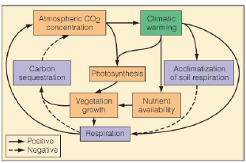
  - The climate warming increase CO₂ emissionmore CO₂ emission drives climate warmingincreases CO₂ emissionetc. positive feedback loop

Altered matter cycling in a warmer arctic
- Changes in the arctic sea ice has decreased significantly in the recent decades
  - 1978 to 1996 sea ice declined 3% per decade
  - 1996 to 2006 the rate of sea ice decline has increased 10% per decade
- Decline in sea ice has been correlated to increases in CO₂ emission and a positive feedback loop called the Arctic amplification
  - When more ice is melting, this exposes the rock, the rock then absorbs the sun, which causes more melting of icepositive feedback
- Arctic amplification- as temperature rises and ice melts, there’s less radiations from the sun that’s being reflectedcauses further heating and melting
- Mean arctic temperatures are 3-5°C warmer compared to 30 years ago
- Arctic amplification would be reinforced by the release of methane (CH₄) which is 25 times as powerful a greenhouse gas as CO₂
  - Methane is trapped in the ice, so when the ice melts, methane is releasedthis amplifies the climate change
- Carbon is also expected to be released with thawing permafrost
- Overall, there are 3 factors that cause C output due to melting ice and contribute to global warming: 1) rock exposure, 2) methane release from permafrost, and 3) C release from permafrost

Anthropogenic influences
- Human intervention of nutrient cycles have resulted in imbalances
  - Forest dieback through Europe and NA has been well documented
  - Symptoms include—crown thinning, leaf discolouration, premature leaf fall
  - In Quebec, over 50% of sugar maples (Acer saccarum) are in a state of dieback
- Forest dieback is caused by multiple factors and conditions with nutrient imbalance considered one of the most important
  - NPP is affected by N
  - In recent decades, human have increased N deposition through burning of fossil fuels, industrial emission, and soil inputs of nitrogen oxide (NOx)

