Chapter 14

What is Monopolistic Competition?

Monopolistic competition is a market structure in which
- A large number of firms compete
- Each firm produces a differentiated product
- Firms compete on product quality, price, and marketing
- Firms are free to enter and exit the industry.

Entry and Exit

There are no barriers to entry in monopolistic competition, so firms cannot make an economic profit in the long run.

Product Differentiation

A firm in monopolistic competition practices product differentiation if it makes a product that is slightly different from the products of competing firms. (eg. iPhone vs. Android)

Competing on Quality, Price, Marketing

Product differentiation enables firms to compete in three areas: quality, price and marketing.

- Quality: Includes design, reliability, and service.
- Price: Because firms produce differentiated products, the demand for each firm’s product is downward sloping. But there is a tradeoff between price and quality.
- Marketing: Because products are differentiated, a firm must market its product. Two main types: advertising and packaging.

The Firm’s Short-Run Output and Price Decision

Quantity: A firm that has decided the quality of its product and its marketing program produces the profit-maximizing quantity at which marginal revenue equals marginal cost.

Price: determined by the demand curve

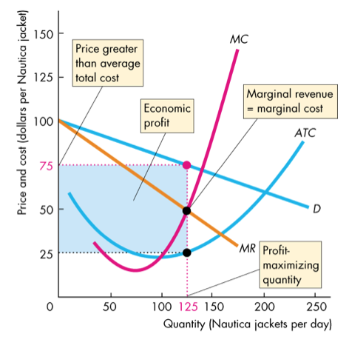

The firm in monopolistic competition operates like a single-price monopoly in the short run.

The firm produces the quantity at which marginal revenue equals marginal cost.

(It earns an economic profit when demand is greater than the average total cost)

Profit Maximizing Might Be Loss Minimizing
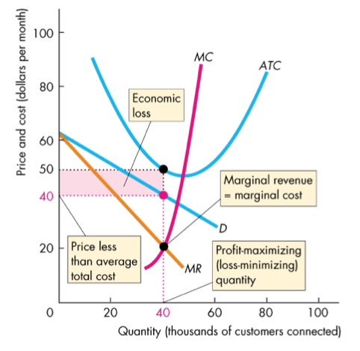

A firm might incur an economic loss in the short run.

Here is an example.

At the profit-maximizing quantity,
P < ATC and the firm incurs an economic loss.

Long Run: Zero Economic Profit

In the long run, economic profit induces entry.

And entry continues as long as firms in the industry earn an economic profit—as long as (P > ATC)

In the long run, a firm in monopolistic competition maximizes its profit by producing the quantity at which its marginal revenue equals its marginal cost, MR = MC.

As new firms enter the industry, demand for each individual firm’s product decreases and the demand curve for its product shifts leftward.

The decrease in demand decreases the quantity at which MR = MC and lowers the maximum price that the firm can charge to sell this quantity.

Price and quantity fall with firm entry until zero economic profit is made.

Monopolistic Competition in the Long Run

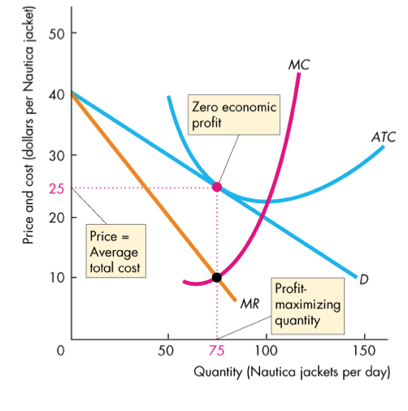
In the long run, firms enter (or exit) until zero economic profit is made. Firms will continue to enter the market until profits drop below zero at which point they will exit the market. Firms will continue to exit the market until profits rise back up above zero.

Monopolistic Competition and Perfect Competition

Two key differences between monopolistic competition and perfect competition are:
- Excess capacity
- Markup
A firm has excess capacity if it produces below its efficient scale (the quantity at which average total cost is minimum the quantity at the bottom of the U-shaped ATC curve).

A firm’s markup is the amount by which price exceeds marginal cost.

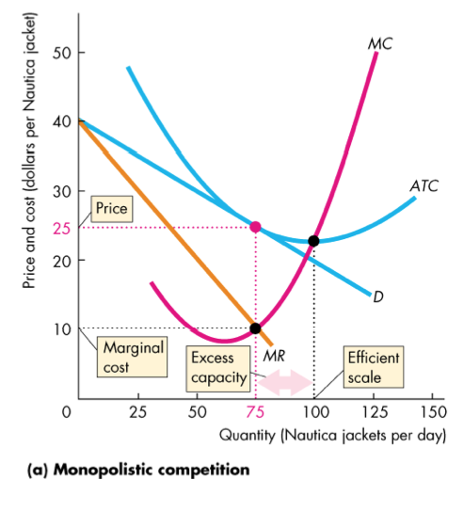
Firms in monopolistic competition operate with excess capacity in long-run equilibrium.

Firms produce less than the efficient scale—the quantity at which ATC is a minimum.

The downward-sloping demand curve for their products drives this result.

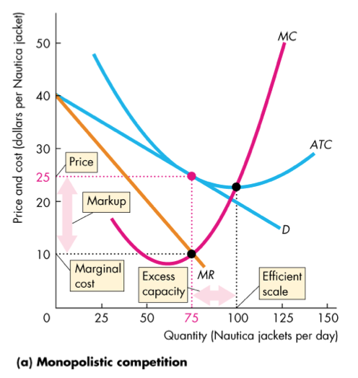

Firms in monopolistic competition operate with positive markup.

Again, the downward-sloping demand curve for their products drives this result.

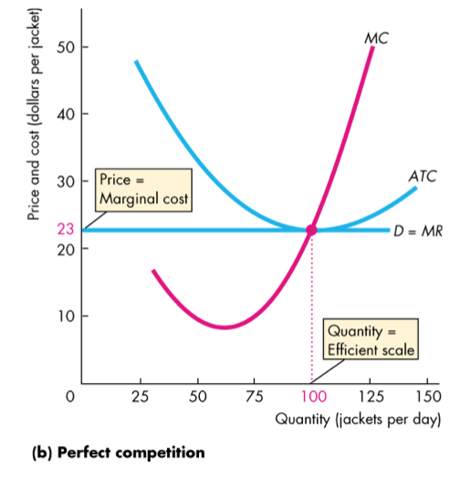

In contrast, firms in perfect competition have no excess capacity and no markup.

The perfectly elastic demand curve for their products drives this result.

Is Monopolistic Competition Efficient?

Price equals marginal social benefit.

The firm’s marginal cost equals marginal social cost.

Price exceeds marginal cost, so marginal social benefit exceeds marginal social cost.

So the firm in monopolistic competition in the long run produces less than the efficient quantity.

