Chapter 13

Monopoly and How it Arises

A monopoly is a market:
- That produces a good or service for which no close substitute exists.
- In which there is one supplier that is protected from competition by a barrier to entry preventing the entry of new firms:
  - Natural
  - Ownership
  - Legal

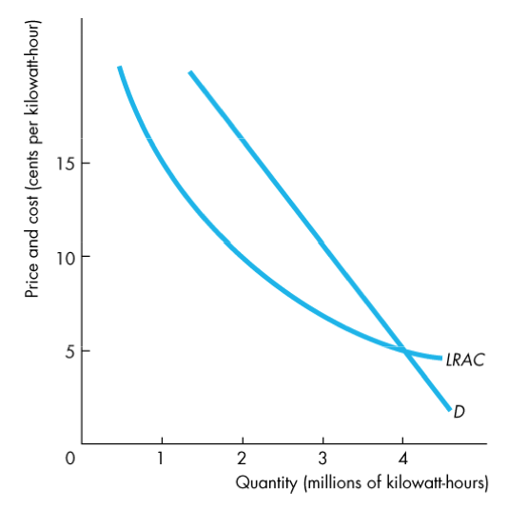
Natural barriers to entry create a natural monopoly: an industry in which economies of scale enable one firm to supply the entire market at the lowest possible cost.

- The market demand curve for electric power is D, and the long-run average cost curve is LRAC. Economies of scale prevail over the entire length of the LRAC curve.

Ownership Barriers to Entry

An ownership barrier to entry occurs if one firm owns a significant portion of a key resource. An example of this type of monopoly occurred during the last century when De Beers controlled up to 90 percent of the world’s supply of diamonds.

Most examples are in industries that sell natural resources (diamonds, nickel, gravel, etc.)

Legal Barriers to Entry

Legal barriers to entry create a legal monopoly.

A legal monopoly is a market in which a competition and entry are restricted by the granting of a :
- Public franchise
- Government license
- Patent
- Copyright

Monopoly Price-Setting Strategies

Two types of monopoly price-setting strategies:

A single-price monopoly is a firm that must sell each unit of its output for the same price to all its customers.

Price discrimination is where a firm sells different units of a good or service for different prices.
(Many firms price discriminate, but not all of them are monopoly firms.)

A Single-Price Monopoly’s Output and Price Decision

Price and Marginal Revenue

A monopoly is a price setter.

The reason is:
- It is the only firm selling the product
- Demand is always elastic

Total revenue, TR, is the price, P, multiplied by the quantity sold, Q.

Marginal revenue, MR, is the change in total revenue that results from a one-unit increase in the quantity sold.

For a single-price monopoly, marginal revenue is less than price at each level of output. That is,

MR < P
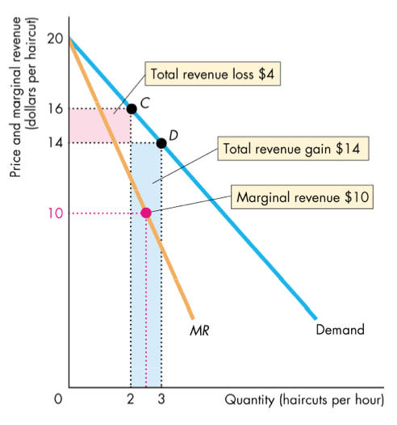

What happens to MR when the monopolist lowers price?

You can see that MR< P at each quantity

Marginal Revenue and Elasticity
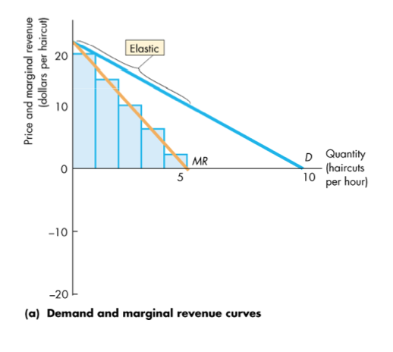
A single-price monopoly’s marginal revenue is related to the elasticity of demand for its good:

If demand is elastic, a 1% fall in the price brings a greater than 1% increase in the quantity demanded.

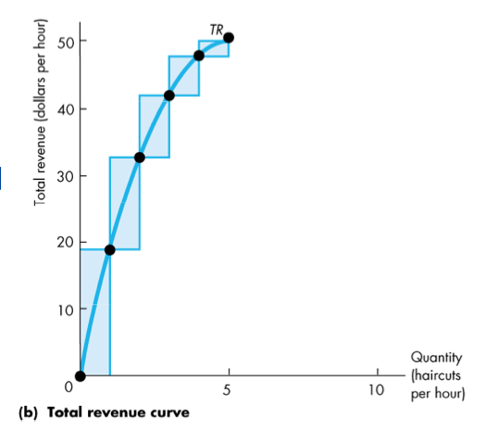

The increase in revenue from the increase in quantity sold outweighs the decrease in revenue from the lower price per unit, and MR is positive.

As the price falls, the total revenue increases.

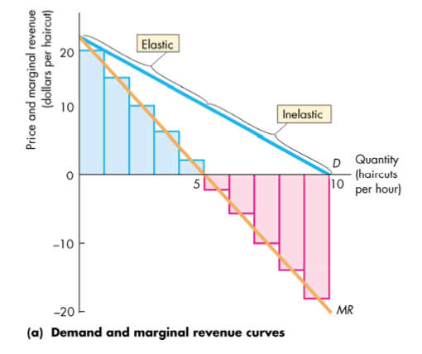
If demand is inelastic, a 1% fall in price brings a less than 1% increase in the quantity demanded.

The rise in revenue from the increase in quantity sold is outweighed by the fall in revenue from the lower price per unit, and MR is negative.

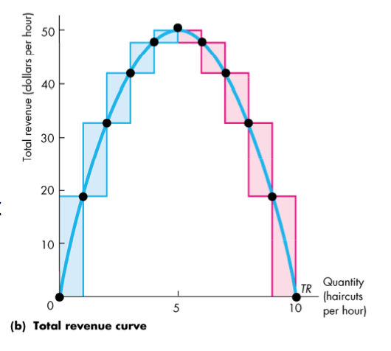
As the price falls, the total revenue decreases.

A single-price monopoly never produces an output at which demand is inelastic.

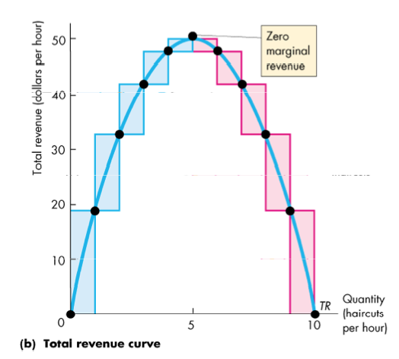
If demand is unit elastic, a fall in price does not change total revenue.

The rise in revenue from the increase in quantity sold equals the fall in revenue from the lower price per unit, and MR = 0.

Price and Output Decision

The monopoly faces the same types of technology constraints as the competitive firm, but the monopoly faces a different market constraint.

The monopoly selects the profit-maximizing quantity where marginal revenue equals marginal cost.

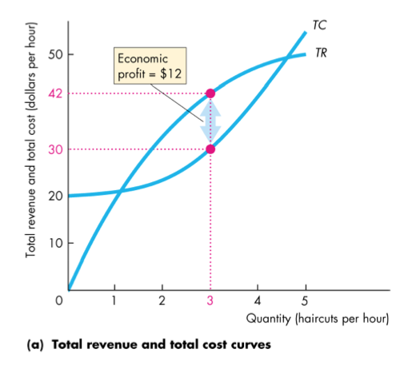
The monopoly sets its price so that exceeds marginal cost, so price exceeds marginal costs.

Profit maximizing choices of a single-price monopoly.

The monopoly produces the quantity that maximizes total revenue minus total cost.

At the Margin
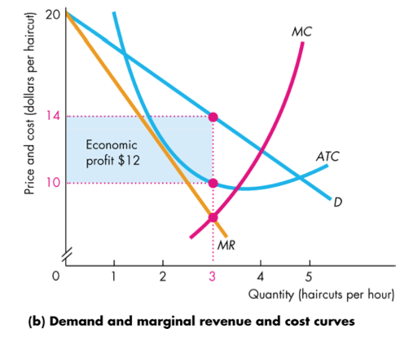
The firm produces the output at which MR = MC and sets price at which it can sell that quantity.

The ATC curve tells us the average total cost.

The monopoly might make an economic profit, even in the long run, because the barriers to entry protect the firm from market entry by competitor firms.

Comparing Price and Output
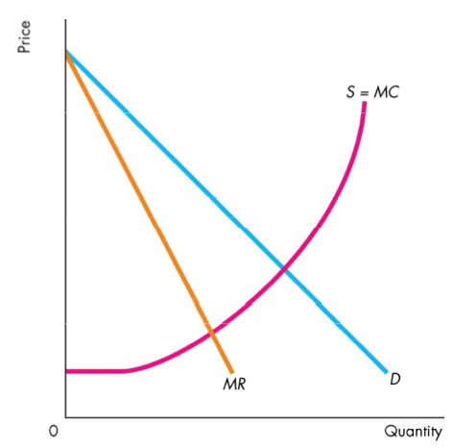
Compare the price and quantity in perfect competition and monopoly:

The market demand curve, D, in perfect competition is the demand curve that the firm in monopoly faces.

The market supply curve in perfect competition is S.

In a monopoly, this is obtained by summing the supply curves of all the individual firms in the market.

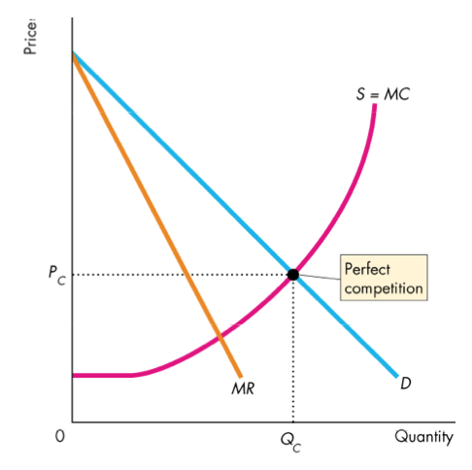
Perfect Competition

Equilibrium occurs where the quantity demanded equals the quantity supplied at quantity Q_{C} and price P_{C}.

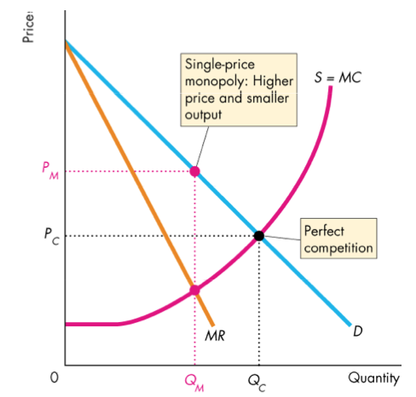

Monopoly

Equilibrium output, Q_{M}, occurs where marginal revenue equals marginal cost, MR = MC.

Equilibrium price, P_{M} occurs on the demand curve at the profit-maximizing quantity.

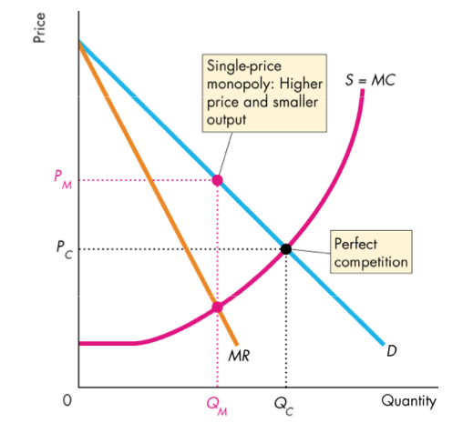
Compared to perfect competition, a single-priced monopoly produces a smaller output and charges a higher price.

Efficiency Comparison

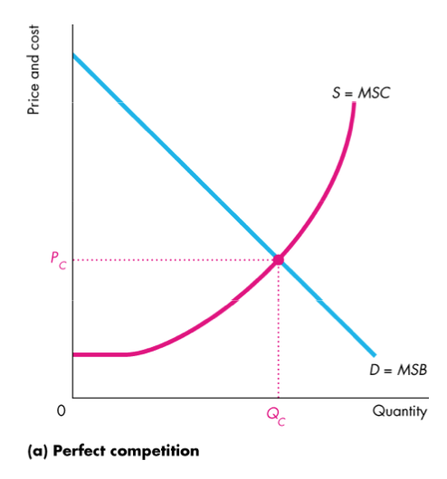
Perfect competition:

The market demand curve is the marginal social benefit curve, MSB, and the market supply curve is the marginal social cost curve, MSC.

So competitive equilibrium is efficient: MSB = MSC.

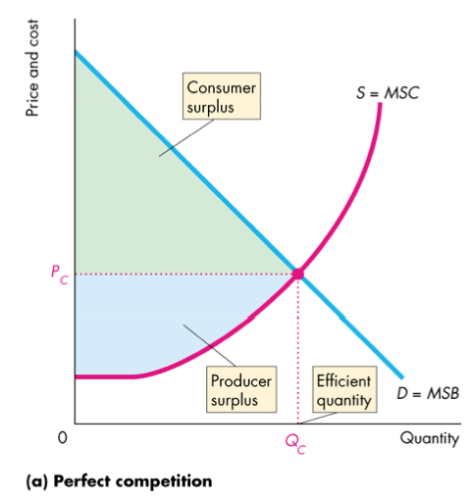
Under perfect competition;
- Output is Q_{C} and the price is P_{C}.
- Marginal Social Benefit (MSB) equals Marginal Social Cost (MSC)
- Total surplus, the sum of consumer surplus (green area) and producer surplus (blue area, is maximized
- In the long run, firms produce at the lowest possible average cost

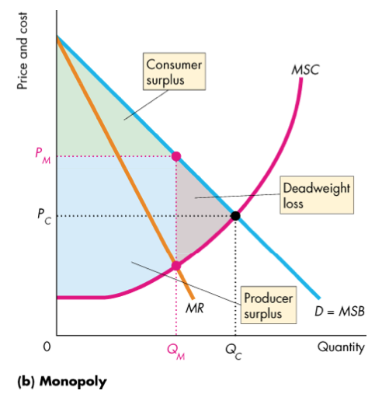
Inefficiency of Monopoly

Because price exceeds marginal cost, marginal benefit exceeds marginal social cost, consumer surplus shrinks, the monopoly gains, and a deadweight loss (grey area) arises.

Redistribution of Surpluses
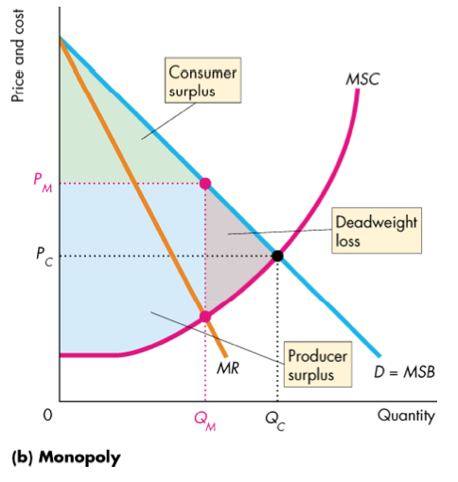

Some of the lost consumer surplus goes to the monopoly as producer surplus.

Price Discrimination

Price discrimination is the practice of selling different units of a good or service for different prices.

To be able to price discriminate, a monopoly must:
- Be able to identify and separate different buyer types
- Sell a product that cannot be resold

NOTE: Price differences that arise from cost differences are not price discrimination.

Capturing Consumer Surplus

Price discrimination captures consumer surplus and converts it into economic profit.

A monopoly can discriminate
- Among units of goods
  - Example: quantity discounts
- Among groups of buyers
  - Example: Advance purchase and student discounts

Profiting By Price Discriminating
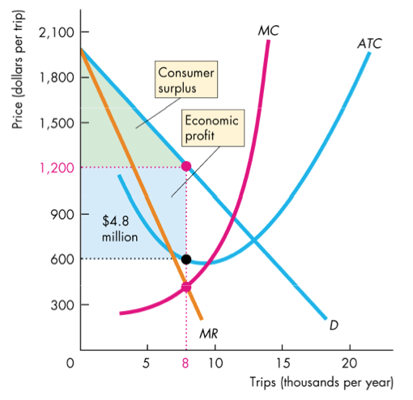
Comparing single price and price discrimination:

As a single price monopoly, this firm maximizes profit by produing 8 trips a year and selling them for $1,200 each.

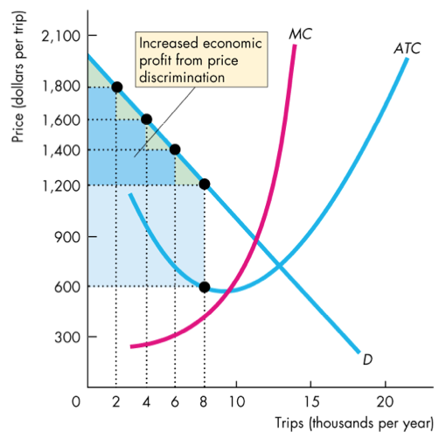

By price discriminating, the firm can increase its profit.

In doing so, it converts consumer surplus into economic profit.

Perfect Price Discrimination
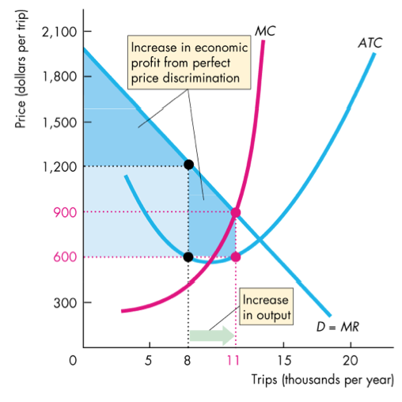

In the extreme case, the firm may be able to perfectly price discriminate.

Efficiency with Price Discrimination

The more perfectly a monopoly can price discriminate, the closer its output is to the competitive output (P = MC) and the more efficient is the outcome.

But unlike perfect competition, the monopoly captures the entire consumer surplus.

***Efficiency, Fairness, and Regulation***

