Chapter 12

What is Perfect Competition?

Perfect competition is an industry in which:
- Many firms sell identical products to many buyers.
- There are no restrictions to entry into the industry.
- Established firms have no advantages over new ones.
- Sellers and buyers are well informed about prices.

How Perfect Competition Arises

Perfect competition arises:
- When firm’s minimum efficient scale is small relative to market demand.
  - Room for many firms
- Each firm produces identical goods or services (Alternatively, consumers perceive them to be the same)
  - Consumers don’t care which firm they buy from

Price Takers

In perfect compeition, each firm is a price taker.
A price taker is a firm that cannot influence the price of a good or service.
Each firm’s output is a perfect substitute for the output of the other firms, so the demand for each firm’s output is perfectly elastic.

Economic Profit and Revenue

The goal of each firm is to maximize economic profit, which equals total revenue minus total cost.
- Total cost is the opportunity cost of production
- A firm’s total revenue equals price multiplied by quantity sold ( P x Q)
- A firm’s marginal revenue is the change in total revenue that results from a one-unit increase in the quantity sold
The demand for a firm’s product is perfectly elastic because one firm’s sweater substitute for the sweater of another firm.
The market demand is perfectly elastic because a sweater is a substitute for some other good.

A perfect competitive firm’s goal is to make maximum economic profit, given the constraints it faces.

So the firm must decide:
1) How to produce at minimum cost
2) What quantity to produce
3) Whether to enter or exit a market

We start by looking at the firm’s output decision.

The Firm’s Output Decision
Profit-Maximizing Output
A perfectly competitive firm chooses the output that maximizes the output that maximizes its economic profit. (one way to find: compare TR to TC)

Economic profit (EP) equals total revenue minus total cost

If EP is negative, the firm is taking an economic loss.

Marginal Analysis and Supply Decision

The firm can use marginal analysis to determine the profit-maximizing output.
Profit is maximized by producing the output at which marginal revenue equals marginal cost (MR=MC)

This is because:
- Marginal revenue is constant
- Marginal cost eventually increases as output increases

If MR > MC, economic profit increases if output increases.
If MR < MC, economic profit decreases if output increases
If MR = MC, economic profit decreases if output changes in either direction, so economic profit is maximized.

Temporary Shutdown Decision

If the firm makes an economic loss it must decide to:
- Exit the market
- Stay in the market
  - Produce something
  - Shut down temporarily (On Sundays, holidays, etc… not long periods of time)
The decision will be the one that minimizes the firm’s loss.

Loss Comparison

Loss occurs when profits are negative.
So Economic loss = TC – TR
= (TFC + TVC) – TR
= TFC + AVC x Q – P x Q
= TFC + (AVC – P) x Q

The firm can choose Q = 0 by shutting down.
The firm incurs an economic loss equal to TFC.
This economic loss is the largest that the firm must bear.

A firm’s shutdown point is the price and quantity at which
- It is indifferent between producing and shutting down (temporarily)
- AVC is at its minimum
- MC curve crosses the AVC curve
At the shutdown point, the firm incurs a loss equal to TFC from either action (producing vs. shutting down)

The firm covers all its variable cost and at least part of its fixed cost.
It incurs a loss, but one that is less than TFC.

The Firm’s Decision

The firm’s supply curve is the MC curve above the MR.
If price equals minimum AVC, the firm is indifferent between producing nothing and producing at the shutdown point, T.

Output, Price, and Profit in the Short Run

Market Supply in the Short Run

The short-run market supply curve shows the portion of the firm’s MC curve that lies above its AVC curve.

The quantity supplied by the market at any given price is the sum of the quantities supplied by all the firms in the market at that price.

At a price equal to minimum AVC, the shutdown price, some firms will produce the shutdown quantity and others will produce zero.

Short-Run Equilibrium

Short-run market supply and market demand determine the market price and output.

A change in Demand

An increase in demand brings a rightward shift of the market demand curve. The price rises and the quantity increases.

Profits and Losses in the Short Run

Maximum profit is not always a positive economic prfit.
Firms can have three possible profit outcomes.
1) Economic profit (Price > Average total cost)
2) Economic loss (Price < Average total cost)
3) Break even (Price = Average total cost)

In short-run equilibrium, a firm may make an economic profit, break even, or incur an economic loss.
Only one of them is a long-run equilibrium because firms can enter or exit the market.

Entry and Exit

New firms enter an industry in which existing firms make an economic profit
Firms exit an industry in which they incur an economic loss.

Enter

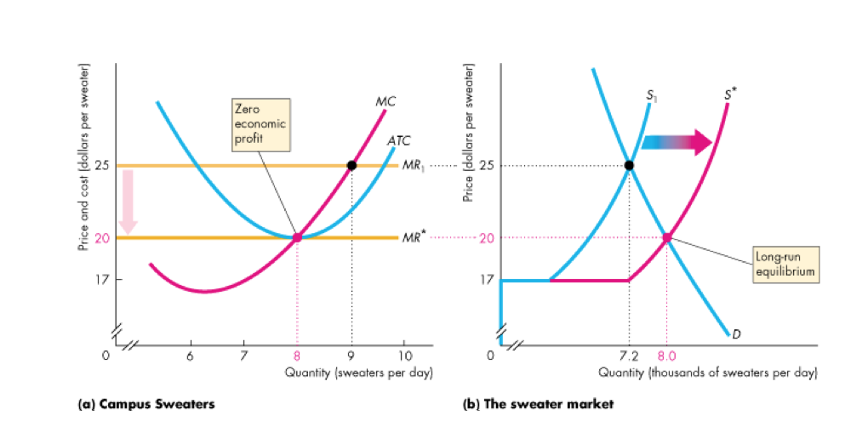
New firms have an incentive to enter the market.
When they do, the market supply increases and the market price falls.

Firms enter as long as firms are making economic profits.
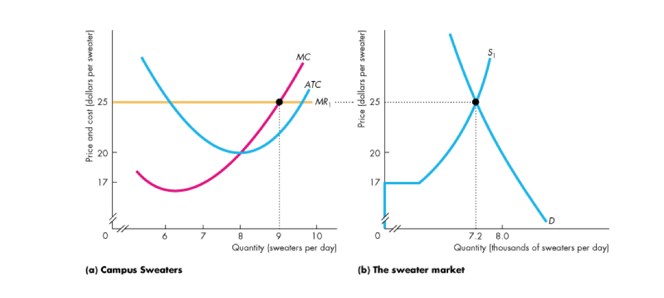
In the long run, the market supply increases, the market price falls and firms make zero economic profit.

Exit

Firms have an incentive to exit the market.
When they do, the market supply decreases the market price rises.
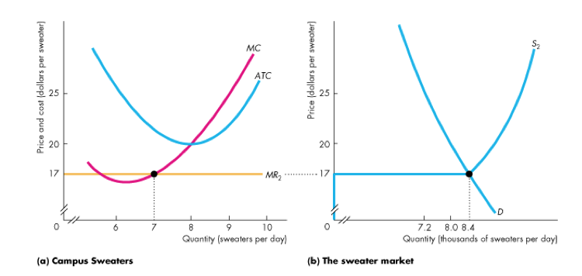

Firms exit as long as firms are incurring economic losses.
In the long run, the market supply decreases, the market price rises and the economic loss decreases. Eventually, economic loss is eliminated and exit stops.
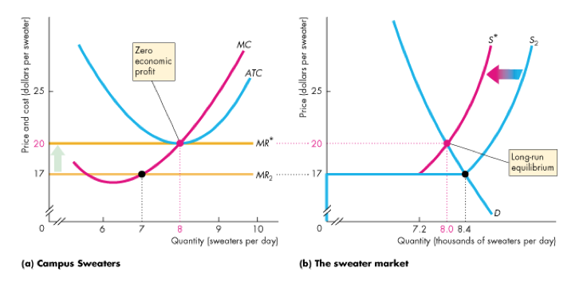

Changing Tastes

A Permanent Change in Demand

A decrease in demand shifts the market demand curve leftward.

External Economies and Diseconomies

The change in the long-run equilibrium price following a permanent change in demand depends on external economies and external diseconomies.

External economies are factors beyond the control of an individual firm that lower the firm’s costs as the industry output increases.
External diseconomies are factors beyond the control of a firm that raise the firm’s costs as industry output increases.

The long-run supply curve shows how the quantity supplied in a market varies as the market price varies after all the possible adjustments have been made, including changes in each firm’s plant and the number of firms in the market.

When external diseconomies are present, an increase in demand brings a higher price in the long run.
The long run market supply curve LS_{B} is upward sloping.

When external economies are present, an increase in demand brings a lower price in the long run.
The long run market supply curve LS_{C} is downward sloping.

Advancing Technology

Technological Change

- New technologies are constantly discovered that lower costs.
- Firms that adopt the new technology make an economic profit (cost curves shift downward, revenue is unchanged).
- New-technology firms enter and old-technology firms either exit or adopt the new technology.
- Industry supply increases (supply curve shifts rightward)
- The price falls and the quantity increases.
- In the long run, all firms use the new technology, price equals minimum ATC, and each firm makes zero economic profit.

