CHAPTER 1

Scarcity: Inability to satisfy all our wants
Incentive: Reward that encourages an action or a penalty that discourages one (e.g price: if cost of a laptop is too high, more will be for sale than people will want to buy and vice versa)
Economics: social science that studies choices that individuals/businesses/ governments/societies make as they cope with scarcity and the incentives that influence those choices
Microeconomics: study of choices that individuals and businesses make; the way the choices interact in markets; influence of governments
Macroeconomics: study of performance of national & global economy

What, How, and for Whom? -> how do those choices determine what goods&services (G&S) are produced?
Goods and Services: Objects that people value and produce to satisfy wants - goods:physical, services: tasks
- What determines patterns of production?
- How do we produce?
  - Factors of Production:
    - Land -> natural resources used to produce g&s
    - Labour -> work time/effort needed to produce g&s through *human* capital = knowledge and skill obtained from education
    - Capital -> tools, instruments, machines, buildings etc. used to produce g&s | financial capital -> money, stocks, bonds; not a factor of production
    - Entrepreneurship -> human resource that organizes labour, land, capital; develop new ideas, make business decisions, bear the risks
- Who consumes the g&s?
  - People earn income by selling services of factors of production they own
    - Land earns rent
    - Labour earns wages
    - Capital earns interest
    - Entrepreneurship earns profit

Self-interest: Choice that is the best one available to you
Social interest: Outcome that is best for society as a whole
- Efficient: resource is efficient if it is not possible to make someone better off without making someone else worse off (situation that cannot be improved upon) *can be efficient in terms of self-interest AND social interest
Globalization: expansion of international trade, borrowing, lending, investment
Information-age monopolies: e.g microsoft
Climate change: e.g fossil fuels
Economic instability: e.g 2008 crash

6 key ideas of economic thinking:
- A choice is a tradeoff -> because of scarcity | tradeoff is an exchange, giving up one thing to get something else
- People make rational choices by comparing benefits and costs -> achieves the greatest benefit over cost; answers “what g&s will be produced in what quantities” -> those that people rationally choose to buy
- Benefit is what you gain from something -> determined by preferences; the most a person is willing to give up to get something
- Cost, what you must give up to get something -> opportunity cost
- Most choices are “how-much” choices made at the margin -> benefit that arises from increase in activity is marginal benefit; opportunity cost of increase in activity is marginal cost (the additional cost)
- Choices respond to incentives -> change in marginal cost/change in marginal benefit changes incentives faced and leads to change in choices

Economists distinguish between two types of statement:
- Positive statement -> what is
- Normative statements -> what ought to be
- A positive statement can be tested by checking it against facts
- A normative statement expresses an opinion and cannot be tested

Economic model: description of some aspect of the economic world that includes only those features that are needed for the purpose at hand; tested by comparing predictions with facts
- Natural experiments
- Statistical investigations
- Economic experiments

CHAPTER 2

Normative Economic statement: describes the world as it should be (attempting to establish a norm)
Positive Economic statement: Describes the world as it is

Production Possibilities Frontier (PPF): Boundary between those combinations of goods and services that can be produced and cannot -> allows us to calculate Opportunity Cost
- To measure: model economy in which everything remains the same (ceteris paribus) except the two goods analyzed
- Production is possible at any point inside or on PPF
Production Efficiency: G&S produced at lowest possible cost
- Occurs at all points on PPF
- Production in PPF in inefficient b/c resources are unused/misallocated
- Unused: when resources are idle but could be working
- Misallocated: resources assigned to tasks for which they are not best match
Opportunity Cost: Decrease in quantity produced of one good divided by increase in quantity produced of another good
- Opportunity cost of X axis is inverse of Y axis (x over y regardless of increase or decrease to find ratio)
Allocative efficiency: when g&s are produced at lowest possible cost and at quantities that provide greatest possible benefit
Marginal benefit curve: shows relationship b/w marginal benefit and quantity consumed (not related to PPF and cannot be derived from it)
Principle of decreasing marginal benefit: the more we have of a g&s, the smaller the marginal benefit and the less we are willing to pay for additional unit of it, bc we like variety
Economic growth: expansion of production possibilities
- Two factors influence economic growth:
- Technological change
- Capital accumulation
Technological change: development of new goods and of better ways of producing goods and services.
Capital accumulation: growth of capital resources, which includes human capital.

Comparative advantage: activity that that person can perform at a lower opportunity cost than anyone else
Absolute advantage: person who is more productive than others

To reap the gains from trade, the choices of individuals must be coordinated, to make coordination work there are four social institutions:
- Firms -> economic unit that hires factors of production and organizes those factors to produce and sell goods and services
- Markets -> any arrangement that enables buyers and sellers to get information and do business with each other
- Property rights -> social arrangements that govern ownership, use, and disposal of resources, goods, or services
- Money -> commodity or token that is generally acceptable as a means of payment

Circular Flow through Market:
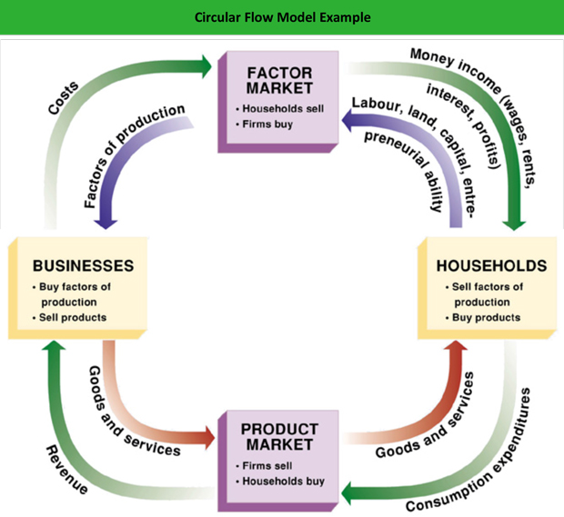

CHAPTER 3

Market: any arrangement that enables buyers and sellers to get information and do business with each other
Competitive market: market that has many buyers and many sellers, no single buyer or seller influences the price
- producers only offer an item for sale if the price is high enough to cover opportunity cost
Money price: amount of money needed to buy a good
Relative price: the ratio of a good’s money price to the money price of the next best alternative good, which is its opportunity cost
- called a ‘basket’ of all goods and services -> found by dividing money price of a good by ‘basket’ price (price index) = opportunity cost of the good in terms of how much of the basket we must give up to buy it

If you demand something, then you
1. Want it
2. Can afford it
3. Have made a definite plan to buy it
Wants: unlimited desires or wishes people have for goods and services; demand reflects a decision about which wants to satisfy
Quantity demanded: the amount that consumers plan to buy during a particular time period, at a particular price -> measured as an amount per unit of time

The law of demand states:
Other things remaining the same, the higher the price of a good, the smaller is the quantity demanded; and the lower the price of a good, the larger is the quantity demanded.
Why does a change in the price change the quantity demanded?
- Substitution effect
  - When relative price (opportunity cost) of g&s rises, people seek substitutes for it = quantity demanded of g&s decreases
- Income effect
  - When price of g&s rises relative to income, people cannot afford everything they previously bought, so quantity demanded of g&s decreases

Demand: entire relationship between the price of the good and quantity demanded of the good;
- quantity demanded -> point on a demand curve; the quantity demanded at particular price
Demand curve: relationship between the quantity demanded of a good and its price when all other influences on consumers’ planned purchases remain the same
- also a willingness-and-ability-to-pay curve
- the smaller the quantity available, the higher the price that someone is willing to pay for another unit
- willingness to pay measures marginal benefit
- quantity demanded -> x axis, price -> y axis
Change in demand: when some influence on buying plans other than the price of the good changes
- quantity of the good that people plan to buy changes at every price = new demand curve
  - When demand increases, the demand curve shifts rightward
  - When demand decreases, the demand curve shifts leftward

6 Main Factors that Change Demand:
- The prices of related goods
- Substitute: good that can be used in place of another good
- Complement: good that is used in conjunction with another good
- Expected future prices
- If price of a good expected to rise future, current demand for good increases & demand curve shifts rightward
- Income -> income increases, consumers buy more goods & demand curve shifts rightward
- Normal good: demand increases as income increases
- Inferior good: demand decreases as income increases (e.g air travel vs bus travel)
- Expected future income and credit -> when income is expected to increase in future or when credit is easy to obtain, the demand might increase now
- Population -> the larger the population, the greater demand for all goods
- Preferences -> people with the same income have different demands if they have different preferences
- Determine the value that people place on each g&s

Movement along demand curve = change in quantity demanded (price of good changes)
Shift of entire demand curve = change in demand (price of good remains constant)
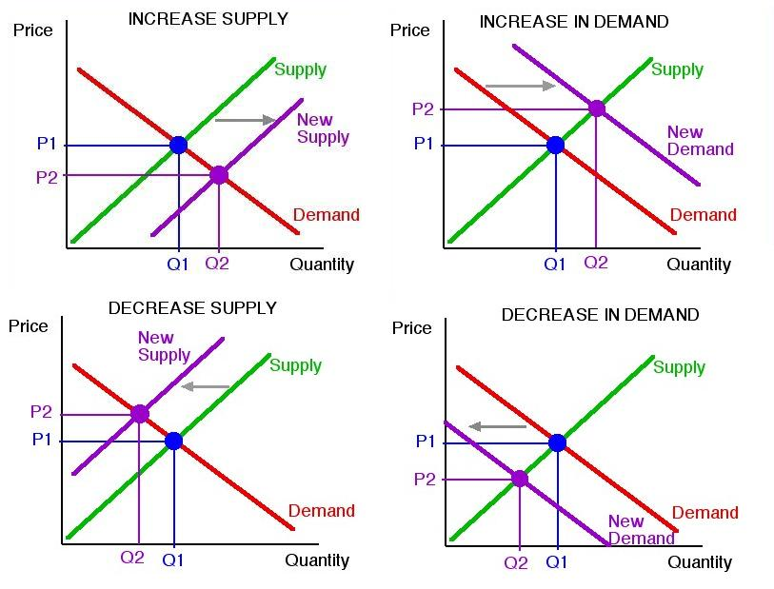
If a firm supplies g&s, it:
1. Has the resources and the technology to produce it
2. Can profit from producing it
3. Has made a definite plan to produce and sell it
Resources and technology: determine what it is possible to produce
Supply: reflects a decision about which technologically feasible items to produce
Quantity supplied: # producers plan to sell during a given time period at particular price

The law of supply:
Other things remaining the same, the higher the price of a good, the greater is the quantity supplied; and the lower the price of a good, the smaller is the quantity supplied.
- Results from the tendency for marginal cost of producing g&s to increase as the quantity produced increases
- Producers are willing to supply a good only if they can at least cover their marginal cost of production
Supply: entire relationship b/w price of a good and quantity supplied of it
- Quantity supplied: point on a supply curve, quantity supplied at a particular price
Supply curve: shows relationship b/w quantity supplied of a good and its price when all other influences on producers’ planned sales remain the same
- Graph of supply schedule
- Quantity supplied -> x axis; price -> y axis
- supply curve -> minimum-supply-price curve
  - As the quantity produced increases, marginal cost increases
  - The lowest price at which someone is willing to sell an additional unit rises
  - This lowest price is marginal cost

Change in Supply: When some influence on selling plans other than the price of the good changes
- Quantity of the good that producers plan to sell changes at each and every price, so there is a new supply curve
  - When supply increases, the supply curve shifts rightward
  - When supply decreases, the supply curve shifts leftward
6 Factors of Change in Supply:
- The prices of factors of production
- If price of a factor of production used to produce a good rises, the minimum price that a supplier is willing to accept for producing each quantity of that good rises
- rise in the price of a factor of production decreases supply and shifts the supply curve leftward
- The prices of related goods produced
- Substitute in production for a good is another good that can be produced using the same resources
  - Supply of a good increases if the price of a substitute in production falls
- Goods are complements in production if they must be produced together
  - Supply of a good increases if the price of a complement in production rises
- Expected future prices
- If price of a good is expected to rise, supply of the good today decreases
  - supply curve shifts leftward
- The number of suppliers
- The larger the number of suppliers of a good, the greater is the supply of the good
  - increase in the number of suppliers shifts the supply curve rightward.
- Technology
- Advances in technology create new products and lower the cost of producing existing products
  - advances in technology increase supply and shift the supply curve rightward
- State of nature
- state of nature includes all the natural forces that influence production e,g, the weather
- A natural disaster decreases supply and shifts the supply curve leftward

Change in quantity supplied = movement along supply curve (price changes)
Change in supply = shift of the supply curve (no price changes)

Equilibrium: situation in which opposing forces balance each other
Market Equilibrium: occurs when the price balances the plans of buyers and sellers
Equilibrium price: price at which the quantity demanded equals the quantity supplied
Equilibrium quantity: is the quantity bought and sold at the equilibrium price
- Price regulates buying and selling plans
- Price adjusts when plans don’t match

Price adjustments:
- At prices above the equilibrium price, a surplus forces the price down
- At prices below the equilibrium price, a shortage forces the price up
- At the equilibrium price, buyers’ plans and sellers’ plans agree and the price doesn’t change until an event changes demand or supply

- When demand increases, price rises and quantity increases
- When demand decreases, price falls and quantity decreases

- When supply increases, price falls and quantity increases
- When supply decreases, price rises and quantity decreases

Change in both demand and supply changes the equilibrium price and the equilibrium quantity

CHAPTER 4

Need to know:
- When supply decreases, equilibrium price rises and equilibrium quantity decreases
- Change in income changes demand
- When price of a substitute rises, demand for product increases
- When price for a complement rises, demand for product decreases
- When demand increases, equilibrium price rises and equilibrium quantity increases

Price Elasticity of Demand: units-free measure of the responsiveness of the quantity demanded of a good to a change in its price when all other influences on buying plans remain the same
Formula = $Percentage change in quantity demanded ÷Percentage change in price$
*Need to know quantity demanded of product at two different prices (all other influences remaining the same)
*Average price gives measurement of elasticity at midpoint
Formula to find % change in price:
*ave=average
$\%ΔP=ΔP/Pave ×100$
AKA, change in price from first price to next divided by the average of those two prices
Formula to find % change in quantity:
$\%ΔQ=ΔQ/Qave×100$
AKA, change in quantity from first quantity to next divided by average of those two quantities
OR
Price Elasticity of Demand = $\%ΔQ÷Qave / \%ΔP÷Pave$
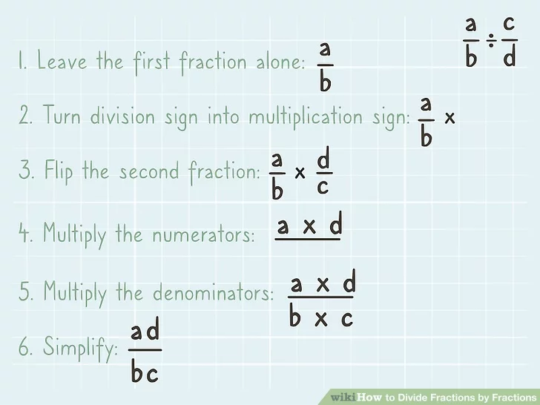

TYPES OF DEMAND:
Perfectly inelastic demand: quantity demanded remains constant when price changes e.g insulin -> need it regardless of price
Unit elastic demand: percentage change in quantity demanded equals percentage change in price, then price elasticity equals 1; consumers’ demand for a product is proportionally related to the product’s price
Inelastic demand: percentage change in quantity demanded is less than percentage change in the price, price elasticity of demand b/w 0 and 1; e.g food and shelter; products are bought to varying degrees regardless of price
Perfectly elastic demand: quantity demanded changes by infinitely large percentage in response to tiny price change, price elasticity is infinity; e.g two vending machines close together but one has even slightly higher price than other, no one buys from that machine - they are perfect substitutes
Elastic demand: percentage change in the quantity demanded exceeds the percentage change in price; e.g cars and furniture
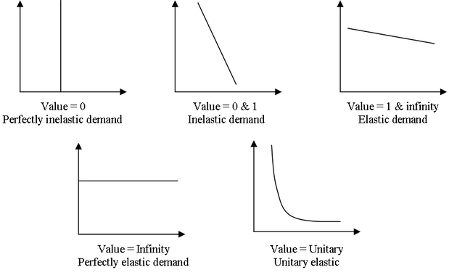

Factors that Influence Elasticity of Demand: (EOD)
- Closeness of substitutes -> closer substitutes for a good, the more elastic the demand is
  - e.g oil as fuel has no close substitutes so demand for oil is inelastic but plastics are close substitutes for metal so demand is elastic
  - Degree of substitutability depends on how narrowly a good is defined
    - e.g smartphone has no close substitutes but iphone is close substitute for samsung galaxy EOD for smartphones is lower than EOD for iphone/galaxy
  - Necessities -> poor substitutes, low EOD; luxuries -> many substitutes, high EOD
- Proportion of income spent on good -> greater the proportion of income spent on a good, the more elastic/less inelastic is demand for it
  - E.g if price of gum rises, you consume almost as much as before but if housing prices rises you look for roomates; bc housing takes big chunk of budget but gum takes little
- Time elapsed since price change -> longer the time that has elapsed since price change, the more elastic is demand
  - E.g when price of oil increased by 400% in 1970s, people barely changed quantity of oil/gas bought, but as more efficient auto/airplane engines developed, quantity bought decreased

Elasticity along Linear Demand Curve
- EOD is not the same as slope
- At midpoint of a linear demand curve, price EOD is 1
- Prices above the midpoint, price EOD is >1; demand is elastic
- Prices below the midpoint, price EOD is <1; demand is inelastic
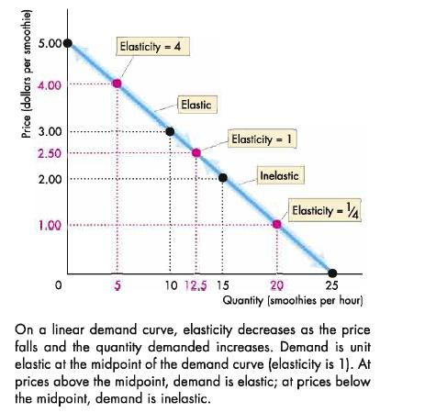

Total Revenue and Elasticity:
Total revenue: price of the good x quantity sold
*When price changes, total revenue changes but cut in price does not always decrease total revenue; depends on elasticity of demand
- If demand is elastic, 1% price cut increases quantity sold by more than 1% and total revenue increases
- If demand is inelastic, 1% price cut increases quantity sold by less than 1% and total revenue decreases
- If demand is unit elastic, a 1% price cut increases the quantity sold by 1% and revenue does not change
Total revenue test: method of estimating price elasticity of demand by observing change in total revenue that results from a change in price
- If price cut increases total revenue, demand is elastic
- If price cut decreases total revenue, demand is inelastic
- If price cut leaves total revenue unchanged, demand is unit elastic

Income Elasticity of Demand: measure of the responsiveness of the demand for a good or service to a change in income, other things remaining the same
- Tells us how much demand curve shifts at a given price
Formula = $Percentage change in quantity demanded ÷percentage change in income$
*find percentage change w formulas above
*Can be positive or negative
- Positive and greater than 1 = normal good, income elastic; percentage of income spent on good increases as income increases
- Positive and less than 1 = normal good, income inelastic; percentage of income decreases as income increases
- Negative = inferior good; quantity demanded/amount spent decrease when income increases

Cross Elasticity of Demand: measure of the responsiveness of the demand for a good to change in the price of a substitute or complement
Formula = $percentage change in quantity demanded÷percentage change in price of substitute or complement$
*Can be positive or negative
- If cross EOD is positive: demand and price of other good change in same direction, so the two goods are substitutes; demand curve shifts right
- If cross EOD is negative: demand and the price of other good change in opposite directions, so two goods are complements; demand curve shifts left
*magnitude of cross EOD determines how far demand curve shifts; larger the absolute value of cross elasticity; greater is the change in demand and the larger the shift in demand curve
- If items are close substitutes, cross elasticity is large; if items are close complements cross elasticity is large
- If items are unrelated to each other, cross elasticity is small or 0

Elasticity of Supply (EOS): measures responsiveness of the quantity supplied to a change in the price of a good when all other influences on selling plans remain the same
- If quantity supplied is not responsive to price, increase in demand brings large rise in price and small increase in equilibrium quantity
- If quantity supplied is highly responsive to price, increase in demand brings small rise in price and large increase in equilibrium quantity
Formula = $percentage change in quantity supplied ÷percentage change in price$
- If EOS is >1, supply is elastic
- If EOS is <1, supply is inelastic

Perfectly inelastic: quantity supplied is fixed regardless of price, supply curve is vertical and elasticity is 0;
Unit elastic: *rare; percentage change in price equals percentage change in quantity, elasticity is 1
- If curve is linear+passes thru origin, no matter how steep it is, supply is unit elastic
Perfectly elastic: if there is price at which sellers are willing to offer any quantity for sale, supply curve is elastic and elasticity is ∞
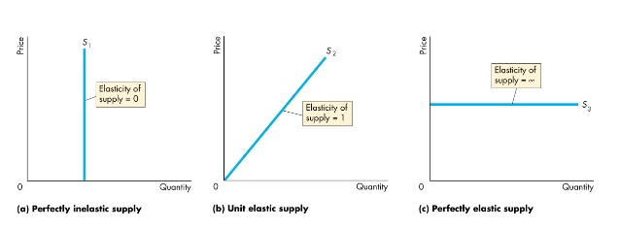

Factors that Influence Elasticity of Supply
- Resource substitution possibilities
  - Some g&s can be produced only by using unique/rare productive resources
    - Low/zero elasticity of supply
    - E.g Van Gogh painting
      - Vertical supply curve, zero EOS
  - Some g&s can be produced by using commonly available resources that could be allocated to a wide variety of alternative tasks
    - High elasticity of supply
    - E.g wheat can be grown on land equally as good for growing corn, so just as easy to grow wheat as corn; opportunity cost of wheat to corn is almost constant
      - Almost horizontal supply curve, very large EOS
    - E.g good is produced in many countries - sugar, beef, etc.
- Quantity supplied increases only by incurring higher cost, higher price is offered, quantity supplied increases; EOS between 0 and ∞

Time frame for Supply Decision: influence of amount of time elapsed since price change
- Momentary supply -> when price of a good changes, immediate response of quantity supply is determined by momentary supply of that good
  - Perfectly inelastic momentary supply: on a given day, no matter what the price of product, producers cannot change output
    - Perfectly inelastic, vertical supply curve
    - E.g fruits and vegetables, quantities supplied depend on crop-planting decisions made years in advance; have to be picked, packed, and shipped & quantity for that day is fixed
  - Perfectly elastic momentary supply: quantity supplied increases, but price remains constant
    - E.g long-distance phone calls, many people make call and big surge in demand for telephone cables
- Short-Run supply -> response of the quantity supplied to a price change when only some of the possible adjustments to production can be made
  - Inelastic short-run supply: most goods have this supply
    - E.g to increase output in short run, firms must work their labour force overtime/hire additional workers; to decrease output, firms lay off workers or reduce hours of work
    - E.g if price of oranges falls, pickers can be laid off and oranges can be left on trees; if price of oranges rises, grower can use more fertilizer to increase yield; cannot change number of trees producing oranges in the short run
- Long-Run supply -> response of the quantity supplied to a price change after all the technologically possible ways of adjusting supply have been exploited
  - Elastic long-run supply: for most g&s long-run supply is elastic/perfectly elastic
    - E.g orange grower, long run time is the time it takes new tree planting to grow to full maturity - about 15 years
    - E.g completely new production plant has been built and workers trained to operate it

See next page for summary!

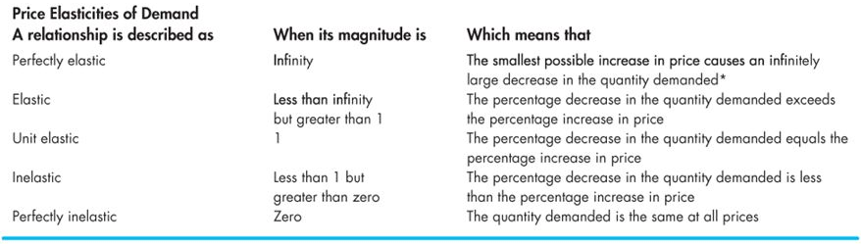
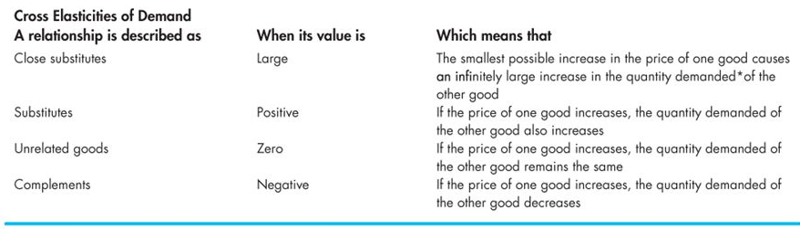
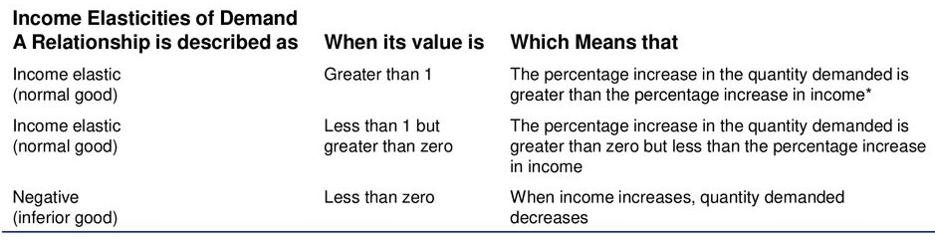
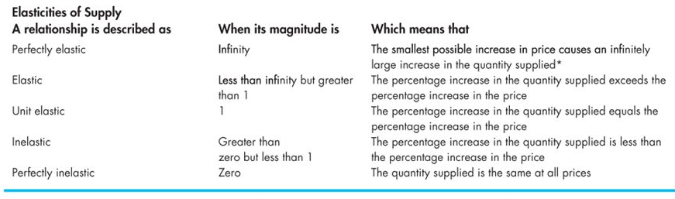

CHAPTER 5

Consumer surplus: excess of benefit received from a good over the amount paid for it
- Marginal benefit (value) of a good minis its price, summed over the quantity bought
- Area of triangle below demand curve and above market price = base x height divided by 2

Firms make profit when they receive more from sale of g&s than cost of producing it
- Cost: what firm gives ip when it produces g&s
- Price: what firm receives when it sells g&s
Cost of producing one more unit of g&s is marginal cost: minimum price producers must receive to induce them to offer one more unit of a g&s for sale
- Minimum supply price determines supply
- Quantity supplied by market: total quantity supplied by all producers at each individual price
Market supply curve: horizontal sum of individual supply curves
For producers: supply curve = marginal cost curve
For society: market supply curve = marginal cost curve
- Society's marginal cost = marginal social cost
$∴$market supply curve = marginal social cost curve

Producer surplus: when price exceeds marginal cost, firm receives producer surplus
- Excess of amount received from the sale of a g&s over the cost of producing it;
- Price received minus marginal cost (minimum supply-price) summed over quantity sold
- Area of triangle below market price and above supply curve = base x height divided by 2
*Producer surplus for market: sum of producer surpluses of producers

