Chapter 11

Decision Time Frames

The firm makes many decisions to achieve its main objective: (economic) profit maximization.

All decisions can be placed in two time frames:
- The short run
- The long run

The short run
The short run is a time frame in which the quantity of one or more resources used in production is fixed.

For most firms:
- Capital is fixed in the short run
- Other resources can be changed in the short run
  - Examples: labour (raw materials, energy)
Short-run decisions are easily reversed

Short run cost

To produce more output (product) in the short run, the firm must:
- Employ more labour
  - Product schedules/curves
- Which means that it must increase its costs
  - Cost schedules/curves

Short-run Technology Constraint

Product Schedules
Three concepts describe the relationship between output and the quantity of labour employed.
Total product is the total output produced in a given period.
Marginal product (of labour) is the change in total product from a one-unit increase in the quantity of labour
Average product (of labour) Is equal to total produce divided by the quantity of labour demanded.

As the quantity of labour employed increases:

- Total product increases
- Marginal product increases initially but eventually decreases.
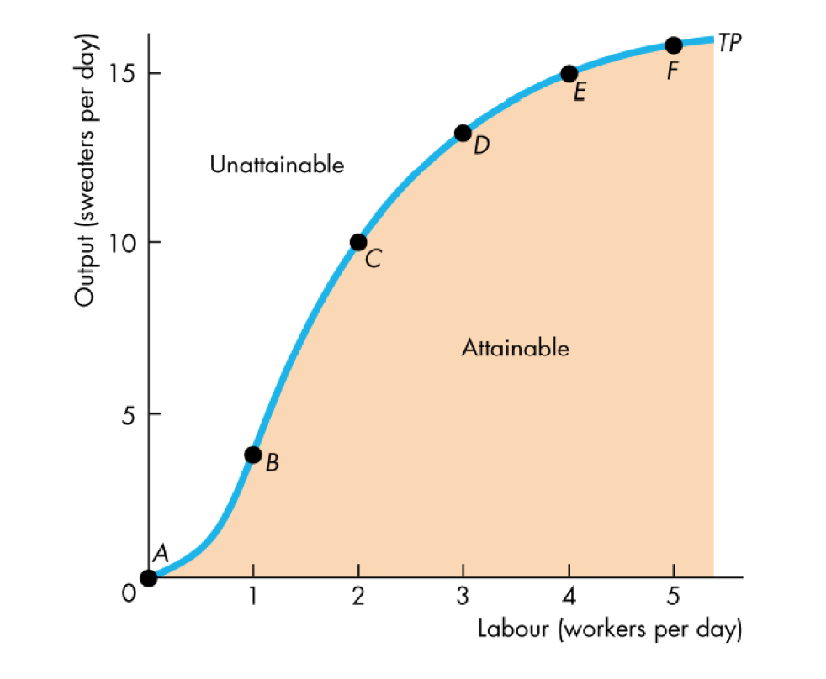
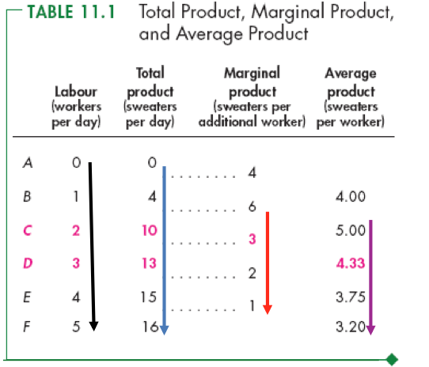
- Average product increases initially but eventually decreases.

Total Product Curve
The total product curve shows how total product changes with the quantity of labour employed.
It separates attainable output levels from unattainable output levels in the short run.

Marginal Product Curve
Almost all production processes are like the one shown here and have:
- Increasing marginal returns initially
- Diminishing marginal returns eventually

We get information for marginal product of labour curve from the total product curve.
The first workers hired produces 4 units of output

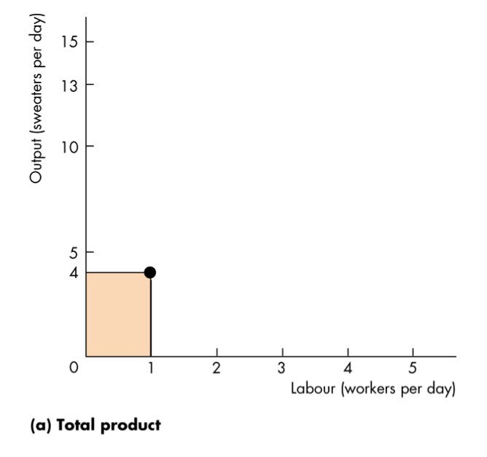

Average Product Curve

The average product curve and the marginal product curve are related.
The marginal product curve “pulls” the average product curve.

When marginal product exceeds average product, average product increases.
When marginal product is below average product, average product decreases.
When marginal product equals average product, average product is at its maximum.

Short-run Cost

To produce more output in the short run, the firm must employ more labour, which means that it must increase its costs.

We describe the way a firm’s costs change as total product changes by using three cost concepts and three types of cost curve:
- Total cost
- Marginal cost
- Average cost

Total Cost

A firm’s total cost (TC) is the cost of all resources used.
Total fixed cost (TFC) is the cost of the firm’s fixed inputs. Fixed costs do not change with output.
Total variable cost (TVC) is the cost of the firm’s variable inputs. Variable costs do change with output.

Total cost equals total fixed cost plus total variable cost.
That is:

TC = TFC + TVC

Marginal Cost
Marginal cost (MC) is the increase in total cost that results from a one-unit increase in total product.
Over the output range with increasing marginal returns, marginal cost falls as output increases.
Over the output range with diminishing marginal returns, marginal cost rises as output increases.

Average Cost
Average cost measures can be derived from each of the total cost measures:
Average fixed cost (AFC) is total fixed cost per unit of output
Average variable cost (AVC) is total variable cost per unit of output
Average total cost (ATC) is total cost per unit of output

ATC = AFC + AVC
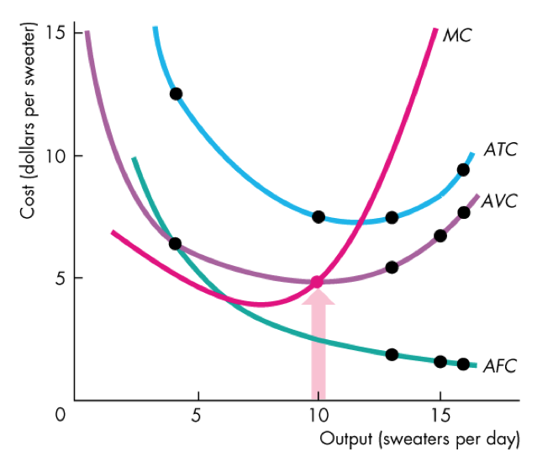
The AFC curve shows that average fixed cost falls as output increases
Pay special attention to the MC curve!
The outputs over which AVC is falling, MC is below AVC.
The outputs over which AVC is rising, MC is above AVC.
The output at which AVC is at the minimum, MC equals AVC.

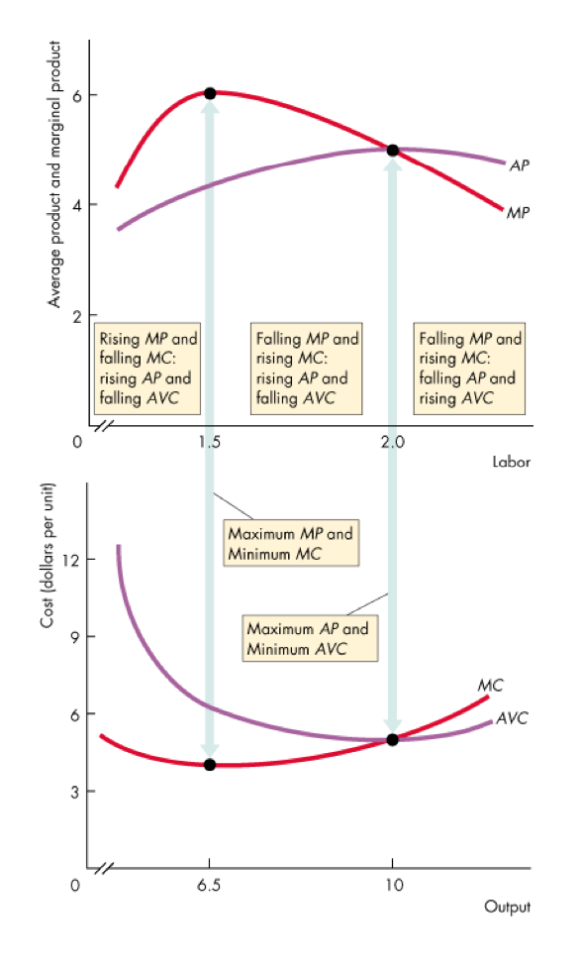
Cost Curves and Product Curves

- When marginal product is rising, marginal cost is falling.
- MC is at its minimum at the same output level at which marginal product is at its maximum.
- Average product is rising, average variable cost is falling.
- AVC is at its minimum at the same output level at which average product is at its maximum.
Decision Time Frames

The Long Run
A sunk cost is a cost incurred by the firm in the past that cannot be changed/recouped.
The amount paid to purchase of capital that has no resale value.
Sunk costs are irrelevant to a firm’s current decisions.

The Production Function
The behavior of long-run cost depends upon the firm’s production function.
The firm’s production function is the relationship between the maximum output attainable and the quantities of both capital and labour.

Long-Run Cost

The Firm’s Production Function
As the size of the plant increases, the output that a given quantity of labour can produce increases.
As the quantity of labour increases, the output that they can produce with a fixed amount of capital increases.
NOTE: they each display diminishing returns!

Diminishing Marginal Product of Capital
The marginal product of capital is the increase in output resulting from a one-unit increase in the amount of capital, holding labour constant.
A firm’s production function exhibits diminishing marginal returns to labour (for a given plant) as well as diminishing marginal returns to capital (for a quantity of labour).
For each plant, diminishing marginal product of labour creates a set of short run, U-shaped costs curves for MC, AVC, and ATC.

Short-Run Cost and Long-Run Cost
The average cost of producing a given output varies and depends on the firm’s plant.
The larger the plant, the greater is the output at which ATC is at a minimum.
The firm has 4 different plants: 1, 2, 3, or 4 knitting machines.
Each plant has a short-run ATC curve.
The firm can compare the ATC for each output at different plants.

Long-Run Average Cost Curve
The long-run average cost curve is the relationship between the lowest attainable average total cost and output when both the plant and labour are varied.
The long-run average cost curve is a planning curve that tells the firm which plant to use.
...that is, which plant minimizes the cost of producing a given output range.

Economies and Diseconomies of Scale
Economies of scale are features of a firm’s technology that lead to falling long-run average cost as output increases.
Diseconomies of scale are features of a firm’s technology that lead to rising long-run average cost as output increases.
Constant returns to scale are features of a firm’s technology that lead to constant long-run average cost as output increases.

Minimum Efficient Scale
A firm experiences economies of scale up to some output level.
Beyond that output level, it moves into constant returns to scale or diseconomies of scale.
Minimum efficient scale is the smallest quantity of output at which the long-run average cost reaches its lowest level.

If the long-run average cost curve is U-shaped, the minimum point identifies the minimum efficient scale output level.

