Chapter 10

The Firm and Its Economic Problem

A firm is an institution that hires factors of production and organizes them to produce and sell goods and services.

The Firm’s Goal

A firm’s goal is to maximize profit

Economic profit: equal to total revenue minus total cost, with total cost measured as the opportunity cost of production

A Firm’s Opportunity Cost of Production

A firm’s opportunity cost of production is the value of the best alternative use of the resources that a firm uses in production.

This is the sum of the cost of using resources.
- Bought in the market (amount spent)
- Owned by the firm (implicit rental rate)
  - Economic depreciation
  - Interest foregone
- Supplied by the firm’s owner (profit for entrepreneurship)

Technology and Economic Efficiency

Economic Efficiency

Economic efficiency: occurs when the firm produces a given level out output at the lowest cost

The economically efficient method depends on the relative costs of capital and labour.

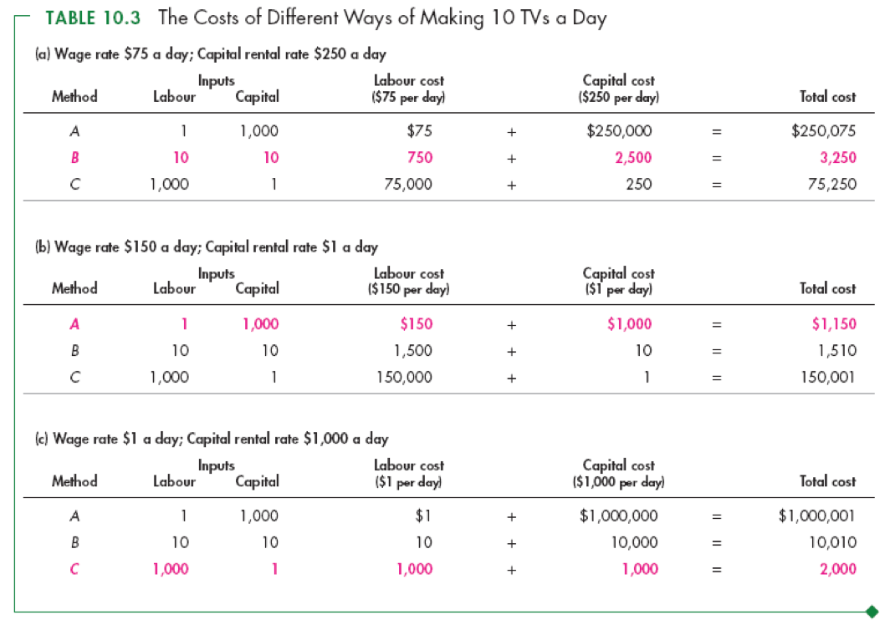

The Firm and Its Economic Problem

The Firm’s Decisions

To maximize profit, a firm must make five basic decisions:

- What to produce and in what quantities
- How to produce
- How to organize and compensate its managers and workers
- How to market and price its products
- What to produce itself and what to buy from other firms

Markets and the Competitive Environment

How firms make these decisions will “look” different depending on the type of market they face/operate in:

- Perfect competition
- Monopolistic competition
- Oligopoly
- Monopoly

