Chapter 9

Consumption Possiblities

The budget line describes the limits to the household’s consumption choices. It is constrained by:
- Income
- Prices

The budget equation

We can describe the budget line by using a budget equation:

Expenditure = Income

Expenditure = Y = (Price of pop x Quantity of pop)
+ (Price of movie x Quantity of movies)
= P_{p}Q_{P} + P_{M}Q_{M}
= (P_{x1} x Q_{x1}) + (P_{x2} x Q_{x2})

(Notation: P_{x} =price of good x; Q_{x} = quantity of good x; Y=income)

The Budget Equation

We can describe the budget line by using a budget equation (in terms of pop and movies):

Real income in terms of pop Y / P_{P} = (P_{p}Q_{P} + P_{M}Q_{M}) / P_{P}
= Q_{P} = (Y/P_{P}) – (P_{M}Q_{M} / P_{P})

Relative price of a movie P_{m} / P_{P}
in terms of pop

Real income: a household’s income expressed as a quantity of goods that the household can afford to buy.

Relative price: the price of one good divided by the price of another good in order to show the opportunity cost.

Changes in Factors

Price (change of slope of budget line)
Increase in price (x-axis) = decreases the affordable quantity of the x-axis good and increases the slope of the budget line,
Decrease in price (x-axis = increases the affordable quantity of the x-axis good and decreases the slope of the budget line
Increase in price (y-axis) = decreases the affordable quantity of the y-axis good and increases the slope of the budget line
Decrease in price (y-axis) = increases the affordable quantity of the y-axis good and decreases the slope of the budget line

Income (shift of budget line)
Increase in income = increases the affordable quantity of both goods and shifts the budget line upwards
Decrease in income = decreases the affordable quantity of both goods and shifts the budget line downwards

Preferences and Indifference Curves

Indifference curves

Indifference curve: a line that shows combinations of goods among which a consumer is indifferent (having no particular interest or sympathy)

Marginal Rate of Substitution

Marginal rate of substitution (MRS): measures the rate at which a person is willing to give up good y to get an additional unit of good x while at the same time remain the same on the difference curve

The magnitude of the slope of the indifference curve measures the marginal rate of substitution
If the indifference curve is relatively steep, the MRS is high.
Assume the consumer values the x-axis good more.
If the indifference curve is relatively flat, the MRS is low.
Assume the consumer values the y-axis good more.

A diminishing marginal rate of substitution is the key assumption of consumer theory.

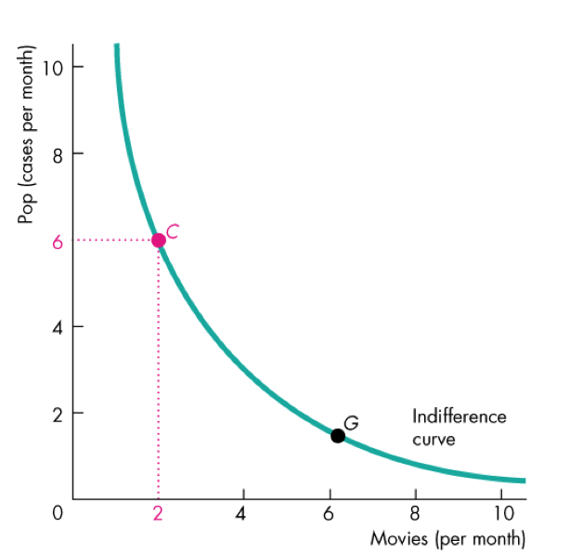
Diminishing marginal rate of substitution: the general tendency for a person to be willing to give up less of good y to get one more unit of x, while at the same time remaining indifferent as the quantity of x increases.

Degree of Substitutability

The shape of the indifference curve reveals the degree of substitutability between two goods.
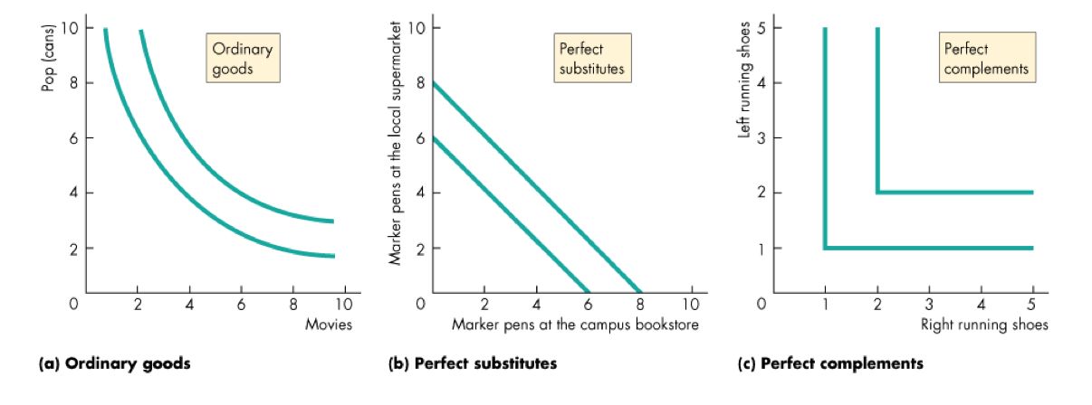

Predicting Consumer Choices

Best affordable choice:

The best affordable choice is:
- On the budget line
- On the highest attainable indifference curve
- Marginal Rate of Substitution equals Relative Price (MRS = RP)

Price effect: the effect of a change in the price of a good on the quantity of the good consumed

Income effect: the effect of a change in income on buying plans

