“Oh How Bitter a Thing is…”
Acid Base Titrations

Written by:

Tram Nguyen, 300065837

TA: Vanessa Susevski

Date: Tuesday, November 6, 2018

Introduction: The Arrhenius definition for acids is that they are proton donors when dissociated in water. The Arrhenius definition of bases is that they are hydroxide ion donors when dissociated in water. Together, these two ions produce water, a product of an acid-base reaction.

When describing acids and bases, their strength and concentration are used. Strength refers to whether or not it is a strong or weak acid/base. Strong acids/bases dissociate completely in water into their ions. Weak acids/bases only dissociate partially in water. Concentration refers to the number of moles in a given volume. The higher the concentration, the higher the ratio or acid/base in water and vice versa. The concentration is given in the following formula:

Concentration (mol/L) = amount of solute (mol)/volume of solution (L)

This lab is considered a titration lab because we are using the information collected in the lab to find an unknown value. In this case, it is to find the concentration of an unknown diprotic acid. The concentration of the unknown acid is found while manipulating

C₁V₁ = C₂V₂

Using the molar ratio of the balanced chemical equation in order to obtain

2c_{base}V_{base} = c_{acid}V_{acid}

This equation was used to find the concentration of Unknown Acid #2. The concentration was found to be 0.244M.

Method: Please refer to “Oh How Bitter a Thing it is…” Acid Base Titrations on Brightspace.

- Safety equipment is put on
- The drop counter is calibrated to the set plastic burette speed with LabQuest
- A diluted solution of NaOH is made using 200mL of distilled water and 6M NaOH
- The diluted solution of NaOH is then standardized to find its concentration and recorded through LabQuest, This is done 3 times total to get an accurate value.
- The acid burette is filled with the unknown acid then titrated with the now standardized NaOH to find its concentration. All results are collected through LabQuest. This is done three times to get an accurate value.
- Area is cleaned, all solutions are properly disposed of and results are signed.

Data Collected: (For data tables, check the end of the report)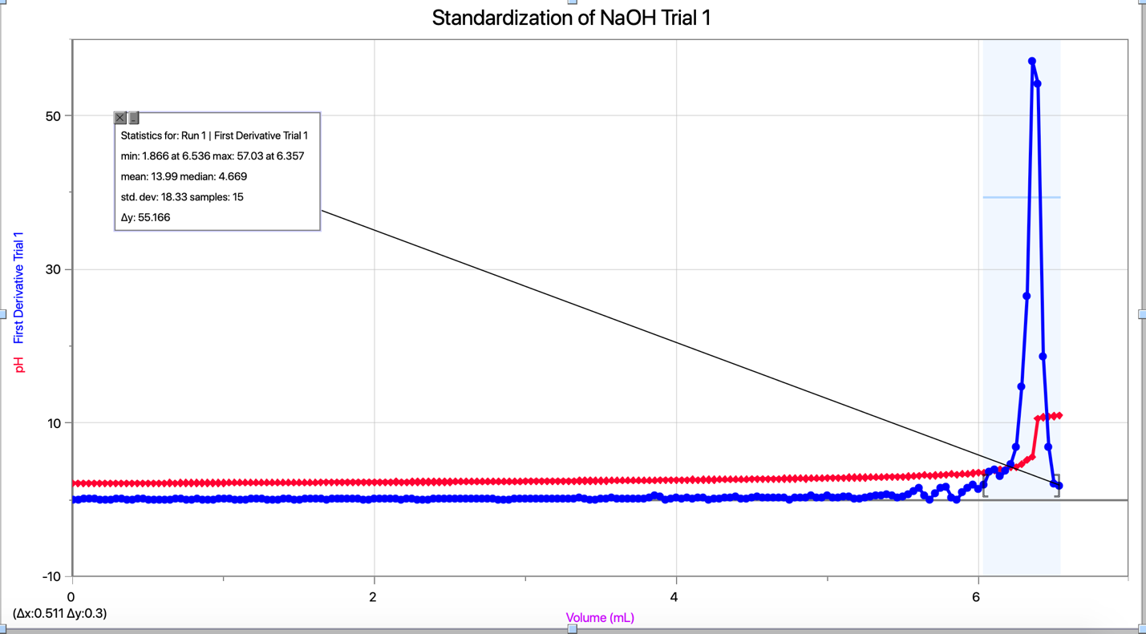

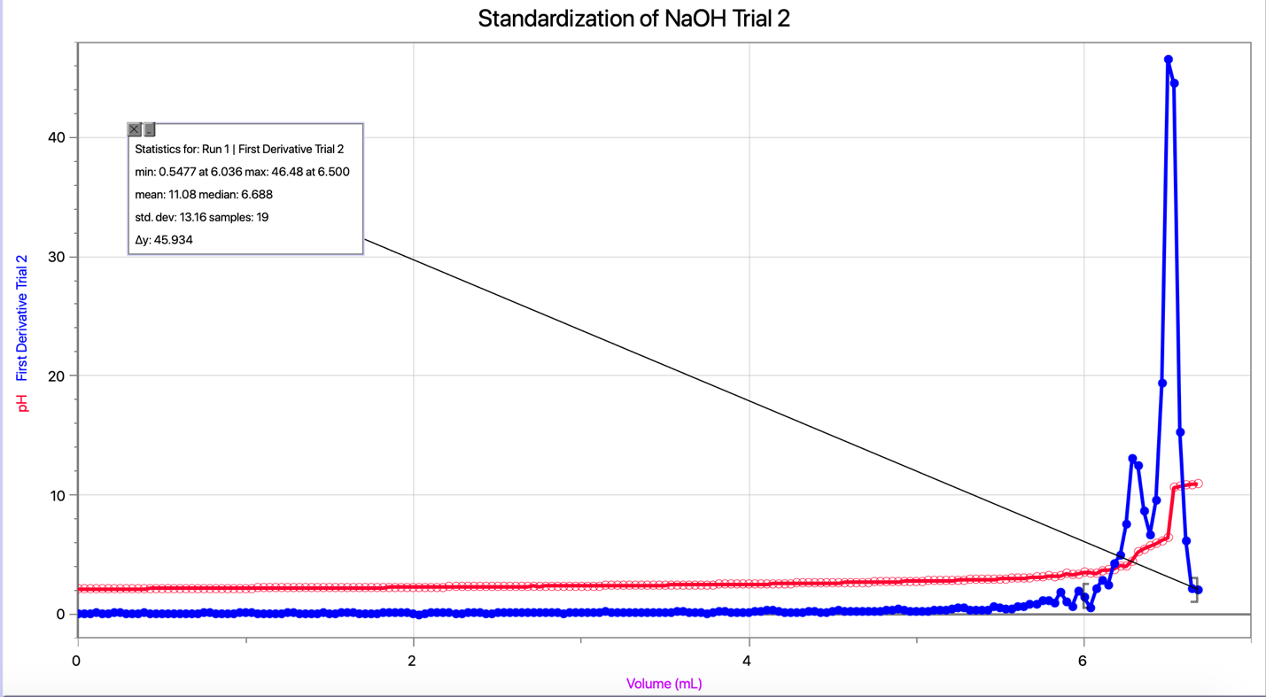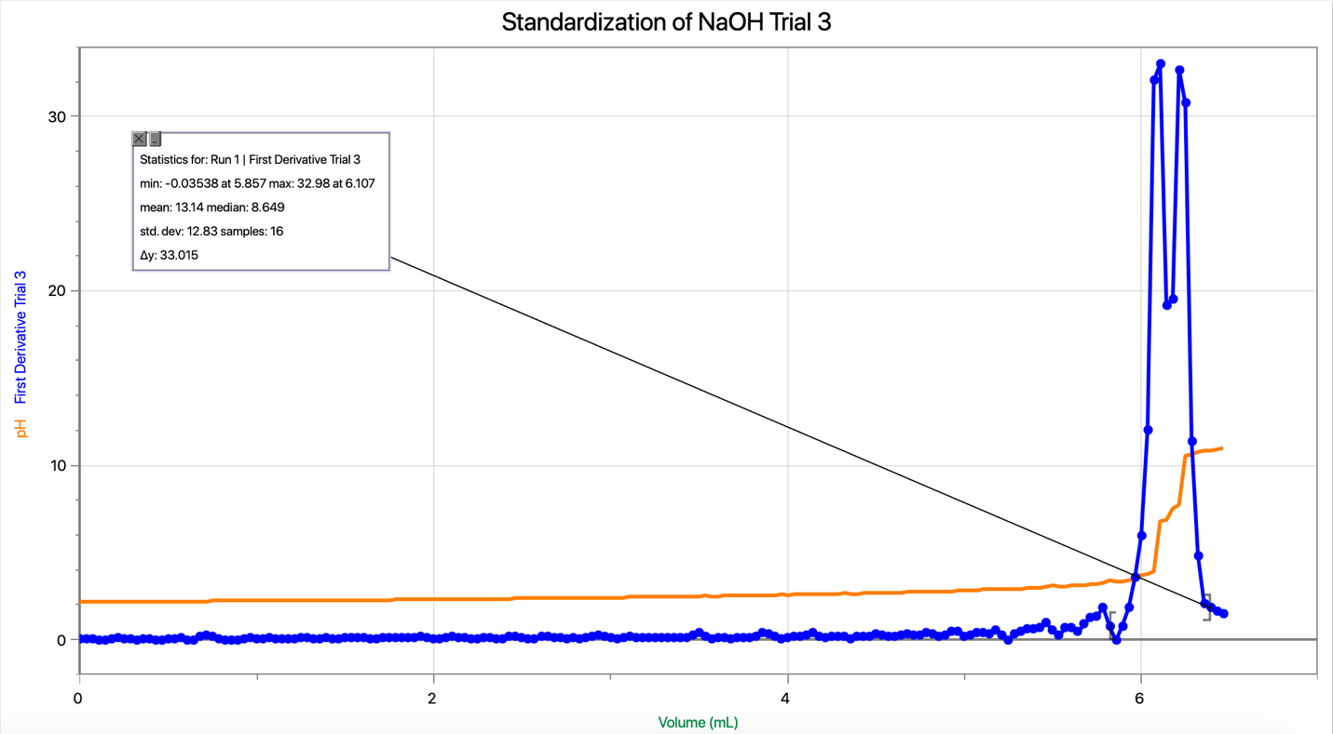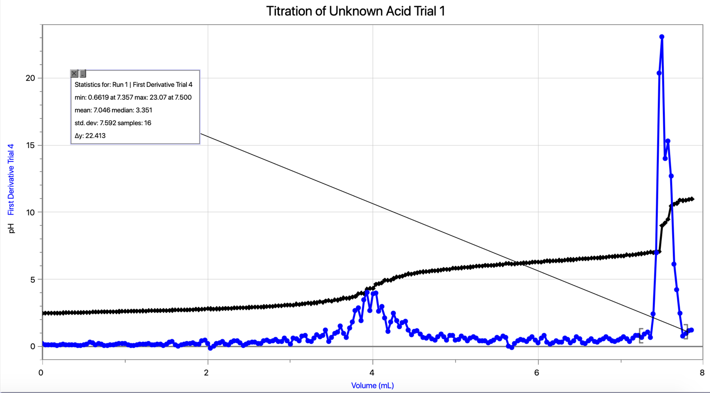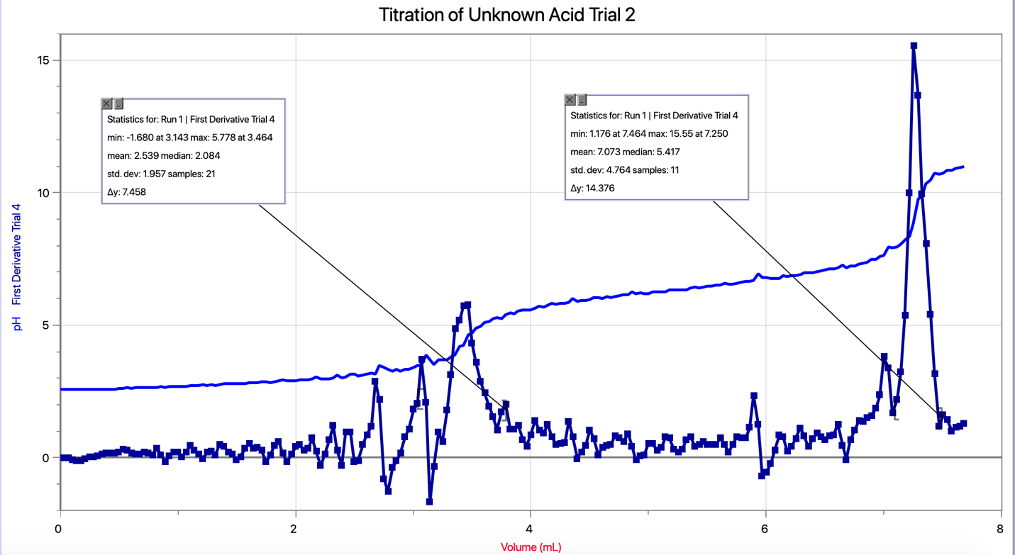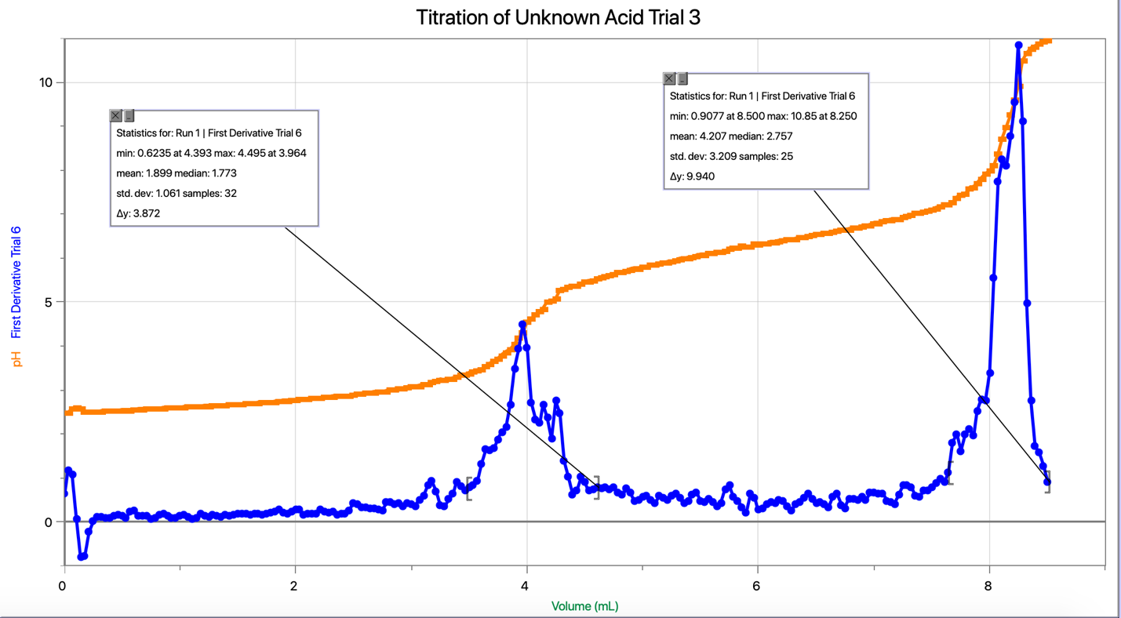

Calculations:
Standardization values
Finding the concentration of NaOH
Trials | Volume of (0.100M) HCl added (L) | Equilibrium value of NaOH using first derivative (L) | Concentration of NaOH  C₁V₁ = C₂V₂
Trial 1 | 1.00 x 10⁻² | 6.357 x 10⁻³ | 0.157M
Trial 2 | 1.00 x 10⁻² | 6.500 x 10⁻³ | 0.154M
Trial 3 | 1.00 x 10⁻² | 6.107 x 10⁻³ | 0.164M
Average Concentration |  |  | 0.158M
Use concentration formula to obtain concentration of another solution in the mixture
C₁V₁ = C₂V₂
(0.100M)(0.0100L) = C₂(0.06357L)
C₂ = (0.100M)(0.0100L)/(0.06357L)
C₂ = 0.1573M

2 NaOH + H₂A 2 H₂O + 2 NaA

Calculations to find number of moles of NaOH used in the reaction with the unknown acid
Trials | Volume of 0.1583M NaOH using first derivative | Moles of NaOH  N_{base}=C_{base}V_{base}
Trial 1 | 7.50 x 10⁻³ | 1.19 x 10⁻³
Trial 2 | 7.25 x 10⁻³ | 1.15 x 10⁻³
Trial 3 | 8.25 x 10⁻³ | 1.31 x 10⁻³
Average | 7.67 x 10⁻³ | 1.27 x 10⁻³
Rearrage C=n/V to obtain the number of moles
N_{base} = (0.1583M)(0.0075L)
Volume of the Unknown Acid
Trial | Volume (L)
Trial 1 | 0.0100
Trial 2 | 0.00982
Trial 3 | 0.0100

2 n_{base} = n_{acid}

Concentration of unknown acid #2:
2 x concentration_{base} + V_{base} = concentration_{acid} x V_{acid}
2c_{base}V_{base} = c_{acid}V_{acid}

Finding the concentration of H₂A
Trial | n_{base} (mol) | n_{acid} required (mol) | Volume of H₂A used (L) | Finding the concentration of H₂A using  2c_{base}V_{base} = c_{acid}V_{acid}
Trial 1 | 1.19 x 10⁻³ | 2.37 x 10⁻³ | 1.00 x 10⁻² | 0.237M
Trial 2 | 1.15 x 10⁻³ | 2.30 x 10⁻³ | 9.82 x 10⁻³ | 0.234M
Trial 3 | 1.31 x 10⁻³ | 2.61 x 10⁻³ | 1.00 x 10⁻² | 0.261M
Average concentration |  |  |  | 0.244M

Manipulating C₁V₁ = C₂V₂ according to the molar ratio between NaOH and a diprotic acid to find the concentration of the diprotic acid
Trial 1:
2c_{base}V_{base} = c_{acid}V_{acid}
2(0.158M)(7.50 x 10⁻³) = c_{scid}(0.0100L)
C_{acid} = 2(0.158M)( 7.50 x 10⁻³)/( 0.0100L)
C_{acid} = 0.237M

Discussion:

During the lab performed, we standardized the diluted NaOH using the known value of previously standardized HCl. When this was done, the concentration was found which was then used to find the concentration of an unknown diprotic acid. It is important to determine the concentration of the diluted NaOH before it is used in order to accurately determine the concentration of another unknown concentration. The concentration of Unknown Acid #2 is 0.244M.

During the last trial of neutralizing the unknown acid, halfway through, it was discovered that the drop counter was not detecting the drops and thus skewing the results. In between the process of starting a fourth trial, the base dropper was actually knocked out of place which would change the volume amount recorded by the drop counter and LabQuest. Because of this, the third trial is slightly skewed away from the first two trials.

Species in each stage:
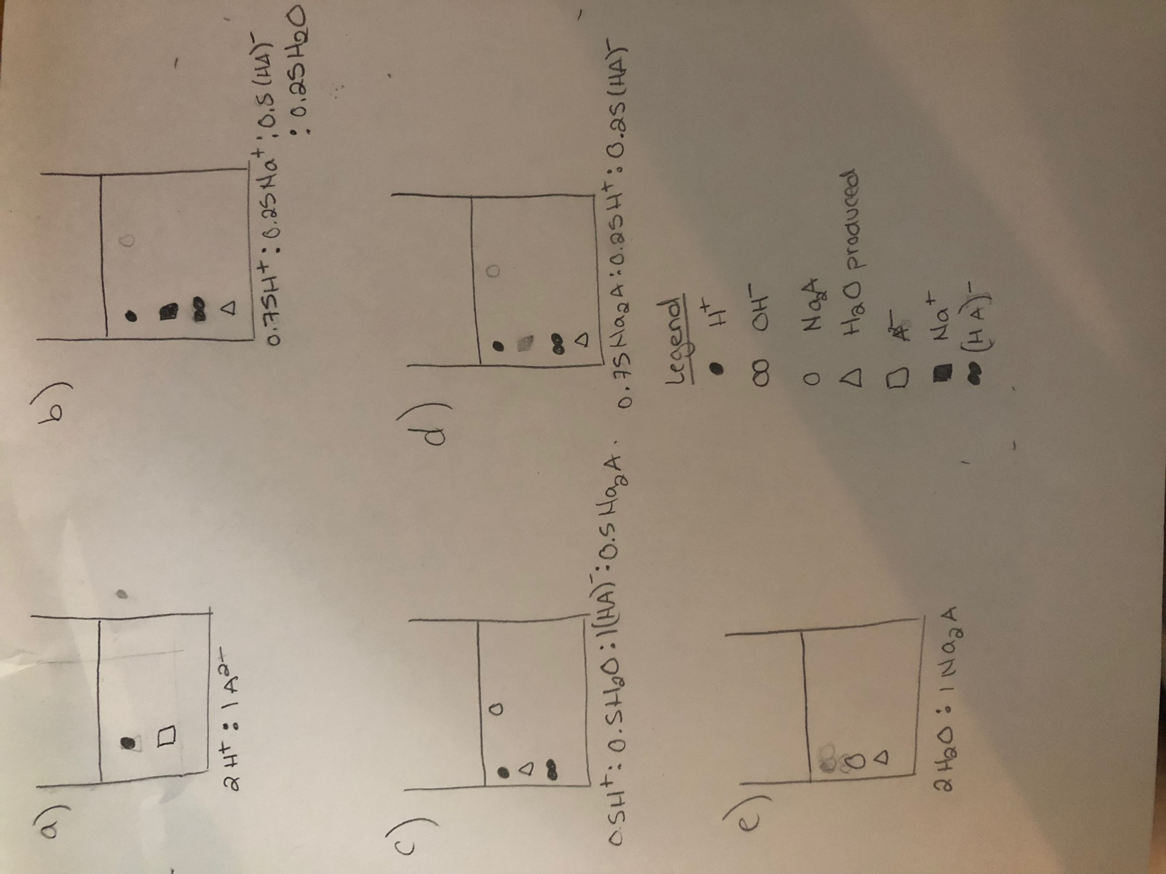
- There should only be the dissociated ions of the unknown diprotic acid
- There should be “75%” of the diprotic acid protons with 25% of the sodium ions as only 25% is reacted at the 25% mark. Half of the monoprotic acid remains.
- All of the first protons of the diprotic acid are consumed leaving the monoprotic version of the acid and half of the final salt is formed.
- Only 25% of the total ions are left. 75% of the salt is formed and there still remains. 25% of the monoprotic acid remains to be consumed.
- All of the acid and base is consumed, leaving only the water formed and the salt.

Conclusion:

After the concentration of diluted NaOH was found, the concentration of an unknown diprotic was found to be 0.244M through calculations.

Data Tables for the following respectively:
Trial 1 for the Standardization of NaOH
Trial 2 for the Standardization of NaOH
Trial 3 for the Standardization of NaOH
Trial 1 for the Standardization of Unknown Acid 2
Trial 2 for the Standardization of Unknown Acid 2
Trial 3 for the Standardization of Unknown Acid 2



