Microeconomics 1021
Chapter 01 Notes

Scarcity: the inability to get everything we want. This is universal.

Incentive: A reward that encourages an action or a penalty that discourages one.
- Example: Prices of goods

Economics: A social science that studies the choices government, firms, and societies have to make as they cope with scarcity and the incentives that influence and reconcile those choices.

Microeconomics: The study of small-scale economic events that impact individuals and firms in society.

Macroeconomics: The study of large economic phenomenon like national economies and global economic stability.

Two BIG questions in economics:
- How do choices end up determining what, how, and for whom goods are produced?
- When do choices made in self-interest also promote social interest?

Goods and services: Objects that people value and produce to satisfy human wants.

Factors of Production: the resources businesses use to produce goods and services.
- Land – earns rent
- Labour – earns wages
- Capital – earns interest
- Entrepreneurship – earns profit

Self-interest: People make choices in support of their own interests with the goal of advancing their own agendas.

Social Interest: An outcome is in the social interest if it benefits society as a whole.

Efficient: An everyday situation that cannot be improved upon.

Tradeoff: an exchange, giving up something to gain something else.

Globalization: expansion of foreign trade, borrowing and lending, and investment.

Market Capitalism: The market is free for individuals to buy and sell goods and services.
- Adam Smith said that an INVISIBLE HAND existed that promoted social interest by corporations competing against each other in their self-interests

Centrally planned socialism: Government controls the means of production and determines the direction of the economy.
- Karl Marx and other theorists supported these ideas
- The modern-day Occupy Wall Street movement advocates to ideas similar to these (redistribution of wealth, greater corporate regulations, etc.)

The MIXED ECONOMY combines these two ideas and is most prevalent in the economies of developed countries, including Canada.

Six economic ways of thinking:
- Choice is a tradeoff
- People make rational choices by comparing benefits and costs
- Benefit is what you gain from something
- Cost is what you must give up for something
- Most choices are how much choices made at the margin
- Choices respond to incentives

OPPORTUNITY COST is the cost of the highest valued alternative to a decision.
- All tradeoffs involve an opportunity cost

Marginal Benefit: The benefit that arises from an increase in an activity.

Marginal Cost: The opportunity cost of an increase in an activity.

When individuals make choices they make them at the MARGIN – comparing the benefit of a little bit more of something with its cost.

Positive Statement: What it is. Generally, policy statements or other statements that can be supported by facts (either proven or disproven).

Normative Statement: What it ought to be. These statements cannot be proven or disproven and generally tend to be subjective statements depending on the individual.

ECONOMIC MODELS are used to explain the economic world.

Microeconomics 1021
Chapter 02 Notes

Production Possibilities Frontier: The boundary between those combinations of goods and services that can be produced and those that cannot. The PPF looks at a MODEL ECONOMY where only TWO GOODS CHANGE and all others do not.

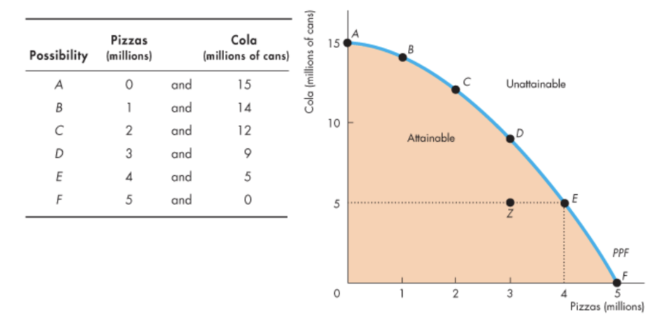

PPF illustrates scarcity because all points inside of the curve are ATTAINABLE and all points outside of the curve are UNATTAINABLE.

Production efficiency: Occurs when we produce the greatest amount of goods for the lowest cost. This occurs at all the points ALONG the PPF.
- Production is INEFFEICIENT when resources are unused or misallocated or both
- Resources are unused when they could be working
- They are misallocated when they are assigned to tasks for which they are not the best match (example: assigning pizza chefs to work in a cola factory)

Opportunity cost: Highest valued alternative forgone. Since there are only two goods on the PPF, the opportunity cost directly correlates to changes in the production rates of both products.

Marginal cost: The opportunity cost of producing one more unit.

Marginal cost is explained through the diagrams below, as it is measured through the marginal increase in the opportunity cost of a good.
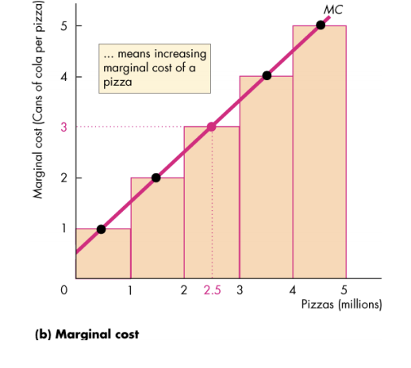
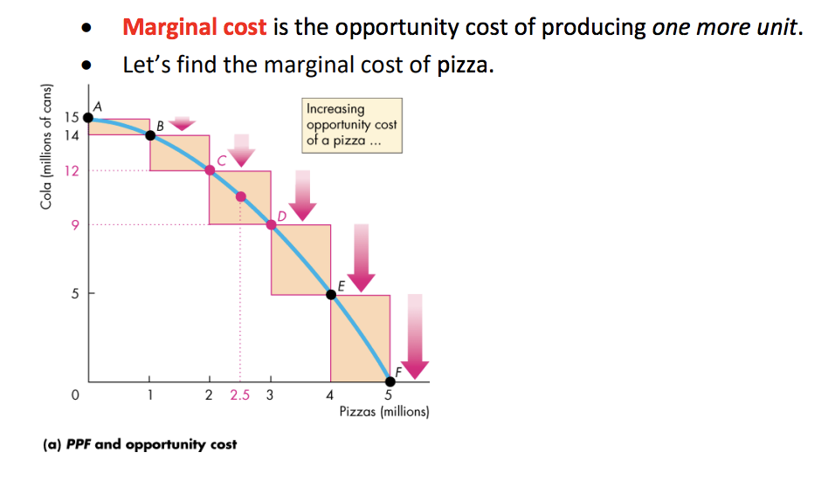

Marginal benefit: The benefit from consuming one more unit of a good or service.
- The most you are willing to pay for something
- Cannot be derived from the PPF

Principle of decreasing marginal benefit: The more we have of a good or service the lower the marginal benefit and thus the lower the price we are willing to pay.

Marginal benefit explained:

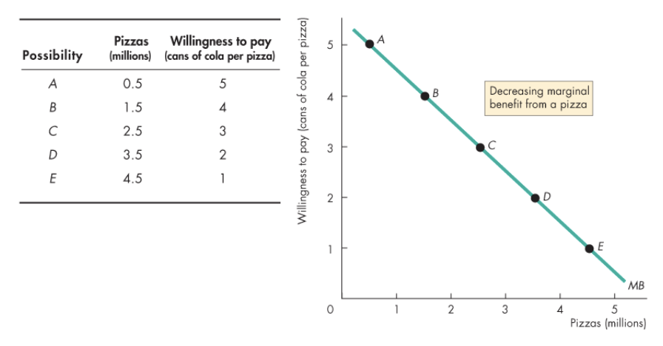

Allocative efficiency: When goods and services are produced at the lowest possible cost for the greatest possible benefit. This can be found by superimposing both the MC and MB curves on one plane and finding where they reach equilibrium.

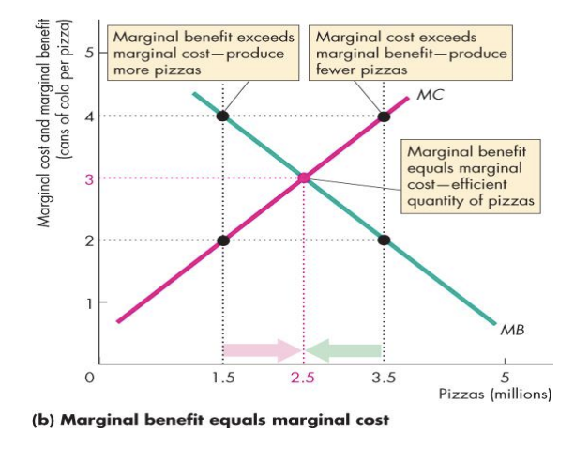

Specialization: Producing only one or few goods.

A COMPARATIVE ADVANTAGE occurs if an individual can produce a product at a lower opportunity cost than anyone else.

An ABSOLUTE ADVNATAGE occurs when an individual is more productive than others.

Economic growth: Expansion of production possibilities.
- Increases standard of living
- Does not overcome scarcity or avoid opportunity cost

Two key factors of economic growth:
- Technological change
- Capital accumulation

Capital accumulation: Growth of capital resources, including human capital.
In the context of economic growth, we must give up producing an abundance of one resource to gain new capital.
- The more of an existing resource a firm gives up to accumulate more capital, the greater their PPF will expand outwards

Two types of economic coordination systems:
- Central planning – Does not work because individuals are tasked with planning the economy’s future without knowing people’s production possibilities and preferences. Thus, production ends up INSIDE the PPF (wrong things are produced)
- Decentralized (market) coordination – Works best, but requires four complementary social institutions
  - Firms – Unit that hires factors of production and organizes them to produce and sell goods and services (ex. Loblaws)
  - Markets – Any arrangement that enables buyers and sellers to get information and do business with each other (ex. World Oil Market)
  - Property rights – Social arrangements that govern the ownership, use, and disposal of anything that people value are called property rights
  - Money – Any commodity or token that is generally acceptable as a means of payment

Microeconomics 1021
Chapter 03

Competitive Market: A market that has many buyers and sellers so that no single buyer or seller can influence the entire market.

Money Price: The price of an object in the number of dollars that must be given up in exchange for it.

Relative Price: Ratio between one price and another. This is an example of OPPORTUNITY COST. When we consider demand and supply we consider it as a RELATIVE PRICE and not a money price.

If you demand something:
- You want it
- Can afford it
- Plan to buy it

DEMAND reflects a decision about which wants to satisfy.

Quantity Demanded: A good or service that consumers plan to buy during a given time period at a particular price.

Law of Demand: Other things remaining the same, the higher the price of a good, the smaller is the quantity demanded; and the lower the price of the good, the greater is the quantity demanded.

Two reasons why the law of demand exists
- Substitution effect – Each good has substitutes and they can be replaced if they are too expensive
- Income effect – When prices increase and income of the consumers does not, it becomes difficult for them to pay and they will give up the expensive items

Demand: Refers to the entire relationship between the price of a good and the quantity demanded of the good.

The willingness and ability to pay for a good is considered to be the MARGINAL BENEFIT.

CHANGES IN DEMAND occur when any factor influencing demand occurs, other than price.

Main factors that influence a change in demand:
- The prices of related goods
- Expected future price

