Import java. Lang.*;
/**
* Header comment , describes program
*/

Public class JavaMain { //start class
Public static void main (String[]args) } // start main
//method
}//end main
}//end class

Comments a note to help read the code
2 main types
Header/block /**
*
*/
used to describe program on large block of code(method)
In line comment //
- Used for single line, can be after code
Class file, container
- Holds code from start { to end }
Main method Start here
Program will execute code line by line from start from { to end }
controls execution of program

• A statement ends in ;
• Blocks are defined by { }

Library ----- code is from creators of Java
-----API

Our code ---- Stored in files ( classes ) on local machine
----access code through the same project if multiple files

Data type var name = value;
Exp
Int a= 10 ;
Declare assign/initialize to vale
- Equals sign means assignment ( not equals sign)

Output message /data to user

System.out.println(….);
- Hits ENTER after output

System.out.print(…….);
prints without hitting ENTER
Use to write on same line

Steps to take input

- Import library to indicate we are using Scanner class from library.
Import java.util.Scanner;
- Create Scanner variable and initialize it.
Scanner input = new Scanner (system.in);

- Get input from user and store it

Int num1;
Num1 = input.nextInt(); //get input

DecimalFormat df=new Decimal Format(“#0.0#”);
Option Import java.text.DecimalFormat;

## -if there are numbers are print (“0.##) integer
(“.00”)- even there are no numbers ,it will still print the numbers 1.00 or 2.00
df=format( the variable or equation)

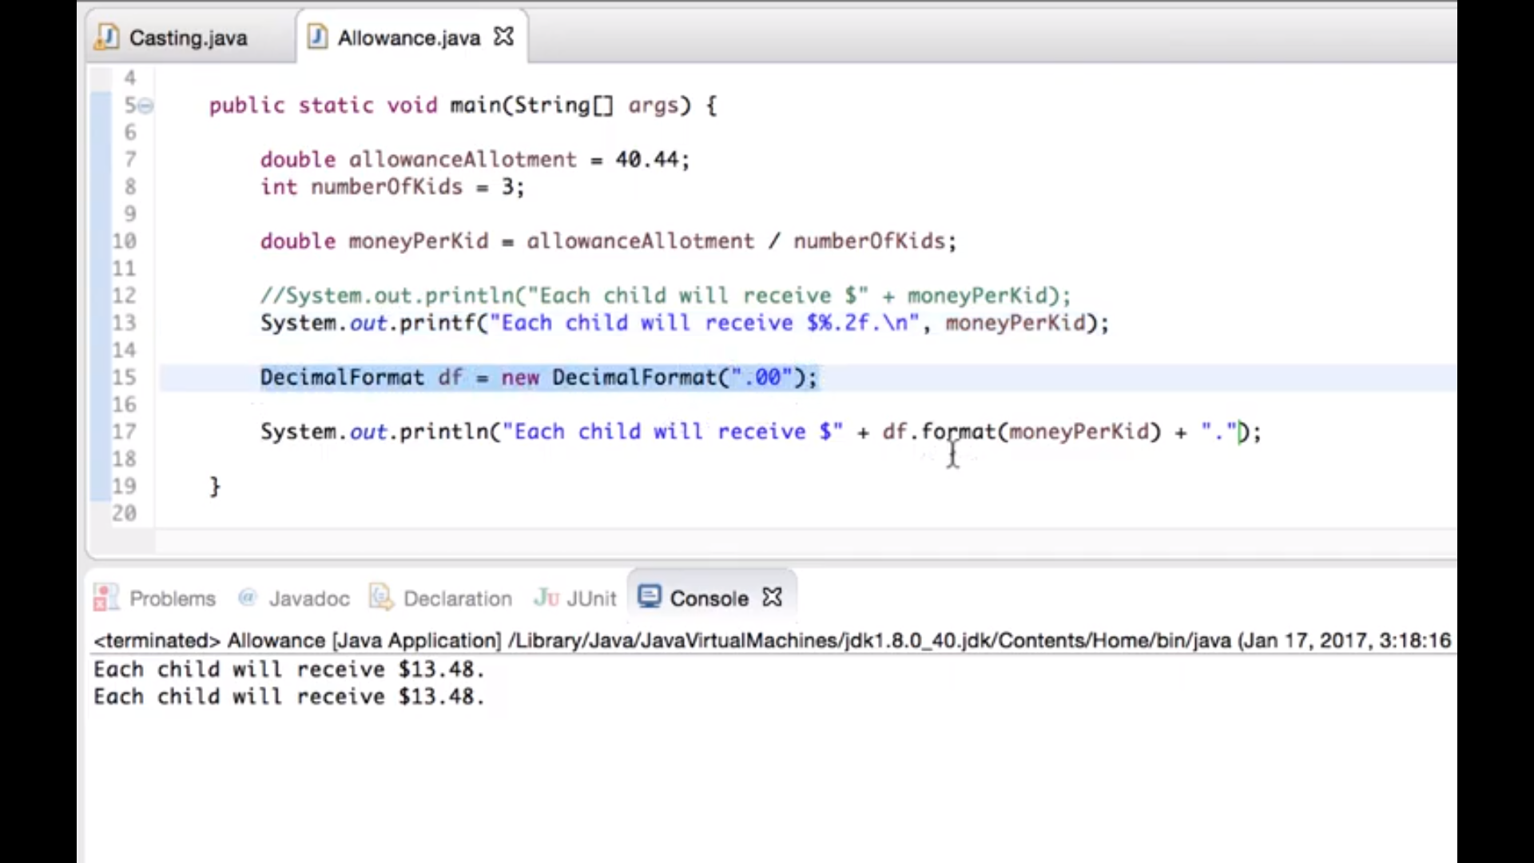
String name = “Howard”;
String name = new String (“Howard”);
System.out

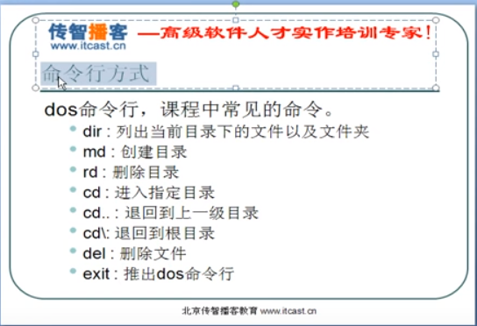

Access modifiers determine the level of visibility (and therefore access) for a Java entity (a class, method, or field). Access modifiers enable us to enforce effective encapsulation. If all member variables of a class can be accessed from anywhere, then there is no point in putting these variables in a class right and no purpose in encapsulating data and methods together in a class.
Java supports four types of access modifiers:
- Private
- Default (no access modifier specified)
- Protected
- public

