Purpose: This lab reinforces your classroom discussions concerning Oracle architecture
Requirements: Complete the required tasks and submit the required responses in the same word document renamed as lab3_fname_lname (e.g., Lab3_Mohamad_Hoda) via Bb by the end of the lab day (11:59 pm). A complete and on-time submission will earn 3 marks.
Tasks:
- Demo / Problem Solving: During Week 3's lab, you will be required to confirm your Oracle 12c installation is working properly. If it is not working, we will develop a plan to get it correctly installed.

- Concepts: Refer to Chapter 13 of the Concepts guide in answering the following questions (https://docs.oracle.com/database/121/CNCPT/startup.htm#CNCPT601). Copy your answers to your submission document.
  - A database instance can be associated with at least one database(s).
  - To start a database instance, configuration parameters must be read. This information is contained in binary format in SPFILE and in text format in PFILE.
  - During STARTUP, the instance knows where the data files are located by reading the Control file.
  - The main difference between a TRANSACTIONAL SHUTDOWN and an IMMEDIATE SHTDOWN is, in a TRANSACTIONAL SHUTDOWN, the shutdown is planned and allows active transitions to be completed.

- Review the Startup/Shutdown Process (Write the queries and their results):
  - Logon as SYS as SYSDBA.
SqlPlus
Sys as Sysdba
Dba123

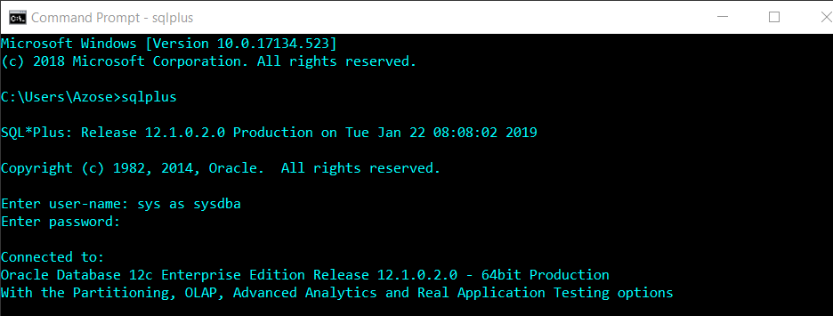

  - Enter SHOW PARAMETERS
    - From the SHOW PARAMETERS results, determine where the SPFILE file is located. Record this location in your lab file.
Show parameters spfile

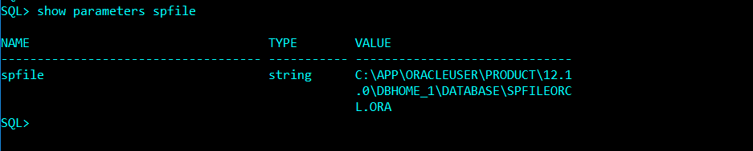

  - Create a PFILE: Enter: CREATE PFILE from SPFILE;
Create pfile from spfile;
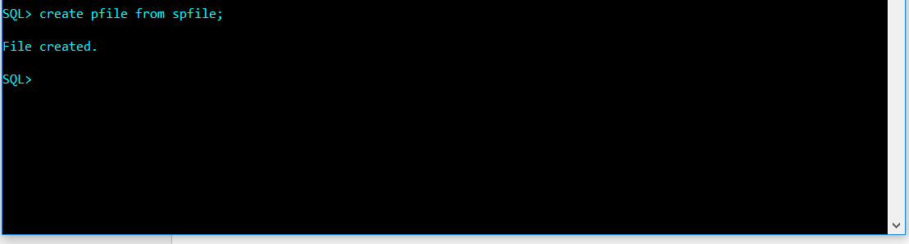
  - Locate and resulting PFILE and in your lab document, specify:
    - the name of the pfile
INITorcl.ORA
    - the oracle_base name

orcl.__oracle_base='C:\app\OracleUser'#ORACLE_BASE set from environment
    - the location of the control_files
*.control_files='C:\app\OracleUser\oradata\orcl\control01.ctl','C:\app\OracleUser\oradata\orcl\control02.ctl'
  - Enter: SHUTDOWN
Shutdown
  - Enter: STARTUP
Startup
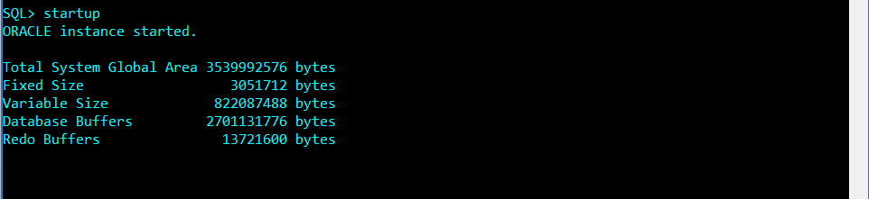
  - Indicate, in your lab document, the sequence of objects being started.

- DATA DICTIONARY: From the SQL prompt, enter DESC DICT- this command describes the structure (the columns) of the internal data dictionary. Throughout the course, when you forget the names of special tables you can return to the dictionary and determine the name. In your lab document answer the following questions (Write the queries and their results):
  - List the number of rows that are in this table (you may not want to select the rows as there are a lot). 3228
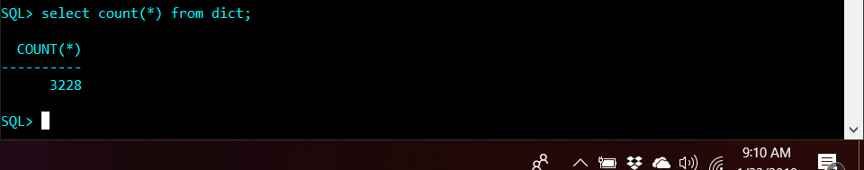

List the name of the view or table that describes Tablespaces: ___________
Select name from V_$TABLESPACE;

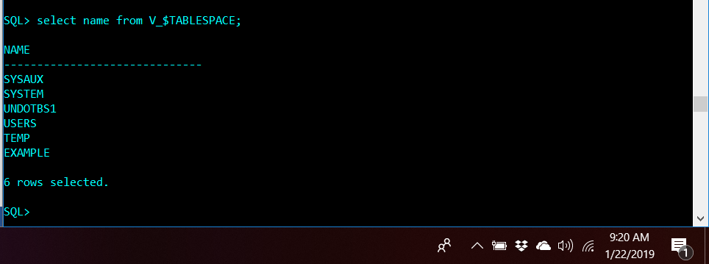

  - List the name of the view or table that describes Datafiles: ___________
Select name from V_$DATAFILE;

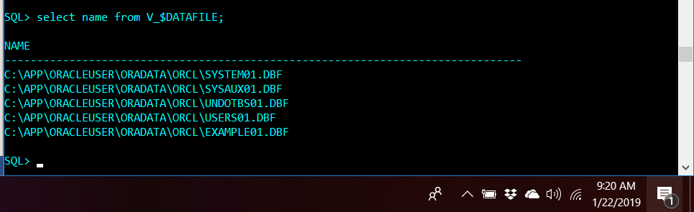

You're done. Submit your lab.

