EC120 / LEC 0

16th Addition textbook ec120 / access code / e-text 114

IMPORTANT COURSE INFO
Section A – Tools for Analysis
Saturday Oct 5, 4:30 PM: MIDTERM 1
WORTH 15%
Section B – Economics of Business
Saturday, Nov 9, 4:30 PM: MIDTERM 2
WORTH 24%

Section C – Economics of Government
Final Exam: TBD During December
WORTH 40%

EC120 / LEC 1

Opportunity Cost
- The forgone alternative
- Opportunity cost is the opportunity lost of doing one thing over another
- Taking into consideration what you have lost when making a CHOICE
- Economics is based on the assumption that people as a whole generally make rational decisions.
- Choices imply forgone alternative es
- Cost Benefit analysis
  - Most decisions seen through a simple cost-benefit analysis
  - What is the cost and benefit of making a certain choice?
- Accounting Profit: tax law around writing odd personal items used for work
- Economic Profit:
  - opportunity cost of your time,
  - opportunity cost of a computer/car/house (low since you would own them anyway)
- University and Marginal Decisions:
  - Many decisions are marginal
  - Uni is not marginal decision
  - Marginal decision: how many classes do I take? Hours spent studying?

Scarcity
- Limited nature of society’s resources
- Economics uses this concept to study how society makes choices and manages scarce resources
- Scarce resources connote an opportunity cost
- Key questions:
  - Who makes what choices?
  - How much info do they have when making this choice?
  - What factors affect the decision making?

Types of Economies:
- Command: totalitarian, government decides everything and answers the key questions
- Market: no government control whatsoever, laissez-faire attitude
- Mixed

CLICKER: scarce resources means we must make choices based on what alternatives we have

Production Possibilities Frontier (PPF)
- Graph that shows all possible combinations of output
- Simplification to two outputs
- Highlights two main concepts
- Points inside or on the curve are feasible, meaning they can be produced
  - Points outside of the curve are infeasible because there are not enough resources to produce at that point
  - Efficiency is anywhere on the curve
  - NOTE: Efficient does not mean GOOD it means achieving maximum productivity while wasting minimal resources

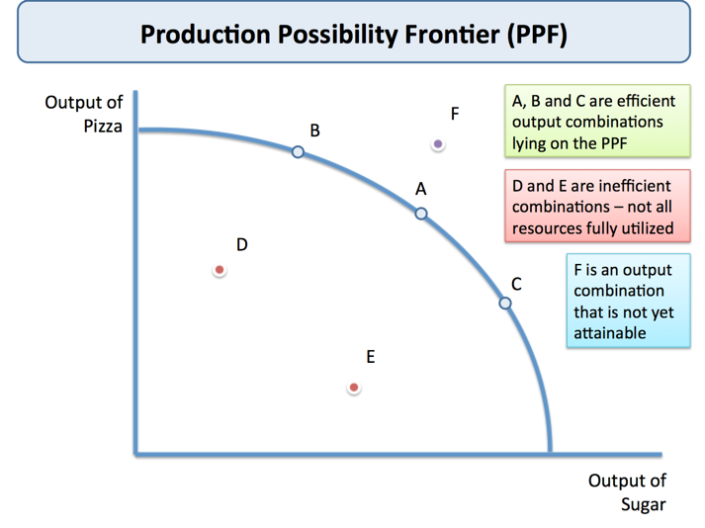

LEC 2

Positive vs. Normative Statements
- Positive
  - A question that potentially has a right answer
  - Factual, evidence based
  - The word would is ok to be used
- Normative
  - A question that could not have a right answer
  - Opinion based (ought to, should have, etc.)

PPF
- Moving along a PPF shows opportunity costs
  - How much of one product do you have to forgo to get an additional unit of the other
  - Slope is the opportunity cost of the x axis variable
  - Inverse is the opportunity cost of y axis variable
- Shifting PPF
  - Technology improvement
  - Weather change
  - Change in labour
  - Change in efficiency

LEC 3

Market
- Group of buyer and sellers of a good or service
- Can be organized or disorganized
- Size of a market depends on the product
- Competitive markets
  - Require that there are many buyers, with free choice
    - 1. Homogeneous Products: No Brand Differentiation
    - 2. Numerous buyers and sellers
  - Monopoly: one seller (hydro)
  - Oligopoly: few sellers who control the market (phone companies)
  - Perfect Competition: rare, everyone sells the same exact product with no differentiation

Demand
- Quantity Demanded
  - Amount of good buyers are willing and able to purchase at a given price
  - This is a point on the demand curve
  - The price will NEVER shift a demand curve, but instead will change Q_{d}
- Law of Demand
  - Price and Quantity Demanded are inversely related
  - As price rises, Q_{d} falls
- Demand Schedule
  - Table showing the relationship between price and Q_{d}
- Demand Curve
  - Graph of the demand schedule
- Market Demand vs. Individual Demand
  - Market demand adds up individual demand
  - Summing individual demand curved horizontally
- Demand Curve Shifters
  - Income
    - Rising income increases demand – normal good
    - Rising income reduces demand – inferior good
  - Prices of Related Goods
    - Increase in price X increases demand for Y – substitutes
    - Increase in price Y reduces demand for Y – complements
  - Tastes
    - Consumer preference
    - Varies and difficult to predict, yet can be measured
  - Expectations
    - Future prices of a durable good can affect demand
  - Number of Buyers

Supply
- Quantity Supplied
  - Amount of a good sellers are willing to and able to sell at a given price
  - This is a point on the supply curve
  - The price will NEVER shift a supply curve, but instead will change Q_{s}
- Law of Supply
  - Price and Quantity Demanded are directly related
  - As price rises, Q_{s} Rises
- Supply Schedule
  - Table showing the relationship between price and Q_{s}
- Supply Curve
  - Graph of the supply schedule
- Market Supply vs. Individual Supply
  - Market supply adds up individual supply
  - Summing individual supply curved horizontally
- Supply Curve Shifters
  - Input prices
    - Wages, supplies, capital cost
    - Change in the production cost of a product
  - Technology
    - Ability to produce with fewer inputs will shift supply to the right
  - Expectations
    - Future prices of a durable good
    - If the supplier will make more money or less money later, they may choose to limit/withhold products until a later date or vice versa
  - Number of Sellers
    - Affects market supply

Intersection of Supply and Demand
- Equilibrium
  - Intersection of supply and demand
- Equilibrium price
  - Price that balances supply and demand
- Equilibrium quantity
  - Quantity supplied and demanded at the equilibrium price
- Excess supply
  - When quantity supplied is greater than quantity demanded
- Excess demand
  - When quantity demanded is greater than quantity supplied

How to Ensure Competitive Markets
- Cases against big-rigging/price-fixing
- Cases against false advertising
- Mergers are evaluated by the Competition Bureau for their effects on competition

LEC 4

When Does Elasticity Matter?
- Business Strategy
  - Optimal pricing strategies for companies
- Tax Policy
  - What happens if we raise taxes on the tickets 1%?
- Environmental Policy
  - What would be the effect of a gasoline or carbon tax
- International Issues
  - Why are food prices highly volatile?

What is Elasticity?
- Proportionately, how much does one factor change as we vary another
- The Price Elasticity of Demand
  - E = Percentage Change in Q_{d}/Percentage Change in Price
    - (Qs₂ – Q₁)/ [(Qs₂ – Qs₁)/2] / (P₂ – P₁)/[(P₂ – P₁)/2]
  - E = Percentage Change in Q_{s}/Percentage Change in Price
    - (Qs₂ – Qs₁)/[(Qs₂ – Qs₁)/2] / (P₂ – P₁)/[(P₂ – P₁)/2]
- Price Elasticity of Demand
  - Are there close alternatives?
  - Necessities vs. Luxuries?
    - Inelastic demand for pharmaceuticals
    - Elastic demand for travel
  - Definition of the Market
    - Rice is a substitute for wheat
    - There are no substitutes for food
    - Elasticity of demand for food will be lower than for wheat
  - Time horizon
    - Alternatives may take time to exploit
    - Demand for gas in the short-term is inelastic
    - In the long-term, alternatives make it more elastic
- Price Elasticity of Supply
  - Access to the inputs to production
    - Supply of beachfront property is inelastic
  - Time horizon is critical
    - Supply of many goods can’t respond in the short-term
    - Short-term supply of food, apartments, doctors, etc. is inelastic
    - Long-term supply can be more elastic

Elasticity of Demand & Revenue
- Inelastic
  - Increasing price increases revenue
- Unit Elastic
  - Increasing price, no effect on revenue
- Elastic
  - Increasing price decreases revenue

Excise Taxes and Elasticity
- Who is affected by taxes? Supplier or Consumer?
- Distribution of the effects of taxes are determined by elasticity of supply and demand
- Inelastic side of the market pays more of the tax

Income Elasticity of Demand
- As income rises, how much more do we demand of a particular good?
- Inferior goods
  - Income elasticity is negative
    - Bus transportation (Canada), potatoes (Canada)
- Necessities
  - Income elasticity is less than one
    - Food (generally), Poultry (Canada), Beer (Canada)
- Luxuries
  - Income elasticity is greater than one
    - Poultry (Sri Lanka), Wine (Canada)

Cross-Price Elasticity
- How does the demand for a good change if the price of others good change?
    - E = % Change in Q_{d} of one good/% Change in Price of other good
- Complements – Cross-Price elasticity is negative
  - Increased price of gasoline reduces demand for cars/trucks that consume a lot of fuel
- Substitutes – Cross-Price Elasticity is Positive
  - Increased price of gasoline will increase demand for public transportation
  - Increased price of wheat increases demand for corn or rice

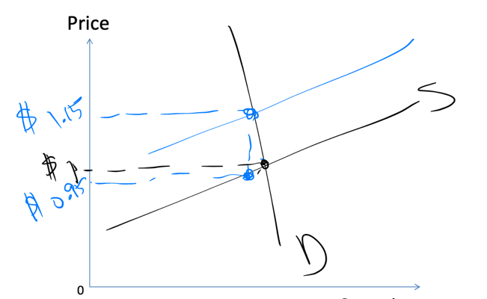
LEC 5

Elasticity and Tax Incidence
- Elasticity of supply and demand determines tax incidence
- Inelastic side of the market bears bulk of tax effect
- Supply shifts this is one points, second point is at the initial supply curve, separating point is at equilibrium
- Buyer is top half, seller is bottom

Demand and Supply Reconsidered
- Demand Curve identifies the maximum consumers would pay for a product
  - Interpret this maximum as equal to the value received
- Supply curve identifies minimum price at which sellers will sell
  - Interpret this minimum at cost

Economic Surplus
- Surplus exists between demand and supply

Competitive Markets and Efficiency
- Equilibrium in a competitive market - intersection of supply and demand
  - Maximizes economic surplus
  - Efficient economic outcome
- A few key caveats
  - True for competitive markets, but not all markets are competitive
  - Positive or negative externalities in production, sale or consumption would mean this isn’t true

Price Ceiling
- Maximum price that can be charged in a market
- Not necessarily binding
  - Only if the ceiling is below equilibrium
  - Causes excess demand (shortages)
    - Inefficient, can create a black market

Price Floor
- Maximum price that can be charged in a market
- Not necessarily binding
  - Only if the ceiling is above equilibrium
  - Causes excess supply (surplus)

Output Quotas
- Government restriction which limits the amount of production a supplier can output into the market during a given time period

Economic Surplus
- The sum of producer surplus and consumer surplus
- Equilibrium Quantity multiplied by the height of the triangle, all over 2 will give the area of the economic surplus
- Consumer Surplus
  - The difference between what a consumer is willing to pay versus what they actually pay
  - Calculated by finding height of triangle above equilibrium and using the bh/2 formula
- Produced Surplus
  - The difference between what a seller is willing to sell at versus what they actually sell at
  - Calculated by finding height of triangle below equilibrium and using the bh/2 formula
- Deadweight Loss
  - Loss in economic surplus
  - Follow same formula
  - Happens when there is a tax imposed or some sort of governmental restriction

LEC 6

To do:
- Practice midterm on MyLS
- BA110

Utility as a Concept
- Utility is a conceptual measure of consumer satisfaction or value
- Assume that consumers make choices to maximize utility
- Assess utility based on observed consumer choices
  - Circular nature of the argument is important
    - Measuring utility based upon the choices consumers make
- Diminishing marginal utility
  - As more of a product is consumed the less value is placed upon that product
  - Consumers derive less value from successive units of particular type of consumption
  - Each coffee adds value, less than before though
  - Total utility increases, at a decreasing rate because of the smaller diminishing increment of marginal utility added each time
- Utility Maximization
  - MU_{x}/P_{x} = MU_{y}/P_{y}
  - What is the marginal utility of my next purchase option?
- Constructing a demand graph based on marginal utility:
  - Demand falls more drastically if marginal utility is diminishing at an increased rate versus the opposite
  - Individual demand curves derived from utility maximization
- Downward sloping demand
  - Income effects: when consumers feel richer or poorer, how do their decisions change?
    - When consumers feel richer or poorer, how do their decisions change?
  - Substitution effect: how do relative prices affect consumer behaviour?
    - Maximizing utility requires substituting towards consuming more of other products which have higher marginal utility

Substitution Effect
- Maximizing utility requires substituting towards consuming more of other (cheaper) products
- Always negative
  - Increasing relative price of a good reduces consumption of that good

Income Effect
- Changing prices make consumers feel richer or poorer
- Increasing the price of coffee reduces the set of choices I can afford to buy
- When I feel poorer, do I buy more of a product or less of a product?
- Normal Goods
  - When you feel poorer, you buy less of the good
- Inferior Goods
  - When you feel poorer, you buy more of the good
- Giffen Goods
  - When I feel poorer, I buy much more of the good
  - Rice, wheat, bread
  - Upward slope demand curve

